Supplementary Information

Manifestation of chirality induced spin selectivity in chiral-photodiodes based on donor-acceptor copolymer/chiral molecule/fullerene blends
Xin Pan¹*, Paul Bailey¹*, Heshan Hewa Walpitage¹, Daniel Nikiforov¹, Hwa-Young Cho², Ohyun Kwon², Zeev Valy Vardeny¹**
¹ Department of Physics & Astronomy, University of Utah, 115 South 1400 East, Salt Lake City, Utah, 84112 USA
² Samsung Advanced Institute of Technology (SAIT), Samsung Electronics Co., Ltd., 130, Samsung-Ro, Youngtong-Gu, Suwon-Si, Gyeonggi-do 16678, Republic of Korea

CONTENTS

1. Figure S1. Circular dichroism (CD) and absorption set ups 2
2. Figure S2. Circular dichroism and absorbance spectra of thin films of [M]/[P]-aza[6]H/F8BT/PC₇₁BM 4
3. Figure S3. Calculated g-factor spectrum of the circular dichroism spectra of [M]/[P]-aza[6]H/ F8BT/PC₇₁BM blend thin films 5
4. Figure S4. Reflection and transmission in a chiral photodetector device 5
5. Table 1. Reflected, transmited and absorbed light intensities in [M]-aza[6]H/F8BT/PC₇₁BM photodiode device under circularly polarized excitation. 7
6. Figure S5. Photogeneration and recombination processes in the time-of-flight configuration 8
7. Figure S6. Photo-induced absorption in two chiral aza/F8BT/PC₇₁BM blend films measured at 40K. 9
8. References 9

S1. Magneto-optical spectroscopy

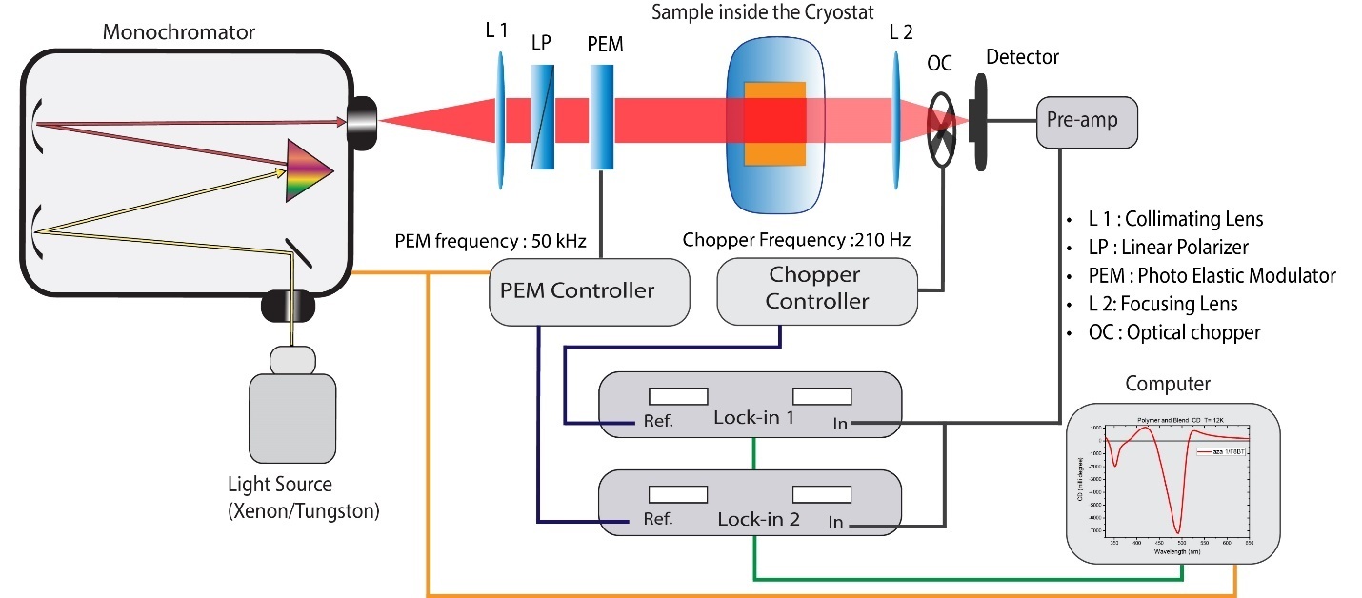

Figure S1. Circular dichroism (CD) and absorption set up. Various optical and electrical elements are denoted. (note, to eliminate room light contribution the chopper was placed right in front entrance into the monochromator)

The set up for measuring the CD and absorption spectra is shown in Fig. S1. The absorbance, A (namely Optical Density, OD) spectrum of the chiral blend was calculated from the measured optical transmission ($T$) spectrum as:
$A=-log⁡(\frac{T}{T_{glass}})=-\frac{ln⁡(T/T_{glass})}{ln10}$ , (S1)

where the transmission through the film is normalized by that of the glass substrate, T_{glass}. The difference in the absorbance ($∆A$) of the two light helicities, namely left- and right-circularly polarized light is given by:
$∆A≅-\frac{∆T}{Tln10}$ , (S2)
where ΔT = T_{L}-T_{R}, the difference between the transmission T_{L} of left-circularly polarized light and T_{R} right circularly polarized light.

Subsequently, the circular dichroism (CD) spectrum of the film was calculated using the relation:[1]
$CD(mdeg)=∆A*\left(\frac{ln10}{4}\right)*(\frac{180000}{π})$ (S3)

From Equations (S2) and (S3), we may express the CD value in mdeg as:
$CD(mdeg)=-\frac{∆T}{Tln10}*32980$ (S4)

As seen in Fig. S1 the transmission $T$ was measured by the first lock-in amplifier, which was referenced to the chopper operating at 210 Hz. The difference, or dissymmetry in transmission, $∆T$ was measured by the second lock-in amplifier, which was referenced to the photoelastic modulator (PEM 200 from Hinds Instruments) operating at 50 kHz. Note that in Equation (S4), $∆T=2X_{2}$, where $X_{2}$ is the output of the second lock-in that operates in phase with the PEM. The factor of 2 arises from the chopper which shortens, by a factor of two the effective integration time of the measured signal. The phase of the second lock-in was determined by replacing the sample by a quarter wave plate and polarizer, to mimic ΔT = T_{L}.

The g-factor related to the CD is calculated using the relation:

$g=\frac{∆A}{A}$ (S5)
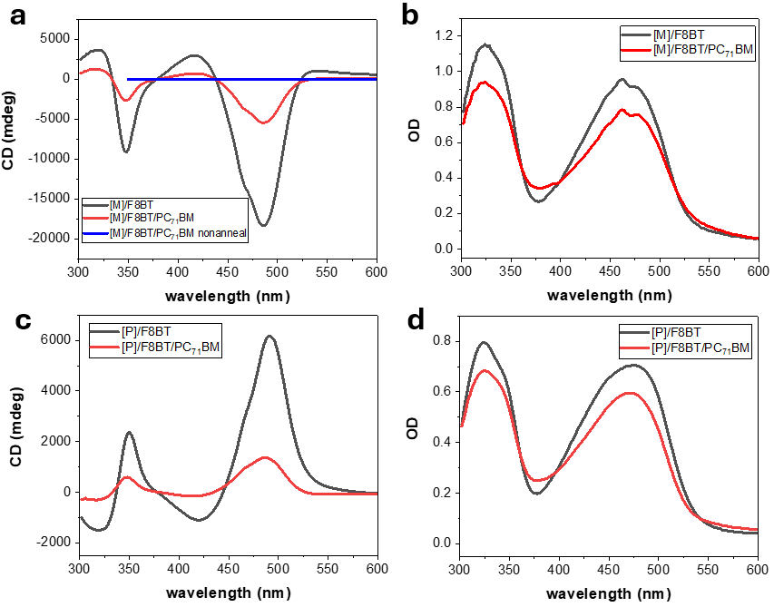
Figure S2. The circular dichroism (a) and (c) and absorbance spectra (b) and (d) of thin films of [M]/[P]-aza[6]H/F8BT blend with (red line) and without (black line) PC₇₁BM.

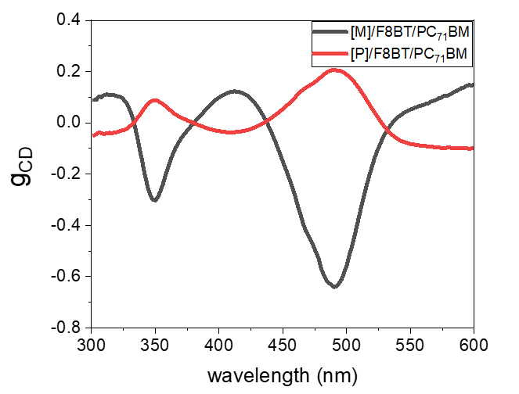
Figure S3. The obtained CD g-factor, g_{CD} spectrum of [M]/[P]-aza[6]H/ F8BT/PC₇₁BM blend thin films.

S2. Measuring the amount of absorbed light intensity in the chiral photodetector device using circularly polarized light of different helicity

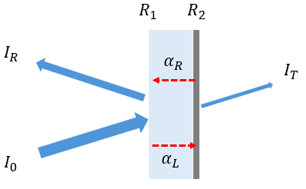
Figure S4. The reflected, I_{R} and transmitted I_{T} light intensities in a photodetector device. α_{L} and α_{R} are the respective absorption coefficient of left- and right-circularly polarized light in the active layer; R1 and R2 are the reflection coefficient of light at the two interfaces as noted.
We used several solid-state lasers with various wavelengths for measuring the amount of the absorbed light intensity in the chiral blend active layer of the device. Figure S4 shows a simplified scheme of absorption and transmission in the device based on the chiral blend, when left circularly polarized light is impinged onto the device. The reflective coefficients at the ITO and Ca/Al surfaces are $R_{1}$ and $R_{2}$, respectively, and we assume that these coefficients do not depend on the light helicity. In our notation the absorption coefficient related to left and right circularly polarized light in the blend film are $α_{L}$ and $α_{R}$, respectively. We calculate the reflection and transmission of the device under left circularly polarized excitation for one light round trip inside the active layer as follows:
$I_{T}=I_{o}(1-R_{1})(1-R_{2})e^{-α_{L}d}$ (S6)
$I_{R}=I_{0}R_{1}+I_{o}{(1-R_{1})}^{2}R_{2}e^{-(α_{L}{+α}_{R})d}$ (S7)
We took into account that the impinging circularly polarized light flips handedness after reflection at the Ca/Al surface. Consequently, the absorption in the chiral blend film includes both handednesses of circularly polarized light, Eq. (S7). In contrast the transmission at the Ca/Al electrode does depend on the impinging light handedness Eq.(S6). From Eqs. S6 and S7 we calculate the absorbed light in the device as I₀-I_{R}-I_{T} as given in Eq. (S8) and in the text (Eq. (1)).
$I_{abs}=I_{0}\left(1-R_{1}\right)[\left(1-R_{2}{(1-R_{1})e}^{-\left(α_{L}+α_{R}\right)d}\right)-(1-R_{2})e^{-α_{L}d}$ ] (S8)
In Table 1 we show the measured amount of the light absorbed in the device upon illumination with left and right circular polarizations, respectively at several wavelengths. Not surprising, the measured amount of absorbed light intensity of the impinging left and right circularly polarized beam, namely the absorption dissymmetry, is within ~1.5 % for all three wavelengths. We thus conclude that difference in light absorption is not the reason for the measured dissymmetry in the photocurrent under circularly polarized excitation that is ~ 20%. This also shows that Eq.(1) in the text is correct; and that the reflectivity coefficients R₁ and R₂ are essentially polarization independent. Note that although the transmission when using opposite light handiness may substantially change in our measurements, as shown in Table 1, the overall effect on the absorbed light in the device is negligible since R₂ ≈ 1 in the visible spectral range.
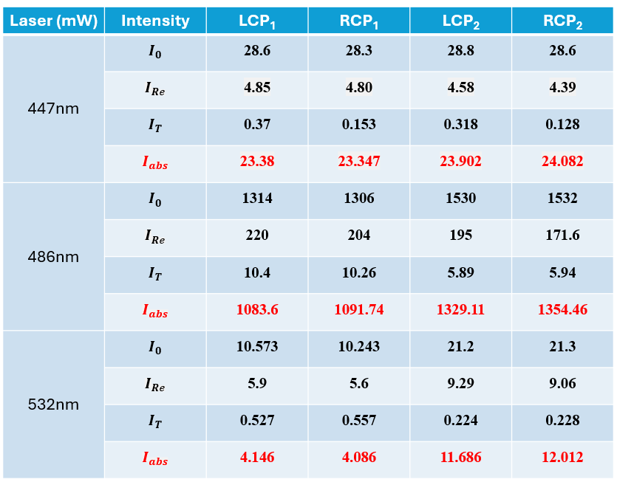
Table 1. Reflection and transmission intensities in [M]-aza[6]H/F8BT/PC₇₁BM photodiode device under circularly polarized excitation with two polarization helicities. The absorbed light intensity of left and right circularly polarized light in the chiral device is <1% for 447nm and 486nm lasers and is ~2% under 532nm laser excitation. Note that we performed two different set of measurements for each wavelength, as shown in the four right rubrics in the Table.

S3. Photogeneration and recombination processes in the TOF configuration
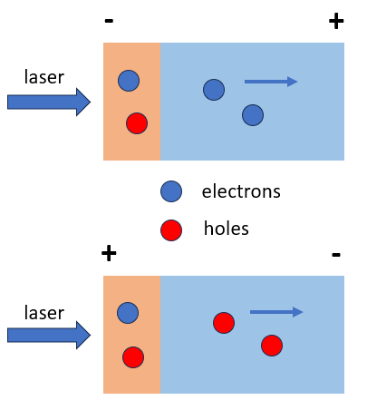
Figure S5. Photogeneration and recombination processes in the TOF configuration.
The time-of-flight (TOF) measurements were conducted on drop cast films, with a thickness of approximately 1μm measured by a profilometer. We identify two zones in the measured blend, namely the photo-generation zone (orange area) and transit zone (blue area). The penetration depth of the 480 nm laser in the photo-generation zone used here was estimated to be ~200 nm in the aza/F8BT/PC₇₁BM film based on the OD of the films. In this photo-generation zone photo generation and recombination processes occur simultaneously since the photocurrent lifetime is relatively short (~2us, see Figure 5) compared to the transit time in the penetration depth. In the transit zone, the electrons (or holes) are transferred to the electrode free of recombination, having transit time that is determined by the bias voltage applied between the two electrodes.

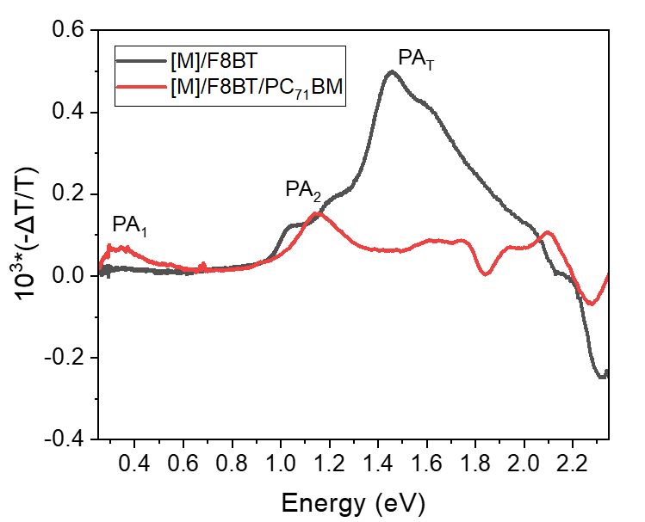
Figure S6. Photo-induced absorption (PA) spectra in two blend films measured at 40K, as denoted. PA_{T} is due to triplet excitons in the aza[6]H/copolymer blend, whereas PA₁ and PA₂ are due to photogenerated polarons in the blend that contains PC₇₁BM. This indicates that charge carriers are photogenerated in the blend that contains PC₇₁BM molecules. For these measurements we used a 447 nm laser diode as ‘pump’ and an incandescent tungsten lamp as a ‘probe’.

References:

[1] Long, G., Jiang, C., Sabatini, R., Yang, Z., Wei, M., Quan, L.N., Liang, Q., Rasmita, A., Askerka, M., Walters, G. and Gong, X., 2018. Spin control in reduced-dimensional chiral perovskites. Nature Photonics, 12(9), pp.528-533.
[2] Bello, A., Laredo, E. and Grimau, M., 1999. Distribution of relaxation times from dielectric spectroscopy using Monte Carlo simulated annealing: Application to α− PVDF. Physical review B, 60(18), p.12764..

