Supplementary Figure
Supplementary Figure 1 Schematic diagram of C3H2C3 conserved sequence alignment of VyRCHCs. Cys(C) and His(H) amino acids were added on a blue and pink background. The C3H2C3 conserved amino acid sequence length of these genes is shown later in the sequence.
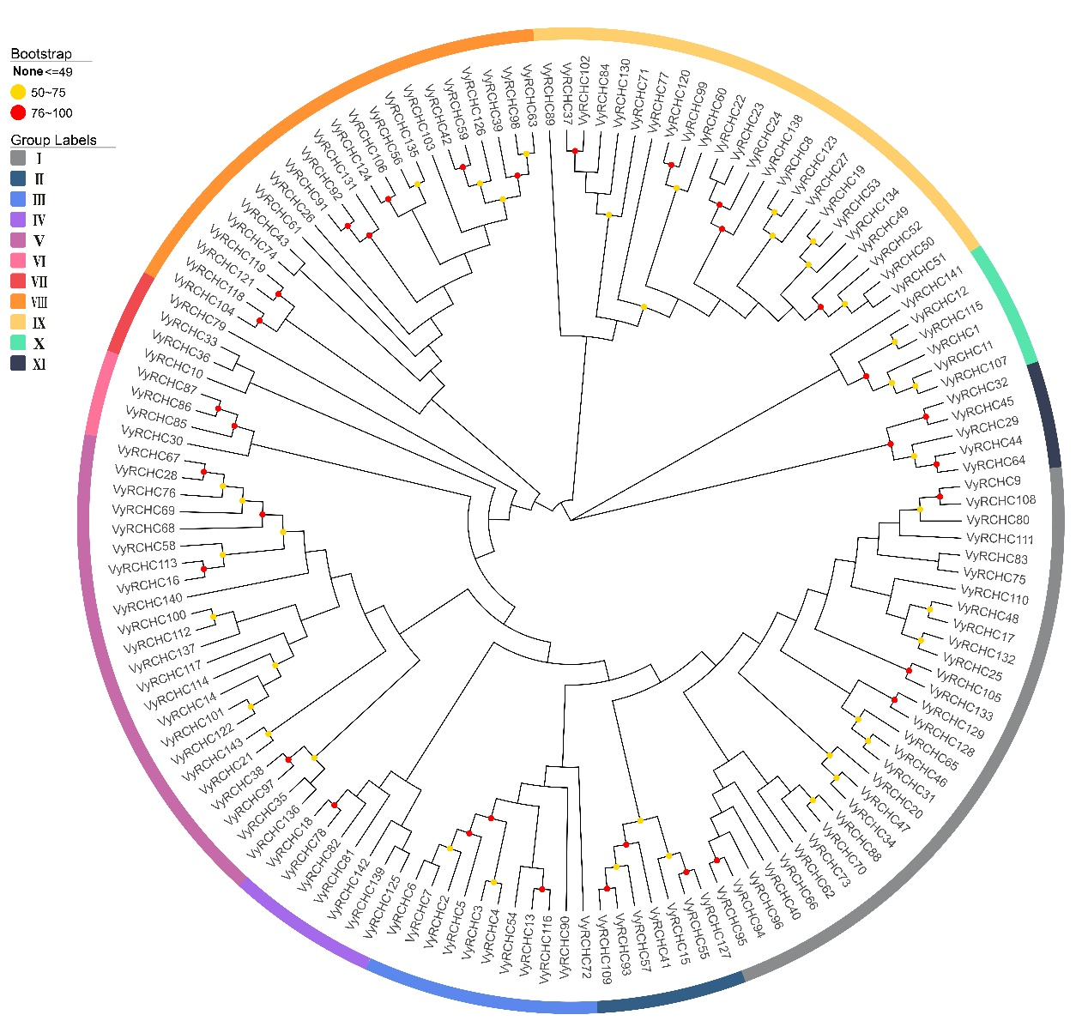

Supplementary Figure 2 Phylogenetic analysis of RCHC protein in grapevine. Via the NJ method, MEGA7.0 was used to construct phylogenetic trees of grapevine. The number of bootstrap repeats was n = 1000. Displayed are the percentages of bootstrap scores greater than 50%. According to phylogenetic analysis, 143 VyRCHCs were divided into 11 groups, which were divided into 6 groups according to the total number of amino acids in the C3H2C3 conserved domain in VyRCHC protein sequence, and marked with 6 different colors.
.
Supplementary Figure 3 Number of introns in VyRCHCs.

Supplementary Figure 4. Analysis of cis-acting elements in the VyRCHCs.
a A list of VyRCHCs to facilitate correspondence. b Color-coded numbers of cis-acting elements of the three major types of VyRCHCs promoters. c Different types of cis-acting elements are represented by different colored squares and their position on each VyRCHC gene promoter.
Supplementary Figure 5: VyRCHC114 in vitro ubiquitin gel imprinting (uncut).
Corresponding to the original image of gel imprinting in Fig.7 A B C D.

