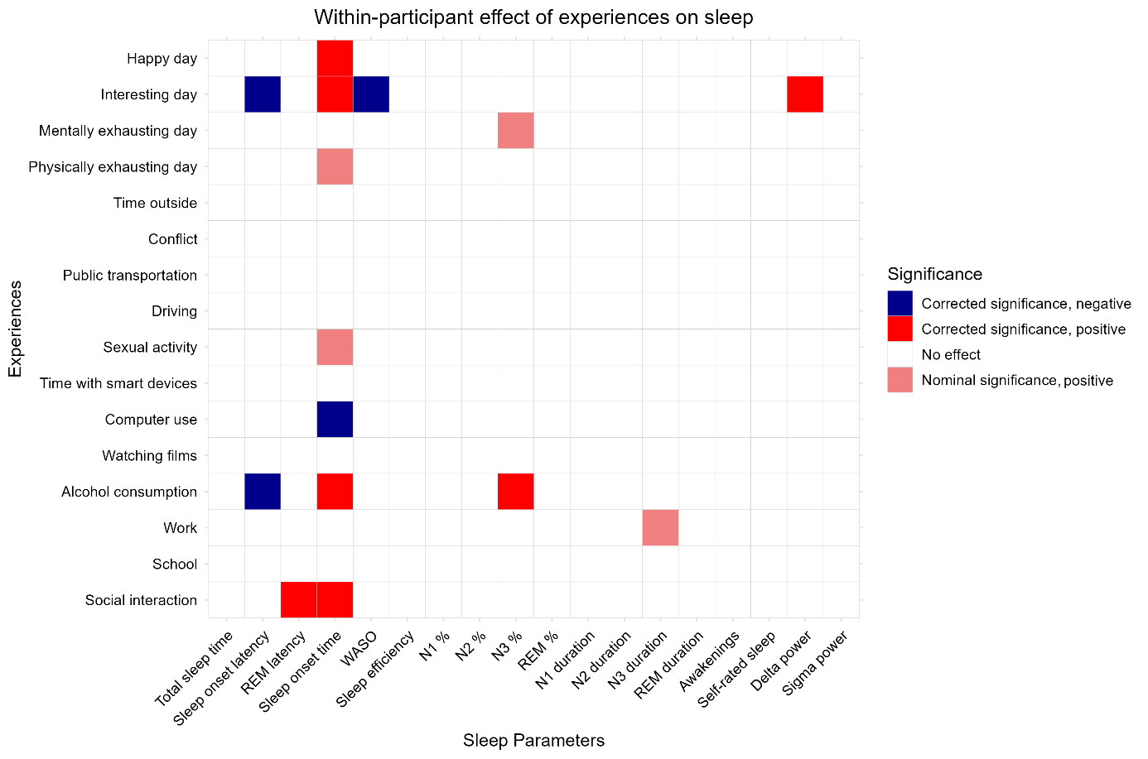
Supplementary figure S1. Within-participant associations between daily experiences and sleep parameters. These effects indicate that the same person’s sleep parameters are influenced by having experienced these events during the previous day. Dark colors show associations which survive correcting for multiple comparisons. All models are corrected for age, sex and day of the week (weekend/weekday) and lagged outcomes but, unlike those reported in the main manuscript, not for the duration of previous wakefulness.
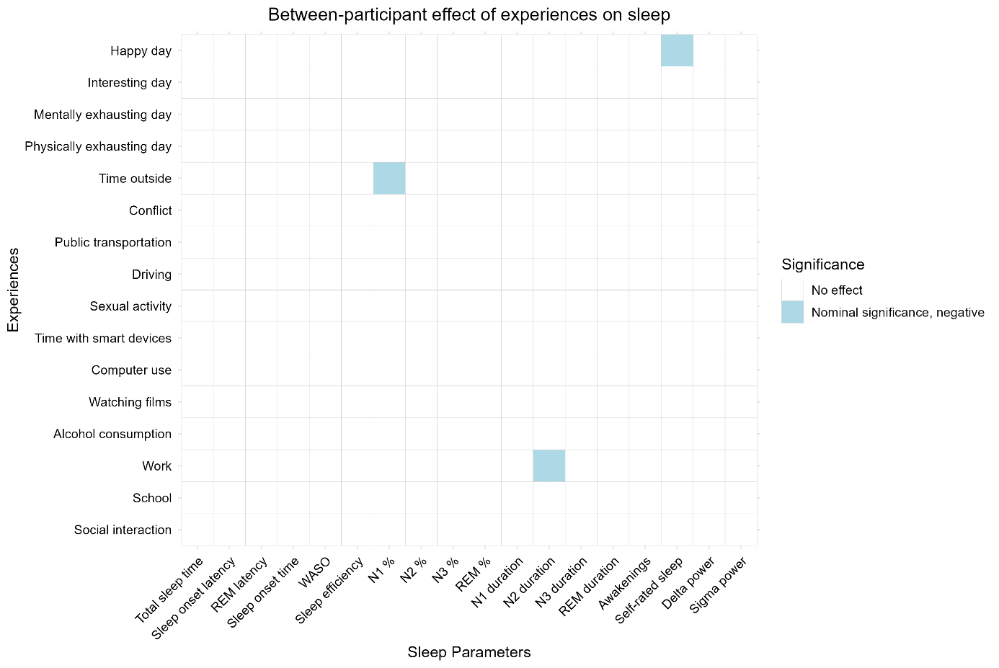
Supplementary figure S2. Between-participant associations between daily experiences and sleep parameters. These effects indicate correlations between habitual sleep characteristics and the frequency of experiencing certain events. No effects are significant after correcting for multiple comparisons. All models are corrected for age, sex and day of the week (weekend/weekday) and lagged outcomes, but, unlike those reported in the main manuscript, not for the duration of previous wakefulness.

