Characterization of the overexpressed recombinant human α11 integrin I domain in Escherichia coli for functional analysis

Elaheh Taviliª, Bahareh Dabirmaneshª, Massoud Amanlou^{b}, and Khosro Khajeh^{a*}
ª Department of Biochemistry, Faculty of Biological Science, Tarbiat Modares University, Tehran, Iran,
^{b} Department of Medicinal Chemistry, Drug Design and Development Research Center, Tehran University of Medical Sciences, Tehran, Iran.

*Corresponding author:
Khosro Khajeh, Department of Biochemistry, Faculty of Biological Science, Tarbiat
Modares University, P.O. Box 14115-175, Tehran, Iran. Tel/Fax; +982182884717; E-mail:
khajeh@modares.ac.ir

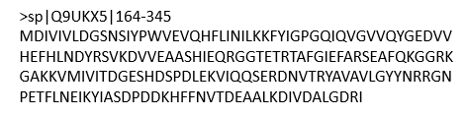
Figure S1. The amino acids sequence of integrin α 11- I domain with the UniProtKB code Q9UKX5.

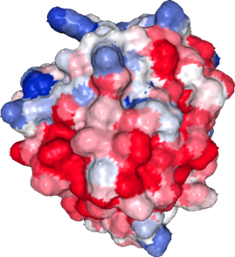
Figure S2. Visualization of the surface hydrophobicity of the integrin α11-I domain was displayed using the surface coloring feature of the UCSF Chimera tool (v.1.10.2), with blue representing the most hydrophilic regions, transitioning to white, and red for the most hydrophobic.

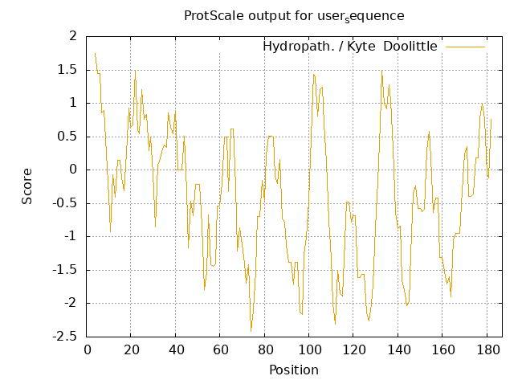
Figure S3. The Hydropath/Kyte & Doolittle diagram based on the sequence of integrin α11-I domain with UniProtKB code Q9UKX5, developed by Expasy (https://web.expasy.org/protscale).

