Table 1. The optimization of reaction conditions
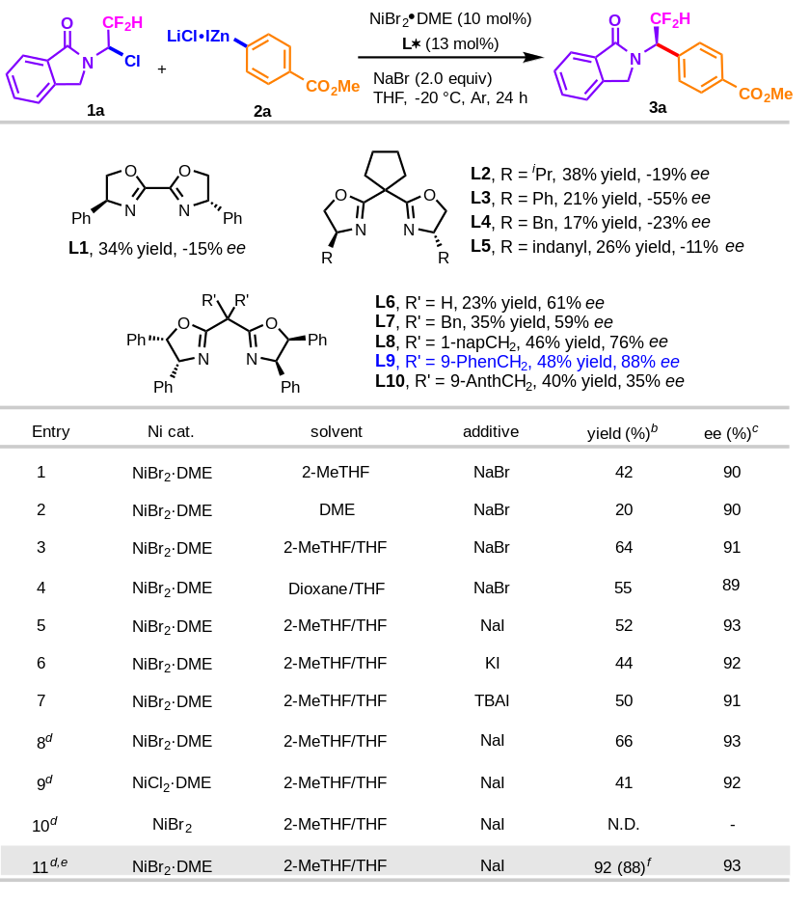
[a] Unless otherwise noted, all reactions were performed with 1a (0.1 mmol, 1.0 equiv), 2a (0.18 mmol, 1.8 equiv), Ni cat. (0.01 mmol, 10 mol%), chiral ligand (0.013 mmol, 13 mol%), additive (2.0 equiv), THF, Ar, -20 ºC, 24 h. [b] Yields were determined by ¹H NMR analysis of crude mixture with CH₂Br₂ as internal standard. [c] Enantiomeric excess (ee) values were determined by HPLC on a chiral stationary phase. [d] NaI (0.5 equiv) was used. [e] 48 h. [f] Isolated yield.
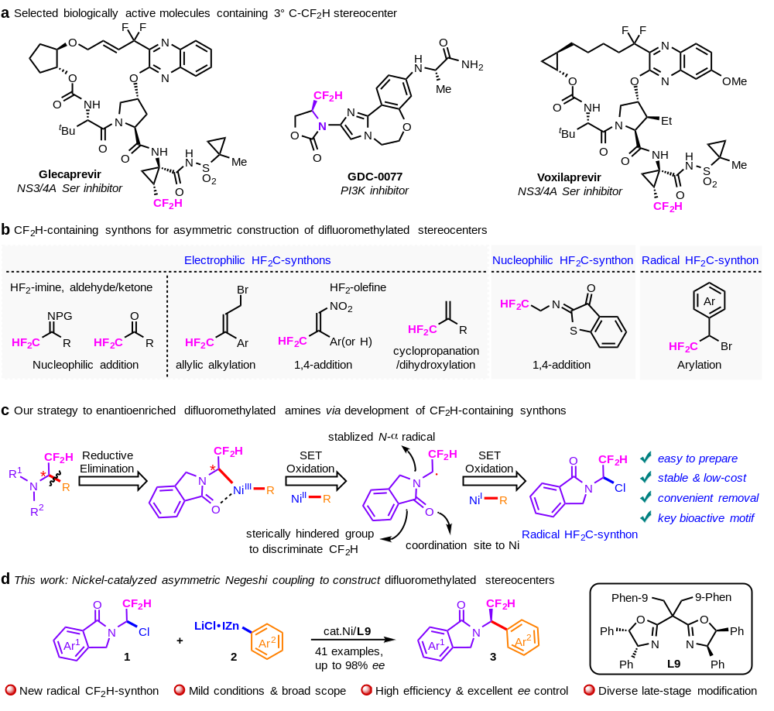
Scheme 1. Selected bioactive molecules and recent synthetic methods. a: Selected biologically active molecules containing 3º C-CF₂H stereocenter; b: CF₂H-containing synthons for asymmetric construction of difluoromethylated stereocenters; c: Our strategy to enantioenriched difluoromethylated amines via development of CF₂H-containing synthons. d: This work.
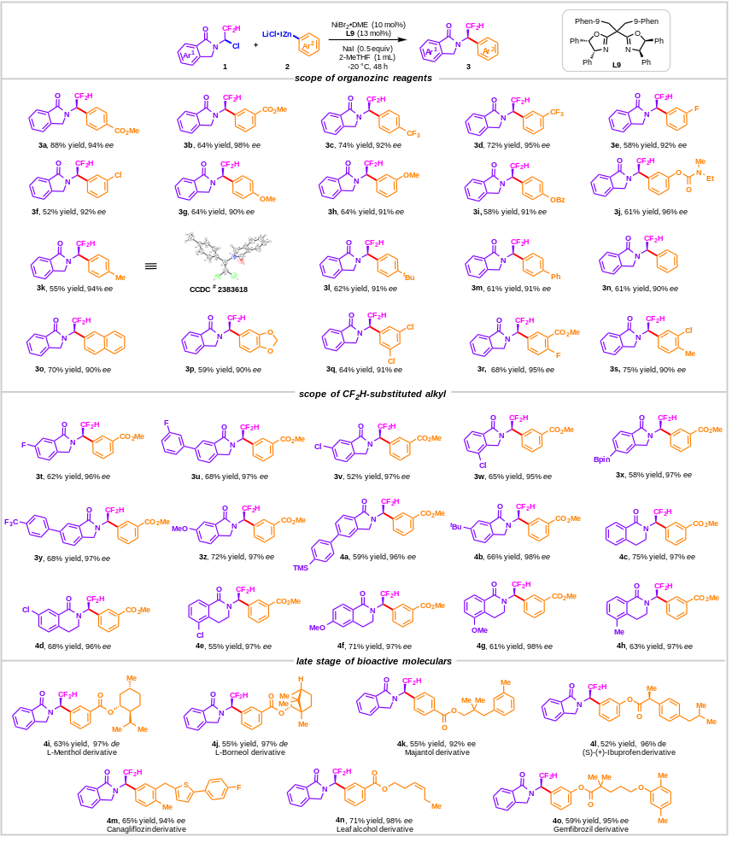
Scheme 2. Scope of substrate. Reaction conditions were as follows: 1 (0.2 mmol, 1.0 equiv), 2 (0.36 mmol, 1.8 equiv), NiBr₂·DME (0.02 mmol, 10 mol%), L9 (0.026 mmol, 13 mol%), NaI (0.1 mmol, 0.5 equiv), 2-MeTHF (1.0 mL), Ar, -20 ºC. Isolated yields. The ee values were determined by HPLC analysis on a chiral stationary phase.

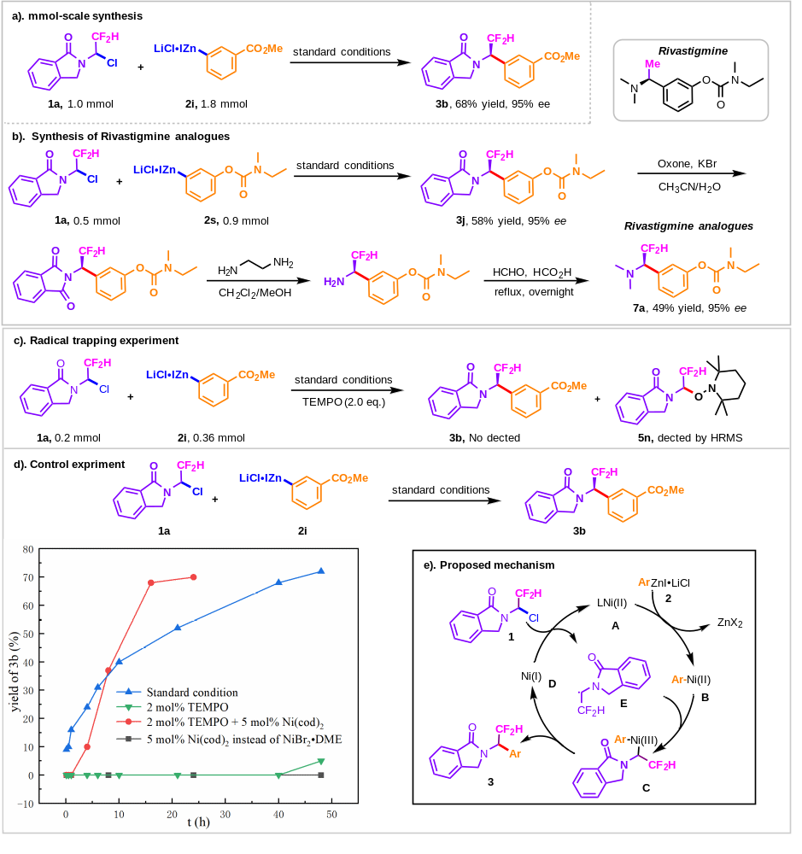

Scheme 3. Synthetic utility and mechanistic studies.²

