A MMP-1 on IS B IS on MMP-1
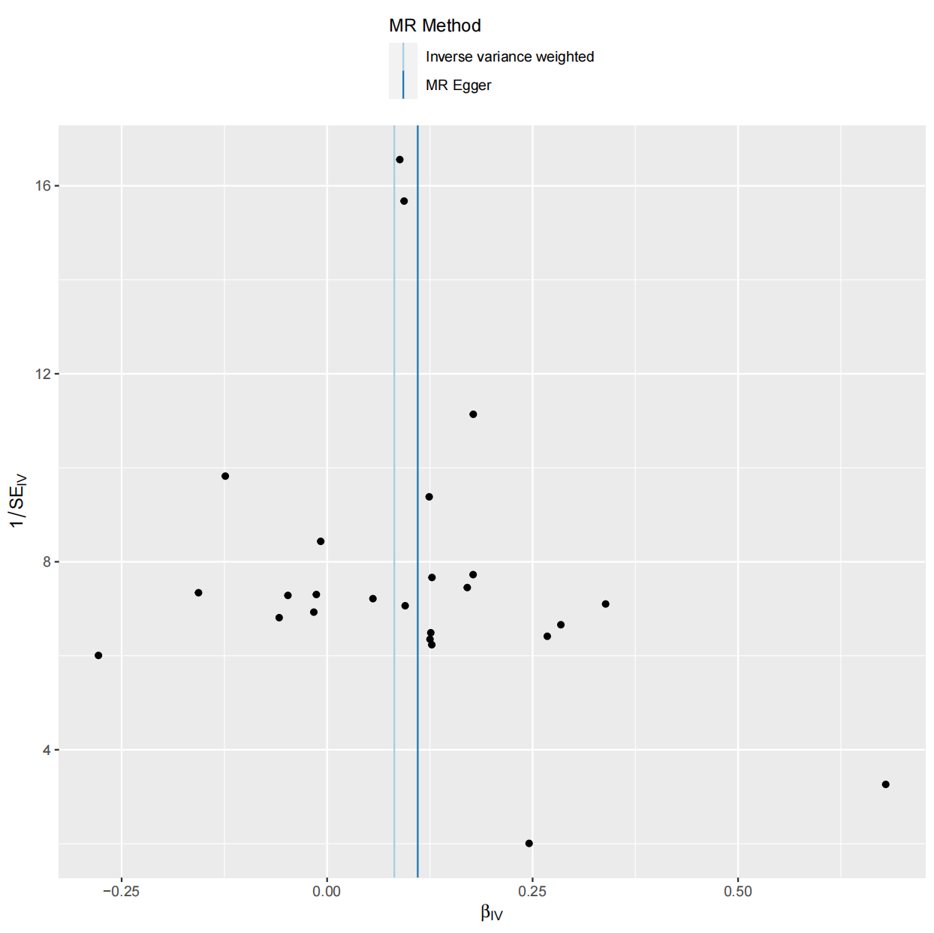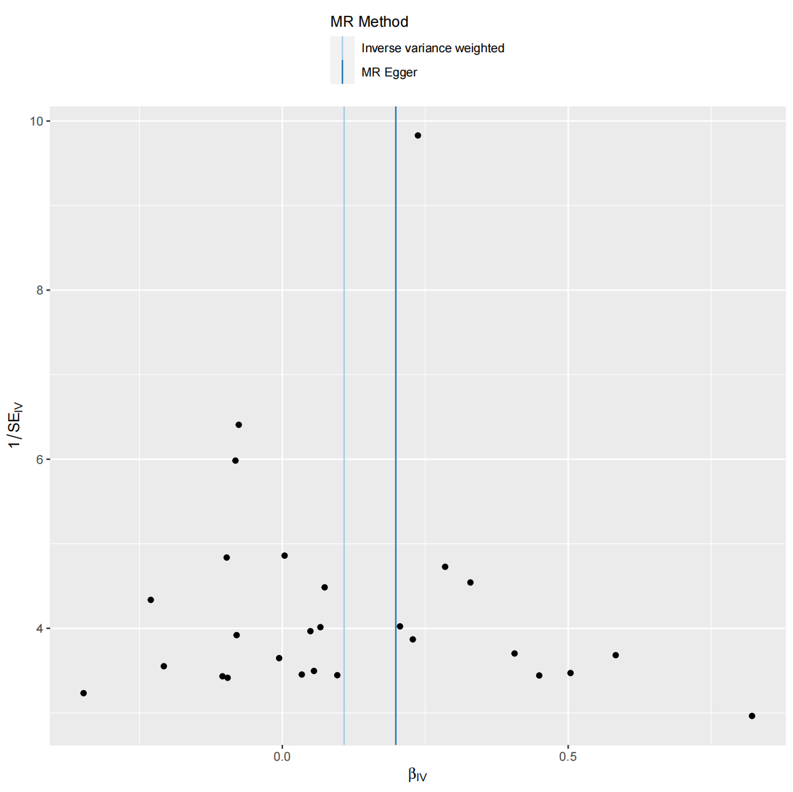
C MMP-1 on LSL D LSL on IS 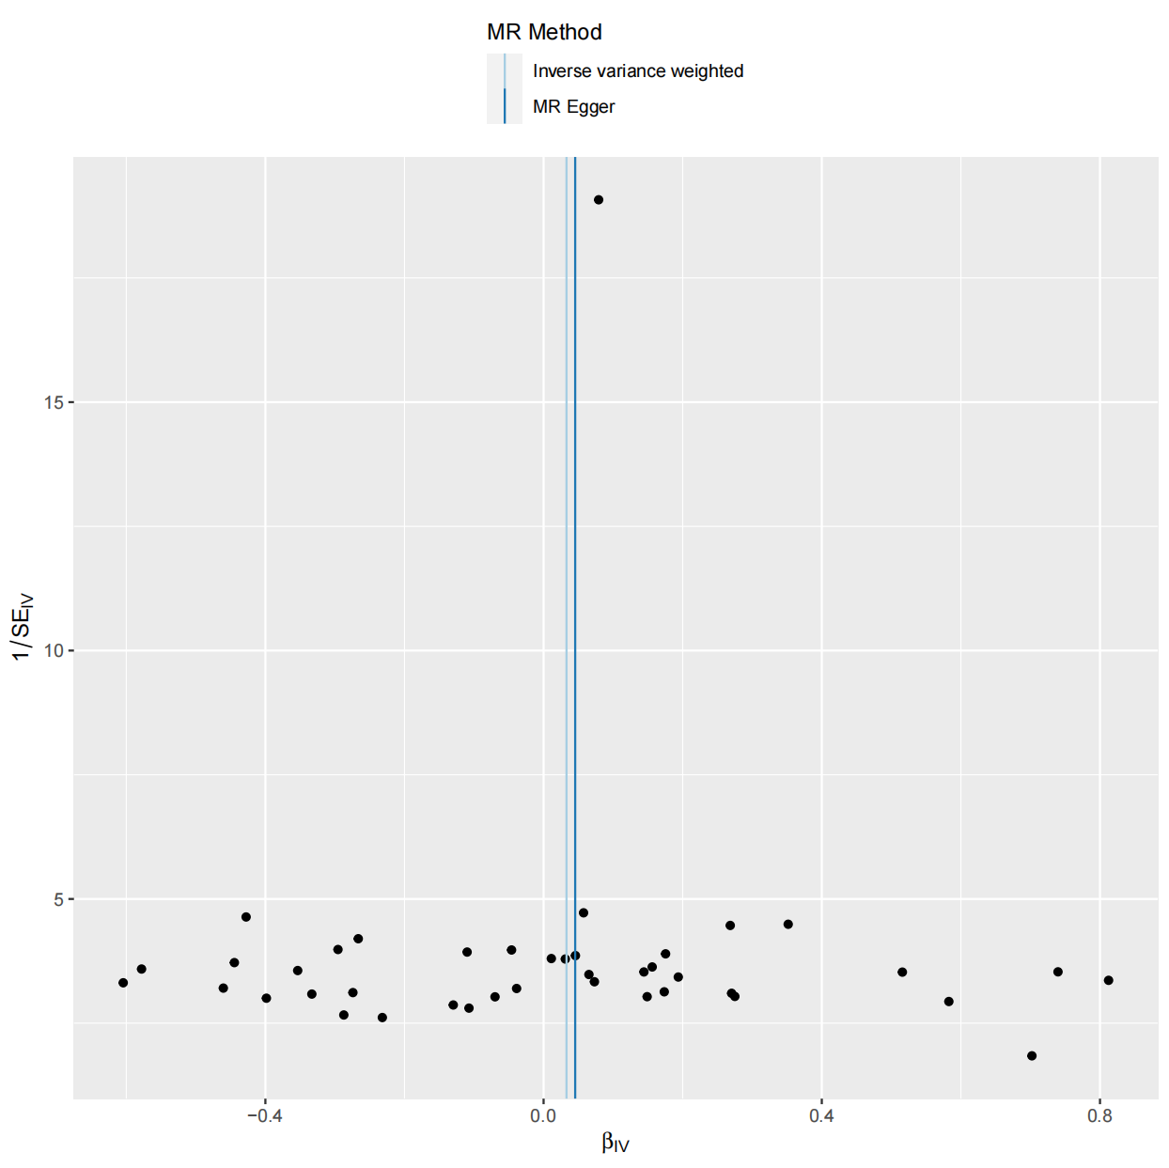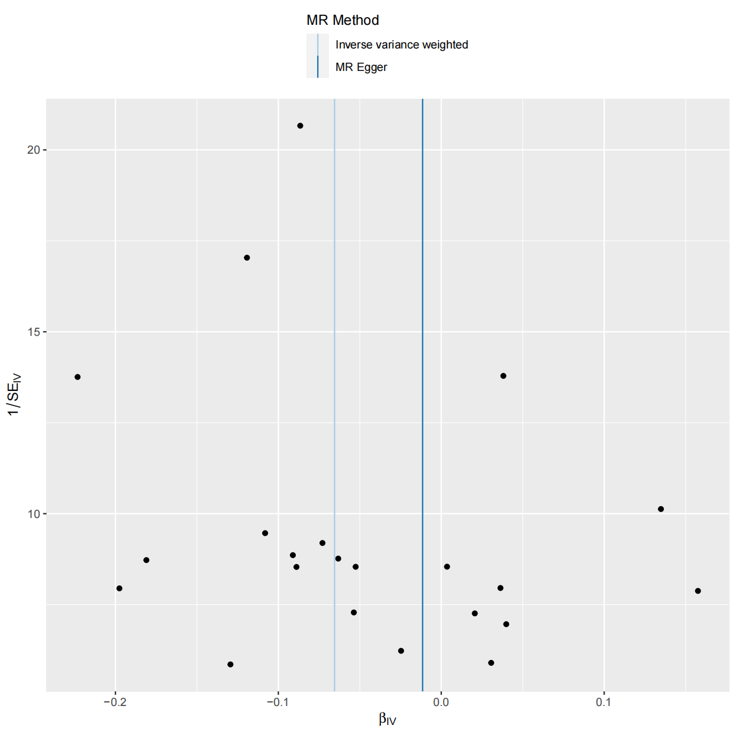
Figure S1: Funnel plots illustrating heterogeneity among SNPs in four sets of data (A, B, C, and D).

