Supplementary document

Decoupling mechanical and morphometric properties in meta-biomaterials

Ebrahim Yarali^{1,2,*}, Urs Staufer², Lidy E. Fratila-Apachitei¹, Reza Mahdavi³, Amir A. Zadpoor¹, Angelo Accardo^{2,*,#}, Mohammad J. Mirzaali^{1,*,#}
¹Department of Biomechanical Engineering, and ²Department of Precision and Microsystems Engineering, Faculty of Mechanical Engineering, Delft University of Technology, Mekelweg 2, 2628 CD, Delft, the Netherlands
³ Department of Industrial Engineering, BIOtech - Center for Biomedical Technologies, University of Trento, Via delle Regole 101, Mattarello, 38123 Trento, Italy
*Corresponding authors: E.yarali@tudelft.nl, A.Accardo@tudelft.nl, M.J.Mirzaali@tudelft.nl
#: These authors jointly supervised this work

S1. Geometrical design of the meta-biomaterials
The meta-biomaterials proposed here were geometrically symmetric (Figure 1b). They possess 9 planes of symmetry, particularly in three orthogonal planes $xy$, $xz$ and $yz$. To design the meta-biomaterials, we assumed that their unit cell was encapsulated within a cube with a fixed size of $H$ (Figure 1c). The six tails of the unit cell (i.e., the red dots in Figure 1c) were fixed on the six faces of the cube. This means that those boundary nodes are always attached to those faces while all other geometrical parameters vary (i.e., $θ$ and $L$). By changing the geometrical input parameters, the non-boundary nodes move along the face diagonal of the cube.
The dimension $H$ serves as a scale factor for the overall size of the meta-biomaterials and does not change their mechanical properties. Therefore, it was not considered as an input parameter in our computational model. To avoid the effect of the overall size (i.e., $H$) on the mechanical and morphometric results, we normalized the dimensions, such as $L$, $d$ and pore sizes by dividing them to $H$.
To parametrically design our meta-biomaterials, we derived all the relationships between the geometrical and morphometric parameters (e.g., pore sizes). The parameter $h$, referred to as the tail length (Figure 1d), had to be explicitly derived first. To achieve this, we extracted the following geometrical constraints (Figure 1d).
$$h_{p}=\frac{H}{2}-h;x=Lcosθ-h;$$ | (S1)
Therefore, by ensuring consistency along the $y$direction (i.e., $x+y=\frac{H}{2}$), the parameter $h$ was derived as follows:
$$h=\frac{H}{2}-L\left(\sin{θ}-cosθ\right)$$ | (S2)
The parameter $h$, therefore, depends on $H, L$ and $θ$. According to Eq.S2, the minimum of $h$ is achieved when $θ_{h}={135.0}^{o}$, regardless of the magnitude of $L$. Moreover, at $θ_{h}={135.0}^{o}$, $h$ tends toward zero when $L$ reaches the maximum:
$L=\frac{H}{2\left(\sin{θ_{h}}-cosθ_{h}\right)}=0.36H$ | (S3)
To further clarify the relationship between $h$ and $L$ and $θ$, we plotted $h$ vs. $θ$ at different $L$ (Figure S1a). Depending on $θ$ and $L$, we divided the unit cells into three categories; Category I, when $θ_{min}<θ≤{90.0}^{o}$ and $0.0<L≤0.5H$, Category II, when ${90.0}^{o}<θ≤{135.0}^{o}$ and $0.0<L≤0.36H$ and Category III when ${135.0}^{o}<θ<θ_{max}$ and $0.0<L≤0.36H$ (Figure 1c).
To elucidate the design space of our meta-biomaterials, the critical values (i.e., minimum and maximum) of the two parameters $θ$ and $L$ need to be calculated first. These critical values are calculated differently, depending on the type of the unit cell (ranges of $θ$). To do so, here, we first need to calculate the pore sizes.
In Categories I, II and III, the pore size within is equal to the diameter of the blue circle encapsulated within the unit cell as shown in Figure 1d, 1e and 1f, respectively (i.e., ${PS}_{W}=2r_{d}-d$). In case of Category I, ${PS}_{W}$ is therefore as follows, considering Eq.S1:
${PS}_{W}=2h_{p}-d=H-2h-d;$ | (S4)
where $d$ corresponds to the strut diameter. The final form of ${PS}_{W}$ was derived as follows, considering Eq. S2:
${PS}_{W}=2L\left(\sin{θ}-\cos{θ}\right)-d$ | (S5)
In Category II, similarly, ${PS}_{W}$ is equal to following formula (Figure 1e):
${PS}_{W}={2h}_{p}\sin\left(π-θ\right)-d$ | (S6)
Eventually, ${PS}_{W}$ in Category II is formulated as follows, considering Eq.S1:
$${PS}_{W}=2L\left(\sin^{2}{θ}-\sin{θ}cos{θ}\right)-d$$ | (S7)
In Category III, $r_{d}$ is formulated as follows (Figure 1f):
$$r_{d}=\sqrt{L^{2}+h_{p}^{2}-2h_{p}Lcos\left(π-θ\right)}=L\sqrt{\sin^{2}{θ}-\cos^{2}{θ}+1}$$ | (S8)
Therefore, considering ${PS}_{W}=2r_{d}-d$, the final form of ${PS}_{W}$ is as follows:
$PS_{W}=2L\sqrt{\sin^{2}{θ}-\cos^{2}{θ}+1}-d$ | (S9)

The pore size between, PS_{B}, on the other hand, is three dimensionally calculated by considering at least $2×2×2$ unit cells, as illustrated in Figure 1h, the light green sphere. To calculate PS_{B}, let’s consider the cube created by $2×2×2$ unit cells. To create such a cube, we linearly pattern a unit cell eight times. The pore size between is equal to the distance between two unit cells on the body diameter of the cube (e.g., the distance between the unit cells at the corner top and the one at the corner bottom). Considering node P20 (Figure 2g) of the top unit cell and node ${P10}_{transfer}$ (Figure 2g) of the bottom unit cell, the coordinate of node ${P10}_{transfer}$ was calculated by transforming the top unit cell by $\left(H,H,-H\right)$. Therefore, the $PS_{B}$ was derived as follows:
$$PS_{B}=3H^{2}+8L^{2}\sin^{2}{θ-8HLsinθ-d}$$ | (S10)
However, at a certain condition, for instance, when $L$ is small, $PS_{B}$ is equal to the face diagonal of the 3D red cube (Figure 1i) as $\sqrt{2}H$, regardless of strut diameter. Therefore, in this case $PS_{B}$ is as follows:
$$PS_{B}=\sqrt{2}H-d$$ | (S11)
Comparing Eqs.S10 and S11, the critical value for $L$ can be obtained at each $θ$. However, as another alternative, we calculated $PS_{B}$ as min ($PS_{B}$ in Eqs.S10 and 11).
Here, to calculate the minimum of $L$, ${PS}_{W}$ should also be minimum. Considering ${PS}_{min}$ as the minimum of the ${PS}_{W}$, and Eq.S5 for Category I, the minimum of $L$ is explicitly formulated as follows:
$L_{min}=\frac{d+{PS}_{min}}{2\left(sinθ-\cos{θ}\right)}$ | (S12)

Similarly, for Category II, considering Eq.S7, the minimum of $L$ is equal to:
$L_{min}=\frac{d+{PS}_{min}}{2\left(\sin^{2}{θ}-sinθ\cos{θ}\right)}$ | (S13)

For Category III, by considering Eq.S9, the minimum of the $L$ is calculated as follows:
$L_{min}=\frac{d+{PS}_{min}}{2\sqrt{\sin^{2}{θ}-\cos^{2}{θ}+1}}$ | (S14)
It should be notated that here ${PS}_{min}$ should not be smaller than the strut diameter, otherwise overlapping between the struts happens. Therefore, here we considered ${PS}_{min}=d$.
On the other hand, the maximum of $L$ is achieved for different conditions, depending on the Category. In Category I, it is achieved when $r$ (Figure 1j) is equal to the half of the face diagonal of the unit cell. However, we should also consider the strut diameter and a clearance between two tips of adjacent struts (i.e., $C$, the diameter of the green circle in Figure 1j). Therefore, considering $r=L\sqrt{\sin^{2}{θ}-\cos^{2}{θ}+1}$, $L_{max}$ is explicitly formulated as follows:
$$L_{max}=\frac{\sqrt{2}H-d-C}{2\sqrt{\sin^{2}{θ}-\cos^{2}{θ}+1}}$$ | (S15)
To calculate the clearance $C$, the value of $L_{max}$ should be the same for Categories I and II when $θ={90}^{o}$. But we need to calculate $L_{max}$ in Categories II and III first.
In Categories II and III, $L_{max}$ is achieved when $h$ is minimum. However, we considered a minimum for $h$ (i.e., $h_{min}=d/2$), because of the strut diameter. Therefore, considering Eq.S2 and $h_{min}$, $L_{max}$ is as follows:
$L_{max}=\frac{H/2-h_{min}}{\left|\sin{θ}-\cos{θ}\right|}$; | (S16)
The constant $C$, considering same value for both Eqs.S15 and 16 when $θ={90.0}^{o}$, is equal to $\sqrt{2}d-d$ and therefore the final form of Eq.S15 is as follows:
$$L_{max}=\frac{\sqrt{2}\left(H-d\right)}{2\sqrt{\sin^{2}{θ}-\cos^{2}{θ}+1}}$$ | (S17)
The critical values of θ (i.e., $θ_{min}$ in Category I and $θ_{max}$ in Category III) are achieved when the maxima and minima of $L$ are equal (i.e., $L_{min}=L_{max}$). Therefore, in Category I, $θ_{min}$ is calculated through the following equation using fsolve function in Matlab.
$\left(d+{PS}_{min}\right)\left(2\sqrt{\sin^{2}{θ_{min}}-\cos^{2}{θ_{min}}+1}\right)-\sqrt{2}\left(H-d\right)\left(2\left(\sin{θ_{min}}-\cos{θ_{min}}\right)\right)=0$ | (S18)
Similarly, $θ_{max}$ (in Category III) was calculated by considering Eqs.S14 and 16, through the following equations (via fsolve function in Matlab):
$$\left(\frac{H}{2}-\frac{d}{2}\right)\left(2\sqrt{\sin^{2}{θ_{max}}-\cos^{2}{θ_{max}}+1}\right)-\left(d+{PS}_{min}\right)\left(\left|\sin{θ_{max}}-\cos{θ_{max}}\right|\right)=0$$ | (S19)

Table S1. The parametrized coordinates of the nodes of a unit cell. These coordinates were used to systematically voxelize the unit cells when changing the input parameters (i.e., $θ$, $L$ and $d$).
node | $$x$$ | $$y$$ | $$z$$
$$P1$$ | $$H/2$$ | $$H$$ | $$H/2$$
$$P2$$ | $$H/2$$ | $$H/2+L(sinθ-cosθ)$$ | $$H/2$$
$$P3$$ | $$H/2+Lsinθ$$ | $$H/2+Lsinθ$$ | $$H/2$$
$$P4$$ | $$H/2+L(sinθ-cosθ)$$ | $$H/2$$ | $$H/2$$
$$P5$$ | $$H$$ | $$H/2$$ | $$H/2$$
$$P6$$ | $$H/2+Lsinθ$$ | $$H/2$$ | $$H/2+Lsinθ$$
$$P7$$ | $$H/2$$ | $$H/2$$ | $$H/2+L(sinθ-cosθ)$$
$$P8$$ | $$H/2$$ | $$H/2$$ | $$H$$
$$P9$$ | $$H/2$$ | $$H/2+Lsinθ$$ | $$H/2+Lsinθ$$
$$P10$$ | $$H/2+Lsinθ$$ | $$H/2$$ | $$H/2-Lsinθ$$
$$P11$$ | $$H/2$$ | $$H/2+Lsinθ$$ | $$H/2-Lsinθ$$
$$P12$$ | $$H/2$$ | $$H/2$$ | $$H/2-L(sinθ-cosθ)$$
$$P13$$ | $$H/2$$ | $$H/2$$ | 0
$$P14$$ | $$H/2+Lsinθ$$ | $$H/2-Lsinθ$$ | $$H/2$$
$$P15$$ | $$H/2$$ | $$H/2-L(sinθ-cosθ)$$ | $$H/2$$
$$P16$$ | $$H/2$$ | 0 | $$H/2$$
$$P17$$ | $$H/2-Lsinθ$$ | $$H/2-Lsinθ$$ | $$H/2$$
$$P18$$ | $$H/2-L(sinθ-cosθ)$$ | $$H/2$$ | $$H/2$$
$$P19$$ | 0 | $$H/2$$ | $$H/2$$
$$P20$$ | $$H/2-Lsinθ$$ | $$H/2$$ | $$H/2+Lsinθ$$
$$P21$$ | $$H/2-Lsinθ$$ | $$H/2$$ | $$H/2-Lsinθ$$
$$P22$$ | $$H/2-Lsinθ$$ | $$H/2+Lsinθ$$ | $$H/2$$
$$P23$$ | $$H/2$$ | $$H/2-Lsinθ$$ | $$H/2-Lsinθ$$
$$P24$$ | $$H/2$$ | $$H/2-Lsinθ$$ | $$H/2+Lsinθ$$

S2. Measuring the connectivity, tortuosity, and permeability of the meta-biomaterials
The connectivity of the meta-biomaterials was calculated as follows [1]:
$$Z_{g}=\frac{\sum_{i=1}^{m}{Z_{i}}}{m}$$ | (S20)
where $m$ is the total number of nodes in the unit cell (here, $m=24$), as shown in Figure 1g. Moreover, the connectivity in each node (i.e., $Z_{i}$) was calculated based on the number of struts connected to each node.
The surface-to-volume ratio ($S/V$) was simply calculated as the ratio of the total surface of the struts in a unit cell to the total volume of the struts as follows:
$$S/V=\frac{πd\left(6h+24L\right)}{π{\left(d/2\right)}^{2}\left(6h+24L\right)}$$ | (S21)
where the simplified form of Eq.S21 is as follows:
$$S/V=4/d$$ | (S22)
The geometrical tortuosity (i.e., $τ$) was calculated as follows:
$$τ=\frac{L_{short}}{L_{e} }=\frac{2h+4L}{H }$$ | (S23)
where $L_{short}$ and $L_{e}$ are the shortest path through the pores and the straight-line distance (or Euclidean distance) across the unit cell, respectively. Considering Eq.S2 for $h$, the final relationship for $τ$ will be as follows:
$$τ=1-\frac{2L}{H}\left(sinθ-cosθ-2\right)$$ | (S24)
To calculate the permeability, $k$, the following relationship from Darcy’s law of media flow in the porous medium was employed:
$$k=u_{out}μ\frac{H}{∆P} .$$ | (S25)
where $u_{out}$, $μ$, $H$ and $∆P$ correspond to the flow velocity of the outlet, dynamic viscosity of the fluid, the length of the unit cell and the pressure difference between the outlet and inlet, respectively.
S3. Numerical homogenization modeling of the meta-biomaterials
The macroscopic elasticity tensor, $E_{ijkl}^{H}$, of a periodic structure according to the homogenization theory is as follows [2]:
$$E_{ijkl}^{H}=\frac{1}{\left|V\right|}\sum_{e=1}^{M}{\int_{V}{E_{pqrs}(ԑ_{pq}^{0\left(ij\right)}-ԑ_{pq}^{\left(ij\right)})(ԑ_{rs}^{0\left(ij\right)}-ԑ_{rs}^{\left(ij\right)})dV}}$$ | (S26)
where $V$, $E_{pqrs}$, $ԑ_{pq}^{0\left(ij\right)}$, $ԑ_{pq}^{\left(ij\right)}$ are respectively describe the volume of the unit cell, the locally varying stiffness tensor, macroscopic strain fields (unit strains in six directions for 3D problems), and locally varying strain fields, which is described as follows:
$$ԑ_{pq}^{\left(ij\right)}=ԑ_{pq}\left(χ^{ij}\right)=1/2\left({χ^{ij}}_{p,q}+{χ^{ij}}_{q,p}\right)$$ | (S27)
wherein $χ^{ml}$ is the displacement field and can be solved through the elasticity equations with prescribed macroscopic (unit) strains as follows:
$\int_{V}{E_{ijpq}ԑ_{ij}(w)ԑ_{pq}(χ^{ml})dV}$= $\int_{V}{E_{ijpq}ԑ_{ij}(w)ԑ_{pq}^{0\left(ml\right)}dV}$ | (S28)
where $w$ is a virtual displacement field. According to homogenization technique, the final stiffness matrix is derived by discretizing Eq.S28 based on FEM. By skipping the FEM details, the final form of the homogenized constitutive matrix ($C^{H}$), assuming isotropy and linear elastic property for the base material (i.e., only two parameters of Poisson’s ratio and Young’s modulus), is finally described as follows [2, 3]:
$C_{ij}^{H}=\frac{1}{\left|V\right|}\sum_{(e)}{\int_{V^{(e)}}{{\left({χ_{(e)}}^{0(i)}-{χ_{(e)}}^{(i)}\right)}^{T}k_{e}\left({χ_{(e)}}^{0(i)}-{χ_{(e)}}^{(i)}\right)dV^{(e)}}}$ | (S29)
Where ${χ_{(e)}}^{0(i)}$ is the unit displacement and ${χ_{(e)}}^{(i)}$ is the global displacement field which is calculated from the global stiffness from the FEM. It should be noted that the $C^{H}$ is the constitutive matrix for the elements which depends on the Young’s modulus and Poisson’s ratio of the based isotropic material and is a $6×6$symmetric matrix in Voigt notation [4].
The effective elastic moduli from the homogenized constitutive matrix ($C^{H}$) can be determined as follows:
$E_{x}=\frac{1}{S_{11}}$; $E_{y}=\frac{1}{S_{22}}$; $E_{z}=\frac{1}{S_{33}}$ | (S30)
where, $S$ is the homogenized compliance matrix and obtained as $\frac{1}{C^{H}}$.
Similarly, the effective shear moduli can be obtained from the other three diagonal entries of the $C^{H}$ matrix as follows:
$G_{yz}=\frac{1}{S_{44}}$; $G_{zx}=\frac{1}{S_{55}}$; $G_{xy}=\frac{1}{S_{66}}$ | (S31)
The Poisson’s ratios in different planes are as follows based on the generalized Hooke’s law:
$v_{xy}=-\frac{S_{21}}{S_{11}}$; $v_{yx}=-\frac{S_{12}}{S_{22}}$; $v_{xz}=-\frac{S_{31}}{S_{11}}$; $v_{zx}=-\frac{S_{13}}{S_{33}}$; $v_{yz}=-\frac{S_{32}}{S_{22}}$; $v_{zy}=-\frac{S_{23}}{S_{33}}$ | (S32)
It should be noted that the $v_{xy}$ can also be calculated in terms of the homogenized constitutive matrix ($C^{H}$) as follows [4, 5]:
$v_{xy}=\frac{C_{12}^{H}}{C_{11}^{H}+C_{12}^{H}}$; | (S33)
Depending on the magnitude of the entries of the matrix $C^{H}$ or $S^{H}$, the meta-biomaterials behave differently, ranging from anisotropic to fully isotropic. The fully isotropic meta-biomaterials are identified with only two mechanical parameters named elastic modulus and Poisson’s ratio in which the shear modulus is dependent on these two parameters. On the other hand, however, if the meta-biomaterial is identified with three properties namely elastic modulus, shear modulus and Poisson’s ratio, it is called cubic meta-biomaterials. In this case, it possess 9 planes of mirror symmetry, although they have the same effective moduli and same effective shear moduli along the three orthogonal directions [6]. As such, depending on the number of the independent properties, different mechanical properties can be assigned to the meta-biomaterials. One parameter to determine the level of anisotropy is called Zener ratio, which is calculated in terms of the entries of the matrix $C^{H}$ as follows [7]:
$A=\frac{{2C}_{44}^{H}}{C_{11}^{H}-C_{12}^{H}}$; | (S34)
If the $A$ is equal or close to 1, means that the meta-biomaterial is isotropic.
S4. Effects of voxels number on the elastic properties of the meta-biomaterials
Prior to discussing the results of the mechanical properties of the meta-biomaterials, we parametrically analyzed the effect of the number of voxels along each axis, $n$, on the mechanical properties and relative density of the meta-biomaterials. This parameter indicates the resolution of voxelization of the meta-biomaterials. Finer voxelization results in more precise results; however, it also increases the computational costs. Therefore, a trade-off between computational costs and the precision of the results was necessary to determine the optimal number of voxels. To achieve this, $n$ was varied from 35 to 185, and the resultant mechanical properties (i.e., $v$, $E_{eff}$, $G_{eff}$ and $A$), relative density and simulation time were calculated (Figure S1d of the supplementary document). The convergence of all properties achieved after voxel number of 160, resulting in significant computational costs (e.g., over 500 s per each simulation, see Figure S1d of the supplementary document). However, to perform relatively large number of simulations (~43,000), we selected $n=75$ as the optimal number of voxels, which showed less than a 10% variation in the convergence of the properties. Moreover, the voxelized unit cells of the meta-biomaterials were visualized to represent the fineness of the voxelization (Figure S1e of the supplementary document) Following this illustration for the effect of $n$, the voxelized unit cell with $n=75$ exhibited a desirable fineness compared to those with $n<75$.
S5. Validation of the homogenization results
The homogenization method that we employed here is an in-house numerical package based on the voxelization of unit cells and the application of periodic boundary conditions. To make sure the validity of our results, we compared them with those derived from the 3D solid elements using commercial FEM code (i.e., Abaqus). Six different unit cells with varying input parameters were analyzed through both the homogenization method and the 3D solid elements, with the corresponding results presented in Table 1. We also measured the actual relative density via 3D solid elements using SolidWorks, as reported in Table 1. The results demonstrated that our in-house computational tool is highly reliable for simulating meta-biomaterials.
It is important to note that the discrepancies between the values of $v$, $E_{eff}/E_{0}$, and $ρ$ derived from the numerical homogenization and the 3D solid elements due to the following reasons: i. The middle layers were exclusively considered for calculating the Poisson’s ratio of the 3D meta-biomaterials in the solid elements. This approach resulted in slightly different $v$ values comparing to considering the entire nodes. For instance, for a meta-biomaterial with $θ={60.0}^{o}, L=140.0/300$, and $d=14/300$(as listed in Table 1), the value of $v$ considering the nodes on the middle unit cells featured 22.72% variation with the solid elements, however, the variation was 13.63% if all side nodes (Figure 1b) is considered. ii. We employed the periodic boundary conditions for the homogenization method, while, in the 3D solid elements, we only considered $5×5×5$ unit cells due to computational costs considerations. It is noted that the reason that we chose $5×5×5$ unit cells for the 3D solid elements was because the results of the 3D solid element and the homogenization converged for $5×5×5$ unit cells. Based on our preliminary study, the Poisson’s ratio did not reach a plateau as early as the effective elastic modulus. Consequently, the absolute values of the Poisson’s ratio and effective elastic modulus derived from the 3D solid models were slightly larger and smaller, respectively, than those from the homogenization method making them more sensitive to the number of the unit cells considered. iii. The results of the homogenization method depend on the number of voxels along each axis, $n$. For example, with $n=120$ (instead of 75), the variation of the Poisson’s ratio with the 3D solid element for a meta-biomaterial with $θ={60.0}^{o}, L=140.0/300$, and $d=14.0/300$was 13.63% instead of 22.72% (when $n=75$).

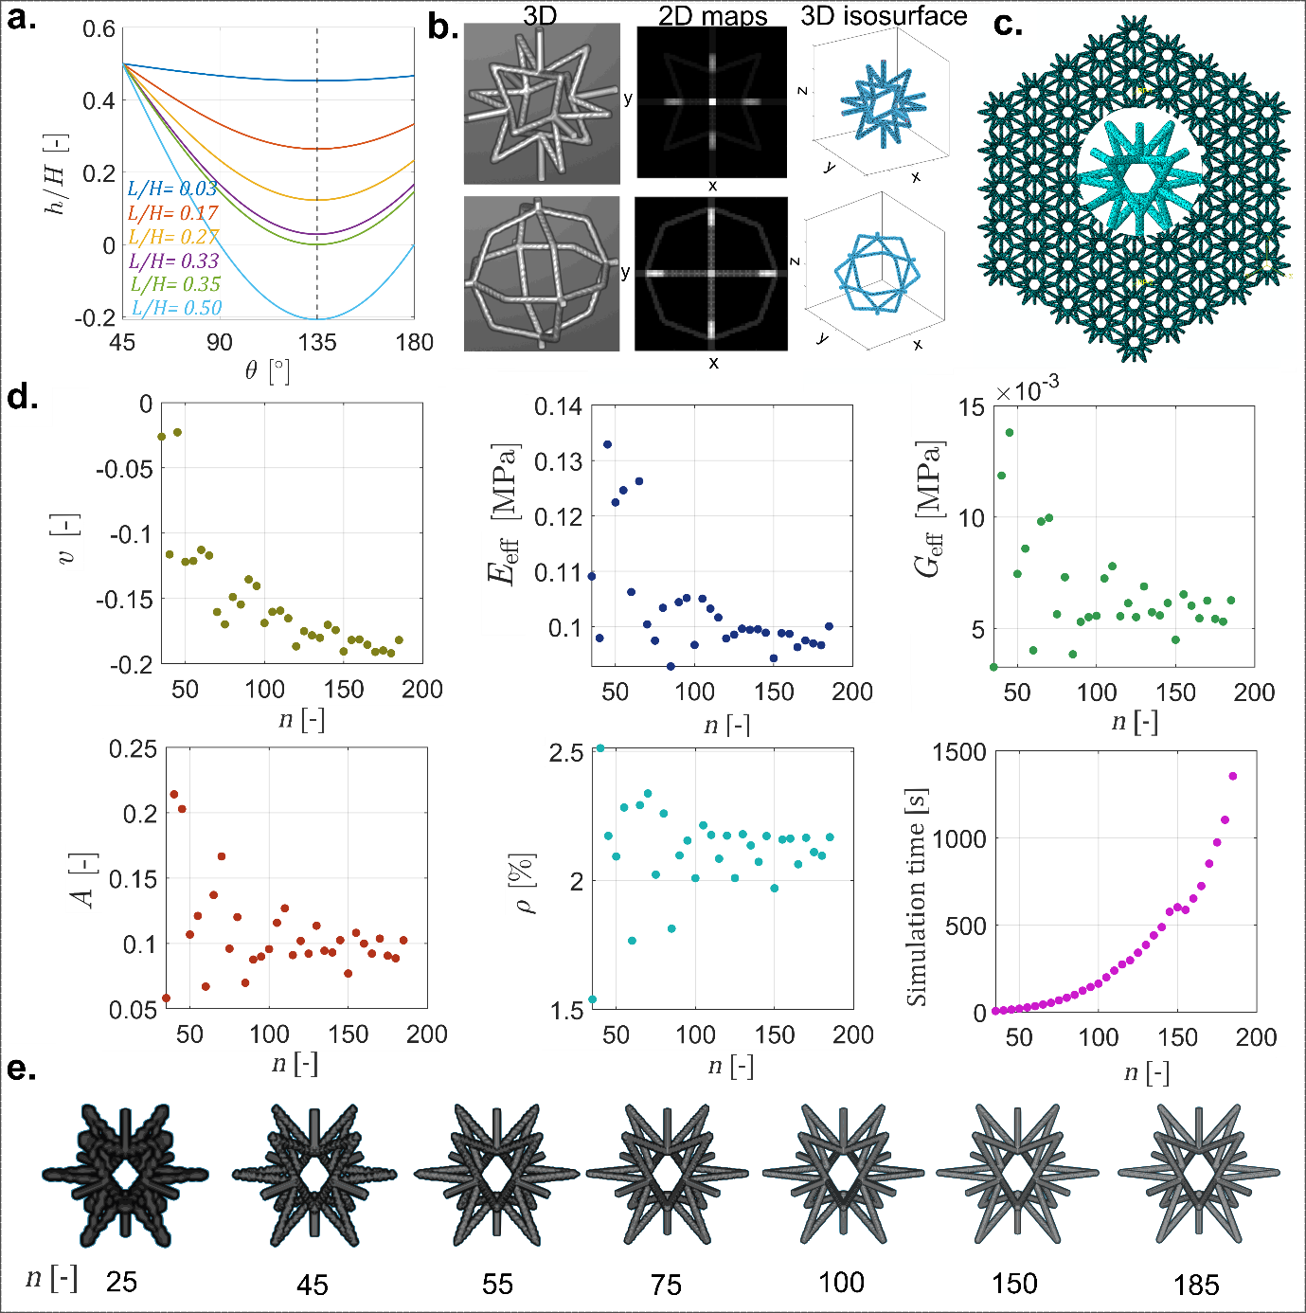
Figure S1. a. the variation of the tail length ($h$) vs angle ($θ$) of the unit cells at different lengths ($L$). b. Schematics showing two 3D voxelized unit cells, their 2D maps, and their 3D isosurface plot. c. The discretized 3D meta-biomaterials with a proper mesh type and number of elements for the 3D solid element analysis. d. The results of the effect of the $n$ on the convergency of elastic properties including $v$, $E_{eff}$, $G_{eff}$, and $A$ , and $ρ$ and simulation time. e. A schematic showing the accuracy of the voxelization in terms of number of voxels varying from 25 to 185 for a certain unit cell with $, θ={60.0}^{o}, L=140.0/300$and $d=14.0/300$.

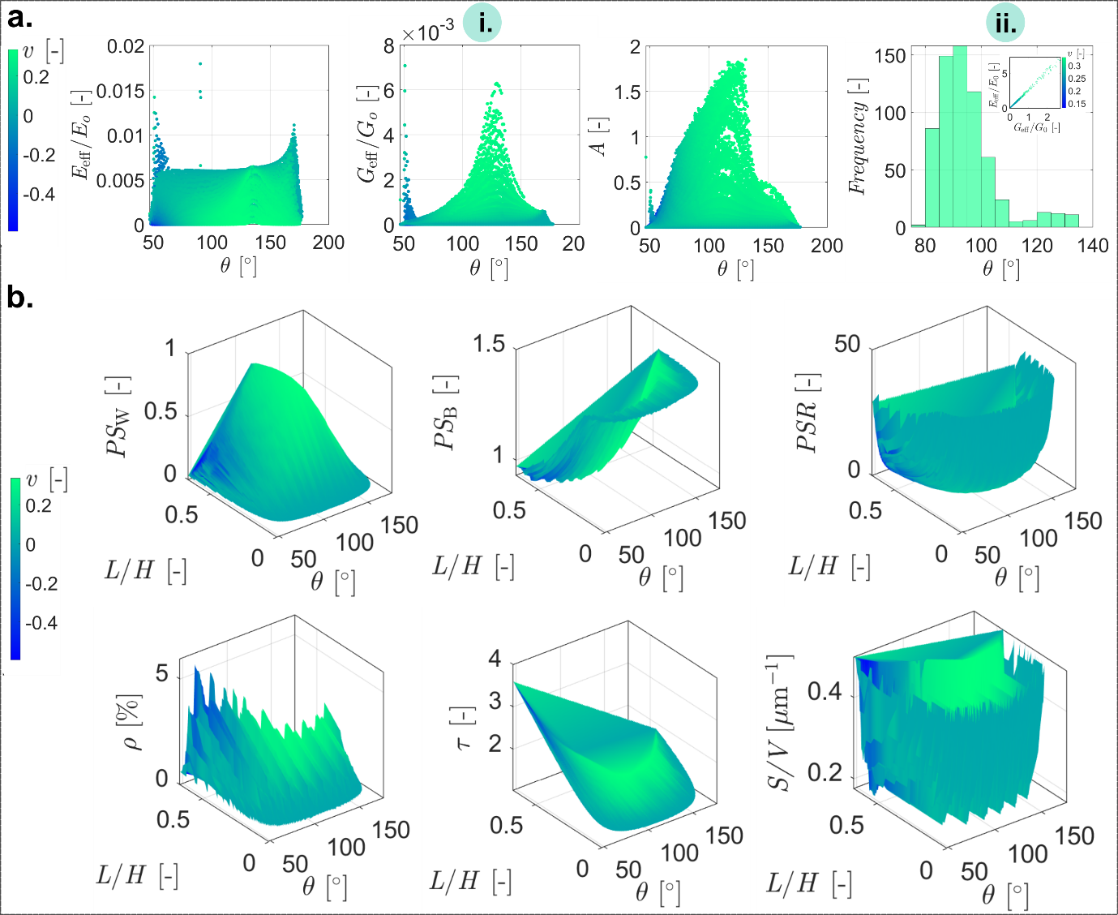
Figure S2. a.i the distribution of the $E_{eff}/E_{0}$, $G_{eff}/G_{0}$ and $A$ in terms of $θ$. The color bar corresponds to the Poisson’s ratio values. a.ii. The histogram plot of the Zener ratio in terms of $θ$ when $0.95<A<1.05$, meaning the fully isotropic meta-biomaterials. b. the dependency of the morphometric properties on the input parameters of the unit cells ($θ$ and $L$).
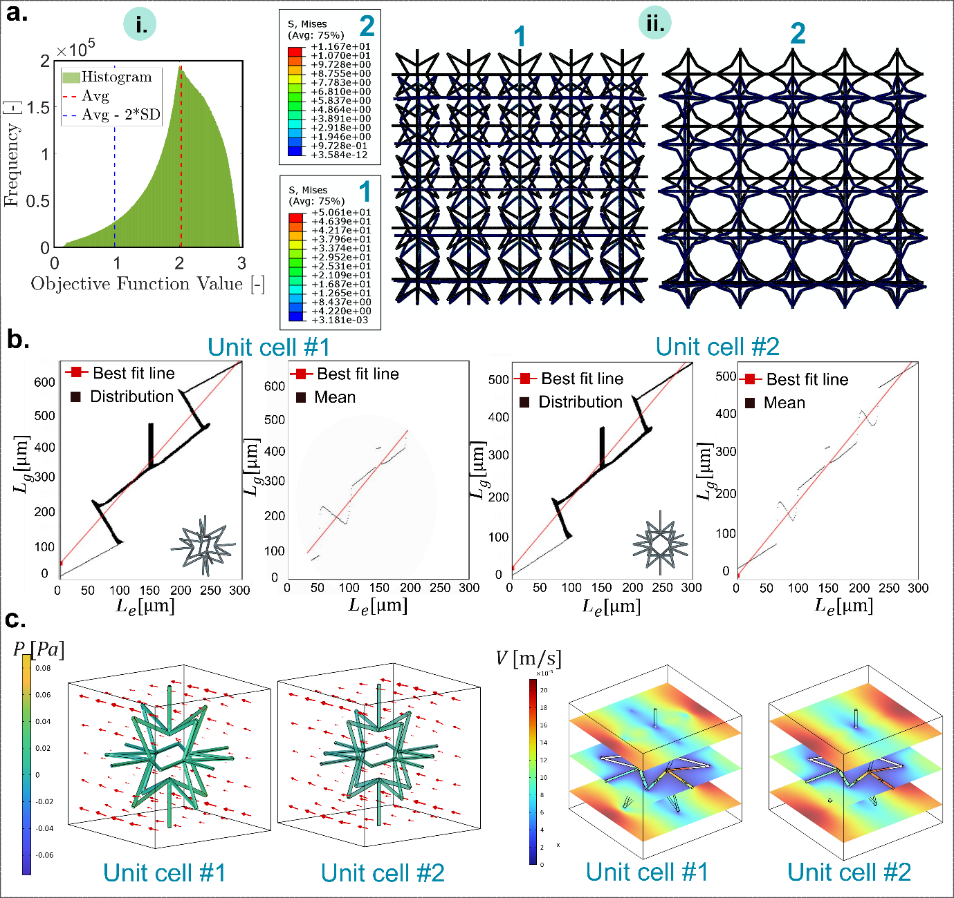
Figure S3. a.i. the histogram of the objective function value defined in Eq.S33, which shows a normal-like distribution. a.ii. the distribution of the Von Misses stress within two 3D meta-biomaterials (category I and III) under 1% strain through 3D solid elements FEM. Note that a magnification of 10 was used here to magnify the deformation. b. The correlation between the Elucident ($L_{e}$) and straight path lines ($L_{g}$) within the isolated meta-biomaterials with respect to the Poisson’s ratio (unit cells #1 and 2). c. the result of the permeability study on the isolated meta-biomaterials with respect to the distributions of the pressure and speed of the flow.

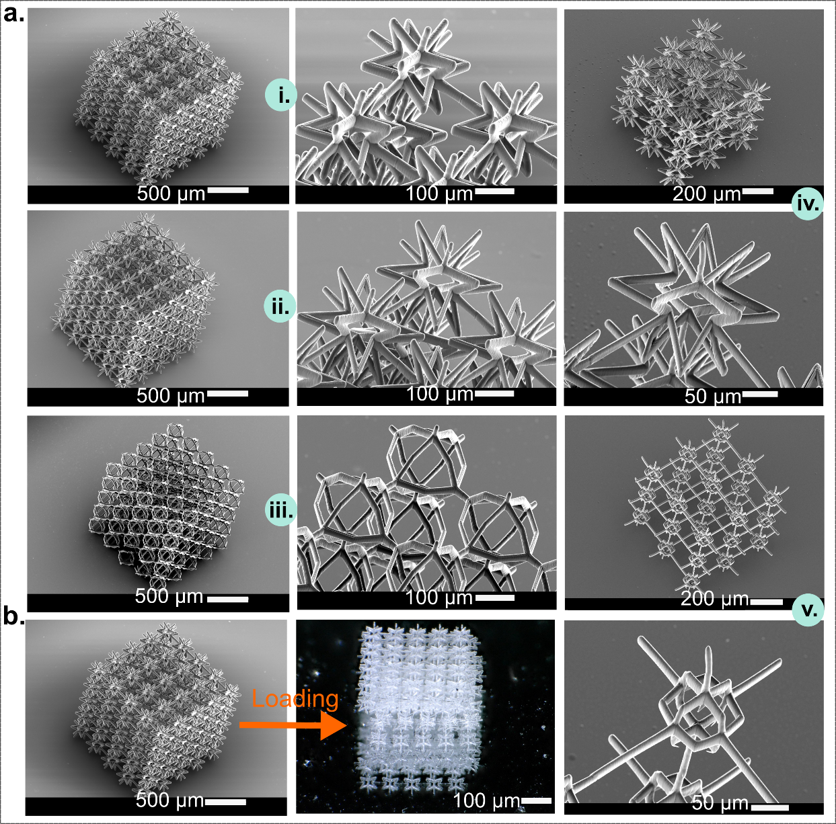
Figure S4. 2PP 3D printing of the meta-biomaterials. a. i. $θ={65.0}^{o}, L=110.0/300$and $d=20.0/300$. ii. $θ={60.0}^{o}, L=140.0/300$and $d=14.0/300$, iii. $θ={90}^{o}, L=120.0/300$and $d=14.0/300$, iv. $θ={64}^{o}, L=104.5/300$and $d=8.0/300$, v. $θ={100.0}^{o}, L=42.9/300$and $d=8.0/300$. b. an optical image of a meta-biomaterial featuring $θ={65.0}^{o}, L=110.0/300$and $d=20.0/300$ (the SEM illustrated in a.i) deformed within 10 s loading and 1000 mN force.
All the videos and figures supplementary must be cited.

Supplementary videos

- video S1: The illustration of the design space of our meta-biomaterials when $θ$ changes from minimum to maximum.
- video S2: The 2D map of the voxelized unit cell # 1
- video S3: The 2D map of the voxelized unit cell # 2
- video S4: A 3D illustration of the voxelized unit cell # 1
- video S5: A 3D illustration of the voxelized unit cell # 2
- video S6: Video capturing of the compression test of the meta-biomaterial with $θ={65.0}^{o}, d=20.0/300$ (from Table 2 and Figure 5)
- video S7: Video capturing of the compression test of the meta-biomaterial with $θ={60.0}^{o}, d=20.0/300$ (from Table 2 and Figure 5)
- video S8: Video capturing of the compression test of the meta-biomaterial with $θ={60.0}^{o}, d=14.0/300$ (from Table 2 and Figure 5)
- video S9: Video capturing of the compression test of the meta-biomaterial with $θ={120.0}^{o}, d=14.0/300$ (from Table 2 and Figure 5)
- video S10: Video capturing of the compression test of the meta-biomaterial with $θ={150.0}^{o}, d=14.0/300$ (from Table 2 and Figure 5)
- video S11: Video capturing of the compression test of the meta-biomaterial with $θ={90}^{.0o}, d=14.0/300$ (from Table 2 and Figure 5)

References
[1] M.J. Mirzaali, H. Pahlavani, A. Zadpoor, Auxeticity and stiffness of random networks: Lessons for the rational design of 3D printed mechanical metamaterials, Applied Physics Letters 115(2) (2019) 021901.
[2] E. Andreassen, C.S. Andreasen, How to determine composite material properties using numerical homogenization, Computational Materials Science 83 (2014) 488-495.
[3] G. Dong, Y. Tang, Y.F. Zhao, A 149 line homogenization code for three-dimensional cellular materials written in matlab, Journal of Engineering Materials and Technology 141(1) (2019) 011005.
[4] X. Chen, J. Moughames, Q. Ji, J.A.I. Martínez, H. Tan, S. Adrar, N. Laforge, J.-M. Cote, S. Euphrasie, G. Ulliac, Optimal isotropic, reusable truss lattice material with near-zero Poisson’s ratio, Extreme Mechanics Letters 41 (2020) 101048.
[5] A.F. Bower, Applied mechanics of solids, CRC press, 2009.
[6] S.C. Cowin, Continuum mechanics of anisotropic materials, Springer Science & Business Media, 2013.
[7] C.M. Zener, S. Siegel, Elasticity and Anelasticity of Metals, The Journal of Physical Chemistry 53(9) (1949) 1468-1468.

