Supplementary material
Comprehensive quantitative evaluation and mechanism analysis of influencing factors on yield and quality of cultivated Gastrodia elata
Xiaojun Jiang^{1,2,3}, Jing Dai^{1,2,3}, Yi Huang⁴, Dan Zhao⁵, Yao Yin^{1,2,3}, Qiao Lin^{1,2,3}, Mengmeng Hou⁶ & Hong Jin^{1,2,3}*
¹School of Pharmacy, Sichuan College of Traditional Chinese Medicine, Mianyang 621000, China. ²Northwest Sichuan Laboratory of Traditional Chinese Medicine Resources Research and Development Utilization, Mianyang 621000, China. ³Mianyang Key Laboratory of Development and Utilization of Chinese Medicine Resources, Mianyang 621000, China. ⁴College of Life Science and Engineering, Southwest University of Science and Technology, Mianyang 621010, China. ⁵Mianyang Academy of Agricultural Sciences, Mianyang 621023, China. ⁶Institute of Chinese Materia Medica, China Academy of Chinese Medical Sciences, Beijing 100700, China. *Corresponding author: Hong Jin, E-mail: jh1120@139.com, Phone: +86-01808-1258966
Supplemental Tables
Supplemental Table S1. Samples location and other information in this study.
Environment | Location | Altitude (m) | Longitude | Latitude | Collection date
GSKX | Kang County, Longnan City, Gansu Province | 1692 | 105°76'E | 33°00'N | 19-Nov-2023
GZDF | Dafang County, Bijie City, Guizhou Province | 1769 | 105°66'E | 27°25'N | 04-Nov-2023
HBYL | Yiling District, Yichang City, Hubei Province | 831 | 111°05'E | 31°01'N | 21-Oct-2023
SCPW | Pingwu County, Mianyang City, Sichuan Province | 1840 | 104°46'E | 32°36'N | 27-Nov-2023
SXLY | Lueyang County, Hanzhong City, Shaanxi Province | 1052 | 105°97'E | 33°49'N | 11-Nov-2023
YNYL | Yiliang County, Zhaotong City, Yunnan Province | 1836 | 104°27'E | 27°79'N | 23-Oct-2023
YNZX | Zhenxiong County, Zhaotong City, Yunnan Province | 1480 | 104°64'E | 27°58'N | 15-Oct-2023

Supplemental Table S2. Classification and process based on single tuber fresh weight.
Single tuber fresh weight (g) | Classification | Steaming duration (min)
>225 | Class 1 | 40
150-225 | Class 2 | 30
75-150 | Class 3 | 20

Supplemental Table S3. Primers and amplification information for DNA barcoding in this study.
Fragment | Marker | Sequence 5'–3' | Amplification procedure | Reference
ITS | ITS4 | TCCTCCGCTTATTGATATGC | 95℃ 3min; 95℃ 30s, 58℃ 30s, 72℃ 40s, 32 cycles; 72℃ 5min | White, et al.1990
 | ITS5 | GGAAGTAAAAGTCGTAACAAGG | 95℃ 3min; 95℃ 30s, 58℃ 30s, 72℃ 40s, 32 cycles; 72℃ 5min
ITS2 | S2F | ATGCGATACTTGGTGTGAAT | 94℃ 5min; 94℃ 30s, 56℃ 30s, 72℃ 45s,40 cycles; 72℃ 10min | Gao, et al.2010
 | S3R | GACGCTTCTCCAGACTACAAT | 94℃ 5min; 94℃ 30s, 56℃ 30s, 72℃ 45s,40 cycles; 72℃ 10min
rbcL | AR | GTAAAATCAAGTCCACCRCG | 95℃ 5min; 95℃ 1min,52℃ 40s,2℃ 1min,37 cycles; 72℃ 7min | Kress, et al.2005
 | AF | ATGTCACCACAAACAGAGACTAAAGC | 95℃ 5min; 95℃ 1min,52℃ 40s,2℃ 1min,37 cycles; 72℃ 7min
matK | 3F-KIM | CGTACAGTACTTTTGTGTTTACGAG | 95℃ 5min; 95℃ 1min,52℃ 40s,2℃ 1min,37 cycles; 72℃ 7min | CBOL Plant Working Group.2009
 | 1R-KIM | ACCCAGTCCATCTGGAAATCTTGGTTC | 95℃ 5min; 95℃ 1min,52℃ 40s,2℃ 1min,37 cycles; 72℃ 7min
psbA-trnH | psbAF | GTTATGCATGAACGTAATGCTC | 95℃ 3min;95℃ 30s,58℃ 30s,72℃ 40s,32 cycles;72℃ 5min | Sang, et al.1997
 | trnHR | CGCGCATGGTGGATTCACAAATC | 95℃ 3min;95℃ 30s,58℃ 30s,72℃ 40s,32 cycles;72℃ 5min
trnL-F | trnLF | GGTTCAAGTCCCTCTATCCC | 95℃ 3min;95℃ 30s,50℃ 30s,72℃ 40s,36 cycles;72℃ 7min | Taberlet, et al.1991
 | trnFR | ATTTGAACTGGTGACACGAG | 95℃ 3min;95℃ 30s,50℃ 30s,72℃ 40s,36 cycles;72℃ 7min

Supplemental Table S4. All ITS2 sequence names and the accession numbers provided by the GenBank database.
Number | Sequence name | Accession number
1 | Gastrodia elata Bl. f. glauca (YNZX1) | PQ182644
2 | Gastrodia elata Bl. f. glauca (YNZX2) | PQ182645
3 | Gastrodia elata Bl. f. glauca (YNZX3) | PQ182646
4 | Gastrodia elata Bl. f. glauca (YNYL1) | PQ182647
5 | Gastrodia elata Bl. f. glauca (YNYL2) | PQ182648
6 | Gastrodia elata Bl. f. glauca (YNYL3) | PQ182649
7 | Gastrodia elata Bl. f. glauca (SCPW1) | PQ182650
8 | Gastrodia elata Bl. f. glauca (SCPW2) | PQ182651
9 | Gastrodia elata Bl. f. glauca (SCPW3) | PQ182652
10 | Gastrodia elata Bl. f. glauca (GZDF1) | PQ182653
11 | Gastrodia elata Bl. f. glauca (GZDF2) | PQ182654
12 | Gastrodia elata Bl. f. glauca (GZDF3) | PQ182655
13 | Gastrodia elata Bl. f. elata (HBYL1) | PQ182656
14 | Gastrodia elata Bl. f. elata (HBYL2) | PQ182657
15 | Gastrodia elata Bl. f. elata (HBYL3) | PQ182658
16 | Gastrodia elata Bl. f. elata (SXLY1) | PQ182659
17 | Gastrodia elata Bl. f. elata (SXLY2) | PQ182660
18 | Gastrodia elata Bl. f. elata (SXLY3) | PQ182661
19 | Gastrodia elata Bl. f. elata (GSKX1) | PQ182662
20 | Gastrodia elata Bl. f. elata (GSKX2) | PQ182663
21 | Gastrodia elata Bl. f. elata (GSKX3) | PQ182664

Supplemental Table S5. Water content of cultivated G. elata before HPLC analysis.
Environment | Sample ID | Water content (%)
GSKX | GSKX1 | 10.08
 | GSKX2 | 9.72
 | GSKX3 | 9.79
GZDF | GZDF1 | 7.42
 | GZDF2 | 7.73
 | GZDF3 | 7.25
HBYL | HBYL1 | 13.83
 | HBYL2 | 13.81
 | HBYL3 | 11.10
SCPW | SCPW1 | 8.03
 | SCPW2 | 8.66
 | SCPW3 | 8.37
SXLY | SXLY1 | 8.44
 | SXLY2 | 8.50
 | SXLY3 | 8.78
YNYL | YNYL1 | 6.97
 | YNYL2 | 8.47
 | YNYL3 | 8.79
YNZX | YNZX1 | 13.82
 | YNZX2 | 14.73
 | YNZX3 | 14.52
HPLC represents high performance liquid chromatography; The formula for calculating water content is (weight before drying – weight after drying) / weight before drying * 100%.

Supplemental Table S6. Ecological factor ranges of G. elata based on the Global Medicinal Plant Geographic Information System.
Biologically meaningful variables | Biological range | Biological mean | Biological standard deviation
BIO1 = annual mean temperature/°C | -0.3–21.4 | 12.2 | 3.8
BIO2 = mean diurnal range (mean of monthly)/°C | 6.5–14.3 | 9.1 | 1.9
BIO3 = isothermality (BIO2/BIO7) (*100) | 23.0–51.0 | 30.9 | 7.2
BIO4 = temperature seasonality (standard deviation*100) | 2.8–13.4 | 7.3 | 1.9
BIO5 = max temperature of warmest month/°C | 14.0–32.5 | 26.4 | 3.3
BIO6 = min temperature of coldest month/°C | -26.6–10.6 | -3.3 | 6.6
BIO7 = temperature annual range (BIO5–BIO6)/°C | 15.4–51.1 | 29.7 | 6.0
BIO8 = mean temperature of wettest quarter/°C | 9.6–26.7 | 20.1 | 3.0
BIO9 = mean temperature of driest quarter/°C | -17.2–15.0 | 2.5 | 5.7
BIO10 = mean temperature of warmest quarter/°C | 9.6–26.7 | 21.1 | 3.2
BIO11 = mean temperature of coldest quarter/°C | -17.2–14.9 | 2.4 | 5.6
BIO12 = annual precipitation/mm | 543.0–2832.0 | 1100.7 | 315.5
BIO13 = precipitation of wettest month/mm | 102.0–490.0 | 210.4 | 60.8
BIO14 = precipitation of driest month/mm | 2.0–103.0 | 15.0 | 11.6
BIO15 = precipitation seasonality  (coefficient of variation*100) | 36.0–107.0 | 74.7 | 15.3
BIO16 = precipitation of wettest quarter/mm | 286.0–1186.0 | 558.5 | 155.1
BIO17 = precipitation of driest quarter/mm | 9.0–356.0 | 53.6 | 39.1
BIO18 = precipitation of warmest quarter/mm | 273.0–1186.0 | 536.0 | 159.0
BIO19 = precipitation of coldest quarter/mm | 9.0–392.0 | 54.7 | 41.3
BIO20 = mean temperature during growing period/°C | 12.2–15.6 | 13.6 | 0.9
BIO21 = relative humidity (*100) | 49.1–76.4 | 65.1 | 6.5

Supplemental Figures
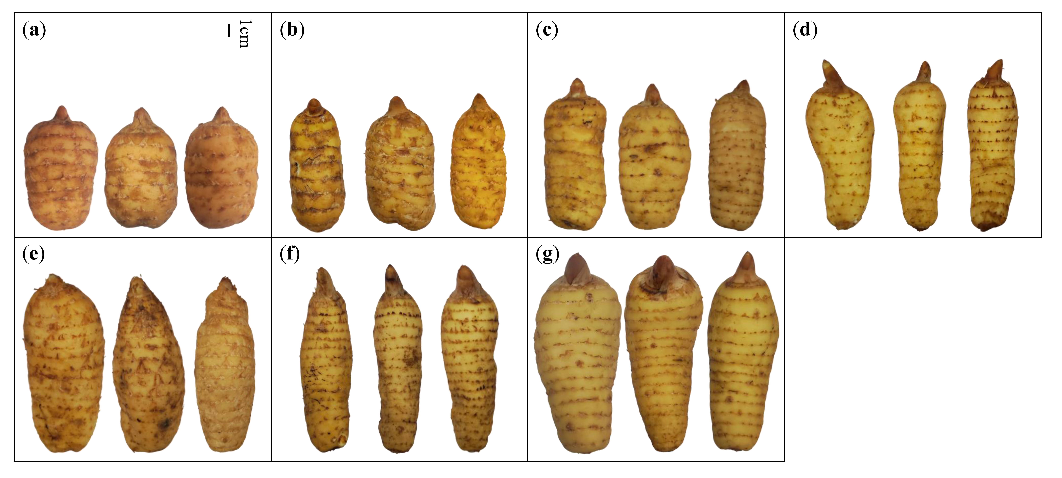
Supplemental Fig. S1. Morphological features of cultivated G. elata in different environments. (a) The environment of YNZX; (b) The environment of SCPW; (c) The environment of YNYL; (d) The environment of GZDF; (e) The environment of HBYL; (f) The environment of SXLY; (g) The environment of GSKX.

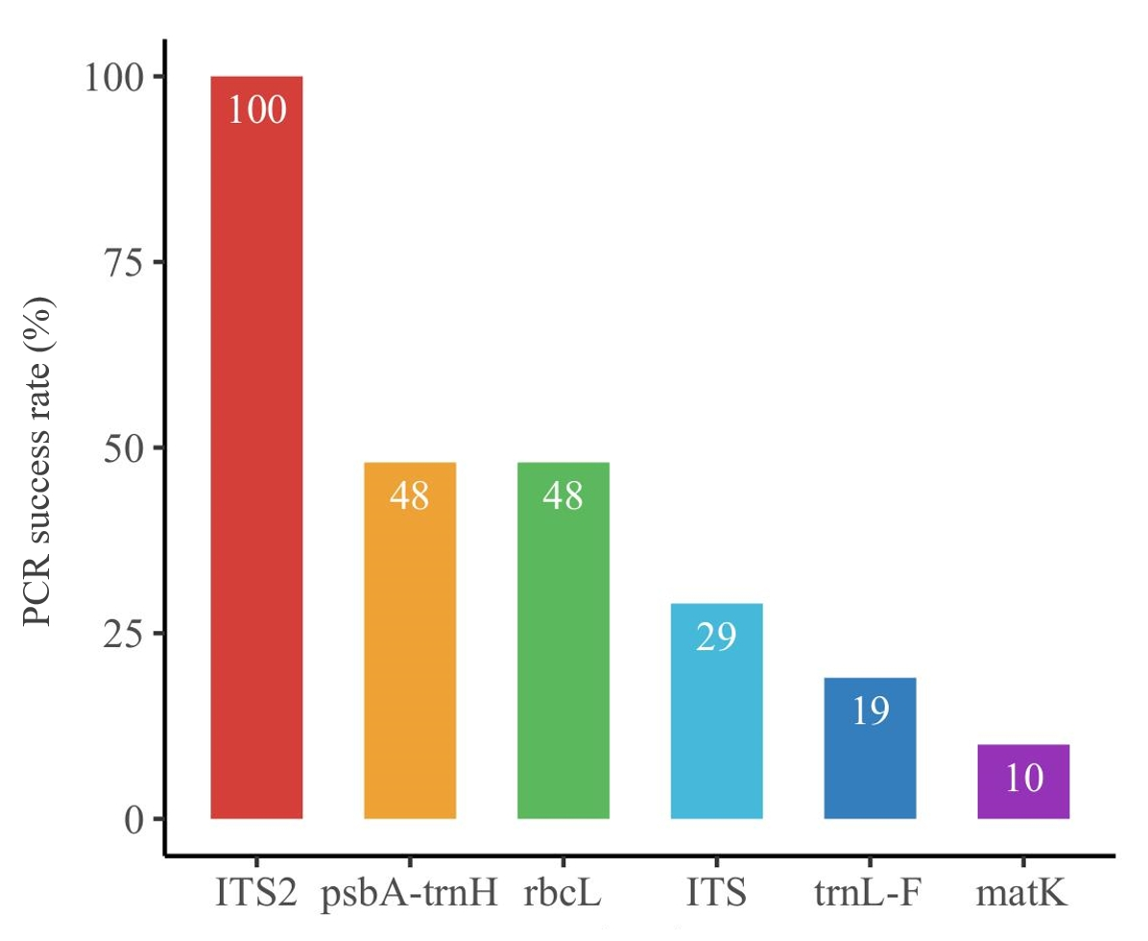
Supplemental Fig. S2. The PCR amplification efficiency of six DNA barcodings.
Supplemental Fig. S3. The rarefaction curves of bacterial and fungal communities. ASVs represent amplicon sequence variants.

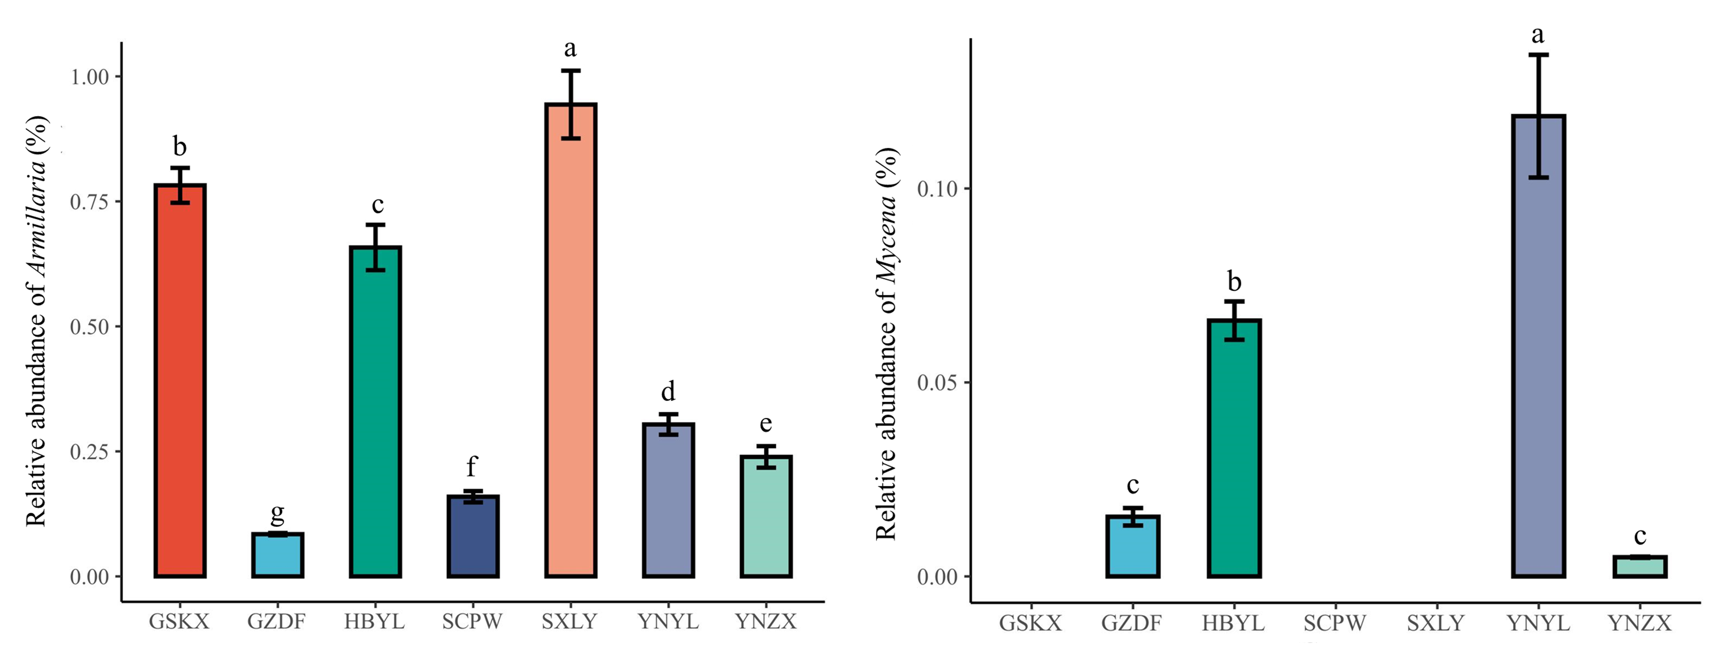
Supplemental Fig. S4. The relative abundance of Armillaria and Mycena. Different lowercase letters showed significant differences (P < 0.05); n=3.

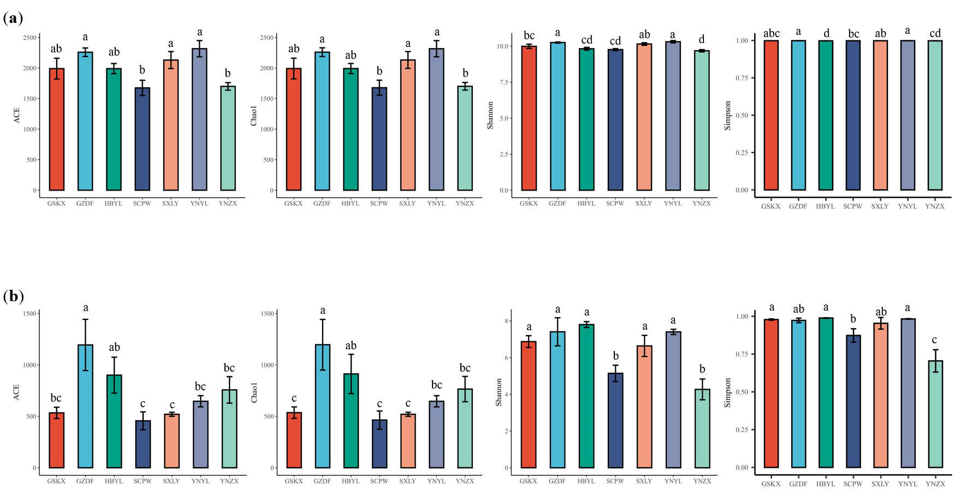
Supplemental Fig. S5. The abundance and diversity comparative analysis in different environments. (a) Colony abundance and diversity indexes of bacteria; (b) Colony abundance and diversity indexes of fungi. Different lowercase letters showed significant differences (P < 0.05); n=3.

Supplemental Fig. S6. The distribution points of wild and cultivated G. elata in China.

