The Importance of ensuring Representative Sample Volumes in Microplastic Monitoring – A predictive methodology

Annex 3: Additional supporting assessment
Cross, Richard.¹, Roberts, S.¹, Jürgens M.¹, Johnson, A. J.¹, Davis, C.², Gouin, T.³
¹ UK Centre for Ecology and Hydrology, Wallingford, Oxfordshire, UK
² ExxonMobil Biomedical Sciences, Inc., Annandale, NJ, USA 08876
³ TG Environmental Research, Sharnbrook, UK MK44 1PL
To whom correspondence may be addressed:
Richard Cross, riccro@ceh.ac.uk
Contents
Table of Figures 1
1. Quality scores and insights from reliability assessment 1
2. Additional supporting analysis of the database 5

Table of Figures
Figure SI1: Quality scores for freshwater and marine data. 2
Figure SI2: Principal component analysis of the dataset. 3
Figure SI3: Analysis of homogeneity of variance across four critical reliability criteria. 4
Figure SI4: Redundancy analysis of the database. 5

Quality scores and insights from reliability assessment
Almost all studies were evaluated as providing a satisfactory level of information with respect to describing the sampling method employed and how samples were treated prior to analysis (Figure SI1). However, several criteria were poorly addressed across the majority of studies, including sample preparation using a laminar flow hood and/or demonstrating that samples were processed in a clear air environment. Studies also failed to generally provide a sufficient level of information related to the use of positive and negative controls. When considering differences between marine and freshwater systems, it is notable that while sample size generally scored well across all marine studies, the sample size was not as well scored for studies in freshwater systems (indicating lower volumes typically taken when sampling these environments).
Information obtained from the quality scores two important purposes. First, the nine quality criteria are meant to promote best practices in reporting standards in a field of research. Since microplastic research has been accelerating over the past two decades, it can be expected that early data reporting concentrations in various environmental media may be subject to errors, which we would expect to improve as the research community develops a greater awareness of factors that might influence data quality. Secondly, the results obtained from the reliability scoring provides contextualisation. For example, given the extent of data prior to 2021 reporting MPs in various aquatic environments, it is important to reflect on the relative quality of the data in helping to provide a potential baseline with respect to the relative level of microplastic contamination using a weight of evidence approach.
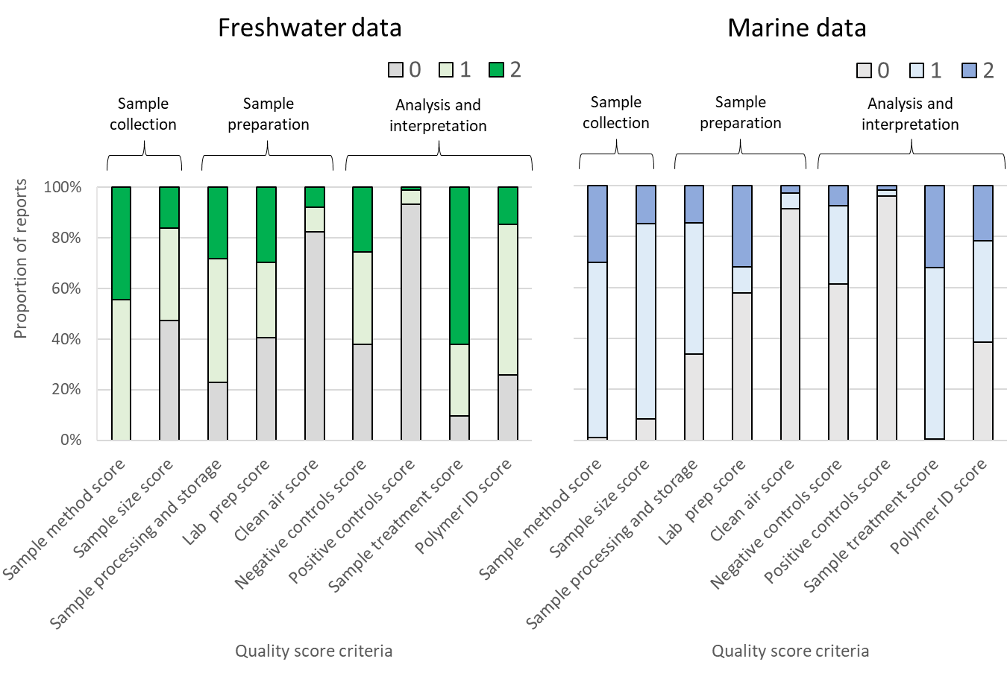
Figure SI1: Quality scores for freshwater and marine data.
The assumption when evaluating the reliability score of a study, is that the quality of the reported data may be influenced by a variety of factors. The extent to which these are sufficiently addressed in a study combine to influence the overall reliability of the data reported. Here we used principal components analysis to evaluate the which set of variables most influenced the overall reliability score assigned across all studies.
From the principal component analysis, the two principal factors (PC1 and PC2) are observed to explain 54.67% of the variance (Figure SI2). The explanatory variables with the highest loading in PC2 are the sampling method and sample volume scores, with loadings of 0.48 and 0.47 respectively. The concentration of MPs is observed to be negatively correlated with the sample method and volume scores, implying that higher concentrations of MPs are reported in studies with lower quality scores for these critical aspects of sample collection and sample volume (i.e. smaller volume samples). As can be seen from the distribution of data from different collection methods, these tended to be grab samples. From the quality scores themselves it is not possible to conclude whether this is due to grab samples being used to capture smaller and therefore more abundant particles than nets for example, or whether the relative scale of extrapolation required from small grab samples to larger scales risks overestimation. The results suggest that the strength in relationship between the different quality criteria and the factors is generally quite low, indicating that the various QA/QC criteria only weakly correlate with the reported concentrations of microplastics.
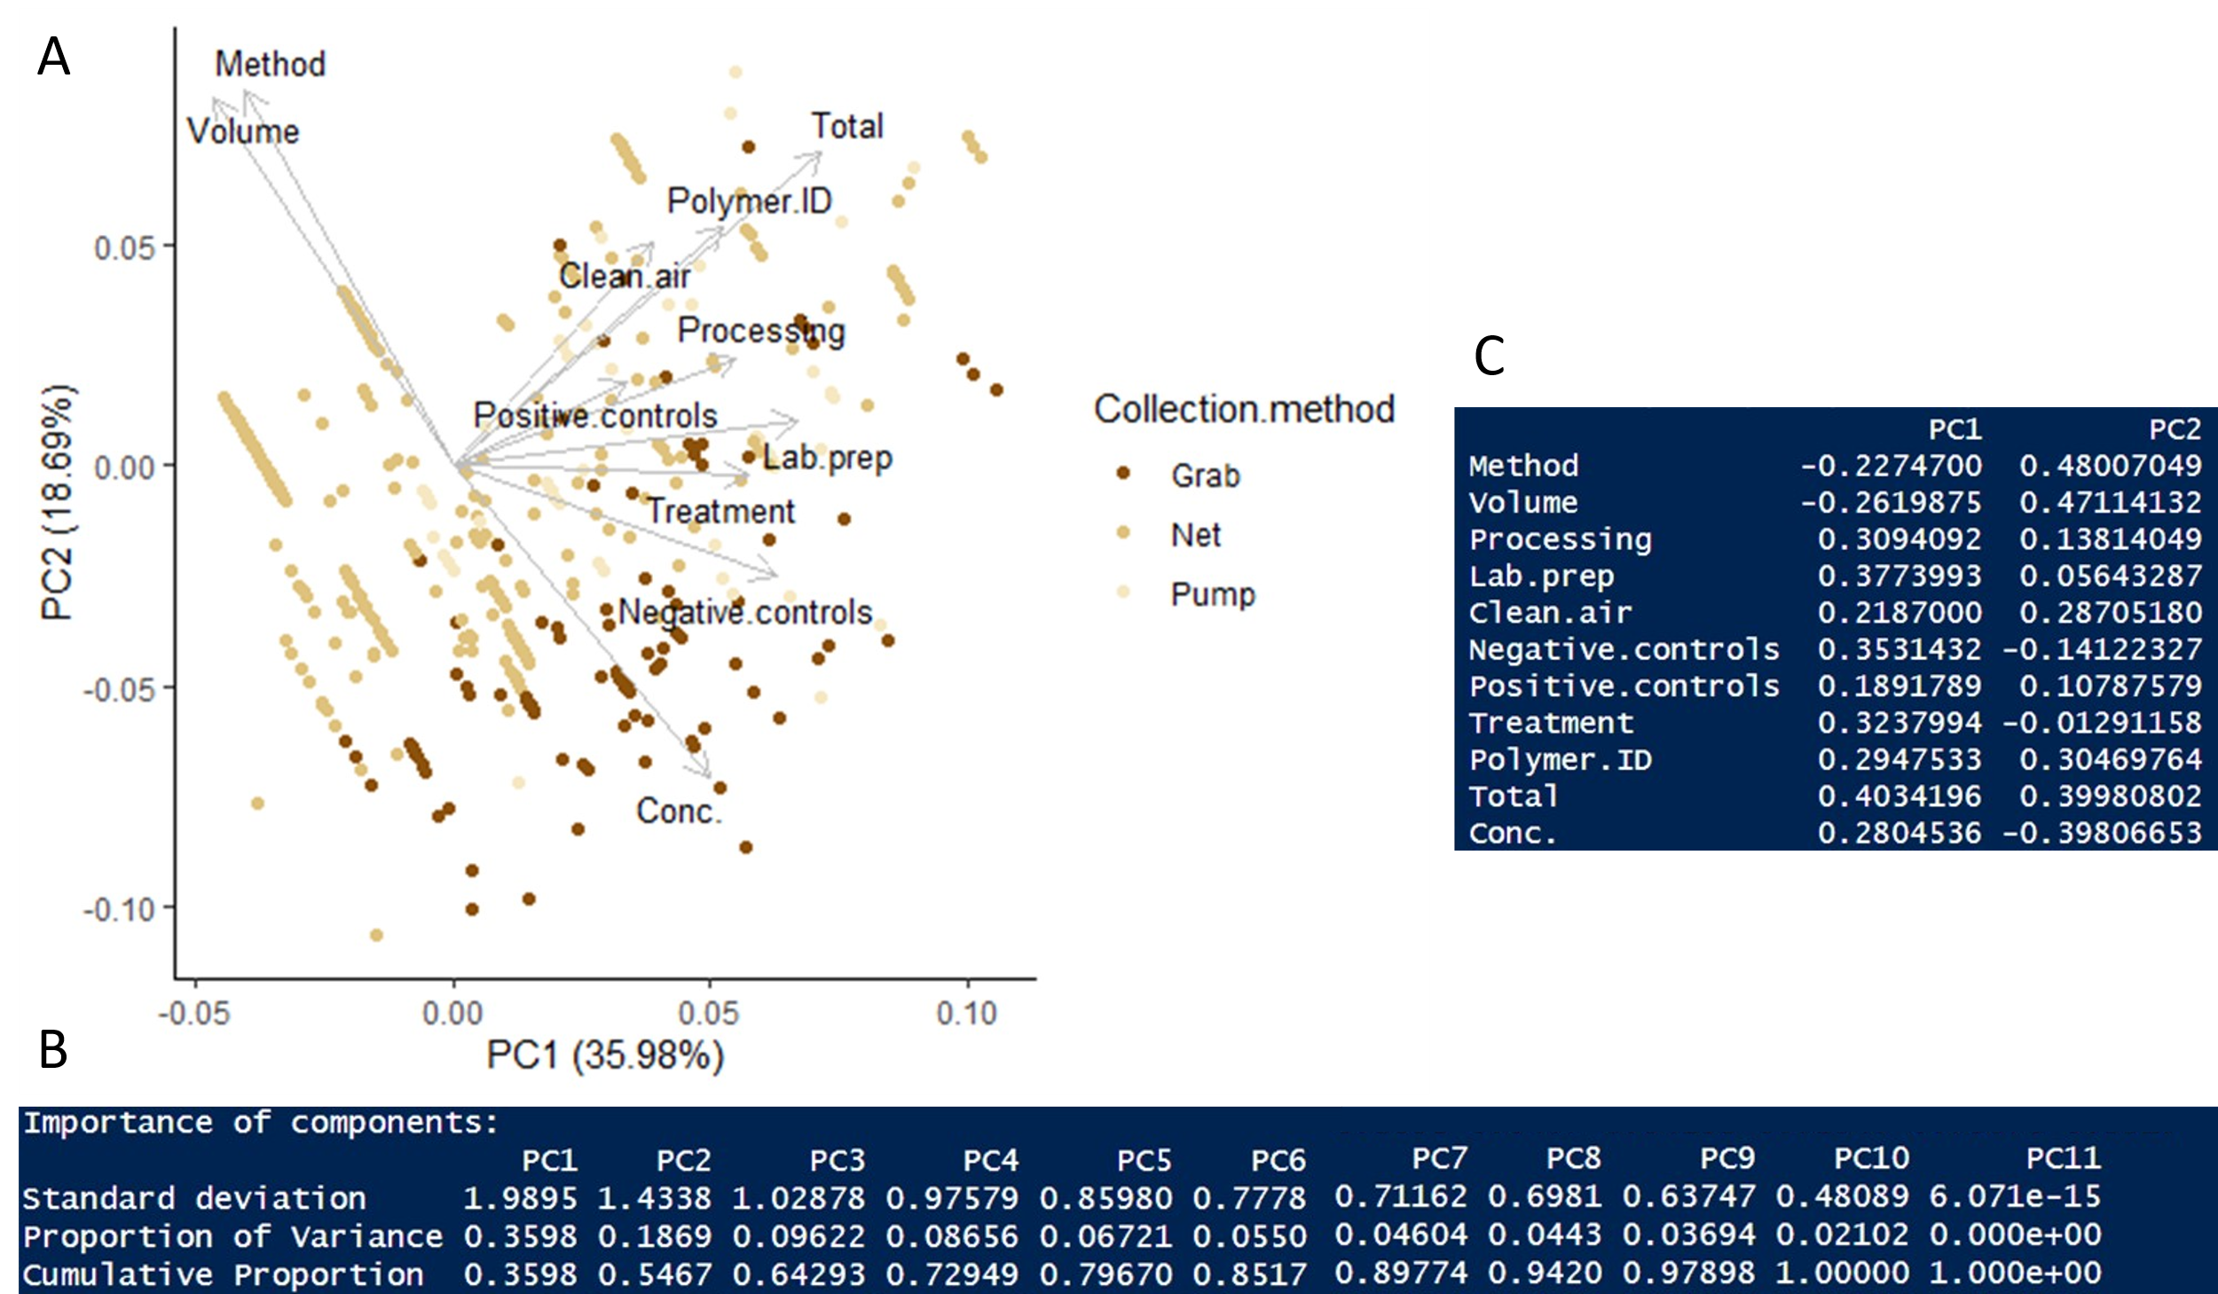
Figure SI2: Principal component analysis of the dataset.
The sample method and sample volume scores are identified as having the highest loading on PC2 and which negatively correlate with the reported concentrations. Evaluating the homogeneity of variance (Levene’s test) in reported microplastic concentrations provides insights into whether poorer quality data is in turn more variable.
Sample method, sample volume, negative controls and sample processing and storage criteria all experienced significant differences in variance between scores (Figure SI3). When considering sample volume, the relative variance was higher in the highest quality data than their poorer scoring counterparts (Levene’s test F=19.2, p<0.01). However, the median concentrations reported were also several orders of magnitude lower, and the absolute variance was actually smaller. This tentatively points to increased confidence in measurements with larger sample volumes, where the data across many different studies converge somewhat, generally reporting concentrations in the region of a few microplastic particles /m³.
When considering negative controls and sample processing, higher quality data was more consistent (relative standard deviations lower for higher quality data, (Levene’s test F=9.8, p<0.01 and F=4.3, p<0.01 respectively). In summary, the sample method and sample volume were identified as critical criteria, whilst better documentation of negative controls and sample processing and storage appear to correspond to more consistent reported concentrations of microplastics.

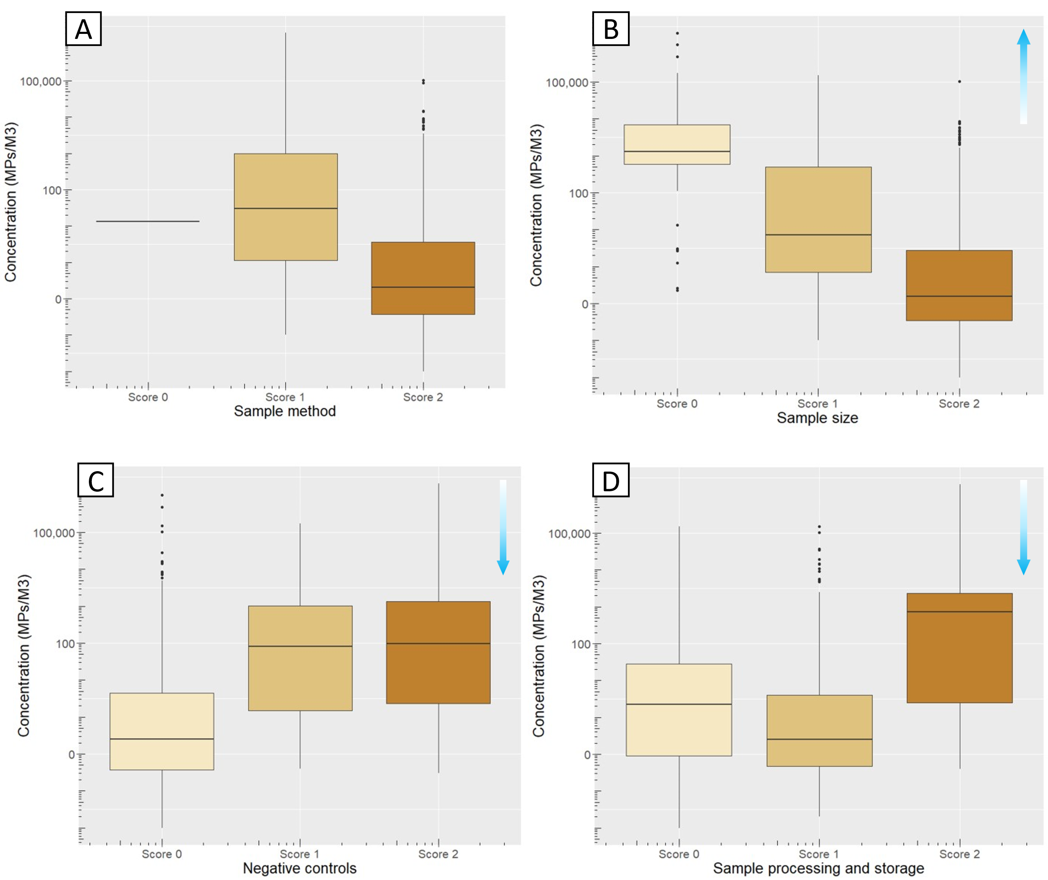
Figure SI3: Analysis of homogeneity of variance across four critical reliability criteria.

Additional supporting analysis of the database
Redundancy analysis models the effect of the matrix of variables in the database in explaining the concentration of MPs reported in the literature. Redundancy analysis of the variables in the combined database of freshwater and marine data supports the observation that the volume sampled, combined with the minimum particle size of MPs reported, are sufficient to explain 73.1% of the variance in the reported concentrations (RDA model F value = 207.17 and p-value = 0.001, number of permutations: 999; Figure SI4). Of these two variables, volume was found to be statistically significant (ANOVA: F = 376.07, p = 0.001, variance = 1.89) whilst the minimum particle size was observed to be not significant when evaluating the entire dataset (ANOVA: F = 0.49, p = 0.490, variance = 0.002).
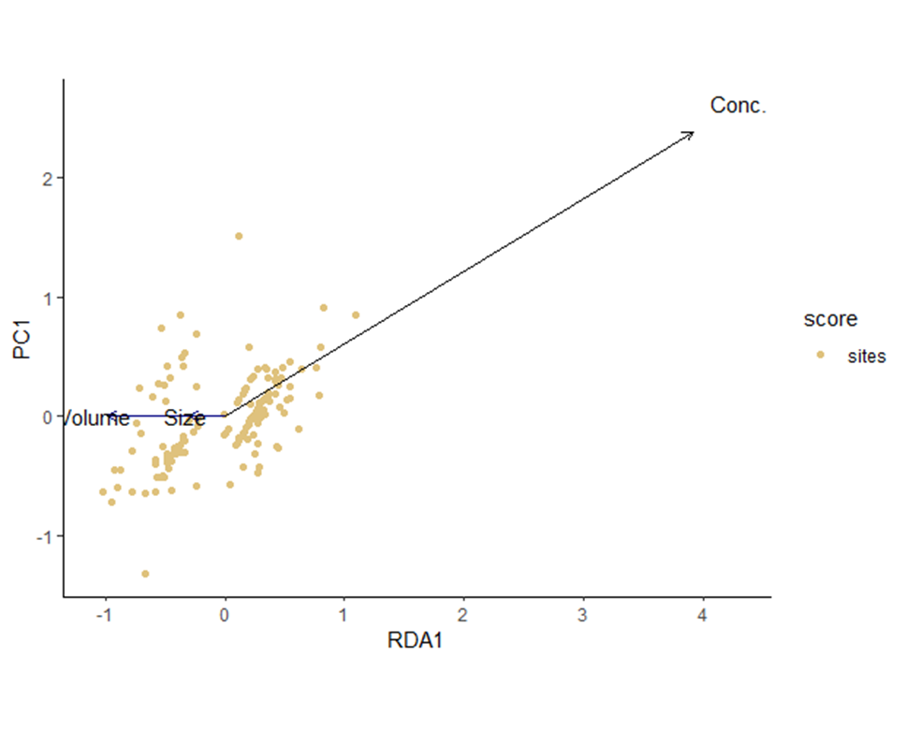
Figure SI4: Redundancy analysis of the database.

Table SI1 and Table SI2 report on the regression analysis for microplastic concentrations as a function of the volume sampled, and the minimum particle size measured respectively.

Table SI1: Regression analysis for reported microplastic concentration against sample volume.
Water type | Collection method | F-statistic | Number of data points | Adjusted R² | p-value | Correlation
Marine | All | 78.3 | 119 | 0.40 | < 0.01 | Negative
Marine | Net | 2.0 | 31 | 0.03 | 0.17 | None
Marine | Pump | 68.3 | 30 | 0.70 | < 0.01 | Negative
Marine | Grab | 19.5 | 58 | 0.24 | < 0.01 | Negative
FW | All | 189.6 | 97 | 0.66 | < 0.01 | Negative
FW | Net | 7.5 | 37 | 0.15 | < 0.01 | Positive
FW | Pump | 6.2 | 26 | 0.26 | 0.03 | Negative
FW | Grab | 25.3 | 44 | 0.36 | < 0.01 | Negative

Table SI2: Regression analysis for reported microplastic concentration against minimum reported particle size
Water type | Collection method | F-statistic | Number of data points | Adjusted R² | p-value | Correlation
Marine | All | 288.4 | 501 | 0.37 | < 0.01 | Negative
Marine | Net | 149.4 | 418 | 0.26 | < 0.01 | Negative
Marine | Pump | 0.6 | 43 | -0.01 | 0.46 | None
Marine | Grab | 0.0 | 40 | -0.03 | 0.92 | None
FW | All | 75.9 | 168 | 0.31 | < 0.01 | Negative
FW | Net | 1.9 | 106 | 0.01 | 0.17 | None
FW | Pump | 11.9 | 15 | 0.44 | < 0.01 | Negative
FW | Grab | 3.4 | 47 | 0.05 | 0.07 | None

If a quality criteria is not addressed in the publication, it receives a score of 0, partially addressed 1 and fully addressed 2.
A) Factor plot of the first two principal components in the PCA of quality scores across the dataset. The collection method of samples is distinguished in the figure through the different coloured points. A summary of the importance of the principle components is described in Table B, whilst the explanatory variable loadings on PC1 and PC2 are reported in Table C.
Comparison in variance between the four quality criteria for which variability in reported concentration of microplastics was influenced by the score the for the quality criteria A) sample method, B) sample volume, C) negative controls and D) sample processing and storage criteria. The blue arrows denote where the relative variance either increased (upward arrow) or decreased (downward) between those studies scoring 0 and scoring 2 for each quality criteria.

