Fig. S1. shows the air quality classification where the 7 air quality sensors were installed. Ambatobe and Ampandrianomby are the least polluted (Fig. S1-A and B), while Ambohidahy and Miandrarivo experience Very Unhealthy pollution levels during October and November (Fig. S1-D and F). An exceptional case is observed in Ambohidahy in march 2023, particularly in March, where 60% of the days are classified as Unhealthy for Sensitive Groups and 40% as Unhealthy (Fig. S1-D). This unique air quality pattern in Ambohidahy is largely due to vehicle emissions, as the sensor is located near a high-traffic area, close to a tunnel.
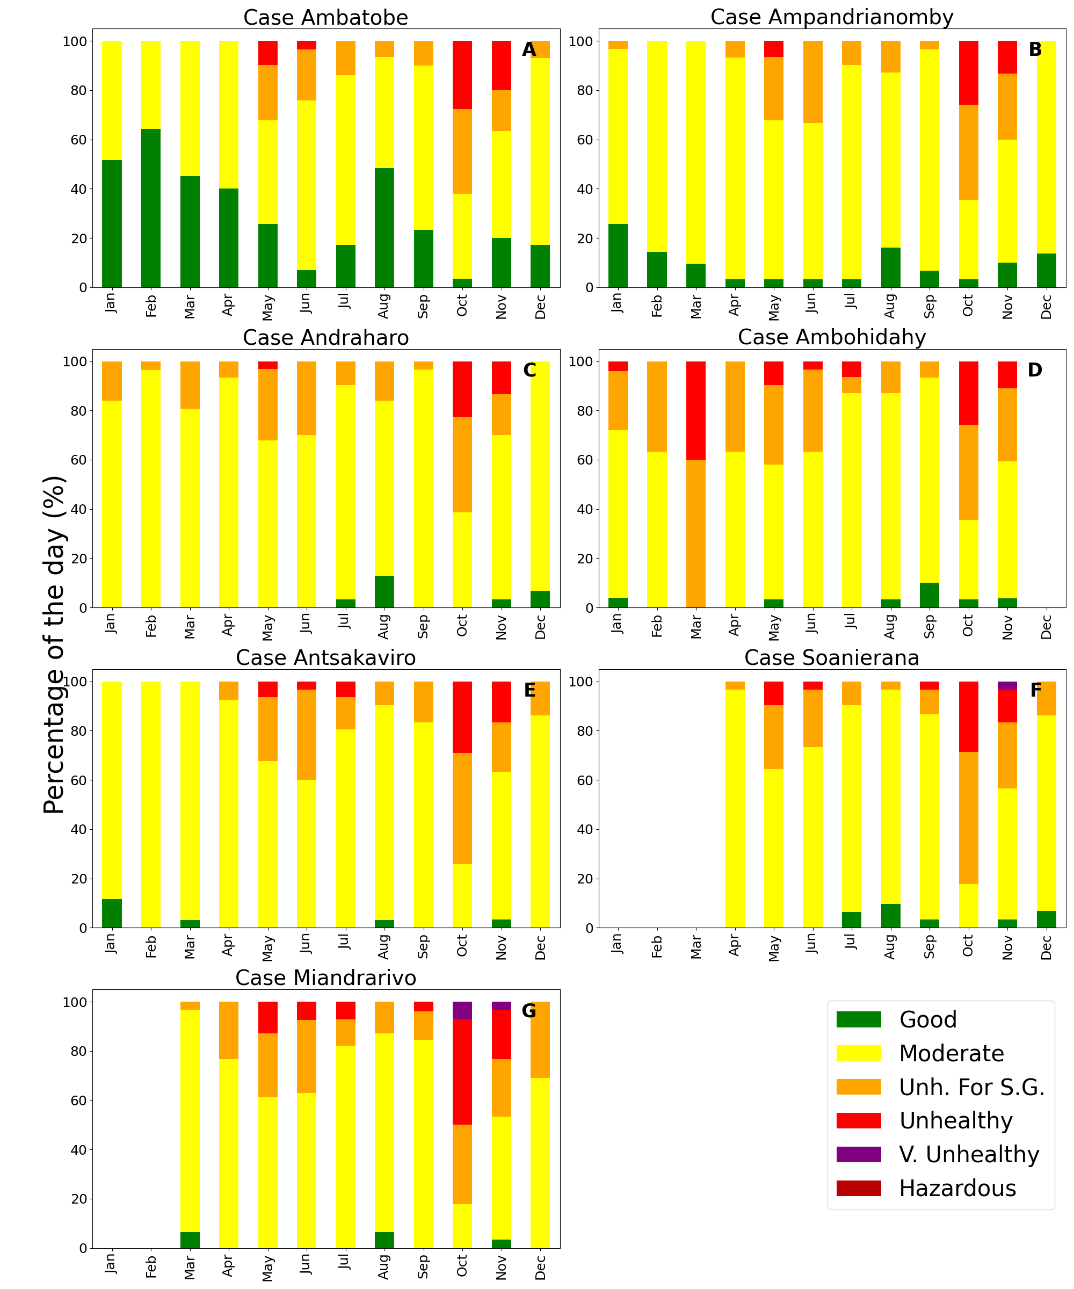
Fig. S1. Monthly classifications of PM2.5 concentrations from January to December 2023.

