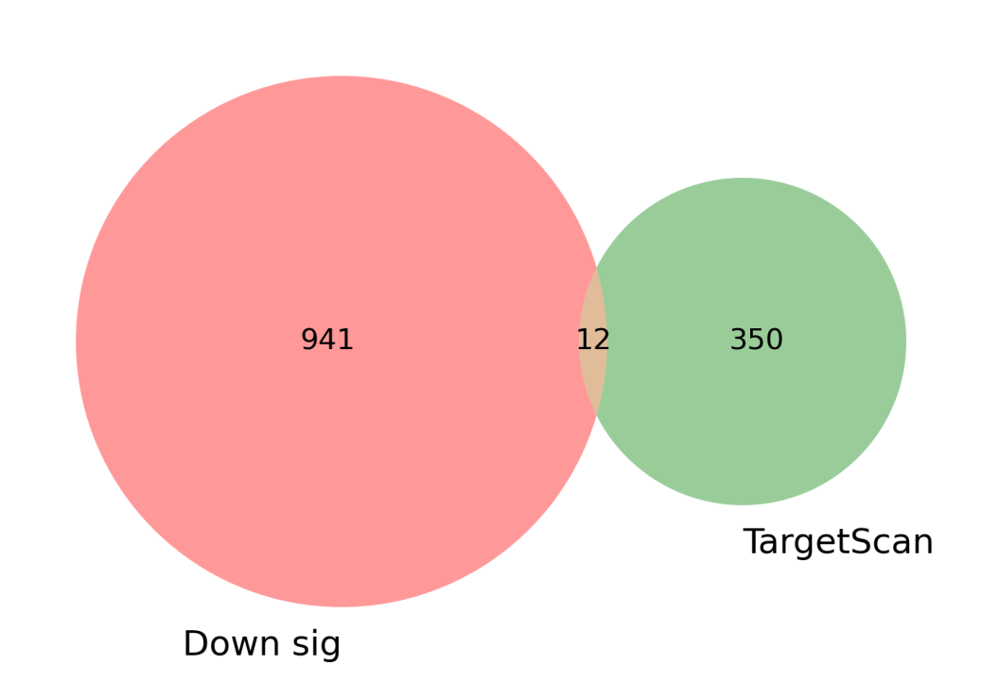

Fig S2 Bioinformatics prediction of miR-21-5p target genes. Venn diagram showing the intersection of TargetScan-predicted miR-21-5p target genes with down-regulated genes in pancreatic cancer.

