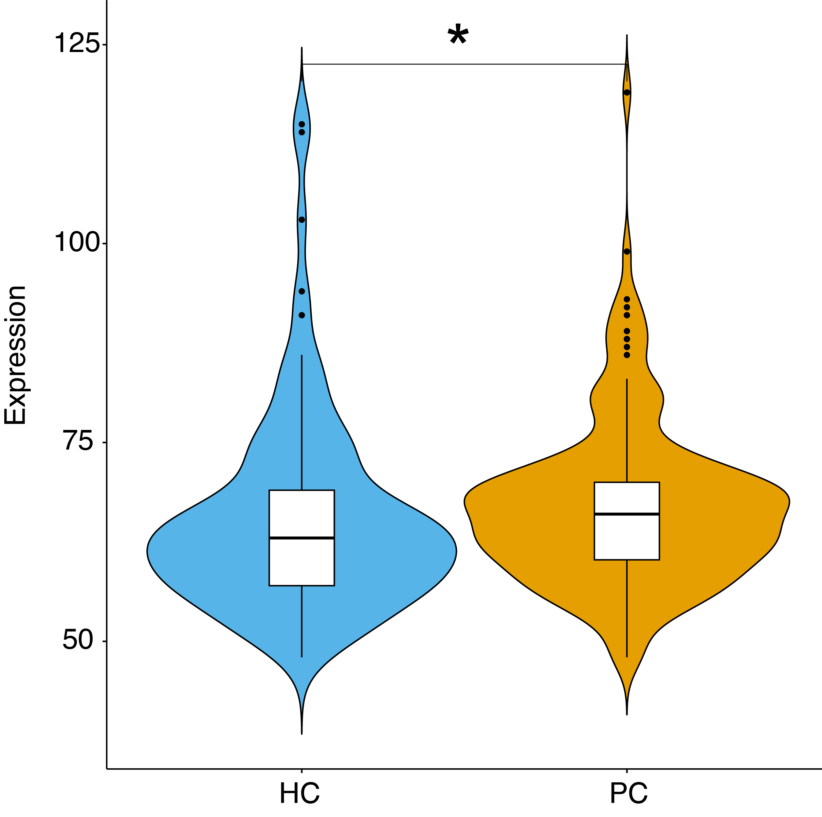
Fig S1 Expression analysis of miR-21-5p in serum from pancreatic cancer patients and healthy controls. Violin plots show the expression distribution of miR-21-5p in serum samples from PC and HC groups. The width indicates the frequency of samples at each expression level. *p < 0.05.

