Supplementary information
for

Selection is more important than complementarity in global grasslands

Yonghui Wang^{1,*}, Wenhong Ma^{1,*}, Bailing Miao¹, Bin Zhang¹, Huping Yang¹, Xinxin Dai¹, Xinhui Jia¹, Lin Jiang^{2,*}

¹Ministry of Education Key Laboratory of Ecology and Resource Use of the Mongolian Plateau & Inner Mongolia Key Laboratory of Grassland Ecology, School of Ecology and Environment, Inner Mongolia University, Hohhot, 010021, China
²School of Biological Sciences, Georgia Institute of Technology, Atlanta, Georgia, USA

E-mail addresses of all authors:
Yonghui Wang, yhwang@imu.edu.cn
Wenhong Ma, whma@imu.edu.cn
Bailing Miao, miaobailing@126.com
Bin Zhang, zhangbin@163.com
Huping Yang, hupingyang@126.com
Xinxin Dai, daixinxin2020@163.com
Xinhui Jia, jiaxinhui1105@163.com
Lin Jiang, lin.jiang@biology.gatech.edu

Running head: Selection effect in global grasslands

*Authors for correspondence:
Yonghui Wang
Phone: +86 15904819953
E-mail: yhwang@imu.edu.cn
Ministry of Education Key Laboratory of Ecology and Resource Use of the Mongolian Plateau & Inner Mongolia Key Laboratory of Grassland Ecology, School of Ecology and Environment, Inner Mongolia University, Hohhot, 010021, China

Wenhong Ma
Phone: +86 15848927086
E-mail: whma@imu.edu.cn
Ministry of Education Key Laboratory of Ecology and Resource Use of the Mongolian Plateau & Inner Mongolia Key Laboratory of Grassland Ecology, School of Ecology and Environment, Inner Mongolia University, Hohhot, 010021, China

Lin Jiang
Tel: +1 404 3852514
Fax: +1 404 8940519
E-mail: lin.jiang@biology.gatech.edu
School of Biological Sciences, Georgia Institute of Technology, Atlanta, Georgia, USA

Supplementary Material: Comparing to the additive partitioning method used in biodiversity experiments

Here, we compare the method established in the current study for partitioning complementarity and selection effects in natural ecosystems (see Box 1 for variable definitions) to the additive partitioning method of Loreau and Hector⁷ often used in biodiversity experiments (Supplementary Figure 1), which has variables defined as the following.

M_{i}: individual number (or yield) of species i in monocultural community, which exists only in biodiversity experiments
P_{E,i}: proportion of monocultural individual number of species i planted in mixture community, which exists only in biodiversity experiments
Y_{E,i} = P_{E,i} M_{i} = Y_{M,i}: expected individual number of species i in mixture community, which has been set to equal to the mean individual number of species i (i.e., Y_{M,i}, see Supplementary Figure 1) defined in the partitioning method for natural ecosystem observations (see Box 1)
Y_{O,i}: observed individual number of species i in mixture community
P_{O,i} = Y_{O,i}/M_{i}: proportion of individual number of species i in mixture community to that in monoculture community, which exists only in biodiversity experiments
ΔP_{i} = P_{O,i} – P_{E,i}: deviation between P_{O,i} and P_{E,i}, which follows that
$ΔP_{i}=\frac{Y_{O,i}}{M_{i}}-\frac{Y_{E,i}}{M_{i}}= \left(\frac{Y_{O,i}-Y_{E,i}}{Y_{E,i}}\right)\frac{Y_{E,i}}{M_{i}}={\left(\frac{Y_{O,i}}{Y_{M,i}}-1\right)P_{E,i}=RC}_{i}P_{E,i}$, (S1)
where, RC_{i} is relative change (Y_{O,i}/Y_{M,i} – 1) of species i defined in the method used to partition complementarity and selection effects in natural ecosystems.

In biodiversity experiments, the difference between ΣY_{O,i} and ΣY_{E,i} (or ΣY_{M,i} because Y_{M,i} = Y_{E,i}) can be described with ΔP_{i} and M_{i} as follows:
$ΔY=\sum{Y_{O,i}}-\sum{Y_{E,i}=}\sum{ΔP_{i}}M_{i}=\sum{{RC}_{i}P_{E,i}\frac{Y_{E,i}}{P_{E,i}}}=\sum{{RC}_{i}Y_{M,i}}$, (S2)
The term in the far-right side of equation (S2) is the same as that in equation (1). In both the partitioning method for natural ecosystems and the additive partitioning method, the individual number of species i in the observed communities is compared to that of an implicit “referencing community” (Supplementary Figure 1). As a result, the two partitioning methods describe the same phenomenon, leading to the comparability between them (see below). However, the two methods differed in how they estimate the change in the individual number of species i between the observed communities and the referencing community. In the partitioning method for natural ecosystems, it is estimated with the relative change (i.e., RC_{i}) in the individual number of species i between the observed communities and the referencing community (see Box 1). In the additive partitioning method, the relative change of species i is weighted by its proportion of individuals (i.e., P_{E,i}) planted in a mixture community (or the referencing community), as shown in equation (S1). Therefore, P_{E} is the only variable that could result in different estimations of the complementarity and selection effects between the two partitioning methods, which is investigated using RC_{i}P_{E,i} = ΔP_{i} and Y_{M,i}/P_{E,i} = Y_{E,i}/P_{E,i} = M_{i}. The descriptions are as follows:
$\sum{{RC}_{i}P_{E,i}\frac{Y_{M,i}}{P_{E,i}}}=S \overline{RC{×P}_{E}} \overline{Y_{M}{×P}_{E}^{-1}}+S cov(RC{×P}_{E}, Y_{M}{×P}_{E}^{-1})$, (S3)
Equation (S3) showed that, in biodiversity experiments, if different species have the same proportion (i.e., the same P_{E}) of individuals planted in a mixture community (or the referencing community), the estimated complementarity and selection effects will be perfectly correlated with those estimated using the method established for natural ecosystems. Conversely, species-specific P_{E} can potentially influence the estimation of the complementarity and selection effects. Based on the above descriptions, we simulated the impacts of P_{E} using the two datasets collected from Inner Mongolian grasslands and Nutrient-Network grasslands. In these datasets, all variables except for P_{E} are already known. We randomly sampled P_{E} from a uniform distribution ranging from 0.05 to 0.95 for different species, conducting this sampling 1,000 times to create 1,000 groups of simulated complementarity and selection effects. We then analyzed the observed complementarity and selection effects in relation to the simulated complementarity and selection effects using linear regressions, with treating the group of randomly sampled P_{E} as a random factor potentially influencing both the intercept and the slope.
We found that species-specific P_{E} had a limited impact on the estimation of complementarity and selection effects (Supplementary Figure 2). As a result, the two methods established for partitioning the complementarity and selection effects in natural ecosystems and biodiversity experiments are comparable. This further suggests that the different patterns of the complementarity and selection effects in shaping diversity–function relationships between natural ecosystems and biodiversity experiments are not resulted from differences in the two partitioning methods.

Supplementary Table 1. Information for 35 sites in Inner Mongolian grasslands included in this study.
Site name | Latitude | Longitude | Observation year | Mean annual precipitation | Mean annual temperature | Community biomass | Recorded  species number | Dominant species  (with relative specie biomass, RSB)
 |  |  |  |  |  |  |  | Latin name | RSB (%)
NM0702 | 45.02 | 116.33 | 2007, 2012–2016, 2020–2023 | 270.4 | 2.7 | 64.8 | 28 | Reaumuria soongarica | 56.9
 |  |  | 2007, 2012–2016, 2020–2023 |  |  |  |  | Convolvulus ammannii | 13.1
 |  |  | 2007, 2012–2016, 2020–2023 |  |  |  |  | Allium polyrhizum | 11.7
 |  |  | 2007, 2012–2016, 2020–2023 |  |  |  |  | Neopallasia pectinata | 8.8
NM0703 | 45.73 | 117.59 | 2007, 2012–2016, 2020– 2023 | 304.4 | 2.1 | 122.1 | 51 | Leymus chinensis | 39.9
 |  |  | 2007, 2012–2016, 2020– 2023 |  |  |  |  | Stipa grandis | 18.7
 |  |  | 2007, 2012–2016, 2020– 2023 |  |  |  |  | Cleistogenes squarrosa | 16.6
NM0704 | 47.87 | 118.78 | 2007, 2012–2016, 2020, 2022–2023 | 367.9 | 0.3 | 137.7 | 81 | Cleistogenes squarrosa | 24.4
 |  |  | 2007, 2012–2016, 2020, 2022–2023 |  |  |  |  | Leymus chinensis | 14.2
 |  |  | 2007, 2012–2016, 2020, 2022–2023 |  |  |  |  | Artemisia frigida | 9.3
 |  |  | 2007, 2012–2016, 2020, 2022–2023 |  |  |  |  | Potentilla acaulis | 6.8
 |  |  | 2007, 2012–2016, 2020, 2022–2023 |  |  |  |  | Allium bidentatum | 6.1
 |  |  | 2007, 2012–2016, 2020, 2022–2023 |  |  |  |  | Stipa grandis | 5.3
NM0705 | 48.27 | 118.47 | 2007, 2012–2016, 2020, 2022–2023 | 318.5 | 0.8 | 58.4 | 39 | Agropyron cristatum | 20.9
 |  |  | 2007, 2012–2016, 2020, 2022–2023 |  |  |  |  | Artemisia frigida | 14.4
 |  |  | 2007, 2012–2016, 2020, 2022–2023 |  |  |  |  | Artemisia desertorum | 11.0
 |  |  | 2007, 2012–2016, 2020, 2022–2023 |  |  |  |  | Carex korshinskyi | 8.4
 |  |  | 2007, 2012–2016, 2020, 2022–2023 |  |  |  |  | Astragalus laxmannii | 6.3
 |  |  | 2007, 2012–2016, 2020, 2022–2023 |  |  |  |  | Potentilla tanacetifolia | 5.6
NM0706 | 48.84 | 118.87 | 2007, 2012–2016, 2020, 2022–2023 | 336.4 | 0.1 | 130.6 | 72 | Leymus chinensis | 49.0
 |  |  | 2007, 2012–2016, 2020, 2022–2023 |  |  |  |  | Stipa capillata | 12.7
 |  |  | 2007, 2012–2016, 2020, 2022–2023 |  |  |  |  | Stipa grandis | 6.9
NM0707 | 49.35 | 120.12 | 2007, 2012,  2014–2015,  2020, 2022–2023 | 372.3 | –0.6 | 198.5 | 82 | Leymus chinensis | 28.9
 |  |  | 2007, 2012,  2014–2015,  2020, 2022–2023 |  |  |  |  | Carex pediformis | 12.3
 |  |  | 2007, 2012,  2014–2015,  2020, 2022–2023 |  |  |  |  | Stipa baicalensis | 9.4
 |  |  | 2007, 2012,  2014–2015,  2020, 2022–2023 |  |  |  |  | Artemisia tanacetifolia | 9.1
 |  |  | 2007, 2012,  2014–2015,  2020, 2022–2023 |  |  |  |  | Carex korshinskyi | 6.7
NM0708 | 49.33 | 120.05 | 2020, 2022–2023 | 412.2 | –0.3 | 192.9 | 47 | Leymus chinensis | 30.7
 |  |  | 2020, 2022–2023 |  |  |  |  | Artemisia tanacetifolia | 7.1
 |  |  | 2020, 2022–2023 |  |  |  |  | Achnatherum sibiricum | 6.9
 |  |  | 2020, 2022–2023 |  |  |  |  | Thermopsis lanceolata | 5.5
NM0709 | 49.08 | 119.71 | 2020, 2023 | 509.9 | 0.4 | 41.9 | 30 | Leymus chinensis | 20.5
 |  |  | 2020, 2023 |  |  |  |  | Carex korshinskyi | 18.1
 |  |  | 2020, 2023 |  |  |  |  | Cleistogenes squarrosa | 15.8
 |  |  | 2020, 2023 |  |  |  |  | Potentilla acaulis | 7.3
 |  |  | 2020, 2023 |  |  |  |  | Poa sphondylodes | 5.3
 |  |  | 2020, 2023 |  |  |  |  | Silene aprica | 5.2
NM0710 | 49.89 | 119.99 | 2007, 2012–2015, 2020, 2022–2023 | 373 | –1.0 | 107.1 | 112 | Stipa baicalensis | 32.6
 |  |  | 2007, 2012–2015, 2020, 2022–2023 |  |  |  |  | Carex pediformis | 29.9
 |  |  | 2007, 2012–2015, 2020, 2022–2023 |  |  |  |  | Carex korshinskyi | 6.2
NM0711 | 50.19 | 120 | 2022–2023 | 319.6 | –1.2 | 69.3 | 20 | Taraxacum mongolicum | 45.2
 |  |  | 2022–2023 |  |  |  |  | Potentilla anserina | 20.6
 |  |  | 2022–2023 |  |  |  |  | Leymus chinensis | 10.8
 |  |  | 2022–2023 |  |  |  |  | Inula britannica | 6.8
 |  |  | 2022–2023 |  |  |  |  | Carex korshinskyi | 6.6
NM0712 | 49.96 | 119.02 | 2016, 2020,  2022–2023 | 311.4 | –0.6 | 137.1 | 52 | Stipa grandis | 24.5
 |  |  | 2016, 2020,  2022–2023 |  |  |  |  | Artemisia frigida | 9.5
 |  |  | 2016, 2020,  2022–2023 |  |  |  |  | Cleistogenes squarrosa | 7.5
 |  |  | 2016, 2020,  2022–2023 |  |  |  |  | Leymus chinensis | 6.9
 |  |  | 2016, 2020,  2022–2023 |  |  |  |  | Artemisia annua | 6.8
 |  |  | 2016, 2020,  2022–2023 |  |  |  |  | Serratula centauroides | 5.4
 |  |  | 2016, 2020,  2022–2023 |  |  |  |  | Heteropappus altaicus | 5.2
NM0713 | 49.55 | 117.57 | 2007, 2012–2015 | 303.4 | –0.2 | 107.4 | 53 | Cleistogenes squarrosa | 30.2
 |  |  | 2007, 2012–2015 |  |  |  |  | Leymus chinensis | 25.1
 |  |  | 2007, 2012–2015 |  |  |  |  | Stipa grandis | 13.0
 |  |  | 2007, 2012–2015 |  |  |  |  | Artemisia frigida | 5.2
NM0714 | 49.1 | 116.99 | 2007, 2012–2016, 2020, 2022–2023 | 251.6 | 1.1 | 70.6 | 48 | Stipa capillata | 46.4
 |  |  | 2007, 2012–2016, 2020, 2022–2023 |  |  |  |  | Leymus chinensis | 12.3
 |  |  | 2007, 2012–2016, 2020, 2022–2023 |  |  |  |  | Allium polyrhizum | 9.7
 |  |  |  |  |  |  |  | Neopallasia pectinata | 7.9
 |  |  |  |  |  |  |  | Convolvulus ammannii | 6.5
NM0715 | 48.77 | 116.23 | 2007, 2012–2016, 2020, 2022–2023 | 218.4 | 1.7 | 115.2 | 51 | Stipa capillata | 58.1
 |  |  | 2007, 2012–2016, 2020, 2022–2023 |  |  |  |  | Leymus chinensis | 12.4
 |  |  | 2007, 2012–2016, 2020, 2022–2023 |  |  |  |  | Cleistogenes squarrosa | 9.8
NM0716 | 48.58 | 116.95 | 2007, 2012–2015, 2020, 2022–2023 | 248.5 | 1.9 | 72 | 34 | Stipa capillata | 49.7
 |  |  | 2007, 2012–2015, 2020, 2022–2023 |  |  |  |  | Allium polyrhizum | 18.1
 |  |  | 2007, 2012–2015, 2020, 2022–2023 |  |  |  |  | Stipa grandis | 10.0
 |  |  | 2007, 2012–2015, 2020, 2022–2023 |  |  |  |  | Carex korshinskyi | 7.2
NM0717 | 48.69 | 117.84 | 2016, 2020, 2023 | 264.3 | 1.0 | 50.4 | 27 | Stipa capillata | 60.5
 |  |  | 2016, 2020, 2023 |  |  |  |  | Carex korshinskyi | 18.3
 |  |  | 2016, 2020, 2023 |  |  |  |  | Cleistogenes squarrosa | 10.9
NM0718 | 49.12 | 117.8 | 2022–2023 | 267.7 | 0.2 | 74.9 | 23 | Stipa capillata | 57.8
 |  |  | 2022–2023 |  |  |  |  | Allium polyrhizum | 9.4
 |  |  | 2022–2023 |  |  |  |  | Carex korshinskyi | 9.1
 |  |  | 2022–2023 |  |  |  |  | Cleistogenes squarrosa | 6.5
NM0719 | 49.46 | 118.24 | 2007, 2012–2016, 2020, 2022–2023 | 302 | –0.1 | 101.2 | 57 | Cleistogenes squarrosa | 15.2
 |  |  | 2007, 2012–2016, 2020, 2022–2023 |  |  |  |  | Stipa grandis | 14.9
 |  |  | 2007, 2012–2016, 2020, 2022–2023 |  |  |  |  | Koeleria macrantha | 8.7
 |  |  | 2007, 2012–2016, 2020, 2022–2023 |  |  |  |  | Artemisia frigida | 6.7
 |  |  | 2007, 2012–2016, 2020, 2022–2023 |  |  |  |  | Serratula centauroides | 6.3
 |  |  | 2007, 2012–2016, 2020, 2022–2023 |  |  |  |  | Allium chrysanthum | 6.1
 |  |  | 2007, 2012–2016, 2020, 2022–2023 |  |  |  |  | Artemisia pubescens | 6.0
NM0722 | 45.84 | 119.33 | 2016, 2020,  2022–2023 | 419.3 | 1.5 | 104.6 | 82 | Leymus chinensis | 16.8
 |  |  | 2016, 2020,  2022–2023 |  |  |  |  | Carex pediformis | 12.3
 |  |  | 2016, 2020,  2022–2023 |  |  |  |  | Stipa baicalensis | 9.8
 |  |  | 2016, 2020,  2022–2023 |  |  |  |  | Filifolium sibiricum | 6.3
 |  |  | 2016, 2020,  2022–2023 |  |  |  |  | Cleistogenes squarrosa | 6.3
NM0723 | 45.75 | 118.23 | 2007, 2012–2016, 2020–2023 | 346.7 | 1.7 | 104.3 | 42 | Stipa capillata | 38.6
 |  |  | 2007, 2012–2016, 2020–2023 |  |  |  |  | Leymus chinensis | 23.6
 |  |  | 2007, 2012–2016, 2020–2023 |  |  |  |  | Cleistogenes songorica | 9.6
 |  |  | 2007, 2012–2016, 2020–2023 |  |  |  |  | Cleistogenes squarrosa | 7.6
 |  |  | 2007, 2012–2016, 2020–2023 |  |  |  |  | Convolvulus ammannii | 5.9
NM0724 | 45.42 | 116.98 | 2007, 2012–2016, 2020–2023 | 269.6 | 2.7 | 72.5 | 37 | Stipa capillata | 62.1
 |  |  | 2007, 2012–2016, 2020–2023 |  |  |  |  | Allium ramosum | 12.3
 |  |  | 2007, 2012–2016, 2020–2023 |  |  |  |  | Neopallasia pectinata | 6.9
NM0725 | 44.77 | 117.46 | 2007, 2012–2016, 2020–2023 | 325.7 | 2.4 | 100 | 37 | Stipa grandis | 38.8
 |  |  | 2007, 2012–2016, 2020–2023 |  |  |  |  | Leymus chinensis | 21.8
 |  |  | 2007, 2012–2016, 2020–2023 |  |  |  |  | Anemarrhena asphodeloides | 18.9
 |  |  | 2007, 2012–2016, 2020–2023 |  |  |  |  | Cleistogenes squarrosa | 6.6
NM0726 | 44.51 | 117.36 | 2007, 2012–2016, 2020–2023 | 330.6 | 2.6 | 109.1 | 30 | Stipa grandis | 34.5
 |  |  | 2007, 2012–2016, 2020–2023 |  |  |  |  | Anemarrhena asphodeloides | 18.2
 |  |  | 2007, 2012–2016, 2020–2023 |  |  |  |  | Leymus chinensis | 16.1
 |  |  | 2007, 2012–2016, 2020–2023 |  |  |  |  | Cleistogenes songorica | 13.7
 |  |  | 2007, 2012–2016, 2020–2023 |  |  |  |  | Cleistogenes squarrosa | 8.1
 |  |  | 2007, 2012–2016, 2020–2023 |  |  |  |  | Agropyron cristatum | 6.0
NM0727 | 44.13 | 116.33 | 2007, 2012–2016, 2020–2021, 2023 | 317.3 | 3.3 | 144 | 22 | Stipa grandis | 55.4
 |  |  | 2007, 2012–2016, 2020–2021, 2023 |  |  |  |  | Leymus chinensis | 23.4
 |  |  | 2007, 2012–2016, 2020–2021, 2023 |  |  |  |  | Cleistogenes squarrosa | 7.4
 |  |  | 2007, 2012–2016, 2020–2021, 2023 |  |  |  |  | Cleistogenes songorica | 6.4
NM0729 | 43.99 | 114.85 | 2007, 2012–2016, 2020–2023 | 269.3 | 2.8 | 95.1 | 36 | Artemisia frigida | 29.7
 |  |  | 2007, 2012–2016, 2020–2023 |  |  |  |  | Kochia prostrata | 22.5
 |  |  | 2007, 2012–2016, 2020–2023 |  |  |  |  | Leymus chinensis | 11.3
 |  |  | 2007, 2012–2016, 2020–2023 |  |  |  |  | Convolvulus ammannii | 9.1
 |  |  | 2007, 2012–2016, 2020–2023 |  |  |  |  | Allium bidentatum | 5.2
 |  |  | 2007, 2012–2016, 2020–2023 |  |  |  |  | Heteropappus altaicus | 5.1
NM0730 | 43.83 | 113.86 | 2007, 2012–2016, 2020–2023 | 204.3 | 4.1 | 44.4 | 45 | Stipa capillata | 19.5
 |  |  | 2007, 2012–2016, 2020–2023 |  |  |  |  | Stipa sareptana | 12.2
 |  |  | 2007, 2012–2016, 2020–2023 |  |  |  |  | Salsola collina | 9.2
 |  |  | 2007, 2012–2016, 2020–2023 |  |  |  |  | Heteropappus altaicus | 7.4
 |  |  | 2007, 2012–2016, 2020–2023 |  |  |  |  | Cleistogenes squarrosa | 7.1
 |  |  | 2007, 2012–2016, 2020–2023 |  |  |  |  | Convolvulus ammannii | 7.1
 |  |  | 2007, 2012–2016, 2020–2023 |  |  |  |  | Artemisia frigida | 6.9
 |  |  | 2007, 2012–2016, 2020–2023 |  |  |  |  | Agropyron mongolicum | 5.9
NM0731 | 43.82 | 113.45 | 2007, 2012–2016, 2020–2023 | 180.6 | 4.7 | 35.8 | 31 | Allium polyrhizum | 22.5
 |  |  | 2007, 2012–2016, 2020–2023 |  |  |  |  | Salsola collina | 16.8
 |  |  | 2007, 2012–2016, 2020–2023 |  |  |  |  | Carex korshinskyi | 10.7
 |  |  | 2007, 2012–2016, 2020–2023 |  |  |  |  | Convolvulus ammannii | 10.2
 |  |  | 2007, 2012–2016, 2020–2023 |  |  |  |  | Stipa sareptana | 8.0
NM0732 | 43.63 | 112.18 | 2007, 2012–2016, 2020–2021, 2023 | 144.7 | 5.4 | 20.2 | 23 | Stipa sareptana | 43.6
 |  |  | 2007, 2012–2016, 2020–2021, 2023 |  |  |  |  | Cleistogenes songorica | 12.6
 |  |  | 2007, 2012–2016, 2020–2021, 2023 |  |  |  |  | Allium mongolicum | 9.2
 |  |  | 2007, 2012–2016, 2020–2021, 2023 |  |  |  |  | Convolvulus ammannii | 9.1
 |  |  | 2007, 2012–2016, 2020–2021, 2023 |  |  |  |  | Asparagus cochinchinensis | 8.8
 |  |  | 2007, 2012–2016, 2020–2021, 2023 |  |  |  |  | Salsola collina | 7.0
NM0733 | 42.88 | 112.57 | 2007, 2012–2016, 2020–2023 | 157.2 | 6.0 | 20.0 | 33 | Stipa sareptana | 78.1
 |  |  | 2007, 2012–2016, 2020–2023 |  |  |  |  | Convolvulus ammannii | 5.2
NM0735 | 41.79 | 111.83 | 2007, 2012–2016, 2020–2023 | 265.7 | 4.6 | 54.7 | 36 | Artemisia frigida | 19.0
 |  |  | 2007, 2012–2016, 2020–2023 |  |  |  |  | Stipa breviflora | 14.9
 |  |  | 2007, 2012–2016, 2020–2023 |  |  |  |  | Stipa capillata | 11.0
 |  |  | 2007, 2012–2016, 2020–2023 |  |  |  |  | Kochia prostrata | 10.0
 |  |  | 2007, 2012–2016, 2020–2023 |  |  |  |  | Convolvulus ammannii | 9.7
 |  |  | 2007, 2012–2016, 2020–2023 |  |  |  |  | Allium polyrhizum | 7.0
 |  |  | 2007, 2012–2016, 2020–2023 |  |  |  |  | Neopallasia pectinata | 6.2
NM0736 | 43.89 | 116.29 | 2016, 2020–2023 | 304.8 | 3.5 | 104.6 | 50 | Leymus chinensis | 33.2
 |  |  | 2016, 2020–2023 |  |  |  |  | Stipa grandis | 26.9
 |  |  | 2016, 2020–2023 |  |  |  |  | Stipa capillata | 9.2
 |  |  | 2016, 2020–2023 |  |  |  |  | Cleistogenes squarrosa | 9.2
 |  |  | 2016, 2020–2023 |  |  |  |  | Carex korshinskyi | 7.4
NM0737 | 43.6 | 116.74 | 2020–2023 | 339.7 | 3.5 | 222.8 | 32 | Artemisia annua | 15.7
 |  |  | 2020–2023 |  |  |  |  | Artemisia frigida | 12.8
 |  |  | 2020–2023 |  |  |  |  | Stipa grandis | 12.7
 |  |  | 2020–2023 |  |  |  |  | Kochia prostrata | 11.0
 |  |  | 2020–2023 |  |  |  |  | Achnatherum sibiricum | 9.7
 |  |  | 2020–2023 |  |  |  |  | Caragana microphylla | 8.0
 |  |  | 2020–2023 |  |  |  |  | Sibbaldianthe bifurca | 7.9
 |  |  | 2020–2023 |  |  |  |  | Carex korshinskyi | 7.1
 |  |  | 2020–2023 |  |  |  |  | Agropyron cristatum | 5.6
NM0738 | 43.6 | 116.75 | 2020–2023 | 340.3 | 3.5 | 76.6 | 30 | Stipa capillata | 28.0
 |  |  | 2020–2023 |  |  |  |  | Agropyron cristatum | 18.1
 |  |  | 2020–2023 |  |  |  |  | Cleistogenes squarrosa | 13.1
 |  |  | 2020–2023 |  |  |  |  | Artemisia annua | 13.0
 |  |  | 2020–2023 |  |  |  |  | Carex korshinskyi | 10.3
NM0739 | 39.5608 | 107.5571 | 2020, 2023 | 212.8 | 8.5 | 47.9 | 10 | Neopallasia pectinata | 62.9
 |  |  | 2020, 2023 |  |  |  |  | Stipa breviflora | 32.0
NM0740 | 39.5608 | 107.5571 | 2020, 2023 | 212.8 | 8.5 | 51.7 | 13 | Neopallasia pectinata | 64.5
 |  |  | 2020, 2023 |  |  |  |  | Stipa breviflora | 22.7
 |  |  | 2020, 2023 |  |  |  |  | Artemisia annua | 6.8

Supplementary Table 2. Information for 57 sites in Nutrient-Network grasslands included in this study.
Site name | Latitude | Longitude | Observation year | Mean annual precipitation | Mean annual temperature | Community biomass | Recorded species number | Dominant species  (with relative species coverage, RSC)
 |  |  |  |  |  |  |  | Latin name | RSC (%)
ahth.is | 65.13 | –19.67 | 2016–2019 | 877.1 | 1.75 | 158.7 | 24 | Betula nana | 48.8
 |  |  |  |  |  |  |  | Empetrum nigrum | 18.2
 |  |  |  |  |  |  |  | Silene acaulis | 12.0
 |  |  |  |  |  |  |  | Vaccinium uliginosum | 5.2
amlr.is | 65.13 | –19.67 | 2016–2019 | 877.1 | 1.75 | 12.1 | 19 | Thymus praecox | 24.6
 |  |  |  |  |  |  |  | Festuca sp | 24.4
 |  |  |  |  |  |  |  | Festuca richardsonii | 23.6
 |  |  |  |  |  |  |  | Silene acaulis | 6.0
 |  |  |  |  |  |  |  | Poa glauca | 5.0
arch.us | 27.17 | –81.22 | 2016–2020 | 1574.8 | 23.95 | 424.2 | 31 | Schizachyrium rhizomatum | 40.2
 |  |  |  |  |  |  |  | Quercus minima | 14.4
 |  |  |  |  |  |  |  | Carphephorus carphephorus | 6.5
 |  |  |  |  |  |  |  | Panicum sp | 5.4
badlau.de | 51.39 | 11.88 | 2016–2020 | 487.7 | 10.45 | 391.8 | 43 | Vulpia myuros | 19.4
 |  |  |  |  |  |  |  | Picris hieracioides | 18.6
 |  |  |  |  |  |  |  | Trifolium dubium | 8.0
 |  |  |  |  |  |  |  | Medicago lupulina | 8.0
 |  |  |  |  |  |  |  | Lolium perenne | 6.2
 |  |  |  |  |  |  |  | Taraxacum campylodes | 6.0
 |  |  |  |  |  |  |  | Bromus hordeaceus | 5.4
bayr.de | 49.92 | 11.58 | 2017–2021 | 621.3 | 9.38 | 145.4 | 41 | Festuca rubra | 39.0
 |  |  |  |  |  |  |  | Luzula campestris | 12.9
 |  |  |  |  |  |  |  | Achillea millefolium | 7.3
 |  |  |  |  |  |  |  | Agrostis capillaris | 6.9
 |  |  |  |  |  |  |  | Plantago lanceolata | 6.0
bldr.us | 39.97 | –105.23 | –– | 431.6 | 7.14 | 98.5 | 18 | Sporobolus airoides | 49.7
 |  |  |  | (2001–2020) | (2001–2020) |  |  | Buchloe dactyloides | 12.9
 |  |  |  |  |  |  |  | Erodium cicutarium | 7.4
 |  |  |  |  |  |  |  | Chondrosum gracile | 6.9
 |  |  |  |  |  |  |  | Bromus tectorum | 5.6
 |  |  |  |  |  |  |  | Bromus arvensis | 5.3
bnch.us | 44.28 | –121.97 | 2008, 2010–2021 | 1207.2 | 6.38 | 273.4 | 32 | Phlox diffusa | 21.0
 |  |  |  |  |  |  |  | Lupinus latifolius | 18.8
 |  |  |  |  |  |  |  | Carex hoodii | 12.5
 |  |  |  |  |  |  |  | Festuca idahoensis | 11.1
 |  |  |  |  |  |  |  | Carex pensylvanica | 10.6
 |  |  |  |  |  |  |  | Bromus carinatus | 6.9
 |  |  |  |  |  |  |  | Penstemon procerus | 5.1
bogong.au | –36.87 | 147.25 | 2010–2021 | 1249.4 | 11.77 | 544.8 | 31 | Poa hiemata | 50.8
 |  |  |  |  |  |  |  | Craspedia jamesii | 14.5
 |  |  |  |  |  |  |  | Trachymene humilis | 13.8
burrawan.au | –27.74 | 151.14 | 2009–2019 | 618.1 | 19.29 | 194.5 | 29 | Eragrostis curvula | 62.5
 |  |  |  |  |  |  |  | Fimbristylis dichotoma | 15.0
 |  |  |  |  |  |  |  | Eragrostis sororia | 5.6
burren.ie | 53.07 | –8.99 | 2016–2020 | 1161.7 | 9.99 | 511.3 | 53 | Centaurea nigra | 15.3
 |  |  |  |  |  |  |  | Carex flacca | 13.6
 |  |  |  |  |  |  |  | Molinia caerulea | 8.8
 |  |  |  |  |  |  |  | Plantago lanceolata | 6.3
 |  |  |  |  |  |  |  | Carex panicea | 6.0
 |  |  |  |  |  |  |  | Festuca rubra | 5.5
 |  |  |  |  |  |  |  | Dactylis glomerata | 5.2
cbgb.us | 41.79 | –93.39 | 2010–2021 | 950.6 | 10.27 | 415.1 | 40 | Schizachyrium scoparium | 42.7
 |  |  |  |  |  |  |  | Andropogon gerardii | 7.8
 |  |  |  |  |  |  |  | Solidago canadensis | 6.7
 |  |  |  |  |  |  |  | Ratibida pinnata | 6.5
 |  |  |  |  |  |  |  | Solidago speciosa | 6.1
cdcr.us | 45.42 | –93.21 | 2008–2021 | 798.6 | 7.21 | 180.0 | 47 | Schizachyrium scoparium | 28.9
 |  |  |  |  |  |  |  | Andropogon gerardii | 23.3
 |  |  |  |  |  |  |  | Poa pratensis | 16.5
 |  |  |  |  |  |  |  | Carex sp | 6.6
 |  |  |  |  |  |  |  | Achillea millefolium | 5.1
cdpt.us | 41.21 | –101.64 | 2008–2021 | 536.6 | 10.28 | 187.7 | 39 | Carex filifolia | 26.0
 |  |  |  |  |  |  |  | Chondrosum gracile | 20.4
 |  |  |  |  |  |  |  | Bromus tectorum | 13.5
 |  |  |  |  |  |  |  | Stipa comata | 11.7
 |  |  |  |  |  |  |  | Artemisia filifolia | 8.1
chilcas.ar | –36.28 | –58.27 | 2014–2020 | 1032.1 | 15.92 | 672.3 | 35 | Festuca arundinacea | 67.9
comp.pt | 38.83 | –8.79 | 2013–2020 | 633.9 | 18.21 | 255.8 | 63 | Tolpis barbata | 17.2
 |  |  |  |  |  |  |  | Tuberaria guttata | 10.0
 |  |  |  |  |  |  |  | Plantago bellardi | 8.3
 |  |  |  |  |  |  |  | Avena barbata | 7.5
 |  |  |  |  |  |  |  | Plantago bellardii | 7.3
 |  |  |  |  |  |  |  | Ornithopus compressus | 6.9
cowi.ca | 48.81 | –123.63 | 2008–2018 | 1747.4 | 9.03 | 516.2 | 10 | Alopecurus pratensis | 83.8
 |  |  |  |  |  |  |  | Vicia sativa | 5.0
elliot.us | 32.88 | –117.05 | 2009–2013, 2015–2019, 2022 | 231.3 | 18.06 | 361.6 | 39 | Erodium botrys | 21.8
 |  |  | 2009–2013, 2015–2019, 2022 |  |  |  |  | Bromus hordeaceus | 21.2
 |  |  | 2009–2013, 2015–2019, 2022 |  |  |  |  | Bromus madritensis | 17.0
 |  |  | 2009–2013, 2015–2019, 2022 |  |  |  |  | Vulpia myuros | 12.6
frue.ch | 47.11 | 8.54 | 2009–2015 | 1179.2 | 9.28 | 794.3 | 33 | Heracleum sphondylium | 21.8
 |  |  |  |  |  |  |  | Alopecurus pratensis | 14.2
 |  |  |  |  |  |  |  | Dactylis glomerata | 12.4
 |  |  |  |  |  |  |  | Phleum pratense | 7.1
 |  |  |  |  |  |  |  | Veronica filiformis | 6.1
 |  |  |  |  |  |  |  | Taraxacum campylodes | 6.0
hall.us | 36.87 | –86.70 | 2008–2014 | 1381.6 | 14.57 | 528.5 | 25 | Andropogon gerardii | 35.9
 |  |  |  |  |  |  |  | Solidago altissima | 24.6
 |  |  |  |  |  |  |  | Sorghastrum nutans | 12.1
 |  |  |  |  |  |  |  | Schizachyrium scoparium | 11.2
 |  |  |  |  |  |  |  | Rubus sp | 8.2
hart.us | 42.72 | –119.50 | 2008–2012 | 240.4 | 8.00 | 74.1 | 27 | Artemisia tridentata | 44.8
 |  |  |  |  |  |  |  | Stipa thurberiana | 11.7
 |  |  |  |  |  |  |  | Poa cusickii | 9.6
 |  |  |  |  |  |  |  | Elymus elymoides | 8.2
 |  |  |  |  |  |  |  | Poa secunda | 7.8
hero.uk | 51.41 | –0.64 | 2008–2012 | 789.1 | 10.45 | 508.9 | 28 | Agrostis capillaris | 38.8
 |  |  |  |  |  |  |  | Lotus corniculatus | 11.4
 |  |  |  |  |  |  |  | Holcus lanatus | 10.2
 |  |  |  |  |  |  |  | Ranunculus repens | 8.2
 |  |  |  |  |  |  |  | Festuca rubra | 7.4
 |  |  |  |  |  |  |  | Holcus mollis | 6.6
hopl.us | 39.01 | –123.06 | 2008–2019 | 1048.5 | 13.01 | 237.6 | 80 | Briza maxima | 20.9
 |  |  |  |  |  |  |  | Avena barbata | 9.4
 |  |  |  |  |  |  |  | Bromus hordeaceus | 8.3
 |  |  |  |  |  |  |  | Elymus glaucus | 7.1
jena.de | 50.94 | 11.53 | 2014–2020 | 601.4 | 9.63 | 356.4 | 44 | Taraxacum campylodes | 22.6
 |  |  |  |  |  |  |  | Poa pratensis | 18.1
 |  |  |  |  |  |  |  | Lolium perenne | 14.3
 |  |  |  |  |  |  |  | Trifolium dubium | 13.3
 |  |  |  |  |  |  |  | Crepis biennis | 8.0
 |  |  |  |  |  |  |  | Geranium pusillum | 5.8
kbs.us | 42.41 | –85.39 | 2014–2019 | 1035.2 | 9.93 | 544.2 | 28 | Bromus inermis | 33.4
 |  |  |  |  |  |  |  | Solidago canadensis | 23.2
 |  |  |  |  |  |  |  | Phleum pratense | 7.3
 |  |  |  |  |  |  |  | Centaurea stoebe | 6.0
 |  |  |  |  |  |  |  | Hieracium sp | 5.5
kibber.in | 32.32 | 78.01 | –– | 352.6 | –1.61 | 37.1 | 12 | Cousinia thomsonii | 36.1
 |  |  |  | (2001–2020) | (2001–2020) |  |  | Heracleum thomsonii | 17.0
 |  |  |  |  |  |  |  | Silene graminifolia | 12.2
 |  |  |  |  |  |  |  | Elymus longiaristatus | 10.1
 |  |  |  |  |  |  |  | Stipa orientalis | 6.5
 |  |  |  |  |  |  |  | Polygonum sp | 6.0
kilp.fi | 69.06 | 20.87 | 2014–2018, 2020–2021 | 620.2 | –2.19 | 168.2 | 38 | Festuca ovina | 30.6
 |  |  |  |  |  |  |  | Harrimanella hypnoides | 8.9
 |  |  |  |  |  |  |  | Anthoxanthum odoratum | 6.4
 |  |  |  |  |  |  |  | Sibbaldia procumbens | 6.4
kiny.au | –36.20 | 143.75 | 2008–2015, 2017–2018 | 409.6 | 16.01 | 164.8 | 46 | Avena barbata | 33.9
 |  |  |  |  |  |  |  | Rytidosperma | 25.5
 |  |  |  |  |  |  |  | Stipa sp | 10.1
 |  |  |  |  |  |  |  | Vulpia bromoides | 6.1
 |  |  |  |  |  |  |  | Maireana humillima | 5.5
koffler.ca | 44.02 | –79.54 | 2011–2019 | 958.7 | 7.63 | 538.2 | 30 | Solidago altissima | 34.6
 |  |  |  |  |  |  |  | Poa sp | 28.7
 |  |  |  |  |  |  |  | Bromus inermis | 9.9
 |  |  |  |  |  |  |  | Monarda fistulosa | 5.3
konz.us | 39.07 | –96.58 | 2008–2012, 2014–2018, 2021 | 904.3 | 13.35 | 463.2 | 45 | Schizachyrium scoparium | 43.8
 |  |  | 2008–2012, 2014–2018, 2021 |  |  |  |  | Andropogon gerardii | 10.0
 |  |  | 2008–2012, 2014–2018, 2021 |  |  |  |  | Sorghastrum nutans | 6.4
 |  |  |  |  |  |  |  | Panicum oligosanthes | 6.0
 |  |  |  |  |  |  |  | Symphyotrichum oblongifolium | 5.3
 |  |  |  |  |  |  |  | Bouteloua curtipendula | 5.1
lancaster.uk | 53.99 | –2.63 | 2009–2011, 2014–2017 | 1127.6 | 9.81 | 104.9 | 19 | Agrostis capillaris | 44.2
 |  |  |  |  |  |  |  | Holcus lanatus | 24.8
 |  |  |  |  |  |  |  | Festuca rubra | 5.3
look.us | 44.21 | –122.13 | 2009–2021 | 1676.8 | 8.40 | 206.9 | 29 | Erigeron aliceae | 25.6
 |  |  |  |  |  |  |  | Carex hoodii | 18.1
 |  |  |  |  |  |  |  | Carex pensylvanica | 14.8
 |  |  |  |  |  |  |  | Elymus glaucus | 8.1
 |  |  |  |  |  |  |  | Rumex acetosella | 7.3
 |  |  |  |  |  |  |  | Bromus carinatus | 6.1
marc.ar | –37.72 | –57.42 | 2012–2021 | 927.4 | 14.85 | 740.2 | 39 | Festuca arundinacea | 49.1
 |  |  |  |  |  |  |  | Bromus catharticus | 15.5
 |  |  |  |  |  |  |  | Spartina densiflora | 10.8
 |  |  |  |  |  |  |  | Veronica peregrina | 6.0
mcla.us | 38.86 | –122.41 | 2008, 2010–2019 | 794.6 | 15.17 | 257.1 | 35 | Bromus hordeaceus | 19.7
 |  |  |  |  |  |  |  | Geranium dissectum | 17.1
 |  |  |  |  |  |  |  | Lolium multiflorum | 13.6
 |  |  |  |  |  |  |  | Taeniatherum caput | 12.7
 |  |  |  |  |  |  |  | Avena fatua | 10.3
msla_2.us | 46.66 | –114 | 2018–2021 | 389.4 | 6.40 | 80.9 | 25 | Elymus spicatus | 26.1
 |  |  |  |  |  |  |  | Poa secunda | 15.2
 |  |  |  |  |  |  |  | Bromus tectorum | 11.5
 |  |  |  |  |  |  |  | Lupinus sericeus | 10.2
 |  |  |  |  |  |  |  | Poa bulbosa | 9.7
 |  |  |  |  |  |  |  | Veronica verna | 6.7
msla_3.us | 46.66 | –114 | 2018–2021 | 389.4 | 6.40 | 87 | 29 | Elymus spicatus | 25.0
 |  |  |  |  |  |  |  | Poa secunda | 21.6
 |  |  |  |  |  |  |  | Veronica verna | 10.8
 |  |  |  |  |  |  |  | Antennaria microphylla | 6.6
 |  |  |  |  |  |  |  | Koeleria macrantha | 6.6
 |  |  |  |  |  |  |  | Bromus tectorum | 5.2
msla.us | 46.66 | –114.00 | 2018–2021 | 389.4 | 6.40 | 115.5 | 31 | Elymus spicatus | 23.6
 |  |  |  |  |  |  |  | Poa bulbosa | 15.4
 |  |  |  |  |  |  |  | Balsamorhiza sagittata | 14.6
 |  |  |  |  |  |  |  | Poa secunda | 7.6
 |  |  |  |  |  |  |  | Veronica verna | 7.0
mtca.au | –31.78 | 117.61 | 2009–2019 | 283.9 | 18.24 | 185.5 | 41 | Stipa nitida_trichophylla | 21.6
 |  |  |  |  |  |  |  | Erodium botrys | 13.7
 |  |  |  |  |  |  |  | Pentaschistis airoides | 11.7
 |  |  |  |  |  |  |  | Erymophyllum tenellum | 9.3
 |  |  |  |  |  |  |  | Waitzia acuminata | 7.6
 |  |  |  |  |  |  |  | Actinobole uliginosum | 7.5
 |  |  |  |  |  |  |  | Brachyscome iberidifolia | 7.4
 |  |  |  |  |  |  |  | Monachather paradoxus | 5.1
nilla.au | –36.90 | 146.01 | 2017–2020 | 826.9 | 14.76 | 152.8 | 17 | Anthoxanthum odoratum | 44.9
 |  |  |  |  |  |  |  | Agrostis capillaris | 17.5
 |  |  |  |  |  |  |  | Ehrharta stipoides | 11.8
 |  |  |  |  |  |  |  | Rytidosperma racemosum | 7.2
 |  |  |  |  |  |  |  | Stenotaphrum secundatum | 6.8
ping.au | –32.50 | 116.97 | 2014–2019 | 464.3 | 17.38 | 234.6 | 13 | Stipa nitida | 25.2
 |  |  |  |  |  |  |  | Avena barbata | 20.4
 |  |  |  |  |  |  |  | Trifolium subterraneum | 18.3
 |  |  |  |  |  |  |  | Erodium botrys | 12.3
 |  |  |  |  |  |  |  | Hypochaeris glabra | 6.7
 |  |  |  |  |  |  |  | Vulpia myuros | 5.2
 |  |  |  |  |  |  |  | Romulea rosea | 5.2
potrok.ar | –51.92 | –70.41 | 2016–2021 | 232.4 | 8.06 | 88.1 | 18 | Poa spiciformis | 35.4
 |  |  |  |  |  |  |  | Stipa speciosa | 19.5
 |  |  |  |  |  |  |  | Carex andina | 11.2
 |  |  |  |  |  |  |  | Festuca pyrogea | 10.0
 |  |  |  |  |  |  |  | Nardophyllum bryoides | 7.8
rook.uk | 51.41 | –0.64 | 2008–2012 | 789.1 | 10.45 | 180.2 | 16 | Galium saxatile | 34.9
 |  |  |  |  |  |  |  | Agrostis capillaris | 28.2
 |  |  |  |  |  |  |  | Rumex acetosella | 18.5
 |  |  |  |  |  |  |  | Luzula campestris | 8.4
saana.fi | 69.04 | 20.84 | 2015–2021 | 637.0 | –2.33 | 109.5 | 56 | Trollius europaeus | 14.9
 |  |  |  |  |  |  |  | Viola biflora | 12.8
 |  |  |  |  |  |  |  | Geranium sylvaticum | 8.2
 |  |  |  |  |  |  |  | Saussurea alpina | 7.2
 |  |  |  |  |  |  |  | Ranunculus acris | 5.1
sage.us | 39.43 | –120.24 | 2008–2013 | 861.3 | 6.89 | 127.4 | 33 | Symphyotrichum spathulatum | 22.3
 |  |  |  |  |  |  |  | Trifolium longipes | 13.5
 |  |  |  |  |  |  |  | Perideridia lemmonii | 10.8
 |  |  |  |  |  |  |  | Poa secunda | 6.9
 |  |  |  |  |  |  |  | Epilobium glaberrimum | 6.5
 |  |  |  |  |  |  |  | Hordeum brachyantherum | 5.1
 |  |  |  |  |  |  |  | Carex nebrascensis | 5.0
saline.us | 39.05 | –99.10 | 2008–2015 | 605.7 | 12.23 | 244.0 | 57 | Andropogon gerardii | 15.3
 |  |  |  |  |  |  |  | Bouteloua curtipendula | 15.3
 |  |  |  |  |  |  |  | Psoralea tenuiflora | 14.6
 |  |  |  |  |  |  |  | Sporobolus compositus | 10.7
 |  |  |  |  |  |  |  | Schizachyrium scoparium | 10.2
 |  |  |  |  |  |  |  | Chondrosum gracile | 7.7
 |  |  |  |  |  |  |  | Sporobolus heterolepis | 5.5
sedg.us | 34.70 | –120.02 | 2008–2017 | 343.9 | 14.80 | 346.5 | 18 | Avena fatua | 59.6
 |  |  |  |  |  |  |  | Bromus diandrus | 29.0
sevi.us | 34.36 | –106.69 | 2008–2018 | 243.2 | 13.81 | 121.3 | 37 | Chondrosum eriopodum | 56.0
 |  |  |  |  |  |  |  | Xanthisma spinulosum | 8.9
 |  |  |  |  |  |  |  | Gutierrezia sarothrae | 6.6
 |  |  |  |  |  |  |  | Salsola kali | 5.3
sgs.us | 40.82 | –104.77 | 2008–2018 | 408.9 | 9.33 | 92.3 | 41 | Chondrosum gracile | 38.5
 |  |  |  |  |  |  |  | Carex duriuscula | 23.2
 |  |  |  |  |  |  |  | Vulpia octoflora | 10.7
 |  |  |  |  |  |  |  | Elymus elymoides | 7.8
 |  |  |  |  |  |  |  | Artemisia frigida | 6.4
shps.us | 44.26 | –112.21 | 2008–2012 | 395.0 | 5.19 | 124.1 | 42 | Artemisia tripartita | 36.7
 |  |  |  |  |  |  |  | Elymus spicatus | 13.6
 |  |  |  |  |  |  |  | Poa secunda | 10.1
 |  |  |  |  |  |  |  | Tetradymia canescens | 8.2
sier.us | 39.24 | –121.28 | 2008–2019 | 994.1 | 15.95 | 287.2 | 57 | Bromus hordeaceus | 19.0
 |  |  |  |  |  |  |  | Taeniatherum caput | 18.6
 |  |  |  |  |  |  |  | Bromus diandrus | 17.0
 |  |  |  |  |  |  |  | Bromus sterilis | 10.8
 |  |  |  |  |  |  |  | Trifolium hirtum | 6.2
smith.us | 48.21 | –122.62 | 2008–2012, 2015–2017, 2019 | 666.8 | 10.59 | 374.9 | 44 | Anthoxanthum odoratum | 20.7
 |  |  | 2008–2012, 2015–2017, 2019 |  |  |  |  | Plantago lanceolata | 15.0
 |  |  | 2008–2012, 2015–2017, 2019 |  |  |  |  | Hypochaeris radicata | 10.1
 |  |  |  |  |  |  |  | Cirsium arvense | 8.8
 |  |  |  |  |  |  |  | Valerianella locusta | 7.5
spin.us | 38.13 | –84.50 | 2008–2020 | 1319.0 | 13.27 | 447.9 | 32 | Poa pratensis | 21.9
 |  |  |  |  |  |  |  | Dactylis glomerata | 13.7
 |  |  |  |  |  |  |  | Vicia grandiflora | 12.1
 |  |  |  |  |  |  |  | Festuca arundinacea | 11.8
 |  |  |  |  |  |  |  | Plantago lanceolata | 10.8
 |  |  |  |  |  |  |  | Viola sp | 9.0
temple.us | 31.04 | –97.35 | 2008–2016, 2020 | 863.5 | 20.12 | 553.0 | 61 | Cocculus carolinus | 18.6
 |  |  |  |  |  |  |  | Schizachyrium scoparium | 14.6
 |  |  |  |  |  |  |  | Symphyotrichum ericoides | 11.1
 |  |  |  |  |  |  |  | Sorghum halepense | 9.8
 |  |  |  |  |  |  |  | Ambrosia trifida | 6.3
 |  |  |  |  |  |  |  | Salvia azurea | 5.3
trel.us | 40.08 | –88.83 | 2009–2015, 2017 | 1071.7 | 11.58 | 1029.2 | 13 | Solidago canadensis | 45.6
 |  |  |  |  |  |  |  | Lespedeza juncea | 22.8
 |  |  |  |  |  |  |  | Juncus sp | 21.4
ukul.za | –29.67 | 30.40 | 2010–2018 | 865.0 | 17.39 | 514.6 | 85 | Tristachya leucothrix | 19.2
 |  |  |  |  |  |  |  | Themeda triandra | 16.8
 |  |  |  |  |  |  |  | Eragrostis curvula | 16.5
 |  |  |  |  |  |  |  | Berkheya umbellata | 7.5
unc.us | 36.01 | –79.02 | 2008–2011 | 1144.6 | 14.95 | 351.0 | 33 | Danthonia spicata | 32.0
 |  |  |  |  |  |  |  | Schedonorus sp | 12.9
 |  |  |  |  |  |  |  | Festuca subverticillata | 12.8
 |  |  |  |  |  |  |  | Tripsacum dactyloides | 8.2
 |  |  |  |  |  |  |  | Poa pratensis | 7.1
 |  |  |  |  |  |  |  | Solidago pinetorum | 6.4
 |  |  |  |  |  |  |  | Panicum sp | 5.1
valm.ch | 46.63 | 10.37 | 2009–2016, 2018–2021 | 1234.7 | 1.83 | 210.7 | 76 | Helianthemum nummularium | 11.3
 |  |  |  |  |  |  |  | Hieracium pilosella | 9.9
 |  |  |  |  |  |  |  | Festuca rubra | 5.3
yarra.au | –33.61 | 150.74 | 2015–2020 | 881.3 | 18.00 | 404.1 | 15 | Cynodon dactylon | 58.6
 |  |  |  |  |  |  |  | Setaria parviflora | 16.0
 |  |  |  |  |  |  |  | Eragrostis curvula | 10.0

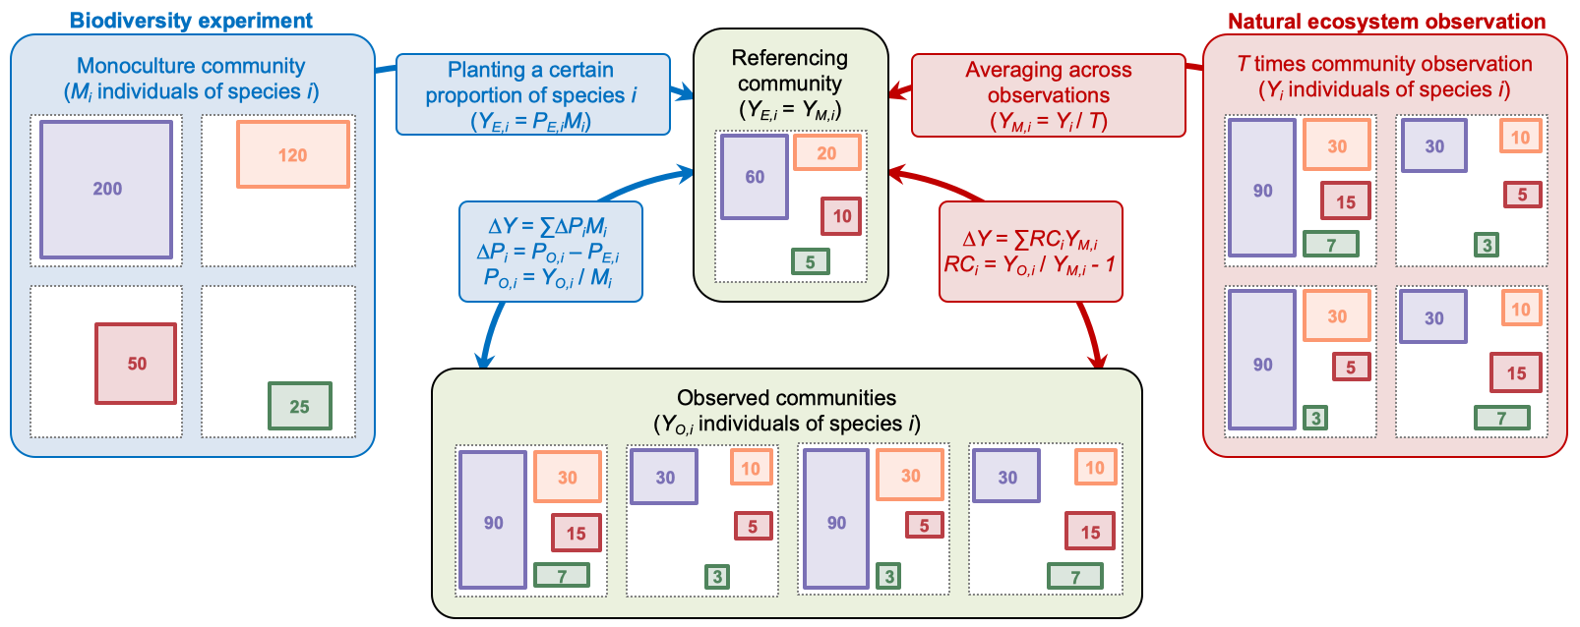
Supplementary Figure 1. A conceptual diagram comparing the methods of partitioning the complementarity and selection effects used in natural ecosystems and biodiversity experiments. Please note that the 4 observed communities that compared with the referencing community are same to the 4 communities obtained by natural ecosystem observation.

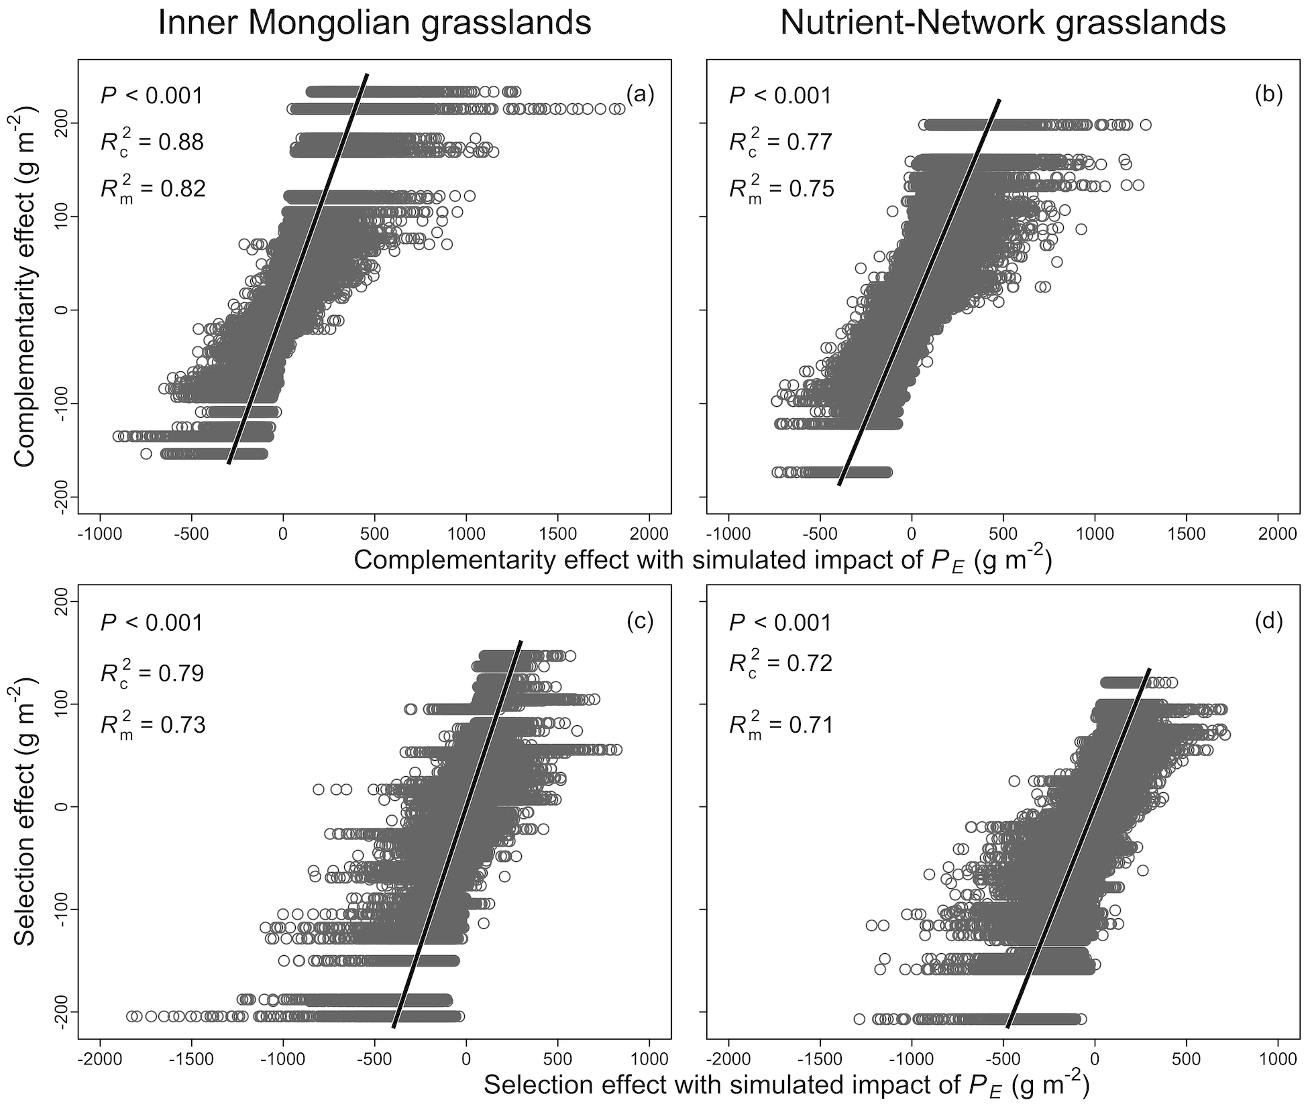
Supplementary Figure 2. The complementarity (a, c) and selection (b, d) effects estimated with the partitioning method for natural ecosystems in relation to those with simulated impacts of P_{E}. Solid lines represent significant regression lines. Conditional R² values (R_{c}²) and marginal R² values (R_{m}²) were shown in figures.

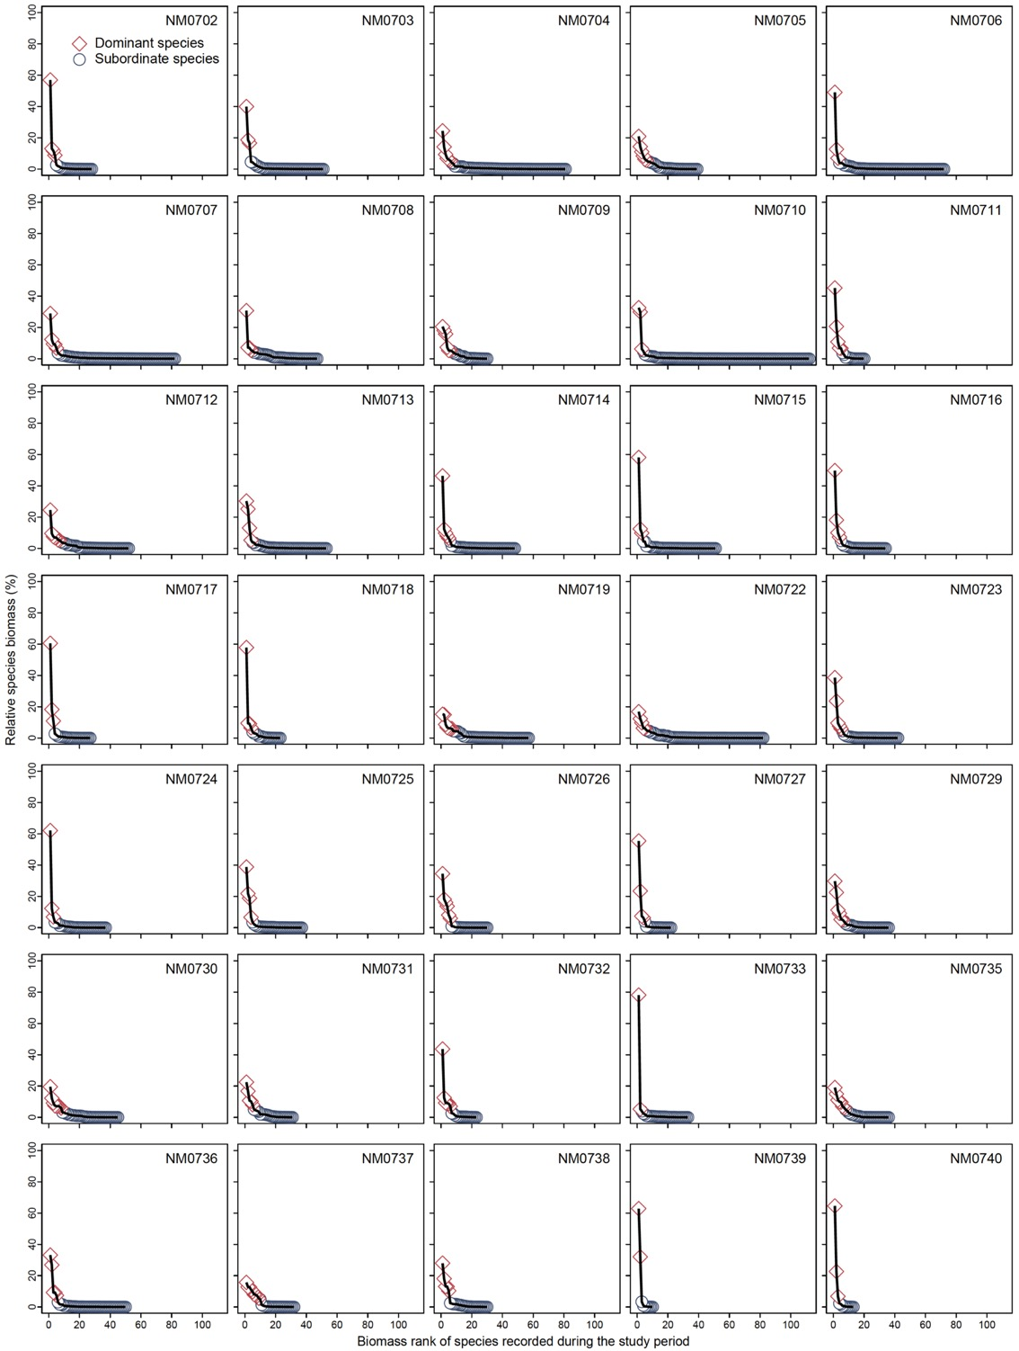
Supplementary Figure 3. Descending order of relative species biomass in Inner Mongolian grasslands, based on data of all species recorded in each site.

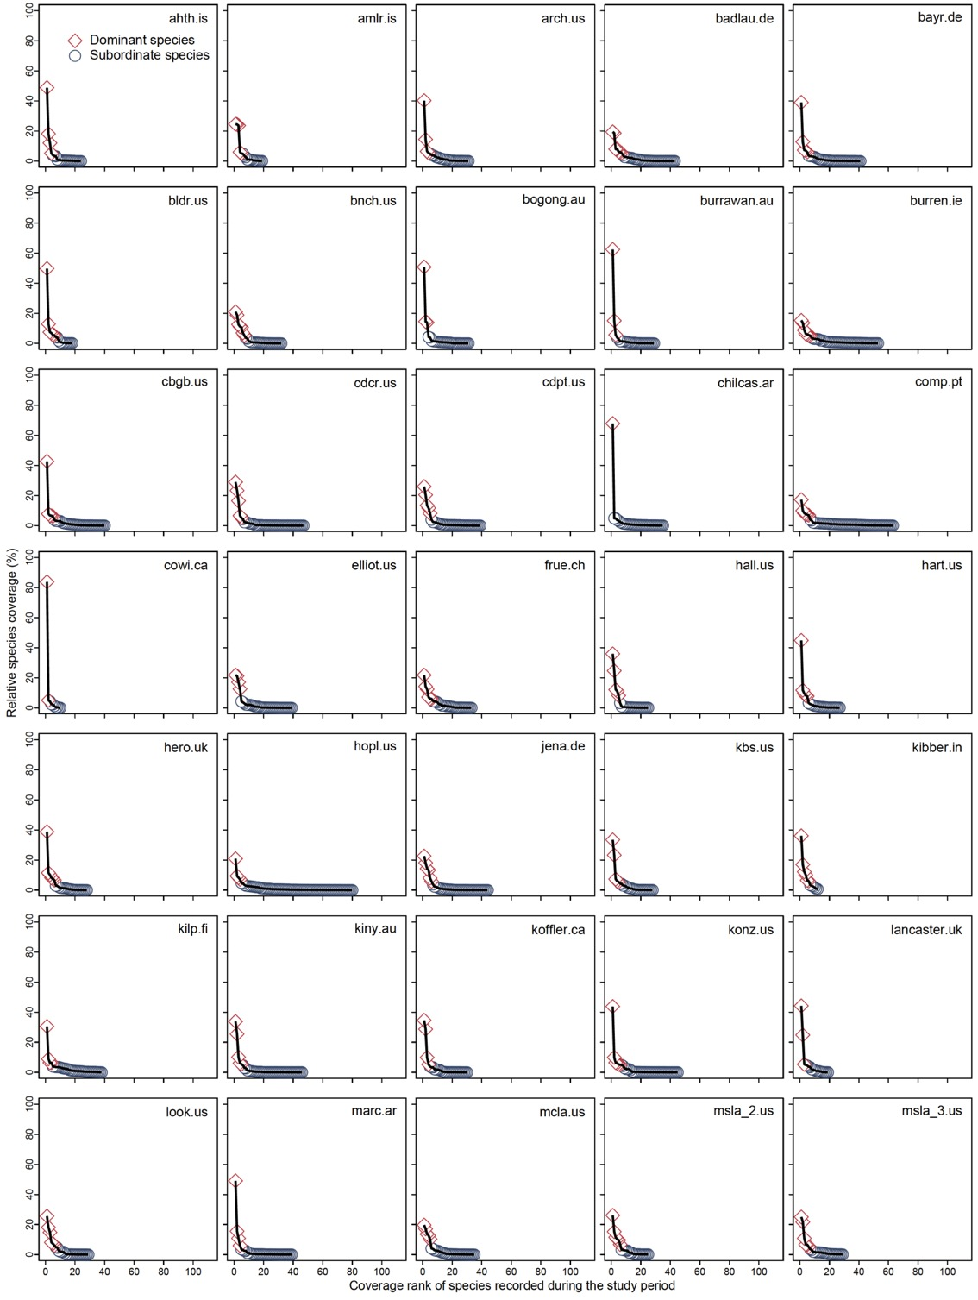
Supplementary Figure 4. Descending order of relative species coverage in Nutrient-Network grasslands, based on data of all species recorded in each site.

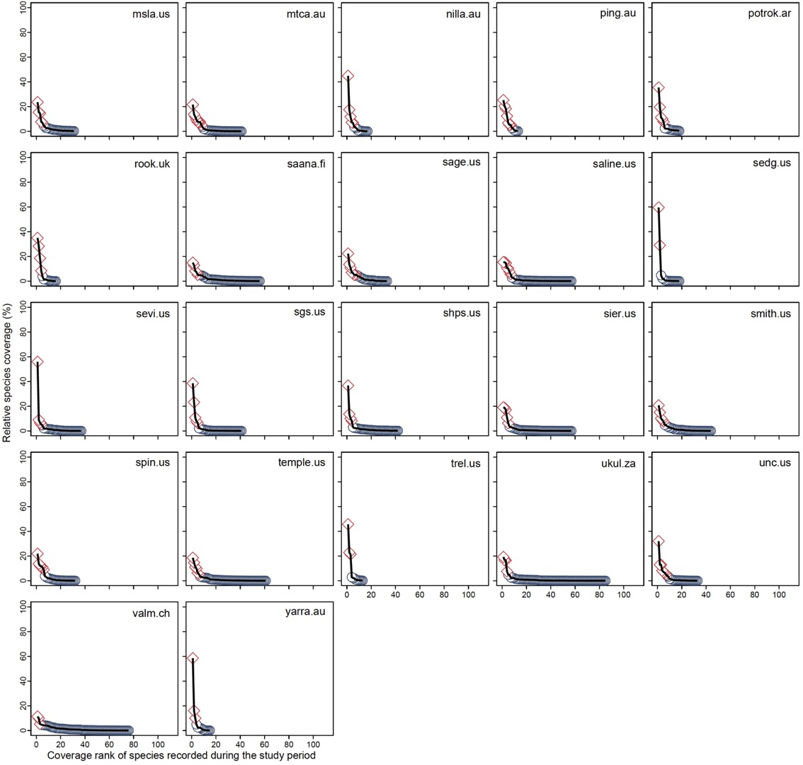
Supplementary Figure 4 (Continued). Descending order of relative species coverage in Nutrient-Network grasslands, based on data of all species recorded in each site.

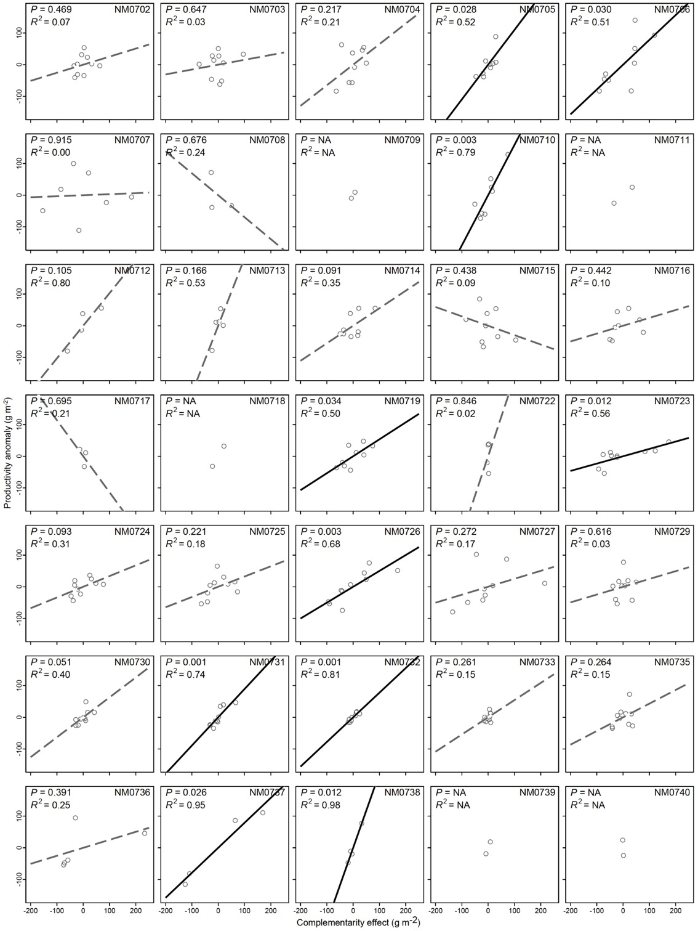
Supplementary Figure 5. Complementarity effect in driving plant community biomass production (productivity) in Inner Mongolian grasslands. Solid black lines represent significant regression lines; dashed grey lines represent non-significant regression lines. R² values of regressions were shown.
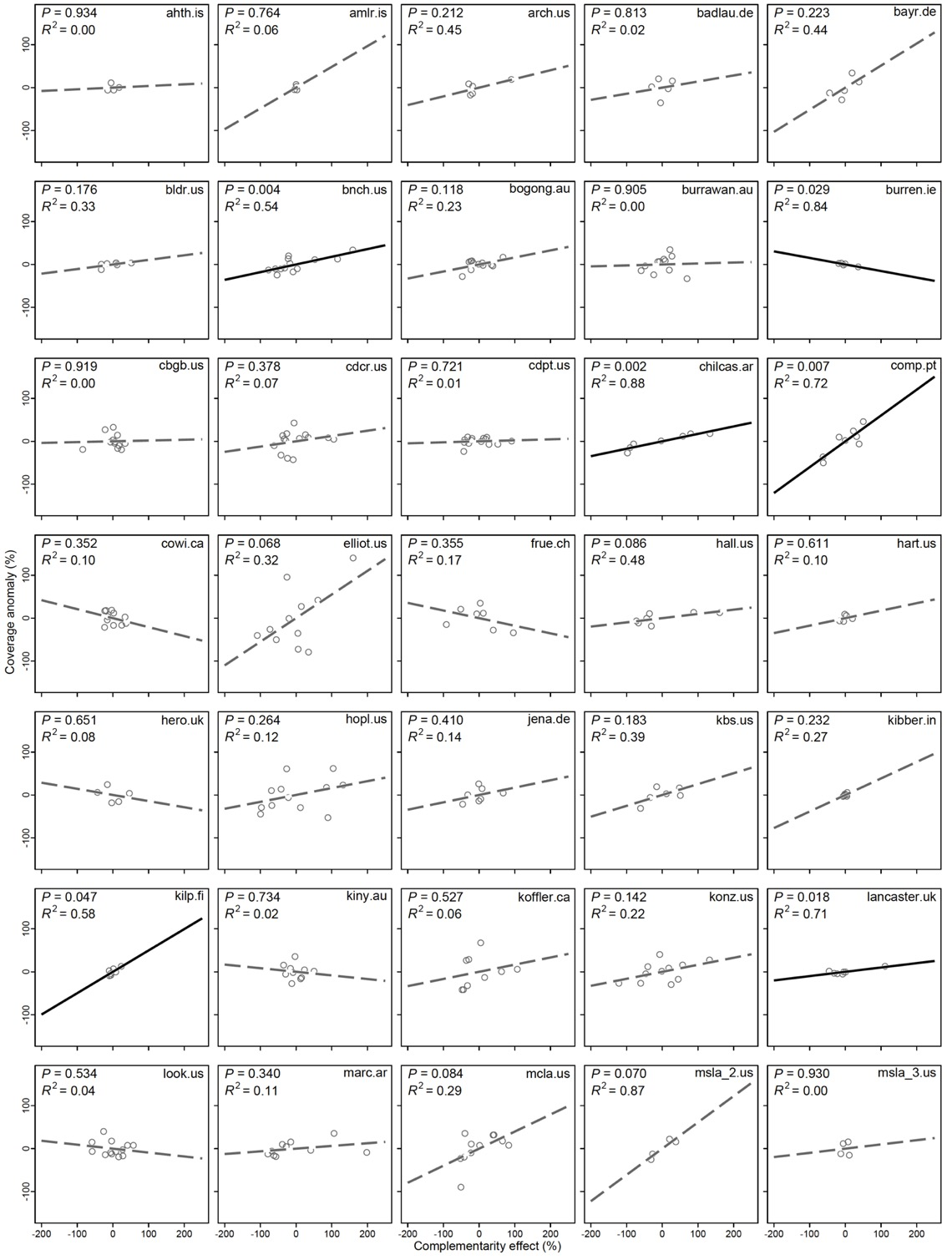
Supplementary Figure 6. Complementarity effect in driving plant community coverage in Nutrient-Network grasslands. Solid black lines represent significant regression lines; dashed grey lines represent non-significant regression lines. R² values of regressions were shown.
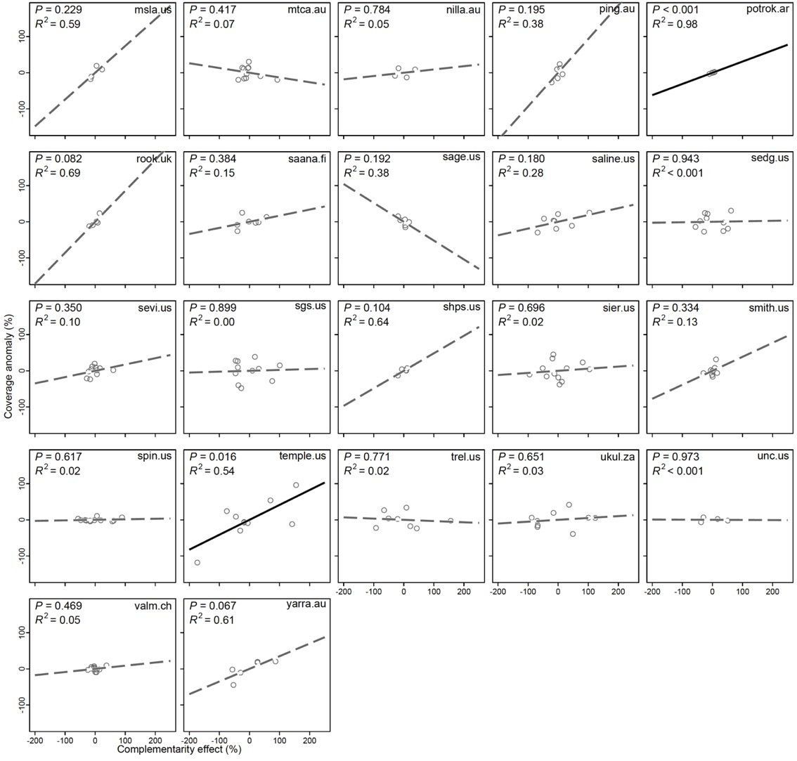
Supplementary Figure 6 (Continued). Complementarity effect in driving plant community coverage in Nutrient-Network grasslands. Solid black lines represent significant regression lines; dashed grey lines represent non-significant regression lines. R² values of regressions were shown.

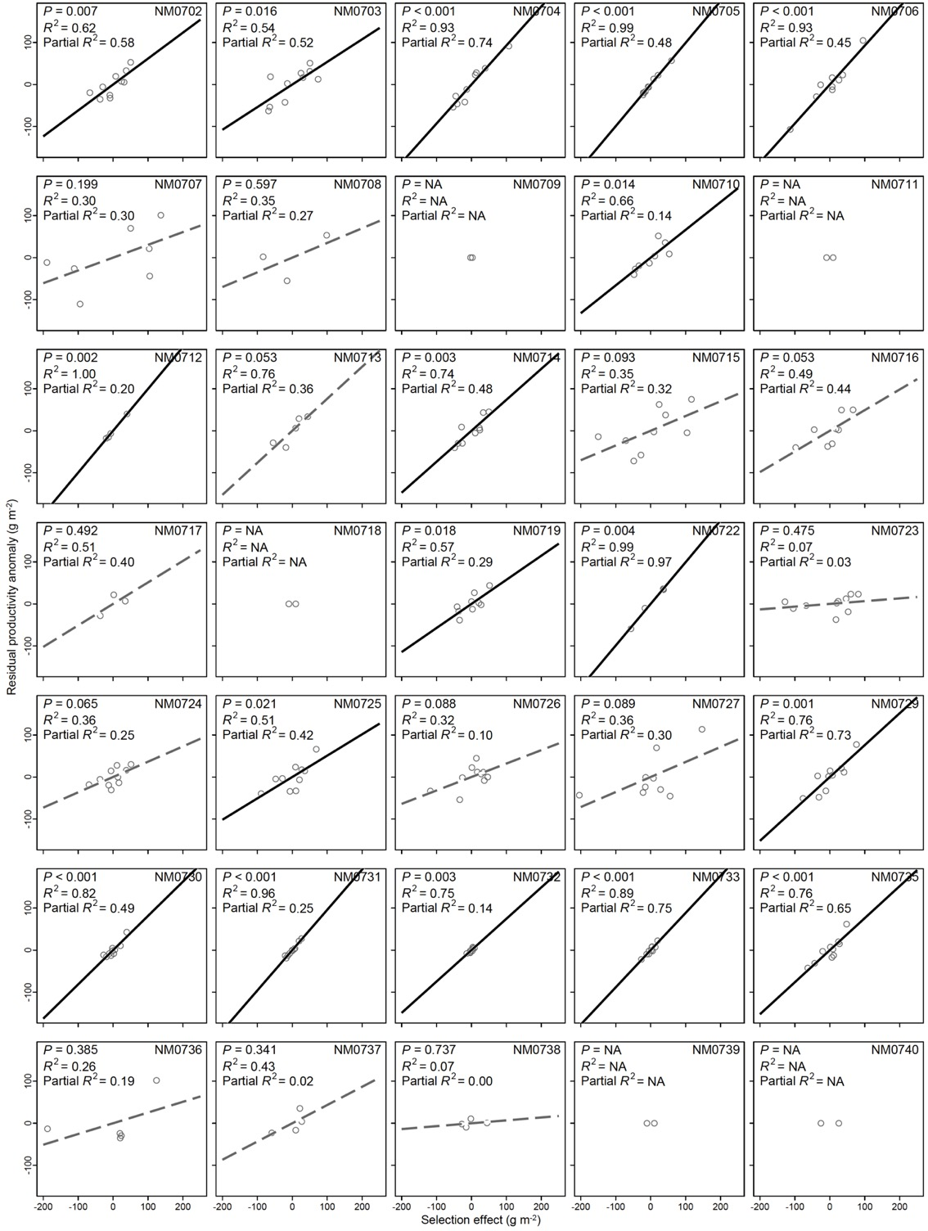
Supplementary Figure 7. Residual regression for selection effect in driving plant community biomass production (productivity) in Inner Mongolian grasslands. Solid black lines represent significant regression lines; dashed grey lines represent non-significant regression lines. R² values of residual regressions were shown. Partial R² values, calculated as the products between the R² of residual regression and the proportion of variances unexplained in linear regressions (Supplementary Figure 5), were also shown.

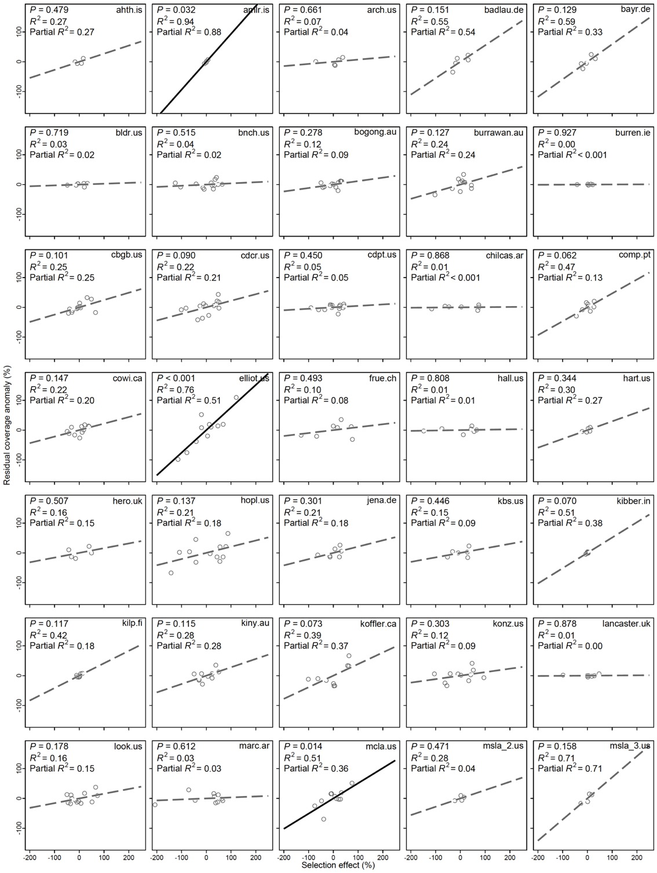
Supplementary Figure 8. Residual regression for selection effect in driving plant community coverage in Nutrient-Network grasslands. Solid black lines represent significant regression lines; dashed grey lines represent non-significant regression lines. R² values of residual regressions were shown. Partial R² values, calculated as the products between the R² of residual regression and the proportion of variances unexplained in linear regressions (Supplementary Figure 6), were also shown.

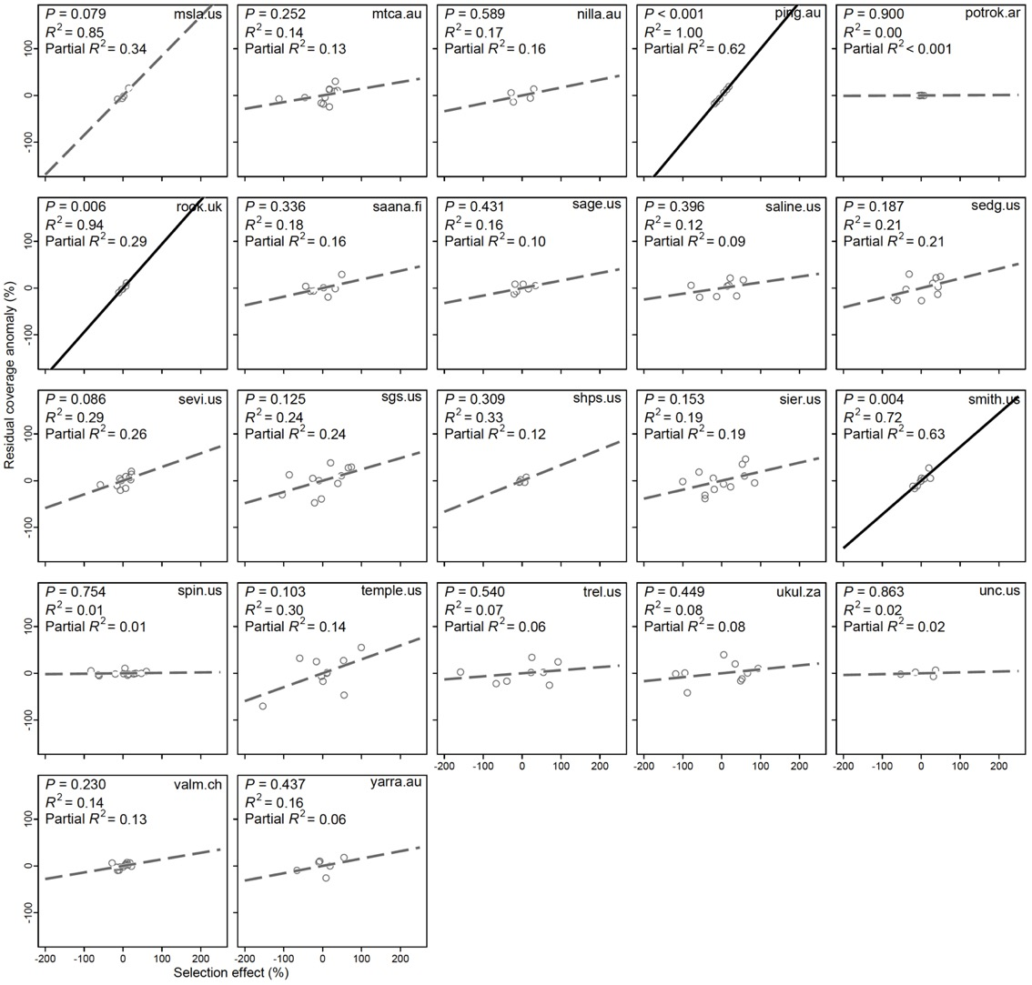
Supplementary Figure 8 (Continued). Residual regression for selection effect in driving plant community coverage in Nutrient-Network grasslands. Solid black lines represent significant regression lines; dashed grey lines represent non-significant regression lines. R² values of residual regressions were shown. Partial R² values, calculated as the products between the R² of residual regression and the proportion of variances unexplained in linear regressions (Supplementary Figure 6), were also shown.

