Extended Data Table 1. Summary of the linear mixed-effect models relating the complementarity effect to its dominant-species component and species richness.
Inner Mongolian grassland
Multiple R_{c}² = 0.81, Multiple R_{m}² = 0.44
 | Estimate | SE | DF | t-value | P-value
Dominant-species component | 2.24 | 0.68 | 210 | 3.31 | 0.001
Species richness | 5.89 | 0.84 | 210 | 6.98 | < 0.001
Nutrient-Network grassland
Multiple R_{c}² = 0.96, Multiple R_{m}² = 0.50
 | Estimate | SE |  | t-value | P-value
Dominant-species component | 0.55 | 0.46 | 408 | 1.18 | 0.237
Species richness | 9.97 | 0.86 | 408 | 11.58 | < 0.001
SE, Standard error; DF, degree of freedom.

Extended Data Table 2. Summary of the linear mixed-effect models relating the selection effect to its dominant-species component and species richness. When both dominant-species components and species richness were included, the impacts of species richness on the community-wide selection effect were not significant.
Inner Mongolian grassland
Multiple R_{c}² = 0.96, Multiple R_{m}² = 0.95
 | Estimate | SE | DF | t-value | P-value
Dominant-species component | 1.17 | 0.03 | 210 | 41.60 | < 0.001
Species richness | –0.09 | 0.08 | 210 | –1.17 | 0.245
Nutrient-Network grassland
Multiple R_{c}² = 0.95, Multiple R_{m}² = 0.94
 | Estimate | SE | DF | t-value | P-value
Dominant-species component | 1.34 | 0.03 | 408 | 45.89 | < 0.001
Species richness | –0.04 | 0.05 | 408 | –0.76 | 0.446
SE, Standard error; DF, degree of freedom.

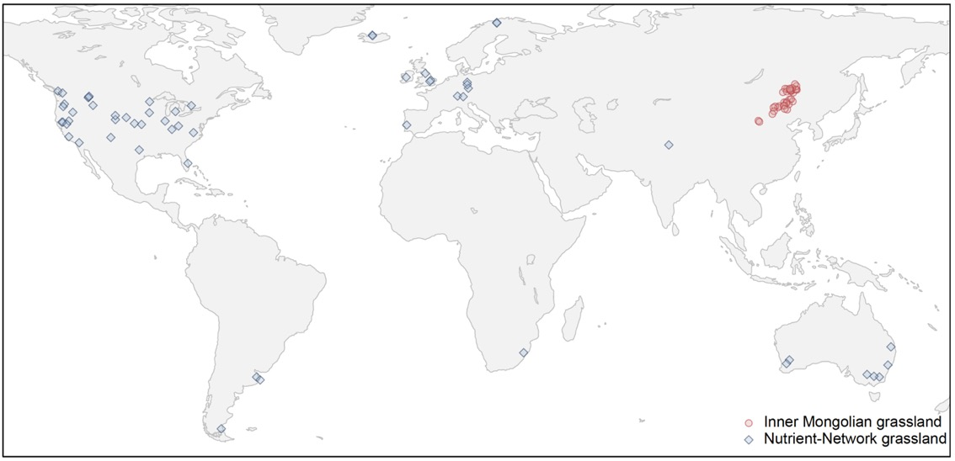
Extended Data Figure 1. Geographical distribution of 35 sites surveyed in the Inner Mongolian grassland and 57 sites collected from Nutrient-Network grassland. Sites are jittered to reduce overlap.

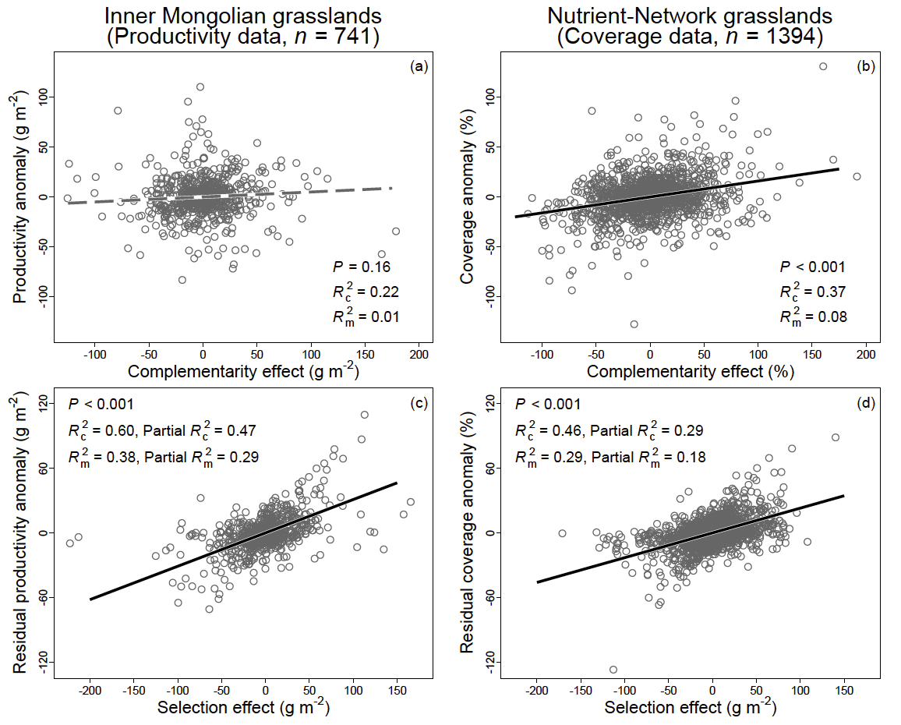
Extended Data Figure 2. Complementarity (a–b) and selection (c–d) effects in driving plant community biomass production (productivity) and coverage. Solid black lines represent significant regression lines; dashed grey lines represent non-significant regression lines. Conditional and marginal R² (R_{c}² and R_{m}²) values of regressions were shown. Partial R_{c}² and R_{m}² of residual regressions (c–d), calculated as the products between them and the proportion of unexplained variances in linear regressions (1–R_{c}² of linear regression), were also shown. Here, complementarity and selection effects were estimated plot-species data from each site-year survey. The analyses also showed the selection effects are significant in impacting productivity and community coverage, and are superior to the impact of complementarity effect. These results are consistent with that of using year-specific data from each site (Figure 1).
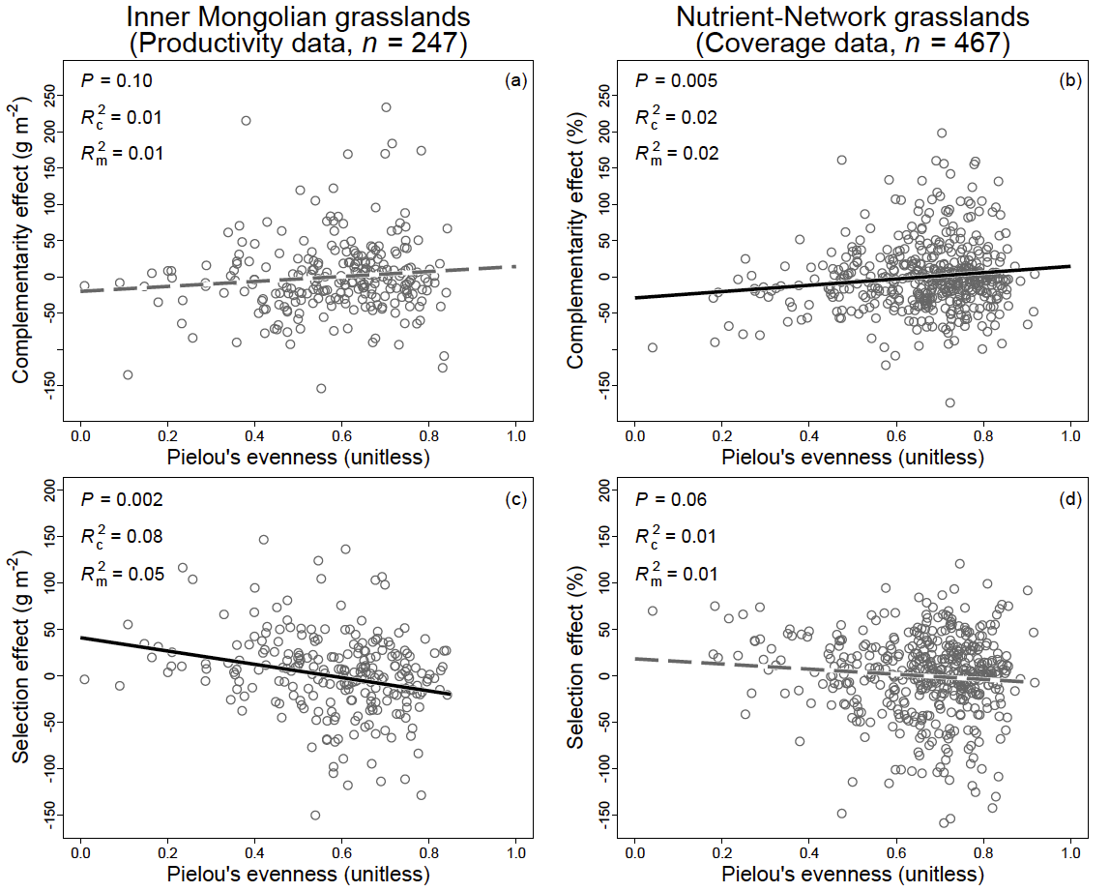
Extended Data Figure 3. Complementarity (a–b) and selection (c–d) effects in relation to the unevenness of species-abundance distribution estimated with Pielou’s evenness. Solid black lines represent significant regression lines; dashed grey lines represent non-significant regression lines. Conditional R² values (R_{c}²) and marginal R² (R_{m}²) values were shown in figures.

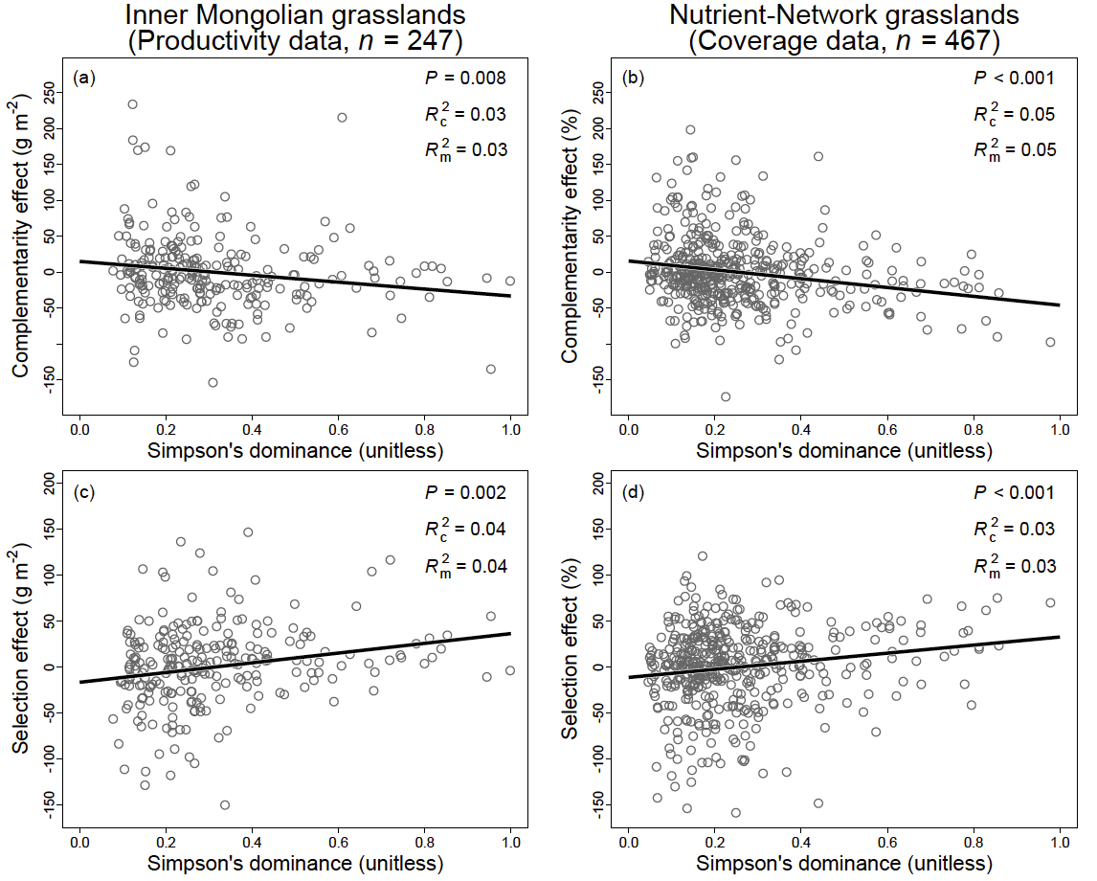
Extended Data Figure 4. Complementarity (a–b) and selection (c–d) effects in relation to the unevenness of species-abundance distribution estimated with Simpson’s dominance. Solid black lines represent significant regression lines. Conditional R² values (R_{c}²) and marginal R² (R_{m}²) values were shown in figures.

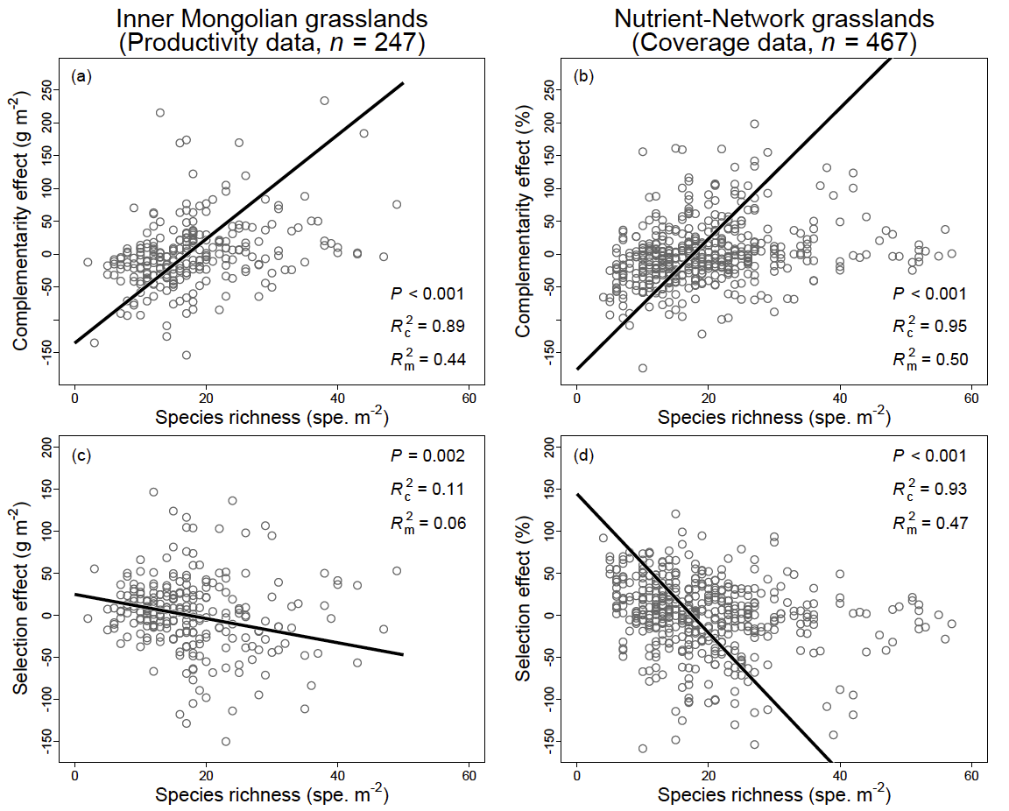
Extended Data Figure 5. Complementarity (a–b) and selection (c–d) effects in relation to species richness. Solid black lines represent significant regression lines. Conditional R² values (R_{c}²) and marginal R² (R_{m}²) values were shown in figures.

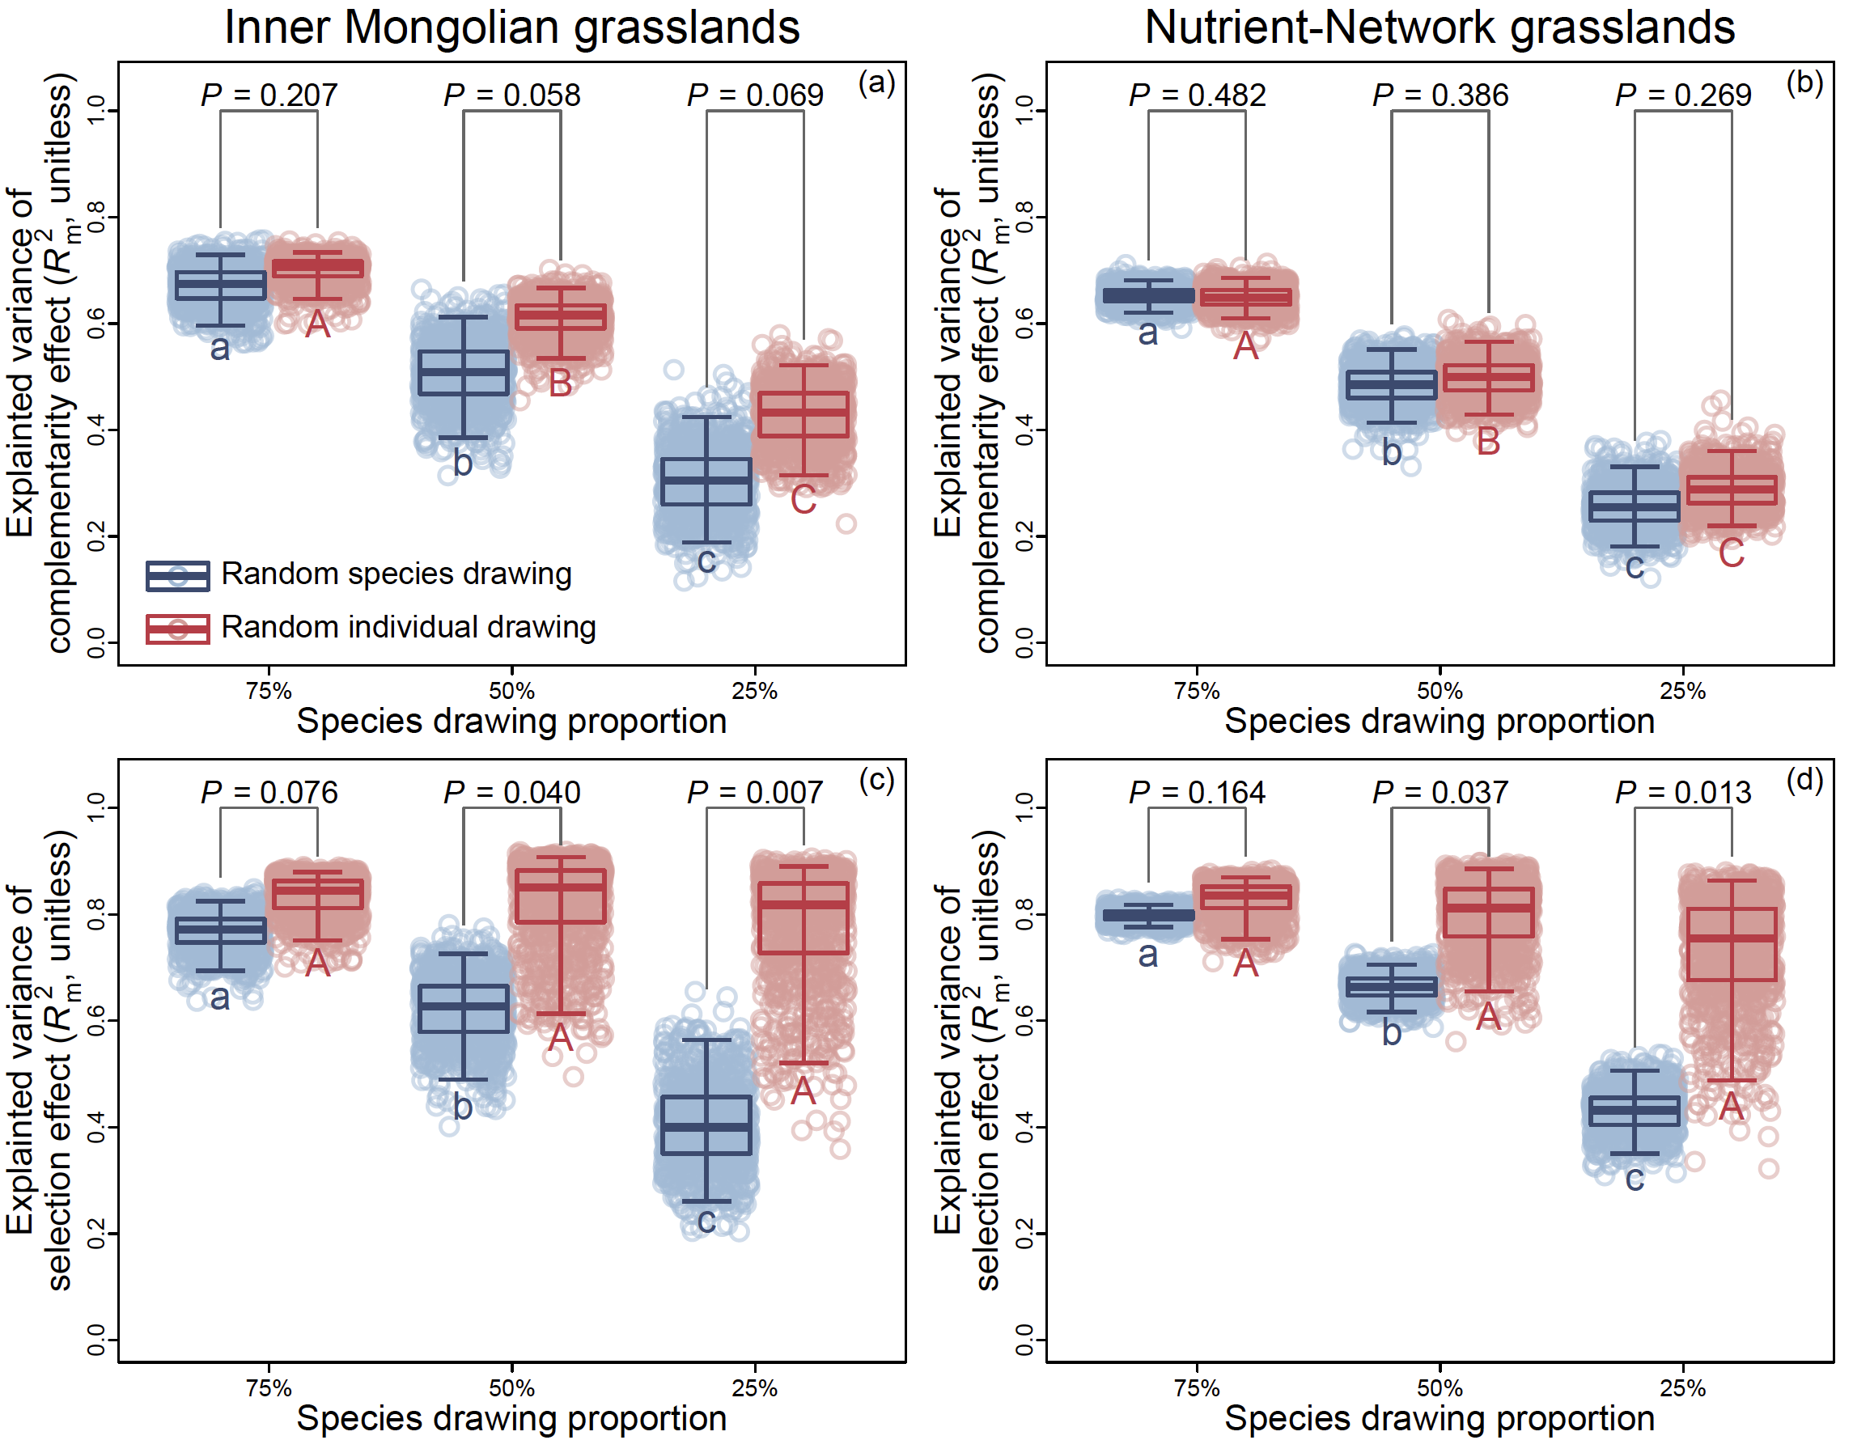
Extended Data Figure 6. Randomly drawing species and individual drawing in affecting the chosen species in representing the complementarity (a–b) and selection (c–d) effects. Here, species were drawn from annual species records of each site-year survey. Boxes (i–l) showed 2.5th, 25th, 50th, 75th and 97.5th of percentiles of 1000 times of resampling. Different lowercase and uppercase letters represent significant differences among species number gradients established by random species and individual drawing, respectively.

