SUPPLEMENTARY FIGURES
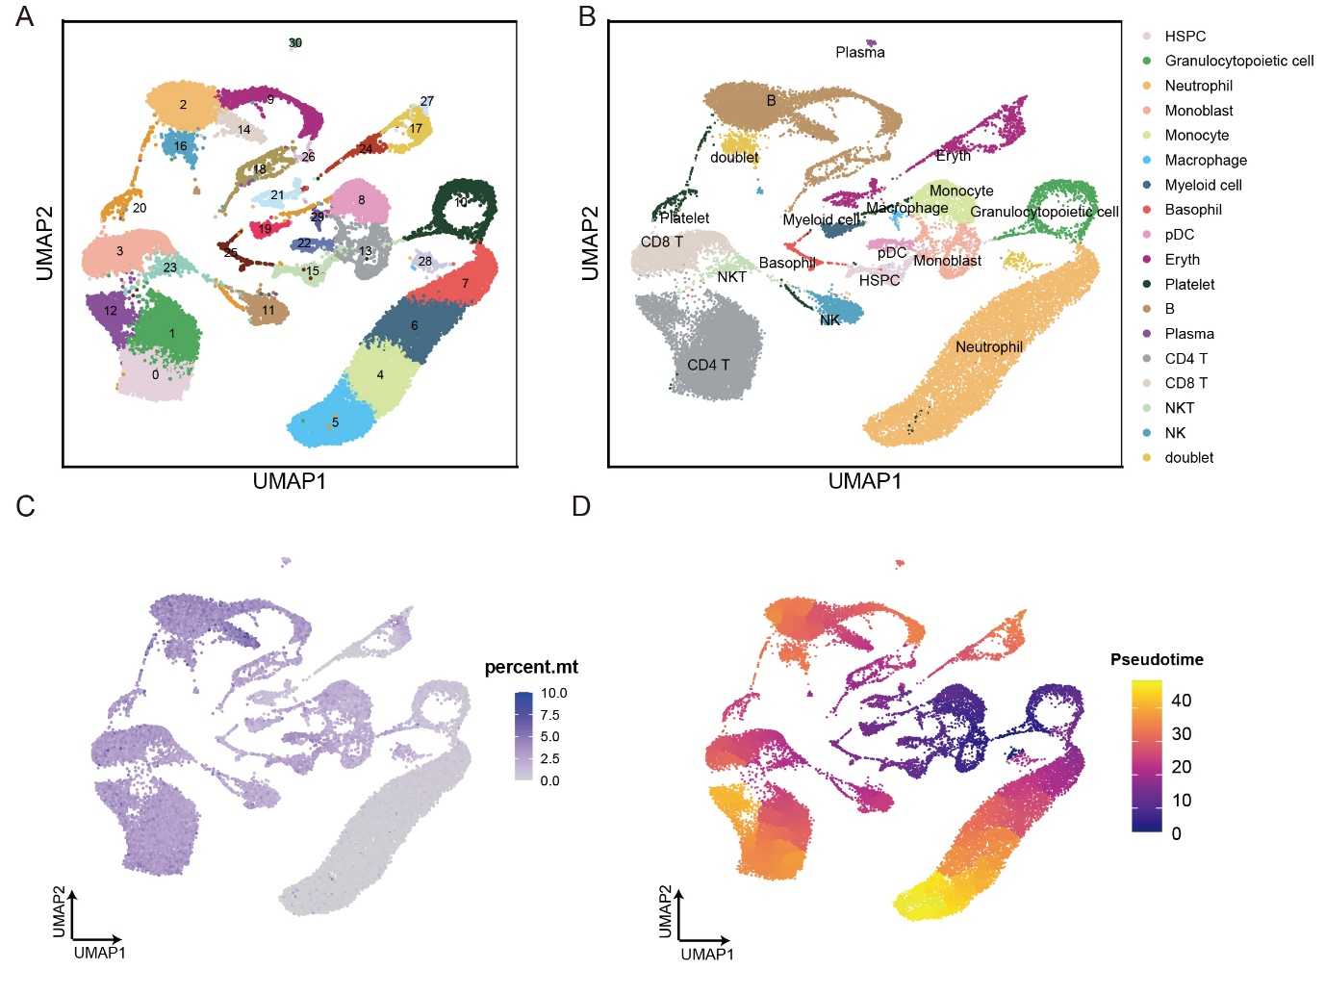Figure S1. Visualization of the clustering results by uniform manifold approximation and projection (UMAP) after data integration for the peripheral blood and bone marrow datasets. (A) UMAP of the scRNA-seq data (n = 34,881 cells) revealed 31 clusters. (B) UMAP representation of the scRNA-seq data showing the 18 main cell identities. (C) UMAP showing the percentage of mitochondrial genes in each cell. (D) UMAP of the pseudotime score of the cells identified in Figure 1B.
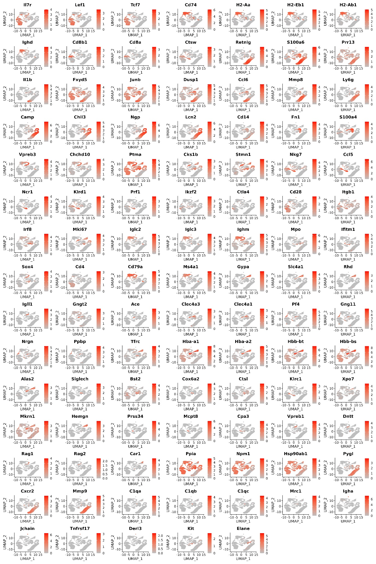
Figure S2. Feature plots showing the expression of marker genes used to identify cell identities on UMAP.

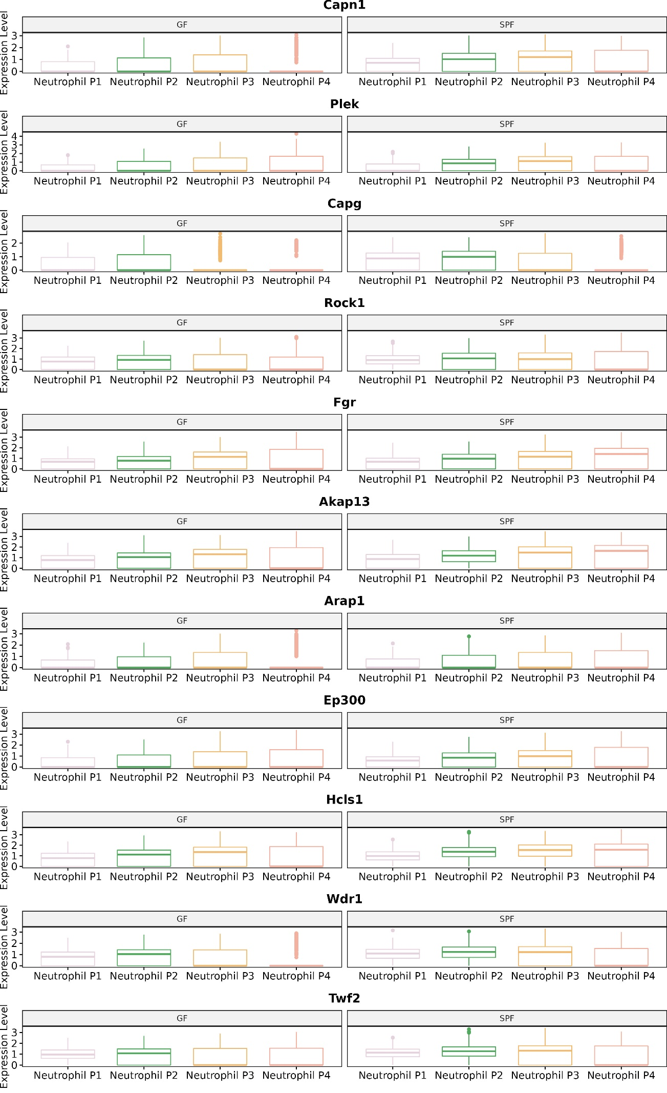
Figure S3. Box plots showing the down-regulated gene expression of the actin-related pathways in GF mouse neutrophils.

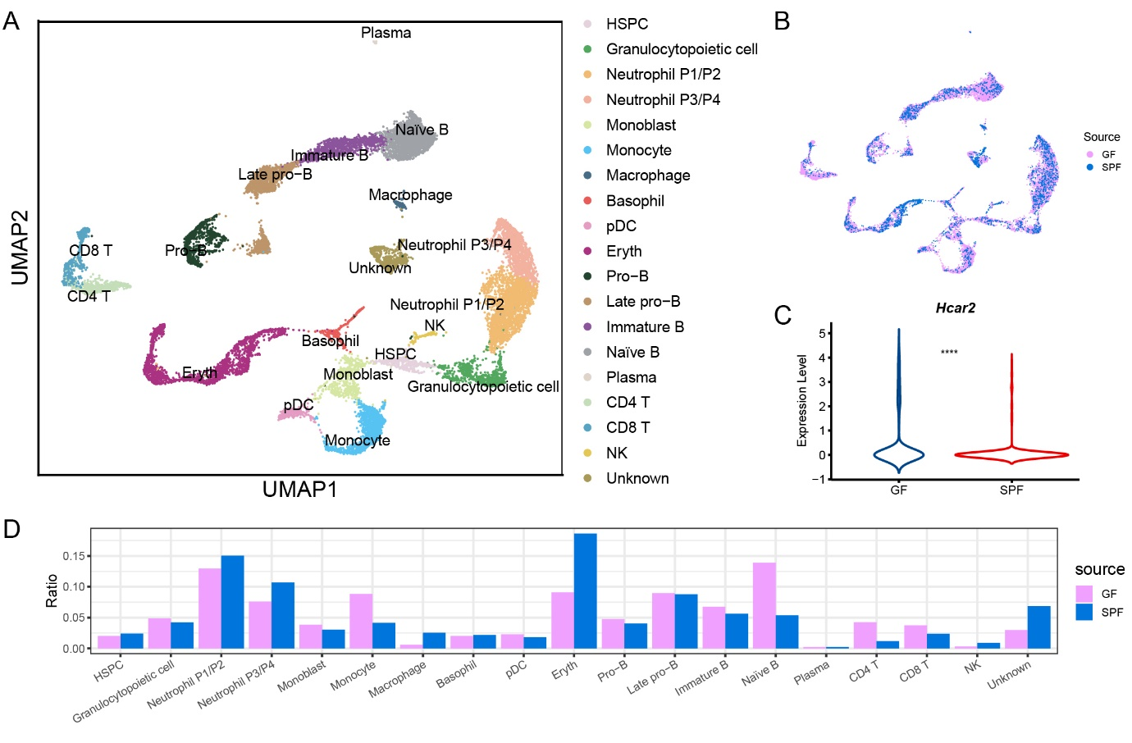
Figure S4. The bone marrow scRNA data generated by the DNBelab C4 platform ware used for validation. (A) UMAP representation of the 18 cell identities. (B) UMAP showing the origin of each cell. (C) Violin plot showing the up-regulation of the Hcar2 gene. ****: p-value < 0.0001. (D) Bar plot showing the ratio of cell identities in the GF and SPF bone marrow.

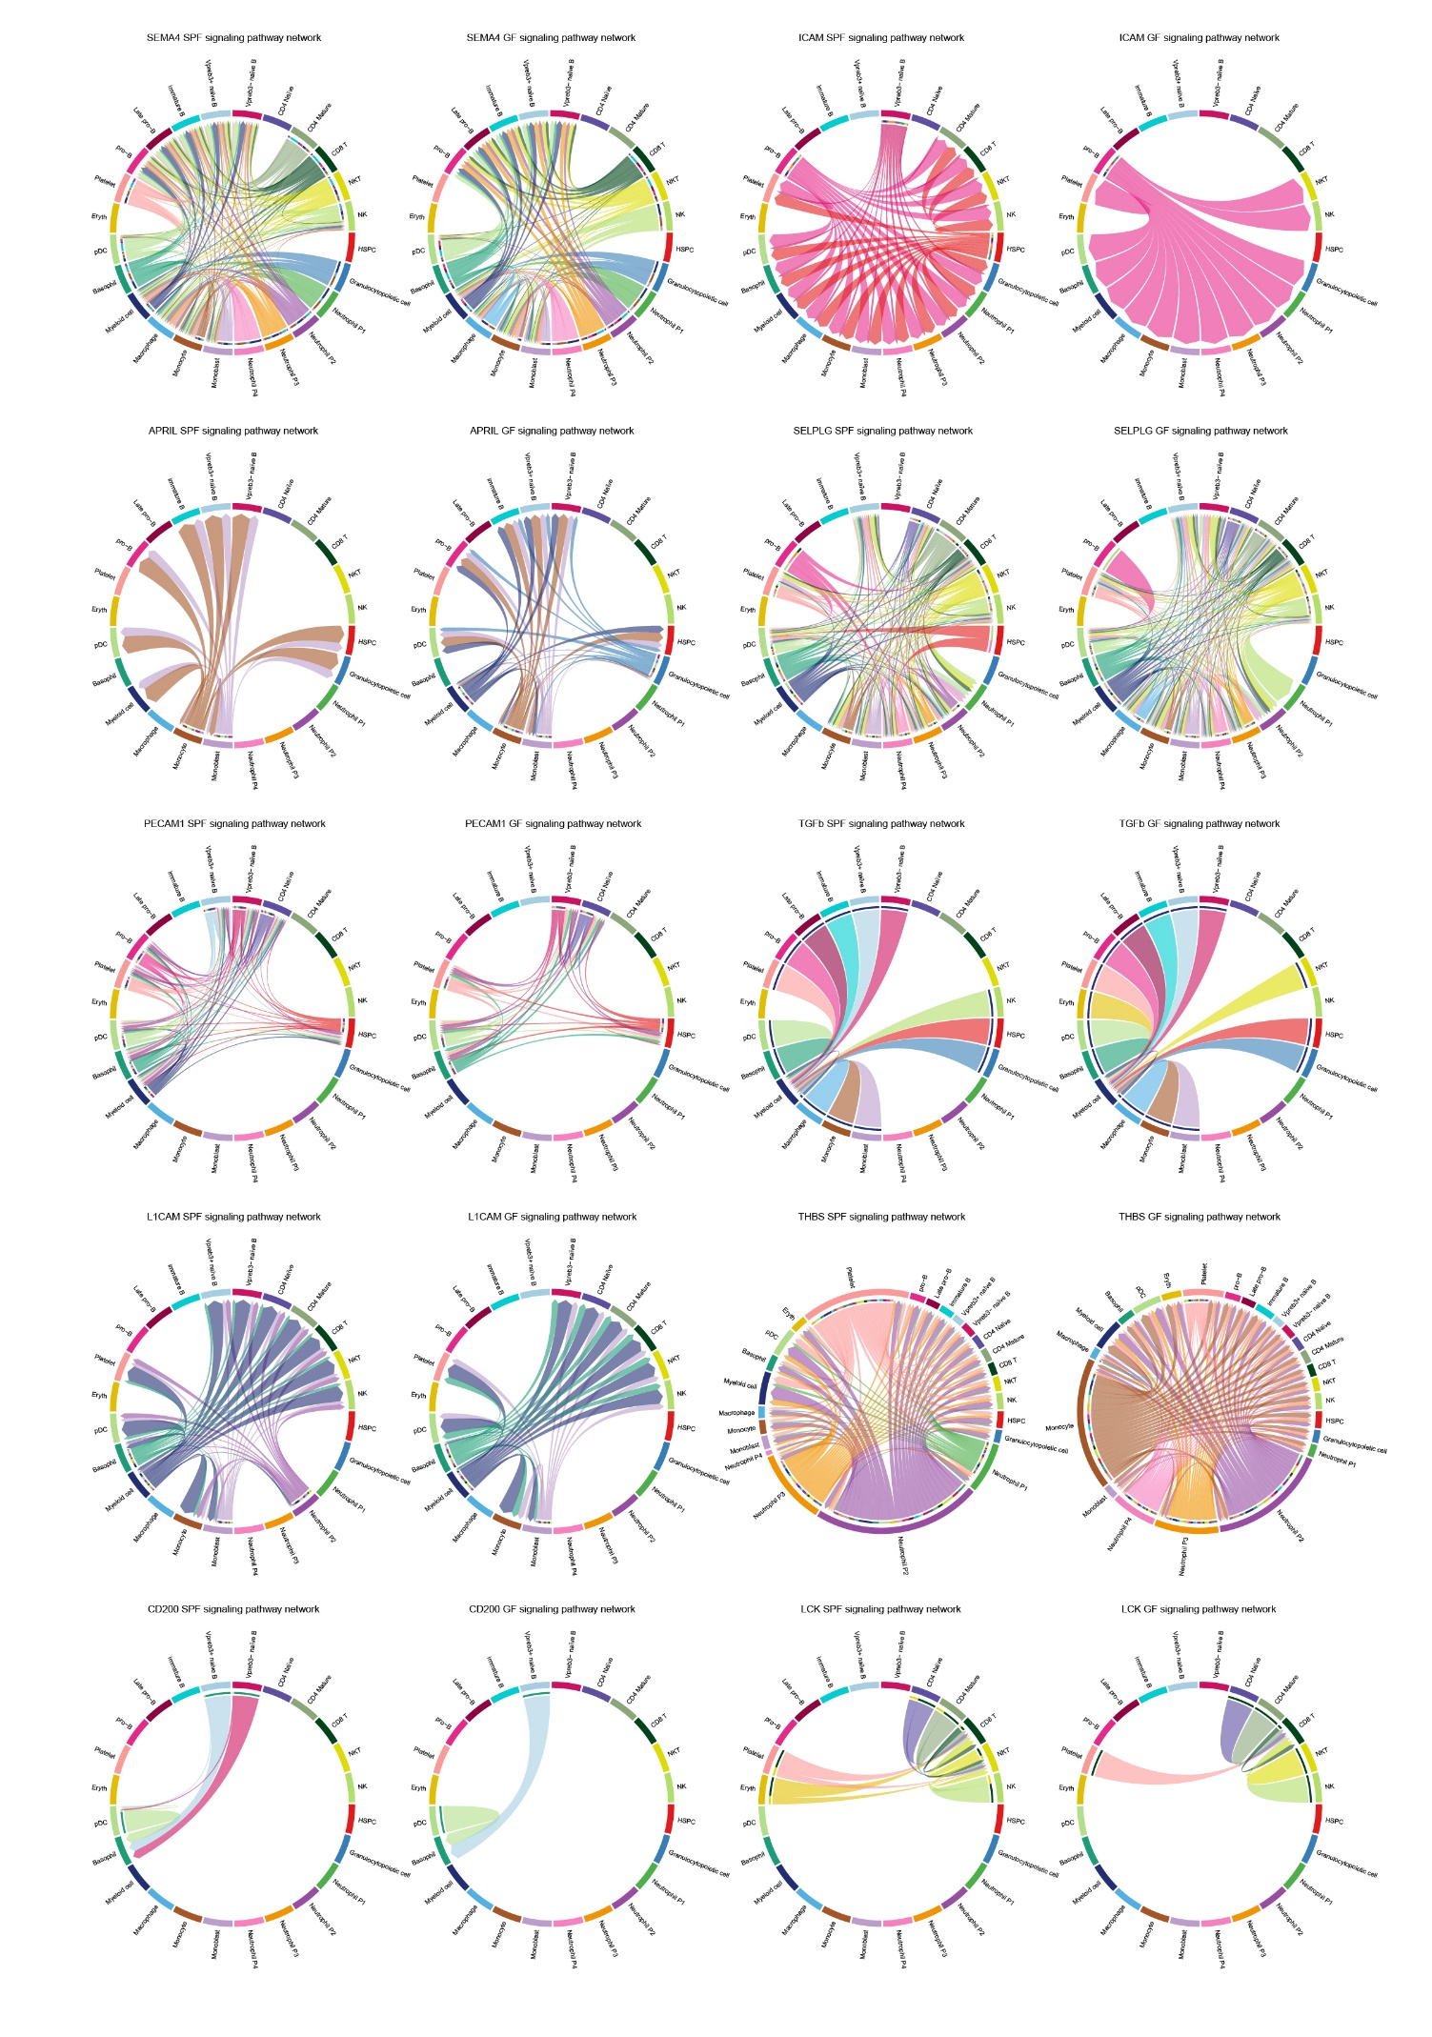Figure S5. Chord plot showing the top 10 most significant pathway interactions, with the exception of the BST2 pathway shown in Figure 5D.

