Table S1. Primer information
Name | Sequence | Application
FLAG-OGTb_tv3-F | GGAGCTGCAGTTGCTAAGCTTATGGCTTGTTACCTGAAGGCAA | Ligated to p3xFLAG-CMV™-14 vector
FLAG- OGTb_tv3-R | TTTGTAGTCAGCCCGGGATCCGGTGCTCTCGCTGGTCTCC | Ligated to p3xFLAG-CMV™-14 vector
GFP- OGTb_tv3-F | TCAGATCTCGAGCTCAAGCTTATGGCTTGTTACCTGAAGGCAA | Ligated to pTurboGFP-N vector
GFP- OGTb_tv3-R | ATGGTGGCGACCGGTGGATCCccGGTGCTCTCGCTGGTCTCC | Ligated to pTurboGFP-N vector
zfGAPDH-F | GTAACTCCGCAGAAAAGCCAGAC | Quantitative real-time PCR
zfGAPDH-R | CAAAAGAAACTAACACACACACA | Quantitative real-time PCR
zfIRF3-F | TGGCTGTCAATCACATTTCTCG | Quantitative real-time PCR
zfIRF3-R | TGGCTGTCAATCACATTTCTCG | Quantitative real-time PCR
zfOGT-F | GCACTGGAGGTGTTCCCAGA | Quantitative real-time PCR
zfOGT-R | GATGCAATTGCTTCAGGAATG | Quantitative real-time PCR
zfOGTb_tv3-F | ATCCTGCTTTTGCTGATGCT | Quantitative real-time PCR
zfOGTb_tv3-R | GTTGCCATGTCTCTCTGCAA | Quantitative real-time PCR
zfMXA-F | GGAGAATCAGTTACAAAACCT | Quantitative real-time PCR
zfMXA-R | GATTGTCTCTTGCCTTGTAACA | Quantitative real-time PCR
zfPKZ-F | GGAGCACCGTACAGGACATT | Quantitative real-time PCR
zfPKZ-R | CTCGGGCTTTATTTGCTCTG | Quantitative real-time PCR
SVCV-N-F | TGAGGTGAGTGCTGAGGATG | Quantitative real-time PCR
SVCV-N-R | CCATCAGCAAAGTCCGGTAT | Quantitative real-time PCR
SVCV-P-F | TTGGACCTGGGATAGTGA | Quantitative real-time PCR
SVCV-P-R | CTTGCTTGGTTTGTGGG | Quantitative real-time PCR
SVCV-G-F | CGACCTGGATTAGACTTG | Quantitative real-time PCR
SVCV-G-R | AATGTTCCGTTTCTCACT | Quantitative real-time PCR
zfIFN-1F | GTCAGGACTAAAAACTTCAC | Quantitative real-time PCR
zfIFN1-R | TCTTAATACACGCAAAGATGAGAACT | Quantitative real-time PCR
zfIFN2-F | CCTCTTTGCCAACGACAGTT | Quantitative real-time PCR
zfIFN2-R | CGGTTCCTTGAGCTCTCATC | Quantitative real-time PCR
zfIFN3-F | TTCTGCTTTGTGCAGGTTTG | Quantitative real-time PCR
zfIFN3-R | GGTATAGAAACGCGGTCGTC | Quantitative real-time PCR
EPC-irf3-F | GGACGAGGAAAGCGTGTTCTC | Quantitative real-time PCR
EPC-irf3-R | GTGAAATCTGCCCCAAACCACC | Quantitative real-time PCR
EPC-PKR-F | AGGCTTGATCCACAGAGACCTGAA | Quantitative real-time PCR
EPC-PKR-R | TCTGAGACTTGTTGAGCGTGAAG | Quantitative real-time PCR
EPC-ifn-F | ATGAAAACTCAAATGTGGACGTA | Quantitative real-time PCR
EPC-ifn-R | GATAGTTTCCACCCATTTCCTTAA | Quantitative real-time PCR
EPC-isg15-F | CAGCCTTGAGGATGATTCCAG | Quantitative real-time PCR
EPC-isg15-R | TGCCGTTGTAAATCAGTCG | Quantitative real-time PCR
EPC-viperin-F | AGCGAGGCTTACGACTTCTG | Quantitative real-time PCR
EPC-viperin- -R | GCACCAACTCTCCCAGAAAA | Quantitative real-time PCR
EPC-mx-F | GGCTGGAGCAGGTGTTGGTATC | Quantitative real-time PCR
EPC-mx-R | TCCACCAGGTCCGGCTTTGTTAA | Quantitative real-time PCR
EPC-β-actin-RT-F | CACTGTGCCCATCTACGAG | Quantitative real-time PCR
EPC-β-actin-RT-R | CCATCTCCTGCTCGAAGTC | Quantitative real-time PCR
zfGFAT1-F | TGGCTTTGGTGGACAAACTC | Quantitative real-time PCR
zfGFAT1-R | TTTGGCACTTGGTGTACGTG | Quantitative real-time PCR
zfGFAT2-F | TCATATGCTGCCAGGACGAC | Quantitative real-time PCR
zfGFAT2-R | CTCGGGCAGTCCACATCATA | Quantitative real-time PCR
zfGNPNAT1-F | AGGGGGAAACAGCTAGGAAAAC | Quantitative real-time PCR
zfGNPNAT1-R | TTTTGGCGCACATTCCAGTG | Quantitative real-time PCR
zfPGM3-F | ACAAAAACGCTCGGTCCTTC | Quantitative real-time PCR
zfPGM3-R | AAGACGATGAACAGCCAAGC | Quantitative real-time PCR
zfUAP1-F | GAACGGGACCCACATACCTG | Quantitative real-time PCR
zfUAP1-R | GATGCTCCAAACCCTCACCA | Quantitative real-time PCR

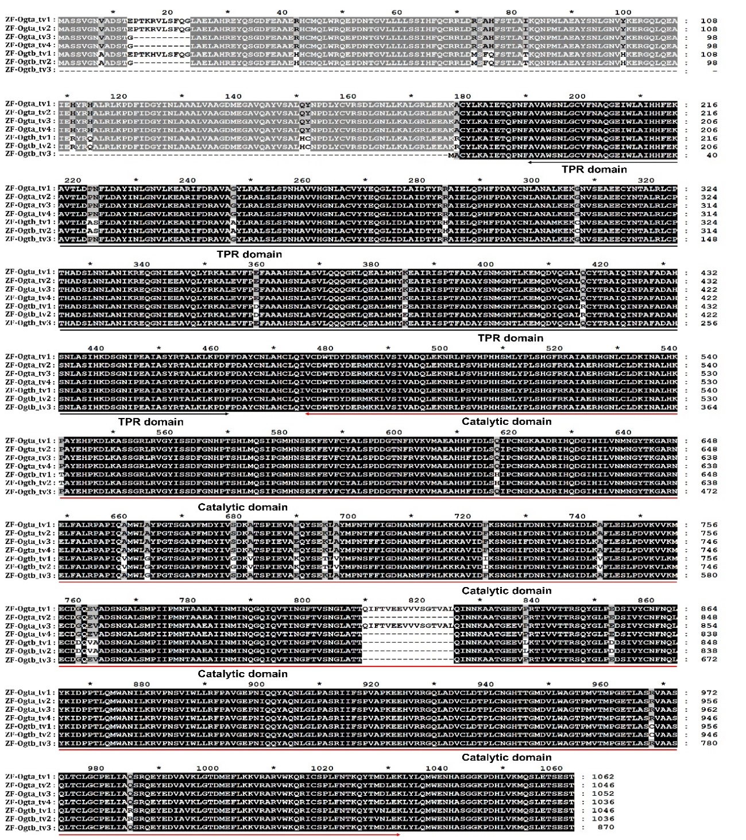

Supplementary Fig. 1 Multiple alignment of Ogtb_tv3 and Ogt isoforms from zebrafish.

