Extended data

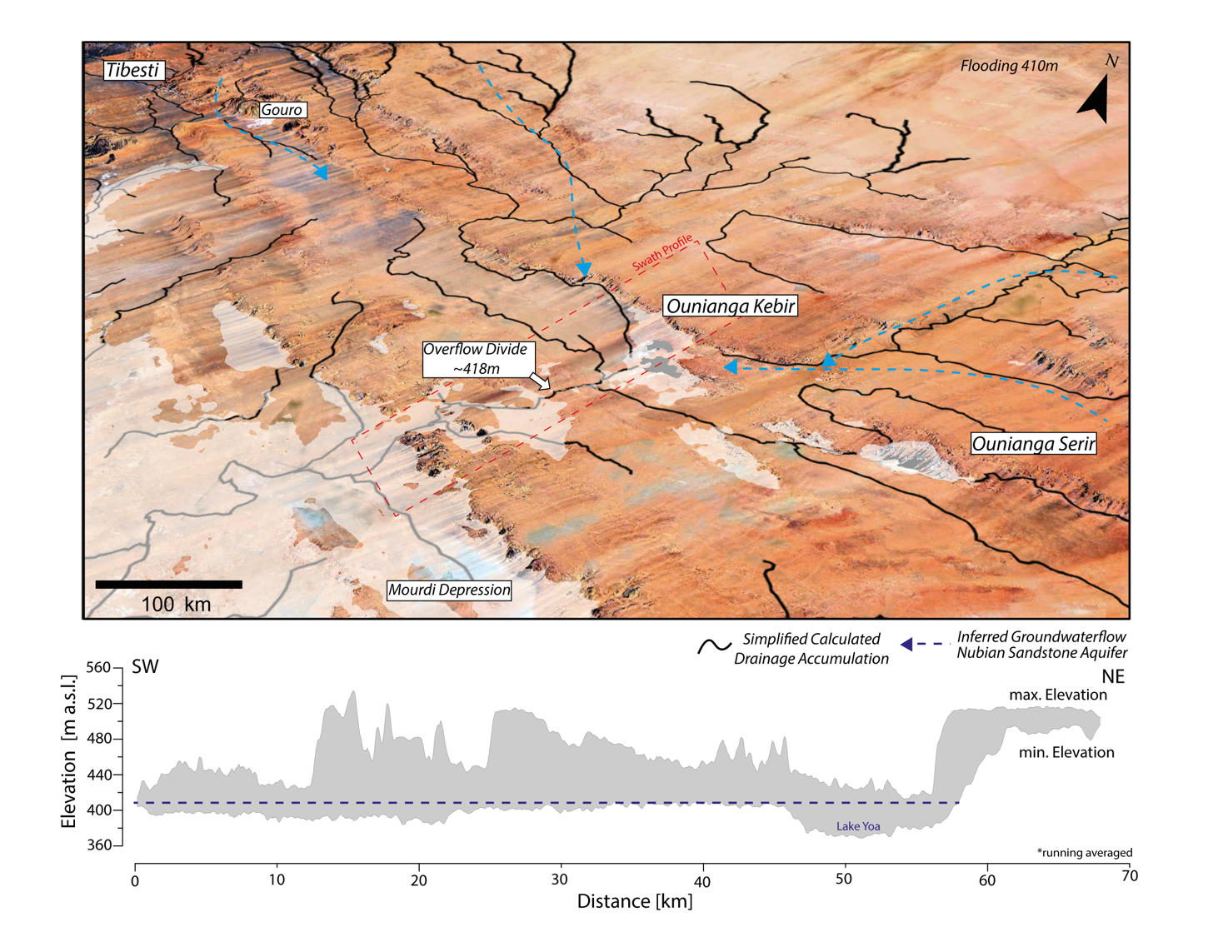
Extended Data Fig. 1: A. Water drainage of the Ounianga Lakes district, which is composed of the western Ounianga Kebir, the main lake Yoa, and the East Ounianga Serir. B. Elevation (m.a.s.l.) from a cross profile (dashed line in A)

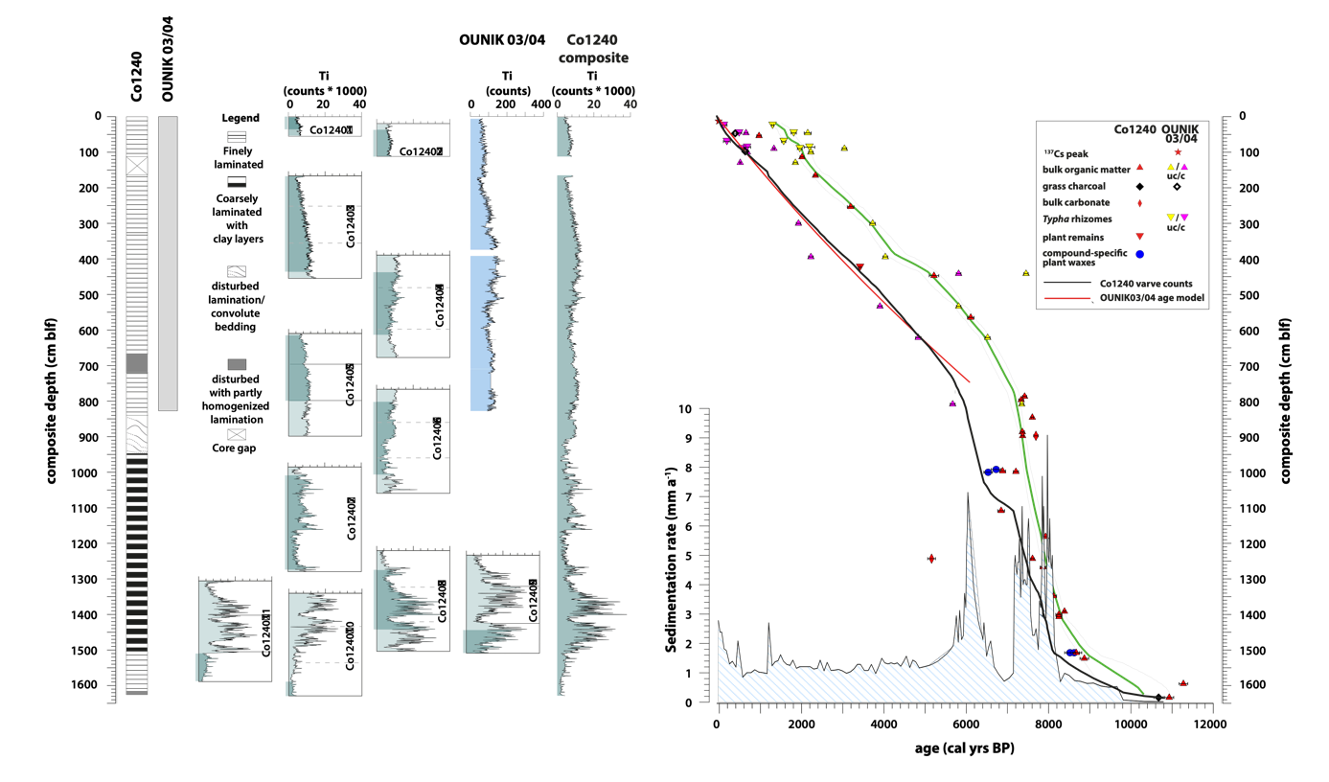

Extended Data Fig. 2: Core Co1240 stratigraphy, core composite based on Ti XRF analysis (core segments building the composite are highlighted with darker shading) and varve-counting-based chronology of core Co1240 (black line) with resultant sedimentation rates (shaded) compared with the chronology of core OUNIK03/04 ³² (red line). The green line indicates the increasing radiocarbon ages obtained for bulk organic matter, Typha rhizomes and bulk carbonate with depth; the difference from the varve-counting-based age-depth model indicates the associated reservoir effects on the radiocarbon ages.

Extended Data Fig. 3: Stratigraphic distribution of dominant fossil pollen [%] according to their preferred habitats in composite cores OUNIK03/04 and Co1240 from Lake Yoa, Ounianga Kebir, northern Chad.

Extended Data Fig. 4: Stratigraphic distribution of dominant fossil diatom taxa [%] according to their preferred habitats in composite cores OUNIK03/04 and Co1240 from Lake Yoa, Ounianga Kebir, northern Chad.

Extended Data Fig. 5: Transient simulation without (black line) and with AMOC correction (blue line) performed with the TRACE and LOVECLIM models.

Extended Data Fig. 6: Annual mean precipitation anomalies [mm/year] simulated by AWI-ESM between the preindustrial period (PI) for (top): 6 kyr BP and 8.2 kyr BP (without hosing) (bottom): between 6 kyr BP and 8.2 kyr BP (without hosing), and 8.2kyr BP with hosing and the pre-industrial period, respectively. The location of Lake Yoa is marked by a star.

Extended Data Table 1: Co1240 and OUNIK03/04 radiocarbon (¹⁴C) ages based on bulk organic matter (35), bulk carbonate (2), grass charcoal (3), compound-specific fatty acids (4) and plant material (6). Blf: below the lake floor; Corr. ¹⁴C Age: after subtracting the estimated lake-carbon reservoir effect of 1467±44 ¹⁴C years. SMM: Science Museum of Minnesota.

