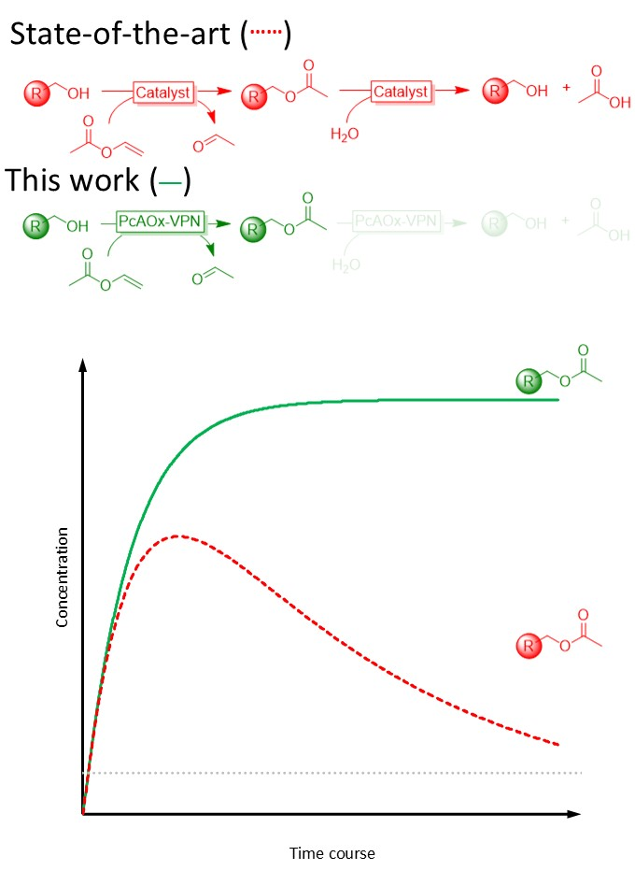
Scheme 1. Comparison of the time courses of classical transesterification time courses in aqueous media as e.g. catalysed by MsAct (red, dotted lines) and the here reported, quasi-irreversible transesterification using PcAOx-VPN (green, solid line). The grey line represents the thermodynamic equilibrium.
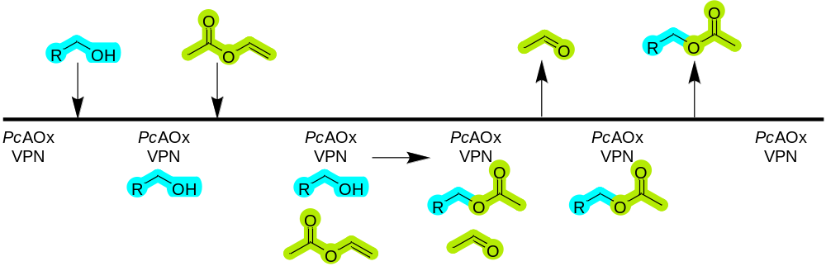
Scheme 2. Plausible ordered sequential mechanism of the PcAOx-VPN-catalysed transesterification reaction.

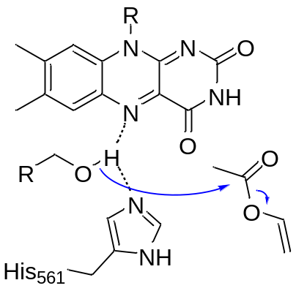
Scheme 3. Plausible role of FAD and His601 in the catalytic transesterification reaction. Hydrogen bonding of the alcohol substrate increases it nucleophilicity and facilitates the attack to the carbonyl-C-atom.

