Supplementary material

Materials and Methods
Molecular Biomarker detection
IDH mutation status, CDKN2A/B co-deletion status, and TERT promoter mutation status were detected via Sanger sequencing on the ABI 3500 Life Technology platform (Thermo Fisher Scientific, Waltham, MA, USA). EGFR amplification, alterations in chromosome 7/10, and 1p/19q deletions were determined using fluorescence in situ hybridization (FISH). Bisulfite modification of extracted DNA from glioma was performed using the Bisul Flash™ DNA Modification Kit (Epigentek, Farmingdale, New York, NY, USA), and PCR amplification for MGMTmet status was conducted using the DRR006 Kit (Takara, Kusatsu, Shiga, Japan).
MRI image acquisition and preprocessing
MRI scanning parameters were: T2WI-FLAIR (TR 6800-8000ms, TE 80-95ms, TI 2000ms); CE-T1WI (TR 195-240ms, TE 4.8-8.6ms); layer thickness 5.0mm, layer spacing 1.5mm, FOV 240mm×240mm, matrix 256×256. Contrast-enhanced sequences utilized intravenous gadolinium contrast agent (0.1mmol/kg).
Radiomics feature extraction
The extracted features encompassing seven categories: first-order, shape, Gray-Level Co-Occurrence Matrix (GLCM), Gray-Level Run-Length Matrix (GLRLM), Gray-Level Size Zone Matrix (GLSZM), Gray Level Dependence Matrix (GLDM), and Neighborhood Gray Tone Difference Matrix (NGTDM) features.

Supplementary figure

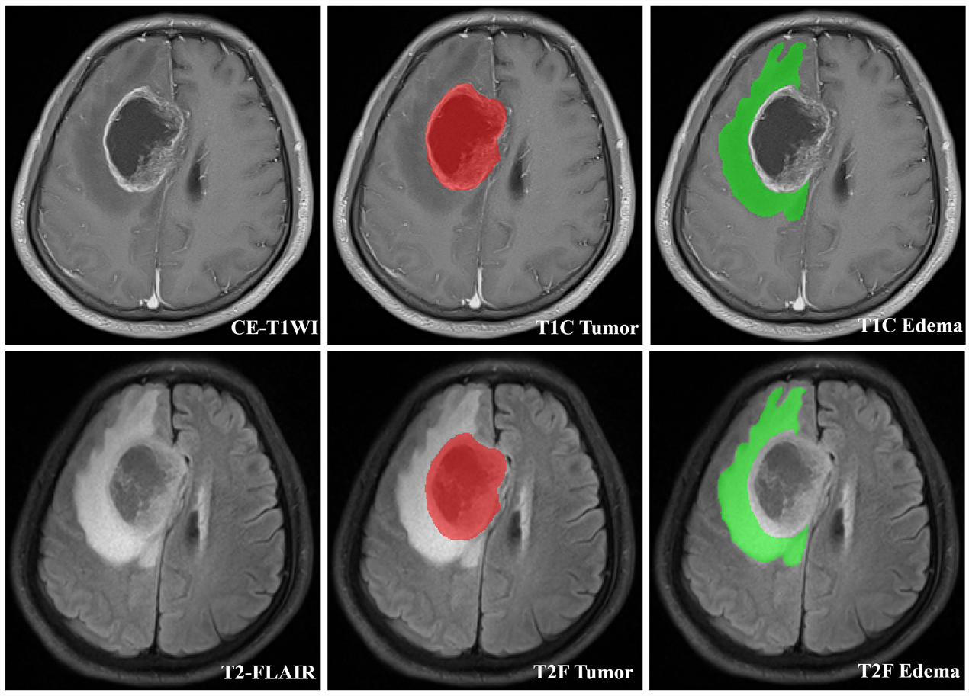
Supplementary Figure 1. ROI segmentation of T1C tumor, T1C edema and T2F tumor. T1C: contrast-enhanced T1-weighted imaging; T2F: T2-weighted imaging fluid attenuated inversion recovery.

