Supplementary Results for:
Empathic stress in the family: Mimicry boosts subjective and parasympathetic empathic stress in adolescents
Jost Ulrich Blasberg¹, Philipp Kanske², Veronika Engert^{1,3,4}
¹Institute for Psychosocial Medicine, Psychotherapy and Psychooncology, Jena University Hospital, Friedrich-Schiller University, Jena, Germany
² Clinical Psychology and Behavioral Neuroscience, Faculty of Psychology, Technische Universität, Dresden, Dresden, Germany
³German Center for Mental Health (DZPG), partner site Halle-Jena-Magdeburg
⁴Center for Intervention and Research in adaptive and maladaptive brain Circuits underlying mental health (C-I-R-C), Halle-Jena-Magdeburg, Germany

Figure S1. Scree plot for exploratory factor analysis including all AU sync times.
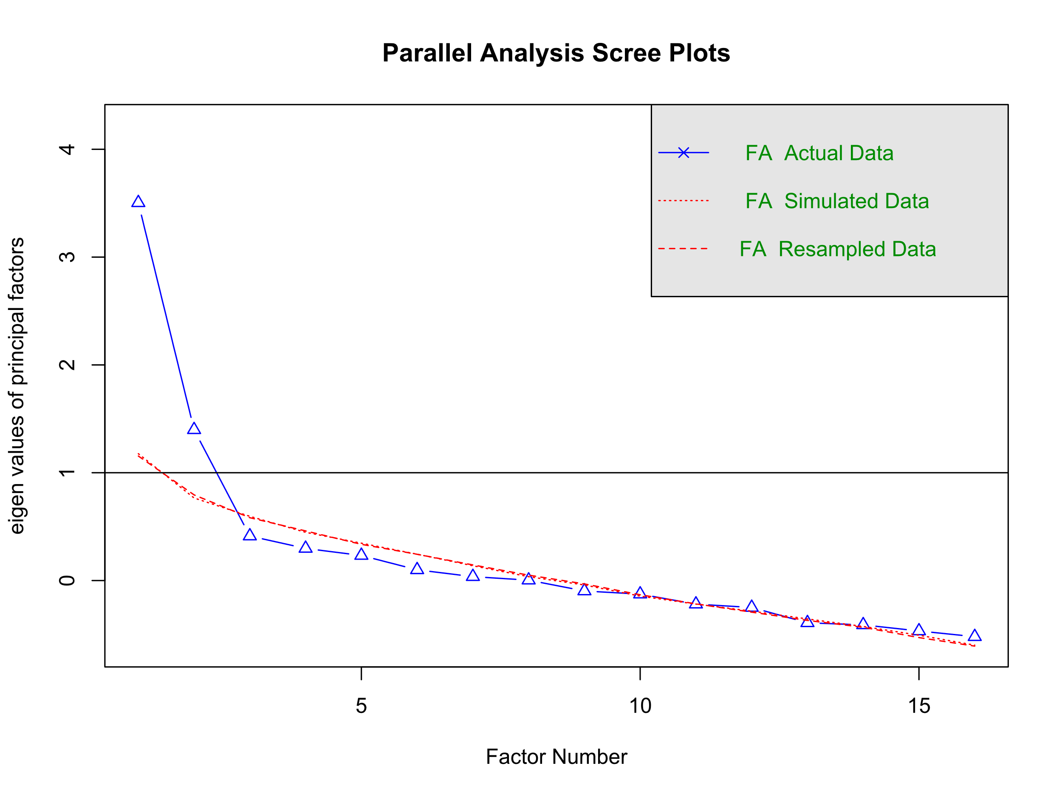
Note. Parallel analysis reveals a two-factor solution for an SEM including the sixteen AU sync times as observed variables.

Figure S2. Correlations between action unit sync times across participants.
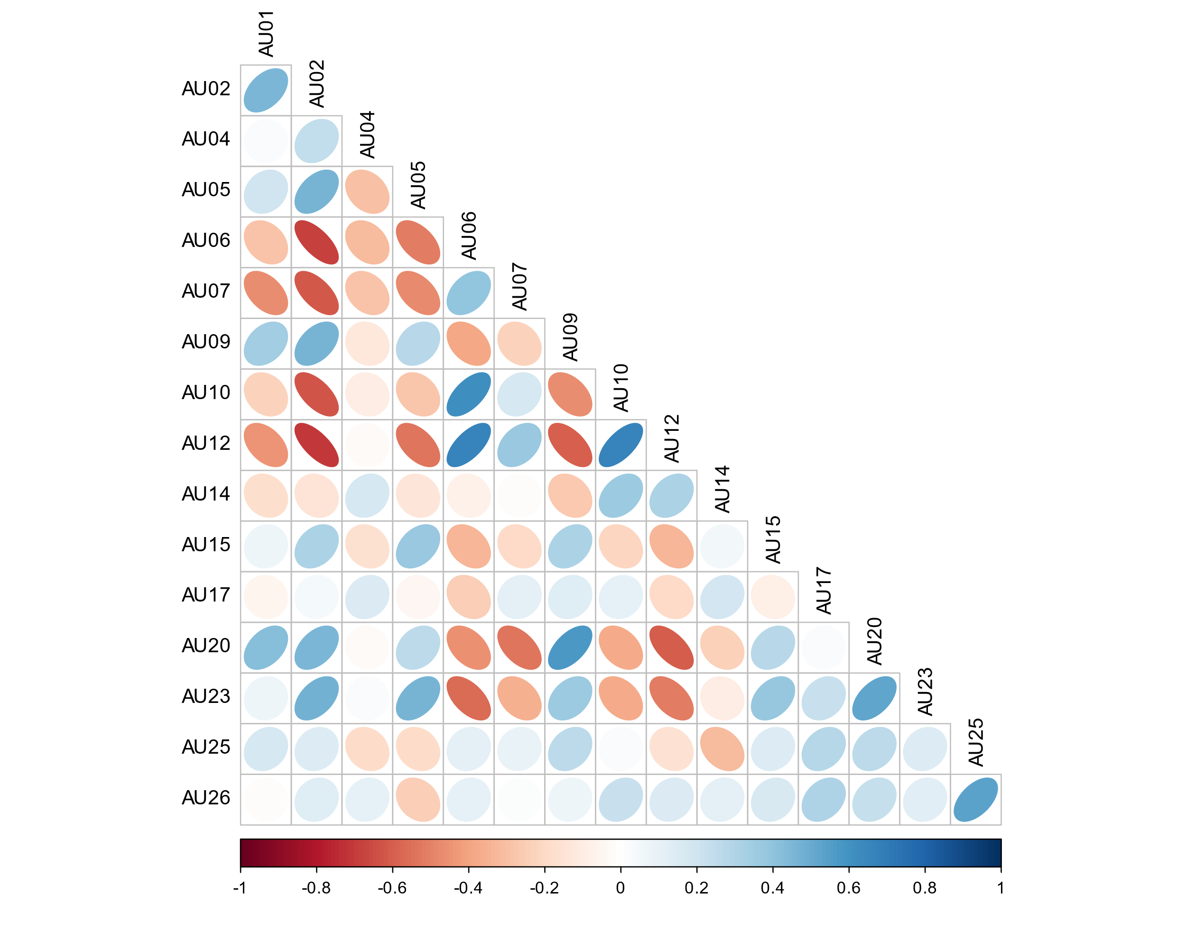
Note. Positive (blue) and negative (red) correlations between action unit sync times.

Table S3. Multiple linear regressions on adolescent cortisol, heart rate, HF-HRV, state empathic concern and state personal distress AUCi.
 | Adolescent AUCi Cortisol
Coefficient | Estimates | CI | p
(Intercept) | -19.00 | -26.40 – -11.61 | <0.001
AUCi cortisol (parent) | -0.58 | -8.33 – 7.17 | 0.882
Mimicry (lf1) | -2.06 | -10.20 – 6.07 | 0.614
Mimicry (lf2) | -1.09 | -9.21 – 7.04 | 0.790
AUCi (parent)—Mimicry (lf1) | -7.69 | -15.78 – 0.39 | 0.062
AUCi (parent)—Mimicry (lf2) | 5.83 | -2.17 – 13.83 | 0.150
Observations | 70
R² / R² adjusted | 0.065 / -0.008
AIC | 686.071
 | Adolescent AUCi Heart rate
Coefficient | Estimates | CI | p
(Intercept) | 1.22 | -0.86 – 3.30 | 0.241
AUCi heart-rate (parent) | 2.73 | 0.29 – 5.16 | 0.029
Mimicry (lf1) | 0.20 | -2.07 – 2.46 | 0.860
Mimicry (lf2) | -0.45 | -2.60 – 1.69 | 0.670
AUCi (parent)—Mimicry (lf1) | -1.78 | -4.35 – 0.78 | 0.166
AUCi (parent)—Mimicry (lf2) | 0.83 | -2.43 – 4.08 | 0.609
Observations | 37
R² / R² adjusted | 0.157 / 0.021
AIC | 245.132
 | Adolescent AUCi HF-HRV
Coefficient | Estimates | CI | p
(Intercept) | 21.69 | -21.72 – 65.11 | 0.316
AUCi HF-HRV (parent) | -108.19 | -166.62 – -49.77 | 0.001
Mimicry (lf1) | -51.01 | -99.53 – -2.50 | 0.040
Mimicry (lf2) | -4.94 | -43.90 – 34.01 | 0.797
AUCi (parent)—Mimicry (lf1) | 93.73 | 40.00 – 147.46 | 0.001
AUCi (parent)—Mimicry (lf2) | -18.02 | -78.70 – 42.66 | 0.549
Observations | 37
R² / R² adjusted | 0.357 / 0.254
AIC | 459.677
 | Adolescent AUCi STAI
Coefficient | Estimates | CI | p
(Intercept) | 116.81 | 16.27 – 217.35 | 0.023
AUCi STAI (parent) | 51.37 | -59.15 – 161.89 | 0.357
Mimicry (lf1) | 128.71 | 22.06 – 235.37 | 0.019
Mimicry (lf2) | 4.57 | -107.68 – 116.81 | 0.935
AUCi (parent)—Mimicry (lf1) | 5.87 | -134.31 – 146.05 | 0.934
AUCi (parent)—Mimicry (lf2) | 7.54 | -97.17 – 112.25 | 0.886
Observations | 70
R² / R² adjusted | 0.107 / 0.038
AIC | 1050.995
 | Adolescent AUCi Empathic Concern
Coefficient | Estimates | CI | p
(Intercept) | -72.96 | -161.65 – 15.73 | 0.105
Mimicry (lf1) | 63.19 | -32.09 – 158.48 | 0.190
Mimicry (lf2) | -87.74 | -183.03 – 7.54 | 0.070
Observations | 71
R² / R² adjusted | 0.054 / 0.027
AIC | 1047.857
 | Adolescent AUCi Personal Distress
Coefficient | Estimates | CI | p
(Intercept) | 81.17 | -34.25 – 196.59 | 0.165
Mimicry (lf1) | 101.76 | -20.55 – 224.07 | 0.101
Mimicry (lf2) | -29.17 | -152.33 – 93.99 | 0.638
Observations | 69
R² / R² adjusted | 0.040 / 0.011
AIC | 1052.780

