Contrasting recovery of metagenome-assembled genomes and derived microbial communities from lizard fecal and cloacal samples

Mauricio Hernández, Jorge Langa, Ostaizka Aizpurua, Yendi E. Navarro-Noya, Antton Alberdi

Supplementary Figures

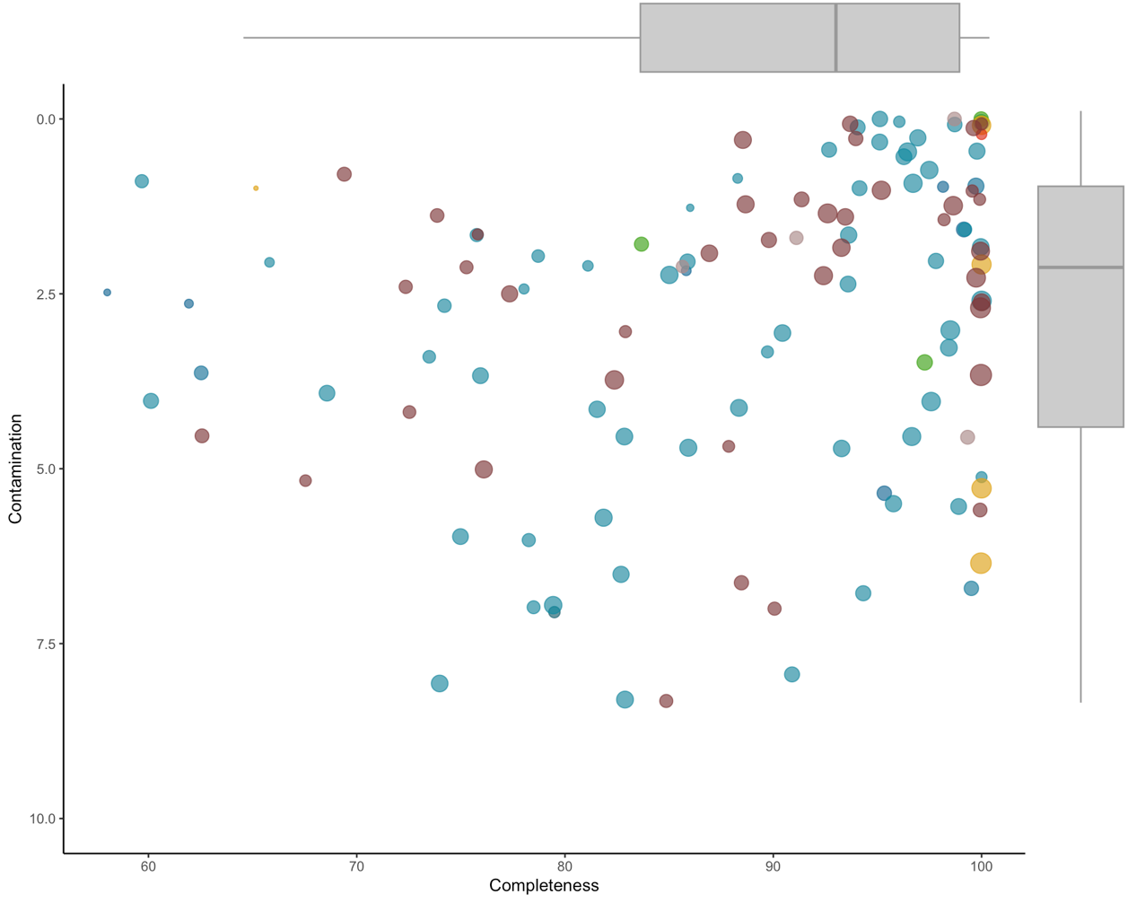
Supplementary Figure S1. Completeness and contamination values of the 127 reconstructed MAGs, as assessed by Checkm2. Colors indicate the phylum (see Figure 1 for the color-code), while size indicates the length of each genome.

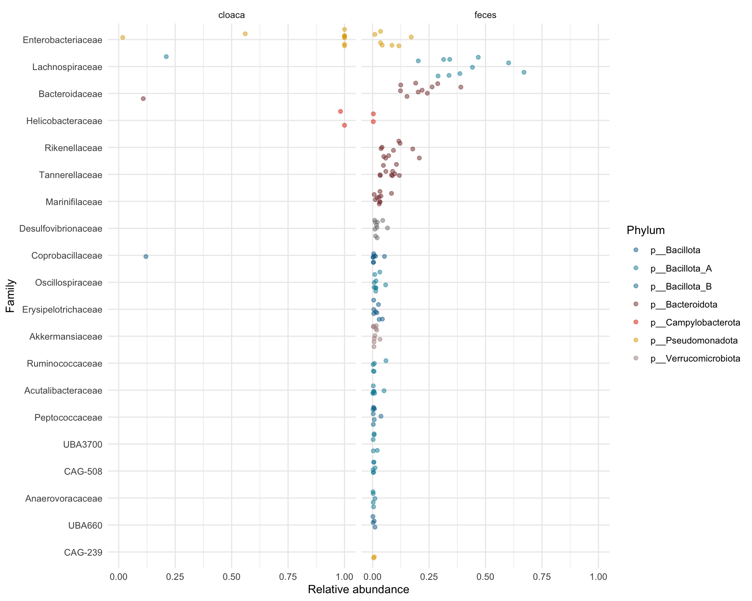
Supplementary Figure S2. Relative abundance of bacterial families between fecal samples and cloacal swabs.

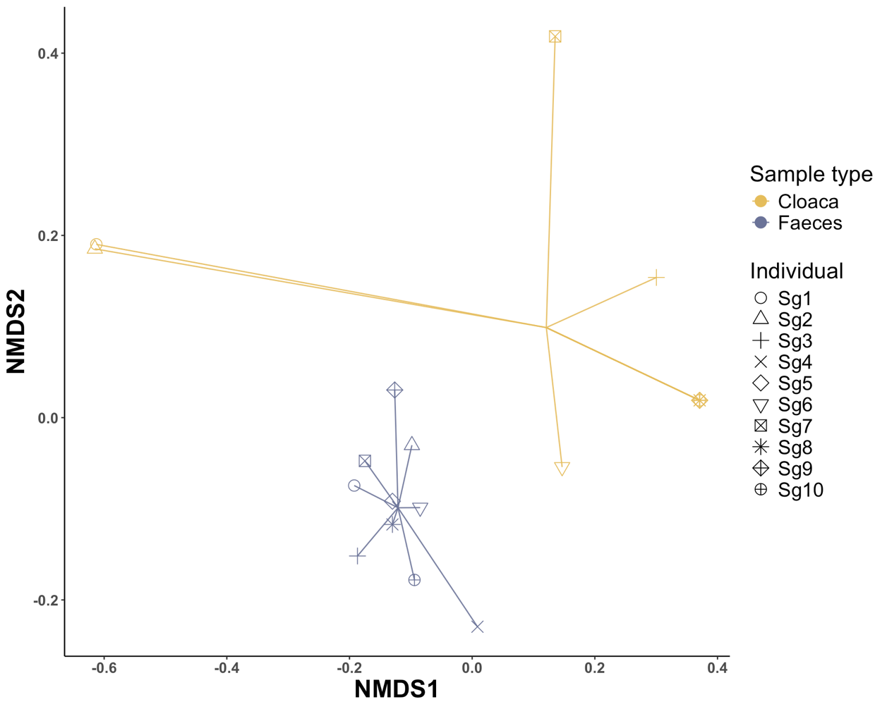
Supplementary Figure S3. Neutral beta diversity ordination.

