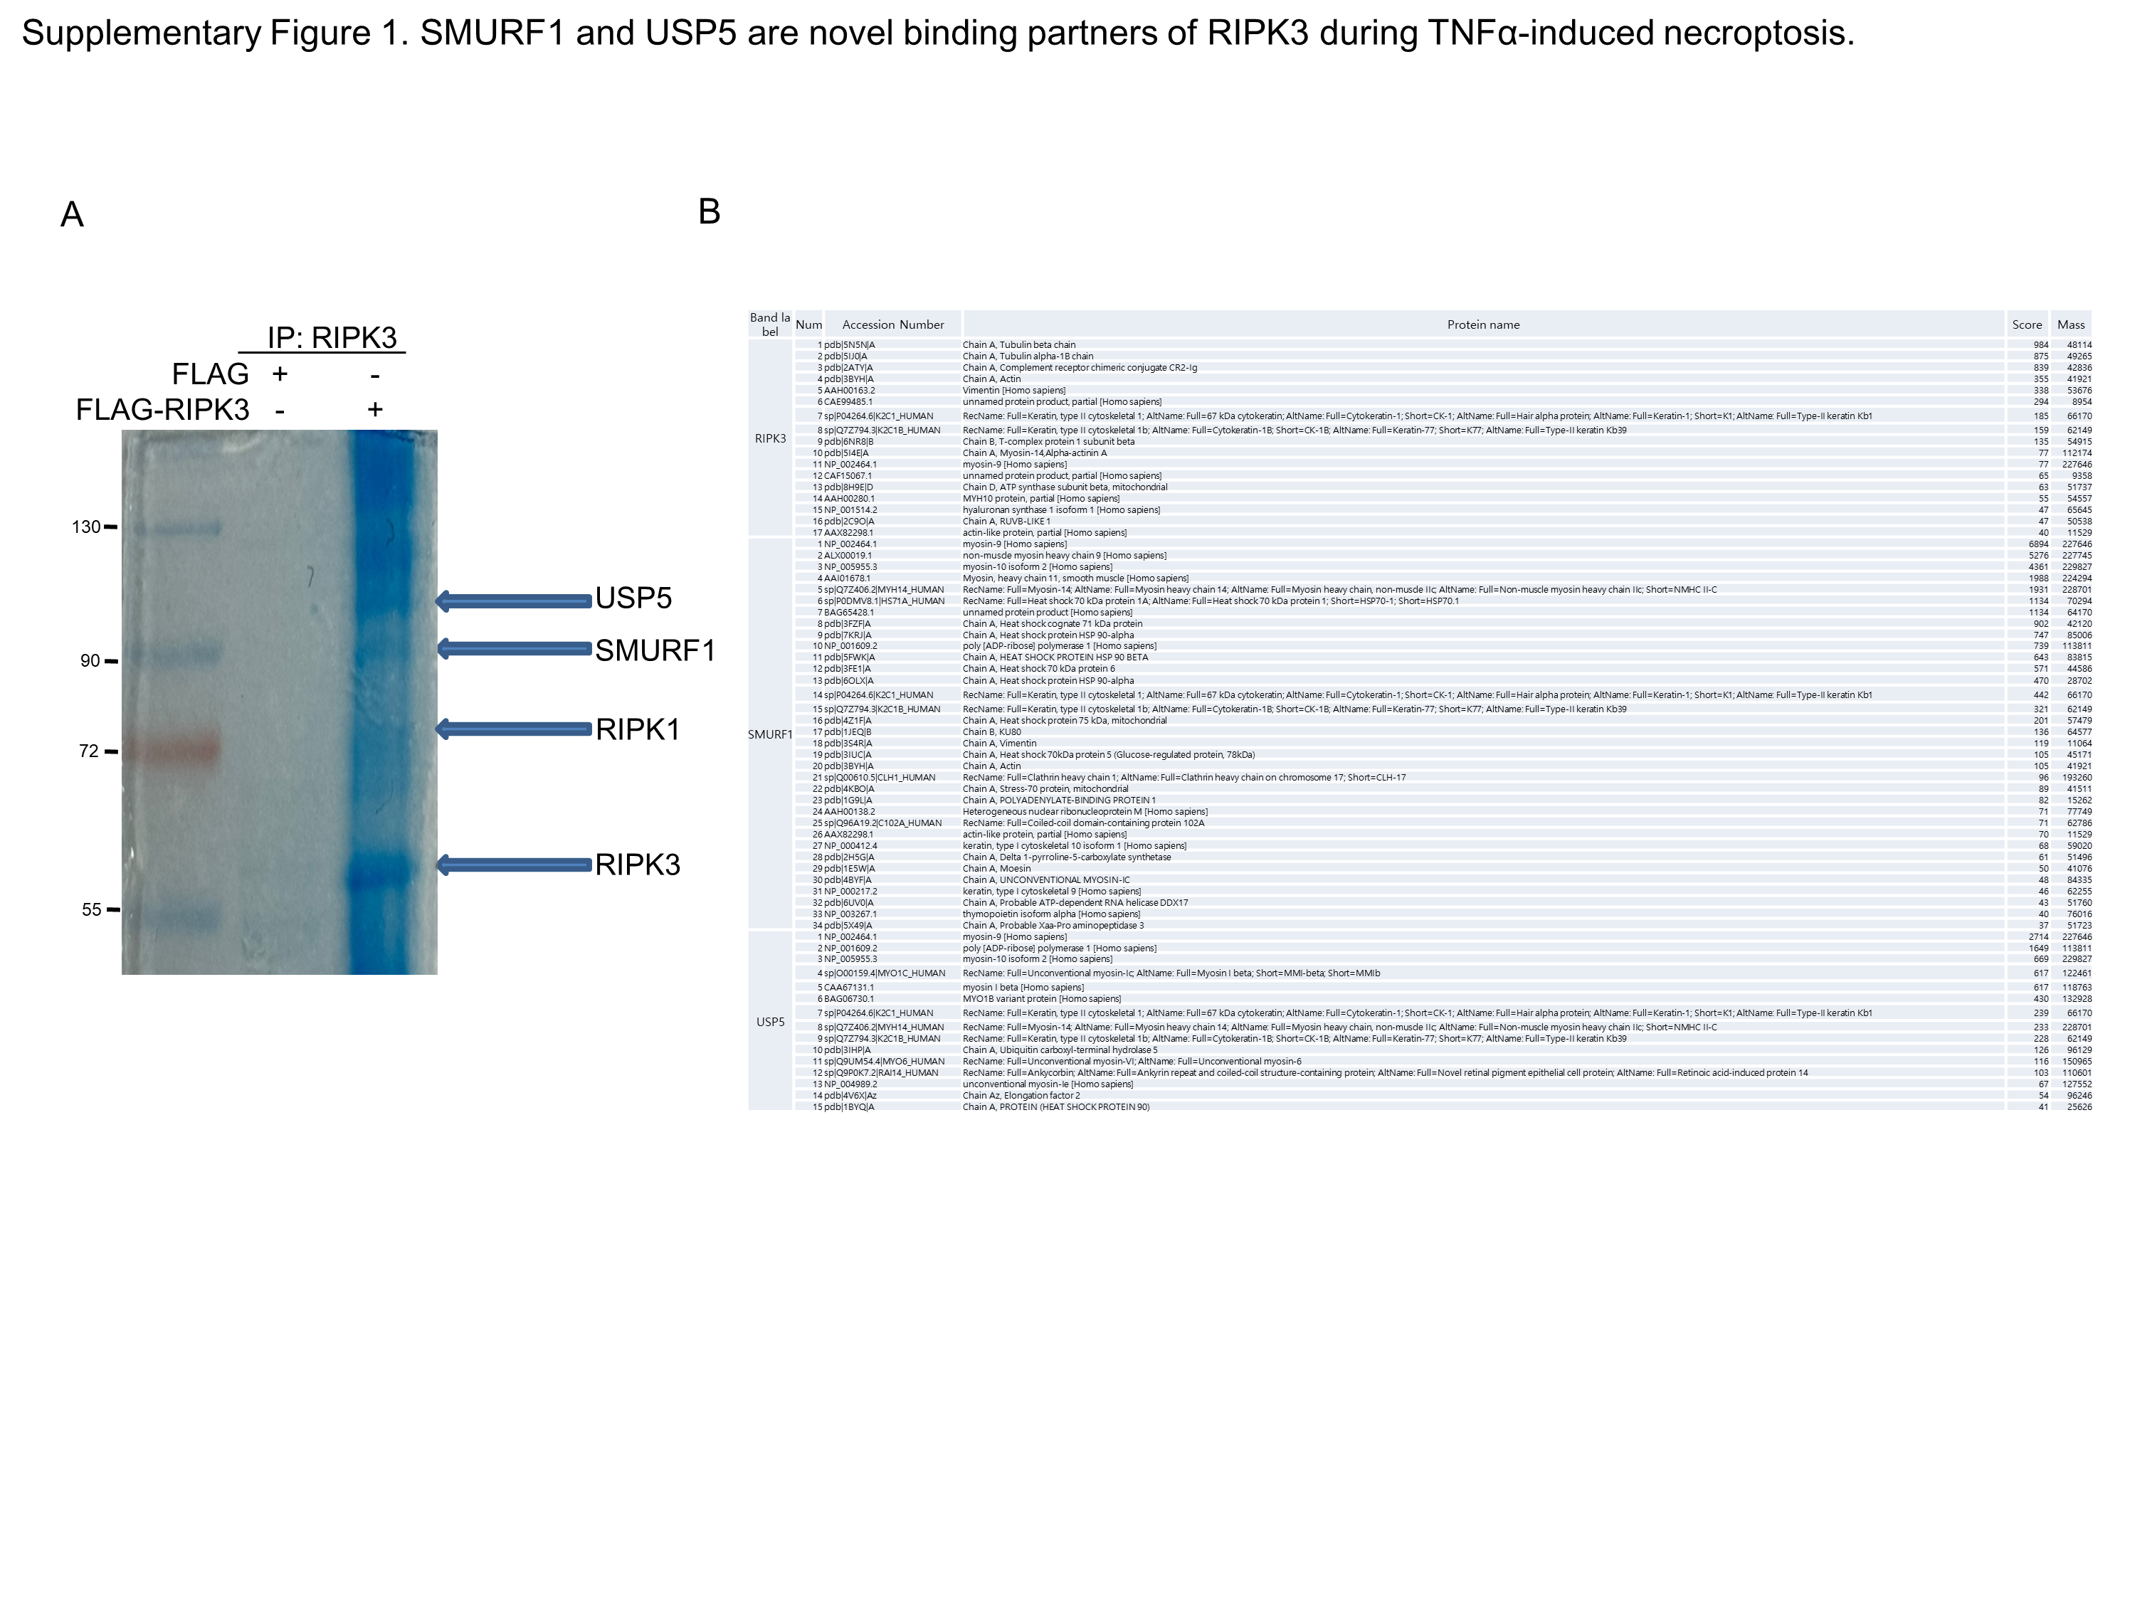

Supplementary Figure 1. SMURF1 and USP5 are novel binding partners of RIPK3 during TNFα-induced necroptosis.
(A) pcDNA3-FLAG and pcDNA3-FLAG-RIPK3 were overexpressed in HEK 293T cells using PEI in ten separate 100 mm dishes. The cells were then collected, and immunoprecipitation was performed with a RIPK3 antibody. Following this, Coomassie brilliant blue (CBB) staining revealed bands corresponding to the sizes of SMURF1 and USP5. (B) This panel shows the results from IP Mass Spectrometry, identifying the proteins that bind to RIPK3.

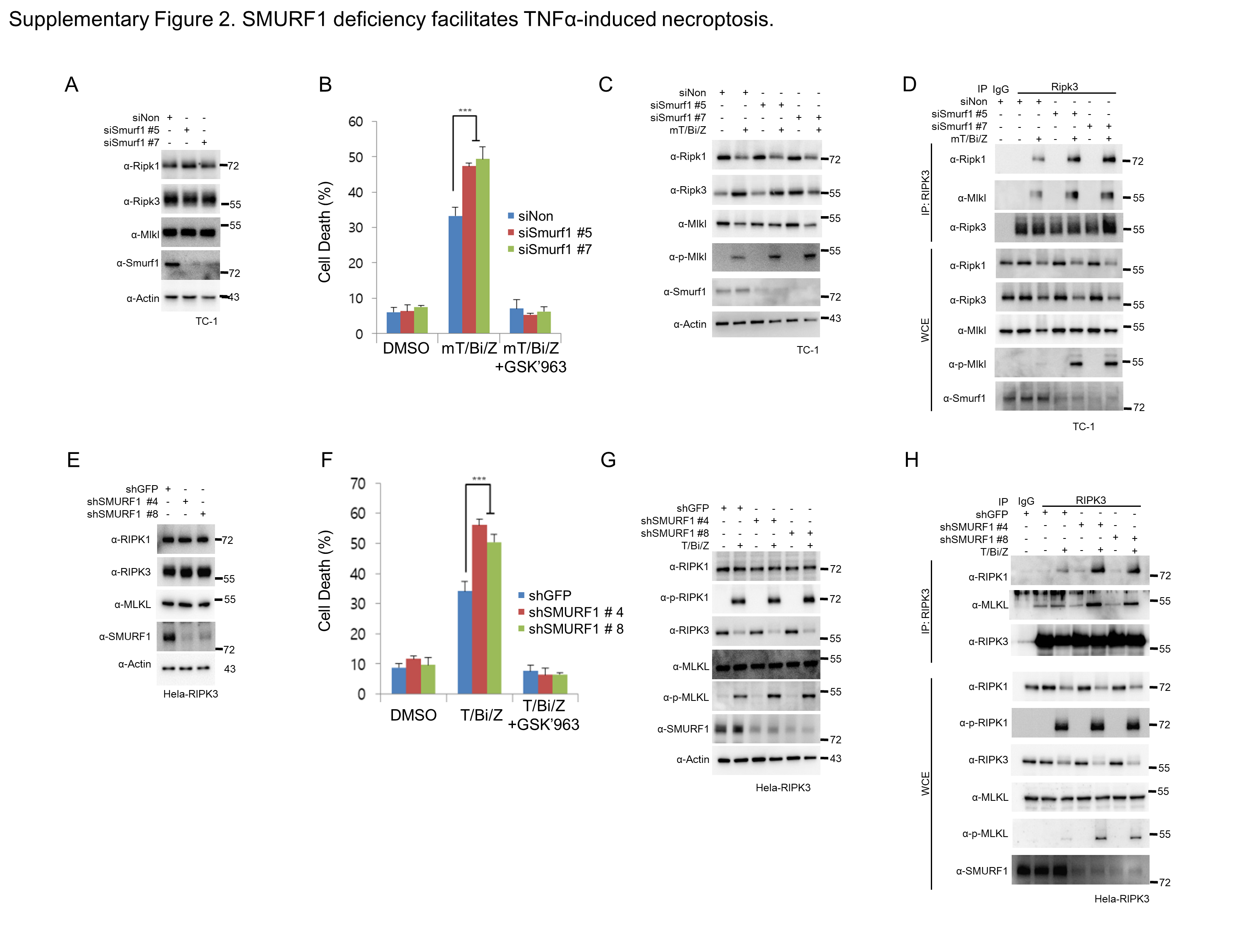

Supplementary Figure 2. SMURF1 deficiency facilitates TNFα-induced necroptosis.
(A) TC-1 cells depleted of SMURF1 using the indicated siRNAs for Smurf1 KD cell lines. The expression levels of Ripk1, Ripk3, Mlkl, and Smurf1 in each cell line were analyzed by western blotting. (B) TC-1 cells depleted of SMURF1 using the indicated siRNAs were treated with T/Bi/Z in the presence or absence of 0.1 μM GSK'963 for 2 hours. The cells were harvested and stained with Annexin V-FITC, and the proportion of necroptotic cells in each cell line was measured using flow cytometry (n = 3). (C) Smurf1 KD and control TC-1 cells were treated with T/Bi/Z to induce necroptosis. GSK'963 was used to confirm that this cell death is necroptosis. Cells were harvested at the indicated time points and analyzed by western blotting. (D) Smurf11 KD and control TC-1 cells treated with T/Bi/Z were lysed after 2 hours. The necrosome was pulled down using an anti-Ripk3 antibody and protein-G agarose beads. The protein-bead conjugate was washed and analyzed by western blotting to assess the assembly of the Ripk1-Ripk33-Mlkl complex. (E) HeLa-RIPK3 cells were transduced with lentivirus to generate stable SMURF1-knockdown (KD) cell lines. The expression levels of RIPK1, RIPK3, MLKL, and SMURF1 in each cell line were analyzed by western blotting. (F) HeLa-RIPK3 cells depleted of SMURF1 using the indicated shRNAs were treated with T/Bi/Z in the presence or absence of 0.1 μM GSK'963 for 3 hours. The cells were harvested and stained with PI, and the proportion of necroptotic cells in each cell line was measured using flow cytometry (n = 3). (G) SMURF1 KD and control HeLa-RIPK3 cells were treated with T/Bi/Z to induce necroptosis. GSK'963 was used to confirm that this cell death is necroptosis. Cells were harvested at the indicated time points and analyzed by western blotting. (H) SMURF1 KD and control HeLa-RIPK3 cells treated with T/Bi/Z were lysed after 3 hours. The necrosome was pulled down using an anti-RIPK3 antibody and protein-G agarose beads. The protein-bead conjugate was washed and analyzed by western blotting to assess the assembly of the RIPK1-RIPK3-MLKL complex.
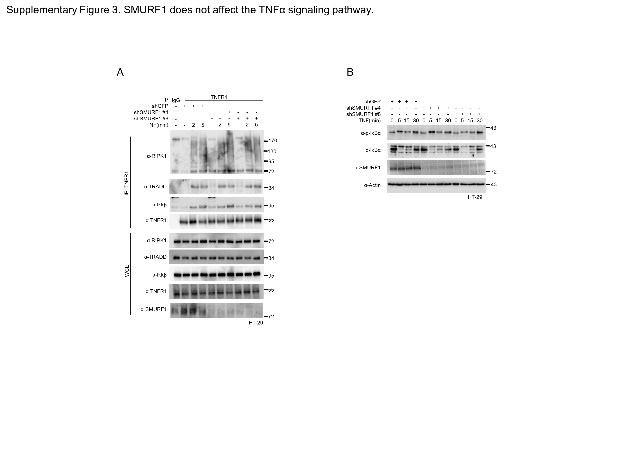
Supplementary Figure 3. SMURF1 does not affect the TNFα signaling pathway.
(A) HT-29 cells were transduced with lentivirus to generate stable SMURF1-KD cell lines and then with TNF-α for the indicated times. After treatment, the cells were analysed using immunoblotting. (B)HT-29 cells were transduced with lentivirus to generate stable SMURF1-KD cell lines were treated with TNFα for the indicated times. After treatment, the cells were analysed by immunoblotting.

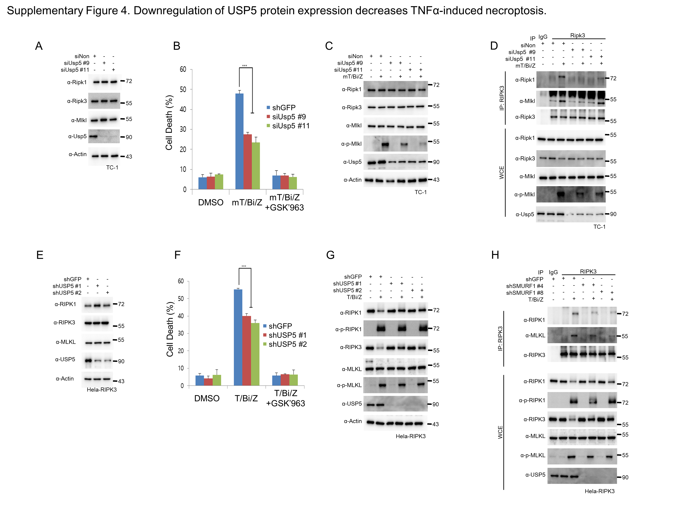
Supplementary Figure 4. Downregulation of USP5 protein expression decreases TNFα-induced necroptosis.
(A) TC-1 cells depleted of Usp5 using the indicated siRNAs for USP5 KD cell lines. The expression levels of Ripk1, Ripk3, Mlkl, and Usp5 in each cell line were analyzed by western blotting. (B) TC-1 cells depleted of USP5 using the indicated siRNAs were treated with T/Bi/Z in the presence or absence of 0.1 μM GSK'963 for 2 hours. The cells were harvested and stained with Annexin V-FITC, and the proportion of necroptotic cells in each cell line was measured using flow cytometry (n = 3). (C) Usp5 KD and control TC-1 cells were treated with T/Bi/Z to induce necroptosis. GSK'963 was used to confirm that this cell death is necroptosis. Cells were harvested at the indicated time points and analyzed by western blotting. (D) Usp5 KD and control TC-1 cells treated with T/Bi/Z were lysed after 2 hours. The necrosome was pulled down using an anti-Ripk3 antibody and protein-G agarose beads. The protein-bead conjugate was washed and analyzed by western blotting to assess the assembly of the Ripk1-Ripk3-Mlkl complex. (E) HeLa-RIPK3 cells were transduced with lentivirus to generate stable USP5-knockdown (KD) cell lines. The expression levels of RIPK1, RIPK3, MLKL, and USP5 in each cell line were analyzed by western blotting. (F) HeLa-RIPK3 cells depleted of USP5 using the indicated shRNAs were treated with T/Bi/Z in the presence or absence of 0.1 μM GSK'963 for 3 hours. The cells were harvested and stained with PI, and the proportion of necroptotic cells in each cell line was measured using flow cytometry (n = 3). (G) USP5 KD and control HeLa-RIPK3 cells were treated with T/Bi/Z to induce necroptosis. GSK'963 was used to confirm that this cell death is necroptosis. Cells were harvested at the indicated time points and analyzed by western blotting. (H) USP5 KD and control HeLa-RIPK3 cells treated with T/Bi/Z were lysed after 3 hours. The necrosome was pulled down using an anti-RIPK3 antibody and protein-G agarose beads. The protein-bead conjugate was washed and analyzed by western blotting to assess the assembly of the RIPK1-RIPK3-MLKL complex.

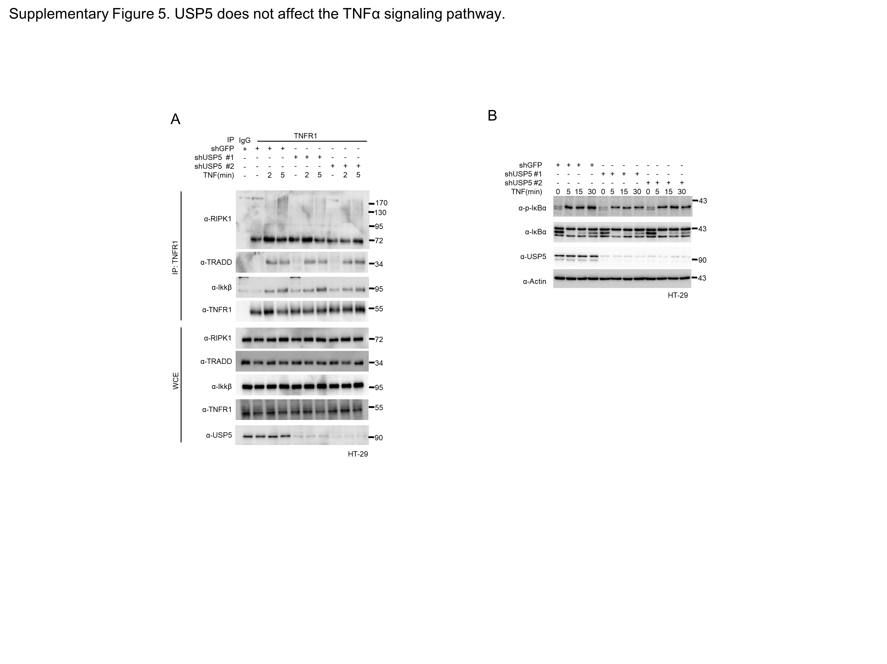

Supplementary Figure 5. USP5 does not affect the TNFα signaling pathway.
(A) HT-29 cells were transduced with lentivirus to generate stable USP5-KD cell lines and then treated with TNF-α for the indicated times. After treatment, the cells were analyzed using immunoblotting. (B) HT-29 cells transduced with lentivirus to generate stable USP5-KD cell lines were treated with TNF-α for the indicated times. After treatment, the cells were analyzed by immunoblotting.
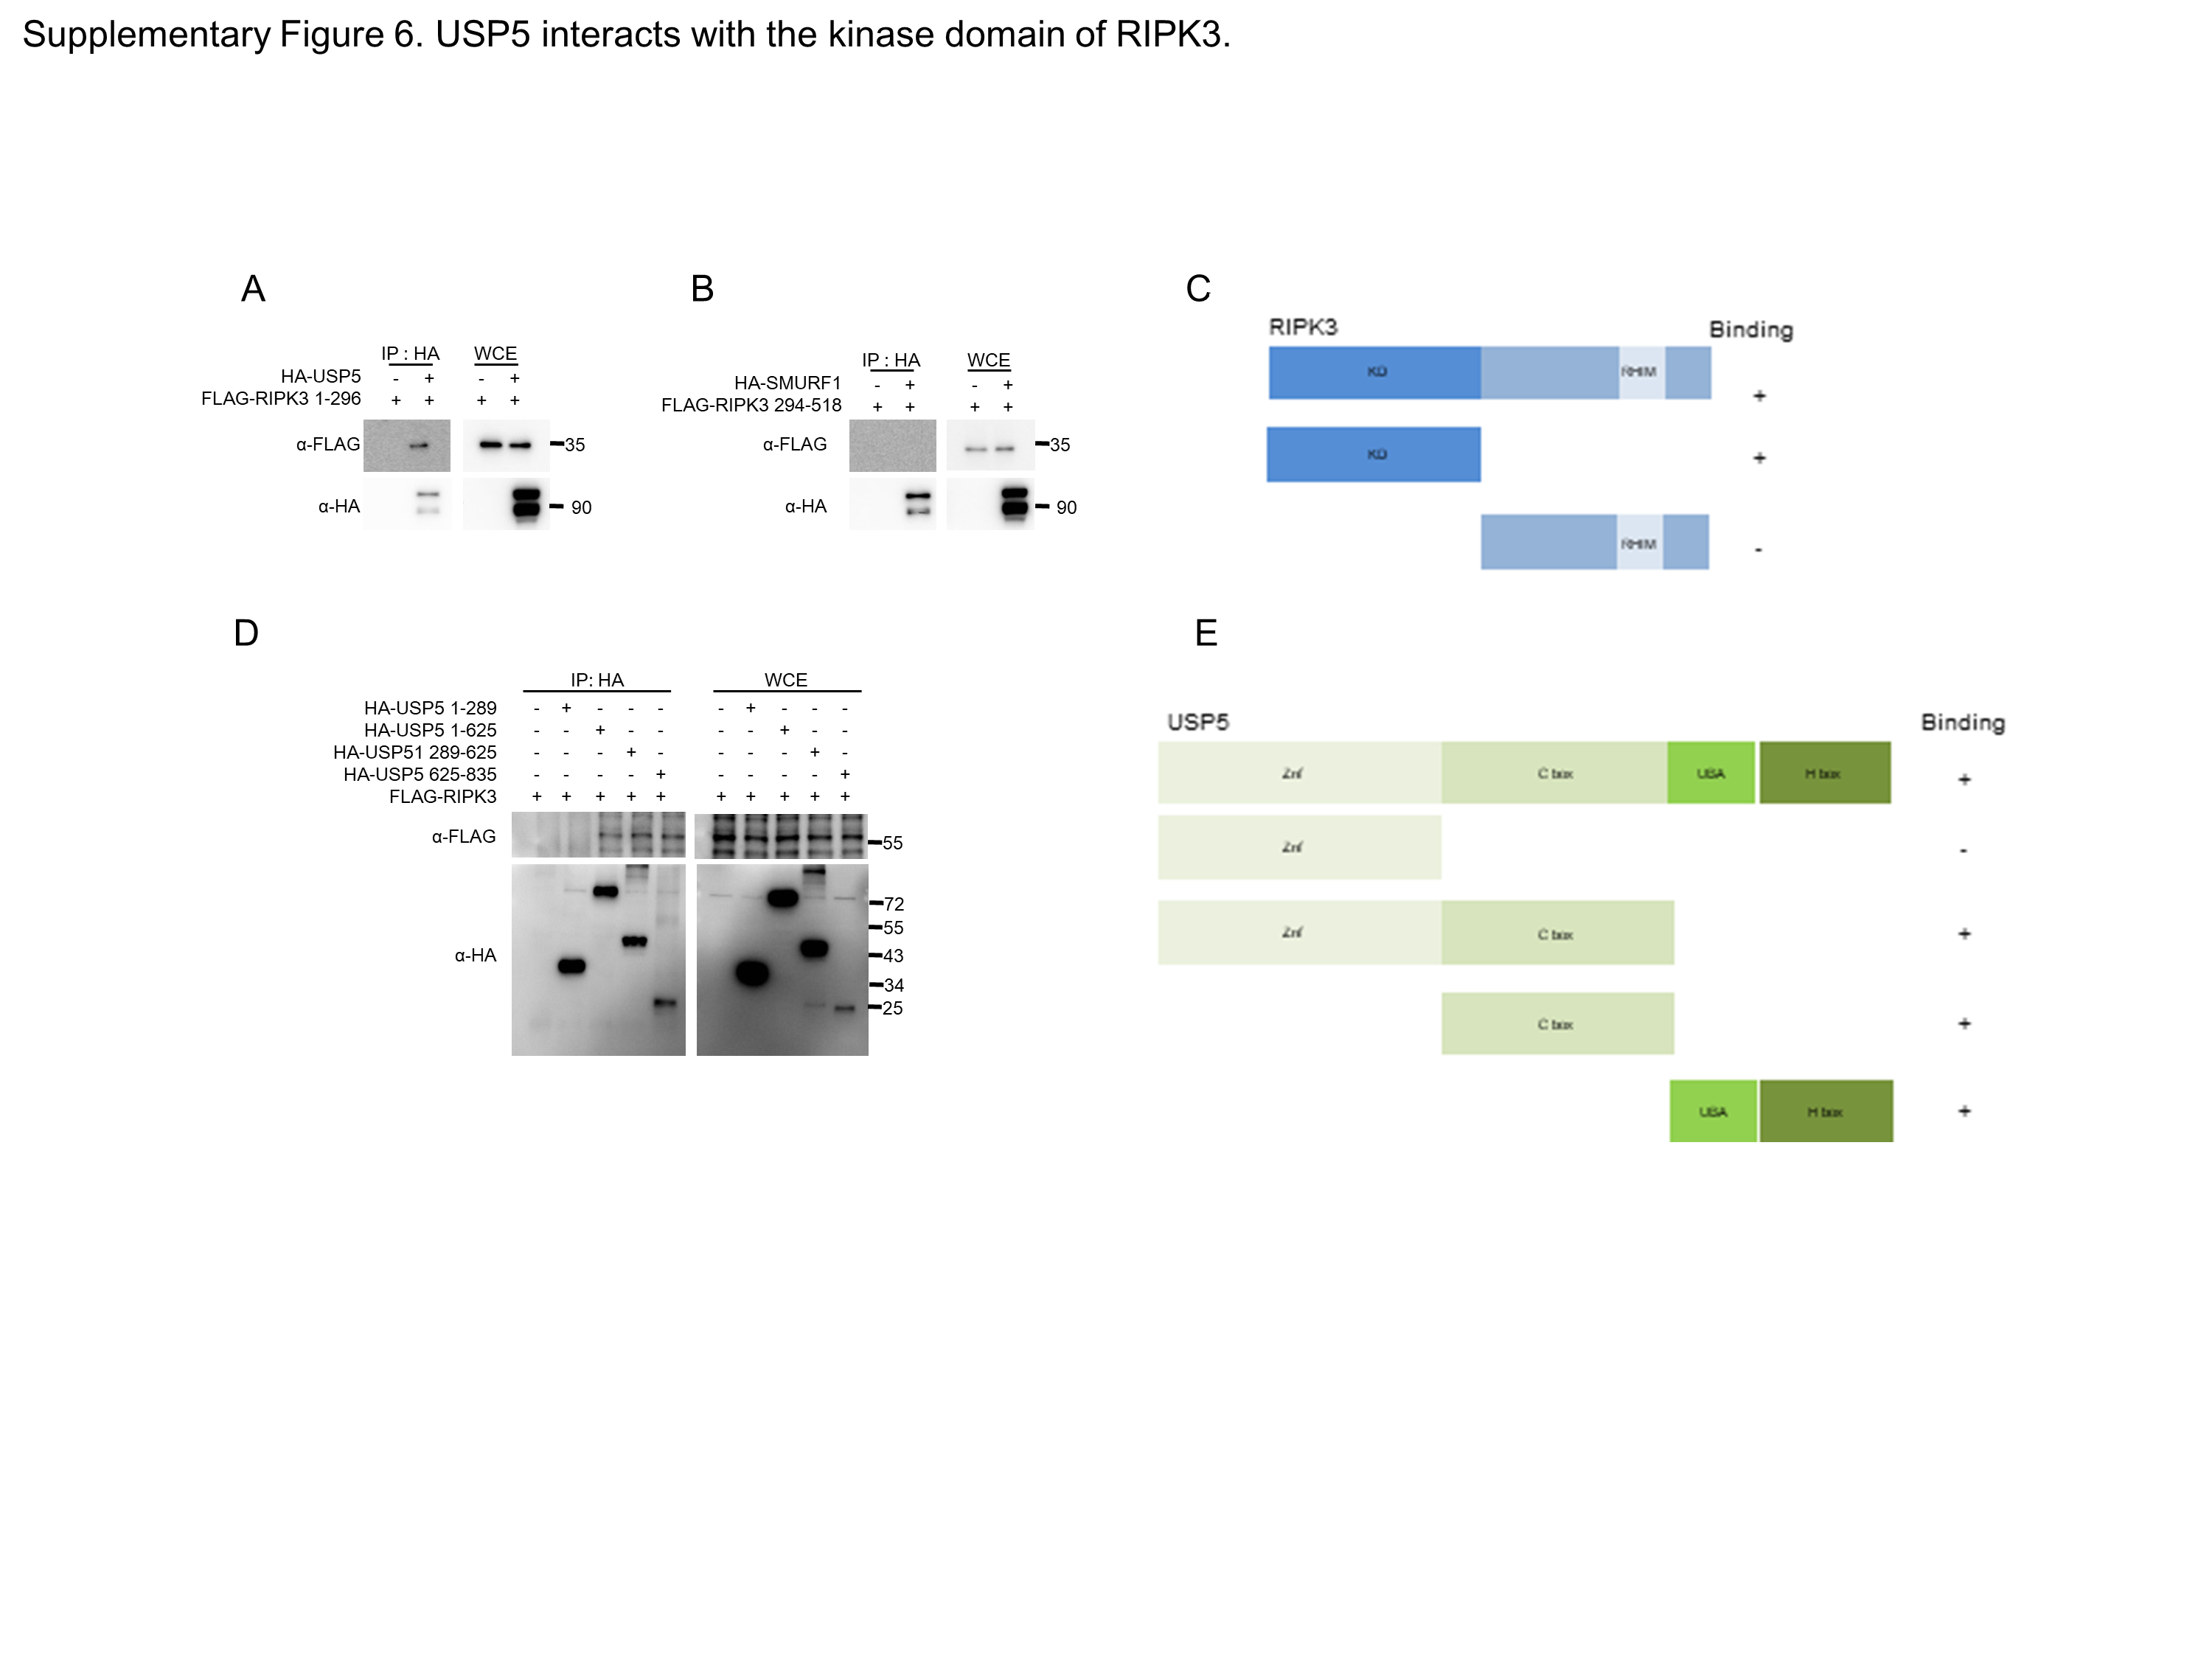
Supplementary Figure 6. USP5 interacts with the kinase domain of RIPK3.
(A, B) pcDNA3-FLAG-RIPK3 (1-296, kinase domain; 294-518, RHIM domain) and pcDNA3-HA-USP5 were overexpressed in HEK 293T cells via PEI transfection. Cells were lysed and incubated with anti-HA antibodies and protein-G agarose beads to pull down HA-SMURF1. The protein-bead conjugate was washed and analyzed by SDS-PAGE. The immunoprecipitation of the SMURF1 and RIPK3 domains was assessed using western blotting. (C) This is a schematic diagram of RIPK3 showing the binding domain for USP5. (D) pcDNA3-HA-USP5 (1-289, 1-625, 289-625, 625-835) and pcDNA3-FLAG-RIPK3 were overexpressed in HEK 293T cells via PEI transfection. Cells were lysed and incubated with anti-HA antibodies and protein-G agarose beads to pull down the specific domain of HA-SMURF1. The protein-bead conjugate was washed and analyzed by SDS-PAGE. The immunoprecipitation of the RIPK3 and USP5domains was assessed using western blotting. (E) This is a schematic diagram of USP5 showing the binding domain for RIPK3.

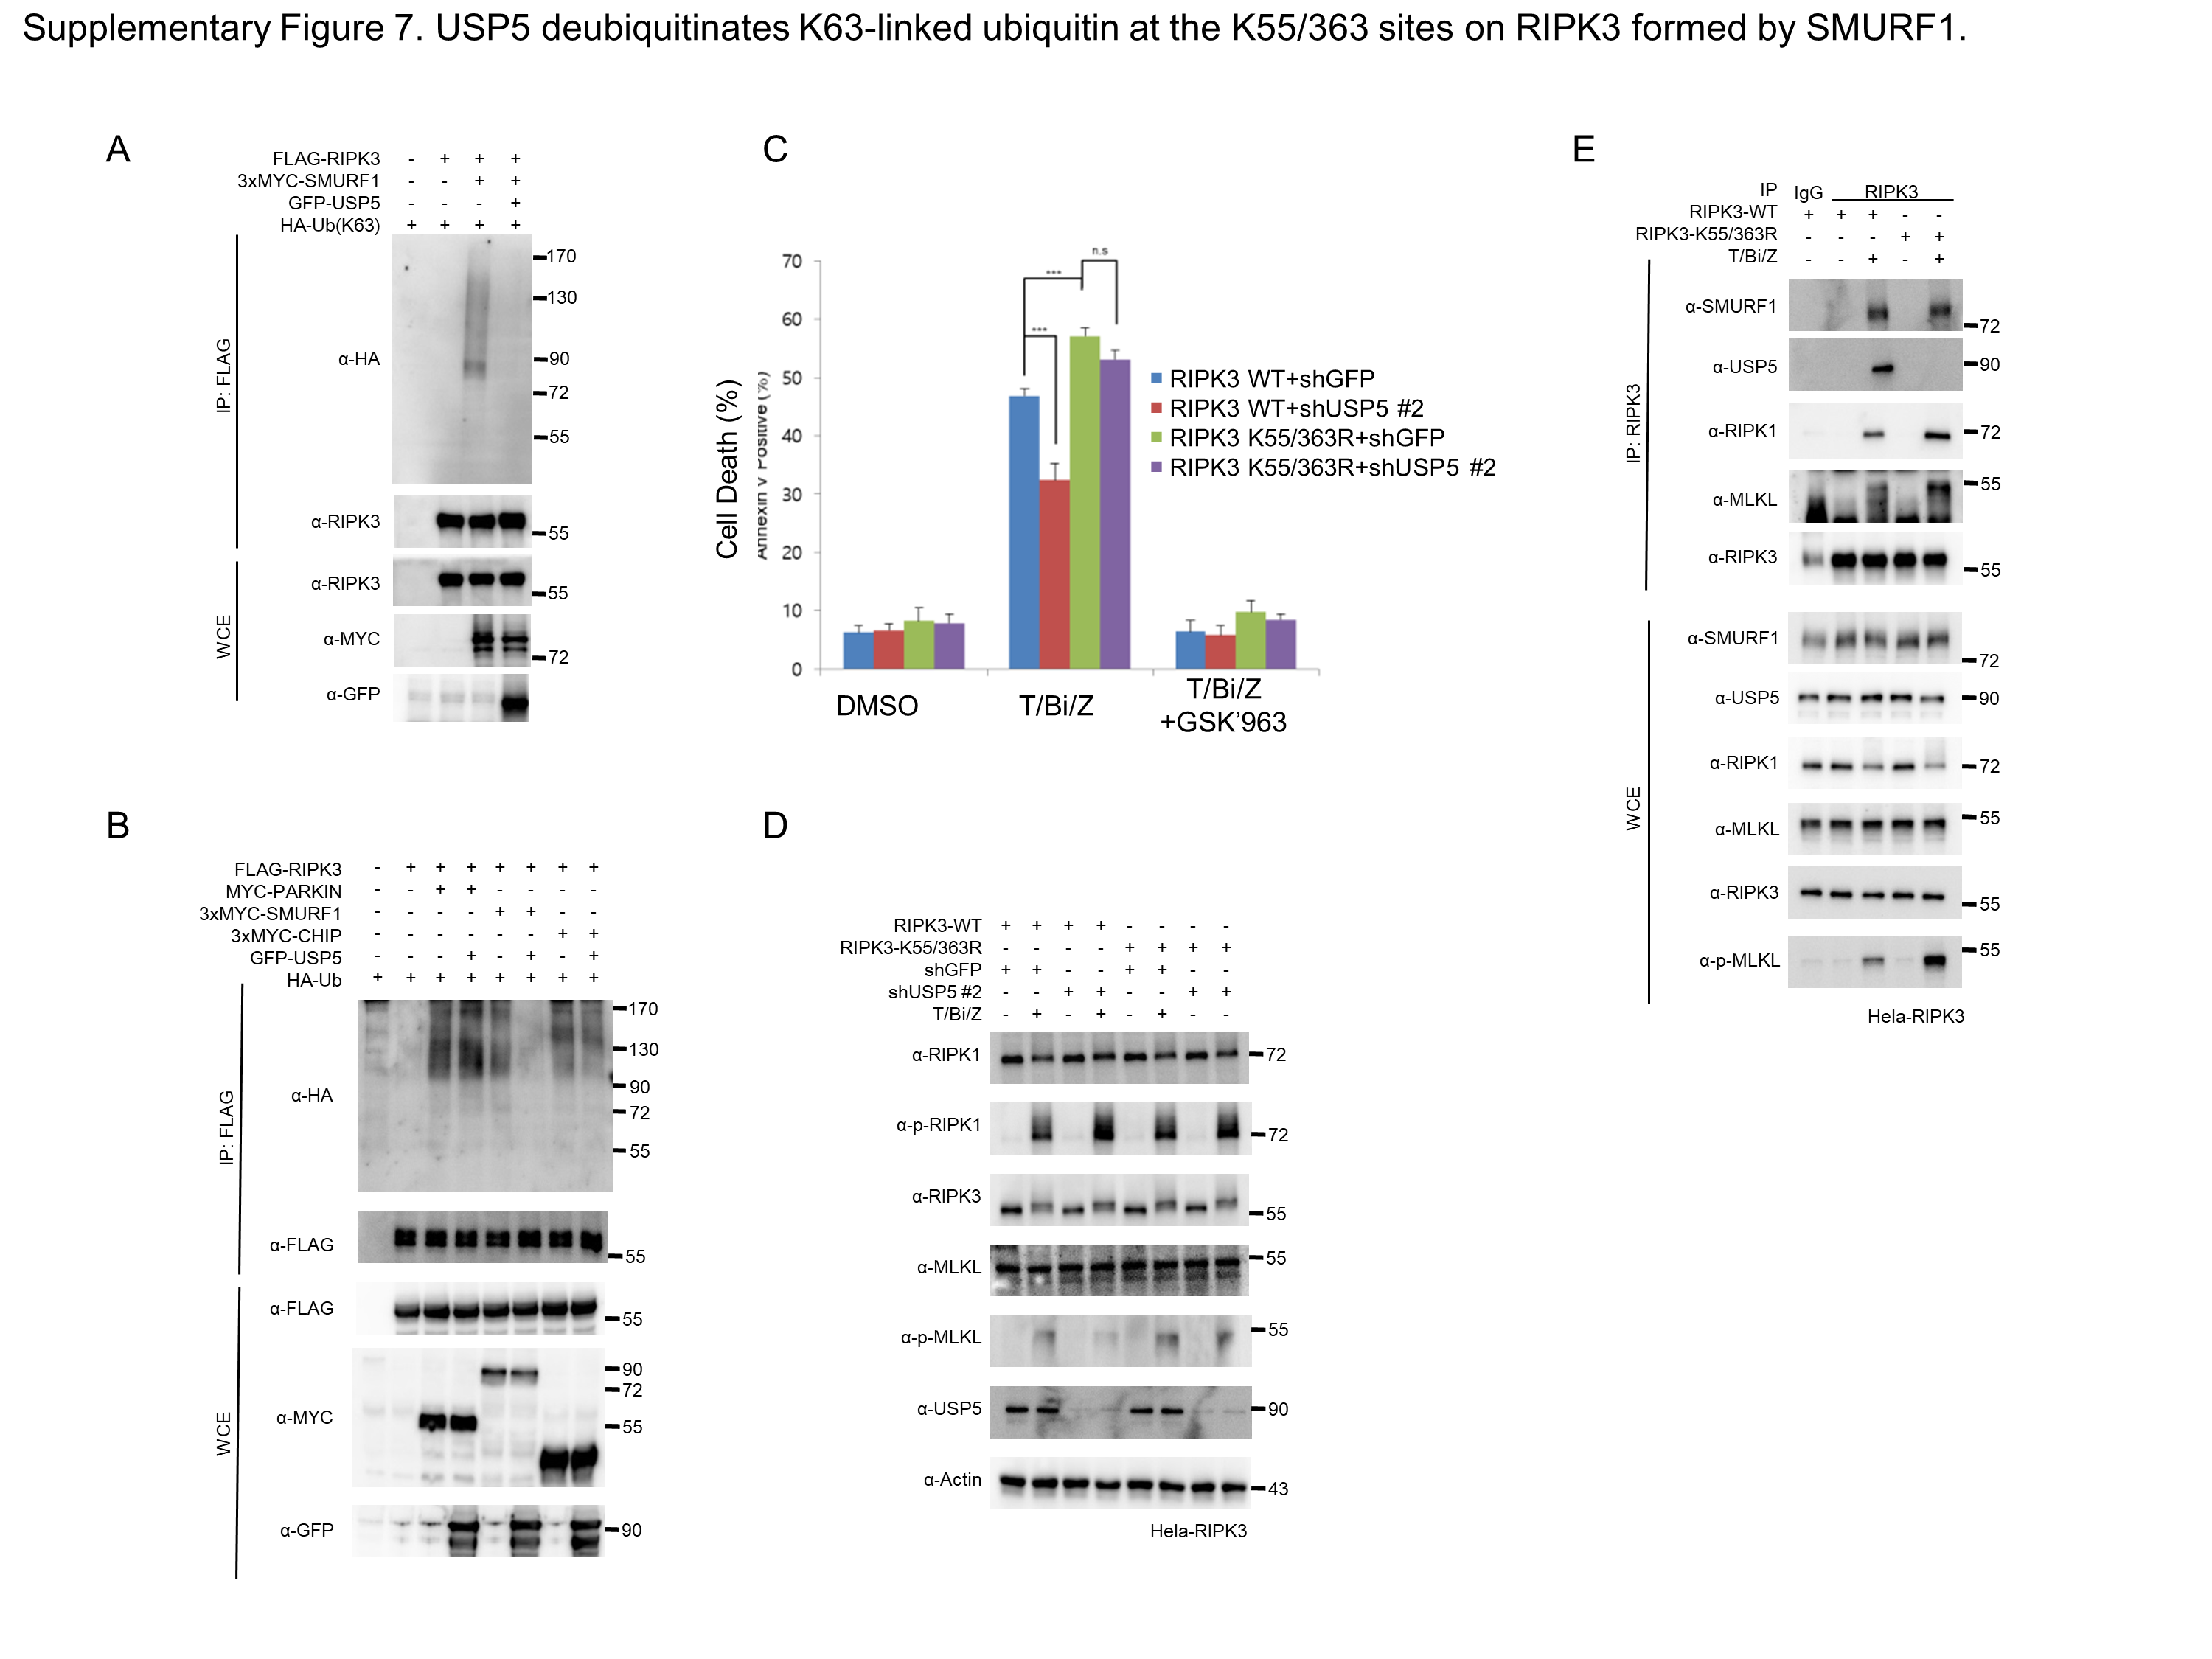
Supplementary Figure 7. USP5 deubiquitinates K63-linked ubiquitin at the K55/363 sites on RIPK3 formed by SMURF1.
(A) pcDNA3-FLAG-RIPK3 was transfected into HEK 293T cells along with HA-Ub, with or without 3xMYC-SMURF1 and GFP-USP5 expression. After 20 hours, cells were lysed in a 1% SDS buffer, and lysates diluted to 0.1% SDS were immunoprecipitated using an anti-FLAG antibody. RIPK3 ubiquitylation was detected by western blotting with an HRP-conjugated anti-HA antibody. (B) pcDNA3-FLAG-RIPK3 was transfected into HEK 293T cells along with HA-Ub, with or without 3xMYC-SMURF1, 3xMYC-CHIP, MYC-PARKIN. After 20 hours, cells were lysed in a 1% SDS buffer, and lysates diluted to 0.1% SDS were immunoprecipitated using an anti-FLAG antibody. RIPK3 ubiquitylation was detected by western blotting with an HRP-conjugated anti-HA antibody. (C) HeLa cells expressing shGFP, shUSP5, RIPK3 WT, and RIPK3 K55/363R were treated with T/Bi/Z to induce necroptosis. After 5 hours, the cells were harvested and stained with propidium iodide (PI). The proportion of necroptotic cells in each cell line was measured using flow cytometry (n = 3) (D) HeLa cells expressing shGFP, shUSP5, RIPK3 WT, and RIPK3 K55/363R were treated with T/Bi/Z to induce necroptosis. After 4 hours, the cells were harvested and analyzed by western blotting. (E) HeLa cells expressing RIPK3 WT, K55/363R were treated with T/Bi/Z to induce necroptosis. After 4 hours, the necrosome was pulled down using an anti-RIPK3 antibody and protein-G agarose beads. The protein-bead conjugate was washed and analyzed by western blotting to examine the assembly of the RIPK1-RIPK3-MLKL complex.

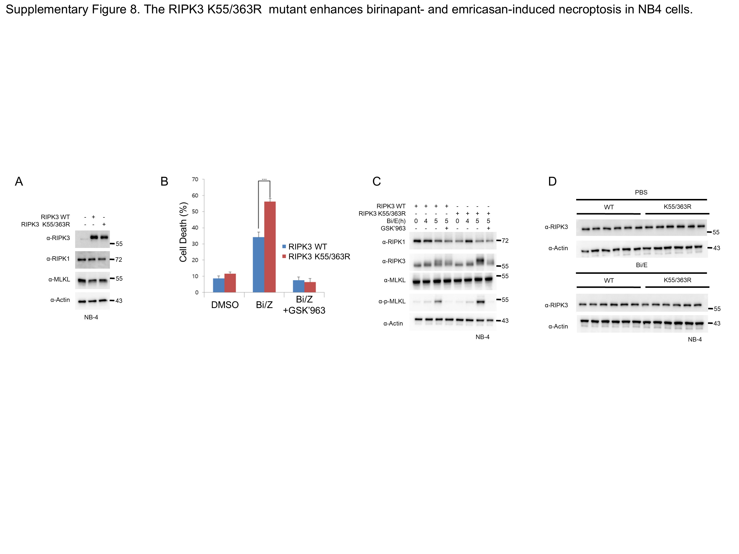

Supplementary Figure 8. The RIPK3 K55/363R mutant enhances birinapant- and emricasan-induced necroptosis in NB4 cells.
(A) NB-4 Cells were transduced with adenovirus to generate stable RIPK3 WT, K55R Cell lines. The expression levels of RIPK1, RIPK3, MLKL in each cell line were analyzed by western blotting. (B) NB-4 Cells expressed RIPK3 WT and K55/363R were treated with Bi/E in the presence or absence of 0.1 μM GSK'963 for 6 hours. The cells were harvested and stained with PI, and the proportion of necroptotic cells in each cell line was measured using flow cytometry (n = 3). (C) RIPK3 WT and K55/363R expressed NB-4 Cells were treated with Bi/E to induce necroptosis. GSK'963 was used to confirm that this cell death is necroptosis. (D) The tumors were lysed, and RIPK3 expression was analyzed using western blotting.

