Appendix C
Simulating Rational Numbers Learning Progression with the
MAB-SCD Simulator

In the school education scenario, Teachers and students are the main actors in the process of teaching and learning implementation of school subject curricula. Correspondingly, the curriculum provides a structured framework for teacher teaching and student learning. The MAB-SCD (Multi-Agent-Based Student Cognitive Development) simulation model represents a sophisticated endeavor tailored to comprehensively encapsulate the dynamic intricacies of students' cognitive structures throughout school curriculum instruction. Firmly grounded in the BDI (Belief-Desire-Intention) cognitive architecture, MAB-SCD distinguishes itself by seamlessly incorporating theories of Cognitive Diagnostic Assessment.
This simulator case study excels in dynamically simulating the evolution of students' cognitive structures in learning Rational Numbers over time. The simulation vividly mirrors students' learning journeys within an educational context, meticulously accumulating essential information for learning tasks and educational goals attainment.

- Simulation Setup
The simulation model developed on the GAMA platform (Version 1.9) adheres to specific technical specifications to ensure optimal functionality and compatibility. The model is coded in GAML (GAMA Modeling Language), the native language of the GAMA platform, leveraging its agent-based modeling capabilities. GAMA provides a user-friendly and extensible environment for developing, running, and analyzing simulations.
The platform and environment requirements for running the simulation model include a system with sufficient computational resources, such as a standard personal computer with a multi-core processor and ample RAM. The GAMA platform is compatible with major operating systems, including Windows, macOS, and Linux, providing flexibility in deployment.
The main parameters of the simulator are initialized with the values outlined in Table C.1.
Table C.1. The initial values of the main parameters
Parameter | value range | Description
v1 | 0.65 | The coefficient governing the Gaussian distribution of overall cognitive abilities.
v2 | 2 | Maximum number of concepts/items students can choose during repetitive learning activities.
v3 | 1 | The threshold for how long an item remains in long-term memory before experiencing decay.

2. Input
Using the definitions of the components of the Hypothetical Learning Progression for Rational Numbers outlined in Appendix A, along with the hierarchical relationship between cognitive attribute items illustrated in Figure 4 of the main text, the simulator's input data included:
- List of cognitive attributes
The details of the list are as follows:
[[1,0.94],[2,0.93],[3,0.85],[4,0.85],[5,0.65],[6,0.93],[7,0.85],[8,0.84],[9,0.65] ,[10,0.50] ,[11,0.63] ,[12,0.50] ,[13,0.50] ,[14,0.65] ,[15,0.58] ,[16,0.41]]
Each item in the list comprises two elements: the identity of the cognitive attribute and the mastery rate of the corresponding core concept of rational numbers. The mastery rate, represented as a floating-point number between 0 and 1, indicates the likelihood of students mastering the core concept, with higher values indicating a higher likelihood.
- Adjacency Matrix
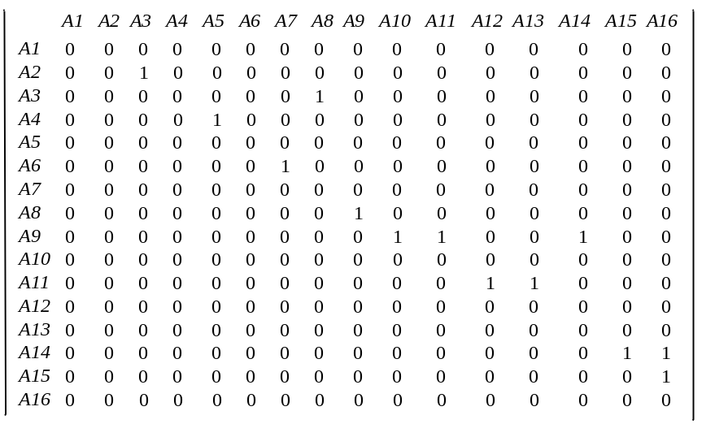
- Reachability Matrix
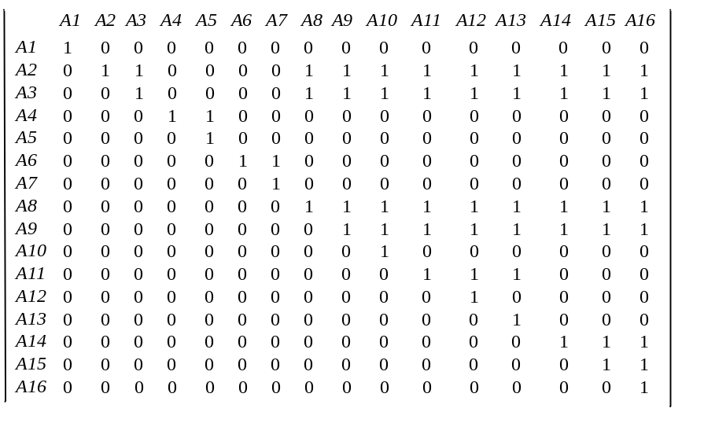
- Teaching Sequence
List of teaching sequence:
[A1, A2, A3, A4, A6, A5, A7, A8, A9, A10, A11, A12, A13, A14, A15, A16]
- Teaching Schedule
List of teaching schedule:
[1, 2, #, 3, #, 4, 6, #, *, #, 5, 7, #, *, #, *, #, 8, #, 9, #, *, #, 10, #, *, #, *, #, *, #, 11, #, 12, #, *, #, 13, #, *, #, *, #, *, #, 14, #, 15, #, *, #, 16, #, *, #, *, #, *, #]
- List of attributes corresponding to different LP levels
List of LP level-1: [1,2,5];
List of LP level-2: [3,4,5,7,8];
List of LP level-3: [9,11,14,15];
List of LP level-4: [10,12,13,16].
3. Operating Result
The simulator includes one teacher agent and 50 student agents. The simulation operates on a daily basis, with the current time span set at 28 days.
The visualisation results of the system's performance are shown in Figure C.1 to Figure C.3.
Figure C.1 dynamically shows the dynamics of each student's mastery after a new simulation cycle.
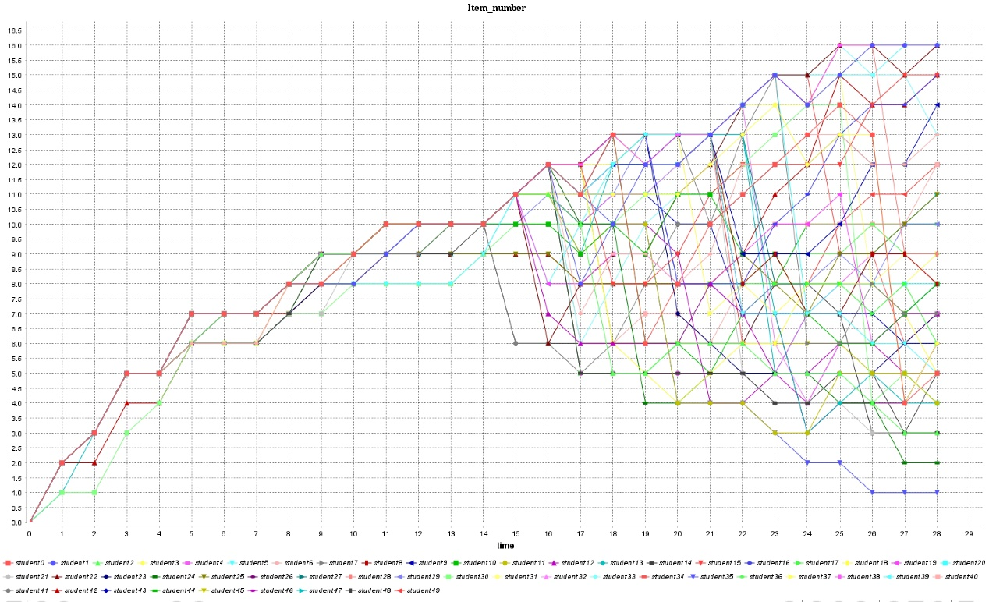
Figure C.1. Cognitive Attributes Mastery Dynamics
Figure C.2 is a histogram showing in detail the distribution of students at different advancement levels.

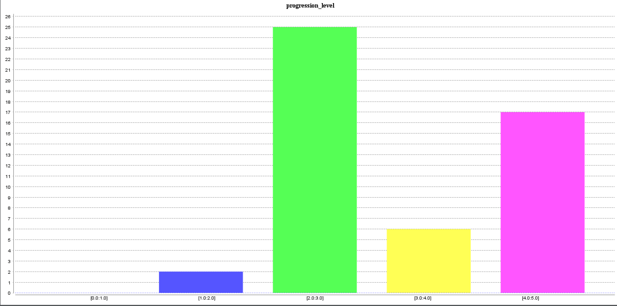
Figure C.2. Number of students at different levels of LP

Figure C.3 depicts for each simulation step, the students' mastery patterns and the corresponding progression level categories.
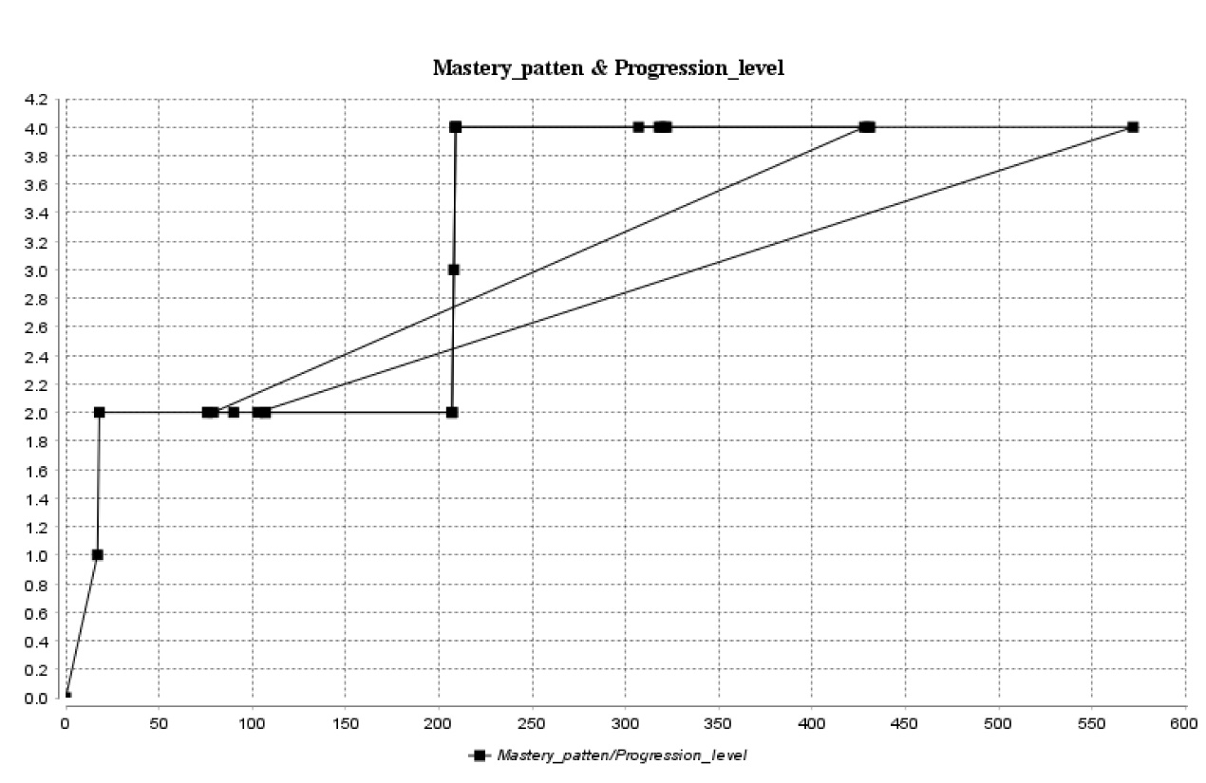 Figure C.3. Learning Progress Levels & Student Mastery Patterns

In addition to these visualizations, at the end of the final cycle of the simulation, the simulator can save both the data processed during the simulation and the outputs as external data files as required for data analysis. These data encapsulate outputs such as a comprehensive knowledge mastery matrix, the number and standard deviation of knowledge points mastered, and the percentage of students achieving each level of progress. Together, these visualizations and data representations provide a comprehensive understanding of system performance and the cognitive dynamics of the simulated educational environment.

