Appendix A
Historical Data Information Extraction Instructions

The dataset used for calibrating and validating the MAB-SCD model is sourced from the teaching materials of a Grade 7 mathematics course at a middle school in Shandong Province, China, during the autumn semester of the 2023-2024 academic year. This dataset includes core concepts and skills covered during the teaching period, midterm and final examination materials, and answer records for 98 students across two classes. Additionally, it encompasses the teaching logs and instructional plans of the class instructor.
The autumn semester of the 2023-2024 academic year represents the first semester for Grade 7 students. The core concepts and skills for this teaching period were extracted based on the Chinese National Curriculum Standards for Mathematics and guidance from domain experts. The instructional themes and cognitive attributes addressed in this phase of the mathematics curriculum are detailed in Table A.1.

Table A.1. Grade 7 Mathematics curriculum content for the autumn semester of compulsory education
Unit | Content and Academic Objectives | Core Concepts and Cognitive Attributes Coding
Rational number | Negative Numbers: Understand negative numbers and their role in representing opposing magnitudes.  Rational Numbers: Use the number line to represent and analyze rational numbers, including opposite numbers and absolute values.  Comparison and Calculation: Compare rational numbers, and accurately calculate their inverses and absolute values.  Multiplication: Multiply rational numbers precisely, understanding the underlying principles.  Arithmetic Operations: Efficiently perform and simplify addition, subtraction, multiplication, and division of rational numbers. | A1: Meaning of Negative Numbers  A2: Concept of Rational Numbers  A3: Applications of Rational Numbers  A4: Number Line (Applications of the Number Line)  A5: Number Line (Geometric Interpretation of the Number Line)  A6: Concept of Opposite Numbers  A7: Concept of Absolute Value  A8: Addition and Subtraction of Rational Numbers  A9: Multiplication and Division of Rational Numbers  A10: Applications of Multiplication and Division of Rational Numbers  A11: Powers of Rational Numbers  A12: Applications of Powers of Rational Numbers  A13: Scientific Notation  A14: Operations with Rational Numbers (Basic Operations)  A15: Operations with Rational Numbers (Advanced Operations)  A16: Multiple Operations with Rational Numbers
Addition and Subtraction of Polynomials | Utilize Algebraic Expressions: Model and solve problems using algebraic expressions, choosing appropriate evaluation methods.  Apply Exponent Properties and Scientific Notation: Effectively use integer exponents and scientific notation for calculations.  Work with Polynomials: Manipulate polynomials by combining like terms, distributing, and performing basic operations.  Multiply and Factor Expressions: Multiply linear and quadratic expressions, apply difference of squares and perfect square formulas, and factor polynomials using relevant methods.  Simplify and Operate on Fractions: Simplify fractions, perform basic operations (addition, subtraction, multiplication, division), and present results in simplest form. | A17: Represent numbers using variables.  A18: Formulate equations to express quantitative relationships and evaluate algebraic expressions.  A19: Concept of monomials.  A20: Concept of polynomials.  A21: Like terms.  A22: Rule for combining like terms.  A23: Rule for removing parentheses.  A24: Operations with polynomials.  A25: Exploring and expressing patterns.
Basic Plane Figures | Geometry Concepts: Understand planes, lines, and points abstracted from objects and models.  Line Segments: Compare lengths, understand their sum and difference, and the role of points on segments.  Basic Properties: Recognize that two points define a straight line and that the segment between them is the shortest.  Distance Measurement: Measure and express the distance between two points accurately.  Angle Concepts: Compare angles, know measurement units (degrees, minutes, seconds), and perform conversions and calculations. | A26: Line Segments, Rays, and Lines  A27: Properties of Line Segments / Midpoints  A28: Calculations Involving Line Segments: Length / Comparison  A29: Concept and Measurement of Angles  A30: Angle Bisectors  A31: Angle Calculations  A32: Polygons  A33: Circles, Arcs, Sectors, and Central Angles  A34: Calculation of Angles in a Circle  A35: Calculation of Sector Area
Linear Equations in One Variable | Interpret Equations in Context: Analyze and interpret the significance of equations derived from real-world scenarios, and formulate appropriate equations for specific problems.  Understand Solutions and Estimations: Comprehend the meaning of solutions to equations and practice estimating solutions through various methods.  Solve Equations: Demonstrate mastery of fundamental properties of equations, including solving quadratic equations and fractional equations that can be transformed into quadratic form. | A36: Concept of Linear Equations in One Variable  A37: Application of Algebraic Rules  A38: Solving Linear Equations in One Variable  A39: Formulating Linear Equations in One Variable  A40: Applications of Linear Equations in One Variable
Data Collection and Analysis | Sample Surveys and Random Sampling: Understand the need for sample surveys and simple random sampling principles.  Questionnaire Design and Data Collection: Create effective questionnaires and collect data using simple random sampling.  Data Visualization: Construct and interpret fan charts, histograms, bar charts, and line graphs.  Data Organization and Description: Organize and describe data with various graphical tools.  Data Interpretation: Analyze and interpret data using fan charts, bar graphs, line graphs, and histograms. | A41: Census and Sampling Surveys  A42: Circle Graph (or Pie Chart)  A43: Bar Chart  A44: Frequency Histogram  A45: Line Graph
The hierarchical relationship between cognitive attributes is shown in Figure A.1.

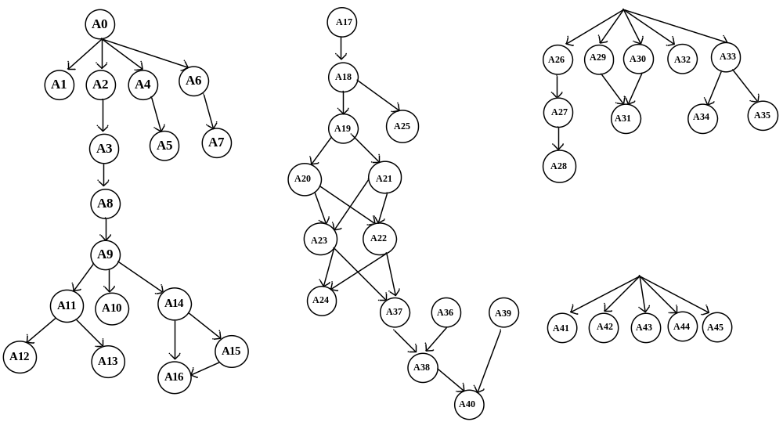
FigureA.1 Hierarchical relationships of Cognitive Attributes
Note: A0 represents the knowledge that students have acquired prior to learning. A1-A45 correspond to the cognitive attribute coding in Table A.1.

Figure A.2 presents the mid-term and final test papers used in this study.

FigureA.2 Mid-term and final test papers (part)

Analysis of the test papers revealed that the mid-term test assessed 17 cognitive attributes across 25 test items, while the final test evaluated 27 cognitive attributes through 31 test items. Based on the established hierarchy of cognitive attributes, Q matrices were constructed for both the mid-term and final tests. The Q-matrix for the mid-term test is presented in Table A.2.

Table A.2 Q-matrix for the final examination of autumn semester of 2023-2024
 | A3 | A4 | A5 | A7 | A9 | A10 | A12 | A13 | A15 | A16 | A17 | A18 | A21 | A22 | A23 | A24 | A25
item1 | 0 | 0 | 0 | 1 | 0 | 0 | 0 | 0 | 0 | 0 | 0 | 0 | 0 | 0 | 0 | 0 | 0
item2 | 0 | 0 | 0 | 0 | 1 | 1 | 0 | 0 | 0 | 0 | 0 | 0 | 0 | 0 | 0 | 0 | 0
item3 | 0 | 0 | 0 | 0 | 0 | 0 | 0 | 0 | 0 | 0 | 1 | 1 | 1 | 0 | 0 | 0 | 0
item4 | 1 | 0 | 0 | 0 | 1 | 0 | 0 | 1 | 0 | 0 | 0 | 0 | 0 | 0 | 0 | 0 | 0
item5 | 0 | 0 | 0 | 0 | 0 | 0 | 0 | 0 | 0 | 0 | 1 | 1 | 1 | 1 | 0 | 0 | 0
item6 | 0 | 0 | 0 | 0 | 0 | 0 | 0 | 0 | 0 | 0 | 1 | 1 | 0 | 0 | 0 | 0 | 0
item7 | 0 | 1 | 1 | 0 | 0 | 0 | 0 | 0 | 0 | 0 | 0 | 0 | 0 | 0 | 0 | 0 | 0
item8 | 1 | 0 | 0 | 0 | 1 | 0 | 0 | 0 | 1 | 1 | 0 | 0 | 0 | 0 | 0 | 0 | 0
item9 | 0 | 0 | 0 | 0 | 0 | 0 | 0 | 0 | 0 | 0 | 1 | 1 | 0 | 0 | 0 | 0 | 1
item10 | 1 | 0 | 0 | 0 | 1 | 0 | 1 | 0 | 0 | 0 | 0 | 0 | 0 | 0 | 0 | 0 | 0
item11 | 1 | 0 | 0 | 0 | 1 | 0 | 0 | 0 | 1 | 0 | 0 | 0 | 0 | 0 | 0 | 0 | 0
item12 | 0 | 1 | 0 | 0 | 0 | 0 | 0 | 0 | 0 | 0 | 0 | 0 | 0 | 0 | 0 | 0 | 0
item13 | 0 | 1 | 1 | 0 | 0 | 0 | 0 | 0 | 0 | 0 | 0 | 0 | 0 | 0 | 0 | 0 | 0
item14 | 0 | 0 | 0 | 0 | 0 | 0 | 0 | 0 | 0 | 0 | 1 | 1 | 1 | 1 | 1 | 0 | 0
item15 | 0 | 0 | 0 | 0 | 0 | 0 | 0 | 0 | 0 | 0 | 1 | 1 | 1 | 1 | 1 | 1 | 0
item16 | 1 | 0 | 0 | 0 | 1 | 1 | 0 | 0 | 0 | 0 | 0 | 0 | 0 | 0 | 0 | 0 | 0
item17 | 1 | 0 | 0 | 0 | 1 | 0 | 0 | 0 | 1 | 1 | 0 | 0 | 0 | 0 | 0 | 0 | 0
item18 | 1 | 0 | 0 | 0 | 0 | 0 | 0 | 0 | 0 | 0 | 0 | 0 | 0 | 0 | 0 | 0 | 0
item19 | 1 | 0 | 0 | 0 | 1 | 0 | 0 | 0 | 1 | 1 | 0 | 0 | 0 | 0 | 0 | 0 | 0
item20 | 0 | 0 | 0 | 0 | 0 | 0 | 0 | 0 | 0 | 0 | 1 | 1 | 0 | 0 | 0 | 0 | 0
item21 | 0 | 0 | 0 | 0 | 0 | 0 | 0 | 0 | 0 | 0 | 1 | 1 | 1 | 1 | 1 | 0 | 0
item22 | 0 | 0 | 0 | 0 | 0 | 0 | 0 | 0 | 0 | 0 | 1 | 1 | 1 | 1 | 1 | 1 | 0
item23 | 0 | 0 | 0 | 0 | 0 | 0 | 0 | 0 | 0 | 0 | 1 | 1 | 1 | 0 | 0 | 0 | 0
item24 | 0 | 0 | 0 | 0 | 0 | 0 | 0 | 0 | 0 | 0 | 1 | 1 | 1 | 1 | 1 | 0 | 0
item25 | 0 | 0 | 0 | 0 | 0 | 0 | 0 | 0 | 0 | 0 | 1 | 1 | 1 | 1 | 1 | 1 | 0

Additionally, by analyzing lecturers' lesson plans, teaching schedules, and class timetables, we extracted the teaching sequences related to the experimental setup as follows: [A1, A2, A3, A4, A5, A6, A7, A8, A14, A9, A10, A11, A12, A13, A15, A16, A17, A18, A19, A20, A21, A22, A23, A24, A25, A26, A27, A28, A29, A30, A31, A32, A33, A34, A35, A36, A37, A38, A39, A40, A41, A42, A43, A44, A45], with the instructional schedule detailed in Table A.3. The length of the simulation cycle was determined based on model calibration and validation requirements.

Table A.3 Instructional schedule of autumn semester of 2023-2024
Week | Instructional Content & Arrangements | Note
Week-1 | A1, #, A2, A3, #, A4, #, A5 , #, A6, A7,#,*,#,*,#
Week-2 | A8, #, *, #, A14, #, *, #, A9, #, *, #, *, #
Week-3 | A10, #, *, #, A11, #, A12, #, A13, #, *, #, *, #
Week-4 | A15, #, *, #, A16, #, *, #, *, #, *, #, *, #
Week-5 | *, #, *, # ,*, #, *, #, *, #, *, #, *, # | Public holiday
Week-6 | A17, #, A18, #, *, #, A19, #, A20, #, *, #, *, #
Week-7 | A21, #, A22, #, *, #, A23, #, *, #, *, #, *, #
Week-8 | A24, #, *, #, *, #, A25, #, *, #, *, #, *, #
Week-9 | *, #, *, #, *, #, *, #, *, #, *, #, *, # | Stage review
Week-10 | *, #, *, #, *, #, *, #, *, #, *, #, *, # | Revision and midterm exam
Week-11 | A26, A27, #, A28, #, A29, A30, #, A31, #, *, #, *, #, *, #
Week-12 | A32, #, 33A, #, A34, #, A35, #, *, #, *, #, *, #
Week-13 | A36, #, *, #, *, #, A37, #, *, #, *, #, *, #
Week-14 | *, #, *, #, *, #, *, #, *, #, *, #, *, # | Stage review
Week-15 | A38, #, *, #, *, #, A39, #, *, #, *, #, *, #
Week-16 | A40, #, *, #, *, #, *, #, *, #, *, #, *, #
Week-17 | A41, #, *, #, A42, #, *, #, A43, #, *, #, *, #
Week-18 | A44, #, *, #, *, #, A45, #, *, #, *, #, *, #
Week-19 | *, #, *, #, *, #, *, #, *, #, *, #, *, # | Semester end revision
Week-20 | *, #, *, #, *, #, *, #, *, #, *, #, *, # | Stage review and final exam
Note: Each teaching week consists of seven days, with a public holiday on Saturday and Sunday. Within the instructional content, * indicates that the day's lectures content is empty, and # indicates the end marker of the day's lectures.

