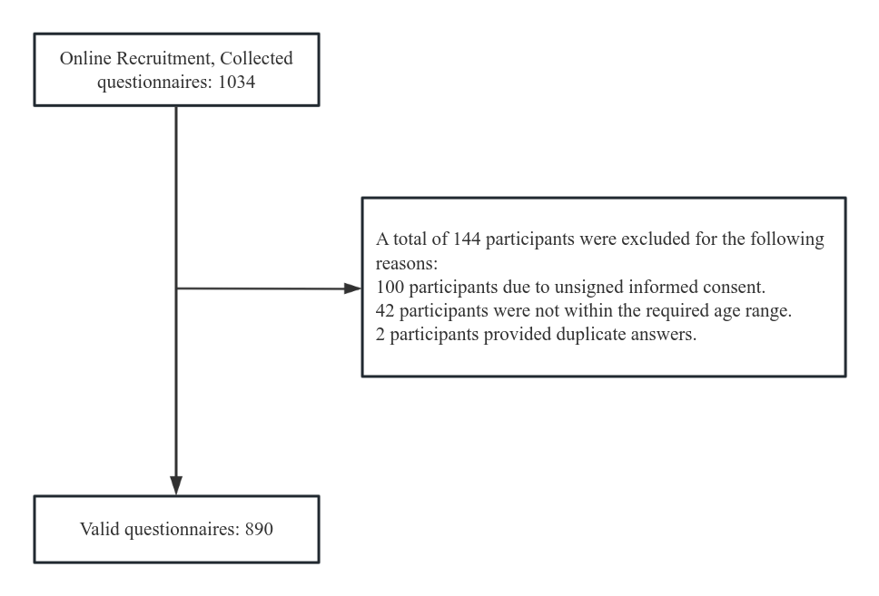
Figure S1：Study flowchart

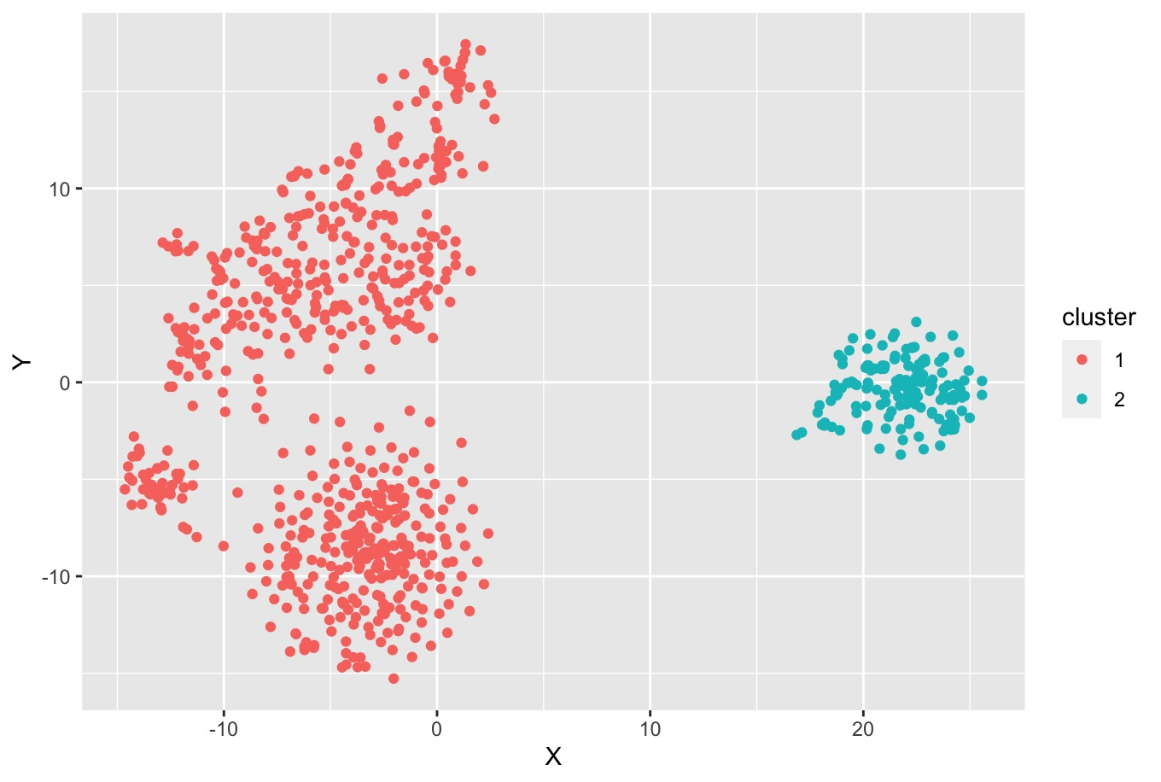
Figure S2: Reduced dimensional scatter plot of Gower clustering results

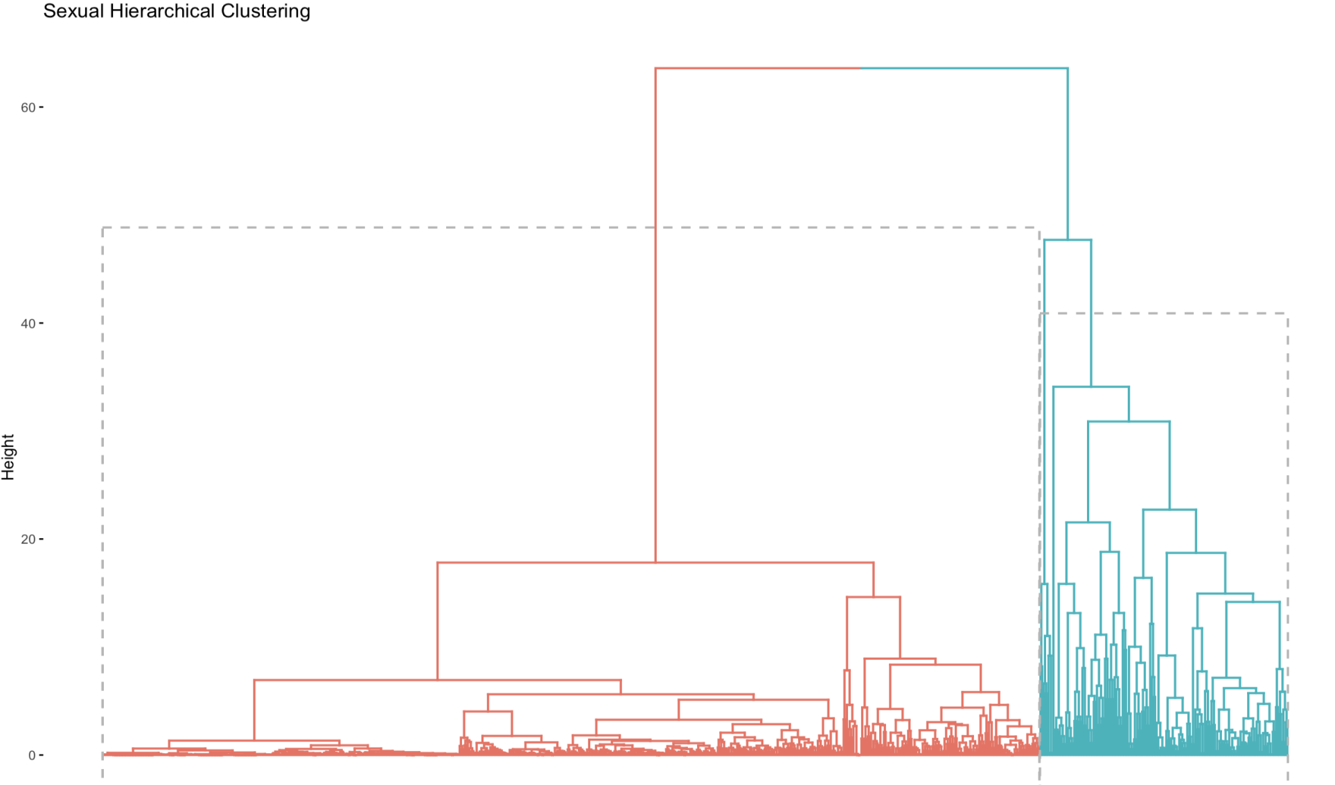
Figure S3: Reduced dimensional scatter plot of hierarchical clustering results

Table S1: Estimated number of sexual acts in the past twelve months across three clusters
Category | Overall (Mean, 95% CI) | Cluster 1 (Mean, 95% CI) | Cluster 2 (Mean, 95% CI) | Cluster 3 (Mean, 95% CI) | H | P-value
any sex act | 52.53 (52.65, 88.61) | 56.10 (53.39, 73.33) | 21.22 (20.80, 35.35) | 61.30 (54.31, 91.13) | 77.97 | <0.0001
kissing | 50.20 (52.26, 78.11) | 54.10 (52.96, 68.10) | 19.14 (18.31, 34.16) | 55.47 (52.25, 76.24) | 61.32 | <0.0001
receptive oral sex | 46.97 (51.44, 59.77) | 48.41 (50.74, 54.00) | 15.67 (13.38, 32.94) | 54.87 (52.21, 70.29) | 60.71 | <0.0001
insertive oral sex | 49.38 (52.07, 73.72) | 52.77 (52.33, 65.73) | 18.24 (16.86, 34.79) | 53.51 (51.66, 70.63) | 53.01 | <0.0001
rimming | 34.90 (45.18, 25.03) | 31.03 (40.81, 23.48) | 4.37 (2.24, 31.77) | 35.80 (30.22, 42.53) | 85.16 | <0.0001
be rimmed | 34.99 (46.39, 25.57) | 33.51 (42.53, 26.56) | 6.80 (3.72, 30.72) | 36.93 (32.12, 43.70) | 69.13 | <0.0001
insertive anal sex | 43.24 (50.35, 41.00) | 44.35 (48.89, 43.55) | 6.72 (4.67, 25.47) | 46.04 (48.51, 48.67) | 92.59 | <0.0001
receptive anal sex | 38.16 (48.23, 31.19) | 38.67 (45.60, 34.22) | 9.20 (6.04, 28.36) | 45.70 (46.69, 48.53) | 63.19 | <0.0001
masturbation | 88.80 (153.18, 59.50) | 82.94 (119.90, 62.81) | 118.52 (70.32, 175.75) | 97.46 (147.79, 65.33) | 328.92 | <0.0001
masturbation for | 45.58 (51.28, 43.76) | 45.90 (49.84, 45.29) | 16.84 (12.53, 33.38) | 45.90 (48.63, 46.69) | 21.27 | <0.0001
masturbation by | 46.18 (51.53, 46.58) | 46.99 (50.15, 47.34) | 20.48 (15.04, 36.11) | 46.40 (49.20, 46.95) | 14.09 | <0.0001

Table S2: Median number of days since last sexual acts across three clusters
Category | Overall (Median, IQR) | Cluster 1 (Median, IQR) | Cluster 2 (Median, IQR) | Cluster 3 (Median, IQR) | H | P-value
any sex act | 14 (3, 60) | 10 (3, 30) | 56 (15, 100) | 7 (3, 30) | 48.79 | <0.0001
kissing | 15 (3.25, 69.75) | 10 (3, 50) | 60 (20, 120) | 10 (3, 30) | 41.83 | <0.0001
receptive oral sex | 22.5 (5, 167.25) | 15 (4, 365) | 60 (30, 180) | 9.5 (3, 41.75) | 38.55 | <0.0001
insertive oral sex | 15 (4, 81.5) | 10 (3, 40) | 60 (20, 150) | 10 (3.5, 40.25) | 41.06 | <0.0001
rimming | 365 (28.5, 365) | 365 (15, 365) | 365 (160.5, 365) | 100 (10, 365) | 12.63 | 0.002
be rimmed | 200 (15, 365) | 365 (10, 365) | 300 (89.5, 365) | 60 (7, 365) | 22.28 | <0.0001
insertive anal sex | 30 (7, 365) | 25 (5, 365) | 180 (60, 365) | 25 (5, 190) | 39.06 | <0.0001
receptive anal sex | 60 (10, 365) | 35 (7, 365) | 167 (60, 365) | 30 (5, 365) | 27.96 | <0.0001
masturbation | 3 (1, 7) | 3 (1, 7) | 2 (1, 4) | 3 (1, 7) | 7.23 | 0.027
masturbation for | 30 (6, 365) | 30 (4, 365) | 60 (30, 200) | 22.5 (5, 365) | 5.88 | 0.052
masturbation by | 30 (5, 365) | 26 (4, 365) | 60 (20, 180) | 24.5 (5, 365) | 4.54 | 0.103

