Clinical case | Scoring severity | Activity status | Treatment decision-making
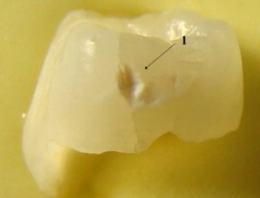 | ICDAS score: B  MODERATE | Activity status:  ACTIVE
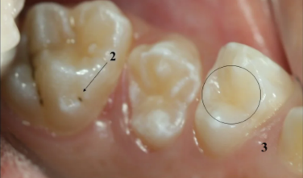 | Site 2:  ICDAS score: A  INITIAL  Site 3:  ICDAS score: 0 | Site 2:  Activity status:  INACTIVE
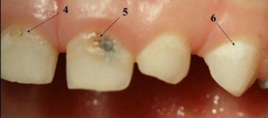 | Site 4:  ICDAS score: B  MODERATE  Site 5:  ICDAS score: C  EXTENSIVE  Site 6:  ICDAS score: A  INITIAL | Site 4:  Activity status:  ACTIVE  Site 5:  Activity status:  ACTIVE  Site 6:  Activity status:  ACTIVE | Site 5:  Management:  OPERATIVE  Site 6:  Management:  NON-OPERATIVE
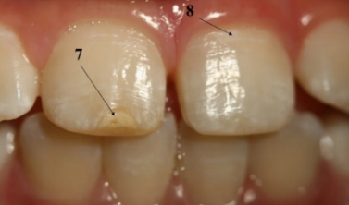 | Site 7:  ICDAS score: 0  Site 8:  ICDAS score: A  INITIAL | Site 8:  Activity status:  ACTIVE | Site 7:  Management:  NO TREATMENT  Site 8:  Management:  NON-OPERATIVE
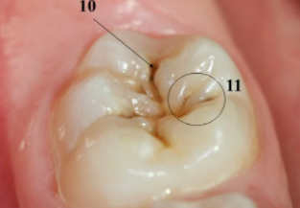 | Site 11:  ICDAS score: B  MODERATE | Site 11:  Activity status:  ACTIVE | Site 11:  Management:  NON-OPERATIVE/  RADIOGRAPH IS NEEDED
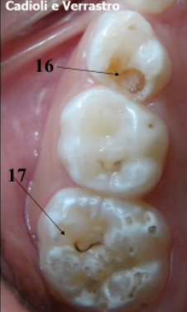 | Site 16:  ICDAS score: C  EXTENSIVE  Site 17:  ICDAS score: A  INITIAL | Site 16:  Activity status:  ACTIVE  Site 17:  Activity status:  INACTIVE | Site 17:  Management:  NO TREATMENT
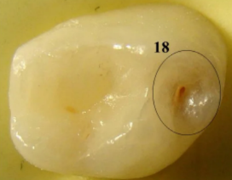 | Site 18:  ICDAS score: B  MODERATE | Site 18:  Activity status:  ACTIVE | Site 18:  Management:  RADIOGRAPH IS NEEDED
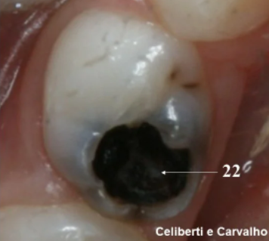 | Site 22:  ICDAS score: C  EXTENSIVE | Site 22:  Activity status:  ACTIVE
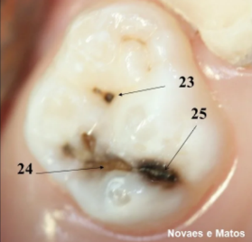 | Site 24:  ICDAS score: C  EXTENSIVE |  | Site 24:  Management:  OPERATIVE  Site 25:  Management:  NO TREATMENT

