Supplementary Figure S2a: Leave-one-out plots for the primary, common effects, meta-analysis with lung cancer as the outcome.

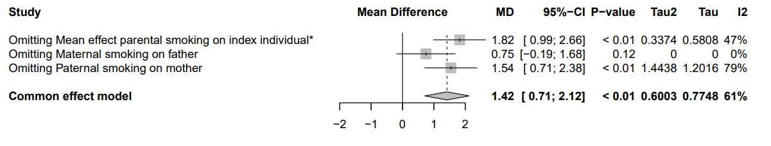

* We included the average of the estimates of maternal and paternal smoking on the index individual in the meta-analysis because these estimates are not independent.

Supplementary Figure S2b: Leave-one-out plots for the primary, common effects, meta-analysis with chronic obstructive pulmonary disease as the outcome.

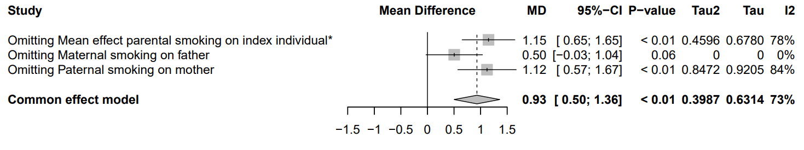
* We included the average of the estimates of maternal and paternal smoking on the index individual in the meta-analysis because these estimates are not independent.

Supplementary Figure S2c: Leave-one-out plots for the primary, common effects, meta-analysis with coronary heart disease as the outcome.

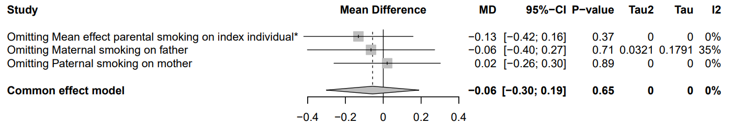
* We included the average of the estimates of maternal and paternal smoking on the index individual in the meta-analysis because these estimates are not independent.

Supplementary Figure S2d: Leave-one-out plots for the primary, common effects, meta-analysis with stroke as the outcome.

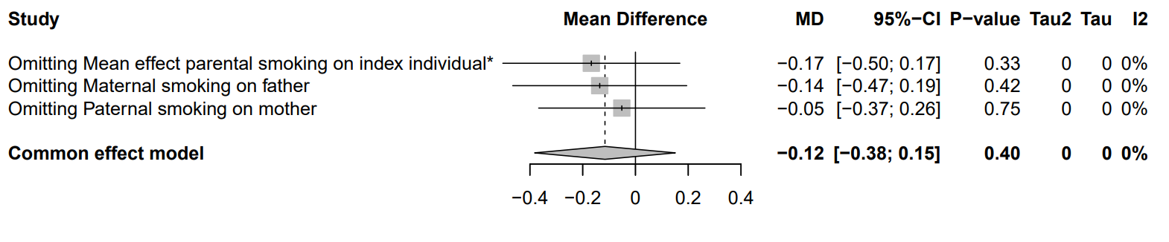
* We included the average of the estimates of maternal and paternal smoking on the index individual in the meta-analysis because these estimates are not independent.

Supplementary Figure S2e: Leave-one-out plots for the primary, common effects, meta-analysis with hypertension as the outcome.

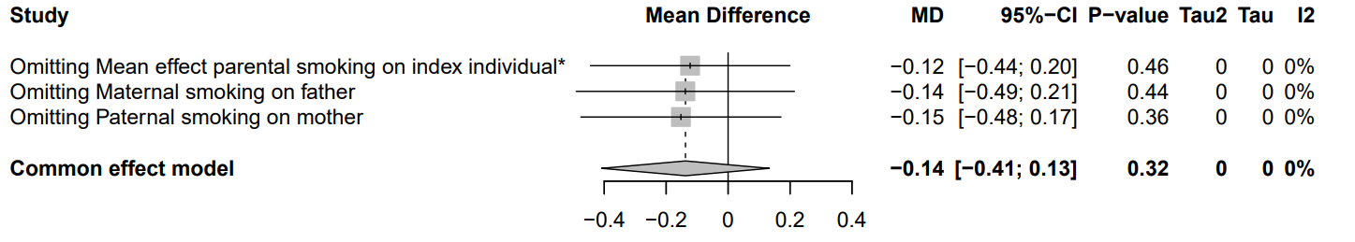
* We included the average of the estimates of maternal and paternal smoking on the index individual in the meta-analysis because these estimates are not independent.

Supplementary Figure S2f: Leave-one-out plots for the primary, common effects, meta-analysis with depression as the outcome.

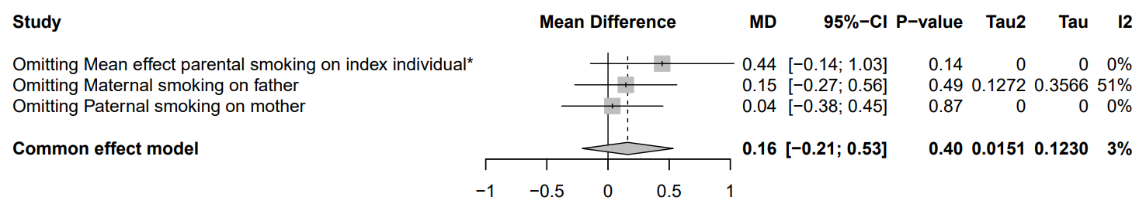
* We included the average of the estimates of maternal and paternal smoking on the index individual in the meta-analysis because these estimates are not independent.

