Supplementary Material for
Human land-use and non-native species erode ecosystem services by changing community size structure

This PDF file includes:

Supplementary Methods
Supplementary Figures 1 to 15
Supplementary Table 1 to 6
Model Diagnostic Plots: Figure 16 to 27.
Reference

Supplementary Methods
Quantifying climatic predictors
As climate indicators, we use precipitation and water temperature measurements. We calculated the mean monthly precipitation (MMP) from 2002 to 2022 for each of the eight surveyed environments. We extracted the MMP data only for the months the fish were collected. The MMP data were obtained from the Chelsa 2.1 version¹ at a horizontal resolution of 30 arc sec (approximately 1km² spatial resolution). The water temperature was estimated in situ simultaneously with the fish samples using an oximeter (Digimed). To test whether these instantaneous temperature measurements are representative of the thermal regime at each site, we calculated the mean monthly air temperature (MMT) from 2002 to 2022 for each of the eight surveyed environments. MMT was extracted from the Chelsa dataset, 2.1, version1. We then used a linear mixed-effect regression model with sites as a random factor, to show that water temperature was strongly related to air temperature (slope = 0.740, p < 0.001; Supplementary Fig. 15). This result indicates that our water temperature measurements are closely associated with more long-term environmental temperature. Consequently, we only used water temperature measurements for our analysis.
Analysis
To understand how the individual body mass (log10 g/m²) of larger and smaller individuals of native and non-native species changed over time, we performed a series of quantile regressions of the 95th, 50th, and 5th percentiles with the quantile function available in R. Specifically, we separated the individual body mass of native and non-native fish into quantiles representing: large-bodied individuals (95), medium-bodied individuals (50) and small-bodied individuals (5). We then employed linear mixed-effect models to test how the body mass of native and non-native species within each quantile changed over time. Linear mixed-effects models were run using the lme function of the nlme package². In this analysis, if the body mass within the 95th decreases and the body mass within the 5th increases, this implies that the species has lost biomass in large-bodied individuals and gained biomass in small-bodied individuals³.
To test the association between human land-use and native and non-native species, we calculated the correlation between the biomass of each fish species and the human land-use using Spearman's correlation. We ran separate correlations for native and non-native fish. As the effects of human land-use can vary between different trophic guilds², we separated native and non-native fish assemblages into five trophic guilds by integrating information about stomach contents and feeding traits. The trophic guilds identified for native and non-native fish were: piscivore, omnivore, detritivore, herbivore, and invertivore. We then ran Spearman correlations between human land use and fish biomass for species within the five trophic guilds.

Supplementary Fig. 1| Annual trends estimated species richness and biomass of fish across a floodplain. a-c, Annual trends (mean ± s.e., n = 167) of estimated species richness (a) the whole-community, (b) native species only, and (c) non-native species only. d-f, Annual trends in biomass density of (d) whole-community, (e) native species only, and (f) non-native species only. Solid colored lines and colored shadings denote the model fits (using the GAM function) and 95% confidence intervals, respectively. The black line is the general time trend (for the entire floodplain) and the colored lines are the specific trends (for each environment).

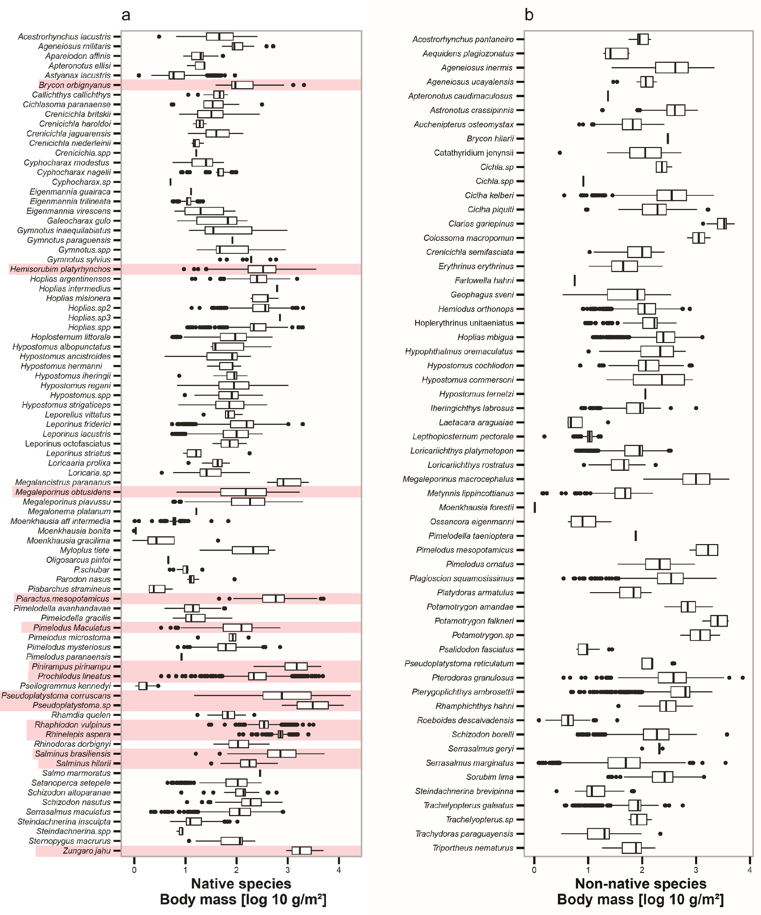
Supplementary Fig. 2| Biomass production for native and non-native fish individuals. Boxplot representing the average and deviation in the biomass of (a) native and (b) non-native fish species. Biomass is in the Log₁₀ scale. The species shaded in pink are migratory species from the upper Paraná River (see Agostinho et al. ref⁴).

Supplementary Fig. 3| Quantile regressions of the 95th, 50th, and 5th percentile of body size (log10 g/m²) of fish community over time. a-c, The linear association between 95th, 50th, and 5th percentile of individual body mass and time for (a) native species, and (b) non-native species. 95th represents the biomass of large-bodied individuals, 50th represents the biomass of medium-bodied individuals and 5th represents the biomass of small-bodied individuals. Statistical analysis was performed using linear mixed-effect models (LMMs). Colored lines are the predicted (fitted) values from LMM. Results of regressions are as follows: (a) native species: 95th: β = –0.006, P < 0.001, 50th: β = 0.002, P < 0.001, 5th: β = 0.003, P < 0.001; (b) non-native species: 95th: β = 0.004, P < 0.001, 50th: β = 0.005, P < 0.001, 5th: β = 0.009, P < 0.001. The complete quantile analysis method is provided in the Supplementary Method: Analysis

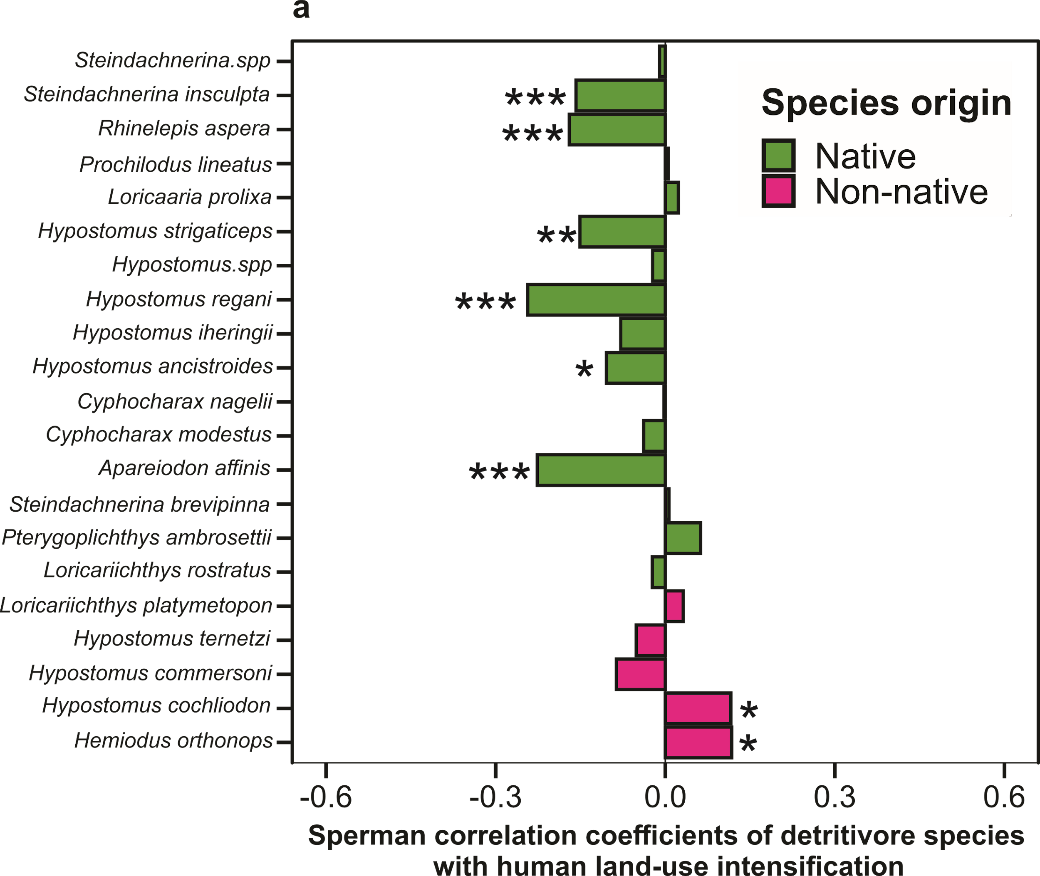
Supplementary Fig. 4| Correlation between the biomass of 21 detritivore fish species and human land-use intensification across the floodplain system. Spearman correlation matrix of detritivore native (green; 16 species) and non-native (pink; 5 species) fish species with human land-use. Negative values indicate low human land-use (left), while positive values represent high human land-use (right). The stars in front of the bars indicate the significance of the correlation, where significance levels are *P < 0.05, **P < 0.01, ***P < 0.001.

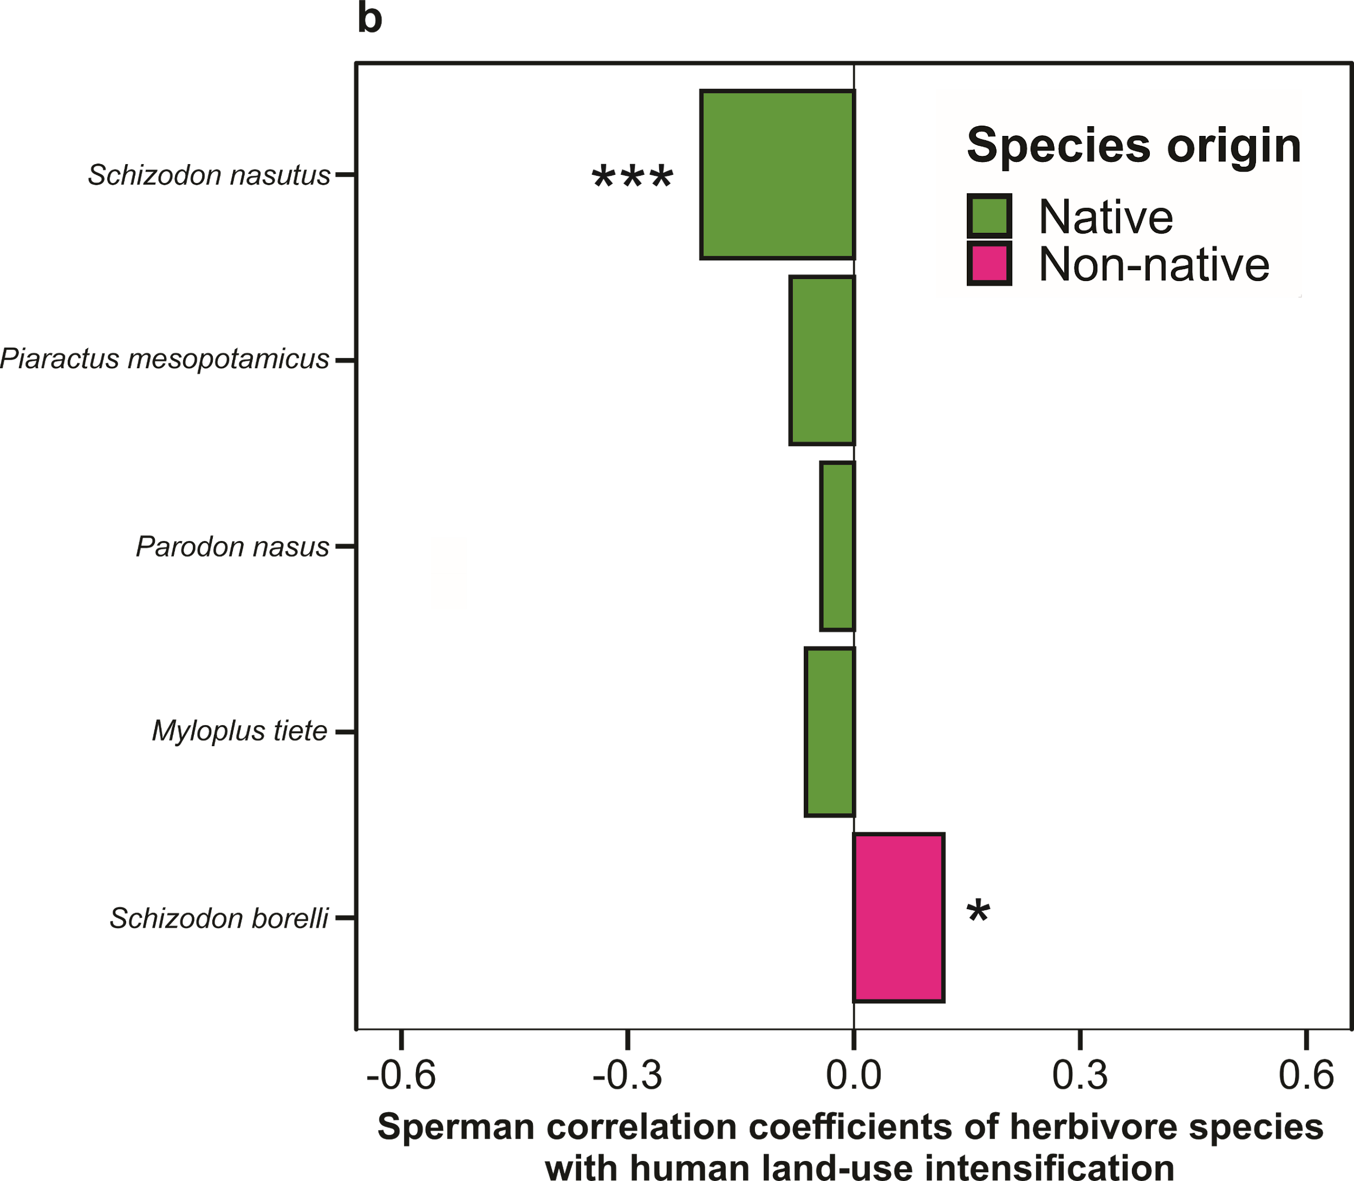
Supplementary Fig. 5| Correlation between the biomass of 5 herbivore fish species and human land-use intensification across the floodplain system. Spearman correlation matrix of herbivore native (green; 4 species) and non-native (pink; 1 species) fish species with human land-use. Negative values indicate a low human land-use effect (left), while positive values represent a high human land-use effect (right). The stars in front of the bars indicate the significance of the correlation, where significance levels are *P < 0.05, **P < 0.01, ***P < 0.001.

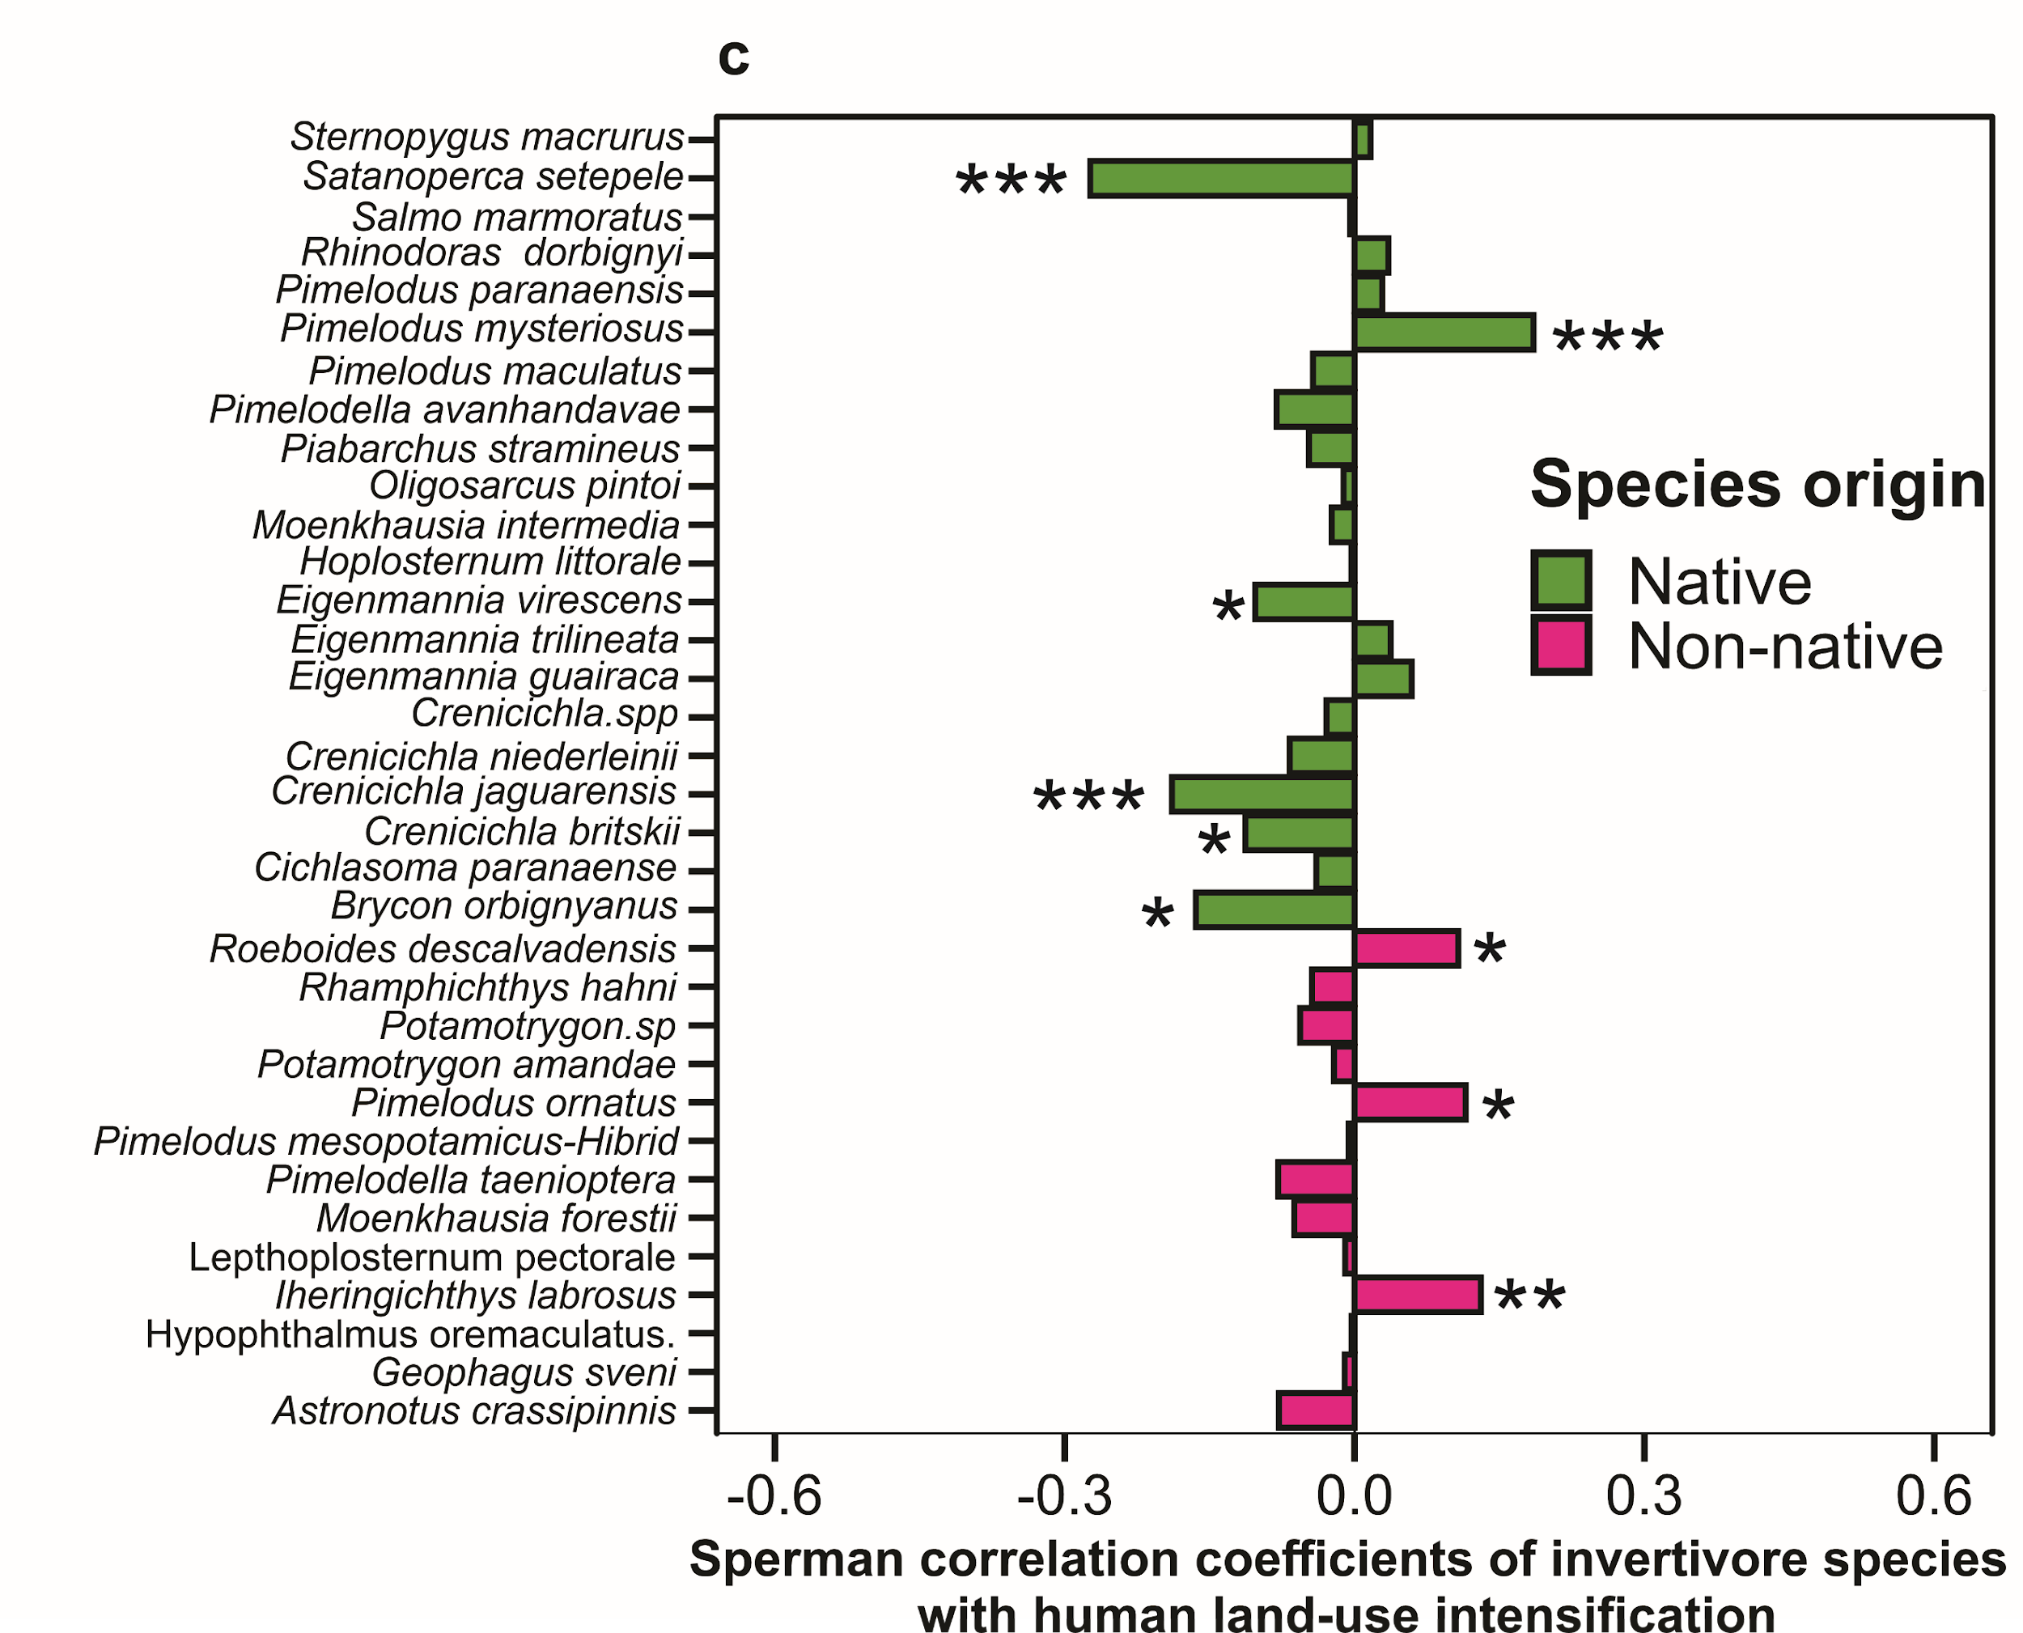
Supplementary Fig. 6| Correlation between the biomass of 34 invertivore fish species and human land-use intensification across the floodplain system. Spearman correlation matrix of invertivore native (green; 21 species) and non-native (pink; 13 species) fish species with human land-use. Negative values indicate low human land-use effects (left), while positive values represent high human land-use effects (right). The stars in front of the bars indicate the significance of the correlation, where significance levels are *P < 0.05, **P < 0.01, ***P < 0.001.

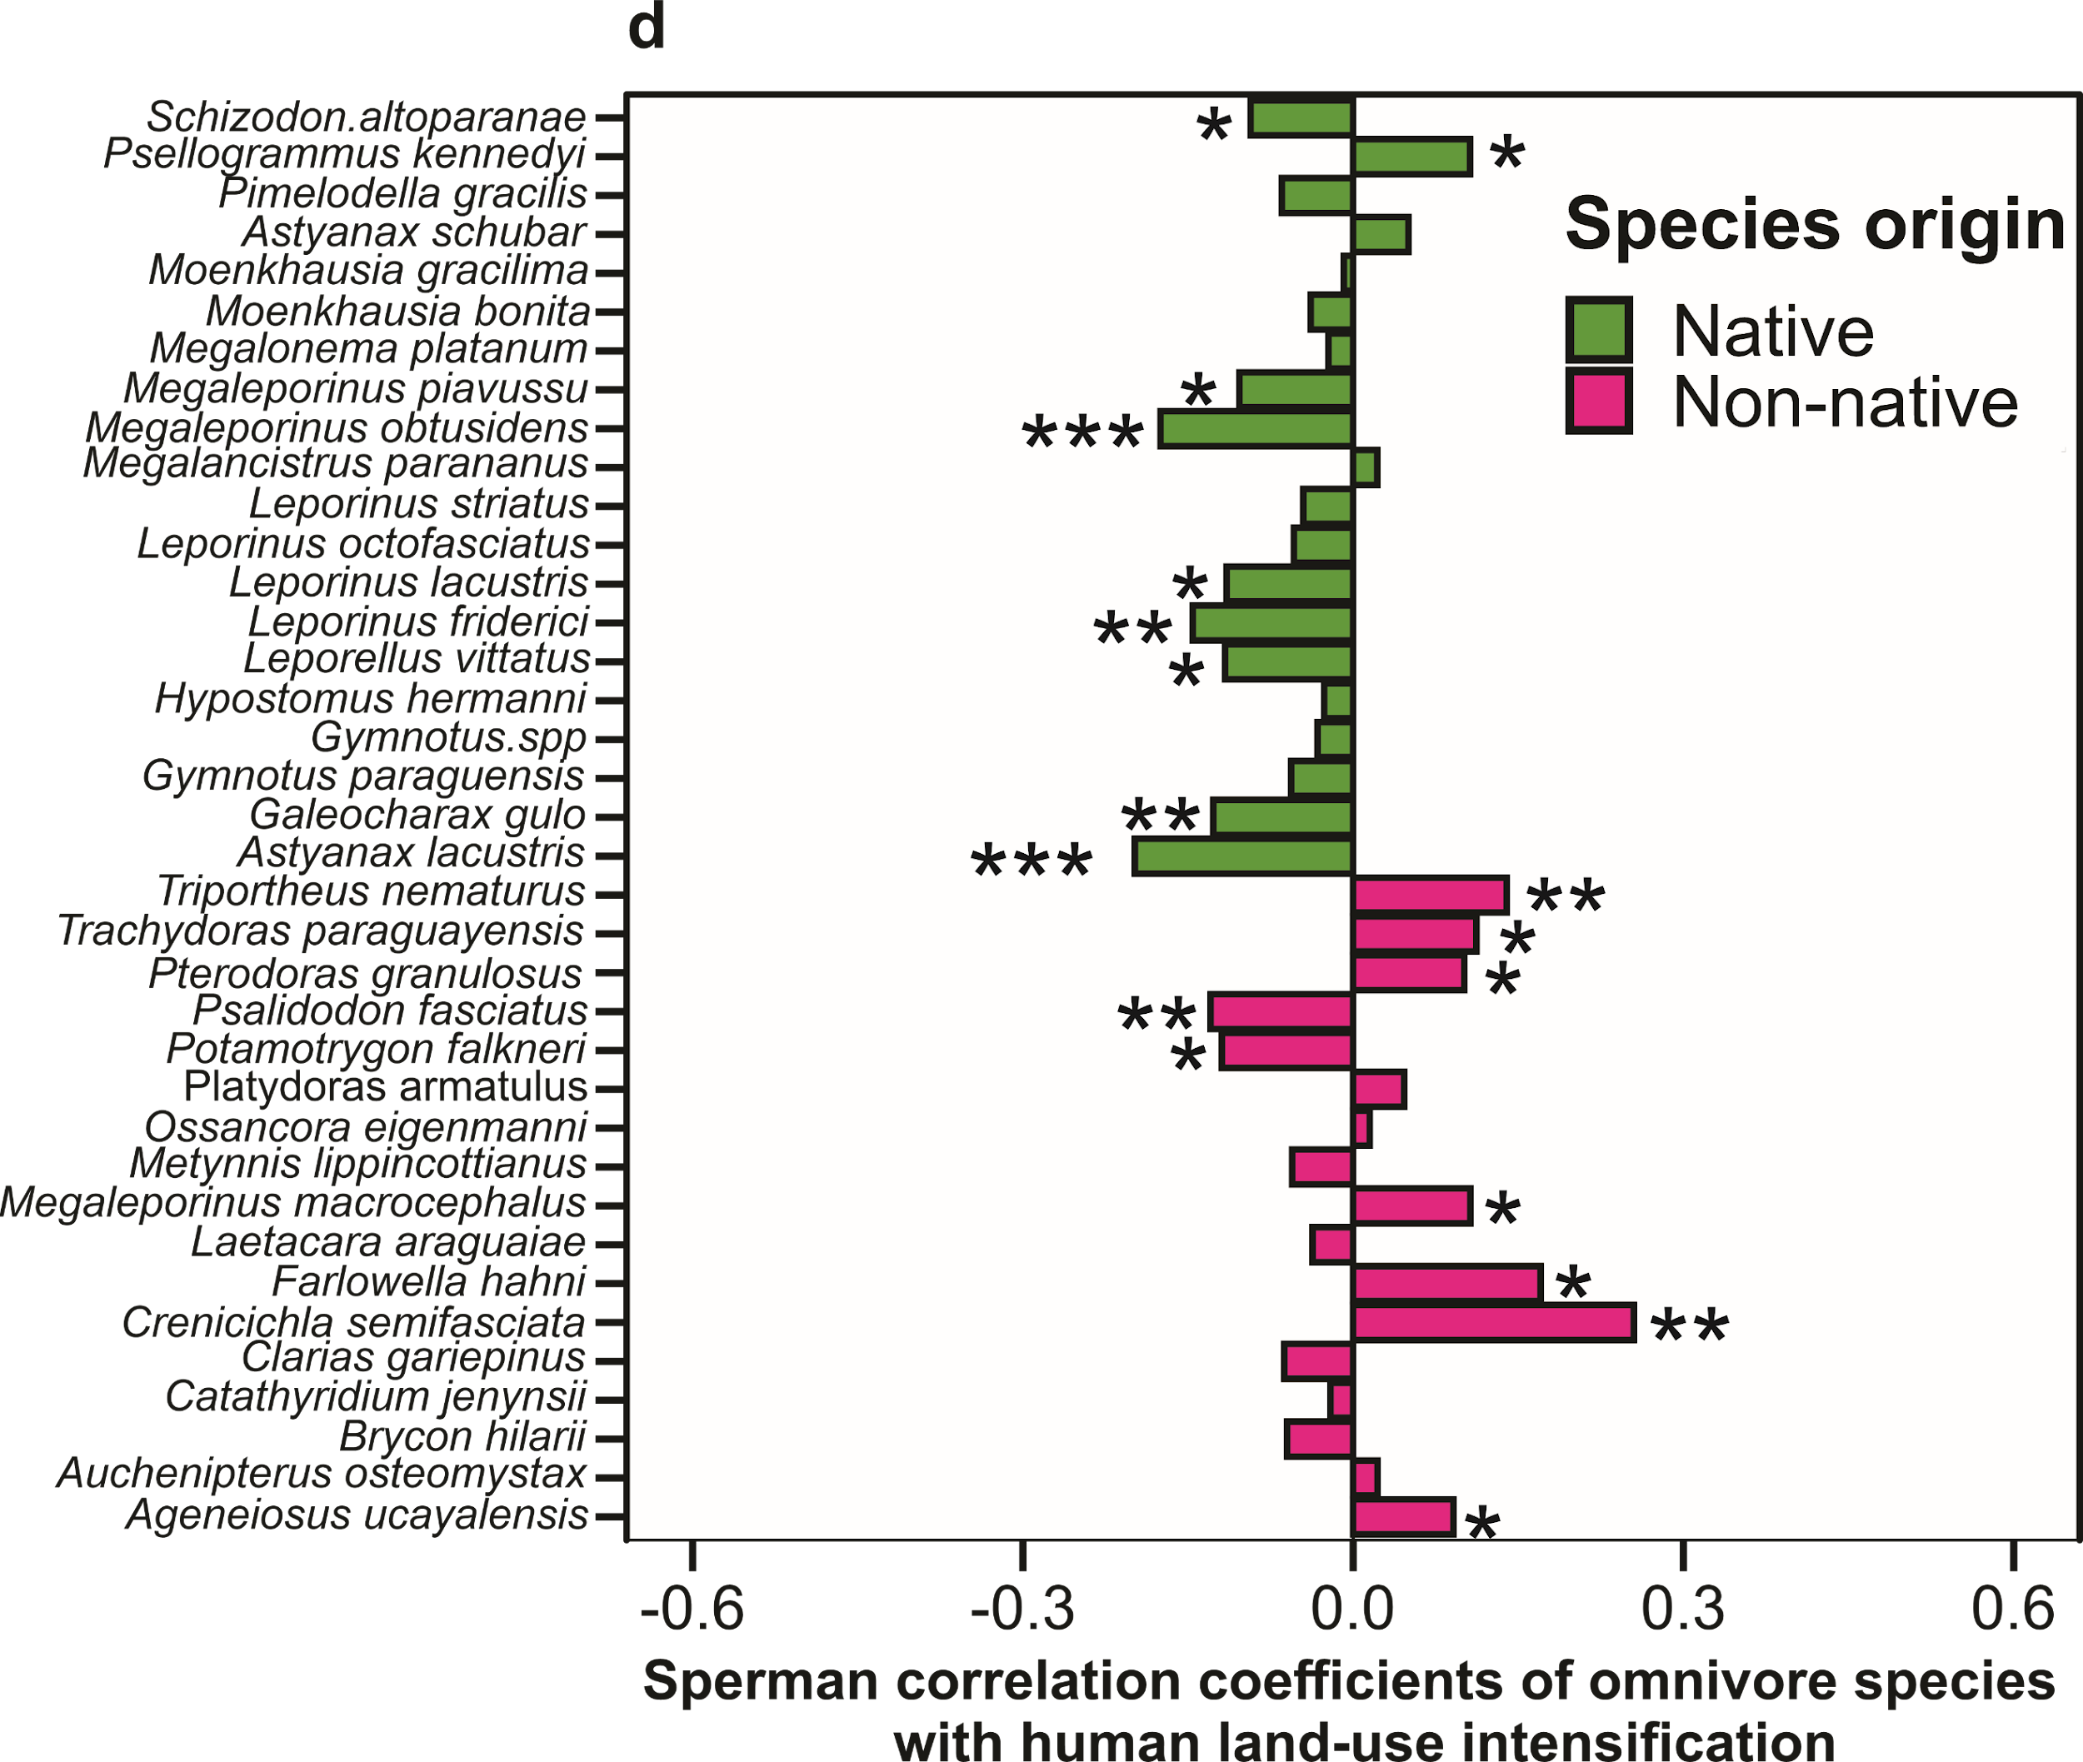
Supplementary Fig. 7| Correlation between the biomass of 37 omnivore fish species and human land-use intensification across the floodplain system. Spearman correlation matrix of omnivore native (green; 20 species) and non-native (pink; 17 species) fish species with human land-use. Negative values indicate low human land-use effects (left), while positive values represent high human land-use effects (right). The stars in front of the bars indicate the significance of the correlation, where significance levels are *P < 0.05, **P < 0.01, ***P < 0.001.

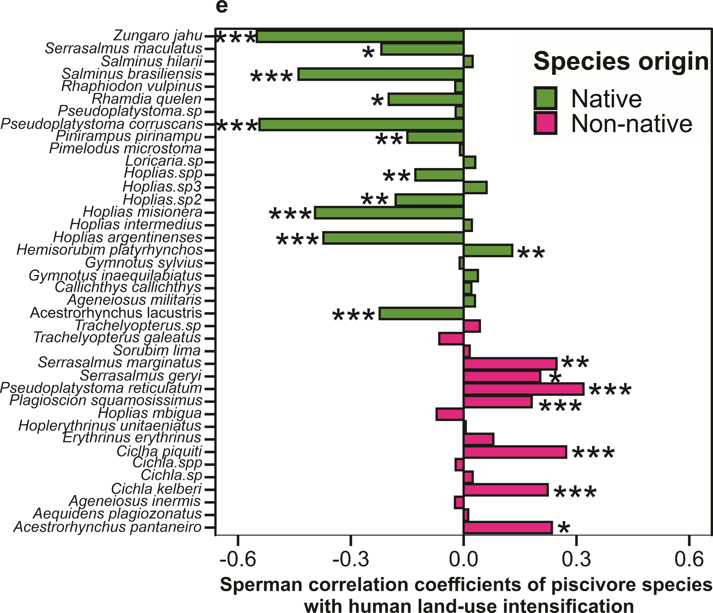
Supplementary Fig. 8| Correlation between the biomass of 40 piscivore fish species and human land-use intensification across the floodplain system. Spearman correlation matrix of piscivore native (green; 23 species) and non-native (pink; 17 species) fish species with human land-use. Negative values indicate low human land-use effects (left), while positive values represent high human land-use effects (right). The stars in front of the bars indicate the significance of the correlation, where significance levels are *P < 0.05, **P < 0.01, ***P < 0.001.

Supplementary Fig. 9| Mean and 95% confidence interval of the size spectrum exponents for the whole-community. Mean and confidence intervals of the size spectrum exponents of the whole-fish community in each year from 2002 to 2022 in eight environments of the Paraná floodplain. Size spectrum exponents were calculated using body mass from a power law in the maximum likelihood estimation method (MLE method) for continuous body mass.

Supplementary Fig. 10| Mean and 95% confidence interval of the size spectrum exponents for the native species only. Mean and confidence intervals of the size spectrum exponents of the native fish species in each year from 2002 to 2022 in eight environments of the Paraná floodplain. Size spectrum exponents were calculated using body mass from a power law in the maximum likelihood estimation method (MLE method) for continuous body mass.

Supplementary Fig. 11| Mean and 95% confidence interval of the size spectrum exponents for the non-native species only. Mean and confidence intervals of the size spectrum exponents of the non-native fish species in each year from 2002 to 2022 in eight environments of the Paraná floodplain. Size spectrum exponents were calculated using body mass from a power law in the maximum likelihood estimation method (MLE method) for continuous body mass.

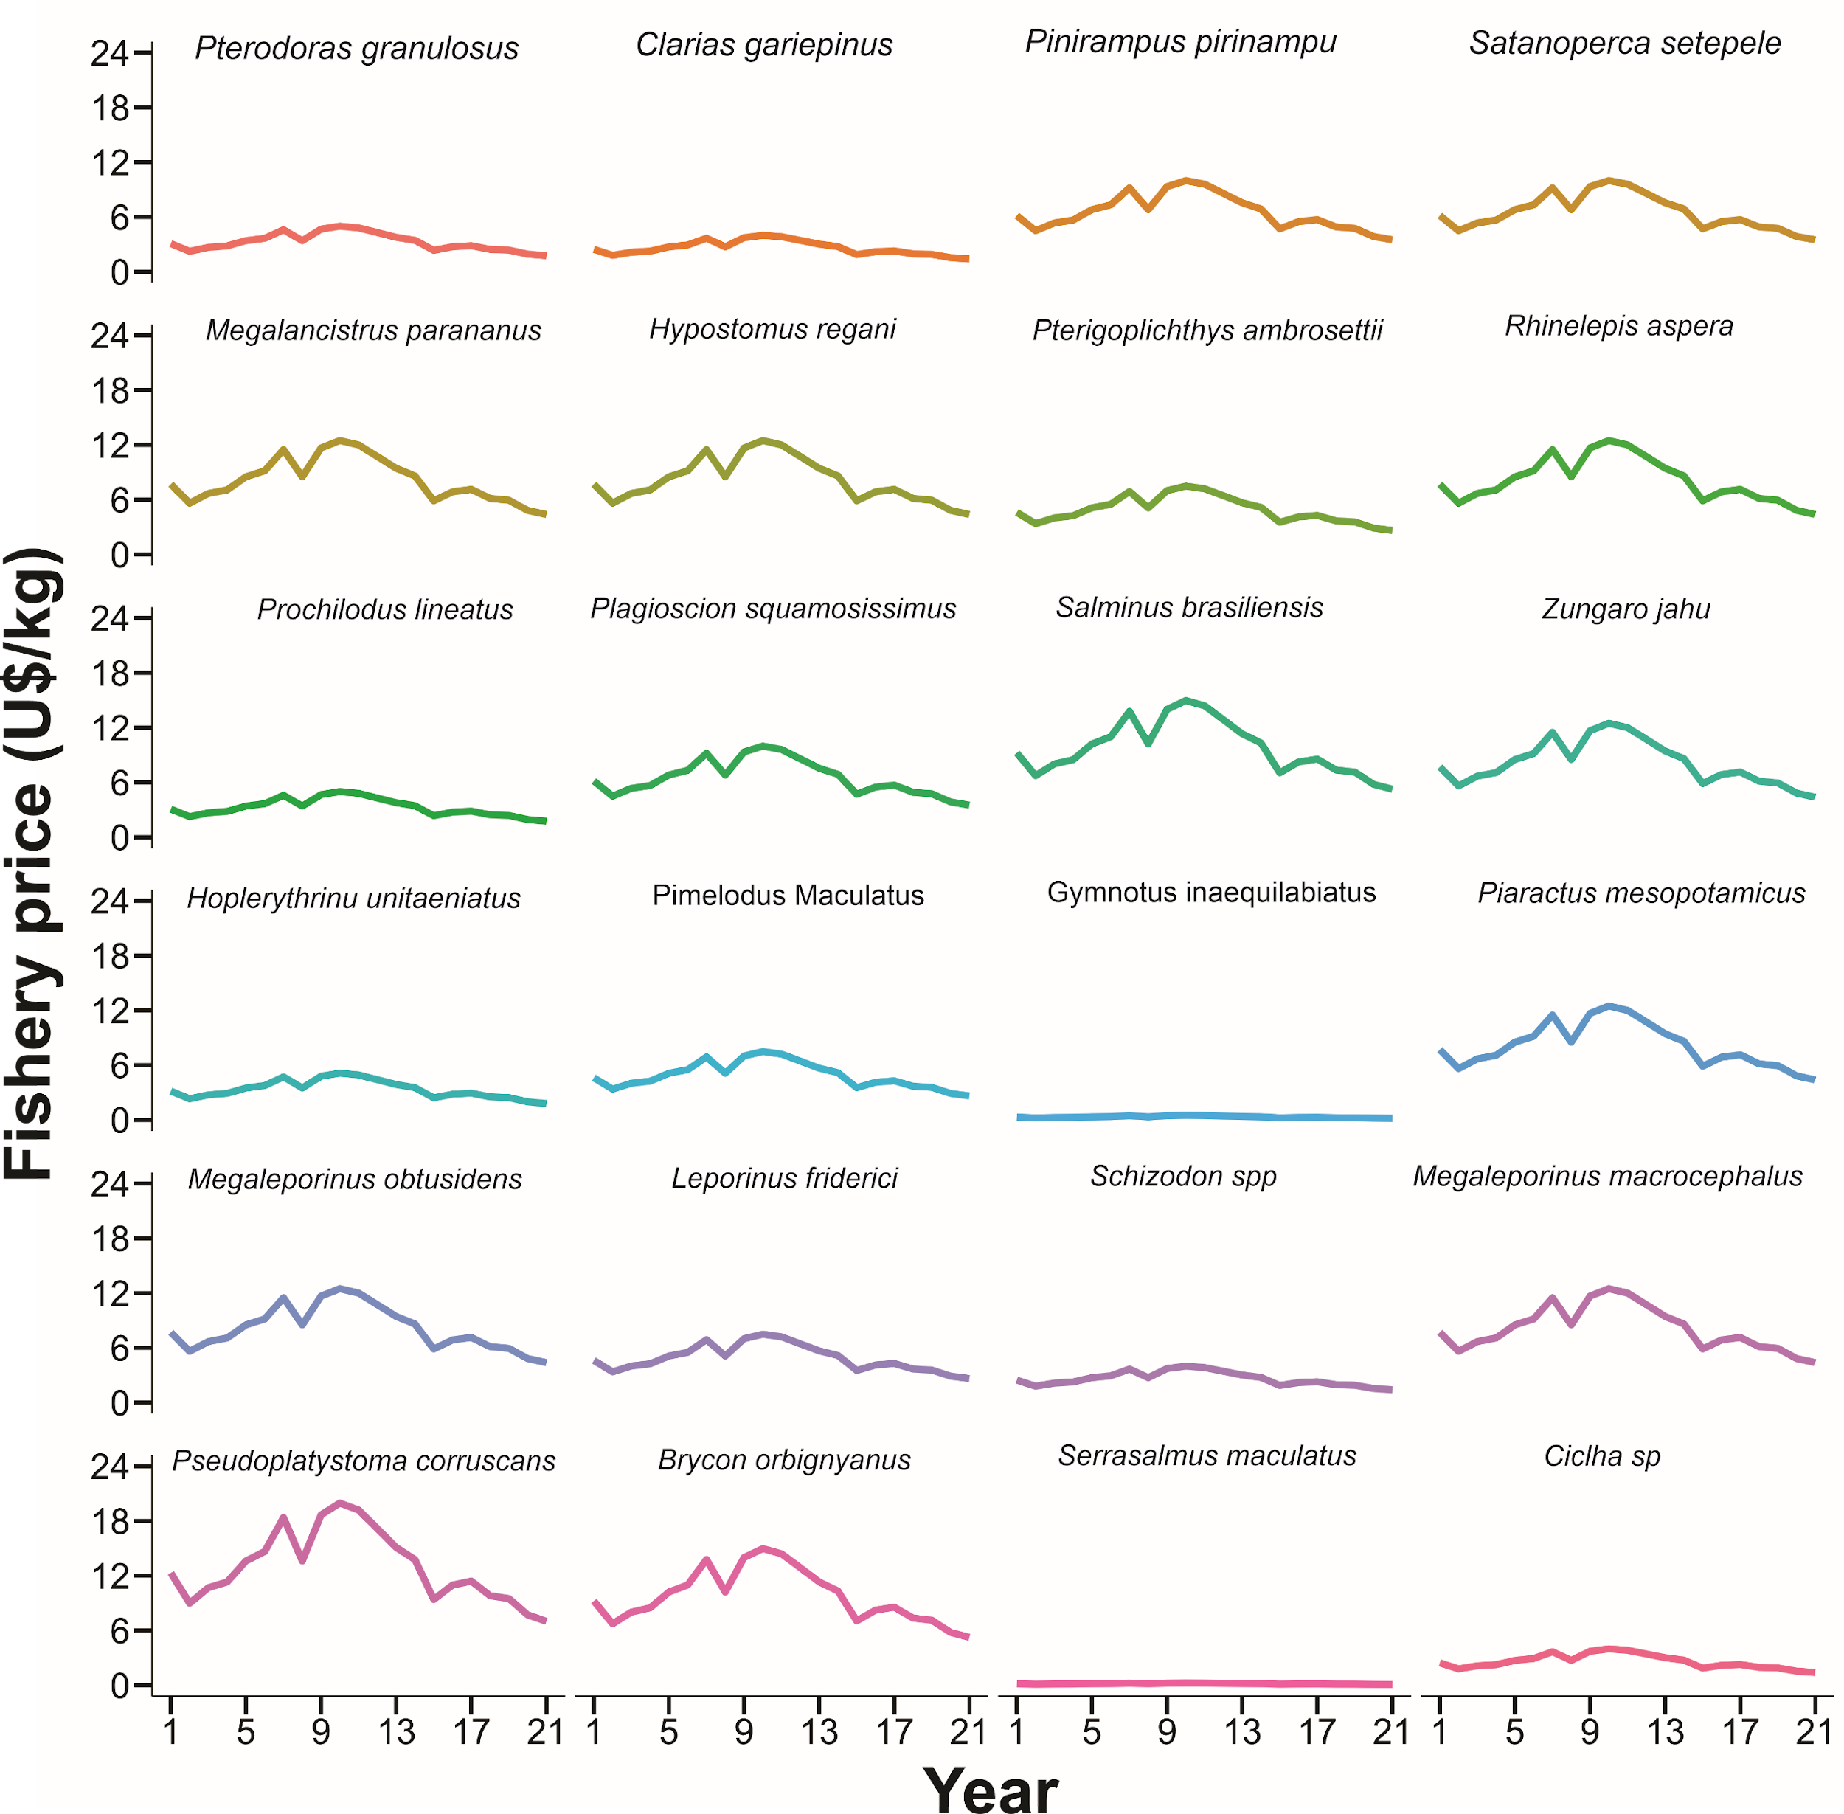
Supplementary Fig. 12| Time series of the price of 24 economically important species in the Upper Parana River. The prices were converted into dollars (U$) following the specific quotations for each year from 1 (2002) to 21 year (2022).

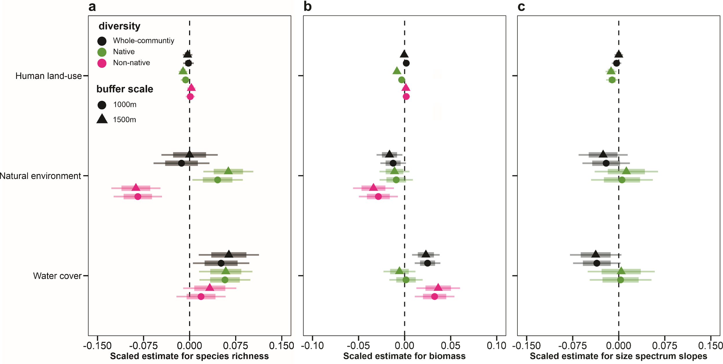
Supplementary Fig. 13| Effects of land-use on species richness, biomass and size spectrum slope of fish community in 1000m and 1500m. Estimated coefficients for the effects of human land-use (agriculture + urbanization), natural environments (forest + wetland), and water cover (river + lakes) measured at 1000 (circle) and 1500 resolutions (triangle) on (a) species richness, (b) biomass, and (c) size spectra slope of whole-community (black), native species (green) and non-native species (pink). Effect sizes were adjusted using linear mixed-effects models. Thick lines represent 75% CIs, and thin lines represent 95% CIs. Species richness was modeled on a square root-scale and biomass was modelled on the log-scale.

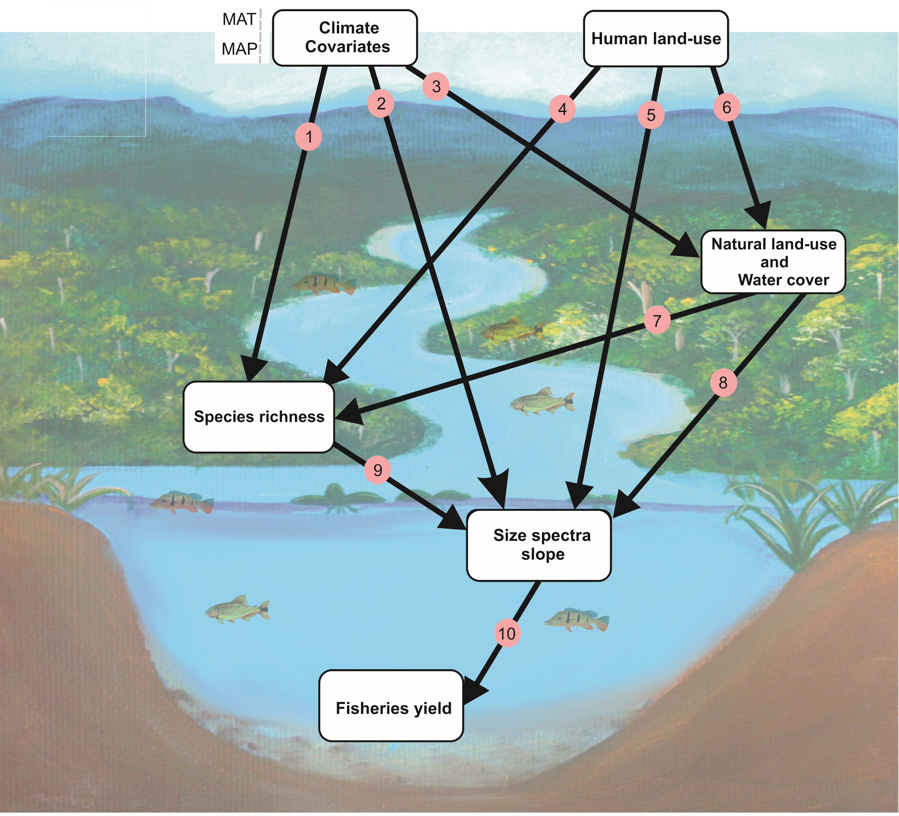
# | Links | Rationale | Ref.
1 | Climate ~ Species richness | Climate is also a key driver of species richness across multiple taxonomic groups. Studies have shown positive effects of rainfall and temperature on fish species richness. | 5–8
2 | Climate ~ Size spectra | Climate is expected to control the functional traits of multiple aquatic organisms. Climate will affect the body size of fish communities. Evidence has shown that increased temperatures reduce the body size of fish. Increased rainfall increases the diversity of large migratory fish, indirectly increasing the size structure of communities. | 7–9
3 | Climate ~ Natural environments | Climate is perhaps the most important factor affecting forest cover and water availability in aquatic environments. Evidence shows that increased precipitation is strongly associated with greater forest cover and water availability. | 10–12
4 | Human land-use ~ Species richness | Human land-use are considered a major driver of global taxonomic biodiversity decline. Cultivated and urban areas generally cause sharp declines in fish richness. | 13–16
5 | Human land-use ~ Size spectra | The conversion of natural landscapes into cropland and urban settlements has caused body size declines in many aquatic and terrestrial communities, including invertebrates and fishes. | 17–20
6 | Human land-use ~ Natural environments | Urban and cultivated areas are major drivers of deforestation worldwide. Generally, increasing urban and cultivated areas is causing forest declines. | 21–23.
7 | Natural environments ~ Species richness | Forest cover is a major structuring factor for fish diversity. Terrestrial forests increase fish richness by increasing the availability of allochthonous resources such as fruit, terrestrial insects, and detritus. | 23–28
8 | Natural environments ~ Size spectra | Terrestrial forests provide an important energy subsidy for aquatic trophic chains. This mainly impacts large-bodied individuals. For example, stable isotope analyses have revealed that much of the biomass of large-bodied individuals in Neotropical rivers comes from allochthonous origin. | 27,28
9 | Species richness ~ Size spectra | Species richness can be a major driver of the body size of natural communities. For example, in fish communities, high species richness occurs during periods of high hydrological levels, when large-bodied individuals are abundant. Consequently, it can be expected that higher fish richness is related to a higher number of large-bodied individuals and a flattened size spectrum slope. | 3,7,8
10 | Size spectra ~ Fisheries yield | In the floodplains, the most economically important fishing species are large-bodied individuals. Therefore, it is expected that as the size spectrum increases (i.e., flatted size spectrum) the fishery yield should increase. | 29–32
Supplementary Fig. 14| A priori structural equation modeling (SEM) aimed to evaluate how human land-use, natural environments, water cover, precipitation, and temperature affect direct and indirect diversity-mediated size spectra slope of native species and whole-community. All variables in the model were measured at stream level, and represent the real conditions of the stream environments. Different categories of predictors were grouped into the same box in the model for graphical simplicity (e.g., climate). However, they were considered individually in the model. In the table, we provide the conceptual support for all the links within the model based on results from other studies. Therefore, all relationships within our model occur in nature and are not spurious.

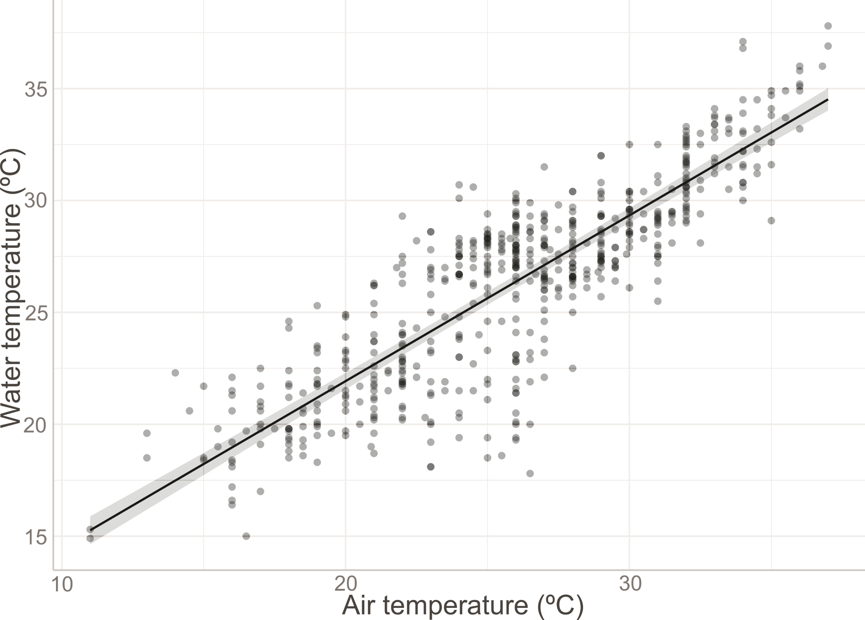
Supplementary Fig. 15| Association between instantaneous water and mean monthly air temperature (ºC) in the floodplain environments. Linear mixed effects model (LMM) analysis revealed a strong relationship between water temperature and air temperature: slope = 0.740, SE = 0.018, df = 578, p < 0.001. SE = standard error; df = degrees of freedom. Solid black line is a predicted fit of LMM, and the shaded area shows the 95% confidence interval. Environments were included as a random factor in the LMM model to account for their independence.

Supplementary Table 1| Fish species researched in the study. The table contains the origin of the species (native or non-native) and its specific trophic level. The trophic level was based on literature data and stomach contents of the species. The places where the species are present can be rivers, lakes or both. The number of sites refers to how many environments the species was found in, 8 of which were studied.
species | origin | trophic level | Present sites | Number of sites presence
Hoplosternum littorale | Native | Invertivore | Both | 8
Moenkhausia aff intermedia | Native | Invertivore | Both | 8
Acestrorhynchus lacustris | Native | Piscivore | Both | 8
Astyanax lacustris | Native | Omnivore | Both | 8
Cyphocharax nagelii | Native | Detritivore | Both | 4
Hoplias spp. | Native | Piscivore | Both | 8
Leporinus friderici | Native | Omnivore | Both | 8
Megaleporinus piavussu | Native | Omnivore | Both | 8
Prochilodus lineatus | Native | Detritivore | Both | 8
Pseudoplatystoma corruscans | Native | Piscivore | Both | 8
Serrasalmus maculatus | Native | Piscivore | Both | 8
Steindachnerina insculpta | Native | Detritivore | Both | 8
Pimelodus microstoma | Native | Piscivore | Both | 4
Rhaphiodon vulpinus | Native | Piscivore | Both | 7
Callichthys callichthys | Native | Piscivore | Both | 7
Gymnotus spp. | Native | Omnivore | Both | 5
Eigenmannia trilineata | Native | Invertivore | Both | 7
Hemisorubim platyrhynchos | Native | Piscivore | Both | 8
Leporinus lacustris | Native | Omnivore | Both | 8
Astyanax schubar | Native | Omnivore | Both | 3
Piaractus mesopotamicus | Native | Herbivore | Both | 8
Pimelodus Maculatus | Native | Piscivore/invertivore | Both | 8
Salminus brasiliensis | Native | Piscivore | Both | 7
Schizodon altoparanae | Native | Omnivore | Both | 6
Sternopygus macrurus | Native | Invertivore | Both | 2
Hypostomus.spp | Native | Detritivore | Both | 5
Pimelodella gracilis | Native | Omnivore | Both | 7
Loricaria sp. | Native | Piscivore | Both | 7
Rhinodoras dorbignyi | Native | Invertivore | River | 2
Salminus hilarii | Native | Piscivore | Both | 6
Schizodon nasutus | Native | Herbivore | Both | 4
Apareiodon affinis | Native | Detritivore | River | 2
Crenicichla britskii | Native | Invertivore | Both | 8
Crenicichla jaguarensis | Native | Invertivore | River | 2
Cyphocharax modestus | Native | Detritivore | Both | 7
Galeocharax gulo | Native | Omnivore | Both | 4
Hypostomus regani | Native | Detritivore | Both | 5
Myloplus tiete | Native | Herbivore | River | 2
Piabarchus stramineus | Native | Invertivore | River | 2
Satanoperca setepele | Native | Invertivore | Both | 8
Gymnotus inaequilabiatus | Native | Piscivore | Both | 8
Hypostomus ancistroides | Native | Detritivore | Both | 5
Pinirampus pirinampu | Native | Piscivore | Both | 4
Rhinelepis aspera | Native | Detritivore | Both | 6
Oligosarcus pintoi | Native | Invertivore | Both | 1
Ageneiosus militaris | Native | Piscivore | Both | 6
Eigenmannia virescens | Native | Invertivore | Both | 4
Cichlasoma paranaense | Native | Invertivore | Both | 6
Pimelodella avanhandavae | Native | Invertivore | Both | 7
Apteronotus ellisi | Native | Piscivore | River | 1
Megalancistrus parananus | Native | Omnivore | River | 2
Hypostomus strigaticeps | Native | Detritivore | River | 3
Parodon nasus | Native | Herbivore | River | 2
Pimelodus mysteriosus | Native | Piscivore/Invertivore | Both | 8
Leporinus octofasciatus | Native | Omnivore | River | 2
Gymnotus sylvius | Native | Piscivore | Lake | 4
Megaleporinus obtusidens | Native | Omnivore | Both | 8
Hoplias intermedius | Native | Piscivore | River | 1
Salmo marmoratus | Native | Piscivore/Invertivore | Lake | 1
Crenicichla niederleinii | Native | Invertivore | River | 1
Rhamdia quelen | Native | Piscivore | Both | 3
Gymnotus paraguensis | Native | Omnivore | Lake | 1
Brycon orbignyanus | Native | Invertivore | Both | 8
Pimelodus paranaensis | Native | Piscivore/Invertivore | River | 1
Leporellus vittatus | Native | Omnivore | River | 1
Leporinus striatus | Native | Omnivore | River | 2
Hoplias argentinenses | Native | Piscivore | Both | 8
Hoplias sp. 2 | Native | Piscivore | Both | 8
Hypostomus iheringii | Native | Detritivore | Both | 4
Hoplias misionera | Native | Piscivore | Lake | 4
Zungaro jahu | Native | Piscivore | River | 2
Pseudoplatystoma sp. | Native | Piscivore | River | 2
Moenkhausia gracilima | Native | Omnivore | River | 2
Steindachnerina spp. | Native | Detritivore | Lake | 1
Hypostomus hermanni | Native | Omnivore | River | 2
Hypostomus albopunctatus | Native | Omnivore | River | 2
Psellogrammus kennedyi | Native | Omnivore | Lake | 5
Crenicichla spp | Native | Invertivore | River | 1
Loricaaria prolixa | Native | Detritivore | Both | 4
Megalonema platanum | Native | Omnivore | River | 1
Crenicichla haroldoi | Native | Invertivore | River | 1
Cyphocharax.sp | Native | Detritivore | Lake | 1
Eigenmannia guairaca | Native | Invertivore | Lake | 1
Moenkhausia bonita | Native | Omnivore | Both | 2
Hoplias sp. 3 | Native | Piscivore | Lake | 1
Hypophthalmus oremaculatus | Non-native | Invertivore | Both | 7
Loricariichthys platymetopon | Non-native | Detritivore | Both | 8
Plagioscion squamosissimus | Non-native | Piscivore | Both | 8
Pterygoplichthys ambrosettii | Non-native | Detritivore | Both | 8
Serrasalmus marginatus | Non-native | Piscivore | Both | 8
Trachelyopterus galeatus | Non-native | Piscivore | Both | 8
Auchenipterus osteomystax | Non-native | Omnivore | Both | 8
Cichla kelberi | Non-native | Piscivore | Both | 8
Metynnis lippincottianus | Non-native | Omnivore | Both | 8
Roeboides descalvadensis | Non-native | Invertivore | Both | 8
Schizodon borelli | Non-native | Herbivore | Both | 8
Steindachnerina brevipinna | Non-native | Detritivore | Both | 8
Hoplerythrinus unitaeniatus | Non-native | Piscivore | Both | 8
Laetacara araguaiae | Non-native | Omnivore | Both | 3
Pterodoras granulosus | Non-native | Omnivore | Both | 8
Rhamphichthys hahni | Non-native | Invertivore | Both | 8
Sorubim lima | Non-native | Piscivore | Both | 8
Loricariichthys rostratus | Non-native | Detritivore | Both | 6
Trachydoras paraguayensis | Non-native | Omnivore | Both | 8
Psalidodon fasciatus | Non-native | Omnivore | River | 2
Astronotus crassipinnis | Non-native | Piscivore/Invertivore | Both | 8
Iheringichthys labrosus | Non-native | Invertivore | Both | 7
Megaleporinus macrocephalus | Non-native | Omnivore | Both | 8
Catathyridiumjenynsii | Non-native | Omnivore | Both | 6
Ciclha piquiti | Non-native | Piscivore | Both | 8
Pimelodus ornatus | Non-native | Piscivore/Invertivore | Both | 6
Hypostomus cochliodon | Non-native | Detritivore | Both | 7
Erythrinus erythrinus. | Non-native | Piscivore | Both | 5
Ossancora eigenmanni | Non-native | Omnivore | Both | 5
Cichla sp. | Non-native | Piscivore | Both | 4
Potamotrygon amandae | Non-native | Piscivore/Invertivore | Both | 5
Ageneiosus inermis. | Non-native | Piscivore | Both | 7
Colossoma macropomun. | Non-native | Herbivore | River | 2
Pimelodus mesopotamicu-Hibrid | Non-native | Piscivore/Invertivore | Both | 3
Clarias gariepinus | Non-native | Omnivore | Both | 7
Potamotrygon sp. | Non-native | Piscivore/Invertivore | Lake | 2
Ageneiosus ucayalensis | Non-native | Omnivore | Both | 4
Apteronotus caudimaculosus | Non-native | Piscivore | Lake | 1
Hypostomus ternetzi | Non-native | Detritivore | River | 1
Potamotrygon falkneri | Non-native | Omnivore | River | 2
Geophagus sveni | Non-native | Invertivore | Both | 8
Hypostomus commersoni | Non-native | Detritivore | River | 2
Hoplias mbigua | Non-native | Piscivore | Both | 8
Hemiodus orthonops | Non-native | Detritivore | Both | 8
Pseudoplatystoma reticulatum | Non-native | Piscivore | Lake | 2
Lepthoplosternum pectorale | Non-native | Invertivore | Both | 7
Acestrorhynchus pantaneiro | Non-native | Piscivore | Both | 3
Platydoras armatulus | Non-native | Omnivore | Both | 3
Moenkhausia forestii | Non-native | Invertivore | Lake | 1
Brycon hilarii | Non-native | Omnivore | Lake | 1
Pimelodella taenioptera | Non-native | Invertivore | River | 1
Cichla spp. | Non-native | Piscivore | River | 1
Trachelyopterus sp. | Non-native | Piscivore | Both | 6
Aequidens plagiozonatus | Non-native | Piscivore | Lake | 2
Farlowella hahni | Non-native | Omnivore | River | 2
Triportheus nematurus | Non-native | Omnivore | Both | 4
Serrasalmus geryi | Non-native | Piscivore | River | 2
Crenicichla semifasciata | Non-native | Omnivore | Both | 5

Supplementary Table 2| Fisheries landed and price (US$/kg/m²) of 24 economically important fish species in the upper Paraná River floodplain from 2002 to 2022. Average annual fishing landings of each species were estimated by adding up the landings for March, June, September, and October in 8 cities in Brazil (Diamante do Norte, Guaíra, Icaraíma, Itaquiraí, Marilena, Porto Rico, Porto São José, and Querência do Norte). The price per kg was estimated as an average (mean ± standard deviation) between 2002 and 2002. However, we estimated the price (US$/kg) for each year, and the prices were corrected for inflation. Species with an asterisk (*) in front of their name are non-native species of the upper Paraná River basin.
Species | Popular name | Average fish landings | Average Annual Price (US$)  Mean ±SD
Pinirampus pirinampu | Barbado | 2948 | 4.13±1.17
Pseudoplatystoma corruscans | Pintado | 2836 | 8.26±2.34
Salminus brasiliensis | Dourado | 1459 | 6.20±1.76
Zungaro jahu | Jaú | 184 | 5.17±1.46
Brycon orbignyanus | Picaranjuba | 1164 | 6.20±1.76
Piaractus mesopotamicus | Pacu | 1006 | 5.17±1.46
Hypostomus regani | Cascudo Barata | 2678 | 5.17±1.46
Megalancistrus parananus | Cascudo-Abacaxi | 2678 | 5.17±1.46
Rhinelepis aspera | Cascudo-Preto | 2678 | 5.17±1.46
Gymnotus inaequilabiatus | Morenita | 1890 | 0.21±0.06
Leporinus friderici | Piau | 2586 | 3.10±0.88
Megaleporinus obtusidens | Piapara | 4100 | 5.17±1.46
Pimelodus Maculatus | Mandí | 1997 | 3.10±0.88
Prochilodus lineatus | Curimba | 16682 | 2.07±0.59
Serrasalmus maculatus | Piranha | 231 | 0.10±0.03
Clarias gariepinus* | Bagre | 1281 | 1.65±0.47
Ciclha sp.* | Tucunaré | 204 | 1.65±0.47
Satanoperca setepele | Cará | 86 | 4.13±1.17
Plagioscion squamosissimus* | Curvina | 2529 | 4.13±1.17
Pterigoplichthys ambrosettii* | Cascudo-Lagoa | 2678 | 3.10±0.88
Pterodoras granulosus* | Armado | 9893 | 2.07±0.59
Megaleporinus macrocephalus* | Piavuçu | 1787 | 5.17±1.46
Hoplerythrinus unitaeniatus* | Jejú | 390 | 2.12±0.60
Schizodon borelli* | Chimboré | 400 | 1.65±0.47

Supplementary Table 3| Temporal trends in diversity, size spectra, and ecosystem service in floodplain environments. GAMMs examine the temporal trends of species richness, biomass, and size spectra exponents of whole-community, native and non-native fishes. In addition, GAMMs also examine the annual trends in fisheries potential in floodplain environments. The year is the fixed effect, whereas environments and seasons are random factors.
source of variation | F-value | p-value | R²_{adjusted}
Species richness
whole-community | 0.201 | 0.657 | 0.006
native species | 26.35 | <0.001*** | 0.104
non-native species | 42.88 | <0.001*** | 0.169
Biomass
whole-community | 14.13 | <0.001*** | 0.278
native species | 25.27 | <0.001*** | 0.272
non-native species | 9.285 | <0.001*** | 0.147
Size spectra exponent
whole-community | 9.513 | 0.002 | 0.044
native species | 10.85 | <0.001*** | 0.163
non-native species | 98.63 | <0.001*** | 0.359
Ecosystem service
fishery potential | 37.49 | <0.001*** | 0.487

Supplementary Table 4| Coefficient estimates and confidence intervals from mixed-effects models that included interaction terms to test the relationship between the size spectra exponent of native species and whole-community, and non-native species and whether this relationship changes over time. We reproduced the slopes (95%) and the p-value for the effects additive and interactive (native species × time). CI, 95% confidence interval. Std.Error, standard error of the estimate.
response | explanatory variables | estimate | 95% CI (lower-upper) | Std.Error | p-value | R²_{marginal}
Whole-community exponent | native exponent | 0.40 | 0.25, 0.56 | 0.079 | <0.001 | 0.222
Whole-community exponent | time | –0.01 | –0.02, 0.00 | 0.006 | 0.132
 | native exponent*time | –0.02 | –0.03, –0.00 | 0.005 | 0.006
Non-native exponent | native exponent | 0.11 | 0.09, –0.31 | 0.101 | 0.266 | 0.388
 | time | 0.00 | –0.02, –0.02 | 0.008 | 0.977
 | native exponent*time | –0.02 | –0.03, –0.00 | 0.007 | 0.035

Supplementary Table 5| Standardized direct paths of all drivers, including species richness (native and non-native), human land-use, natural environments, water cover, water temperature and precipitation on the size spectrum exponents (slope) of native and non-native fishes and the consequences to ecosystem service (measured as fishery potential; main document, Fig. 4). This table includes all significant and nonsignificant paths considered by our model, as well as those variables which were allowed to covary. Double-headed arrows indicate the variables that covary (error correlations).
Predictors |  | Response | Standardized coefficients | Std.Error | P-value
Fig. 4
native species richness path: R²_{marginal} = 0.44; R²_{conditional} = 0.49
time |  | native richness | –0.240 | 0.057 | 0.003
natural environments |  | native richness | 0.247 | 0.179 | 0.006
water cover |  | native richness | –0.015 | 0.174 | 0.845
precipitation |  | native richness | 0.238 | 0.000 | 0.003
temperature |  | native richness | 0.217 | 0.306 | 0.016
non-native species richness path: R²_{marginal} = 0.44; R²_{conditional} = 0.47
time |  | non-native richness | 0.691 | 0.046 | <0.001
natural environments |  | non-native richness | 0.136 | 0.140 | 0.133
water cover |  | non-native richness | 0.110 | 0.140 | 0.176
precipitation |  | non-native richness | –0.014 | 0.000 | 0.860
temperature |  | non-native richness | –0.100 | 0.247 | 0.276
native size spectrum slope path: R²_{marginal} = 0.25; R²_{conditional} = 0.26
time |  | native exponent | –0.164 | 0.005 | 0.169
native richness |  | native exponent | 0.388 | 0.005 | <0.001
non-native richness |  | native exponent | –0.060 | 0.008 | 0.589
non-native size spectra slope path: R²_{marginal} = 0.37; R²_{conditional} = 0.46
time |  | non-native exponent | 0.304 | 0.003 | 0.004
native richness |  | non-native exponent | –0.081 | 0.004 | 0.383
non-native richness |  | non-native exponent | 0.289 | 0.005 | 0.003
native exponent |  | non-native exponent | 0.088 | 0.064 | 0.297
ecosystem service path: R²_{marginal} = 0.21; R²_{conditional} = 0.33
native exponent |  | fishery potential | 0.279 | 0.379 | 0.001
non-native exponent |  | fishery potential | –0.314 | 0.517 | <0.001
interactions among drivers
human land-use path: R²_{marginal} = 0.01; R²_{conditional} = 0.95
time |  | human land-use | 0.119 | 0.085 | 0.002
natural environments path: R²_{marginal} = 0.17; R²_{conditional} = 0.73
time |  | natural environments | –0.098 | 0.027 | 0.199
human land-use |  | natural environments | –0.509 | 0.024 | <0.001
precipitation |  | natural environments | 0.230 | 0 | 0.002
water cover path: R²_{marginal} = 0.25; R²_{conditional} = 0.32
time |  | water cover | –0.358 | 0.027 | <0.001
human land-use |  | water cover | –0.342 | 0.014 | <0.001
precipitation |  | water cover | –0.043 | 0 | 0.609
error correlations
natural environments |  | temperature | 0.270 | – | 0.002
fishery potential |  | water cover | –0.192 | – | 0.022
fishery potential |  | time | 0.325 | – | <0.001

Supplementary Table 6| Land use and cover categories and main transitions in the 1500m buffers between 2001 and 2022.
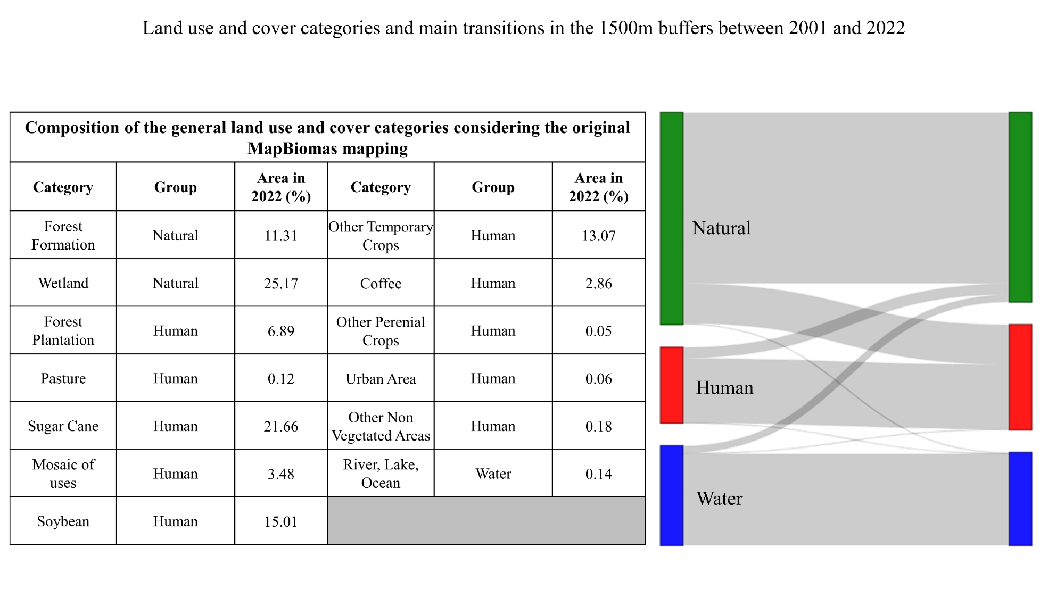
S2: Model Diagnostic Plots
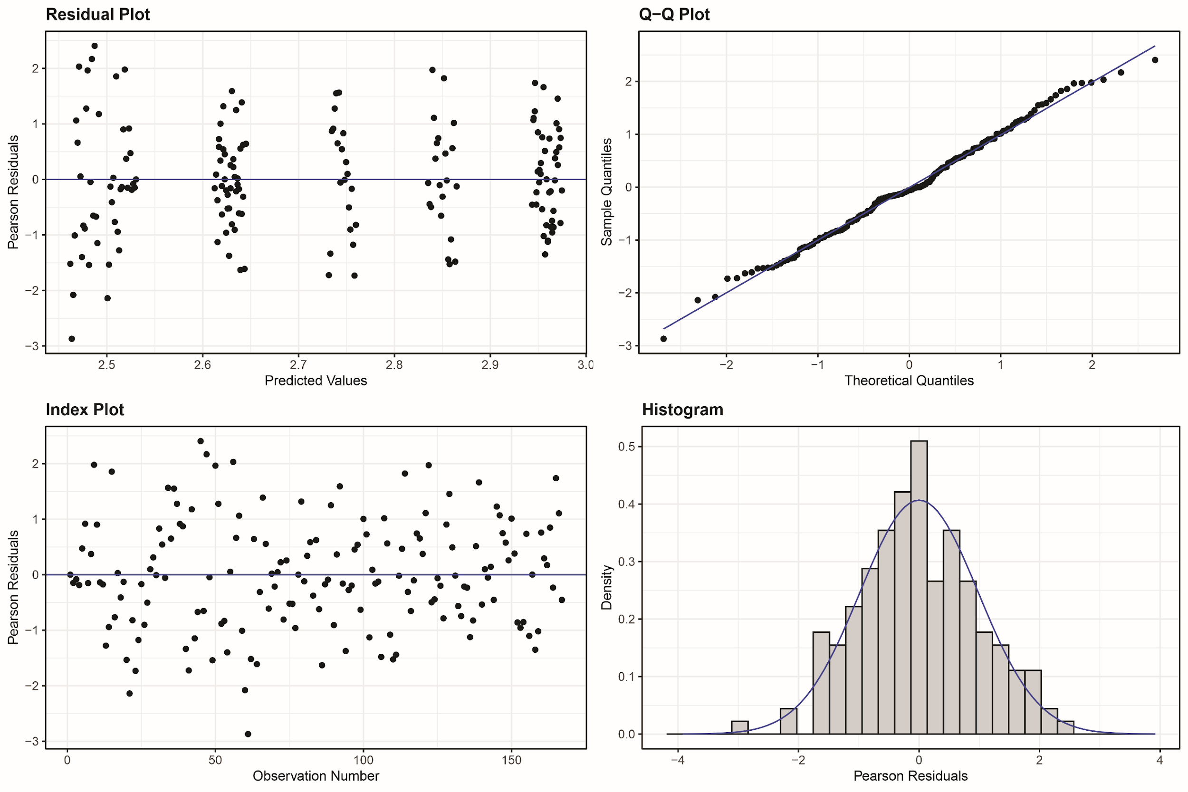
Supplementary Fig. 16| Model checks for the generalized additive mixed models (GAMM) of the whole-community species richness as a function of time. a, Predicted (fitted) values versus residuals to check for constant variance across the range of fitted values. b, Normal Q-Q plot to check the normality of the residuals. c, plot of residuals versus observation numbers to check how well the entire set of observed values for observation points matches the solution data. d, a histogram of residuals to check the dispersion of the residuals.

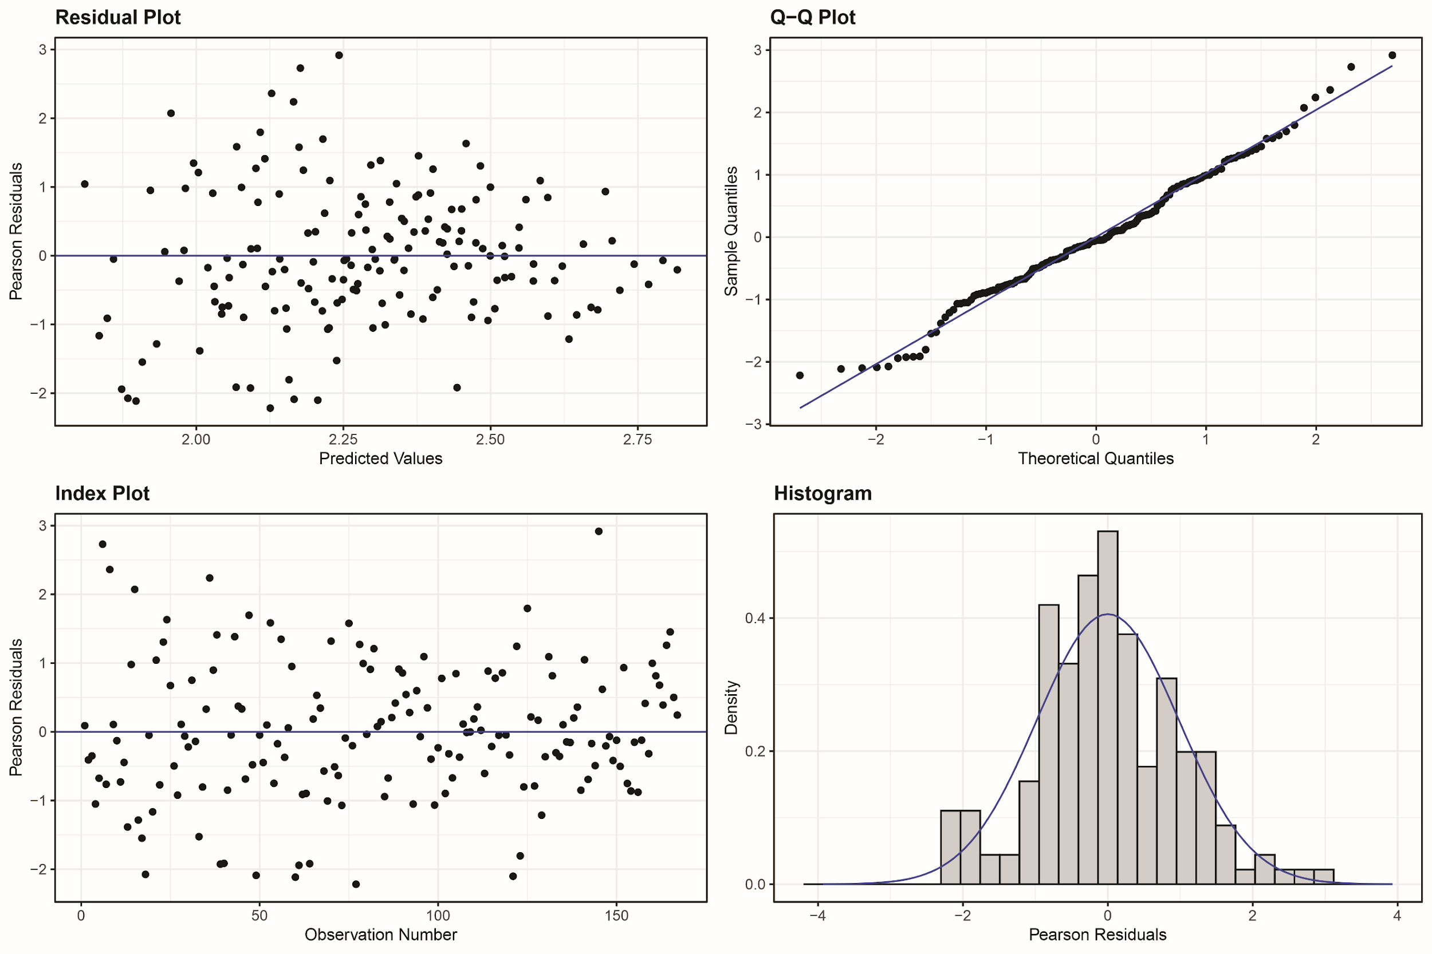
Supplementary Fig. 17| Model checks for the generalized additive mixed models (GAMM) of the native species richness as a function of time. a, Predicted (fitted) values versus residuals to check for constant variance across the range of fitted values. b, Normal Q-Q plot to check the normality of the residuals. c, plot of residuals versus observation numbers to check how well the entire set of observed values for observation points matches the solution data. d, a histogram of residuals to check dispersion of the residuals.

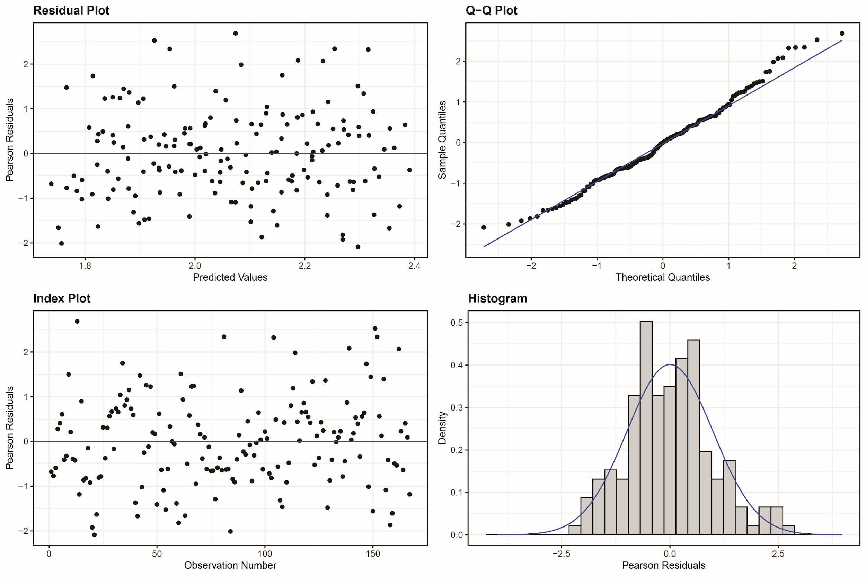
Supplementary Fig. 18| Model checks for the generalized additive mixed models (GAMM) of the non-native species richness as a function of time. a, Predicted (fitted) values versus residuals to check for constant variance across the range of fitted values. b, Normal Q-Q plot to check the normality of the residuals. c, plot of residuals versus observation numbers to check how well the entire set of observed values for observation points matches the solution data. d, a histogram of residuals to check dispersion of the residuals.

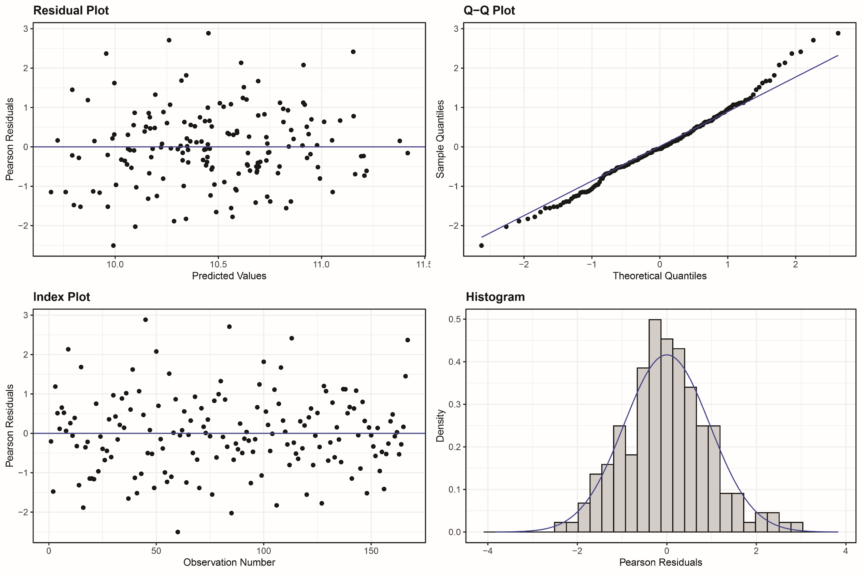
Supplementary Fig. 19| Model checks for the generalized additive mixed models (GAMM) of the whole-community biomass as a function of time. a, Predicted (fitted) values versus residuals to check for constant variance across the range of fitted values. b, Normal Q-Q plot to check the normality of the residuals. c, plot of residuals versus observation numbers to check how well the entire set of observed values for observation points matches the solution data. d, a histogram of residuals to check dispersion of the residuals.

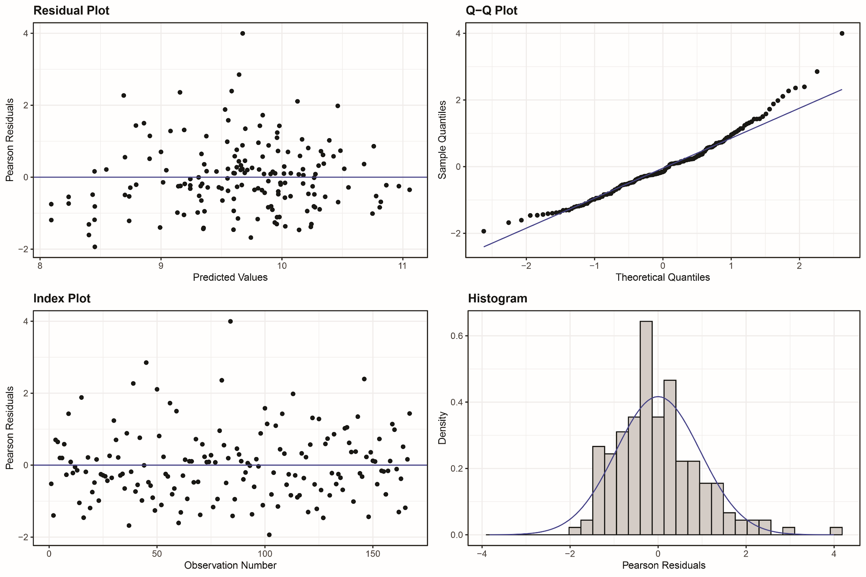
Supplementary Fig. 20| Model checks for the generalized additive mixed models (GAMM) of the native biomass as a function of time. a, Predicted (fitted) values versus residuals to check for constant variance across the range of fitted values. b, Normal Q-Q plot to check the normality of the residuals. c, plot of residuals versus observation numbers to check how well the entire set of observed values for observation points matches the solution data. d, a histogram of residuals to check dispersion of the residuals.

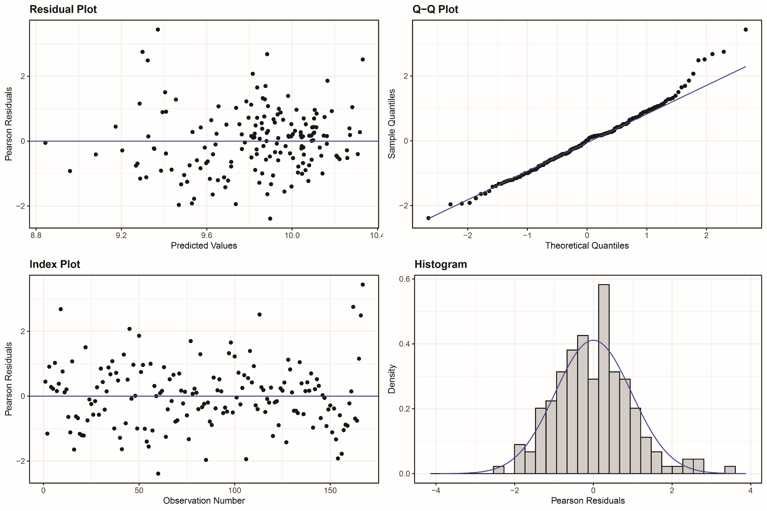
Supplementary Fig. 21| Model checks for the generalized additive mixed models (GAMM) of the non-native biomass as a function of time. a, Predicted (fitted) values versus residuals to check for constant variance across the range of fitted values. b, Normal Q-Q plot to check the normality of the residuals. c, plot of residuals versus observation numbers to check how well the entire set of observed values for observation points matches the solution data. d, a histogram of residuals to check dispersion of the residuals.

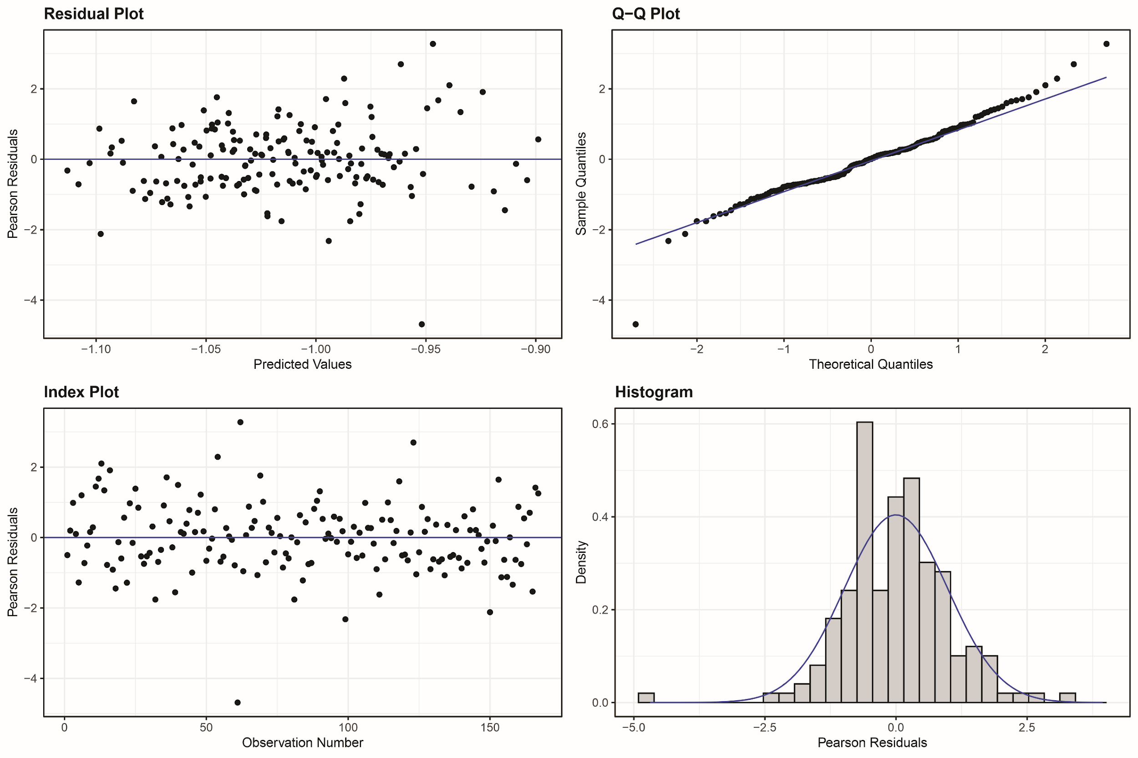
Supplementary Fig. 22| Model checks for the generalized additive mixed models (GAMM) of the whole-community size spectra exponent as a function of time. a, Predicted (fitted) values versus residuals to check for constant variance across the range of fitted values. b, Normal Q-Q plot to check the normality of the residuals. c, plot of residuals versus observation numbers to check how well the entire set of observed values for observation points matches the solution data. d, a histogram of residuals to check dispersion of the residuals.

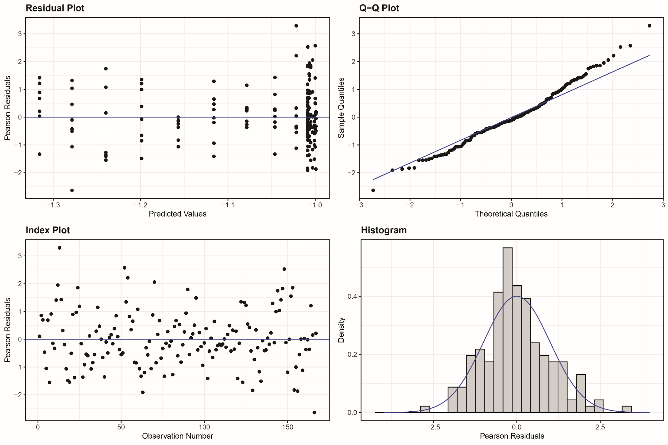
Supplementary Fig. 23| Model checks for the generalized additive mixed models (GAMM) of the native size spectra exponent as a function of time. a, Predicted (fitted) values versus residuals to check for constant variance across the range of fitted values. b, Normal Q-Q plot to check the normality of the residuals. c, plot of residuals versus observation numbers to check how well the entire set of observed values for observation points matches the solution data. d, a histogram of residuals to check dispersion of the residuals.

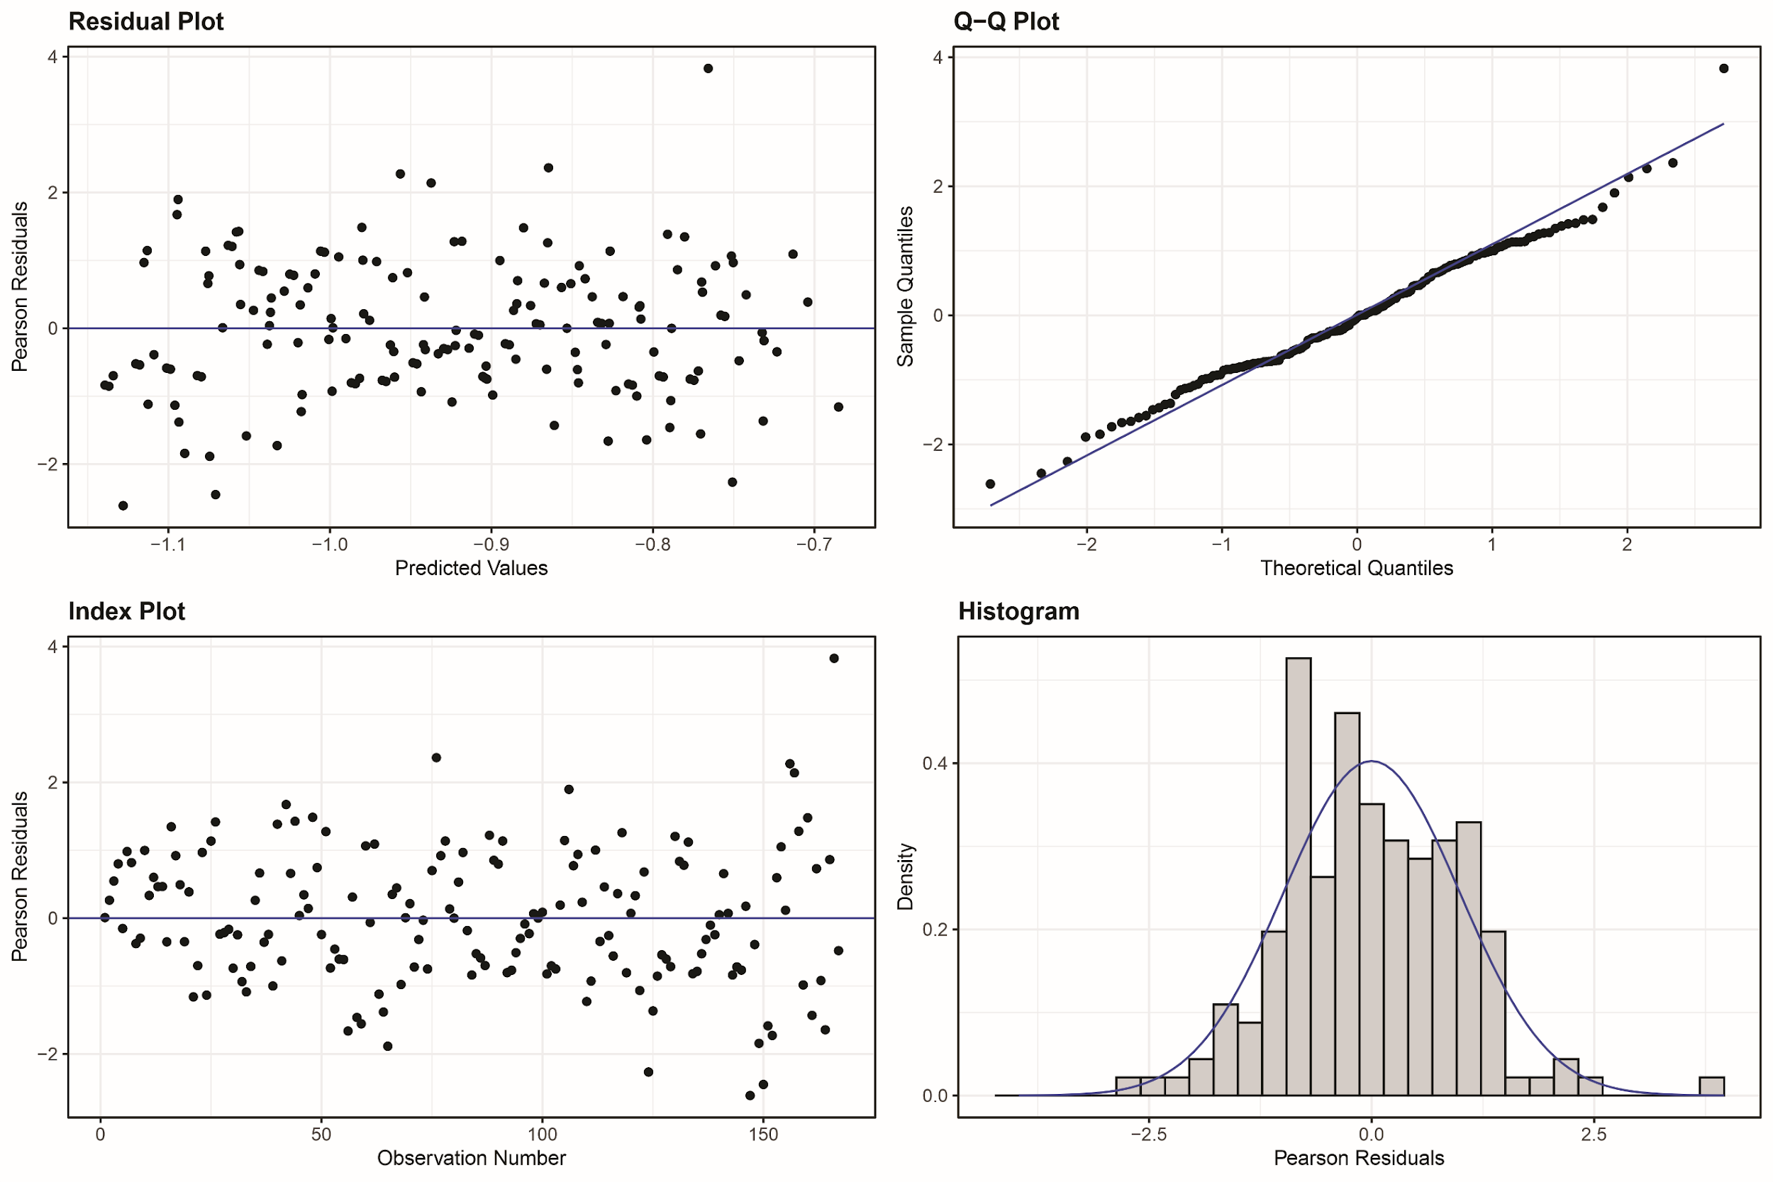
Supplementary Fig. 24| Model checks for the generalized additive mixed models (GAMM) of the non-native size spectra exponent as a function of time. a, Predicted (fitted) values versus residuals to check for constant variance across the range of fitted values. b, Normal Q-Q plot to check the normality of the residuals. c, plot of residuals versus observation numbers to check how well the entire set of observed values for observation points matches the solution data. d, a histogram of residuals to check dispersion of the residuals.

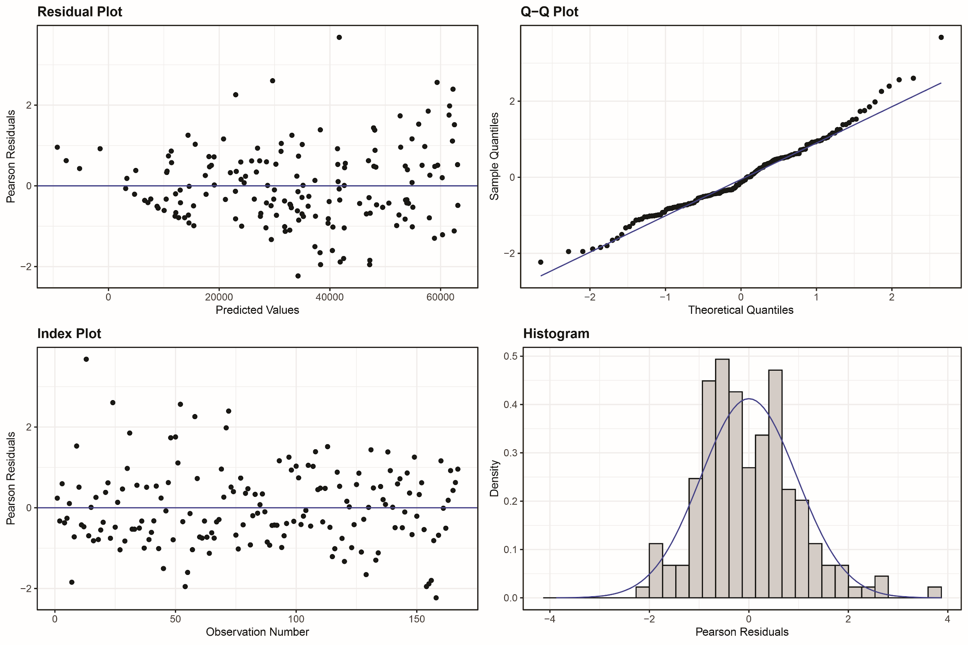
Supplementary Fig. 25| Model checks for the generalized additive mixed models (GAMM) of the fishery potential as a function of time. a, Predicted (fitted) values versus residuals to check for constant variance across the range of fitted values. b, Normal Q-Q plot to check the normality of the residuals. c, plot of residuals versus observation numbers to check how well the entire set of observed values for observation points matches the solution data. d, a histogram of residuals to check dispersion of the residuals.

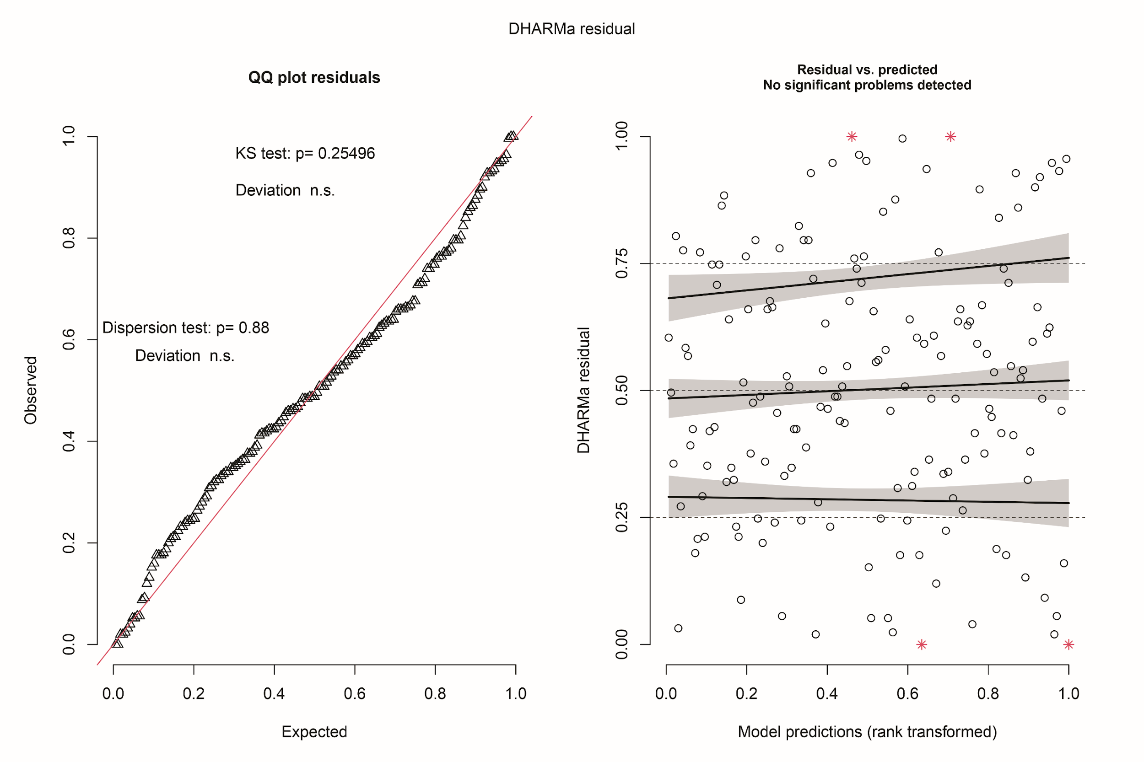
Supplementary Fig. 26|. Model checks for the generalized linear mixed models (GLMM) of the whole-community size spectra exponent as a function of native size spectra exponent and time. a, Normal Q-Q plot to check the normality of the residuals. b, Predicted (fitted) values versus residuals to check for constant variance across the range of fitted values. Durbin-Watson test revealed no temporal autocorrelation in data: DW = 2.148, p-value = 0.7302.

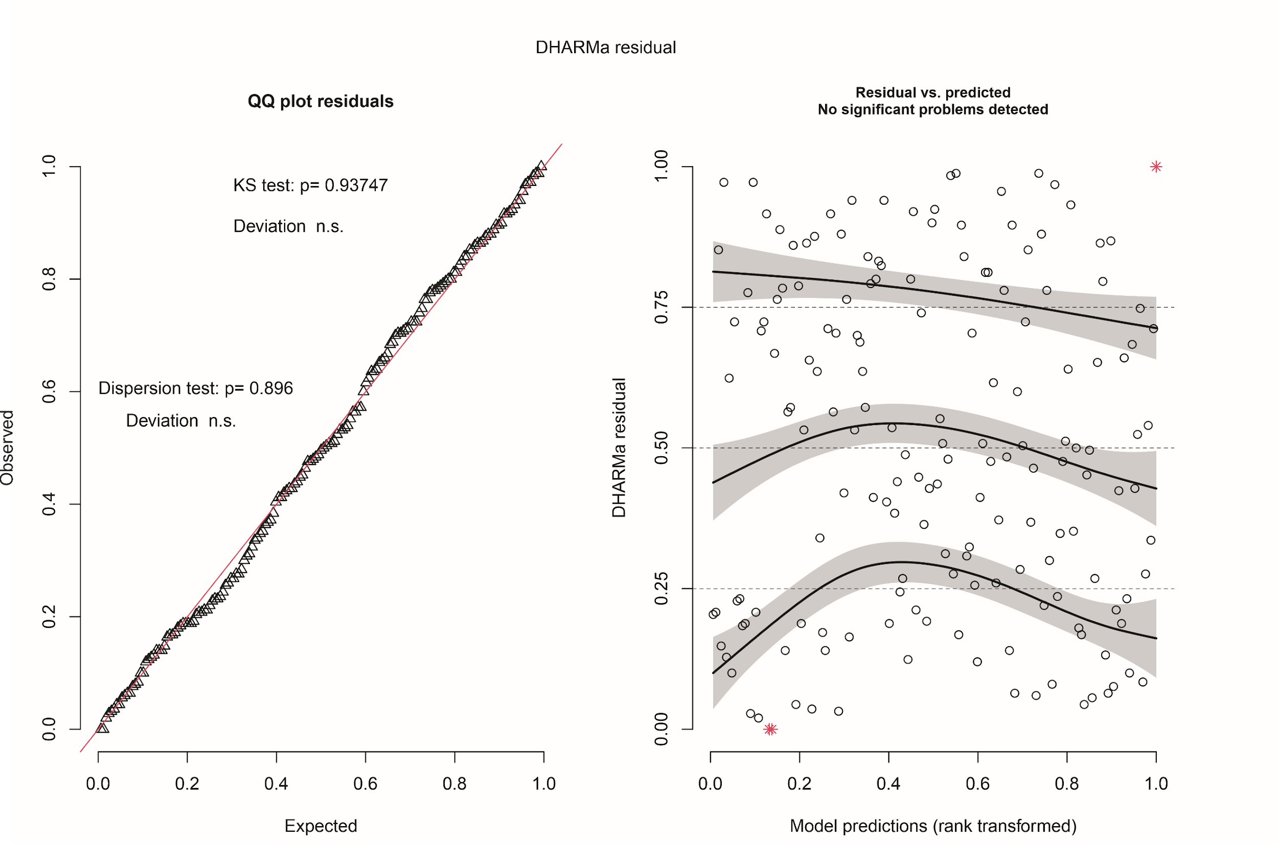

Supplementary Fig. 27|. Model checks for the generalized linear mixed models (GLMM) of the non-native size spectra exponent as a function of native size spectra exponent and time. a, Normal Q-Q plot to check the normality of the residuals. b, Predicted (fitted) values versus residuals to check for constant variance across the range of fitted values. Durbin-Watson test revealed no temporal autocorrelation in data: DW = 2.148, p-value = 0.7302.

References
- Karger, D.N., et al. Data Descriptor: Climatologies at high resolution for the earth’s land surface areas. Sci. Data, 4,170122(2017).
- Pinheiro, J., Bates, D., DebRoy, S., Sarkar, D. & R Core Team. nlme: Linear and nonlinear mixed effects models. R version 3.1.137 https://CRAN. Rproject.org/package=nlme (2018).
- Collyer, G. et al. Land-use intensification systematically alters the size structure of aquatic communities in the Neotropics. Glob. Chang. Biol. 29, 4094–4106.
- Agostinho, A. A., Gomes, L. C., Suzuki, H. I. & Júlio Jr, H. F. Migratory fishes of the Upper Paraná River Basin Brazil. In: Carolsfield, J., Harvey, B., Ross, C. & Baer, A (Eds). Migratory Fishes of South America: Biology, Fisheries, and Conservation Status, pp. 23–78. 23–78. World Fisheries Trust, World Bank, IDRC. Ontario, Canadá, (2003).
- Guo, C. et al. Predicting fish species richness and assemblages with climatic, geographic and morphometric factors: A broad-scale study in Chinese lakes. Limnologica. 54, 66–74 (2015).
- Audzijonyte, A. et al. Fish body size change with temperature but not all species shrink with warming. Nat. Ecol. Evol. 4, 809–814 (2020).
- Oliveira, A. G. et al. Interspecific variation in migratory fish recruitment in the Upper Paraná River: effects of the duration and timing of floods. Enviro. Biol. Fish 98, 1327–1337 (2015).
- Agostinho, A. A. et al. Flood regime, dam regulation and fish in the Upper Paraná River: Effects on assemblage attributes, reproduction and recruitment. Rev. Fish. Biol. Fish. 14, 11–19 (2004).
- Arranz, I., Grenouillet, G., & Cucherousset, J. Human pressures modulate climate warming-induced changes in size spectra of stream fish communities. Nat. Ecol. Evol. 7, 1072–1078 (2023).
- Ehbrecht, M. et al. Global patterns and climatic controls of forest structural complexity. Nat. Comm. 12, 519 (2021).
- Gauthier, S. et al. Boreal forest health and global change. Science 349, 819–822 (2015).
- Teixeira de Mello, F. et al. Effects of urbanization and accessibility to sanitation services on water quality in urban streams in Uruguay. Environ. Monit. Assess. 196,185 (2024).
- Allan, J. D. Landscape and riverscape: the influence of land-use on stream ecosystems. Annu. Rev. Ecol. Evol. Syst. 35, 257–284 (2004).
- Tong, Y. et al. Influence of social and environmental drivers on nutrient concentrations and ratios in lakes: A comparison between China and Europe. Wat. Res. 227, 119347 (2022).
- Moi, D. A. et al. Human land-uses homogenize stream assemblages and reduce animal biomass production. J. Anim. Ecol. 92, 1176–1189 (2023).
- Moi, D. A. et al. Human pressure drives biodiversity–multifunctionality relationships in large Neotropical wetlands. Nat. Ecol. Evol. 6, 1279–1289 (2022).
- Moi, D. A. & Teixeira de Mello, F. Cascading impacts of urbanization on multitrophic richness and biomass stock in neotropical streams. Sci. Tot. Environ. 806, 151398 (2022).
- Merckx, T. et al. Body-size shifts in aquatic and terrestrial urban communities. Nature, 558. 113–116 (2018).
- Collyer, G., et al. Land-use intensification systematically alters the size structure of aquatic communities in the Neotropics. Glob. Change Biol. 29, 4094–4106 (2023).
- Martins, A. et al. Land use change affects macroinvertebrates community size spectrum in streams: the case of Pinus radiata plantations. Freshwater Biol. 61, 69–79 (2016).
- Song, X.-P. et al. Massive soybean expansion in South America since 2000 and implications for conservation. Nat. Sustain. 4, 784–792 (2021).
- Laurance, W. F. et al. Averting biodiversity collapse in tropical forest protected areas. Nature 489, 290–294 (2012).
- Zalles, V. et al. Rapid expansion of human impact on natural land in South America since 1985. Sci. Adv. 7, eabg1620 (2021).
- Kong, X. et al. Reservoir water quality deterioration due to deforestation emphasizes the indirect effects of global change. Wat. Res. 221, 118721 (2022).
- Agostinho, A. A. et al. Fish diversity in the upper Paraná River basin: habitats, fisheries, 912 management and conservation. Aquat. Ecosyst. Health Manag. 10, 174–186 (2007).
- Arantes, C. C. et al. Floodplain land cover affects biomass distribution of fish functional diversity in the Amazon River. Sci. Rep. 9, 16684 (2019).
- Arantes, C. C. et al. Relationships between forest cover and fish diversity in the Amazon River floodplain. J. Appl. Ecol. 55, 386–395 (2017).
- González-Bergonzoni, I. et al. Origin of fish biomass in a diverse subtropical river: an allochthonic supported biomass increase following flood pulses. Ecosystems, 22, 1736–1753 (2019).
- Myers, B. J. et al. Diversity–production relationships of fish communities in freshwater stream ecosystems. Div. Distrib. 27, 1807–1817 (2021).
- Brooks, E. G. E. et al. Global evidence of positive impacts of freshwater biodiversity on fishery yields. Glob. Ecol. Biogeo. 25, 553–562 (2016).
- Pelicice, F. M. et al. Ecosystem services generated by Neotropical freshwater fishes. Hydrobiologia, 850, 2903–2926 (2023).
- Rabuffetti, A. P. et al. Commercial fisheries in a mega unregulated floodplain river: Assessment of the most favourable hydrological conditions for its preservation. J. Fish Biol. 96, 59–73 (2020).

