Additional file 1: Supplementary Information

Escherichia coli combination with PD-1 blockade synergistically enhances immunotherapy in glioblastoma multiforme by regulating the immune cells

Guochen Li, Haiyan Yang, Tengfei Ke, Na Tan, Xiaolan Du, Xirui Duan, Xinyan Zhou, Guangrong Zheng, Chengde Liao

Supplementary Figures and Tables
Supplementary Figure S1 is related to Figure 1.
Supplementary Figure S2 is related to Figure 2.
Supplementary Figure S3 is related to Figure 3.
Supplementary Figure S3 is related to Figure 4.
Supplementary Table S1 is related to Table 1.
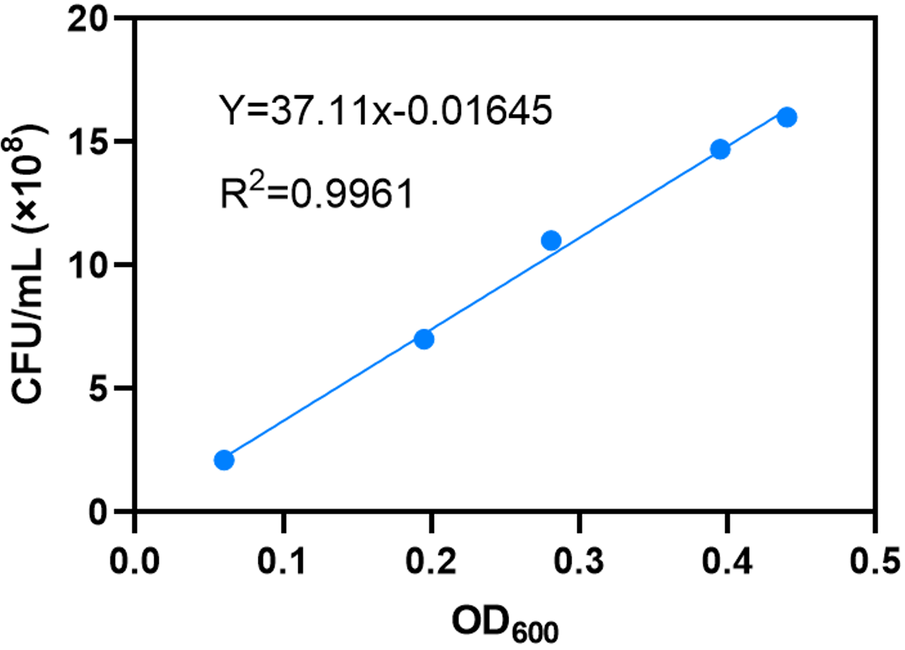
Supplementary Figure S1 is related to Figure 1.
The relationship equation between the OD₆₀₀ value of the bacterial solution and the number of colonies.

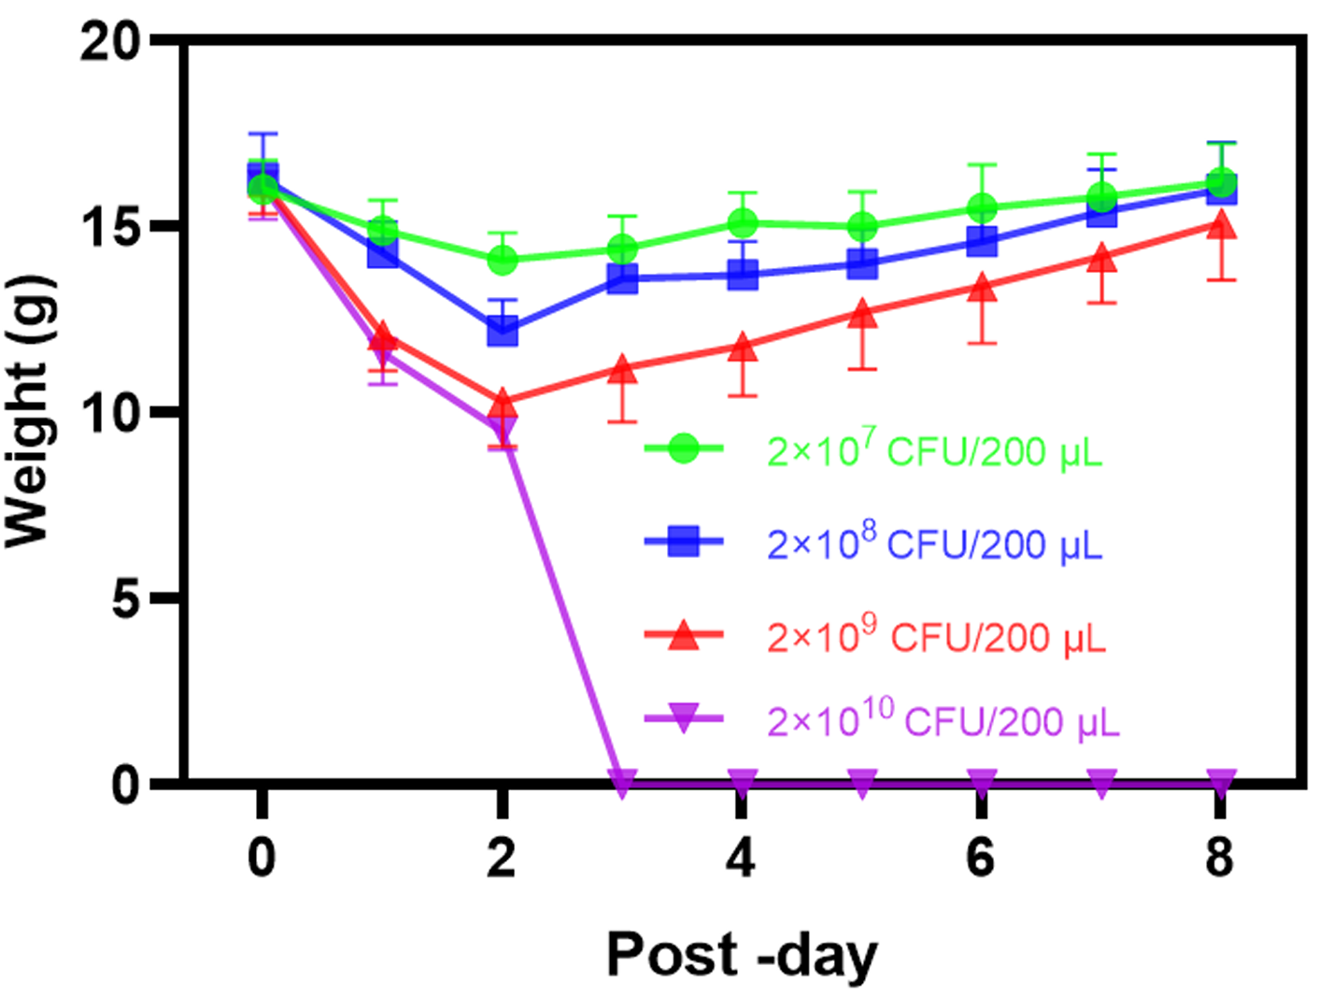
Supplementary Figure S2 is related to Figure 2.
Changes in body weight of mice over time after injection of various concentrations of E. coli.
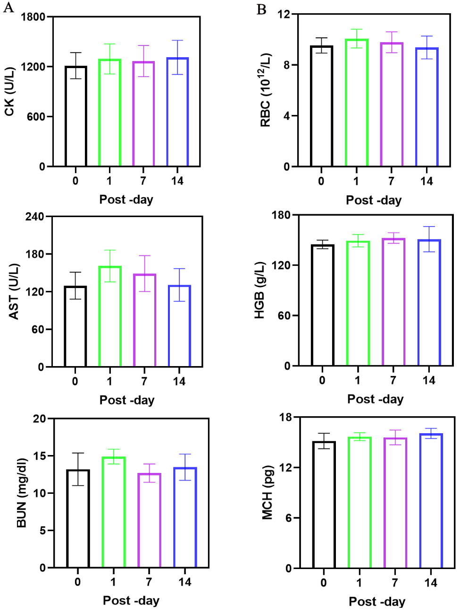
Supplementary Figure S3 is related to Figure 3.
Changes in organ damage serum index (A) and complete blood count (B) at different times.

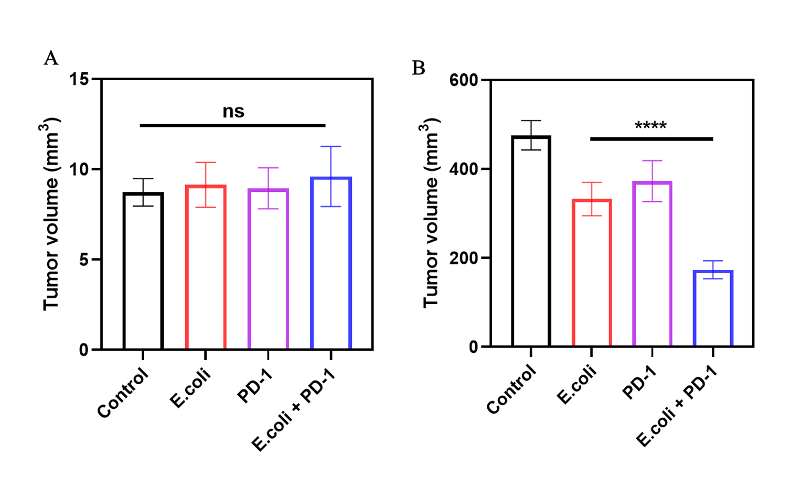
Supplementary Figure S4 is related to Figure 4.
Tumor volume of CT2A tumor-bearing mice on day 0 (A) and day 14 (B) following various treatments (n=5, ns: not significant, *P <0.05, **P < 0.01, ***P <0.001, ****P <0.0001, calculated by one-way ANOVA).

Supplementary Table 1. IRT calculated based on tumor volume on day 14.
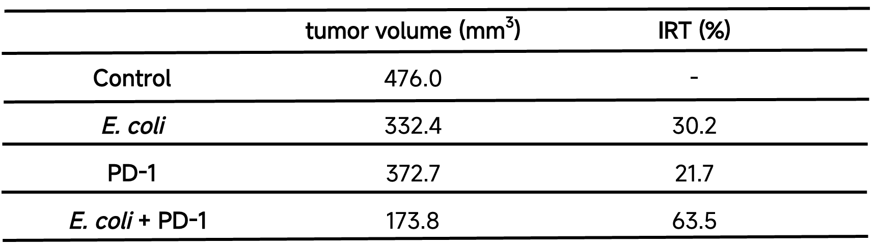
*. a=476.0, b=332.4, c=372.7, d=173.8, IRT_{(E. coli)} = (a-b)/a, IRT_{(PD-1)} = (a-c)/a, IRT_{(E. coli + PD-1)} = (a-d)/a.

