Quantitative methodology for poly (butylene adipate-co-terephthalate) (PBAT)
microplastic detection in soil
Yvan D. Hernandez-Charpak¹, Harshal J. Kansara¹, Jeffrey S Lodge², Nathan C. Eddingsaas³, Christopher L. Lewis⁴, Thomas A Trabold¹, Carlos A. Diaz⁵

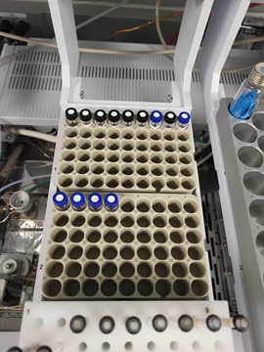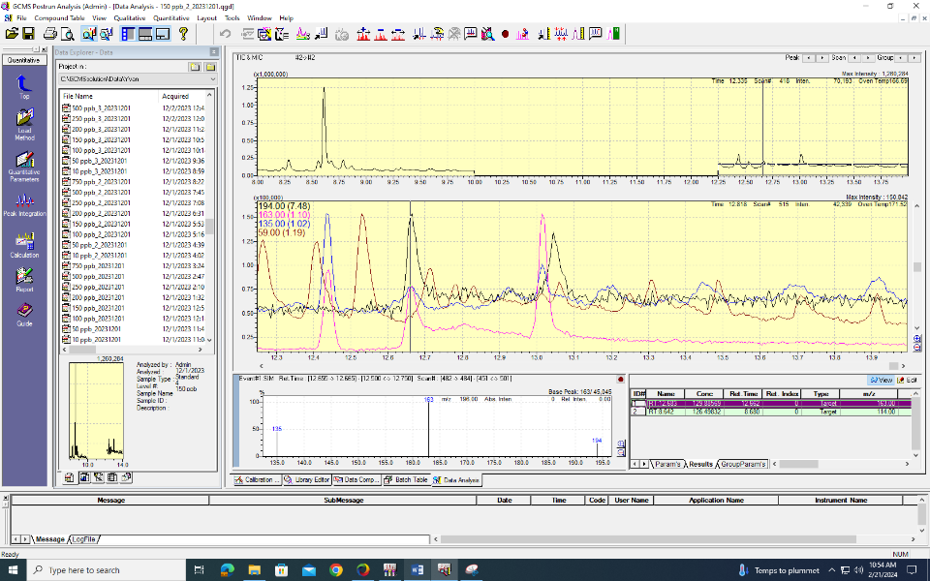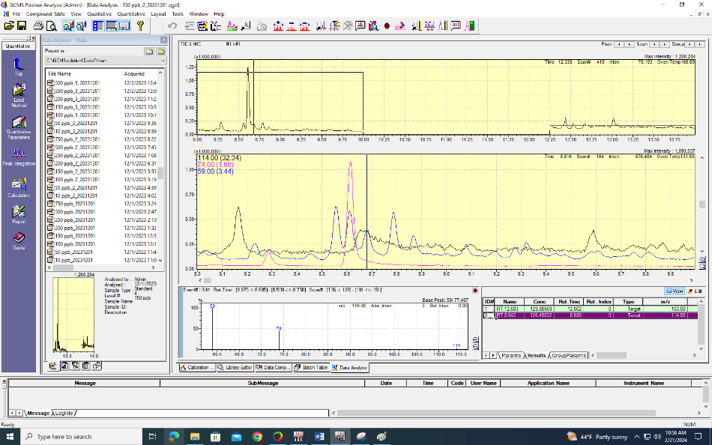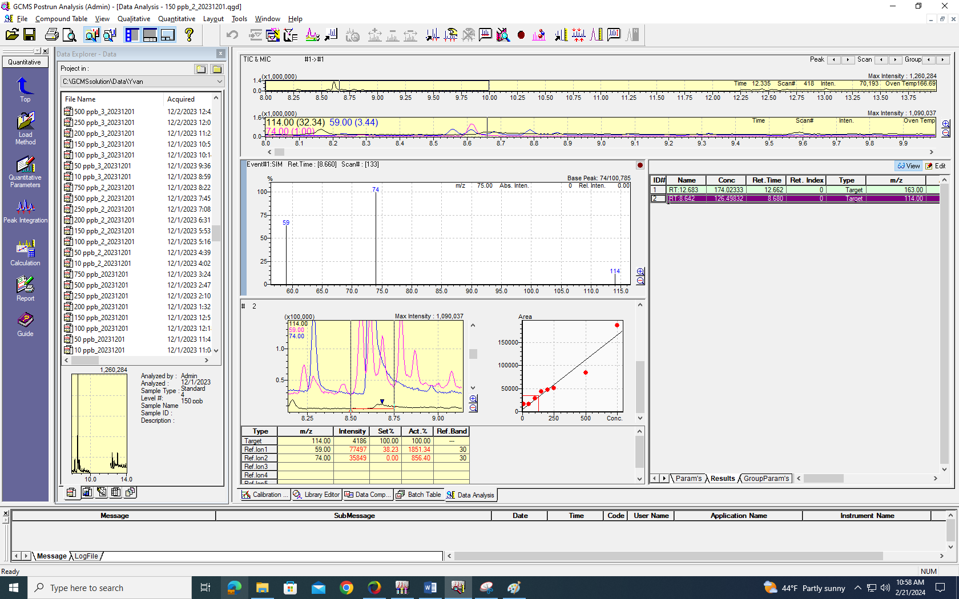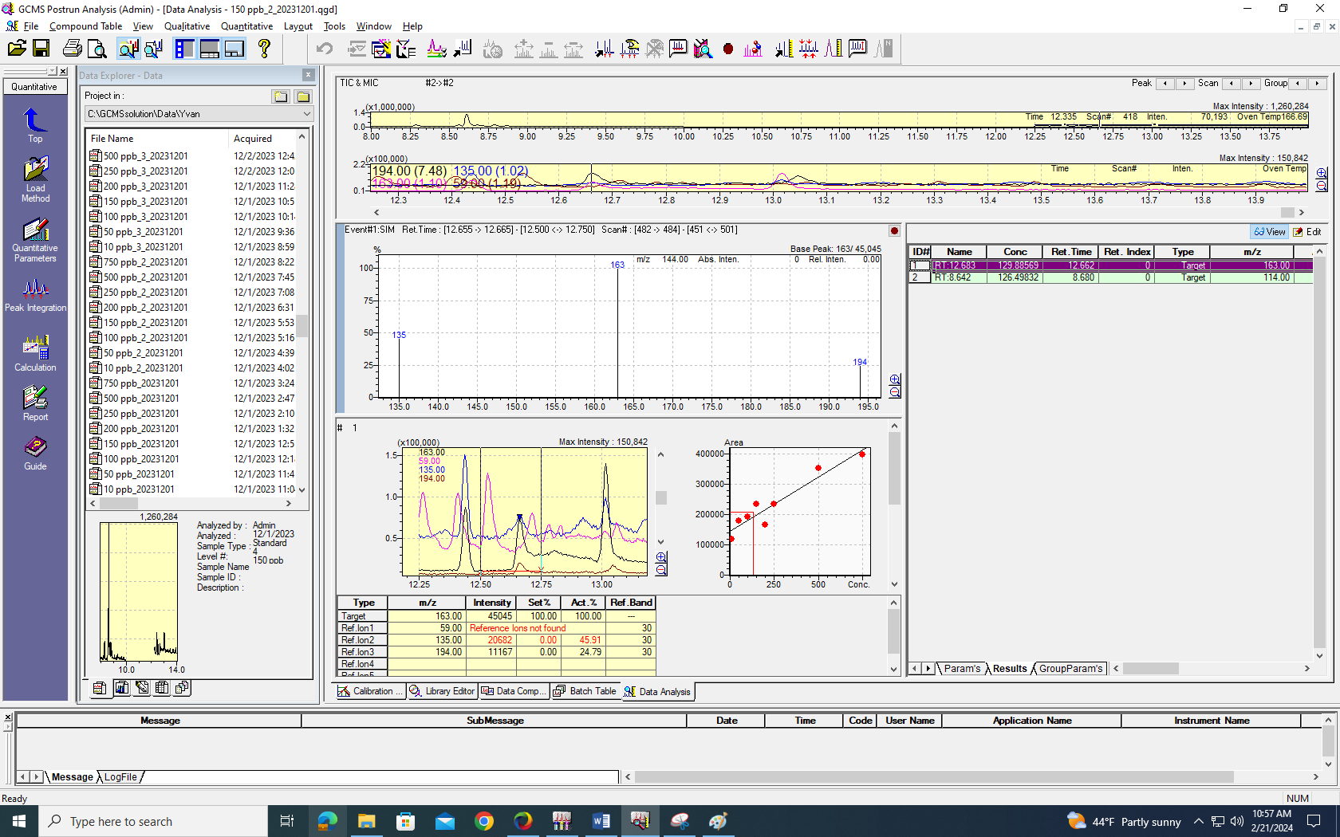Figure S1. Process of quantification of GCMS response of an example sample of 150 ppb.
Selected Ionic Monitoring
Adipic Acid, dimethyl ester (RT: 8.6 min)
Terephthalic acid, dimethyl ester (RT: 12.6 min)
Adipic Acid, dimethyl ester (RT: 8.6 min), Manual integration for ion 114 m/z between 8.5 min and 8.75 min
Terephthalic acid, dimethyl ester (RT: 12.6 min), Manual integration for ion 163 m/z between 12.5 min and 12.75 min
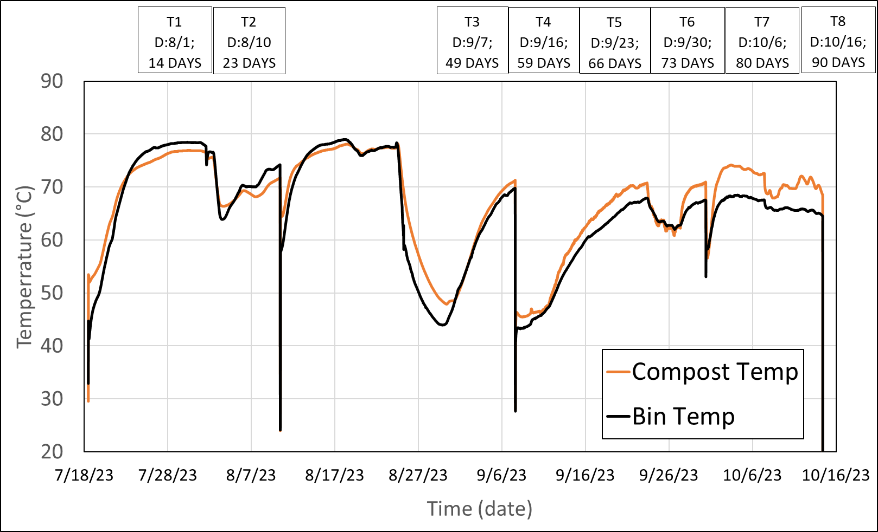
Figure S2. Industrial compost temperatures.

