Table S1. Pv47 sequences by country of origin.
Country | No. Samples | Haplotypes
El Salvador | 1 | 1
Mexico | 81 | 9
Colombia | 90 | 10
Peru | 69 | 16
Brazil | 83 | 24
Mauritania | 3 | 2
Ethiopia | 211 | 21
Sudan | 23 | 6
Madagascar | 6 | 3
Iran | 7 | 4
Afghanistan | 54 | 16
India | 26 | 6
Bangladesh | 11 | 9
China | 9 | 6
North Korea | 1 | 1
Korea | 4 | 4
Philippines | 5 | 5
Thailand | 118 | 51
Cambodia | 112 | 37
Vietnam | 66 | 33
Laos | 1 | 1
Bhutan | 3 | 3
Myanmar | 7 | 6
Indonesia | 3 | 2
Malaysia | 60 | 9
Papua Indonesia | 120 | 32
Papua New Guinea (PNG) | 19 | 8
Vanuatu | 6 | 6
Total samples | 1199

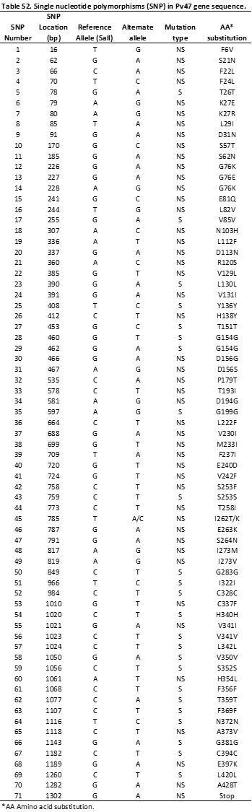

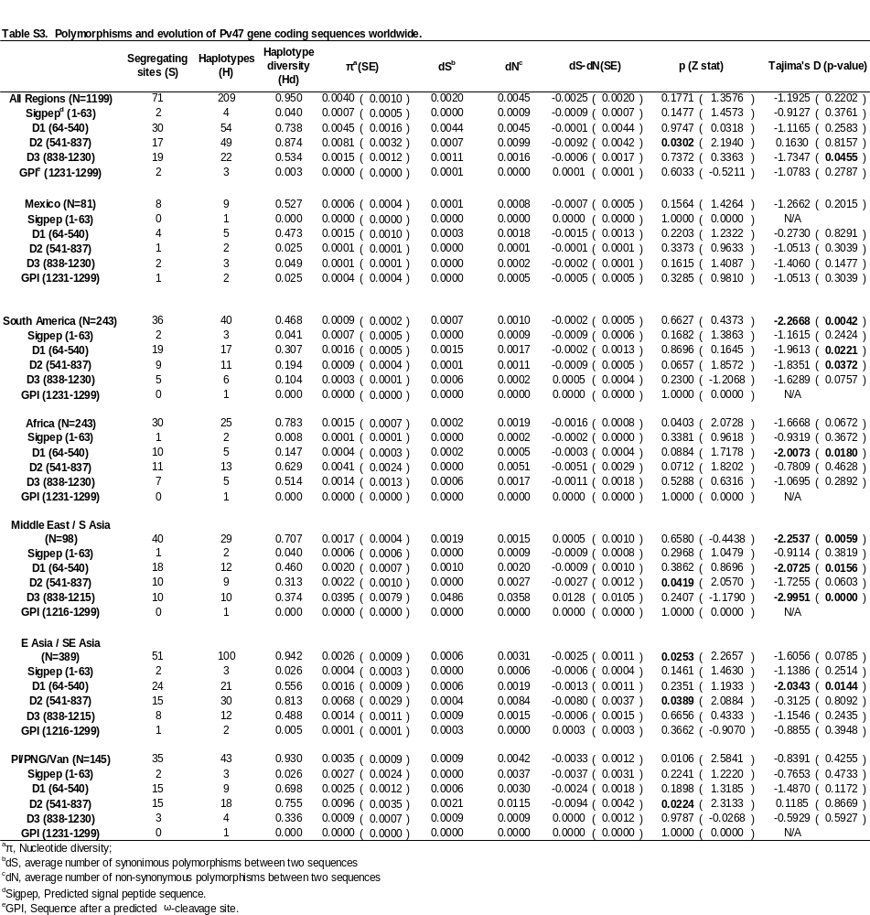

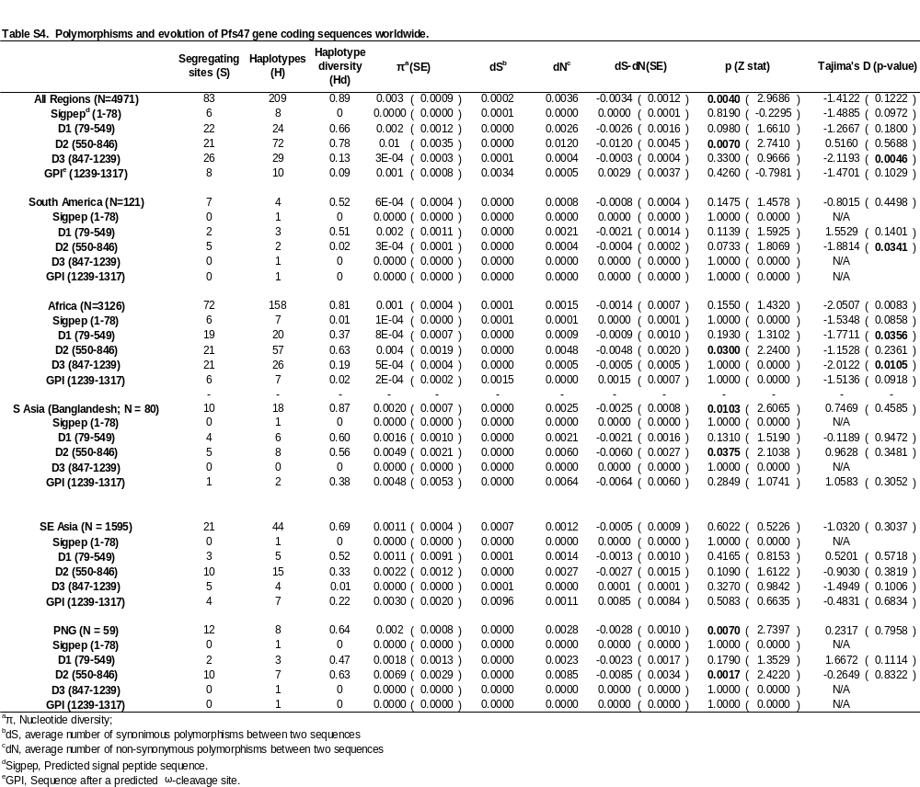

Table S5. Population structure of Pfs47 haplotypes. The fixation index (F_{ST}) between Pfs47 country populations analyzed is shown.

Table S6. Infectivity of in blood samples from Southern Mexico to local vectors Anopheles albimanus and Anopheles pseudopunctipennis. Laboratory colonies of An. albimanus and An. pseudopunctipennis were feed simultaneously with blood samples and the infection prevalence and average number of oocysts per experiment were determined. N, Number of mosquitoes analyzed for infectivity in the midgut. Inf. Prev., Infection Prevalence; SD, Standard Deviation; Chi-Square; *, p< 0.05; **, p < 0.01; ***, p < 0.001; ****, p < 0.0001.
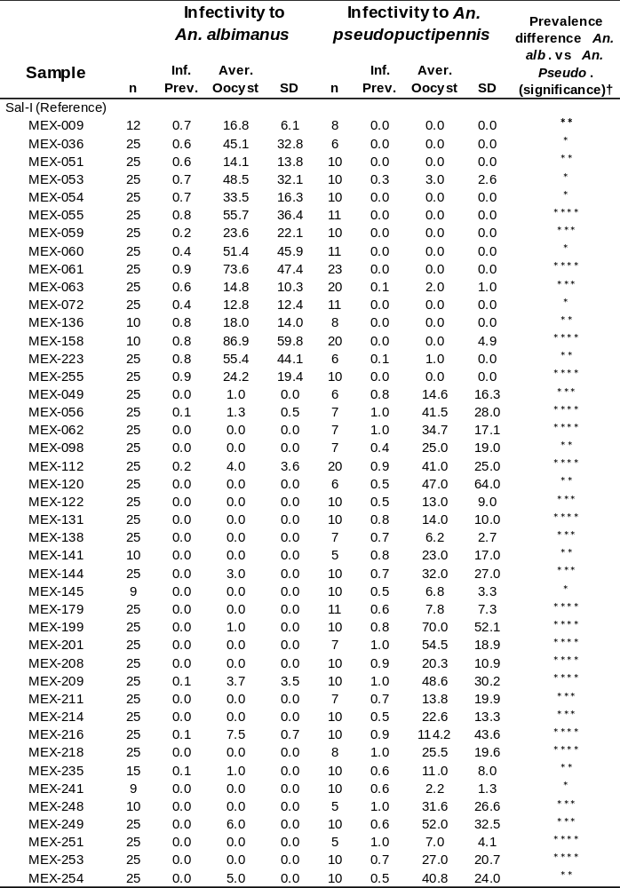

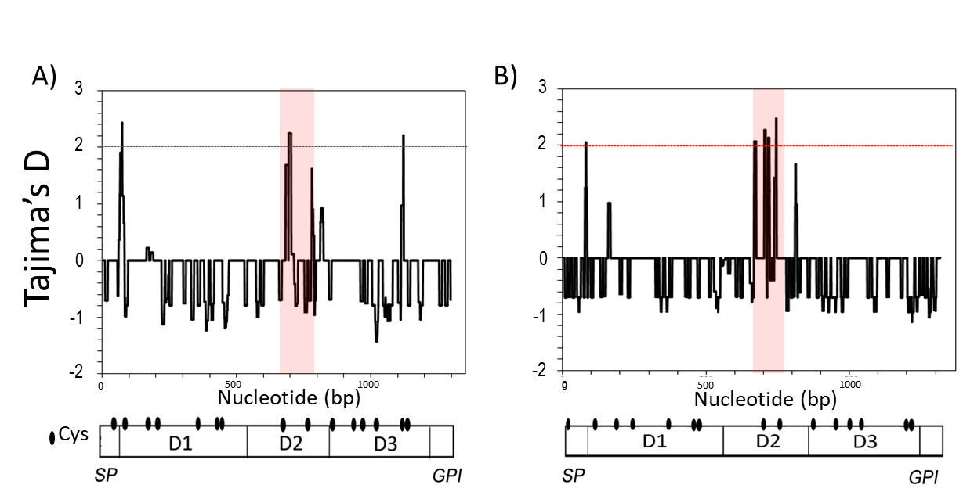
Figure S1. Signatures of selection in Pv47 and Pfs47 sequences. Tajima’s D per 15 nt window is shown for Pv47 (A) and Pfs47 (B). The predicted protein domain structure and Cys location are indicated for both Pv47 and Pfs47. SP, signal peptide; D1, domain 1; D2, domain 2; D3, Domain 3; GPI, predicted glycosilphosphatidyl inositol anchoring. The region between two Cys in D2 is shaded in red.

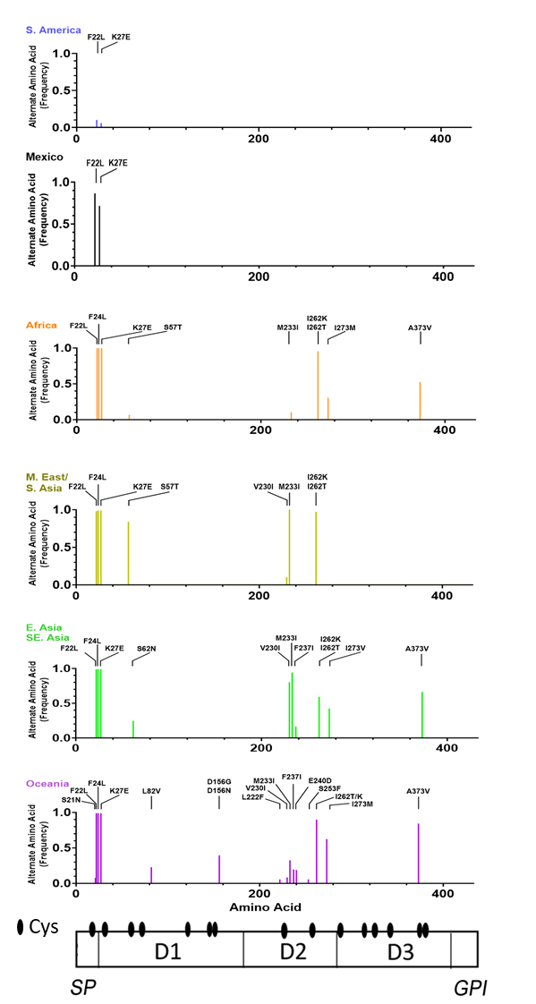
Fig S2. Main amino acid polymorphisms in Pv47 protein sequences. The alternate amino acid frequencies for polymorphisms that have >0.05 frequency in any of the geographic region analyzed are indicated. The domain structure of Pv47 is indicated (bottom), with the relative position of Cys. SP, signal peptide; D1, domain 1; D2, domain 2; D3, Domain 3; GPI, predicted glycosilphosphatidyl inositol anchoring; S. America, South America; M. East, Middle East; S. Asia, South Asia; E. Asia, East Asia; SE Asia, Southeast Asia; Oceania, Papua New Guinea, Papua Indonesia, and Vanuatu.
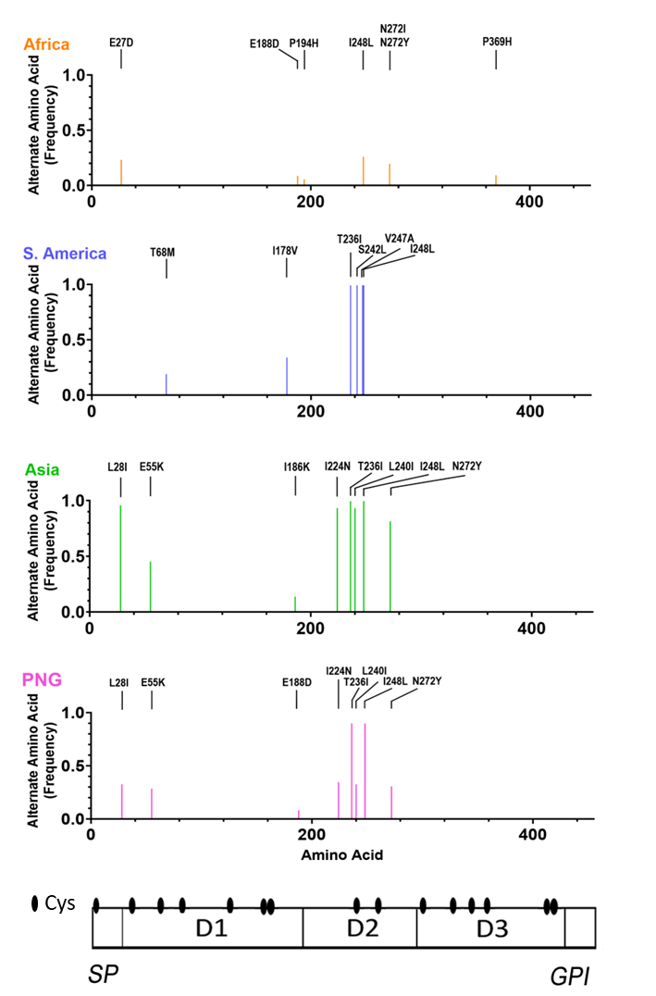

Fig S3. Main amino acid polymorphisms in Pfs47 protein sequences. The alternate amino acid frequencies for polymorphisms that have >0.05 frequency in any of the geographic region analyzed are indicated. The domain structure of Pfs47 is indicated (bottom), with the relative position of Cys. SP, signal peptide; D1, domain 1; D2, domain 2; D3, Domain 3; GPI, predicted glycosilphosphatidyl inositol anchoring; S. America, South America; PNG, Papua New Guinea.

