Assessment of Conformational Dynamics of Cutinases and Fusarium oxysporum- Poly(ethylene terephthalate) interaction
Carlos Gabriel da Silva de Souza ¹, Clauber Henrique Souza da Costa ², Pedro H. A. Silva,¹ Maycon Vinicius Damasceno de Oliveira¹, Edilene Oliveira da Silva¹ , Alberdan Silva Santos¹, Munir S. Skaf ², Jerônimo Lameira ^{1*}
¹Institute of Biological Sciences, Federal University of Pará (UFPA), 66075-110, Belem, Para, Brazil.
²Institute of Chemistry and Center for Computer in Engineering and Sciences, University of Campinas (UNICAMP), 13084-862, Campinas, Sao Paulo, Brazil.
SUPPORTING INFORMATION
Figure SI 1. The tridimensional structure of FoCut5a (A) with the flap helix (74-93) in highlighted in lime green and the binding loop (172-192) in cyan; The RMSF of FoCut5a (B) and FsCut1 (C), both with the flap helix and binding loop highlighted in lime green and cyan respectively.
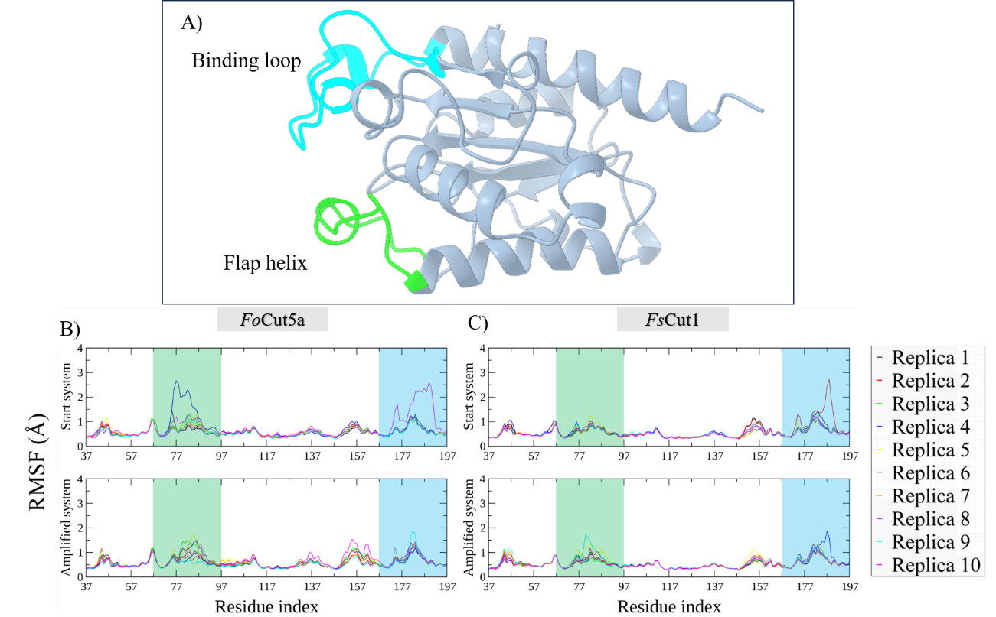
Figure SI 2. PC₁ vs PC₂ distributions for FoCut5a in A) and FsCut1 in B), and the FEL_{PC1vsPC2} for FoCut5a in C) and FsCut1 in D).
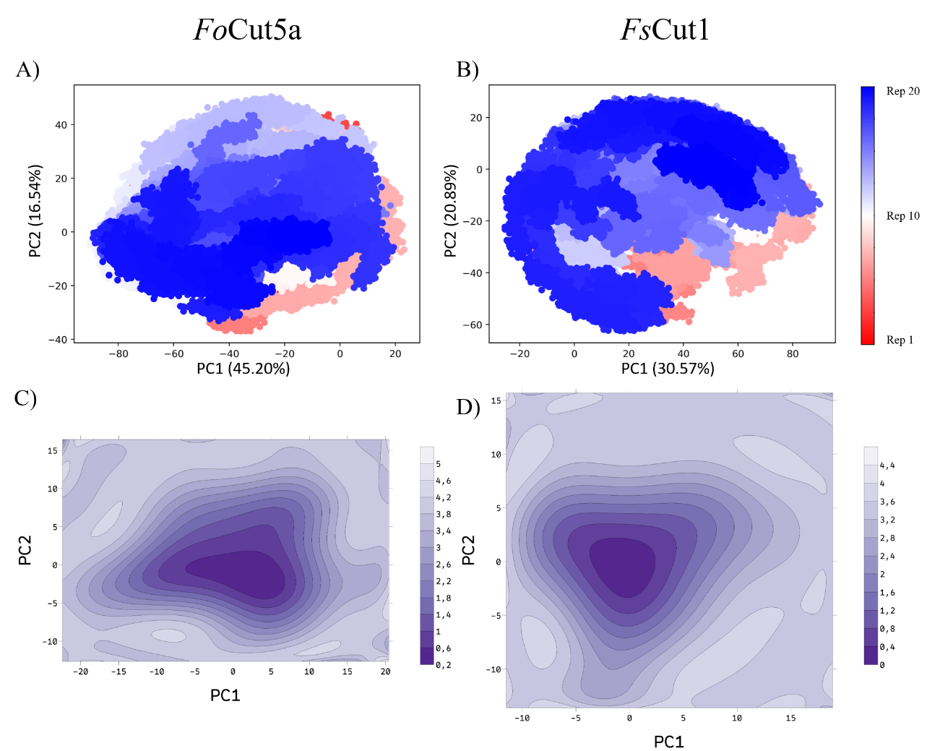
Table SI 1. Key distance D1 (Ala 86 CB – Leu 183 CB) and D2 (Leu 82 CB – Leu 183 CB), defining the opened and closed states of Cutinases obtained from strutures on the FES.
Trigger | closed state | transition state 1 | transition state 2 | open state
D1 | 4.5 - 6.5 | 4.5 - 6.5 | 7.0 - 9.5 | 7.0 - 9.5
D2 | 4.5 - 6.8 | 7.2 - 13.3 | 4.5 - 6.8 | 7.2 - 13.3
FoCut5a frames | 18,359 | 53,312 | 4,917 | 68,263
FsCut1 frames | 29,517 | 88,719 | 2,052 | 31,323

Table SI 2. Start set PCA Eigenvalues and variances.
FoCut5a |  |  |  | FsCut1
PC | Eigenvalues | Explained  variance | Cumulative  variance | PC | Eigenvalues | Explained  variance | Cumulative  variance
1 | 17.04 | 28.78 | 28.78 | 1 | 11.75 | 31.96 | 31.96
2 | 12.75 | 21.52 | 50.31 | 2 | 6.52 | 17.74 | 49.70
3 | 6.91 | 11.67 | 61.98 | 3 | 3.70 | 10.06 | 59.76
4 | 4.81 | 8.13 | 70.10 | 4 | 3.06 | 8.34 | 68.09
5 | 3.77 | 6.37 | 76.47 | 5 | 1.71 | 4.65 | 72.74
6 | 2.82 | 4.76 | 81.23 | 6 | 1.50 | 4.09 | 76.83
7 | 1.74 | 2.93 | 84.16 | 7 | 1.46 | 3.98 | 80.82
8 | 1.33 | 2.24 | 86.40 | 8 | 1.00 | 2.72 | 83.53
9 | 1.18 | 2.00 | 88.40 | 9 | 0.95 | 2.59 | 86.12
10 | 0.94 | 1.59 | 90.00 | 10 | 0.90 | 2.44 | 88.56
11 | 0.84 | 1.42 | 91.42 | 11 | 0.72 | 1.95 | 90.51
12 | 0.84 | 1.42 | 92.84 | 12 | 0.57 | 1.56 | 92.06
13 | 0.73 | 1.23 | 94.07 | 13 | 0.50 | 1.35 | 93.42
14 | 0.67 | 1.13 | 95.19 | 14 | 0.47 | 1.29 | 94.71
15 | 0.62 | 1.05 | 96.25 | 15 | 0.41 | 1.12 | 95.83
16 | 0.61 | 1.03 | 97.27 | 16 | 0.37 | 1.02 | 96.85
17 | 0.45 | 0.76 | 98.03 | 17 | 0.33 | 0.89 | 97.75
18 | 0.42 | 0.71 | 98.74 | 18 | 0.31 | 0.85 | 98.59
19 | 0.39 | 0.66 | 99.40 | 19 | 0.27 | 0.73 | 99.33
20 | 0.35 | 0.60 | 100.00 | 20 | 0.25 | 0.67 | 100.00

Table SI 3. Amplified set PCA Eigenvalues and variances.
FoCut5a |  |  |  | FsCut1
PC | Eigenvalues | Explained  variance | Cumulative  variance | PC | Eigenvalues | Explained  variance | Cumulative  variance
1 | 29.41 | 44.62 | 44.62 | 1 | 14.54 | 30.63 | 30.63
2 | 9.63 | 14.61 | 59.24 | 2 | 10.85 | 22.85 | 53.48
3 | 6.30 | 9.55 | 68.79 | 3 | 4.77 | 10.04 | 63.52
4 | 4.42 | 6.71 | 75.50 | 4 | 2.90 | 6.11 | 69.63
5 | 2.83 | 4.29 | 79.80 | 5 | 2.52 | 5.31 | 74.94
6 | 2.50 | 3.79 | 83.59 | 6 | 1.76 | 3.70 | 78.64
7 | 1.67 | 2.53 | 86.12 | 7 | 1.50 | 3.16 | 81.80
8 | 1.45 | 2.20 | 88.32 | 8 | 1.35 | 2.85 | 84.66
9 | 1.20 | 1.82 | 90.15 | 9 | 1.13 | 2.37 | 87.03
10 | 1.15 | 1.75 | 91.90 | 10 | 0.87 | 1.83 | 88.86
11 | 0.77 | 1.17 | 93.07 | 11 | 0.84 | 1.78 | 90.64
12 | 0.73 | 1.11 | 94.18 | 12 | 0.75 | 1.57 | 92.21
13 | 0.67 | 1.02 | 95.21 | 13 | 0.66 | 1.39 | 93.60
14 | 0.62 | 0.94 | 96.15 | 14 | 0.64 | 1.36 | 94.95
15 | 0.52 | 0.78 | 96.93 | 15 | 0.51 | 1.06 | 96.02
16 | 0.49 | 0.75 | 97.68 | 16 | 0.48 | 1.00 | 97.02
17 | 0.43 | 0.64 | 98.32 | 17 | 0.42 | 0.90 | 97.91
18 | 0.41 | 0.62 | 98.94 | 18 | 0.35 | 0.74 | 98.66
19 | 0.36 | 0.55 | 99.49 | 19 | 0.33 | 0.70 | 99.35
20 | 0.33 | 0.51 | 100.00 | 20 | 0.31 | 0.65 | 100.00

Table SI 4. Full set PCA Eigenvalues and variances.
FoCut5a |  |  |  | FsCut1
PC | eigenvalues | explained  variance | cumulative  variance | PC | eigenvalues | explained  variance | cumulative  variance
1 | 34.59 | 45.20 | 45.20 | 1 | 12.99 | 30.57 | 30.57
2 | 12.66 | 16.54 | 61.74 | 2 | 8.88 | 20.89 | 51.47
3 | 6.59 | 8.61 | 70.35 | 3 | 4.32 | 10.16 | 61.63
4 | 4.81 | 6.29 | 76.64 | 4 | 3.00 | 7.07 | 68.69
5 | 3.16 | 4.13 | 80.78 | 5 | 2.06 | 4.86 | 73.55
6 | 2.71 | 3.54 | 84.32 | 6 | 1.67 | 3.93 | 77.48
7 | 1.71 | 2.23 | 86.55 | 7 | 1.50 | 3.52 | 81.00
8 | 1.54 | 2.01 | 88.56 | 8 | 1.16 | 2.73 | 83.73
9 | 1.27 | 1.66 | 90.23 | 9 | 1.04 | 2.45 | 86.18
10 | 1.19 | 1.55 | 91.78 | 10 | 0.88 | 2.07 | 88.25
11 | 0.99 | 1.30 | 93.08 | 11 | 0.84 | 1.97 | 90.22
12 | 0.92 | 1.20 | 94.28 | 12 | 0.70 | 1.64 | 91.86
13 | 0.72 | 0.94 | 95.22 | 13 | 0.62 | 1.47 | 93.32
14 | 0.64 | 0.84 | 96.06 | 14 | 0.54 | 1.28 | 94.60
15 | 0.59 | 0.77 | 96.83 | 15 | 0.50 | 1.17 | 95.77
16 | 0.58 | 0.76 | 97.60 | 16 | 0.44 | 1.04 | 96.80
17 | 0.56 | 0.73 | 98.33 | 17 | 0.41 | 0.96 | 97.77
18 | 0.47 | 0.61 | 98.94 | 18 | 0.34 | 0.80 | 98.57
19 | 0.43 | 0.56 | 99.49 | 19 | 0.31 | 0.72 | 99.30
20 | 0.39 | 0.51 | 100.00 | 20 | 0.30 | 0.70 | 100.00

Figure SI 3. FoCut5a PCA distributions trough replicates data sets.
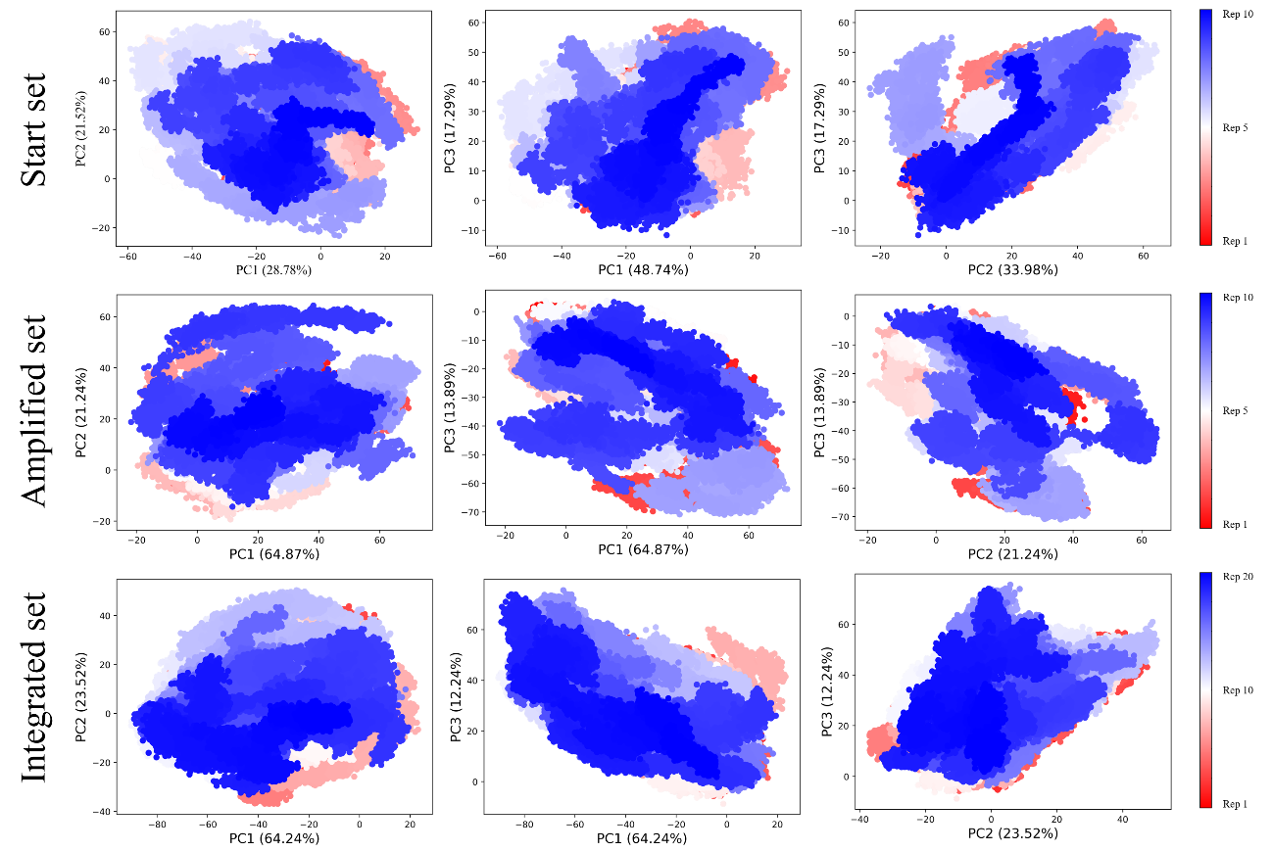
Figure SI 4. FsCut1 PCA distributions trough replicates data sets.
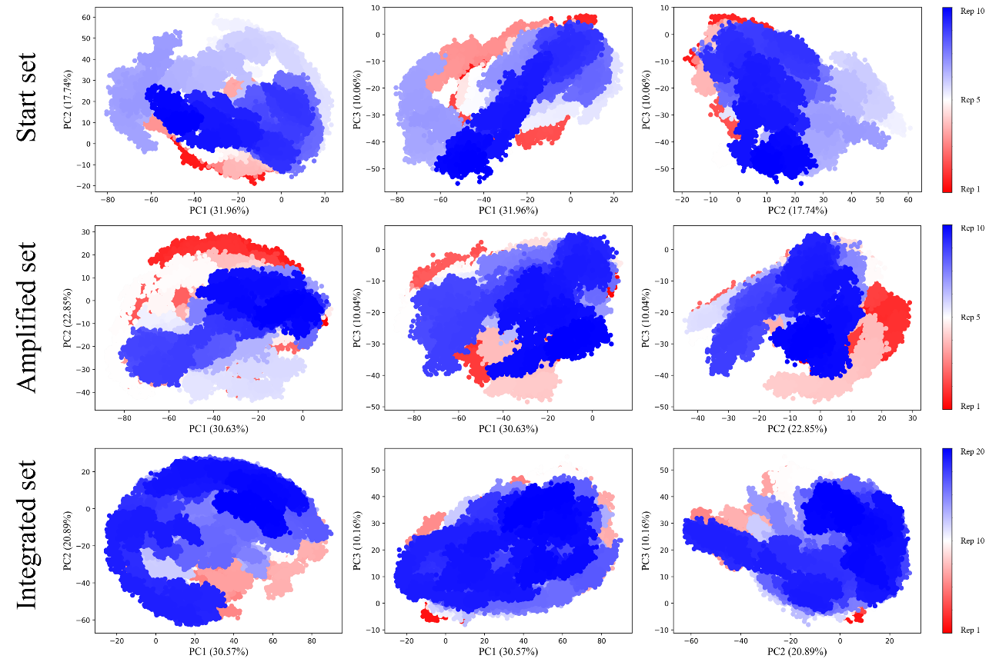
Figure SI 5. FoCut5a and FsCut1 FEL plots for the replicates data set.
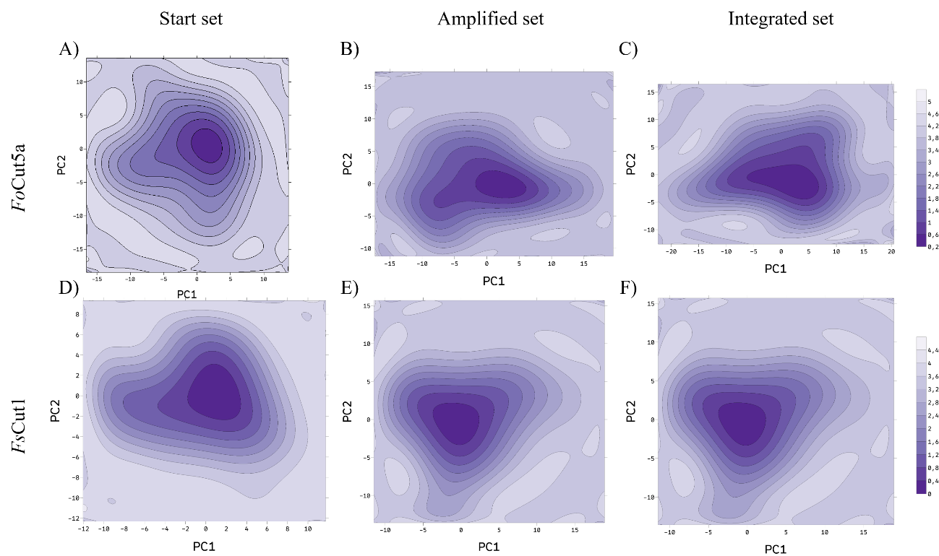
Figure SI 6. FoCut5a FEL plots and representative structures
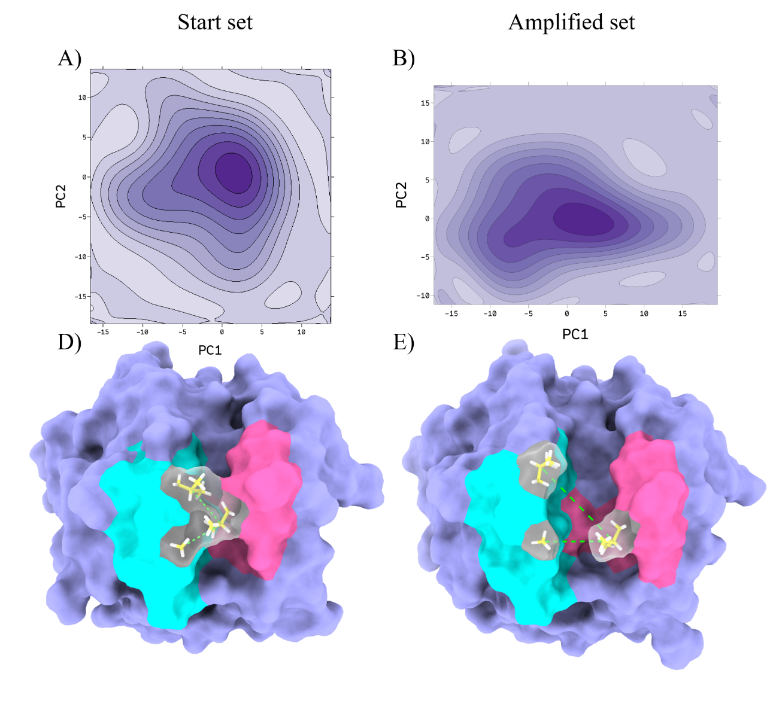
Table SI 5. Docking results for the complexes with PET tetramer.
Enzyme | Ranking | MolDock Score | Hbond
FoCut5a | 1 | -184.68 | -15.63
FoCut5a | 2 | -172.87 | -19.29
FoCut5a | 3 | -159.32 | -16.89
FsCut1 | 1 | -131.045 | -8.50
FsCut1 | 2 | -123.125 | -10.31
FsCut1 | 3 | -122.639 | -9.70

