Table 1 Distribution of samples and their respective groups

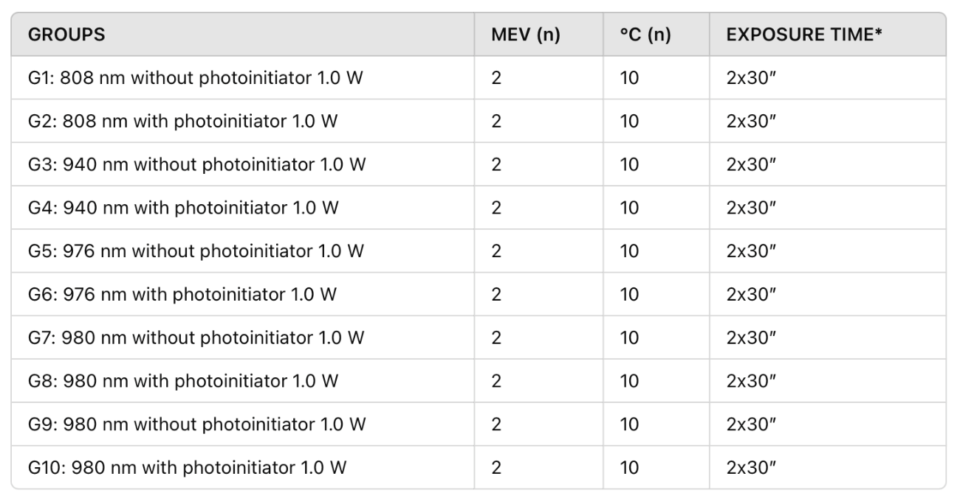
*Intervalo de 30s entre as duas aplicações (tempo para relaxação térmica)

Table 2: Statistical analysis of temperature variation in the pulp chamber between the groups whose samples used a photoinitiator and those that did not.
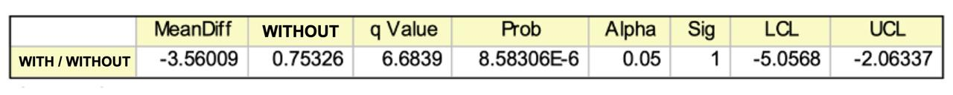

Table 3: Statistical analysis of temperature variation in the apical region between the groups whose samples used a photoinitiator and those that did not.

