Graph 1: Average value and standard deviation of the temperature increase recorded by the thermocouple in the pulp chamber.

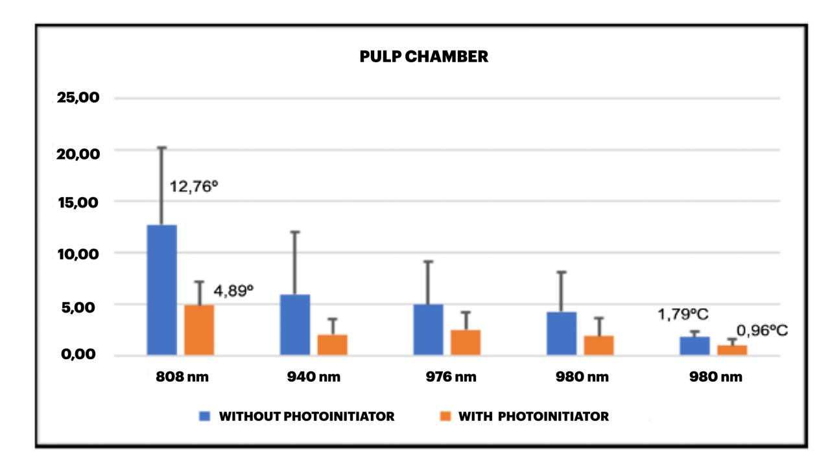

Graph 2: Average value and standard deviation of the temperature increase recorded by the thermocouple in the apical region.

