A comprehensive assessment of the applicability of semi-analytical models of vortex characterization for gravitational water vortex hydropower plants.
Theoretical and Computational Fluid Dynamics
Mateo Duarte Garcia^{1* - 0000-0002-9926-3104}, Jose Alejandro Posada Montoya¹ ⁻ ⁰⁰⁰⁰⁻⁰⁰⁰¹⁻⁵⁸³⁶⁻⁰⁶⁸⁰, Edwin Chica² ⁻ ⁰⁰⁰⁰⁻⁰⁰⁰³⁻¹⁴⁸³⁻⁰¹⁰⁴, Jhon Fredy Hincapie Montoya¹ ⁻ ⁰⁰⁰⁰⁻⁰⁰⁰²⁻⁰⁸⁴¹⁻⁸⁹⁴¹, Laura Velásquez² ⁻ ⁰⁰⁰⁰⁻⁰⁰⁰³⁻¹⁴⁸³⁻⁰¹⁰⁴, Iván David Patiño Arcila¹ ⁻ ⁰⁰⁰⁰⁻⁰⁰⁰²⁻²⁸⁷⁶⁻⁸⁹³⁰
¹Grupo de Investigación e Innovación Ambiental (GIIAM), Facultad de Ingeniería, Institución Universitaria Pascual Bravo, Medellín, Colombia
² Grupo de Energía Alternativa, Facultad de Ingeniería, Universidad de Antioquia, Medellín, Colombia
*Corresponding author: mateo.duarte462@pascualbravo.edu.co
Supplementary material
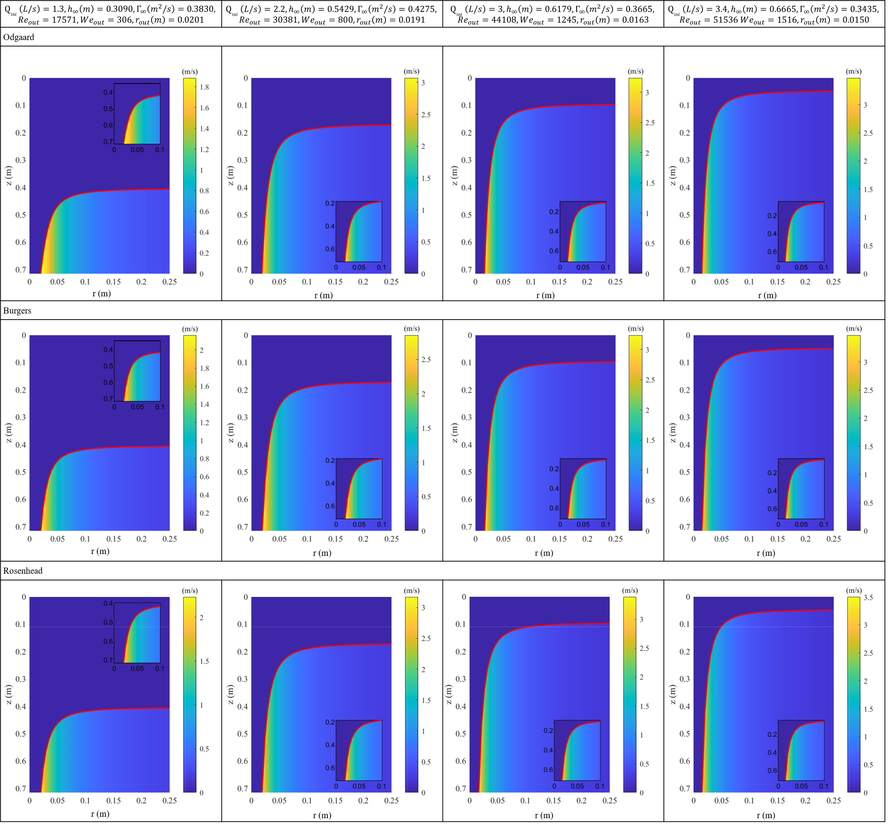
Figure 1. Tangential velocity fields in Odgaard, Burgers and Rosenhead models for strong vortexes.
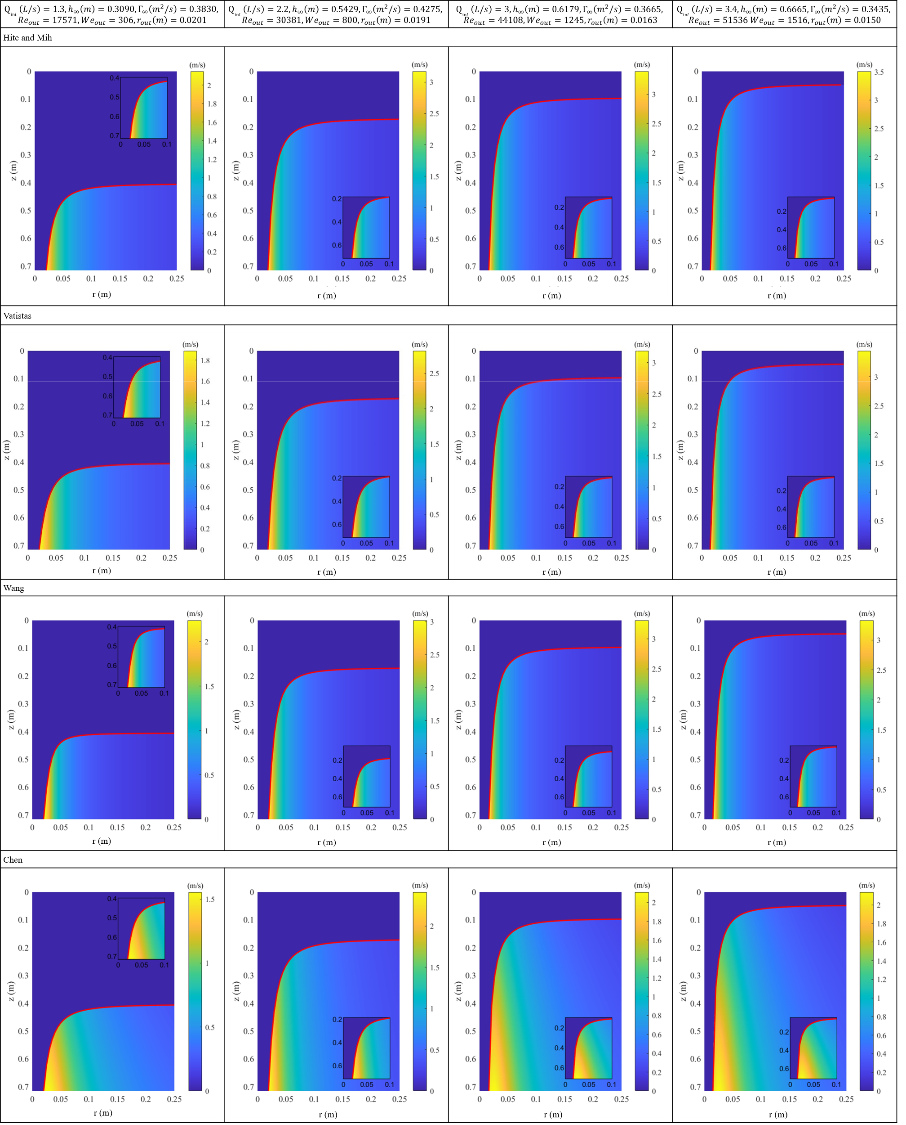
Figure 2. Tangential velocity fields in Hite and Mih, Vatistas, Wang and Chen models for strong vortexes.
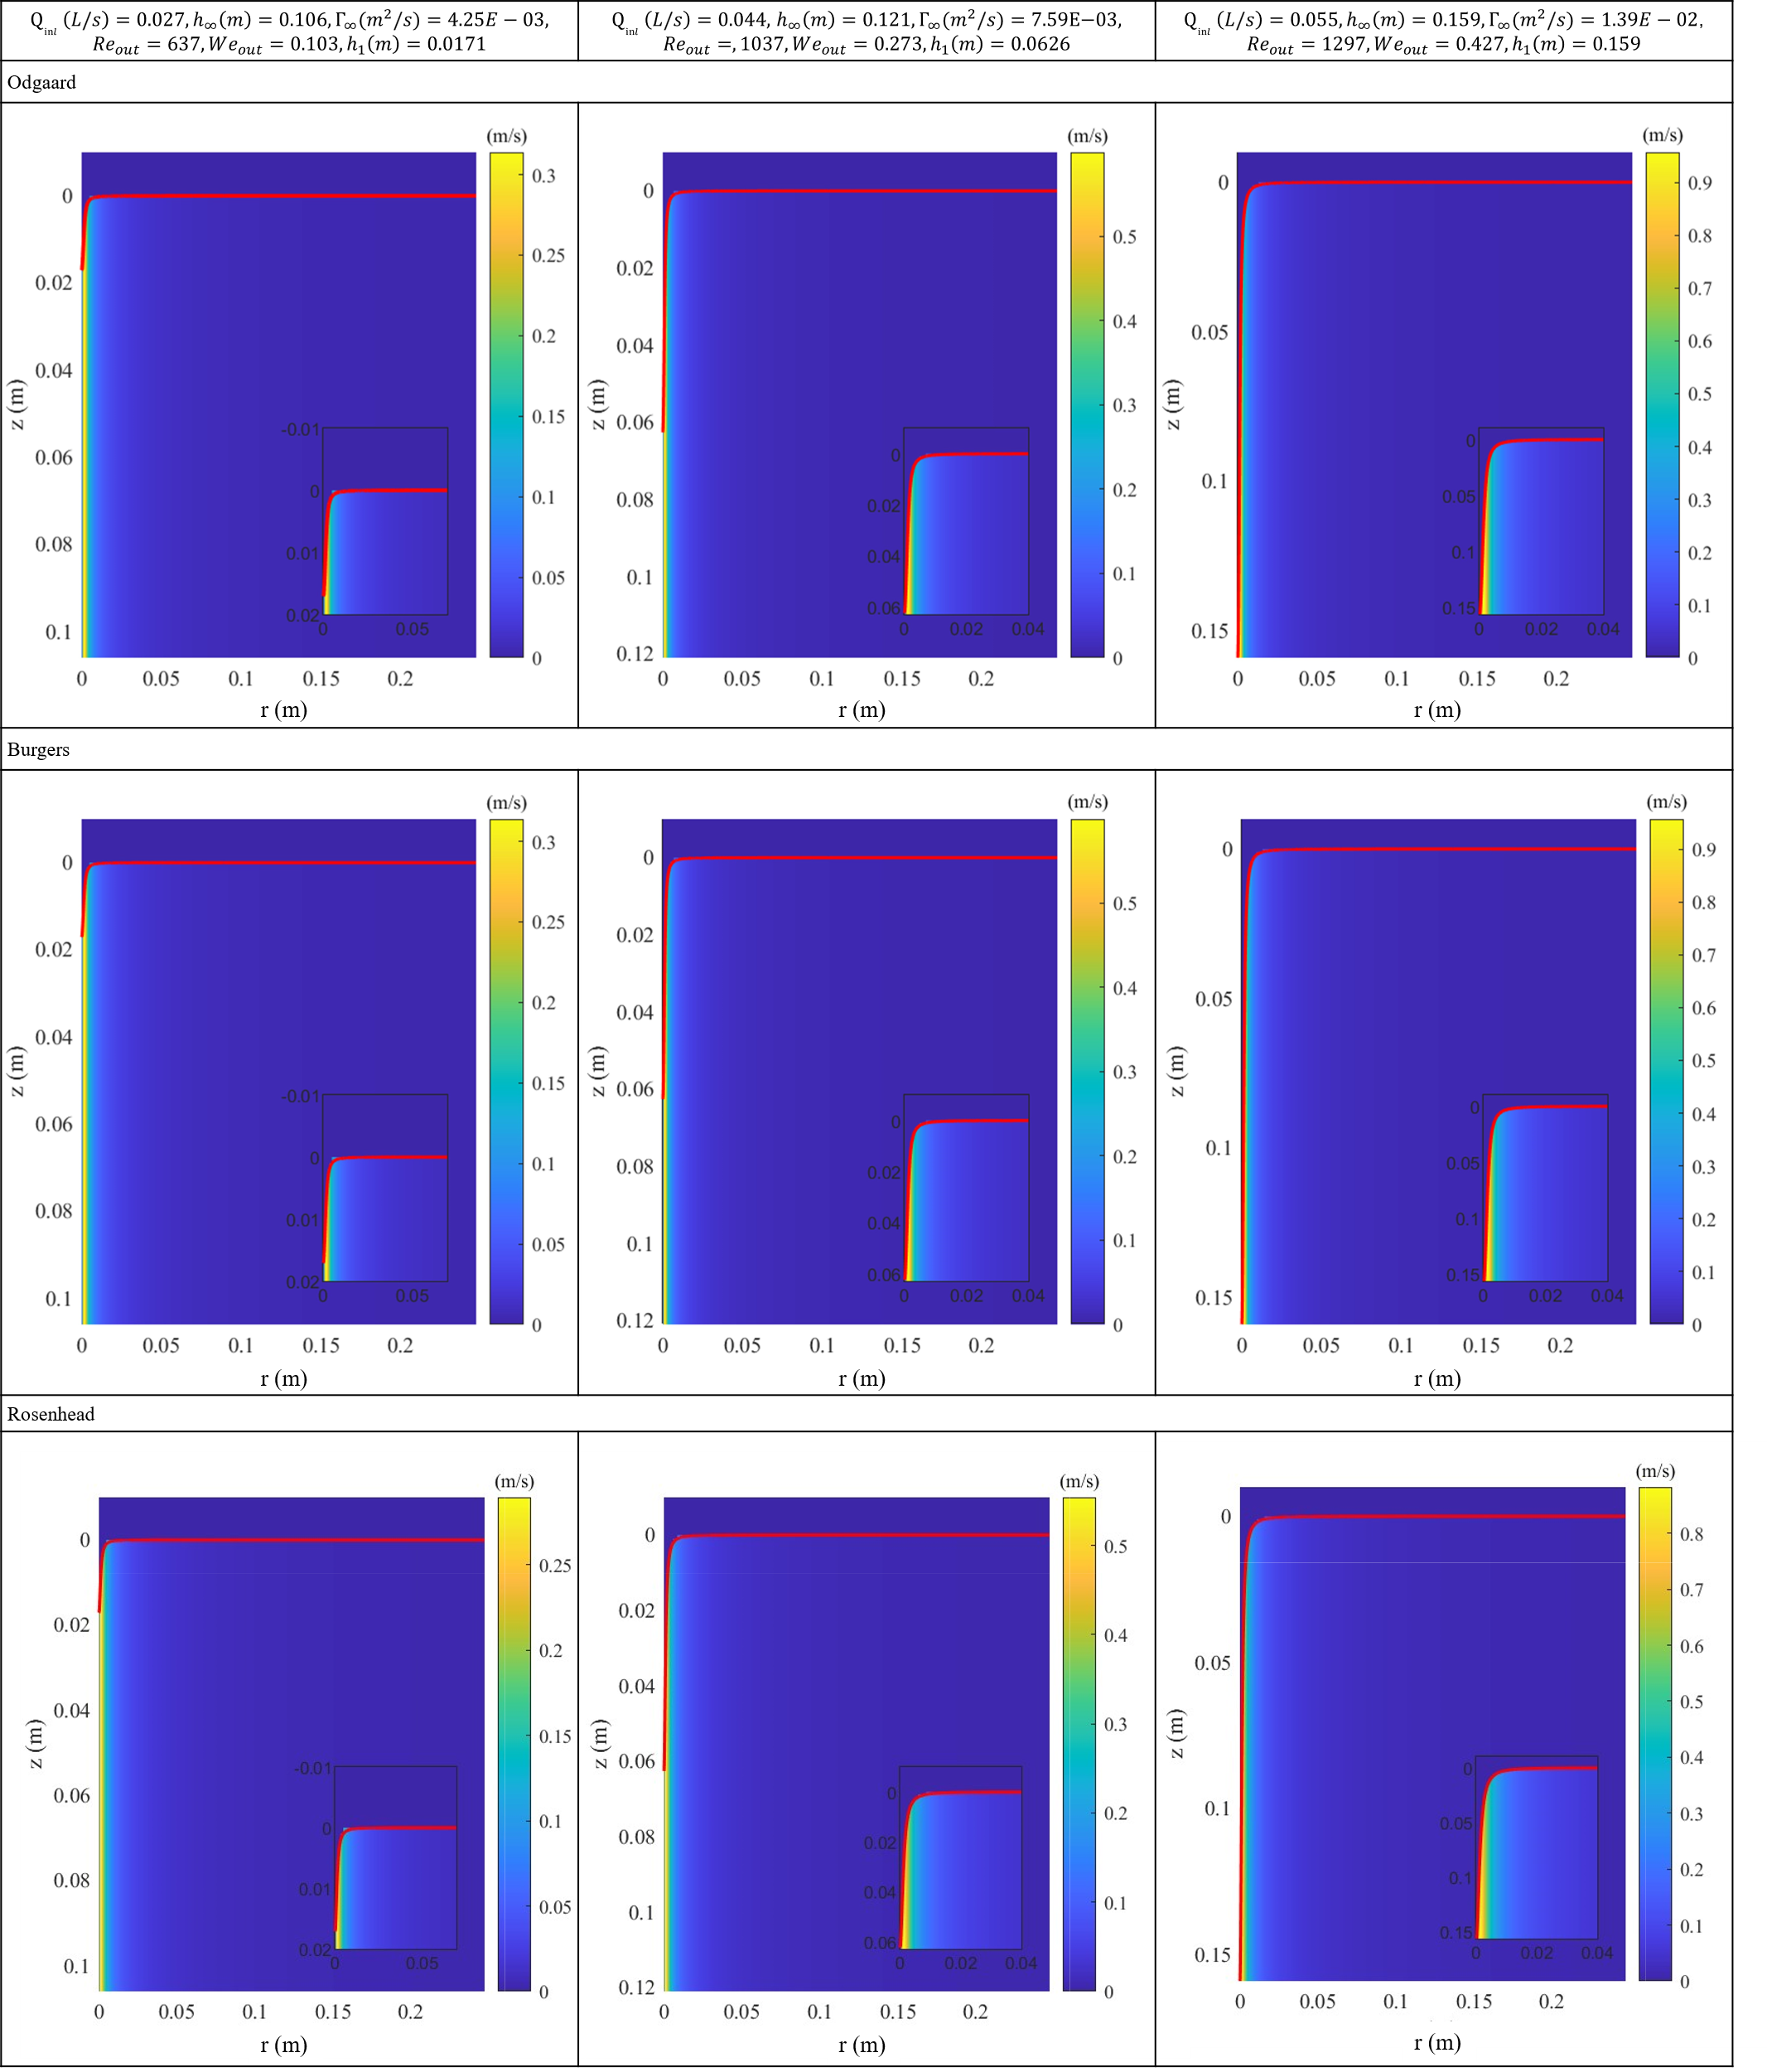
Figure 3. Tangential velocity fields in Odgaard, Burgers and Rosenhead models for weak vortexes.
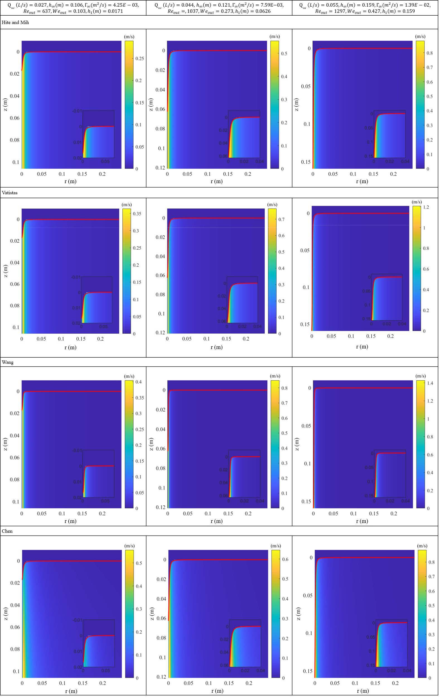
Figure 4. Tangential velocity fields in Hite and Mih, Vatistas, Wang and Chen models for weak vortexes.
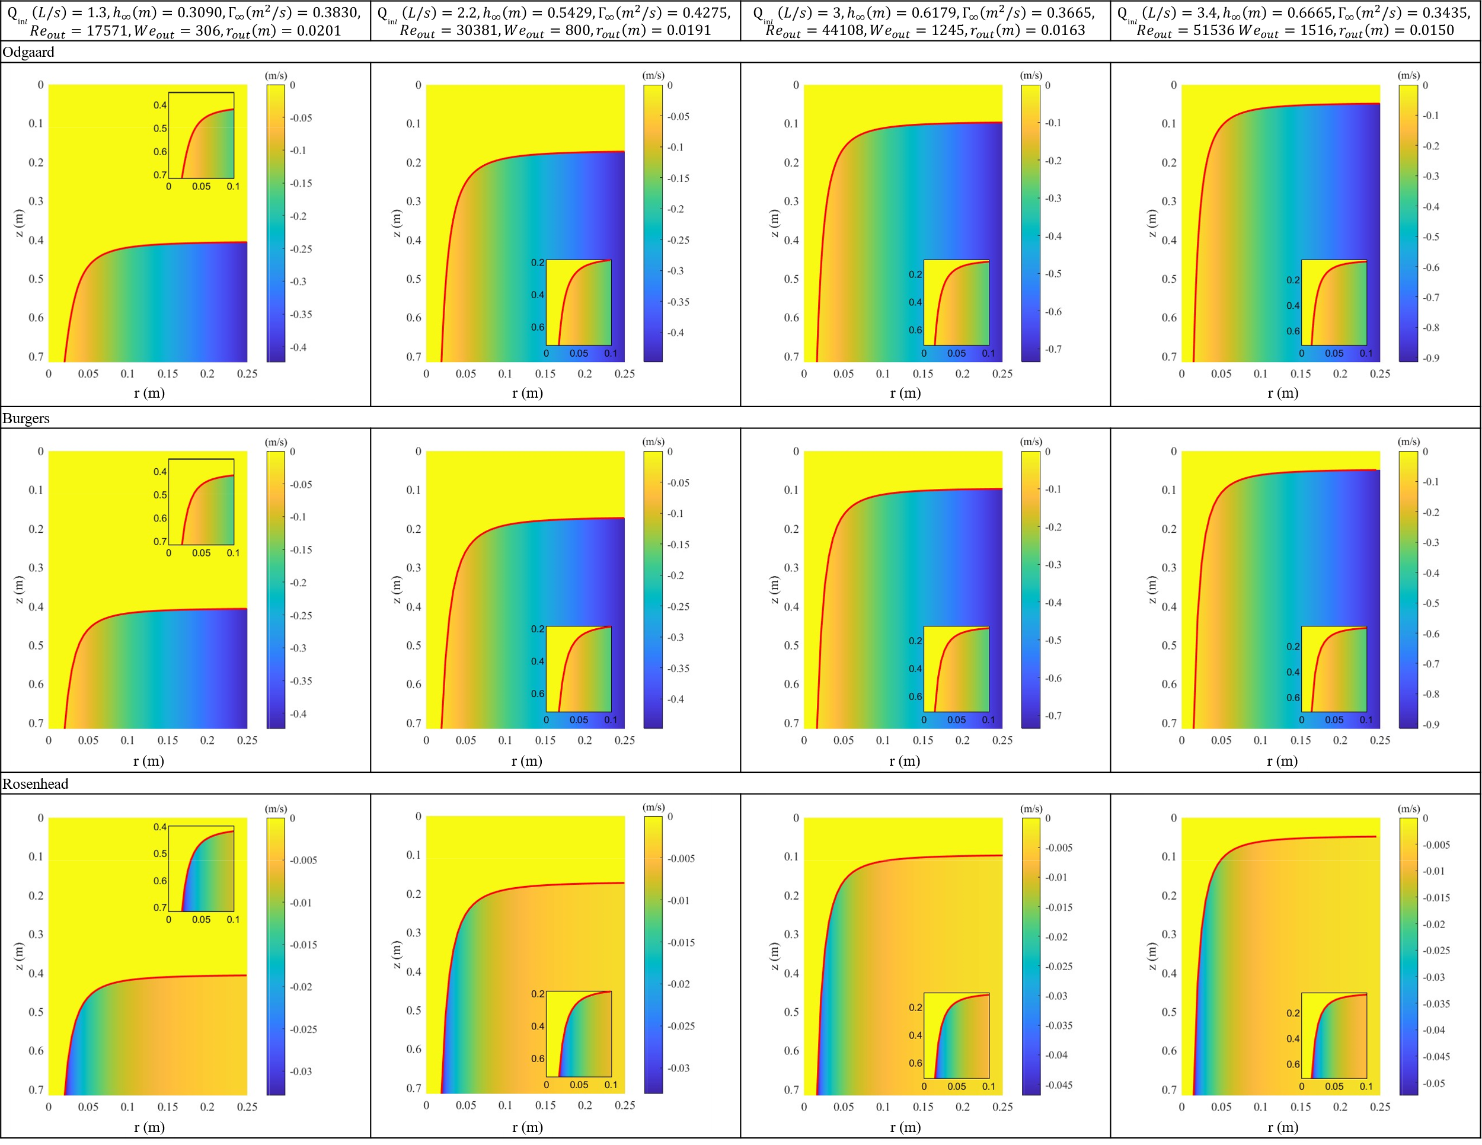
Figure 5. Radial velocity fields in Odgaard, Burgers and Rosenhead models for strong vortexes.
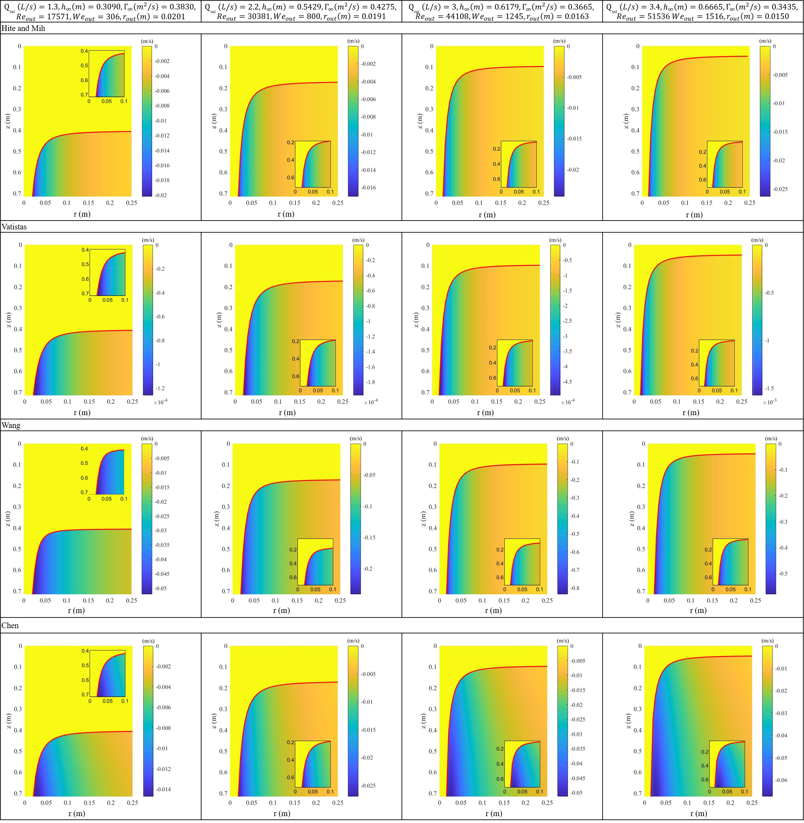
Figure 6. Radial velocity fields in Hite and Mih, Vatistas, Wang and Chen models for strong vortexes.
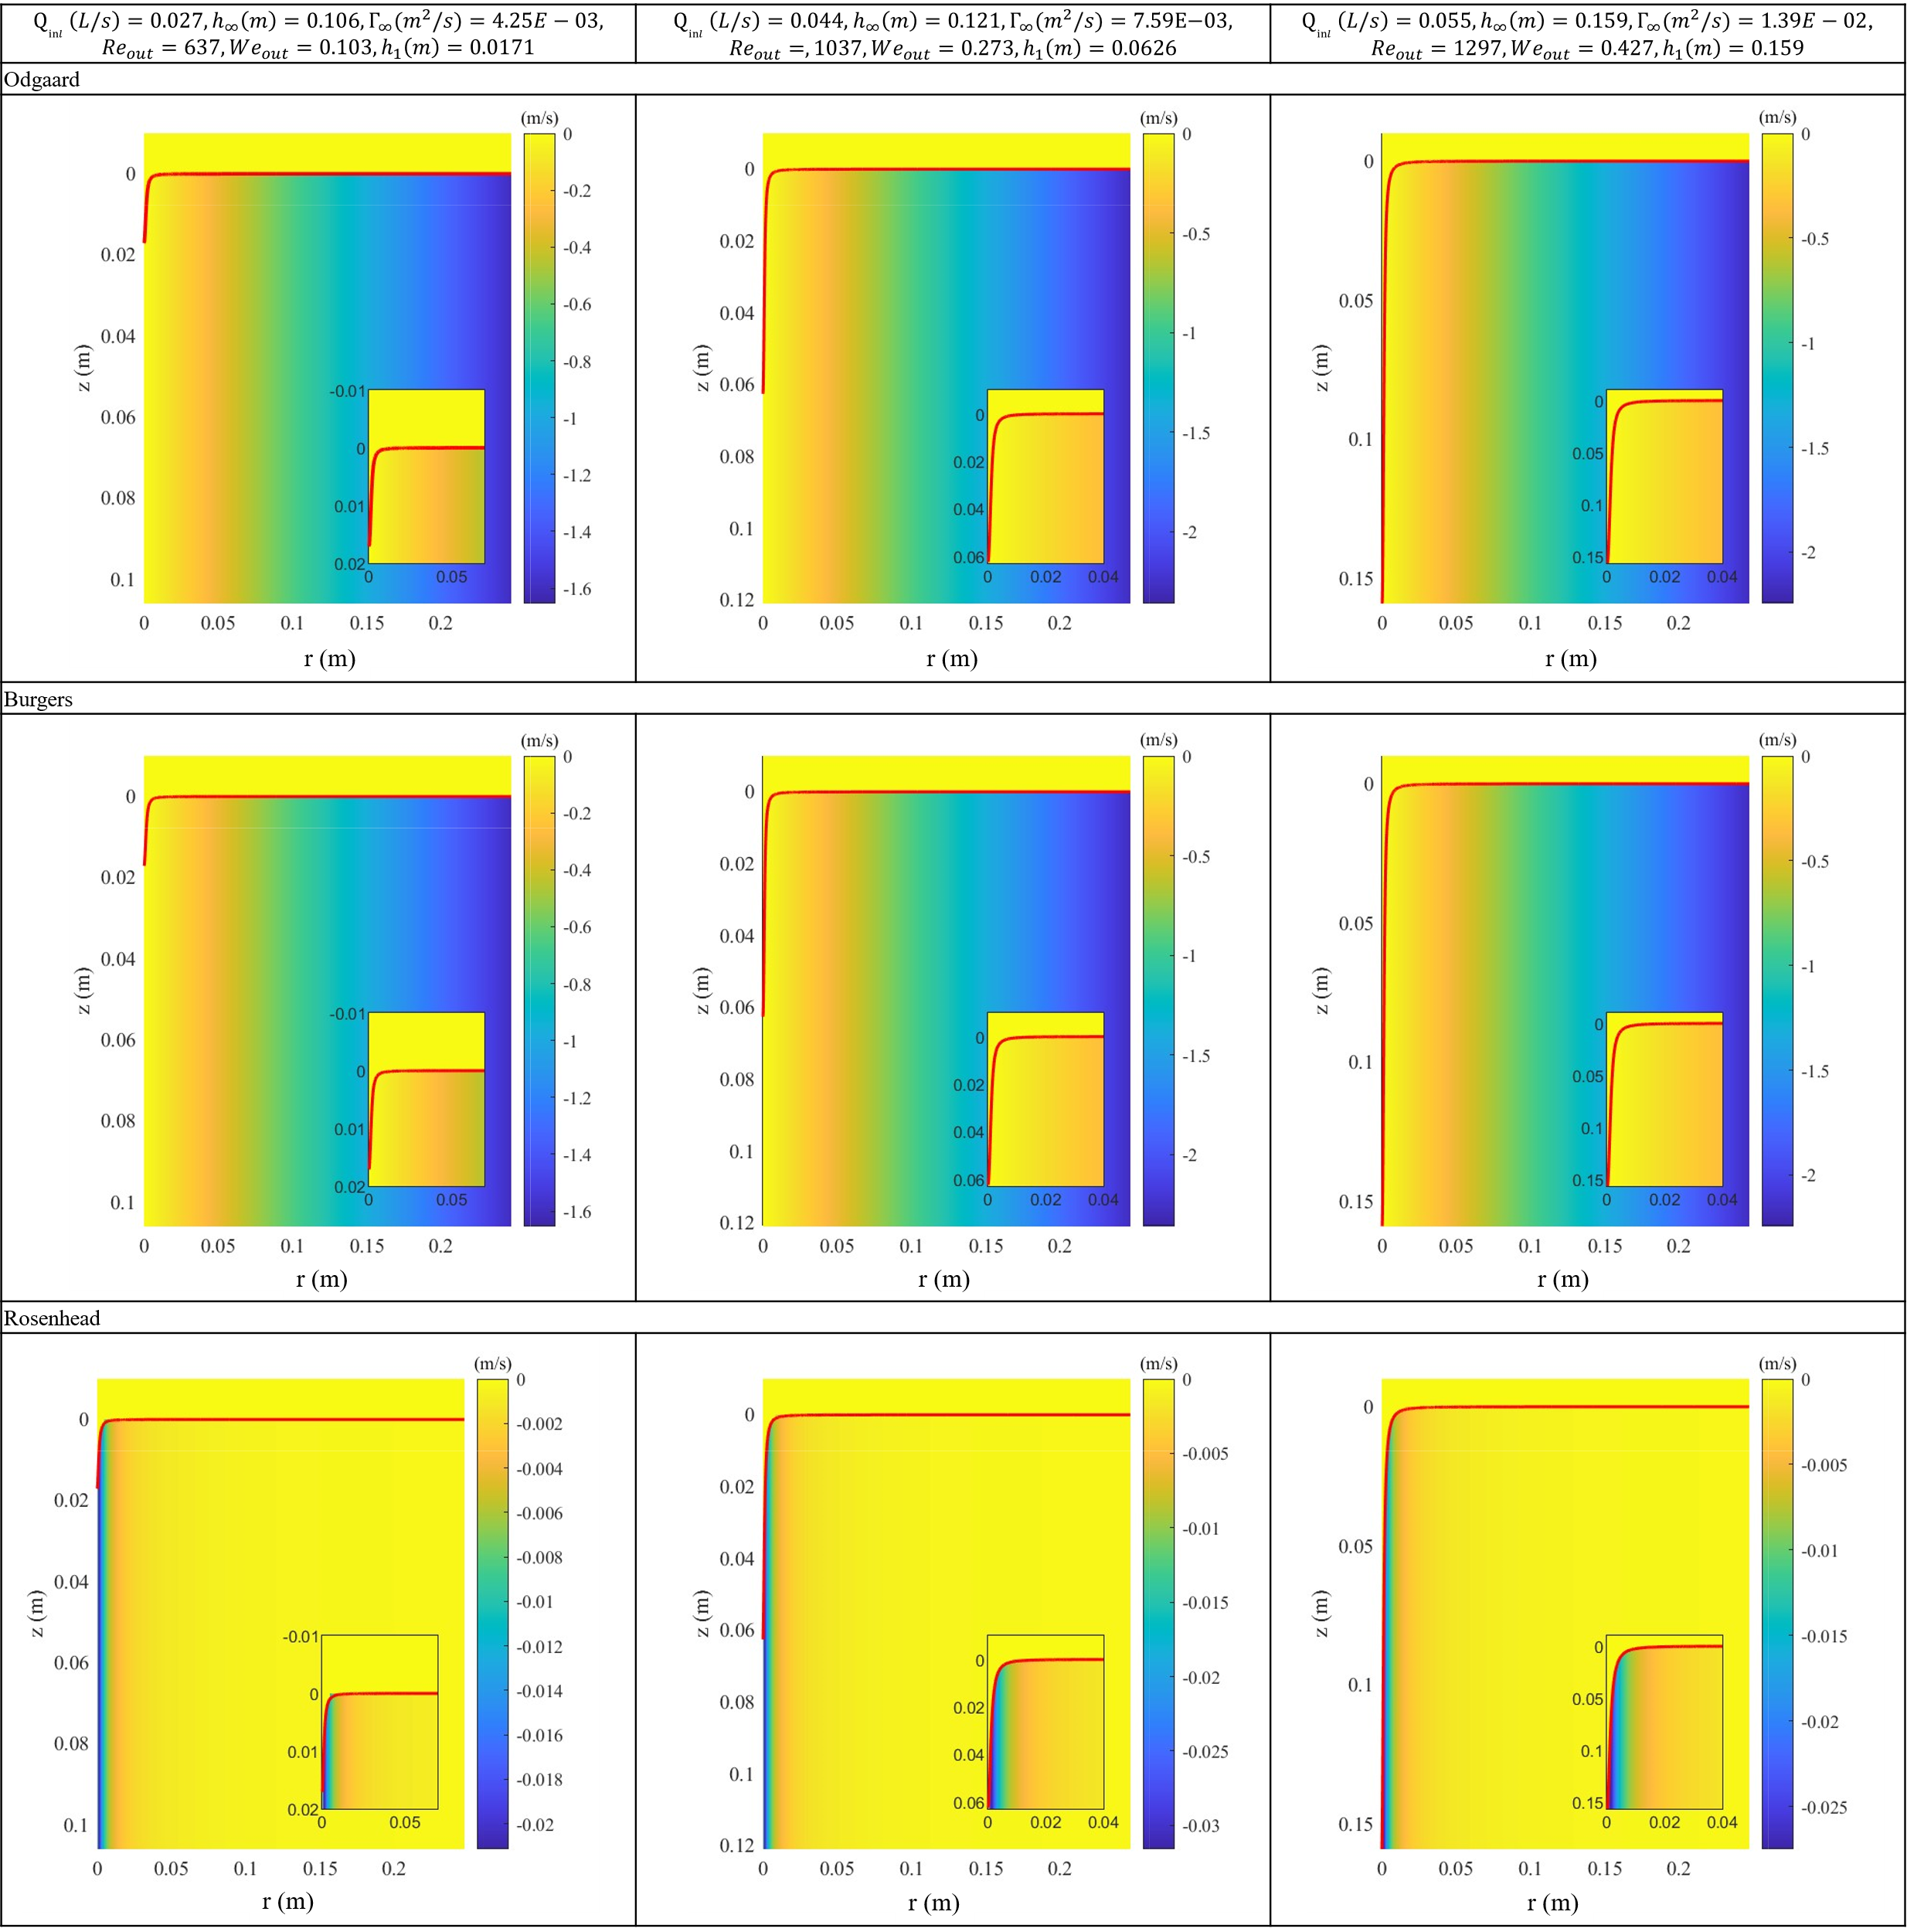
Figure 7. Radial velocity fields in Odgaard, Burgers and Rosenhead models for weak vortexes.
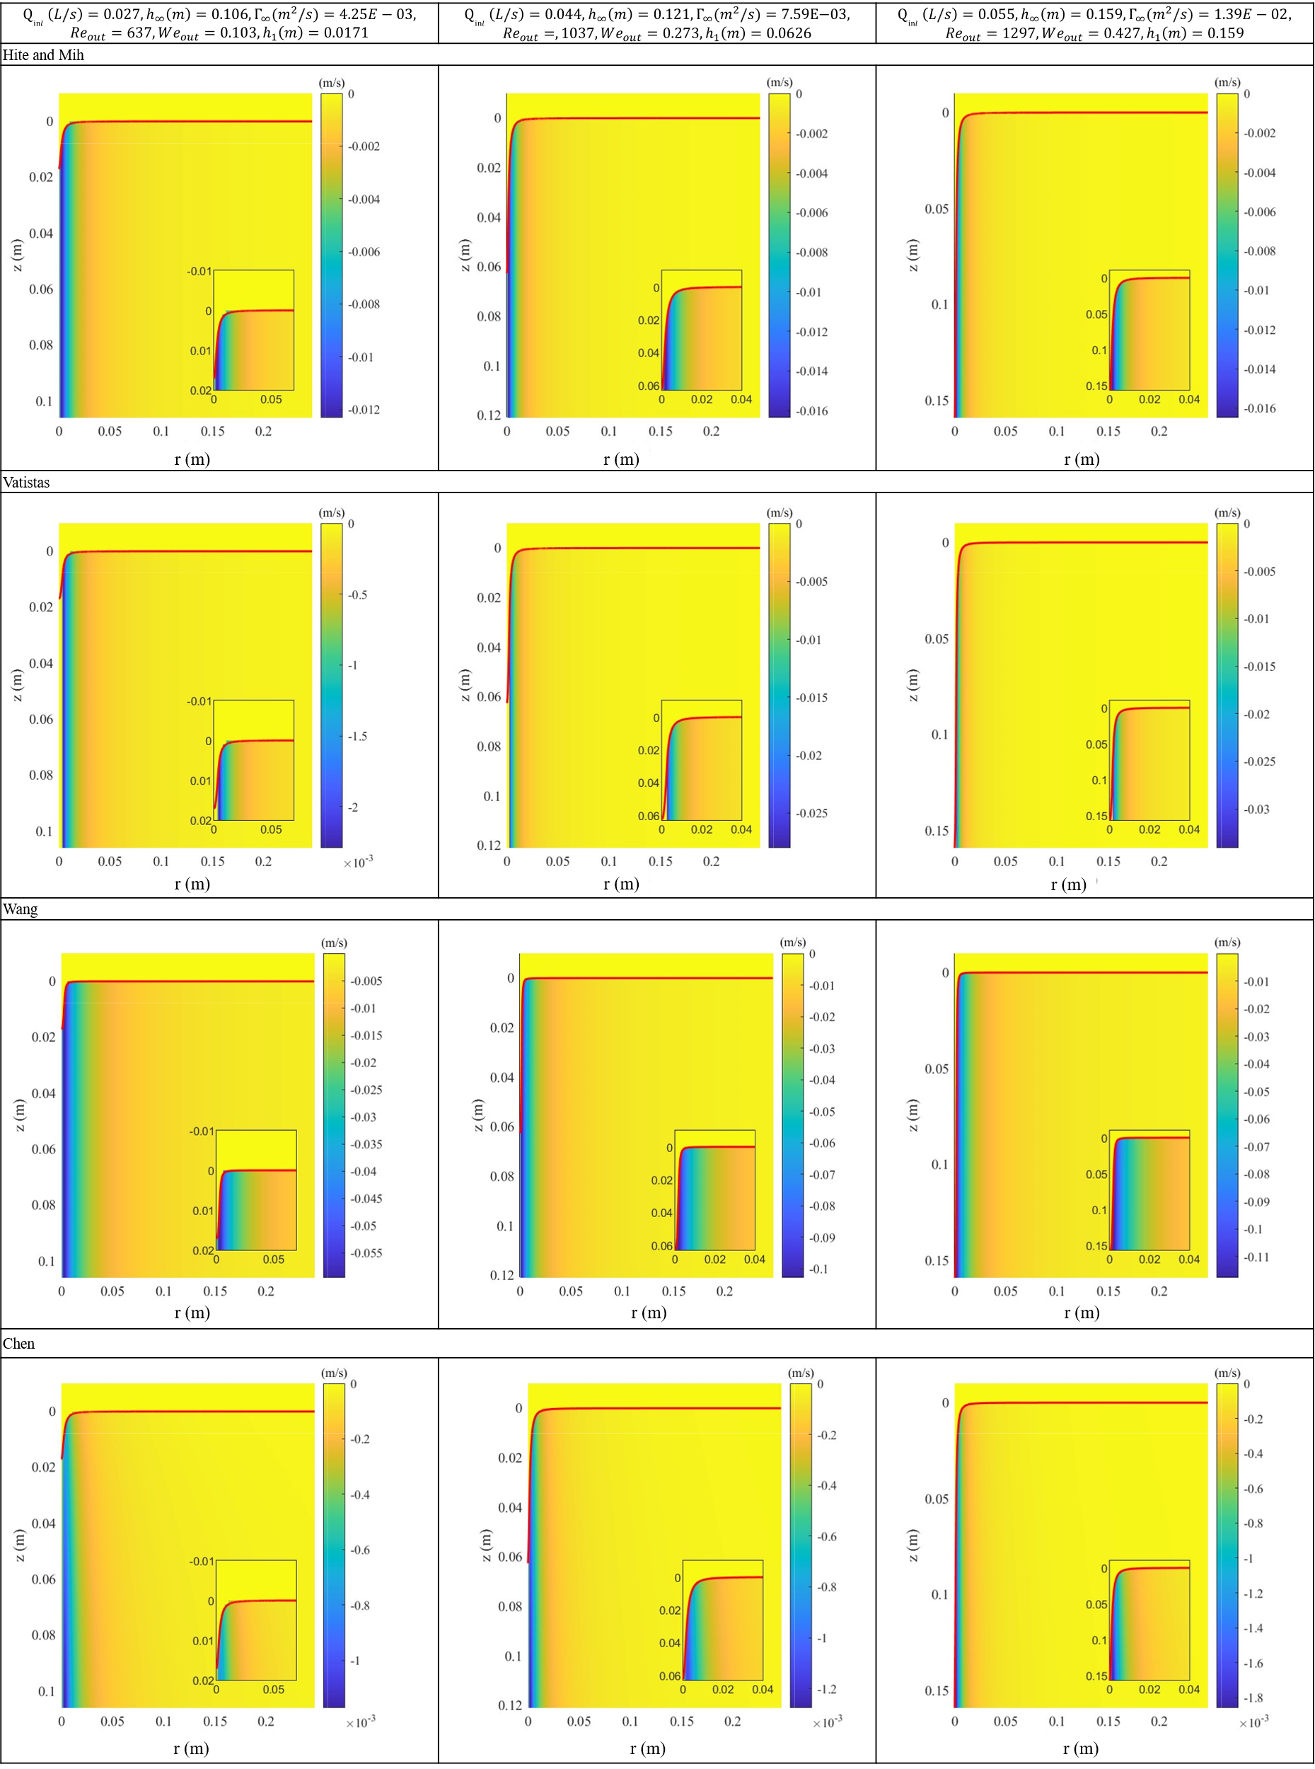
Figure 8. Radial velocity fields in Hite and Mih, Vatistas, Wang and Chen models for weak vortexes.

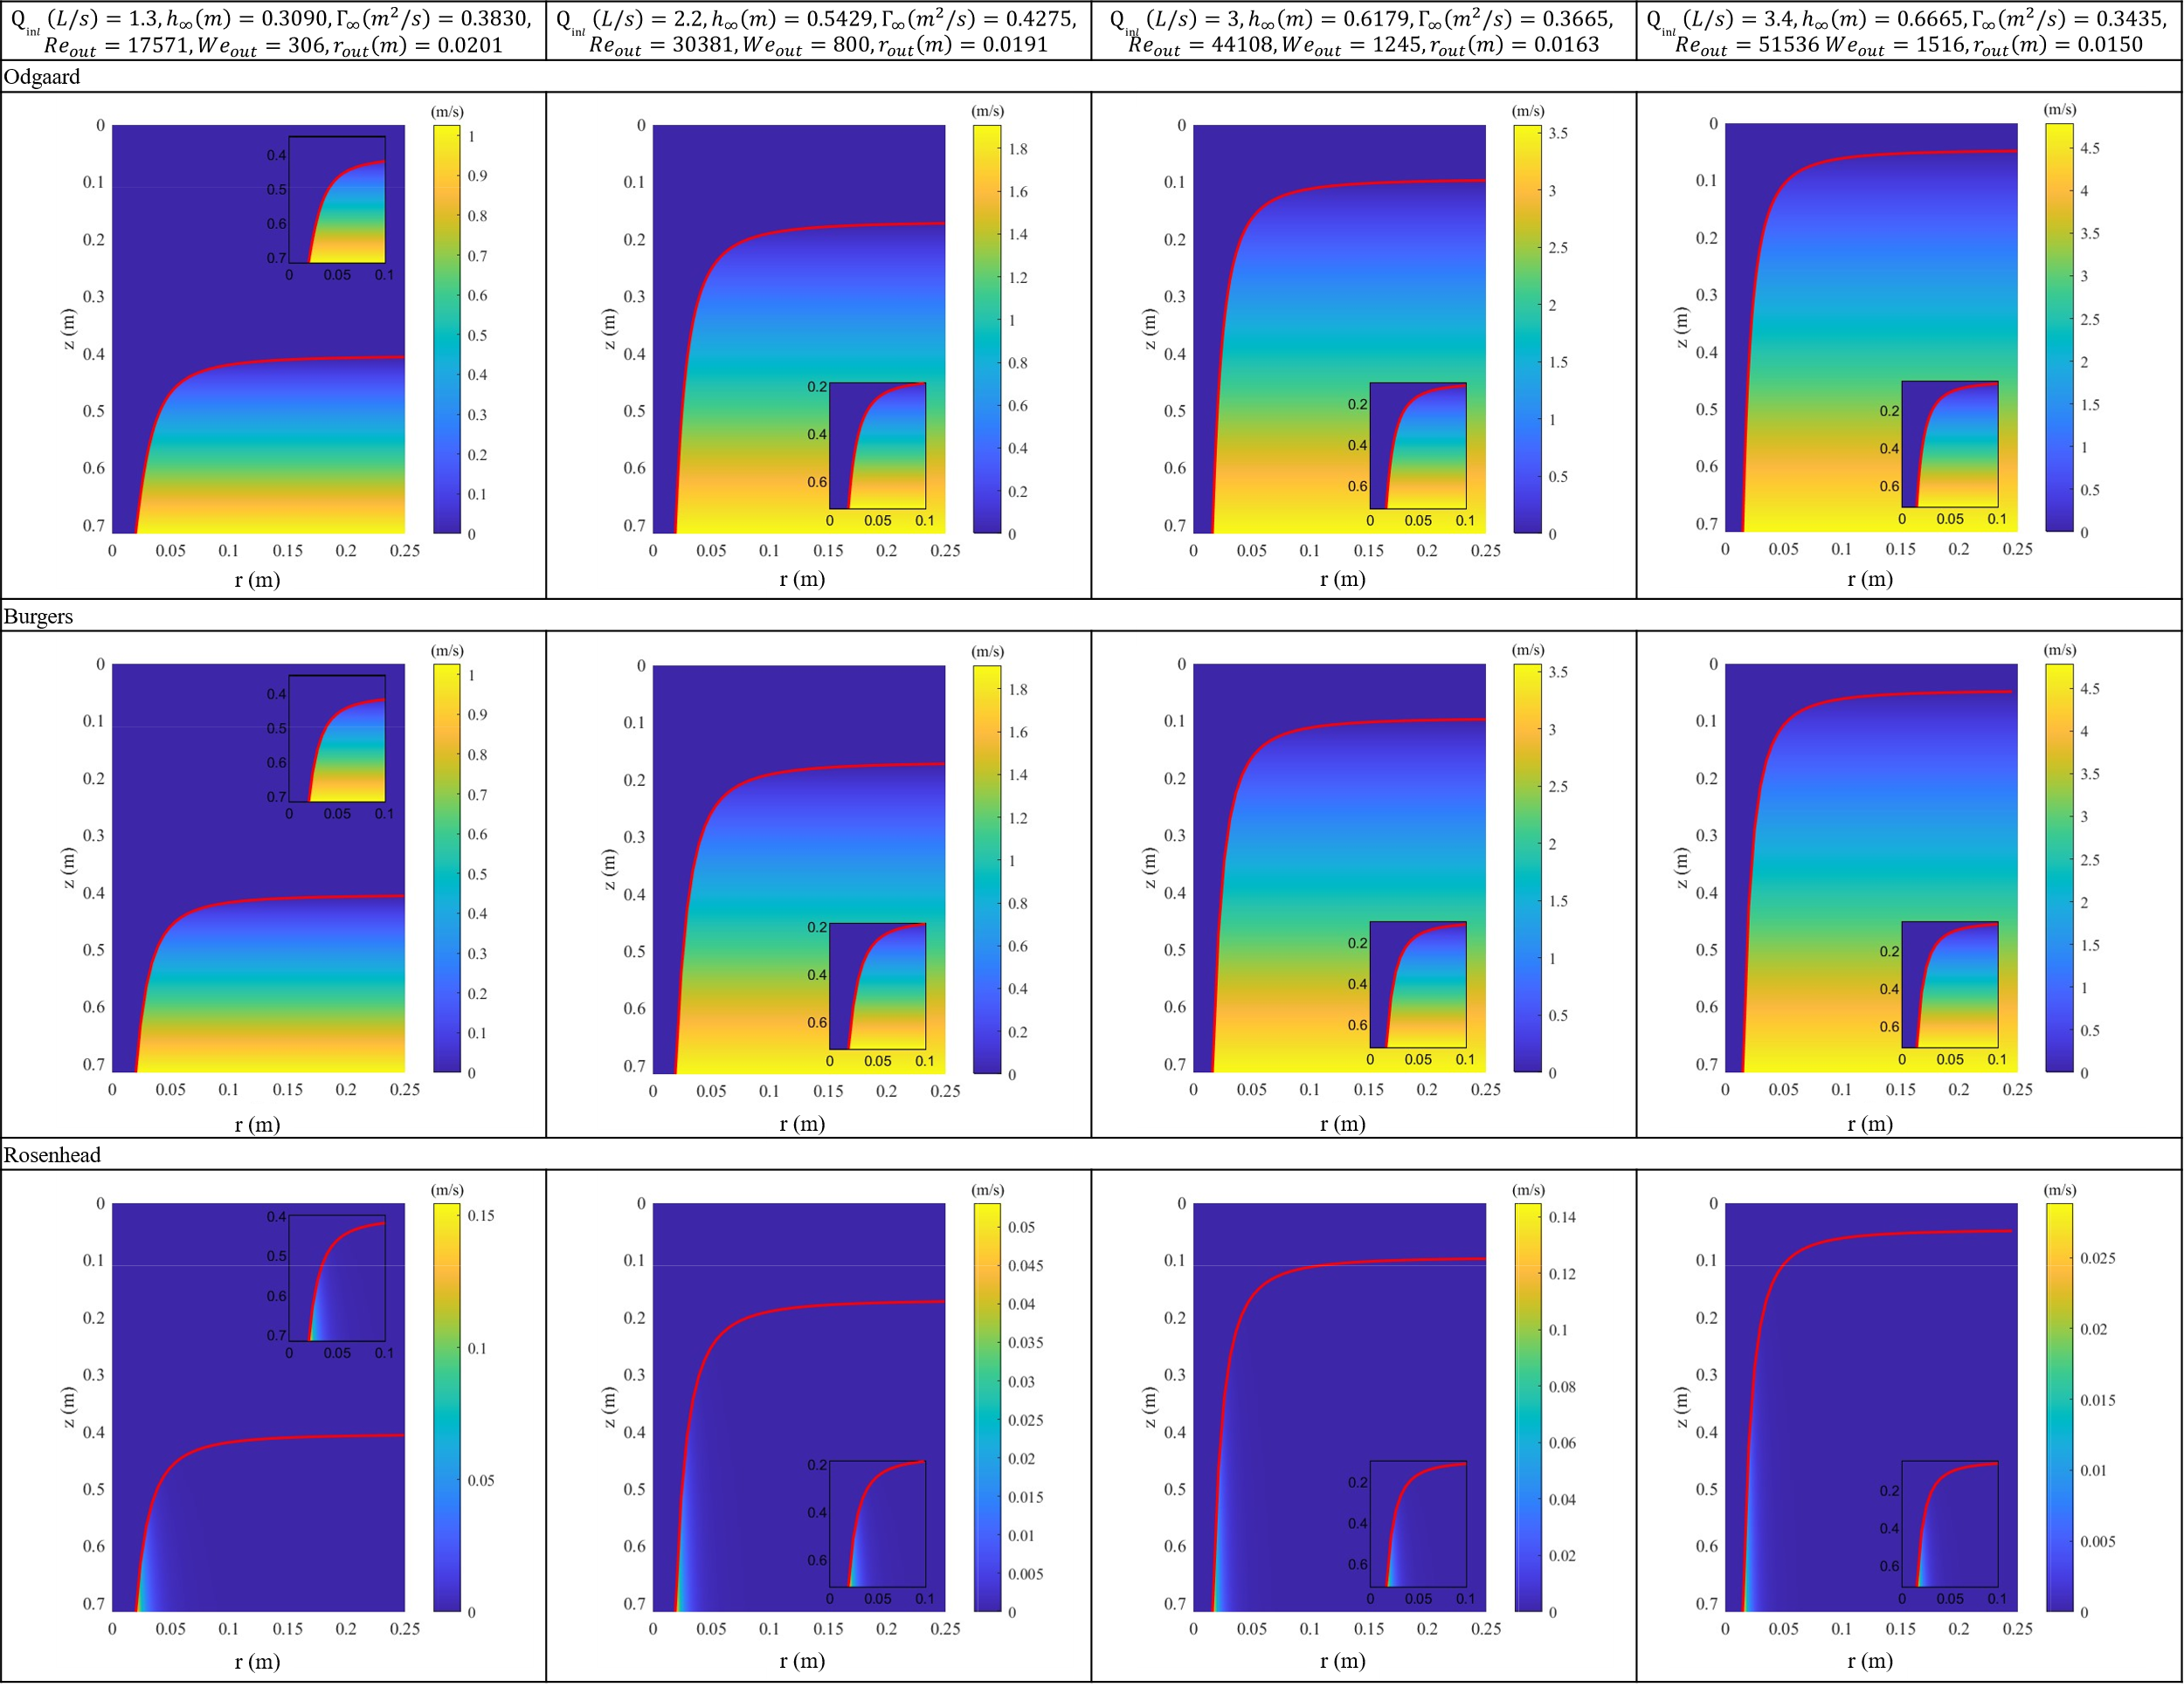
Figure 9. Axial velocity fields in Odgaard, Burgers and Rosenhead models for strong vortexes.
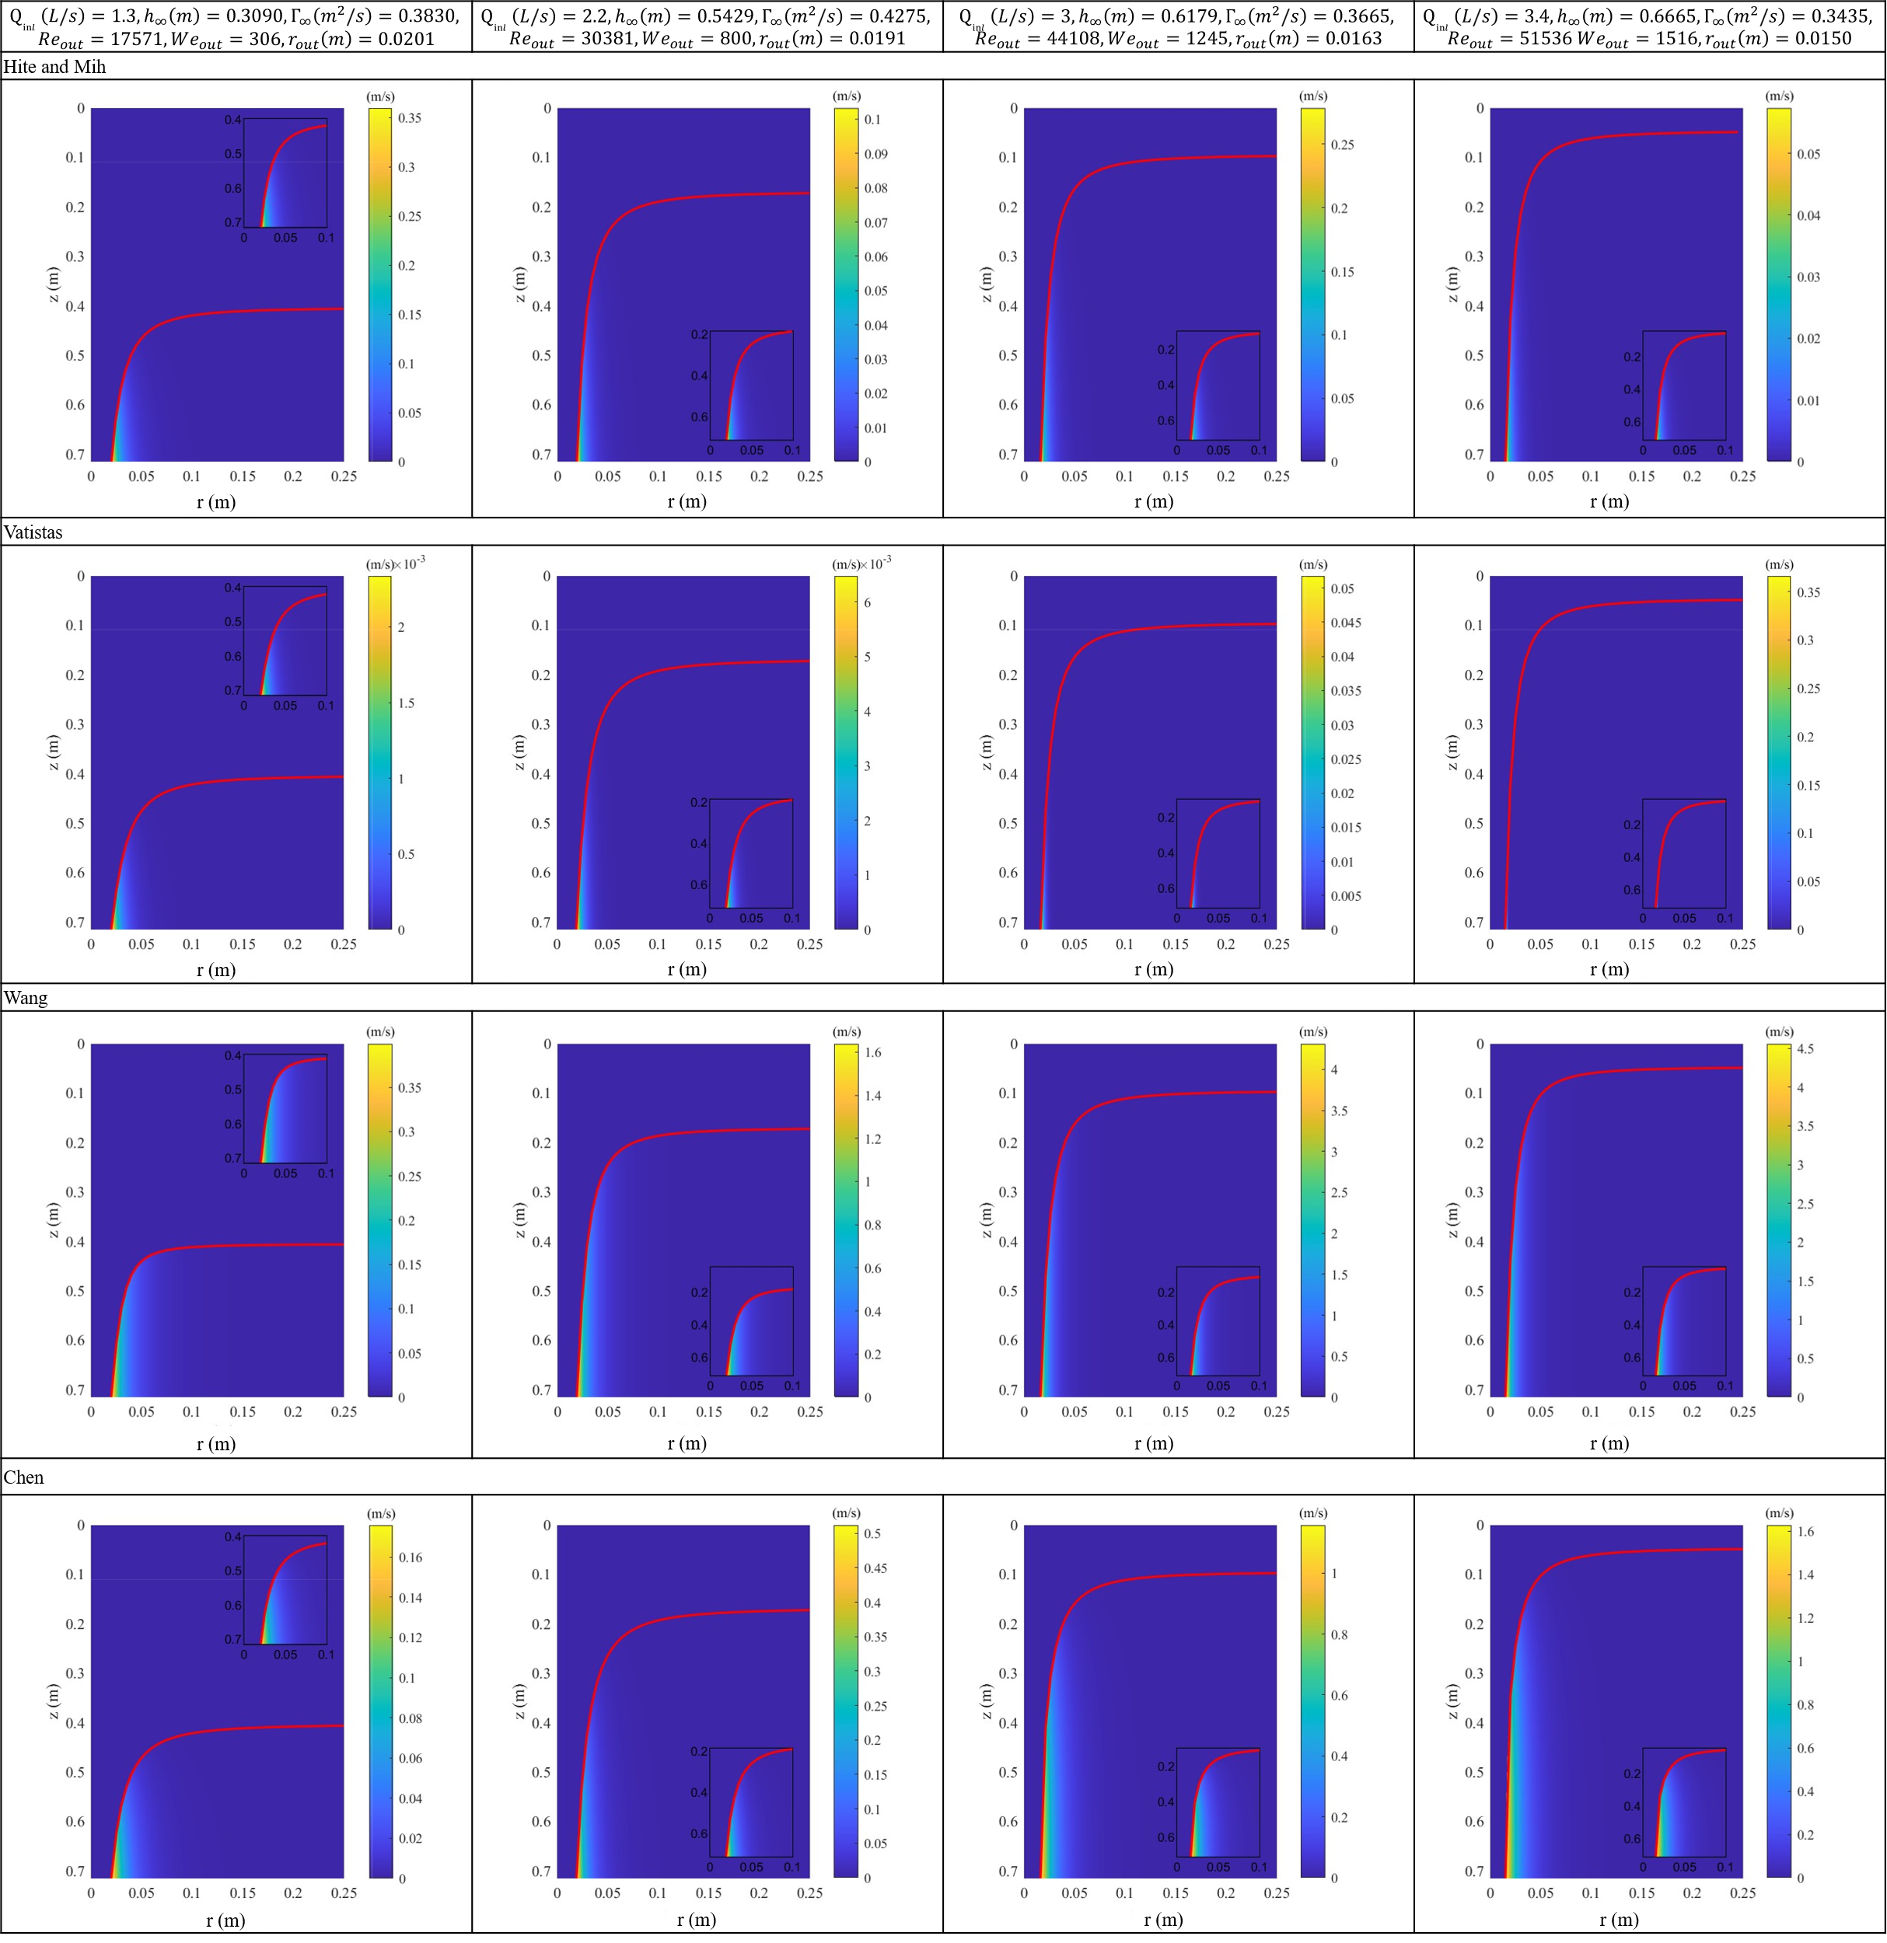
Figure 10. Axial velocity fields in Hite and Mih, Vatistas, Wang and Chen models for strong vortexes.
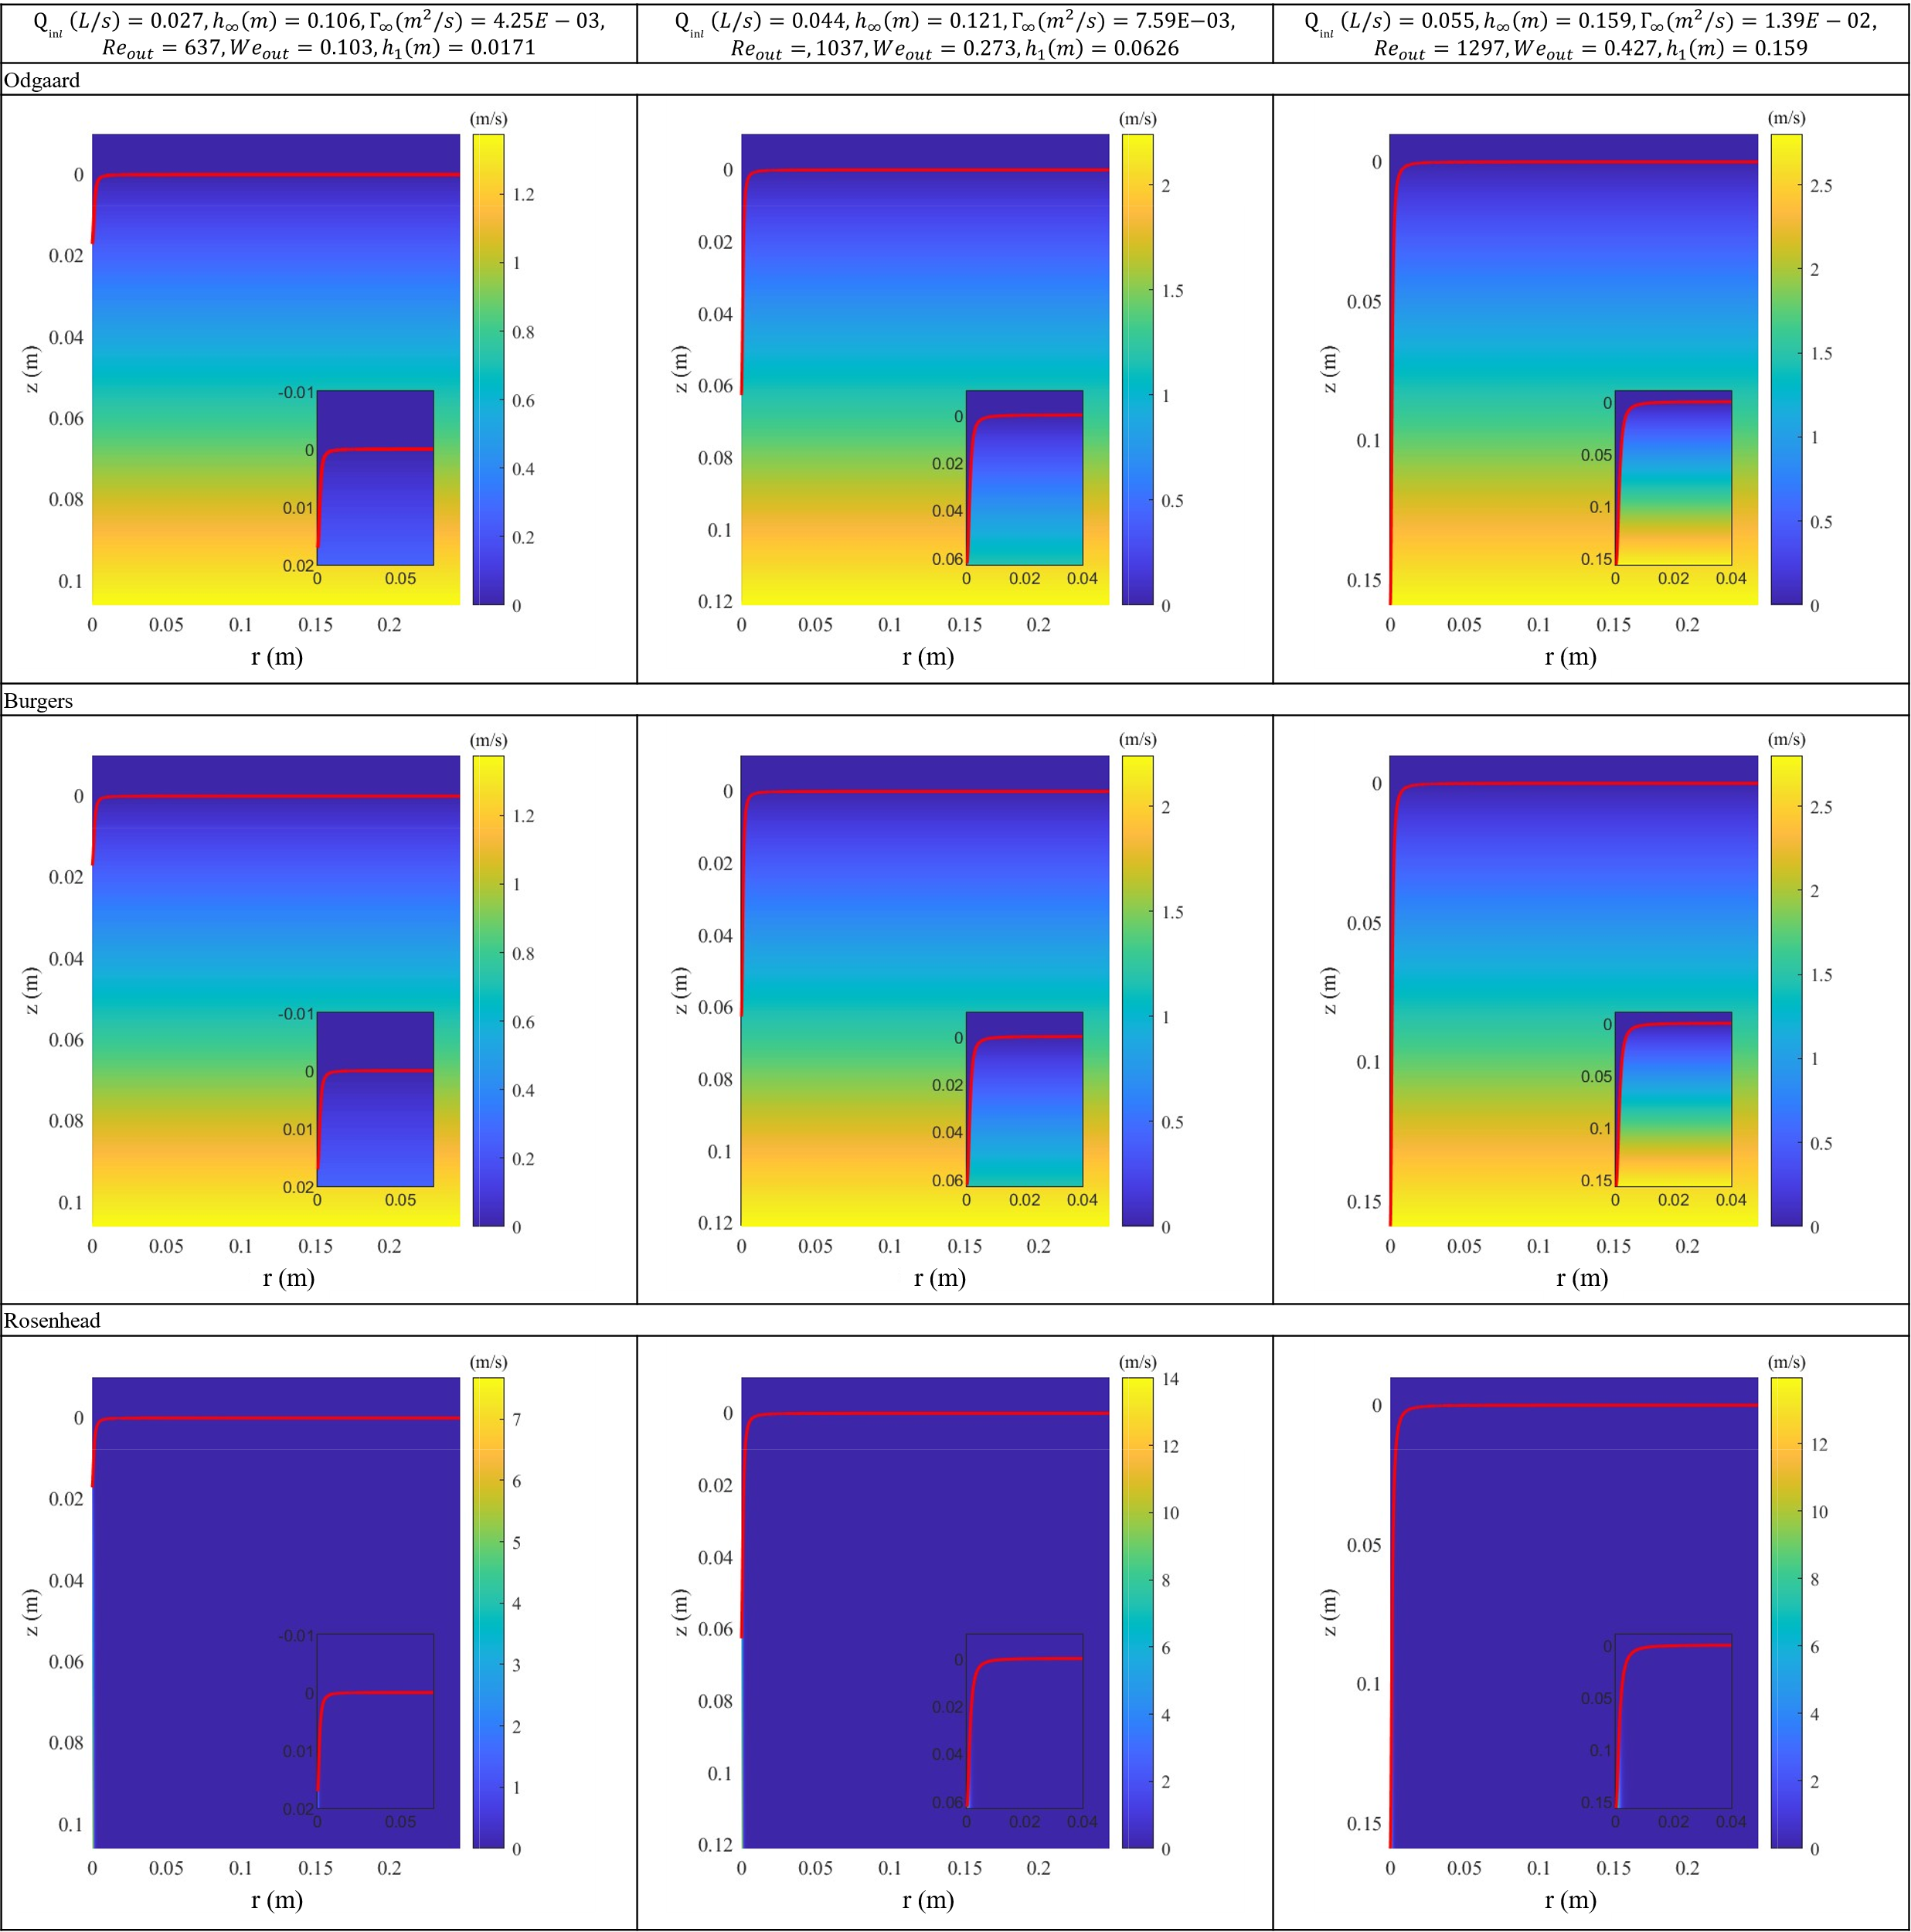
Figure 11. Axial velocity fields in Odgaard, Burgers and Rosenhead models for weak vortexes.
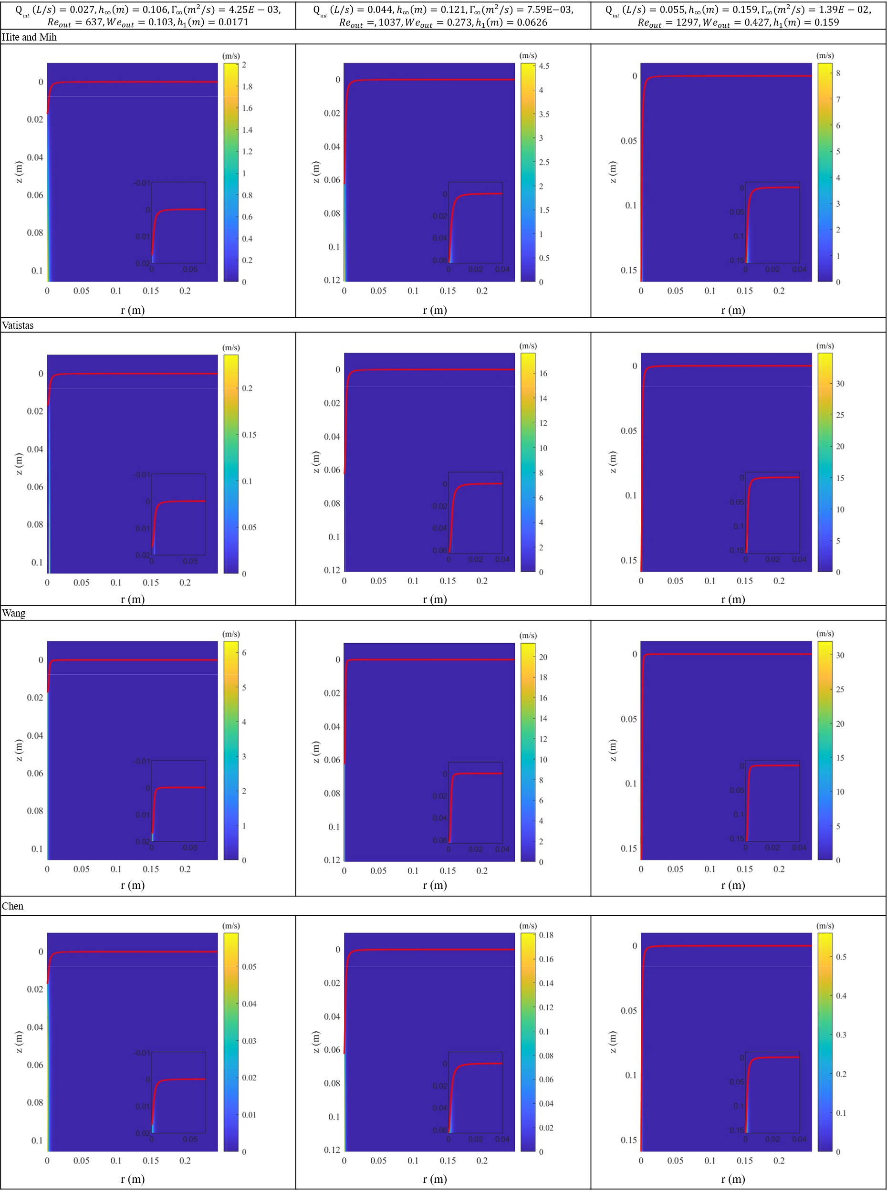
Figure 12. Axial velocity fields in Hite and Mih, Vatistas, Wang and Chen models for weak vortexes.
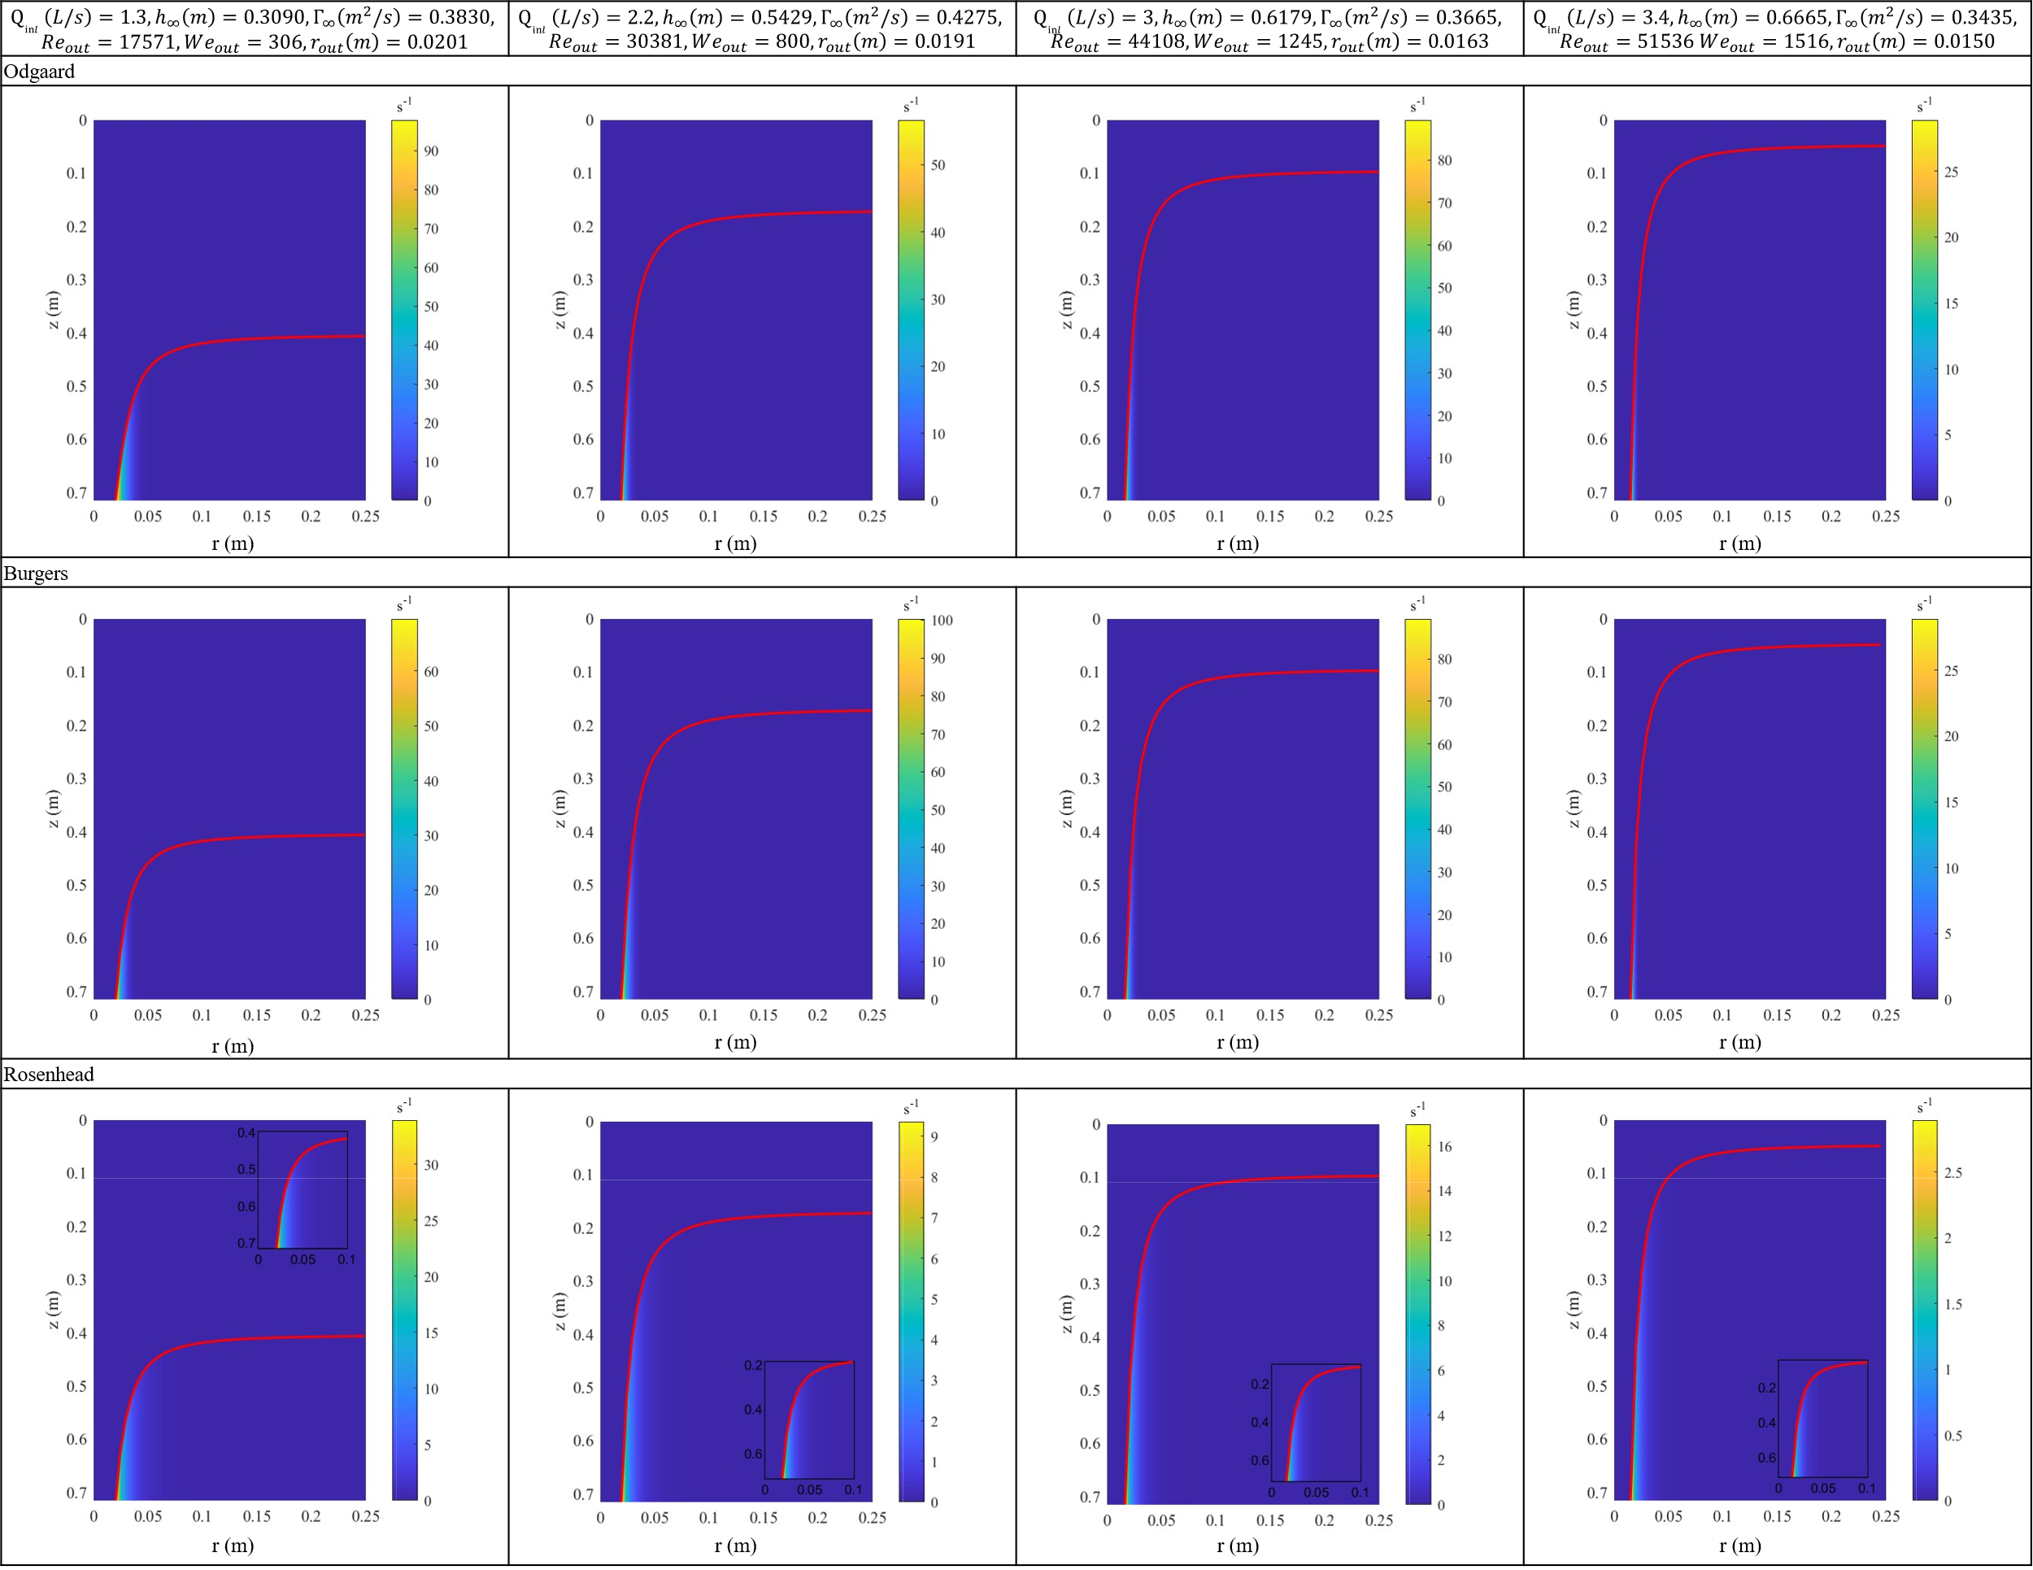
Figure 13. Axial vorticity fields in Odgaard, Burgers and Rosenhead models for strong vortexes.
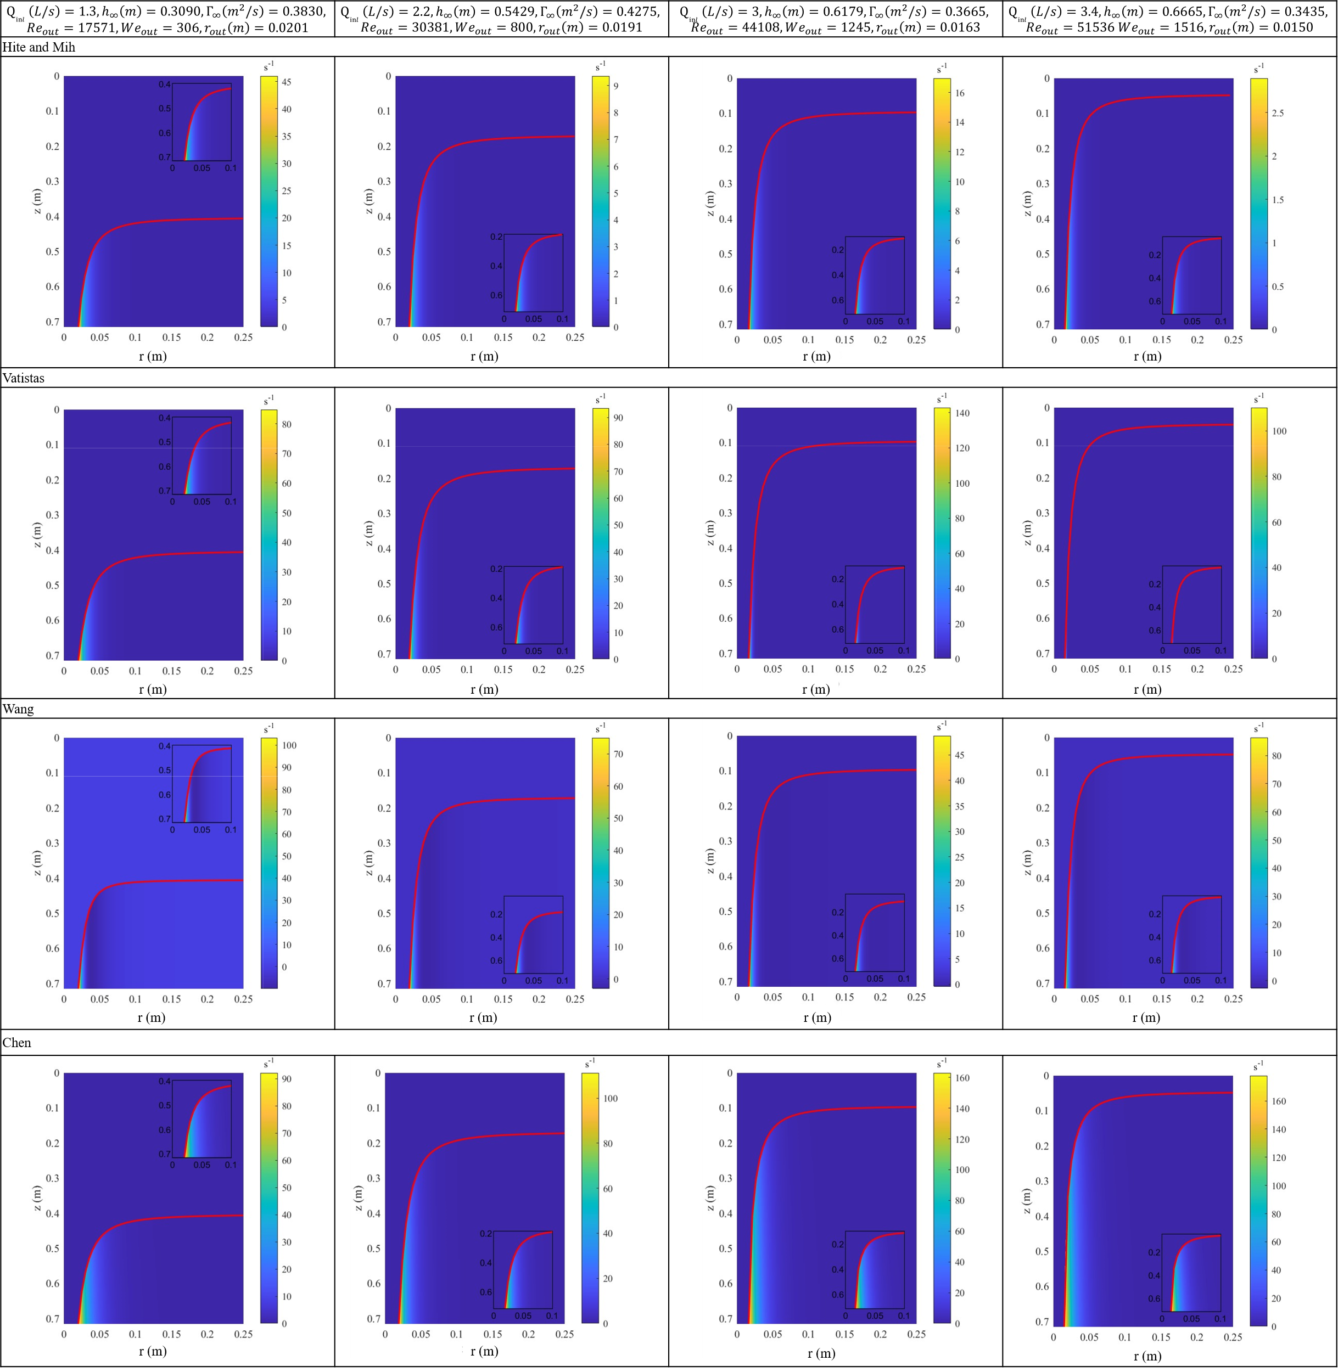
Figure 14. Axial vorticity fields in Hite and Mih, Vatistas, Wang and Chen models for strong vortexes.
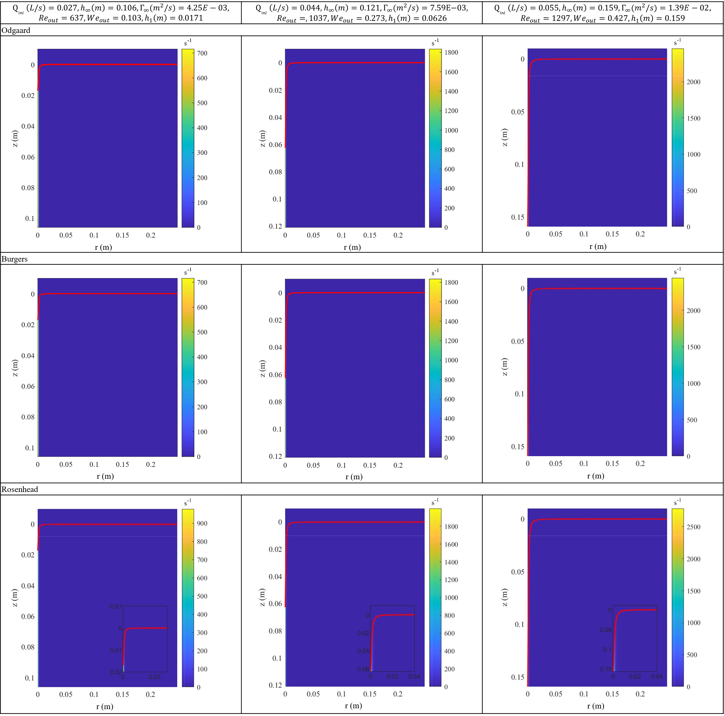
Figure 15. Axial vorticity fields in Odgaard, Burgers and Rosenhead models for weak vortexes.
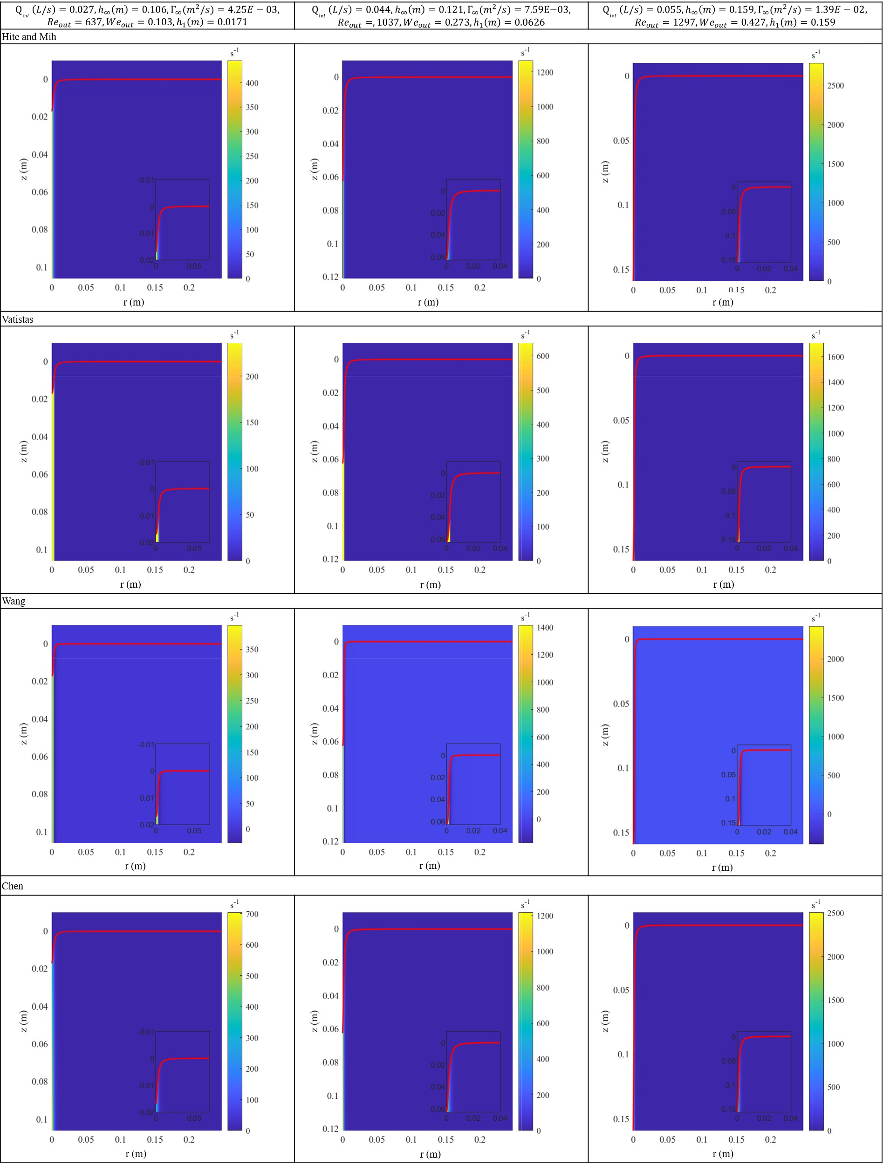
Figure 16. Axial vorticity fields in Hite and Mih, Vatistas, Wang and Chen models for weak vortexes.

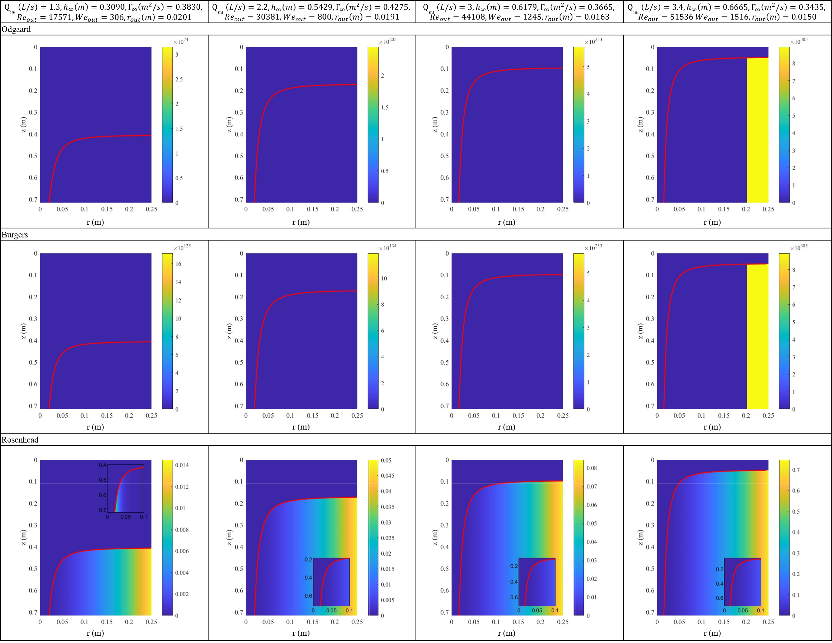
Figure 17. ${Ro}_{r}^{2}$ fields in Odgaard, Burgers and Rosenhead models for strong vortexes.
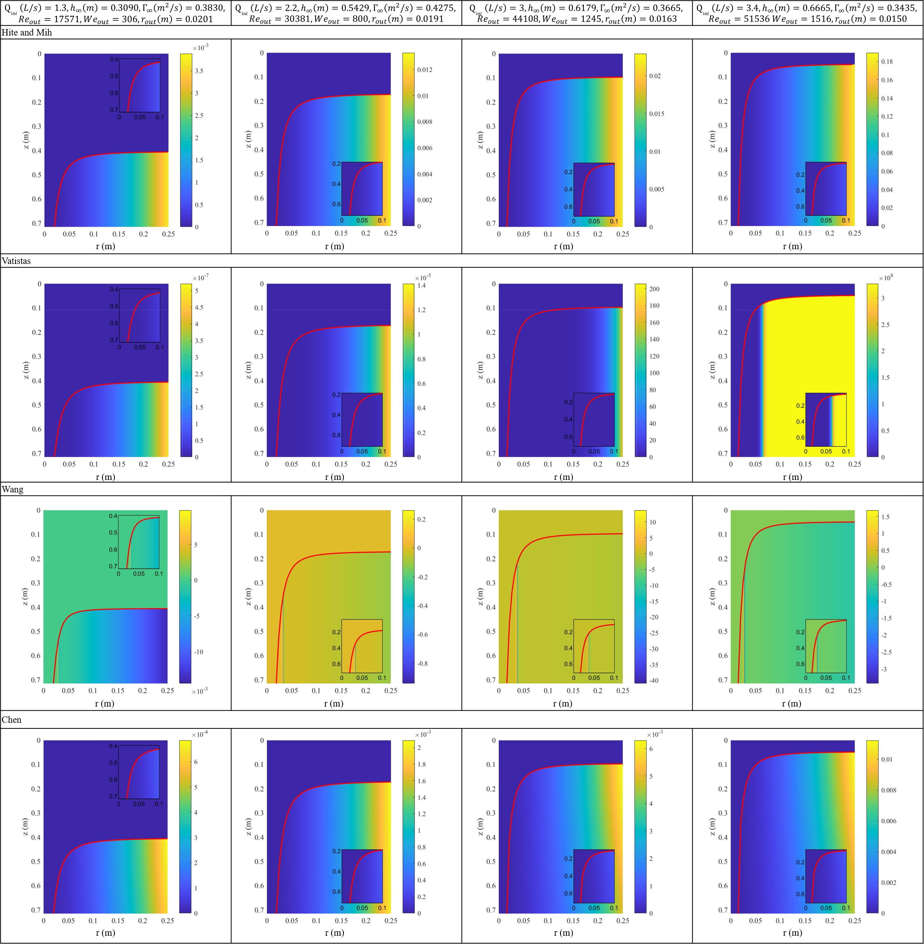
Figure 18. ${Ro}_{r}^{2}$ fields in Hite and Mih, Vatistas, Wang and Chen models for strong vortexes.
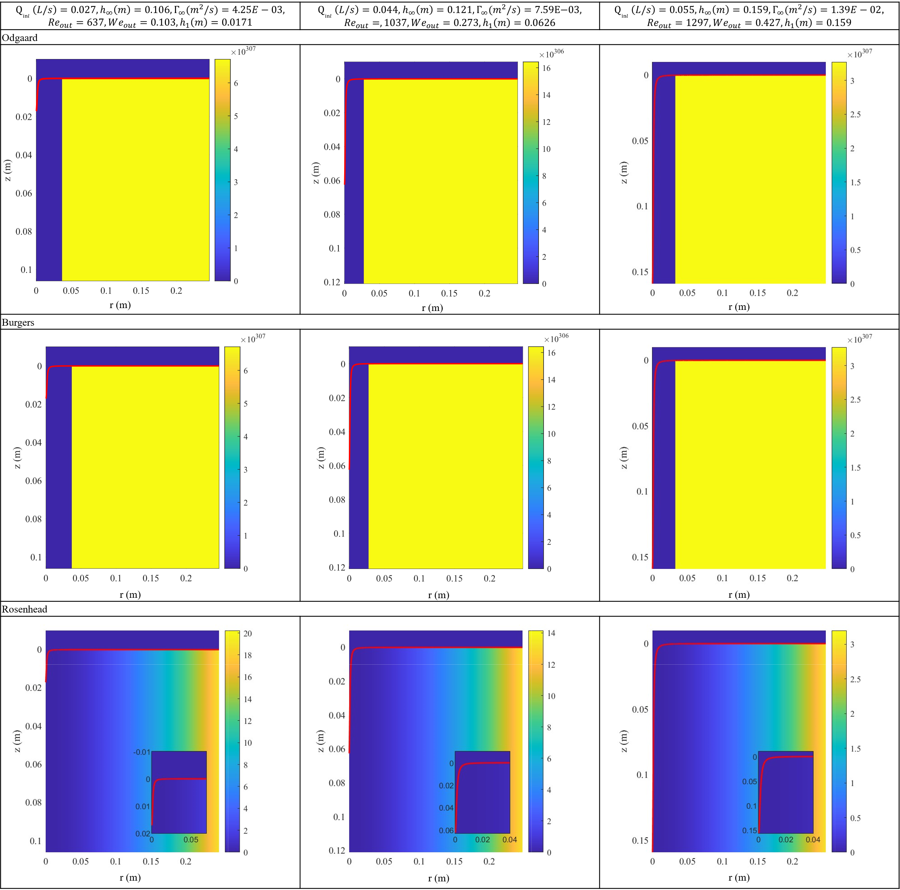
Figure 19. ${Ro}_{r}^{2}$ fields in Odgaard, Burgers and Rosenhead models for weak vortexes.
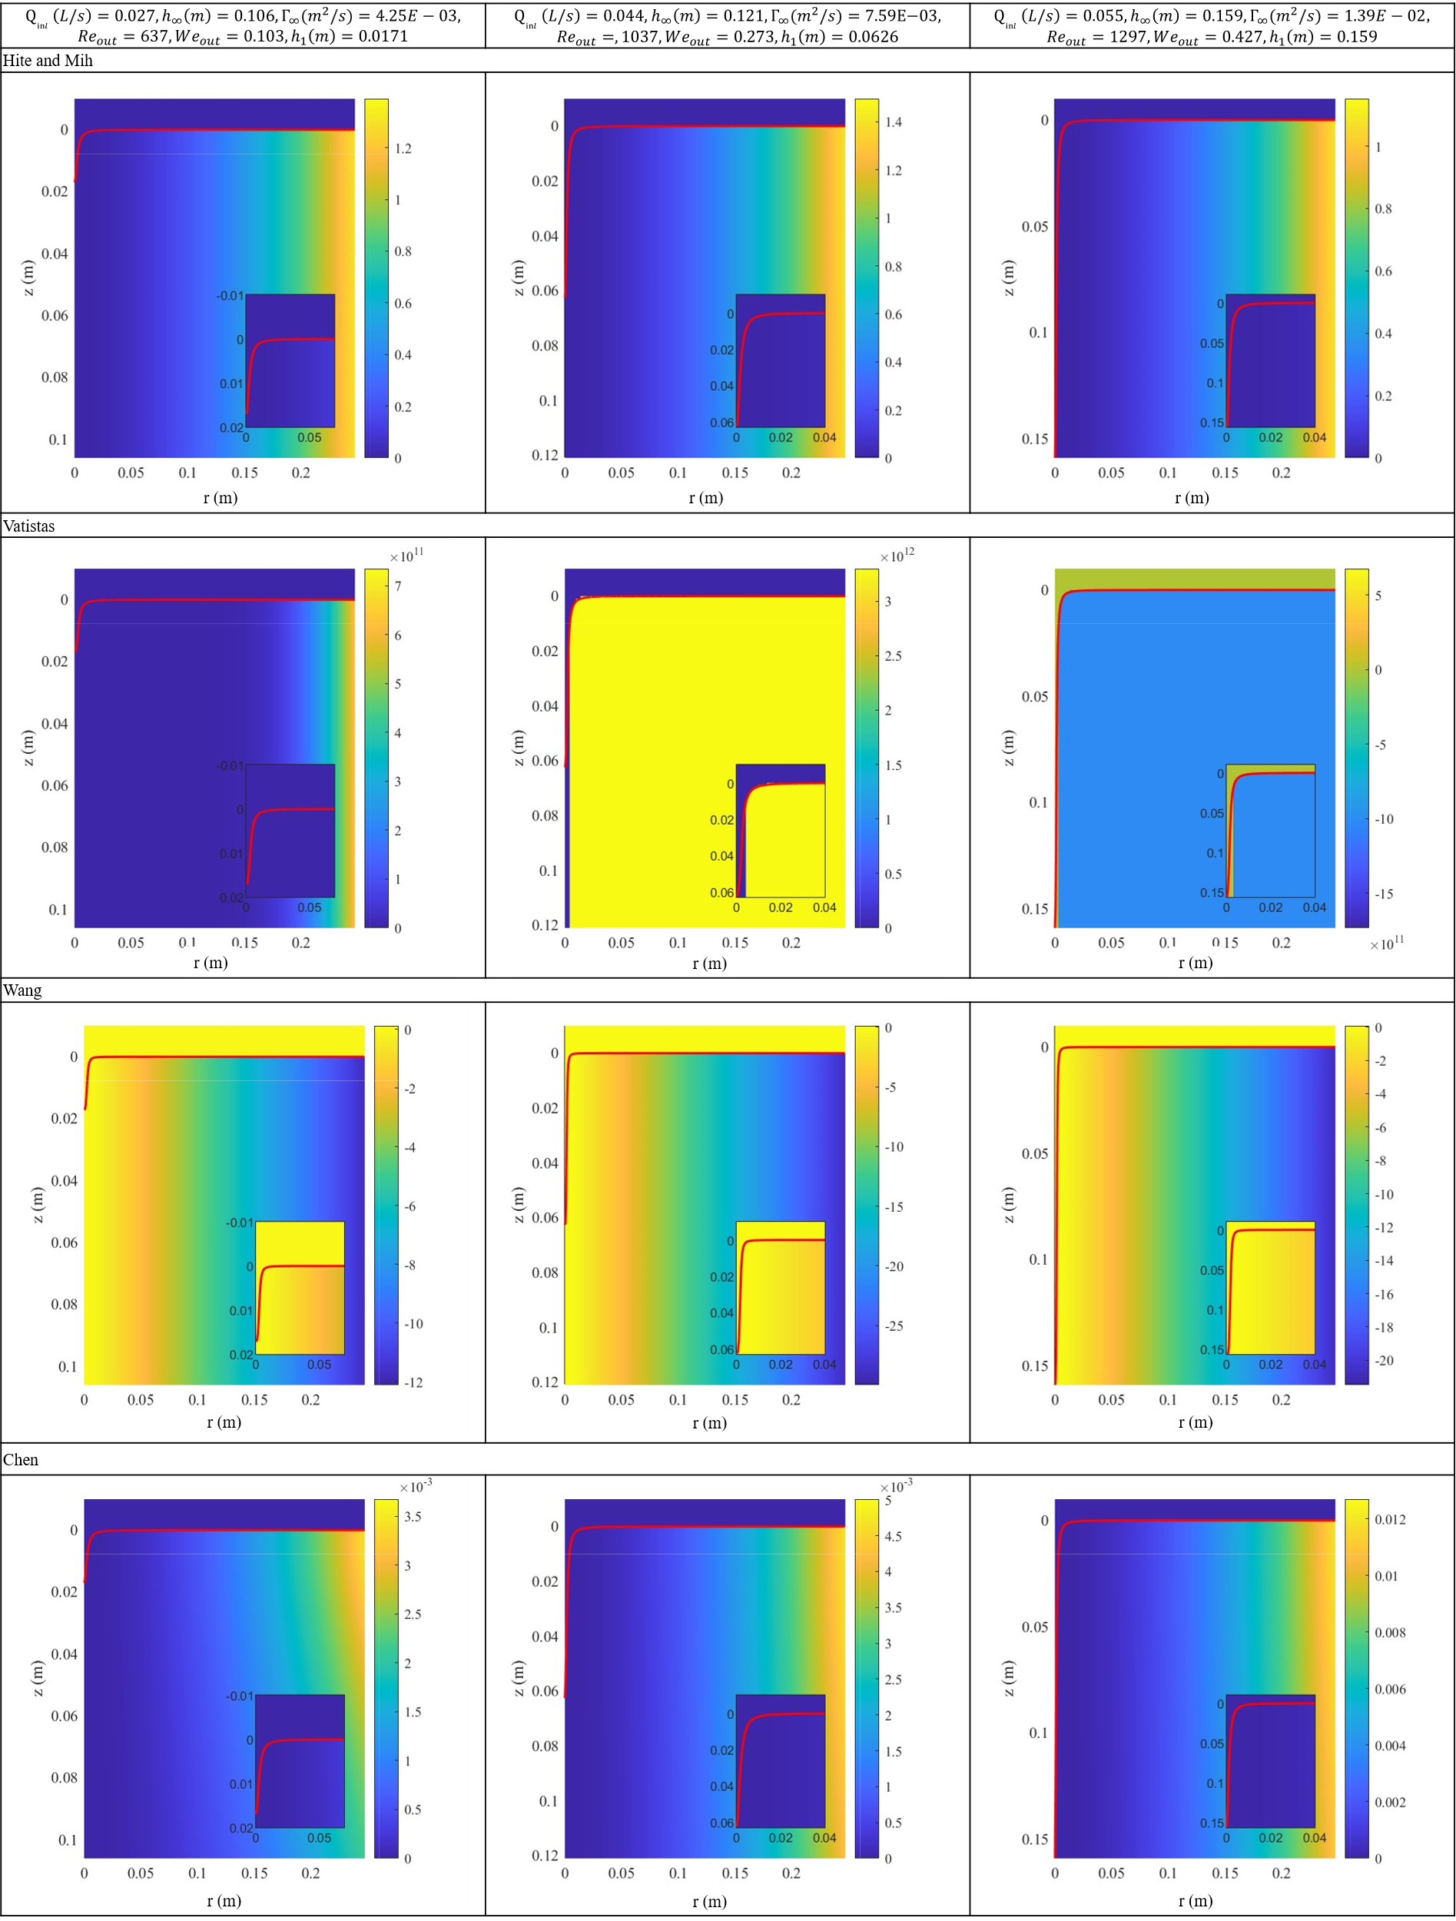
Figure 20. ${Ro}_{r}^{2}$ fields in Hite and Mih, Vatistas, Wang and Chen models for weak vortexes.

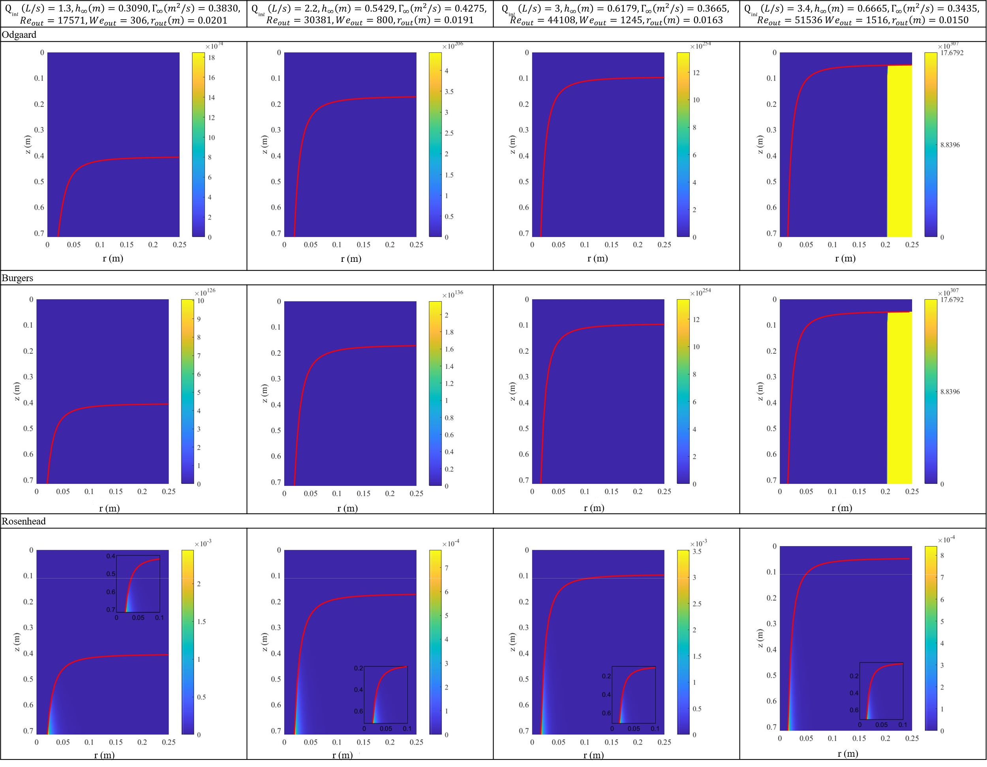
Figure 21. ${Ro}_{z}^{2}$ fields in Odgaard, Burgers and Rosenhead models for strong vortexes.
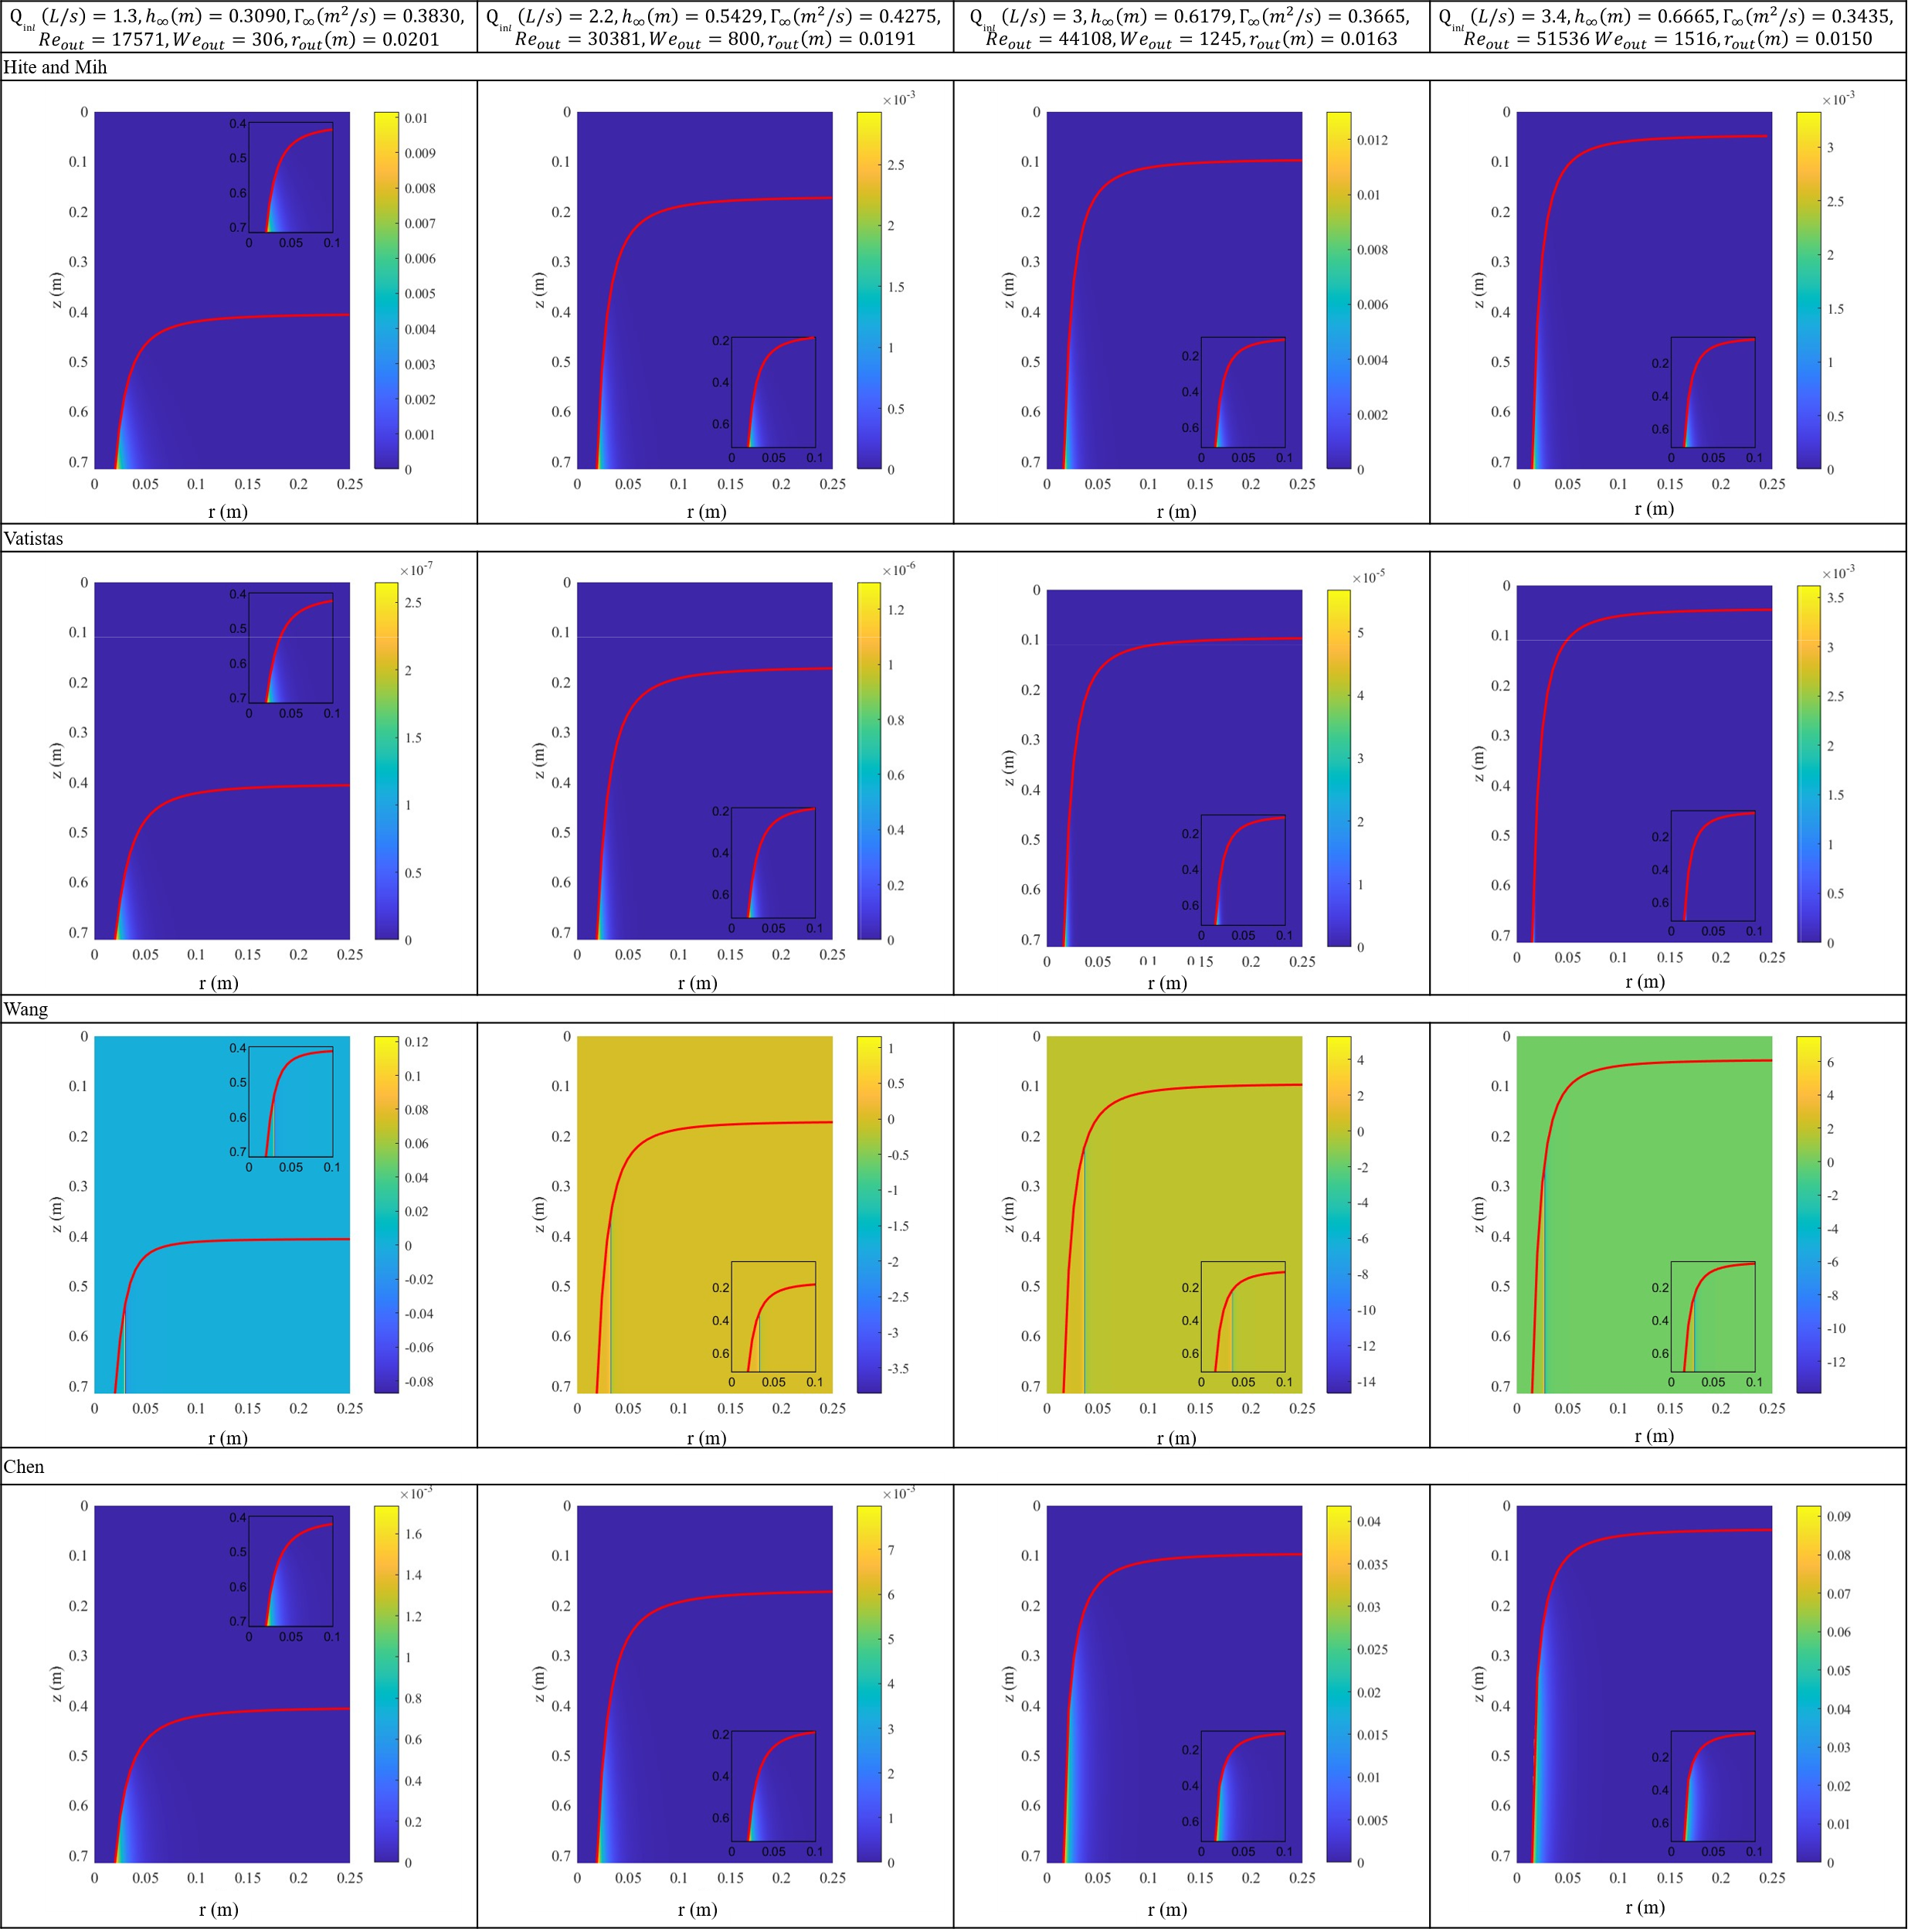
Figure 22. ${Ro}_{z}^{2}$ fields in Hite and Mih, Vatistas, Wang and Chen models for strong vortexes.
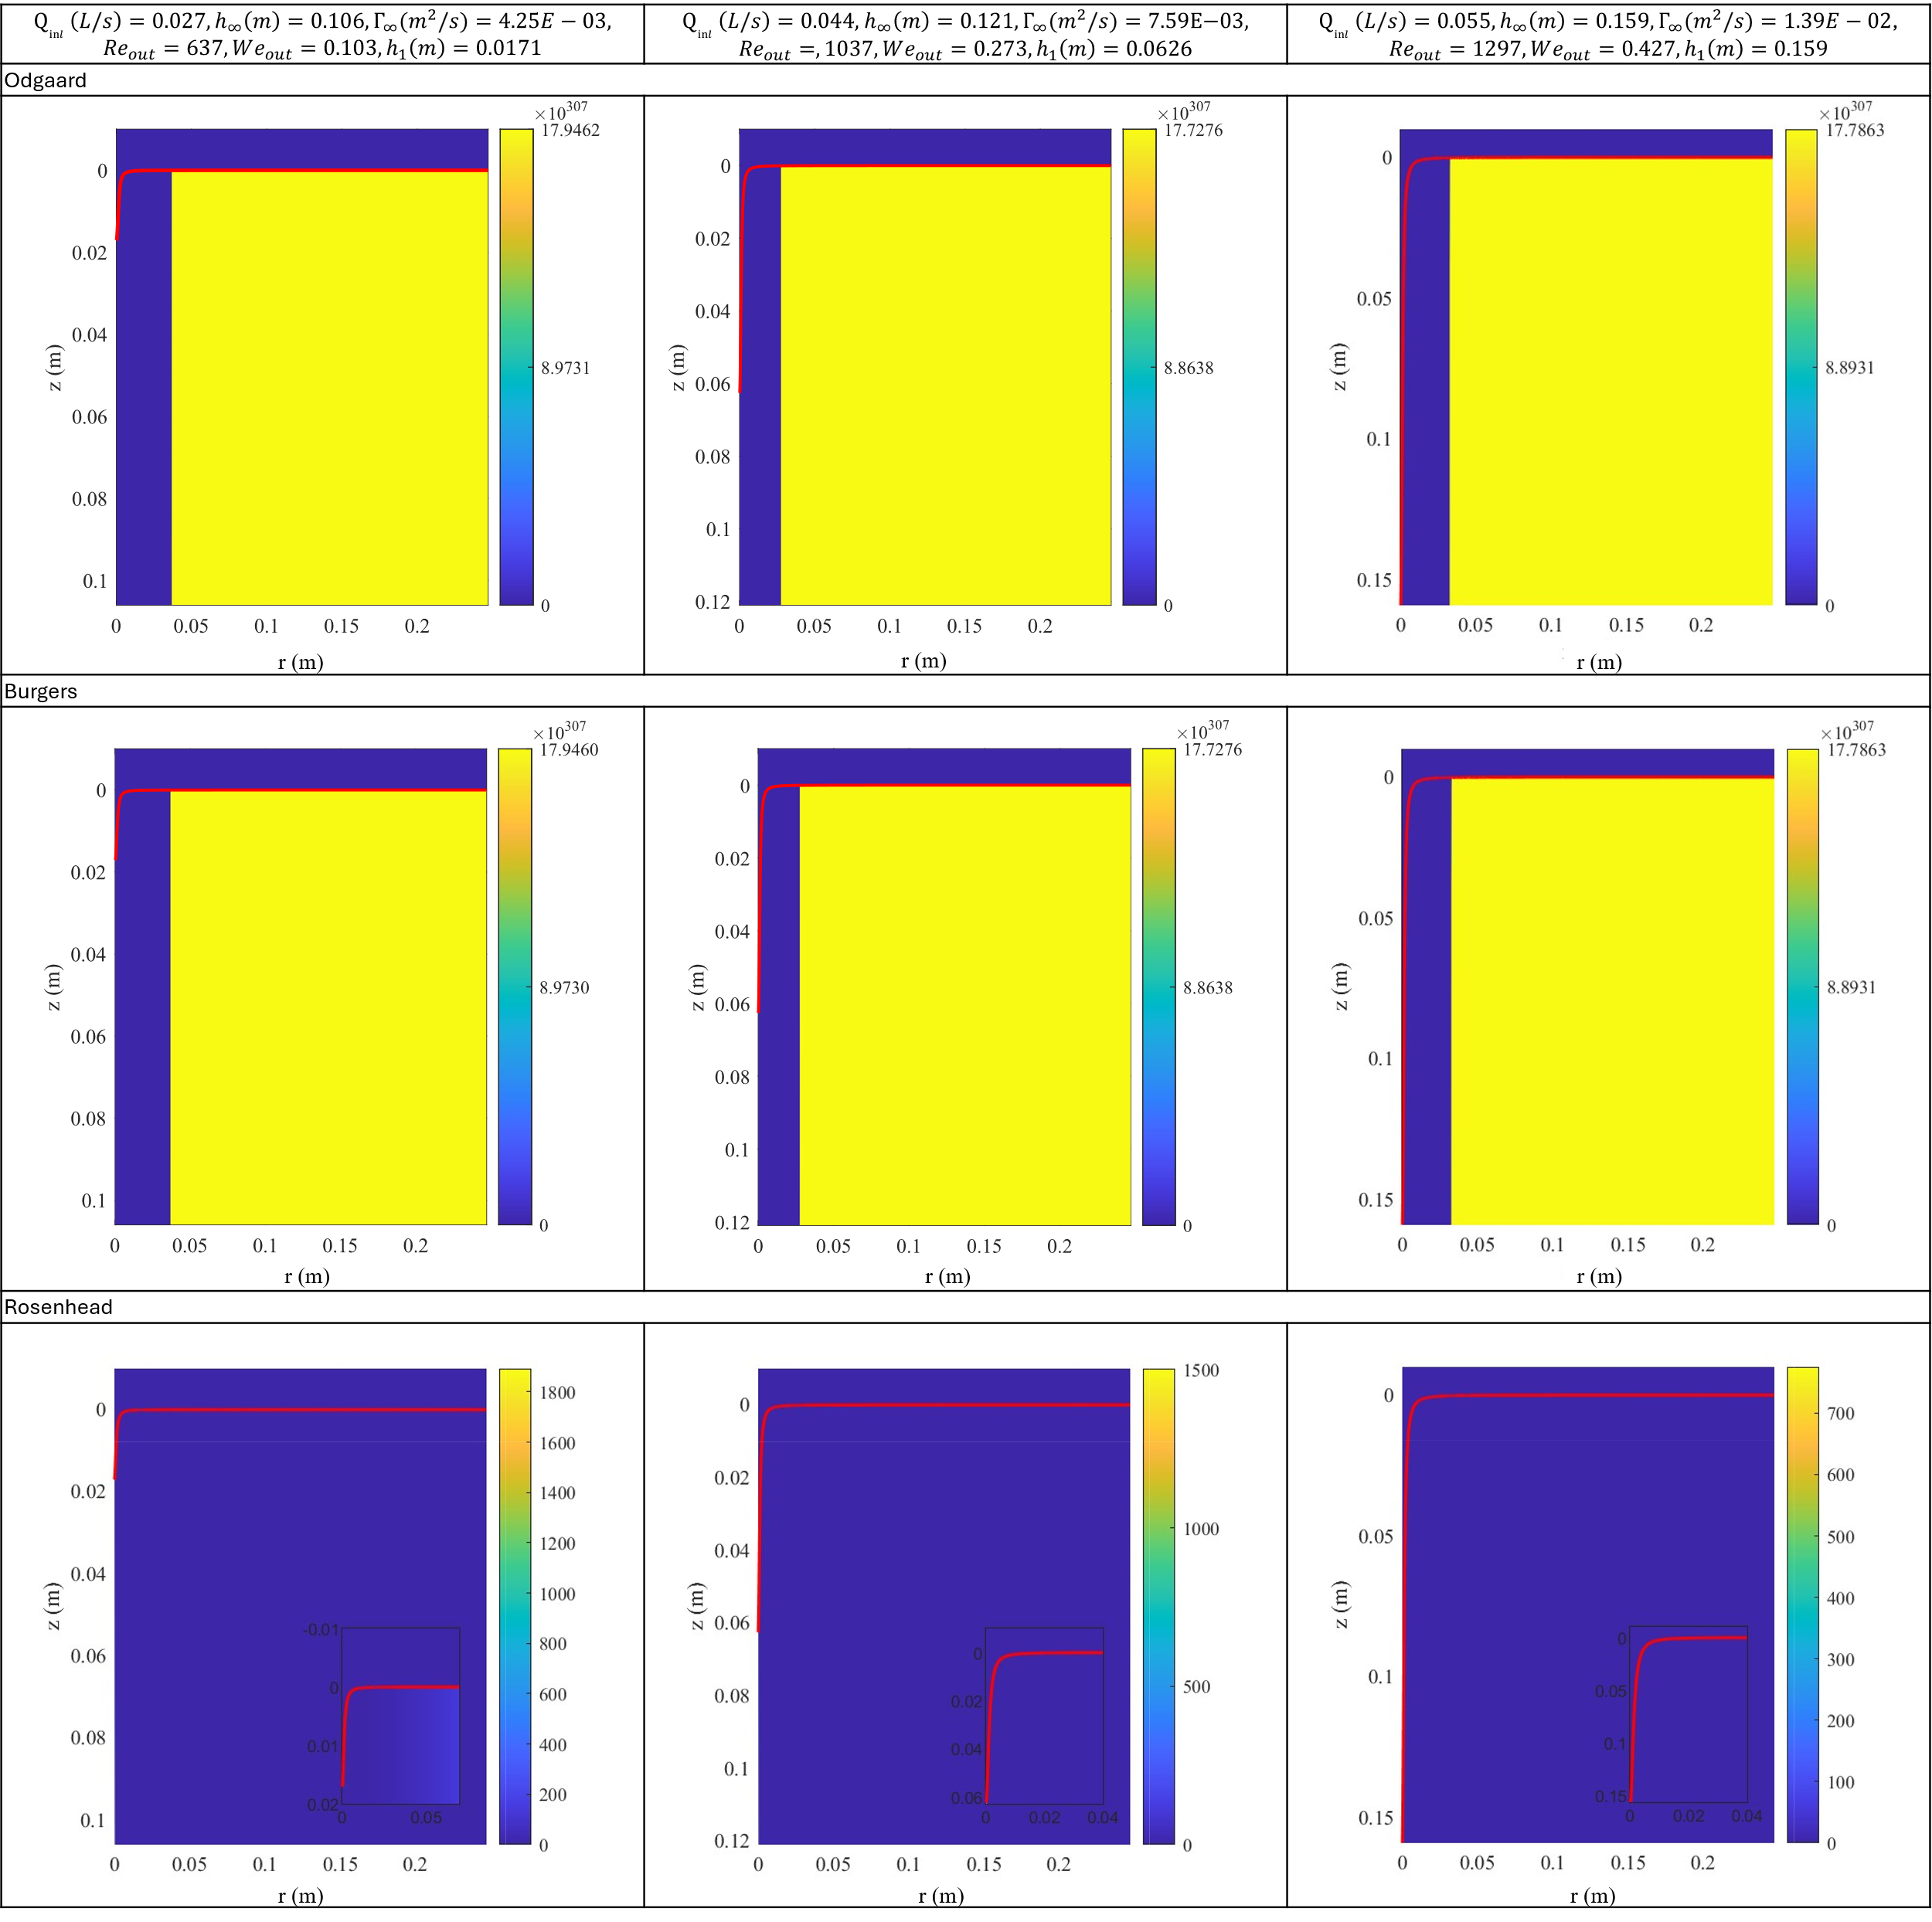
Figure 23. ${Ro}_{z}^{2}$ fields in Odgaard, Burgers and Rosenhead models for weak vortexes.
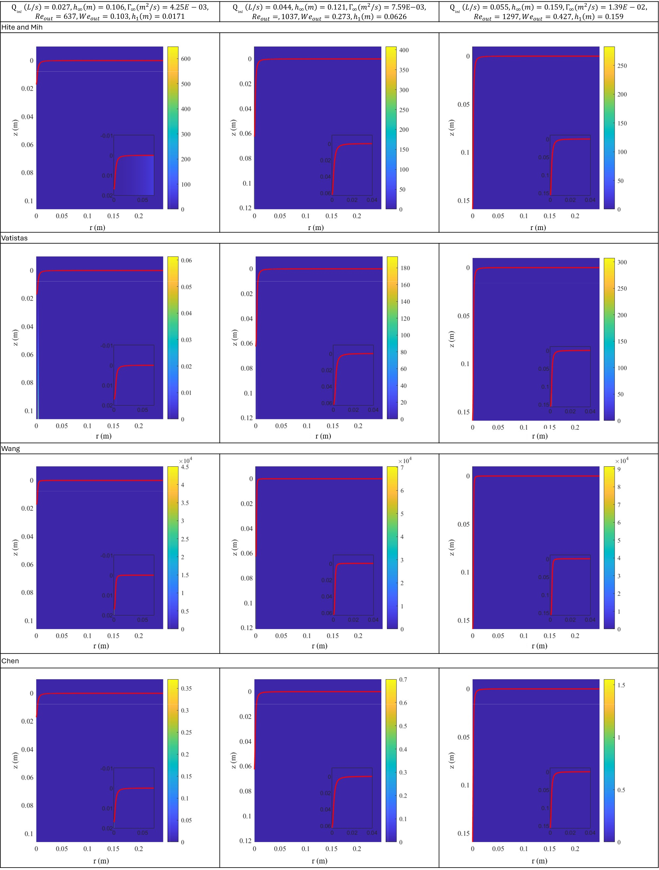
Figure 24. ${Ro}_{z}^{2}$ fields in Hite and Mih, Vatistas, Wang and Chen models for weak vortexes.

