Supplementary Table Legend

Table S1: The general information of the samples which were used in our study.
Table S2: The list of differentially regulated genes between LPMI samples vs CTRL comparison.
Table S3: The list of differentially regulated genes between SPMI samples vs CTRL comparison.
Table S4: The list of genes that resulted from LMPI vs CTRL and SPMI vs CTRL results. The list includes the list of commonly upregulated genes, commonly downregulated genes and differentially regulated genes in LMPI and SPMI comparison vs CTRL samples.

Supplementary Fig. Legend

Supplementary Fig.1: Scatter plot demonstrating a lack of correlation for PMI, RIN and age (X axis) with the number of sequenced reads (Y axis) for all samples. The correlation co-efficient score is represented on each plot.

Supplementary Fig.2: A) The number of differentially regulated genes (DEGs) for the comparison of CTRL samples with all processing conditions. The number of DEGs and different conditions are represented on the Y and X axes, respectively. The percentage of up and down-regulated genes is shown within the stacked bar plots. Upregulated and downregulated genes for each comparison are marked in blue and orange, respectively. B) Scatter plot showing the correlation of highly upregulated genes in 36h 20°C and 24h 20°C with the LMPI and SPMI samples. The average expression values from both groups were used to measure the correlation. C) Confusion matrix showing the results of machine learning predictions as a heatmap. The number of samples used for each domain is represented by the color gradient and is also shown on the plot.

Supplementary Figure 1

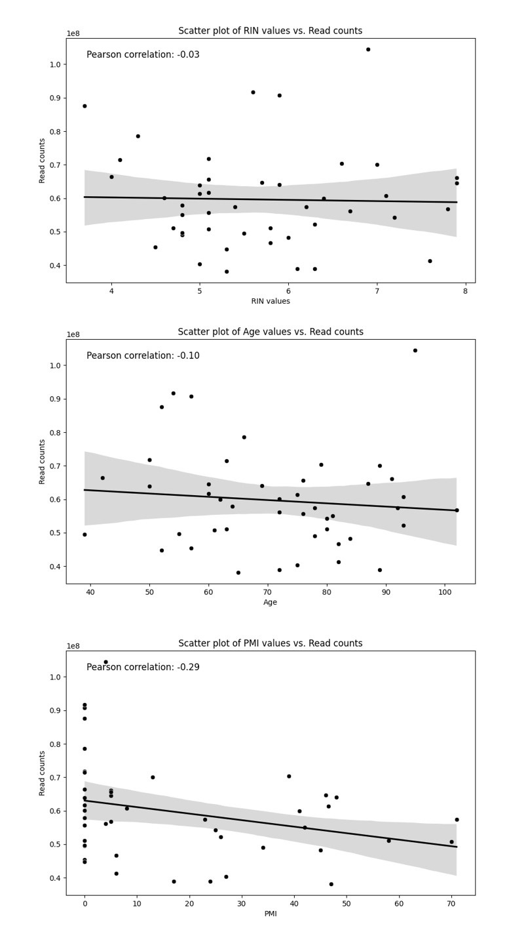

Supplementary Figure 2

