Supplementary Figures

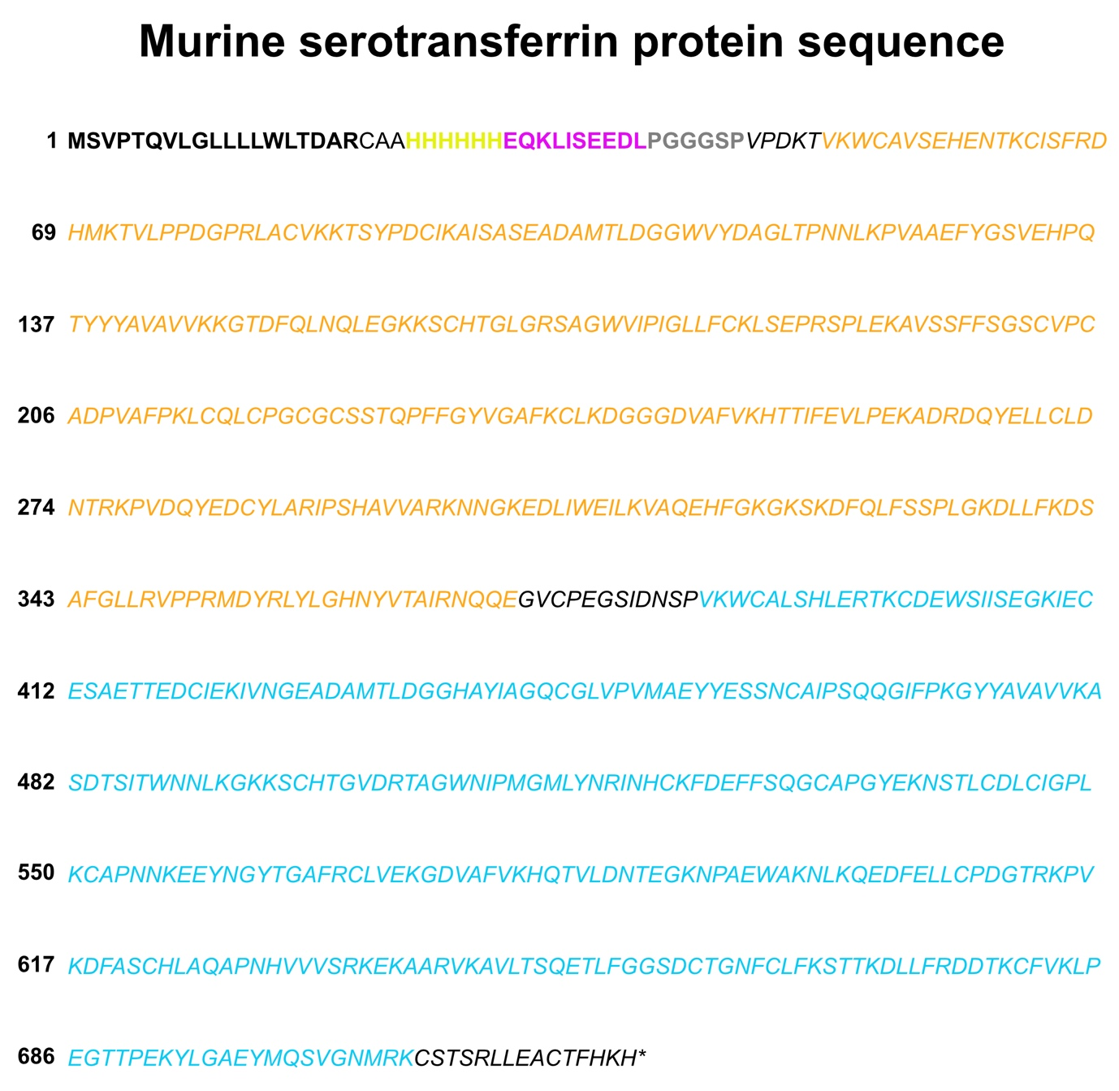Supplementary Figure 1: Amino acid sequence of recombinant murine serotranserrin. The seqeunce in bold black lettering corresponds to the signal peptide. The sequence in bold yellow and magenta lettering corresponds to the his- and mys-tags respectively. The sequence in bold grey lettering corresponds to the PGGGSP linker used to attached the his- and myc-tags to the mouse serotransferrin protein. The italic lettering corresponds to mouse serotransferrin, with the orange and cyan coloured lettering corresponding to Transferrin-like domains 1 and 2 respectively.
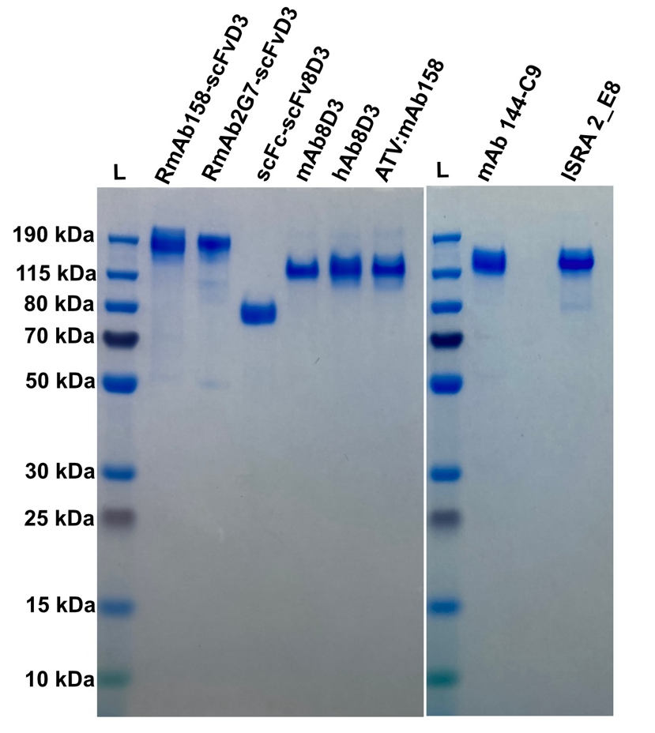
Supplementary Figure 2: SDS-PAGE gel analysis of the purified recombinant antibodies in non-reducing conditions. A pre-stained ladder (L) was used to determine the approximate molecular weight corresponding to the eight antibodies.

Supplementary Figure 3: In Vivo biodistribution 6-hours post-intravenous injection of I¹²⁵ labelled construct at 0.3 nmol/kg Rmab158-scFv8D3 (n=3) or hAb8D3 (n=4) and 0.3 nmol/kg RmAb158-scFv8D3 + 96 nmol/kg mouse serotransferrin (n=4) or hAb8D3 + 96 nmol/kg mouse serotransferrin (n=4).

