Research Article
Discovery Oncology
Ki-67 expression in anti-programmed cell death protein-1 antibody-bound CD8⁺ T cells as a predictor of clinical benefit

Toshiaki Tsurui^{a,b,c,d}, Masahiro Hosonuma^{a,b,d}, Aya Sasaki^{a,b,d}, Yuuki Maruyama^{a.b,d,e}, Yasunobu Amari^{b,d,f,g}, Eiji Funayama^{b,d,h}, Kohei Tajima^{b,i}, Hitoshi Toyoda^{a,b,d,j}, Junya Isobe^{b,k}, Yoshitaka Yamazaki^{d,l}, Yuta Baba^{b,m}, Midori Shida^{b}, Yuko Udaka^{a,d}, Emiko Mura^{n}, Risako Suzuki^{n}, Nana Iriguchi^{n}, Tomoyuki Ishiguro^{n}, Yuya Hirasawa^{n}, Ryotaro Ohkuma^{n}, Masahiro Shimokawa^{n}, Hirotsugu Ariizumi^{n}, Yutaro Kubota^{n}, Atsushi Horiike^{n}, Satoshi Wada^{n,o}, Atsuo Kuramasu^{b}, Mayumi Tsuji^{d}, Yuji Kiuchi^{a,d}, Takuya Tsunoda^{n}, Kiyoshi Yoshimura^{b,n,*}

ªDivision of Medical Pharmacology, Showa University Graduate School of Medicine, Tokyo, Japan
^{b}Department of Clinical Immuno-Oncology, Clinical Research Institute for Clinical Pharmacology and Therapeutics, Showa University, Tokyo, Japan
^{c}Division of Medical Oncology, Department of Medicine, Showa University School of Medicine, Tokyo, Japan
^{d}Pharmacological Research Center, Showa University, Tokyo, Japan
^{e}Department of Otorhinolaryngology-Head and Neck Surgery, Showa University School of Medicine, Tokyo, Japan
^{f}Division of Clinical Pharmacology, Showa University Graduate School of Medicine, Tokyo, Japan
^{g}Department of Otorhinolaryngology, Showa University Fujigaoka Hospital, Kanagawa, Japan
^{h}Division of Pharmacology, Showa University Graduate School of Pharmacy, Tokyo, Japan
^{i}Department of Gastroenterological Surgery, Tokai University School of Medicine, Kanagawa, Japan
^{j}Department of Orthopedic Surgery, Showa University School of Medicine, Tokyo, Japan
^{k}Department of Hospital Pharmaceutics, Showa University School of Pharmacy, Tokyo, Japan
^{l}Division of Toxicology, Showa University Graduate School of Pharmacy, Tokyo, Japan
^{m}Department of Hematology, Showa University Fujigaoka Hospital, Kanagawa, Japan
^{n}Department of Medical Oncology, Showa University Graduate School of Medicine, Tokyo, Japan
ºDepartment of Clinical Diagnostic Oncology, Clinical Research Institute for Clinical Pharmacology and Therapeutics, Showa University, Tokyo, Japan

* Corresponding author:
Kiyoshi Yoshimura, M.D., Ph.D., M.O.T.
Department of Clinical Immuno-Oncology, Clinical Research Institute for Clinical Pharmacology and Therapeutics, Showa University, 6-11-11 Kitakarasuyama, Setagaya-Ku, Tokyo 157-8577, Japan
Tel: +81-3-3300-5256
Fax: +81-3-3300-1653
Email: kyoshim1@med.showa-u.ac.jp
ORCID ID: 0000-0003-4816-1826

Supplementary information
Supplementary figures

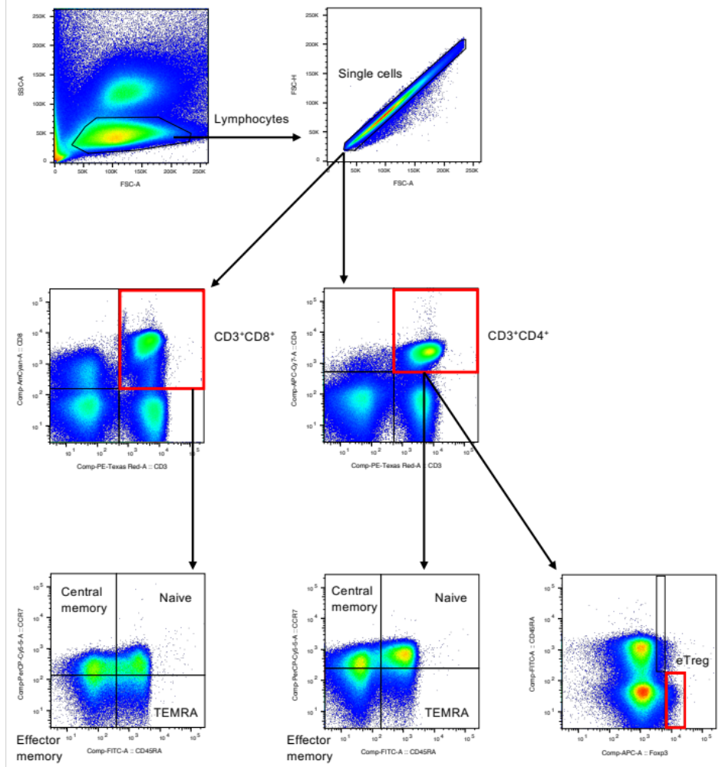
Fig. S1. Gating strategy for the analysis of T cell subset. Memory T cell subsets were gated as follows: naïve memory T cells (T_{N}), CCR7⁺CD45RA⁺; central memory T cells (T_{CM}), CCR7⁺CD45RA–; effector memory T cells (T_{EM}), CCR7–CD45RA–; and terminally differentiated effector memory T cells re-expressing CD45RA (T_{EMRA}), (CCR7–CD45RA⁺). Effector regulatory T cells (eTregs) were gated against CD4⁺CD45RA–Foxp3^{hi}.
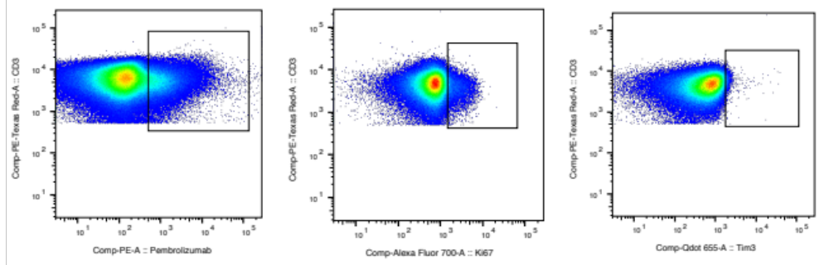Fig. S2. Detection of pembrolizumab-bound (PB) cells and gating of Ki-67 and Tim-3 of T cells. IgG4-positive cells were gated as a pembrolizumab-bound (PB) population. Cells positive for Ki-67 and TIM-3 were gated as described, respectively.

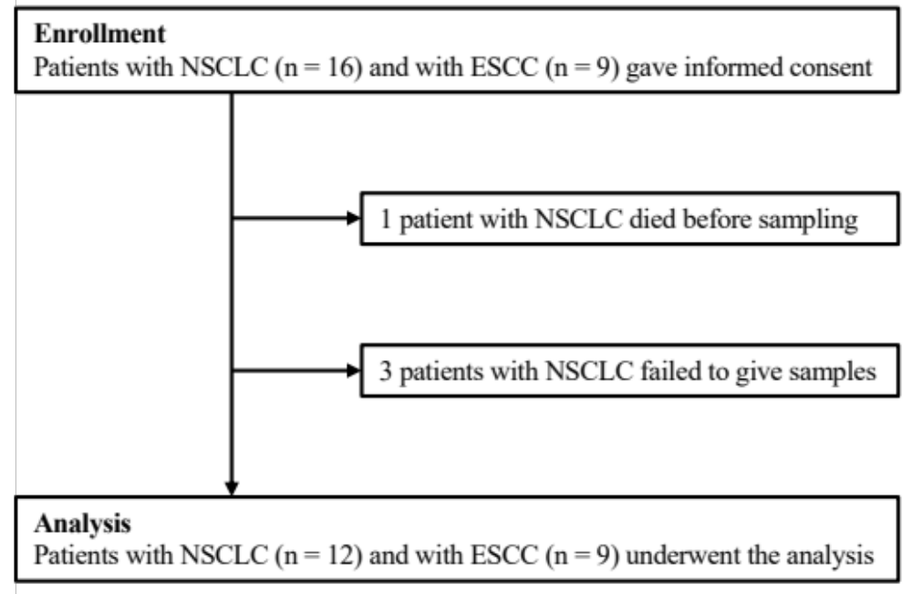
Fig. S3. Flow diagram of patient enrollment. NSCLC, non-small cell lung cancer; ESCC, esophageal squamous cell carcinoma.

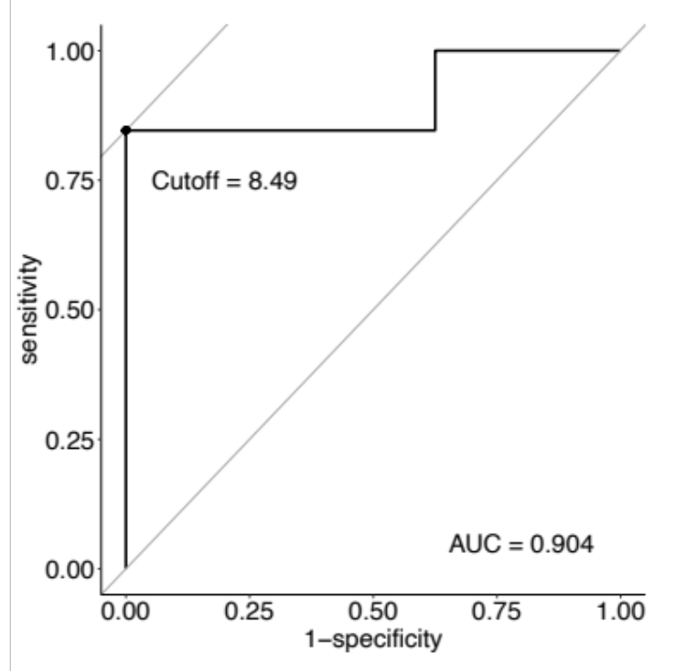
Fig. S4. Receiver operating characteristic (ROC) curve of Ki-67 for PB-CD8⁺CD45RA⁻ T cells (T_{CM} and T_{EM}) with disease control as the outcome. The cutoff value of Ki-67 for PB-CD8⁺CD45RA⁻ T cells (T_{CM} and T_{EM}) was estimated as 8.49 % with the Youden index. The area under the curve (AUC) was 0.904. The specificity and sensitivity were 100% and 84.6%, respectively.

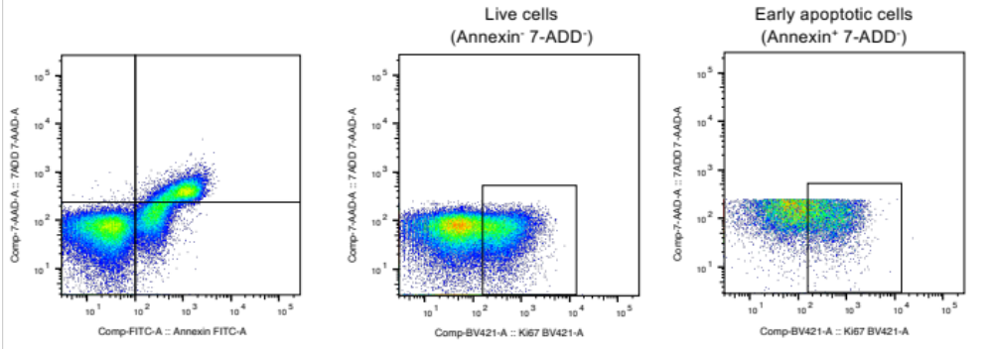Fig. S5. Detection of apoptosis with Annexin V and 7-ADD. Annexin⁻7-ADD⁻ cells were gated as live cells and Annexin⁺7-ADD⁻ cells as early apoptotic cells; 7-ADD, 7-amino-actinomycin D. Live cells and early apoptotic cells were gated according to Ki-67.

Supplementary tables
Table S1. Ratio of each T cell subset and each PD-1 receptor occupancy.
(a) The ratio of each T cell subset.
 | Frequency (%), mean (range)
CD8⁺
CD8⁺ T_{N} | 16.7 (7.81–38.5)
CD8⁺ T_{CM} | 20.6 (7.29–35.6)
CD8⁺ T_{EM} | 39.2 (16.4–56.0)
CD8⁺ T_{EMRA} | 23.5 (6.33–52.1)
CD4⁺
CD4⁺ T_{N} | 26.5 (4.32–65.8)
CD4⁺ T_{CM} | 25.9 (13.0–42.8)
CD4⁺ T_{EM} | 39.2 (12.6–60.0)
CD4⁺ T_{EMRA} | 8.43 (1.98–22.1)
eTreg | 1.14 (0.19–1.98)
T_{N}, naïve memory T cell; T_{CM}, central memory T cell; T_{EM}, effector memory T cell; T_{EMRA}, terminally differentiated effector memory T cell re-expressing CD45RA; eTreg, effector regulatory T cell.

(b) PD-1 receptor occupancy on each T cell subset.
 | PD-1 receptor occupancy (%), mean (range)
CD8⁺ | 67.0 (41.0–98.2)
CD8⁺ T_{N} | 82.7 (41.9–100)
CD8⁺ T_{CM} | 69.6 (43.8–100)
CD8⁺ T_{EM} | 68.4 (43.7–97.5)
CD8⁺ T_{EMRA} | 64.7 (33.1–100)
CD4⁺ | 64.8 (42.9–94.1)
CD4⁺ T_{N} | 100 (31.3–100)
CD4⁺ T_{CM} | 65.3 (42.0–100)
CD4⁺ T_{EM} | 65.1 (44.2–99.3)
CD4⁺ T_{EMRA} | 100 (28.1–100)
eTreg | 55.4 (18.7–100)
Measured values above 100 % were described as 100%.
T_{N}, naïve memory T cell; T_{CM}, central memory T cell; T_{EM}, effector memory T cell; T_{EMRA}, terminally differentiated effector memory T cell re-expressing CD45RA; eTreg, effector regulatory T cell.

Table S2. Multivariable logistic regression models for the disease control ratio and Ki-67 of all T cells.
 |  | Univariable analysis |  | Multivariable analysis
 | Ki-67 (%), mean (range) | OR (95% CI) | p-value | OR (95% CI) | p-value
CD8⁺
CD8⁺ T_{N} | 1.39 (0.36–3.72) | 0.71 (0.28–1.80) | 0.46 | 0.69 (0.27–1.78) | 0.44
CD8⁺ T_{CM} | 3.79 (1.17–10.4) | 0.14 (0.02–0.97) | 0.05 | 0.10 (0.01–1.73) | 0.11
CD8⁺ T_{EM} | 6.10 (1.81–17.0) | 0.22 (0.05–1.01) | 0.05 | 0.19 (0.03–1.29) | 0.09
CD8⁺ T_{EMRA} | 2.13 (0.53–6.02) | 0.71 (0.38–1.33) | 0.29 | 0.70 (0.37–1.31) | 0.26
CD4⁺
CD4⁺ T_{N} | 0.36 (0.07–0.90) | 2.72×10⁶ (11.5–6.47×10¹¹) | 0.02 | 3.22×10⁶ (8.14–1.28×10¹²) | 0.02
CD4⁺ T_{CM} | 2.66 (1.14–4.33) | 1.59 (0.59–4.26) | 0.36 | 1.64 (0.999–1.003) | 0.34
CD4⁺ T_{EM} | 4.59 (2.00–8.46) | 0.71 (0.41–1.21) | 0.20 | 0.70 (0.41–1.21) | 0.20
CD4⁺ T_{EMRA} | 1.03 (0–2.62) | 1.49 (0.38–5.78) | 0.57 | 1.81 (0.38–8.67) | 0.46
eTreg | 11.5 (2.74–19.8) | 0.94 (0.78–1.13) | 0.49 | 0.94 (0.78–1.15) | 0.55
The odds ratio in the multivariable analysis was adjusted for the total lymphocyte count.
OR, odds ratio; CI, confidence interval; PB, pembrolizumab-bound; T_{N}, naïve memory T cell; T_{CM}, central memory T cell; T_{EM}, effector memory T cell; T_{EMRA}, terminally differentiated effector memory T cell re-expressing CD45RA; eTreg, effector regulatory T cell.

Table S3. Multivariable logistic regression models for the disease control ratio and TIM-3 of T cells.
(a) TIM-3 of PB-T cells.
 |  | Univariable analysis |  | Multivariable analysis
 | TIM-3 (%), mean (range) | OR (95% CI) | p-value | OR (95% CI) | p-value
PB-CD8⁺
PB-CD8⁺ T_{N} | 0.41 (0–3.57) | 2.73 (0.38–19.8) | 0.32 | 2.69 (0.39–18.8) | 0.32
PB-CD8⁺ T_{CM} | 0.19 (0–0.99) | 0.98 (0.03–37.5) | 0.99 | 0.92 (0.02–36.2) | 0.97
PB-CD8⁺ T_{EM} | 0.37 (0–1.00) | 0.20 (0.01–3.75) | 0.29 | 0.21 (0.01–3.96) | 0.30
PB-CD8⁺ T_{EMRA} | 0.60 (0–1.63) | 0.84 (0.16–4.39) | 0.83 | 0.93 (0.16–5.51) | 0.94
PB-CD4⁺
PB-CD4⁺ T_{N} | 2.07 (0–12.8) | 1.30 (0.76–2.24) | 0.34 | 1.30 (0.76–2.24) | 0.34
PB-CD4⁺ T_{CM} | 0.44 (0–1.50) | 5.38 (0.30–96.7) | 0.25 | 5.16 (0.28–95.7) | 0.27
PB-CD4⁺ T_{EM} | 0.65 (0.10–2.18) | 1.44 (0.23–9.24) | 0.70 | 1.50 (0.22–10.0) | 0.68
PB-CD4⁺ T_{EMRA} | 2.80 (0–11.9) | 1.24 (0.88–1.76) | 0.22 | 1.24 (0.87–1.75) | 0.23
PB-eTreg | 9.48 (0–100) | 1.03 (0.93–1.14) | 0.54 | 1.03 (0.93–1.14) | 0.56

(b) TIM-3 of all T cells.
 |  | Univariable analysis |  | Multivariable analysis
 | TIM-3 (%), mean (range) | OR (95% CI) | p-value | OR (95% CI) | p-value
CD8⁺
CD8⁺ T_{N} | 0.33 (0–1.11) | 3.94 (0.13–120) | 0.43 | 3.60 (0.12–110) | 0.46
CD8⁺ T_{CM} | 0.25 (0–0.70) | 1.01 (0.01–80.4) | 1.00 | 0.82 (0.01–77.3) | 0.93
CD8⁺ T_{EM} | 0.42 (0–1.10) | 1.96 (0.08–50.2) | 0.68 | 1.84 (0.07–51.4) | 0.72
CD8⁺ T_{EMRA} | 0.47 (0–1.45) | 0.14 (0.01–3.17) | 0.22 | 0.14 (0.01–3.47) | 0.23
CD4⁺
CD4⁺ T_{N} | 0.98 (0.16–2.68) | 0.31 (0.08–1.18) | 0.09 | 0.25 (0.05–1.19) | 0.08
CD4⁺ T_{CM} | 0.54 (0.16–1.64) | 0.39 (0.04–4.06) | 0.43 | 0.26 (0.02–3.51) | 0.31
CD4⁺ T_{EM} | 1.02 (0.23–3.97) | 0.91 (0.33–2.52) | 0.86 | 0.84 (0.28–2.45) | 0.74
CD4⁺ T_{EMRA} | 2.05 (0.27–12.1) | 0.84 (0.55–1.27) | 0.41 | 0.81 (0.52–1.26) | 0.34
eTreg | 1.83 (0–10.5) | 1.21 (0.71–2.08) | 0.48 | 1.20 (0.67–2.13) | 0.54
The odds ratio in the multivariable analysis was adjusted for the total lymphocyte count.
OR, odds ratio; CI, confidence interval; PB, pembrolizumab-bound; T_{N}, naïve memory T cell; T_{CM}, central memory T cell; T_{EM}, effector memory T cell; T_{EMRA}, terminally differentiated effector memory T cell re-expressing CD45RA; eTreg, effector regulatory T cell.

Table S4. Cox proportional hazard analysis of progression-free survival (PFS) and overall survival (OS).
(a) PFS of all the patients.
 | Univariable analysis |  | Multivariable analysis
 | HR (95% CI) | p-value | HR (95% CI) | p-value
PB-CD8⁺
PB-CD8⁺ T_{N} | 1.19 (0.96–1.43) | 0.08 | 1.25 (1.00–1.54) | 0.04
PB-CD8⁺ T_{CM} | 1.18 (1.06–1.30) | < 0.01 | 1.19 (1.06–1.34) | < 0.01
PB-CD8⁺ T_{EM} | 1.14 (1.06–1.23) | < 0.01 | 1.15 (1.06–1.26) | < 0.01
PB-CD8⁺ T_{EMRA} | 1.13 (0.94–1.30) | 0.14 | 1.11 (0.93–1.29) | 0.19
PB-CD4⁺
PB-CD4⁺ T_{N} | 0.76 (0.43–1.20) | 0.28 | 0.64 (0.36–1.05) | 0.10
PB-CD4⁺ T_{CM} | 1.14 (0.94–1.35) | 0.16 | 1.12 (0.92–1.36) | 0.23
PB-CD4⁺ T_{EM} | 1.07 (0.96–1.19) | 0.23 | 1.06 (0.94–1.19) | 0.34
PB-CD4⁺ T_{EMRA} | 1.07 (0.91–1.23) | 0.36 | 1.09 (0.92–1.26) | 0.31
PB-eTreg | 0.96 (0.91–1.01) | 0.14 | 0.94 (0.88–1.00) | 0.05

(b) OS of all the patients.
 | Univariable analysis |  | Multivariable analysis
 | HR (95% CI) | p-value | HR (95% CI) | p-value
PB-CD8⁺
PB-CD8⁺ T_{N} | 1.19 (0.96–1.43) | 0.09 | 1.25 (1.00–1.54) | 0.06
PB-CD8⁺ T_{CM} | 1.18 (1.06–1.30) | < 0.01 | 1.19 (1.06–1.34) | < 0.01
PB-CD8⁺ T_{EM} | 1.14 (1.06–1.23) | < 0.01 | 1.15 (1.06–1.26) | < 0.01
PB-CD8⁺ T_{EMRA} | 1.13 (0.94–1.30) | 0.66 | 1.11 (0.93–1.29) | 0.05
PB-CD4⁺
PB-CD4⁺ T_{N} | 0.76 (0.43–1.20) | 0.32 | 0.64 (0.36–1.05) | 0.16
PB-CD4⁺ T_{CM} | 1.14 (0.94–1.35) | 0.07 | 1.12 (0.92–1.36) | 0.10
PB-CD4⁺ T_{EM} | 1.07 (0.96–1.19) | 0.03 | 1.06 (0.94–1.19) | 0.04
PB-CD4⁺ T_{EMRA} | 1.07 (0.91–1.23) | 0.66 | 1.09 (0.92–1.26) | 0.61
PB-eTreg | 0.96 (0.91–1.01) | 0.20 | 0.94 (0.88–1.00) | 0.12

(c) PFS of the patients with NSCLC.
 | Univariable analysis |  | Multivariable analysis
 | HR (95% CI) | p-value | HR (95% CI) | p-value
PB-CD8⁺
PB-CD8⁺ T_{N} | 1.27 (0.95–1.69) | 0.09 | 1.33 (0.98–1.87) | 0.06
PB-CD8⁺ T_{CM} | 1.32 (1.11–1.64) | < 0.01 | 1.32 (1.10–1.67) | < 0.01
PB-CD8⁺ T_{EM} | 2.02 (1.36–3.92) | < 0.01 | 1.99 (1.35–3.93) | 0.01
PB-CD8⁺ T_{EMRA} | 1.40 (1.05–2.30) | 0.07 | 1.43 (1.06–2.51) | 0.07
PB-CD4⁺
PB-CD4⁺ T_{N} | 0.83 (0.42–1.45) | 0.53 | 0.70 (0.34–1.30) | 0.28
PB-CD4⁺ T_{CM} | 1.02 (0.76–1.33) | 0.87 | 0.98 (0.68–1.31) | 0.92
PB-CD4⁺ T_{EM} | 1.05 (0.89–1.22) | 0.56 | 1.04 (0.86–1.23) | 0.66
PB-CD4⁺ T_{EMRA} | 1.07 (0.88–1.26) | 0.46 | 1.09 (0.89–1.32) | 0.39
PB-eTreg | 0.95 (0.88–1.02) | 0.13 | 0.93 (0.84–1.00) | 0.06

(d) OS of the patients with NSCLC.
 | Univariable analysis |  | Multivariable analysis
 | HR (95% CI) | p-value | HR (95% CI) | p-value
PB-CD8⁺
PB-CD8⁺ T_{N} | 1.27 (0.95–1.69) | 0.28 | 1.33 (0.98–1.87) | 0.24
PB-CD8⁺ T_{CM} | 1.32 (1.11–1.64) | < 0.01 | 1.32 (1.10–1.67) | < 0.01
PB-CD8⁺ T_{EM} | 2.02 (1.36–3.92) | < 0.01 | 1.99 (1.35–3.93) | < 0.01
PB-CD8⁺ T_{EMRA} | 1.40 (1.05–2.30) | 0.07 | 1.43 (1.06–2.51) | 0.07
PB-CD4⁺
PB-CD4⁺ T_{N} | 0.83 (0.42–1.45) | 0.18 | 0.70 (0.34–1.30) | 0.07
PB-CD4⁺ T_{CM} | 1.02 (0.76–1.33) | 0.29 | 0.98 (0.68–1.31) | 0.33
PB-CD4⁺ T_{EM} | 1.05 (0.89–1.22) | 0.18 | 1.04 (0.86–1.23) | 0.20
PB-CD4⁺ T_{EMRA} | 1.07 (0.88–1.26) | 0.49 | 1.09 (0.89–1.32) | 0.46
PB-eTreg | 0.95 (0.88–1.02) | 0.29 | 0.93 (0.84–1.00) | 0.19
The hazard ratio in multivariable analysis was adjusted for the total lymphocyte count.
PFS, progression-free survival; OS, overall survival; HR, hazard ratio; CI, confidence interval; PB, pembrolizumab-bound; T_{N}, naïve memory T cell; T_{CM}, central memory T cell; T_{EM}, effector memory T cell; T_{EMRA}, terminally differentiated effector memory T cell re-expressing CD45RA; eTreg, effector regulatory T cell.

