Design, synthesis and biological evaluation of novel 1,2,3-triazoles chromone-oxime derivatives as potent indoleamine 2,3-dioxygenase 1 inhibitors
Zi-Han Fan^{1, 3†}, Ri-Zhen Huang^{1,2†*}, Jia-Jia Liu¹, Mei-Shan Li¹, Xiao-Teng Jing^{2*}, and Heng-Shan Wang^{1*}

ª State Key Laboratory for Chemistry and Molecular Engineering of Medicinal Resources, Key Laboratory for Chemistry and Molecular Engineering of Medicinal Resources (Ministry of Education of China), Collaborative Innovation Center for Guangxi Ethnic Medicine, School of Chemistry and Pharmaceutical Sciences, Guangxi Normal University, Guilin, 541004, China
^{b}Guangxi Key Laboratory of Drug Discovery and Optimization, Guangxi Engineering Research Center for Pharmaceutical Molecular Screening and Druggability Evaluation, School of Pharmacy, Guilin Medical University, Guilin 541199, China
^{c}Department of Chemistry & Pharmaceutical Science, Guilin Normal College, Xinyi Road 15, Guangxi 541001, China

*Corresponding author.

*Corresponding author. State Key Laboratory for Chemistry and Molecular Engineering of Medicinal Resources, Key Laboratory for Chemistry and Molecular Engineering of Medicinal Resources (Ministry of Education of China), Collaborative Innovation Center for Guangxi Ethnic Medicine, School of Chemistry and Pharmaceutical Sciences, Guangxi Normal University, Guilin, 541004, China
E-mail addresses: whengshan@163.com (H. -S. Wang), 13152580596@163.com (X.-T. Jing), rzhuang1783@163.com (R. -Z. Huang).
¹Co-first author: These authors contributed equally to this work.

1. Biological assays
1.1 Enzymatic assays
IDO1 inhibition assays were carried out according to the manufacturers’ procedures, as described previously [1]. The standard assay mixture (100 μL) contained 50 mM of potassium phosphate buffer (pH = 6.5), 10 mM ascorbate, 10 μM methylene blue, 100 μg/mL catalase, 1 mM L-tryptophan and 10 μg/mL of rhIDO1. The plate was incubated at 37 °C in a dark environment, and reactions were terminated after 60 min by the addition of 50 μL of fluorogenic developer solution and further incubated at 45 °C in dark for 3 h. Then, the plate was allowed to cool to room temperature for at least 1 h. After centrifugation at 1500 g for 5 min at 20 °C, the fluorescence intensity (Ex/Em = 402/488 nm) was measured with a Fluoroskan Ascent microplate reader (Infinite M1000 Pro, Tecan US, Morrisville, NC) in an end-point mode. All determinations were carried out in triplicate.

1.2 Cellular IDO1 activity assays
Cellular IDO1 inhibition activity assays were carried out as described previously [2]. HeLa cells were seeded in 96-well culture plates at a density of 1 × 10⁴ per well. On the next day, human IFN-γ (40 ng/mL) and compounds in a total volume of 200 µL culture medium containing 15 µg/mL of L-Trp were added to the cells. After incubation for 48 h, 140 µL of the supernatant was mixed with 10 µL of 6.1 N trichloroacetic acid and the mixture was incubated for 30 min at 50 °C. The reaction mixture was then centrifuged for 10 min at 2000 rpm to remove sediments. 100 µL of the supernatant was mixed with 100 µL of 2% (w/v) p-dimethylaminobenzaldehyde in acetic acid. The amount of generated kynurenine was measured by the absorbance at 480 nm using a microplate reader.

1.3 Cell viability assays
The cell lines Hct-116, A2780 and HeLa were obtained from the Shanghai Cell Bank at the Chinese Academy of Sciences. Hct-116, A2780 and HeLa cell lines were grown on 96-well microtiter plates at a density of 10 × 10⁵ cells/well in DMEM with 10% FBS. DMEM and FBS were obtained from Gibco-Thermo (BRL Co. Ltd., USA). The plates were incubated at 37 °C in a humidified atmosphere of 5% CO₂/95% air overnight. The cells were then exposed to different concentrations of target compounds, 1-MT, epacadostat and incubated for another 48 h. The cells were stained with 10 μl of MTT at incubator for approximately 4 h. The medium was discarded and replaced by 100 mL DMSO. The O.D. value was read at 570/630 nm with a spectrophotometer.

1.4 Molecular docking
Molecular docking was carried out in Sybyl-X 2.0 on a Windows workstation. The crystal structure of IDO1 protein with inhibitor was retrieved from the RCSB Protein Data Bank (IDO1: 6KOF) [3]. Firstly, the 3D structure of the selected compound was built with Sybyl-X 2.0 sketch followed by energy minimization with the MMFF94 force field and Gasteiger-Marsili charges. The Powell’s method was used to optimize the geometry with a distance dependent dielectric constant and a termination energy gradient of 0.005 kcal/mol. After extracting the natural ligand, the water molecules were removed from the crystal structure. Subsequently, the protein was prepared with the Biopolymer module implemented in Sybyl. The polar hydrogen atoms were added, and other parameters were established by default to estimate the binding affinity characterized by the Surflex-Dock scores in the software. Before the docking process, the docking model was confirmed with epacadostat docked into the designated target using the default glide settings. Then, the selected compounds were automatically docked into the binding pocket of IDO1 through an empirical scoring function and a patented search engine in the Surflex docking program. The Surflex-Dock total scores, which were expressed in -log10 (K_{d}) units to represent binding affinities, were applied to estimate the ligand-receptor interactions of newly designed molecules.

1.5 SPR experiments
Surface plasmon resonance experiments were performed with a Biacore T200 instrument at 25 °C. Sensor chips, buffer stock solutions and immobilization reagents were from GE Healthcare. Recombinant human IDO1 protein was immobilized on sensor chip CM5 (GE Healthcare) following the activation of spots 1 and 2 with the coupling reagents EDC and NHS for 10 min. For kinetics and affinity measurements, PBS-DMSO buffer was used as the running buffer and sample dilution buffer. The binding affinity (KD) between compounds and the IDO1 protein was derived from the ratio of the association and dissociation rate constants.

1.6 UV−visible spectra
The optical absorption spectra were recorded at room temperature using a NanoDrop 2000 spectrophotometer (Thermo Fisher Scientific Inc.) in the range of 200 to 700 nm. The measurement was performed with 100 μM IDO1 mixed with 2 mM tested compound.

¹H NMR, ¹³C NMR and HR-MS of compounds:
D1

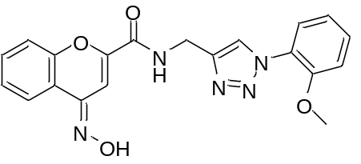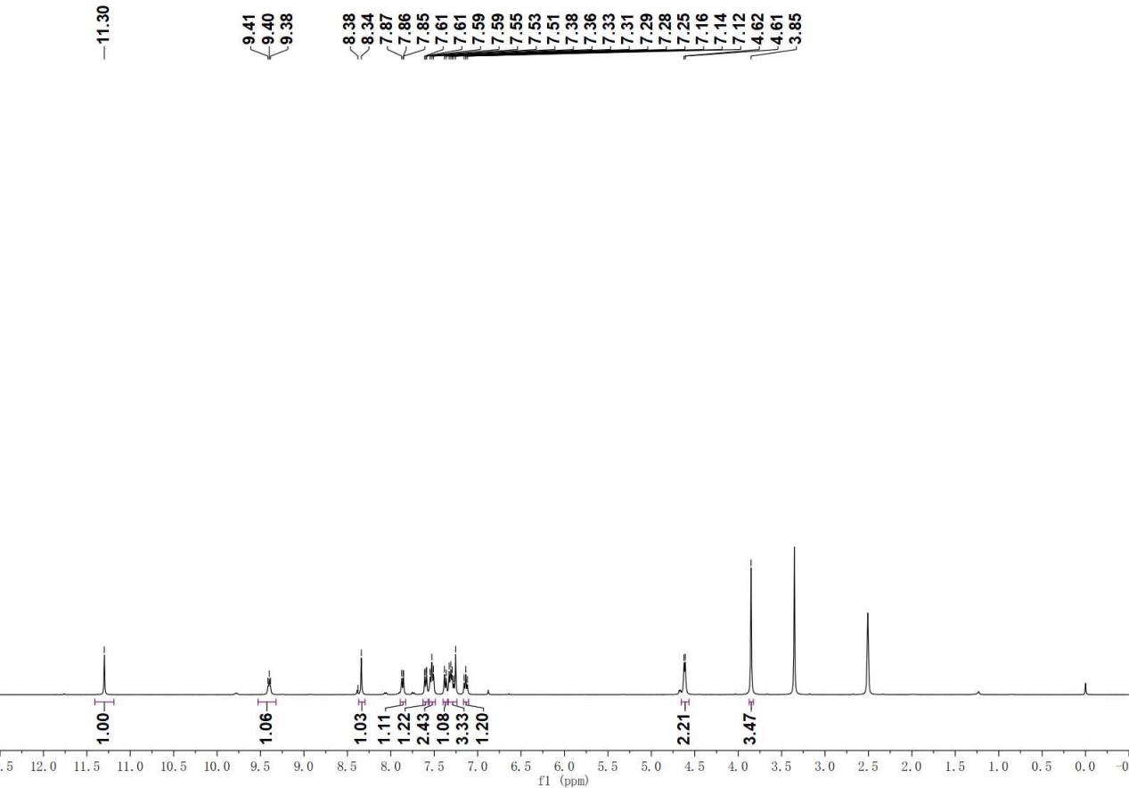

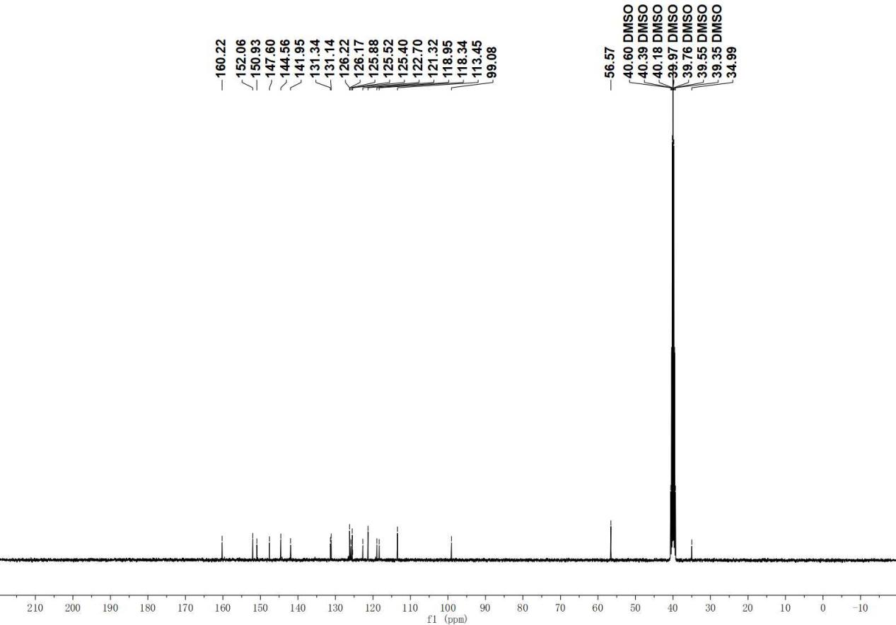

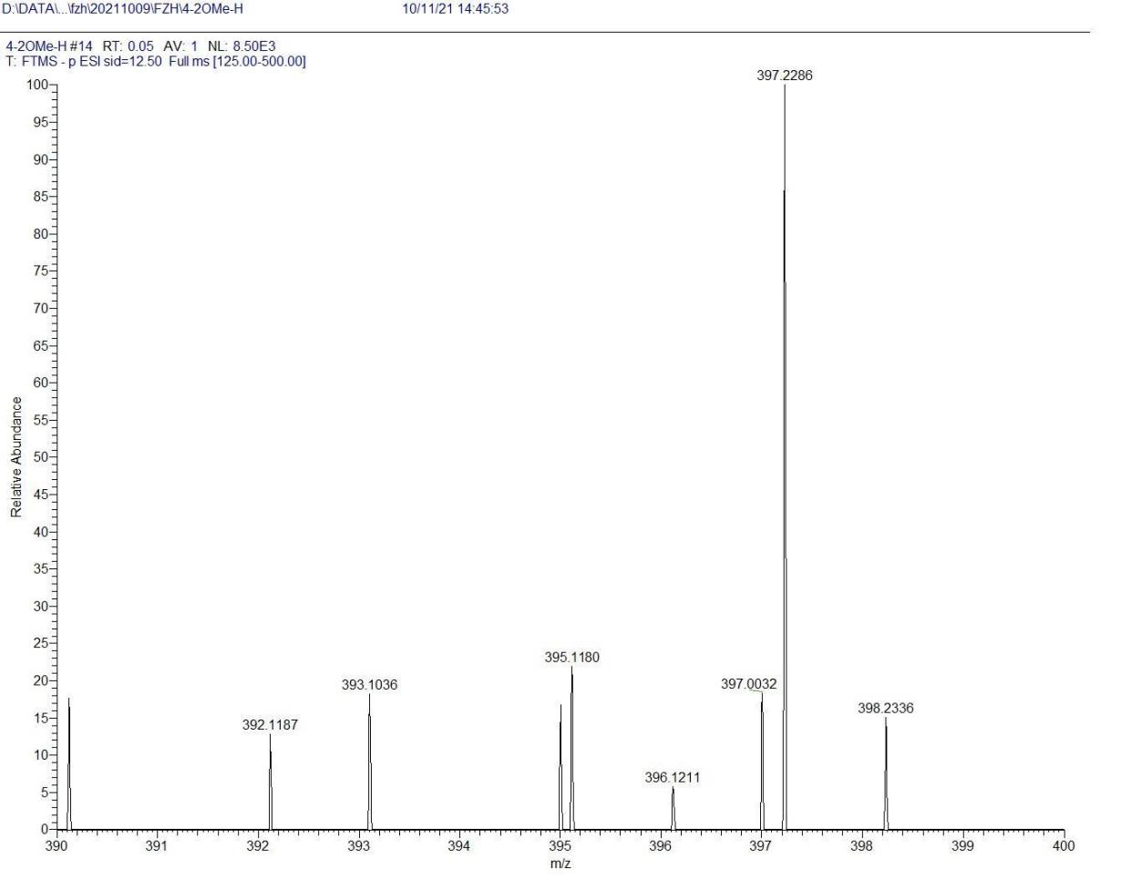
D2

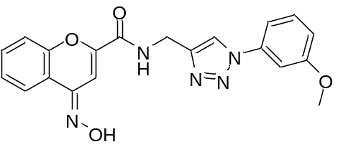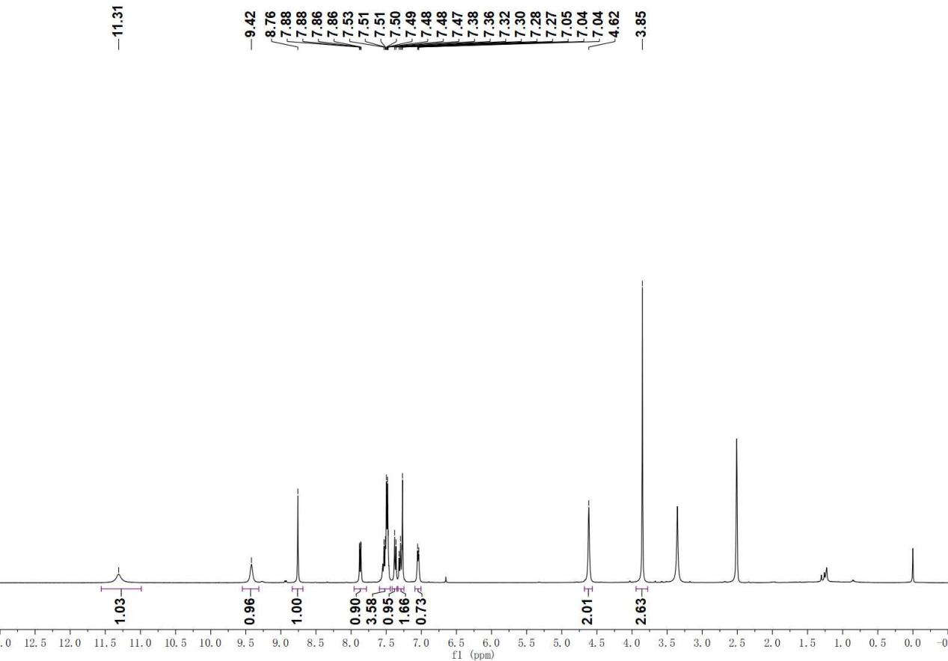

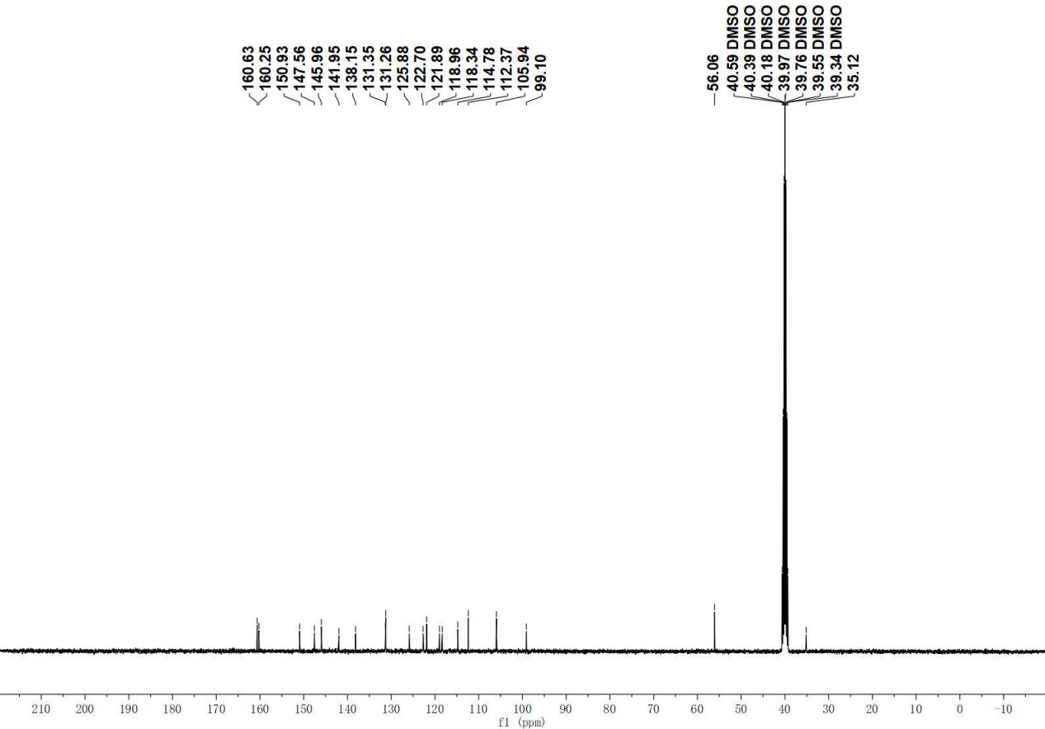

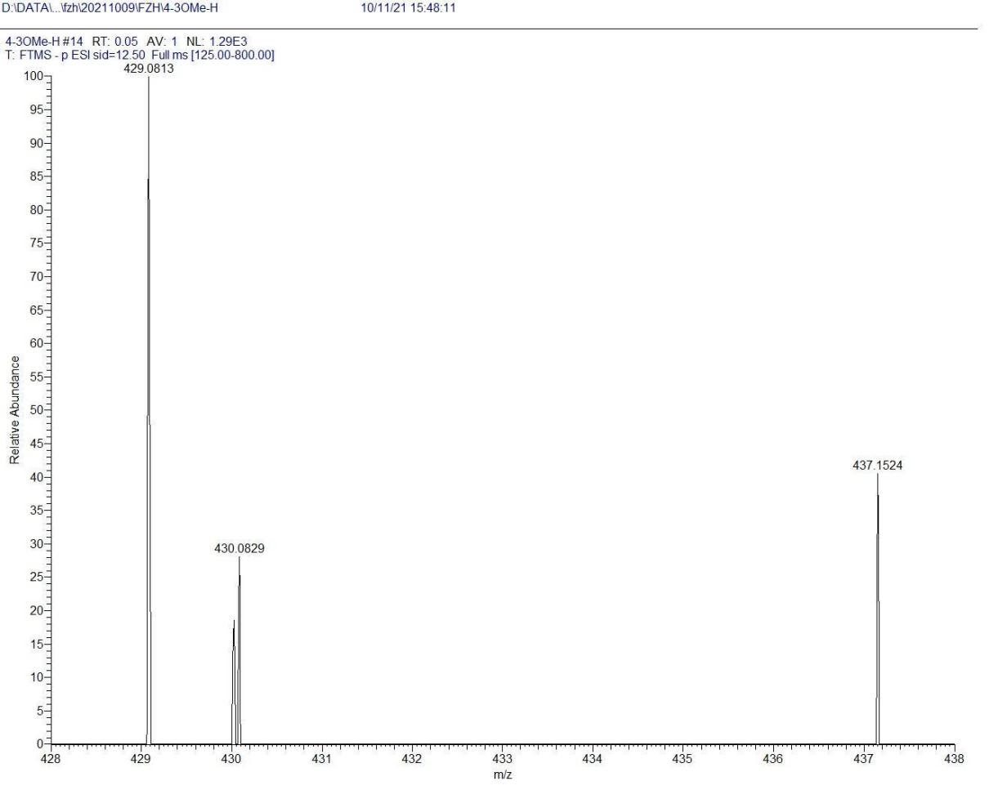

D3

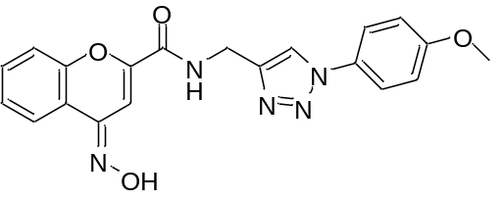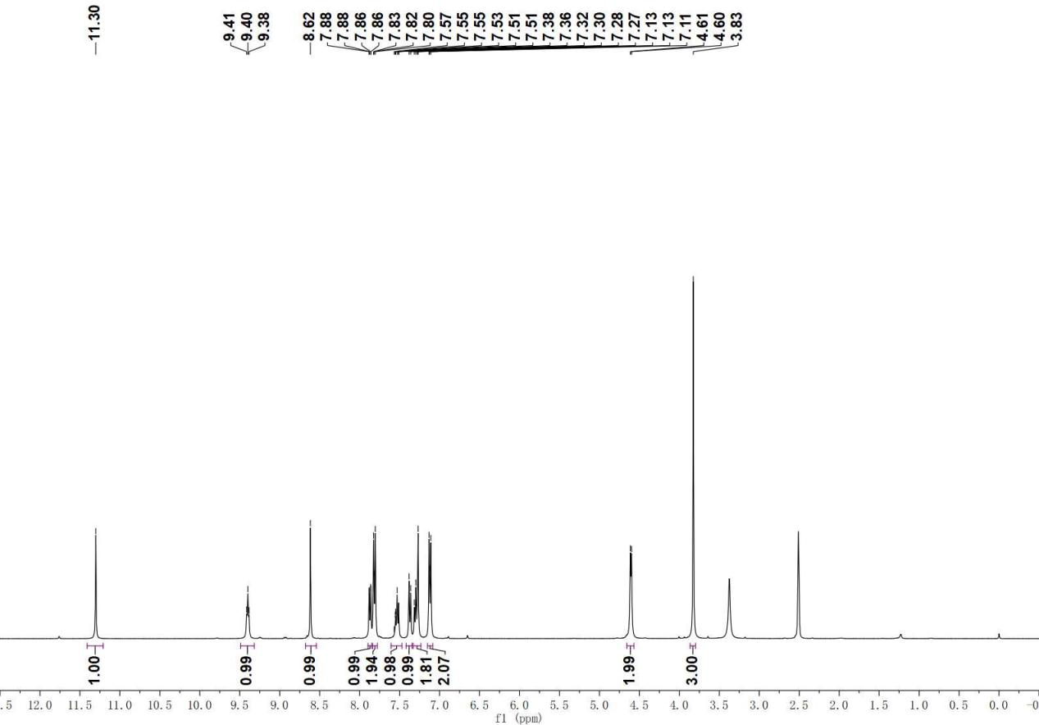

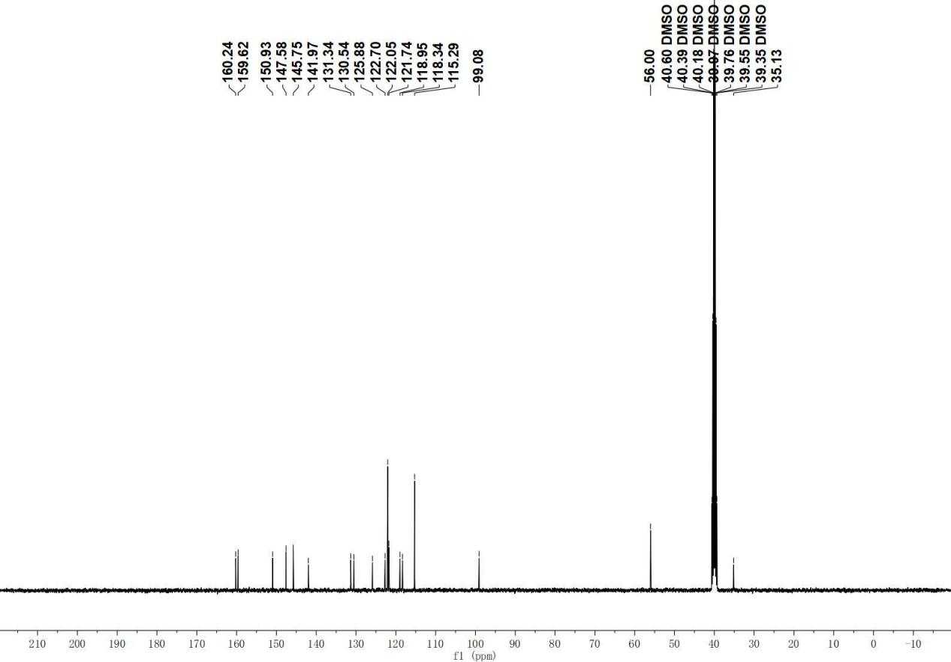

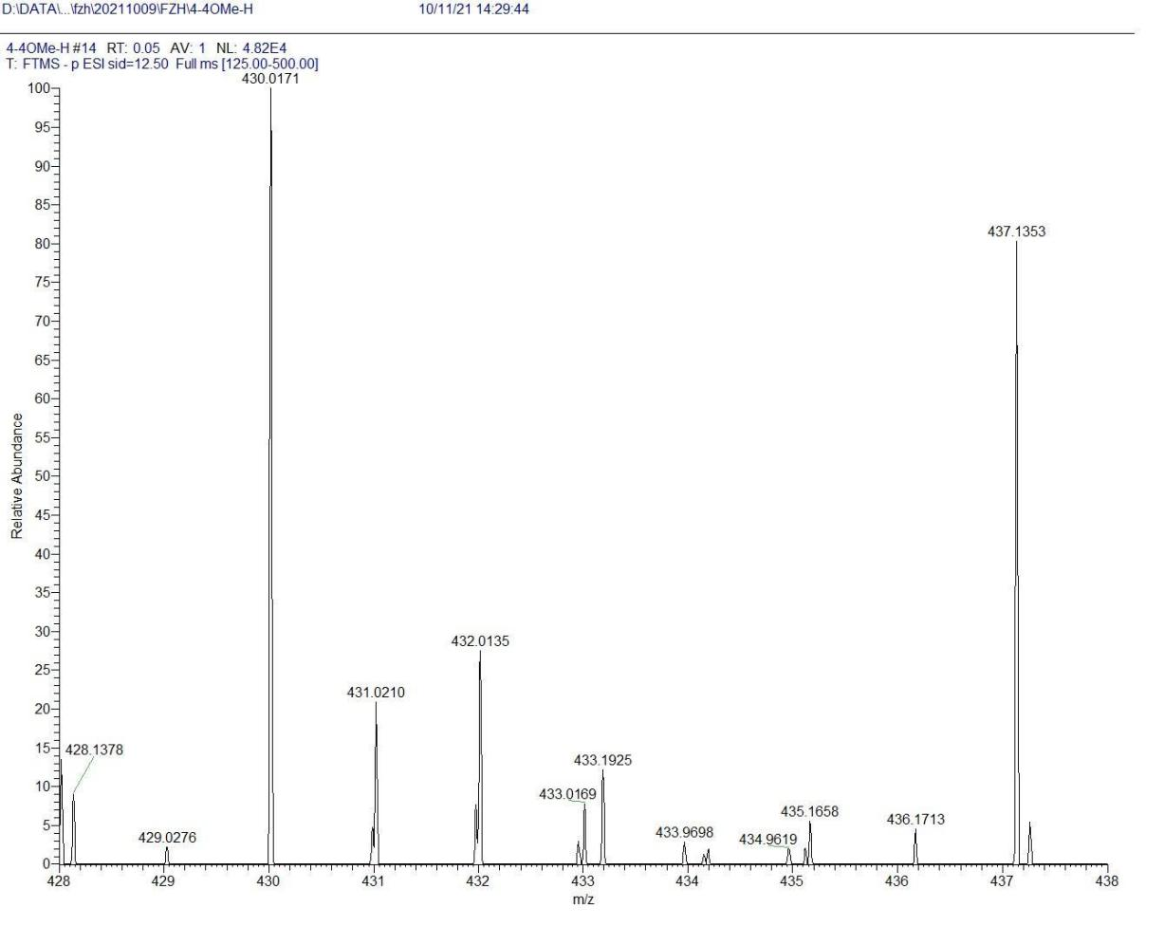
D4

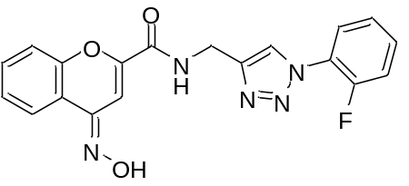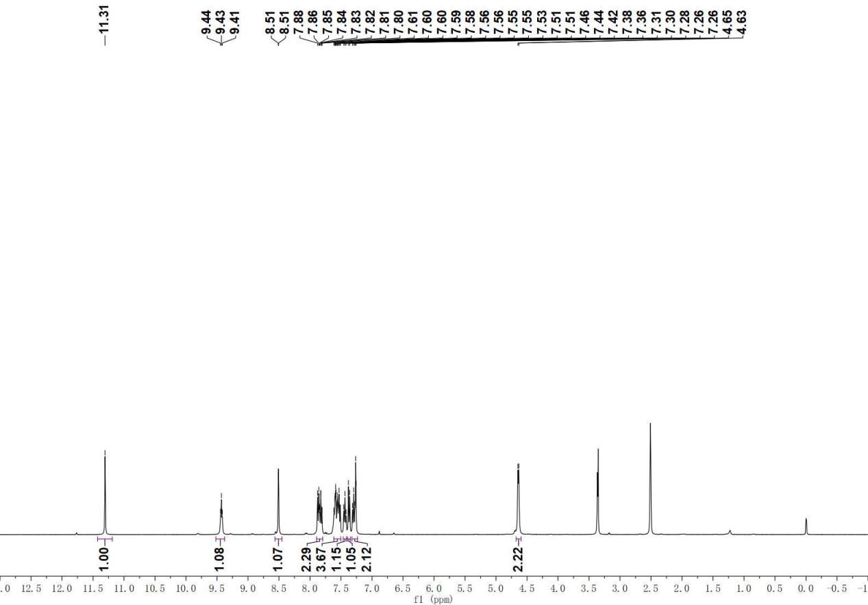

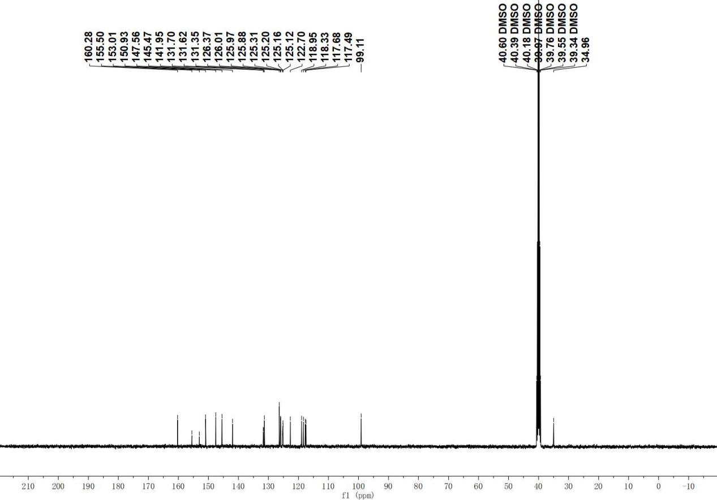

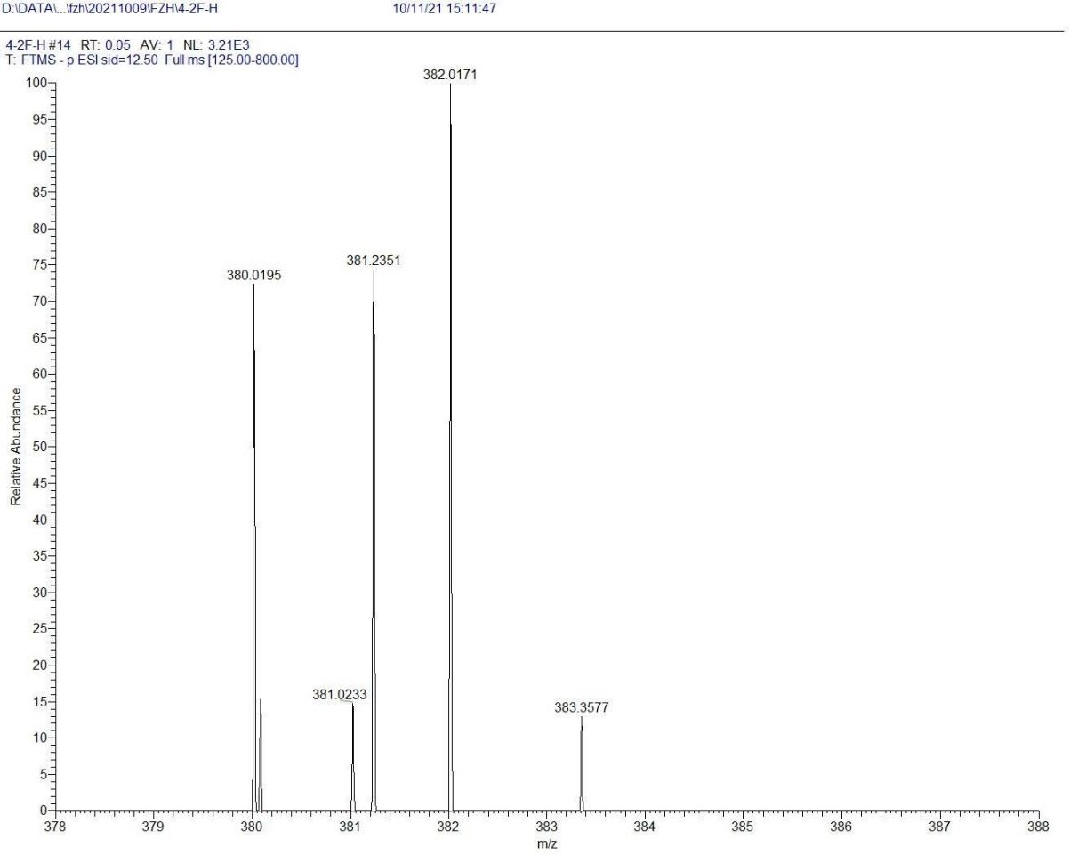

D5

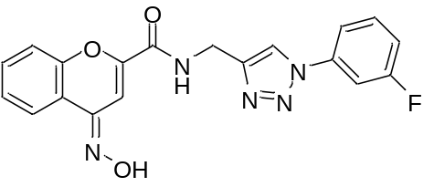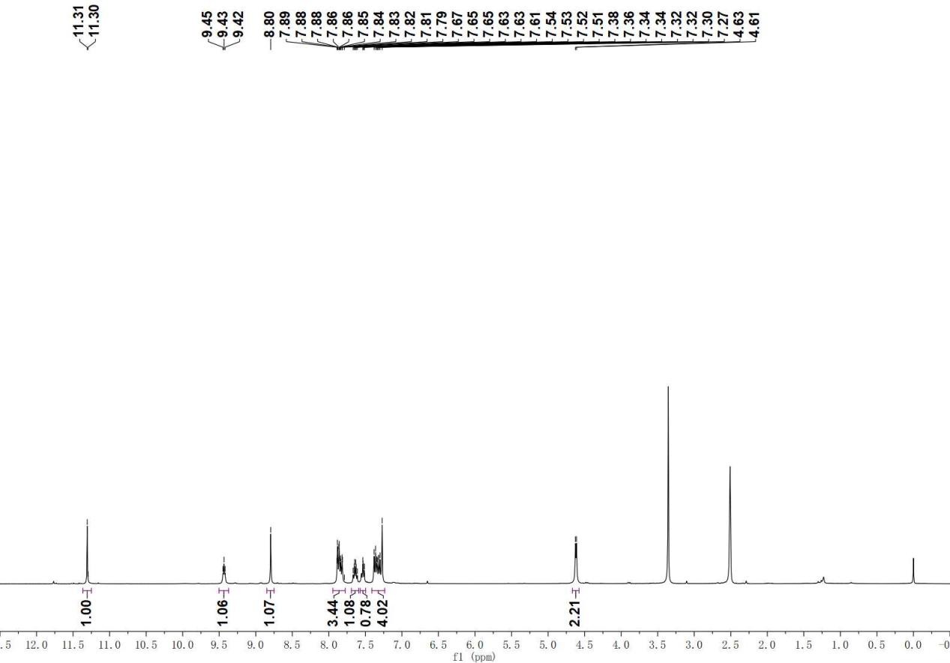

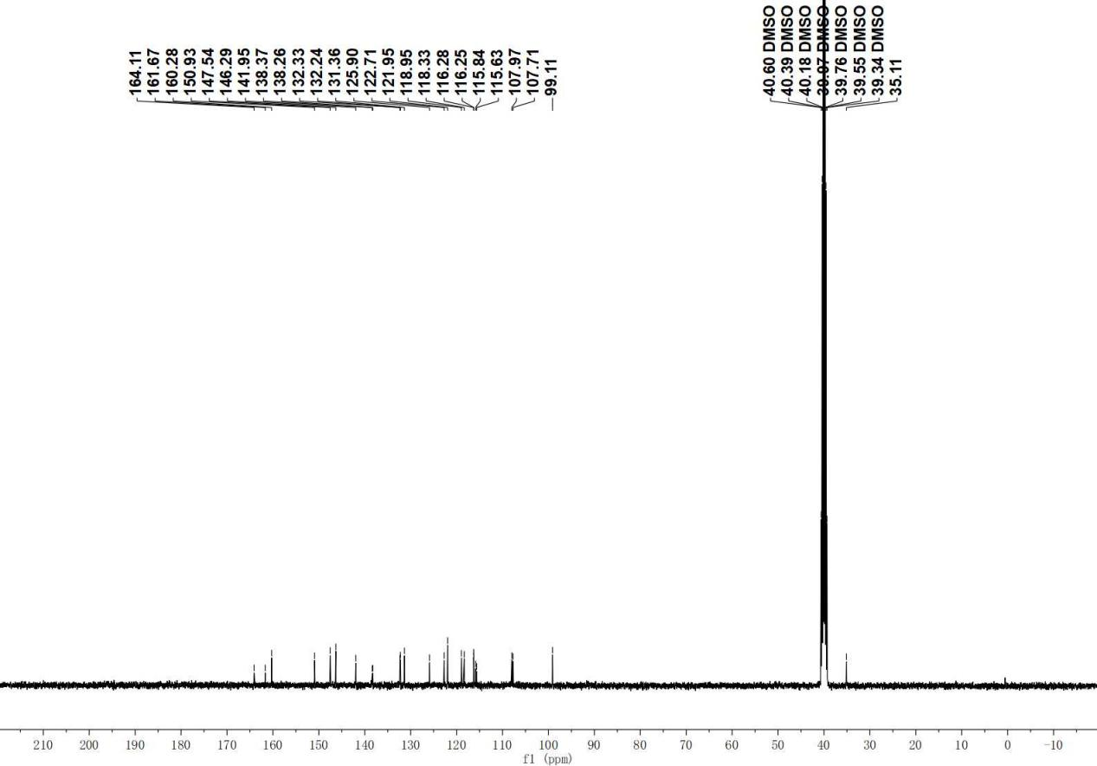

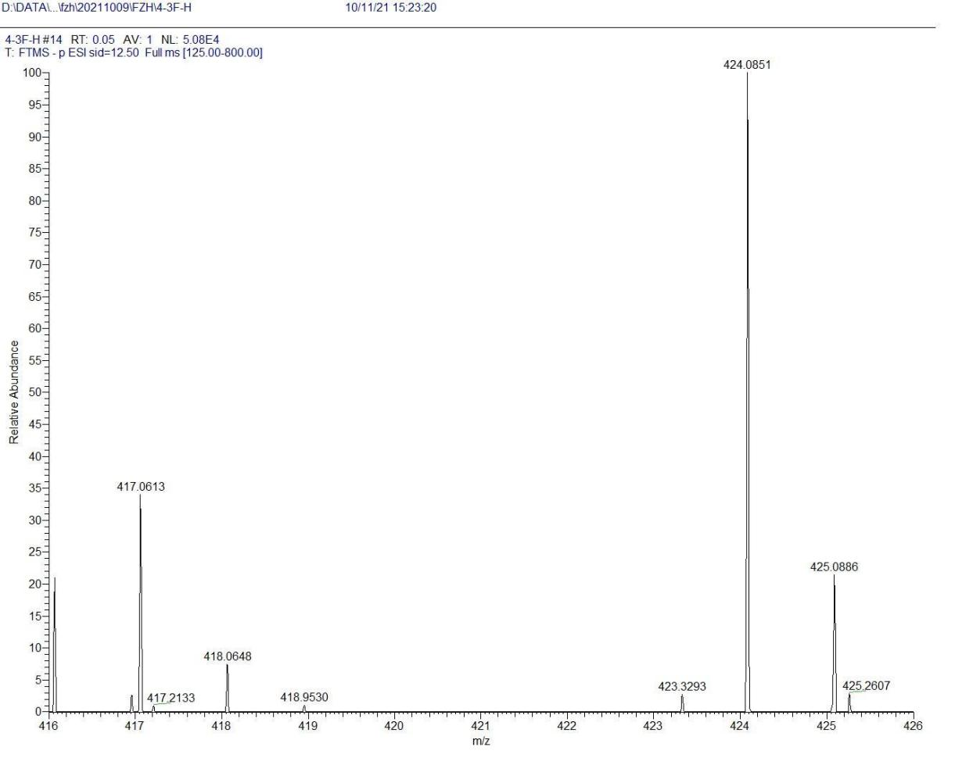
D6

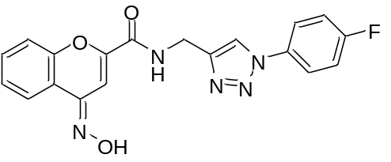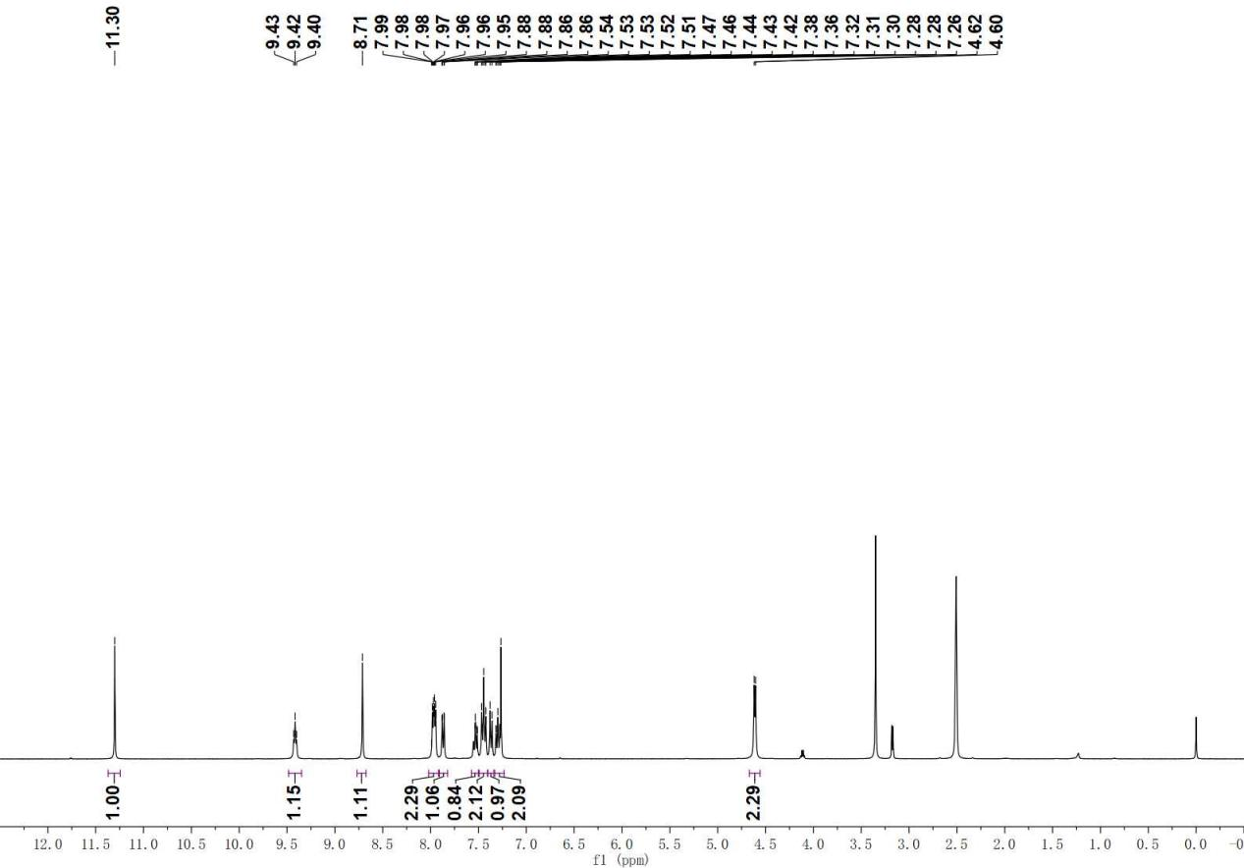

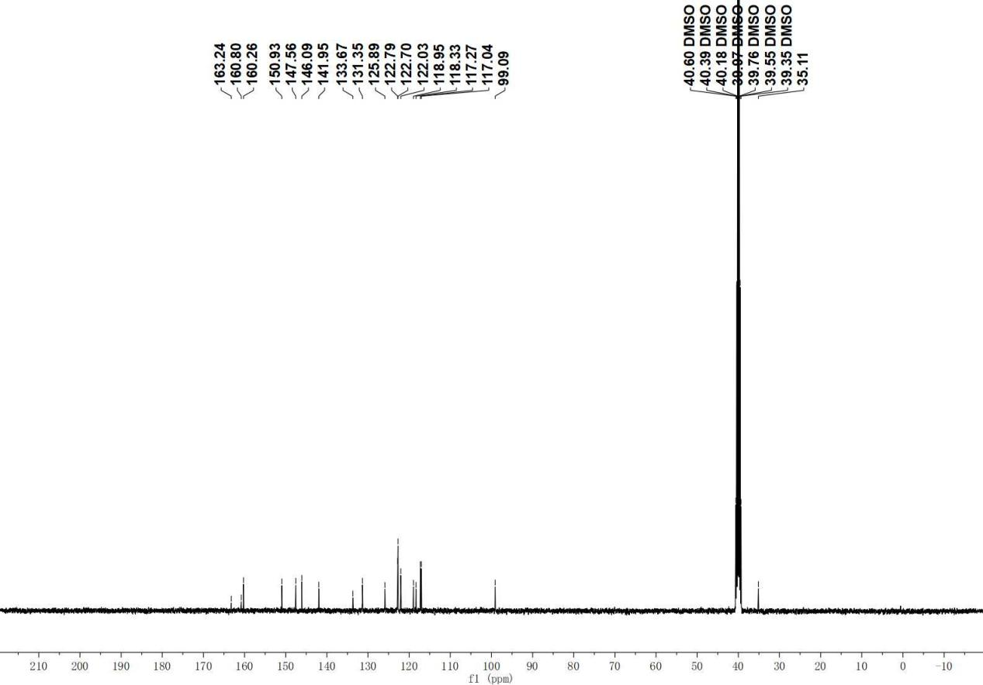

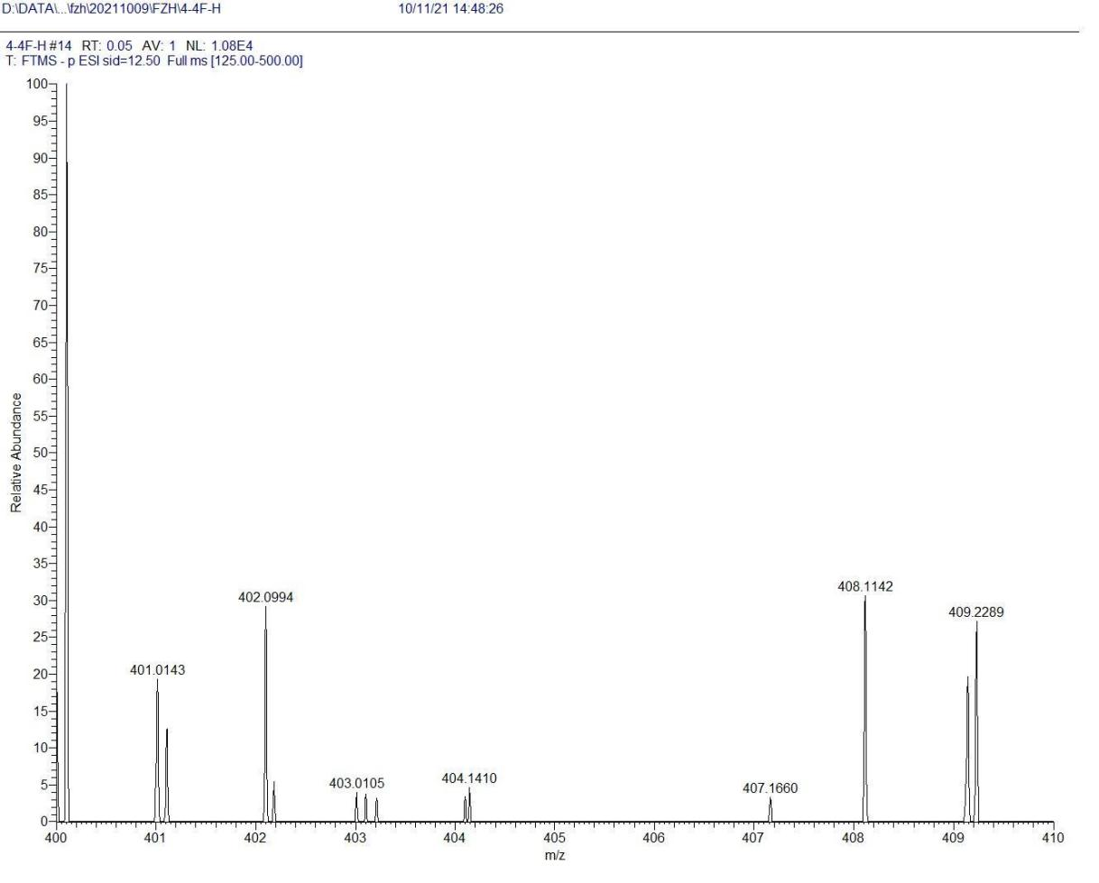

D7

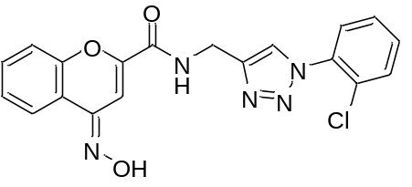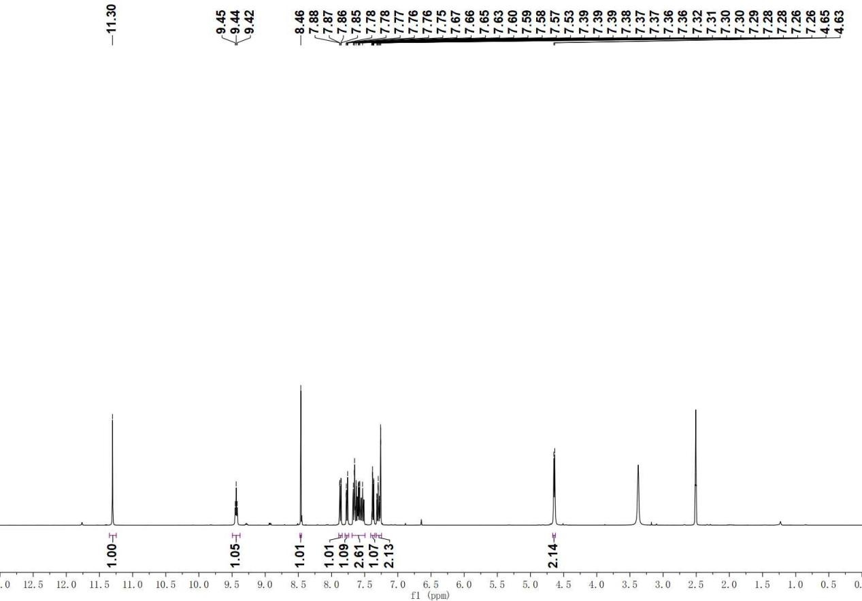

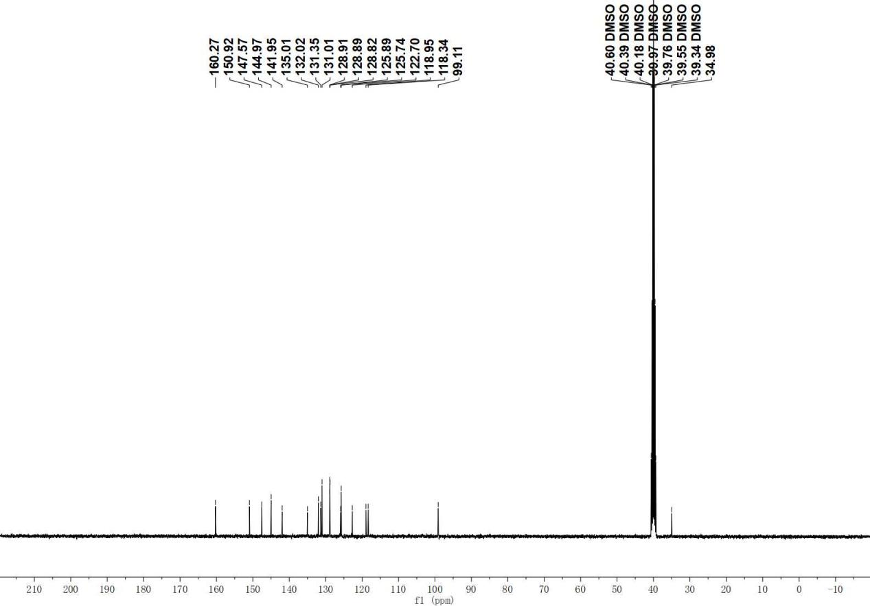

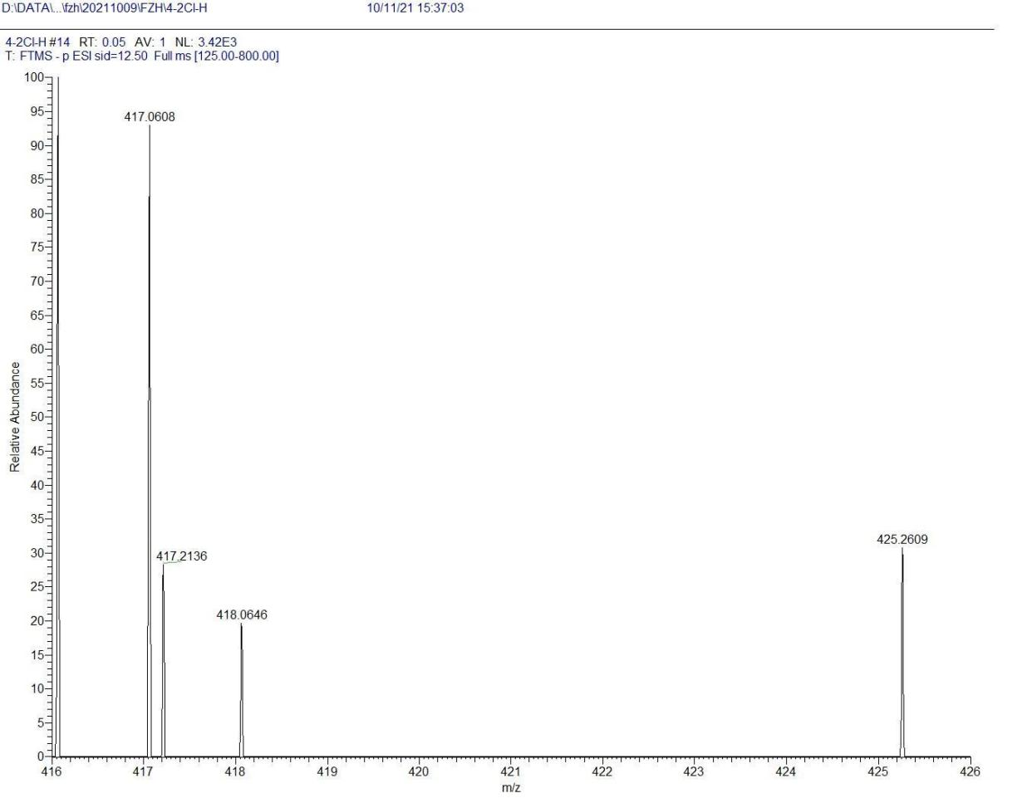

D8
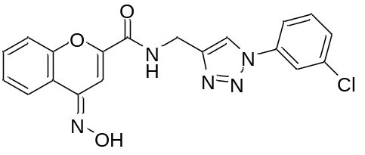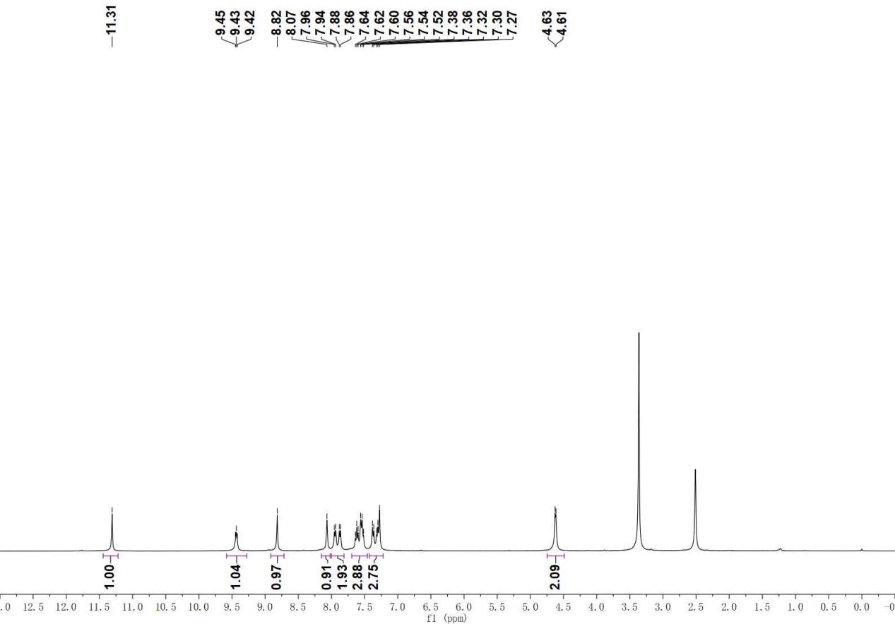

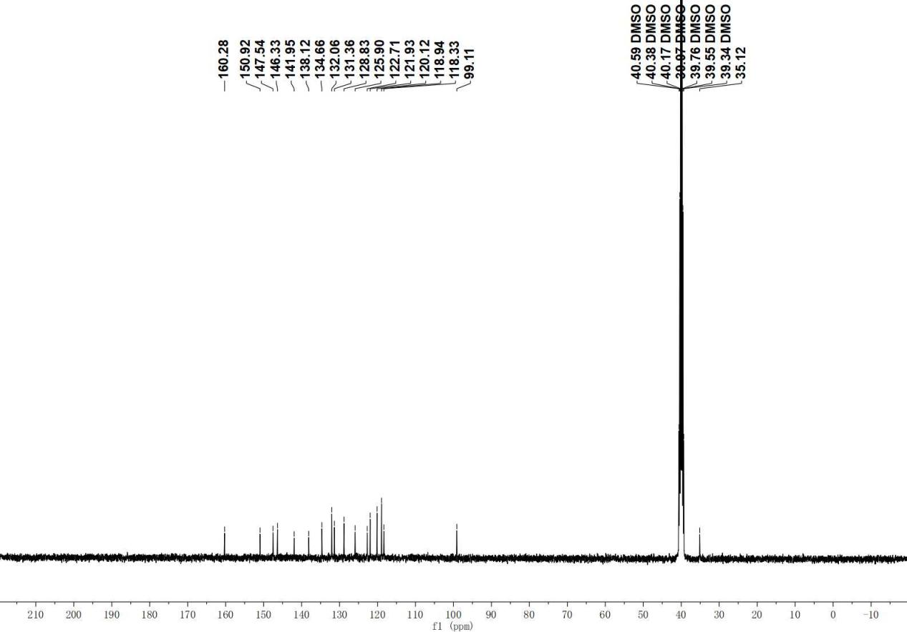

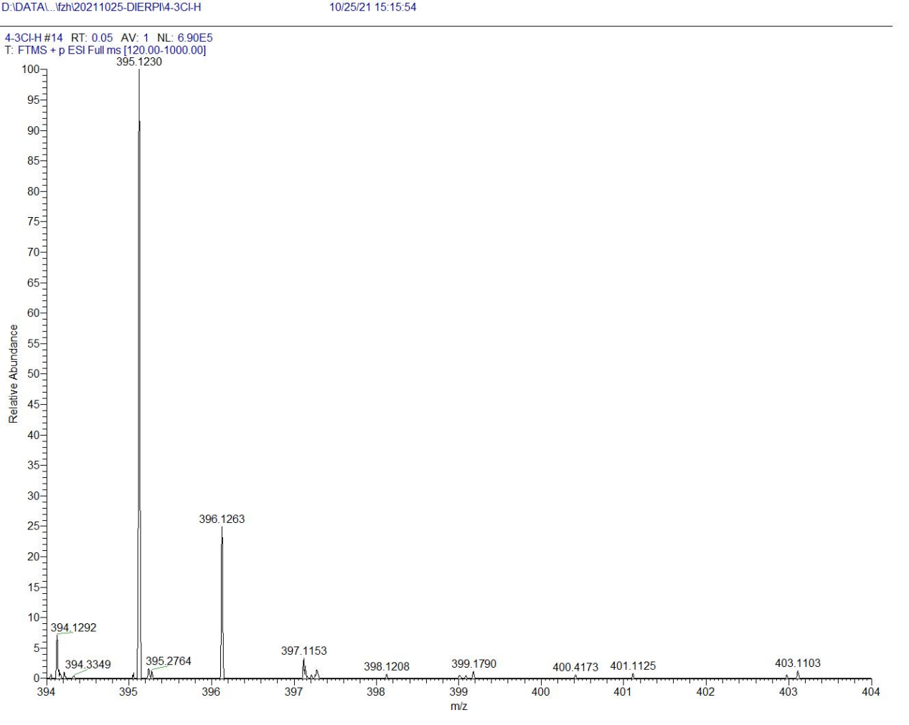

D9

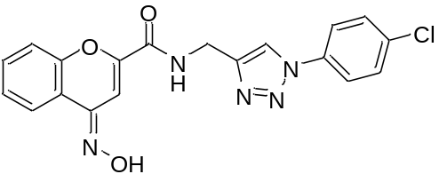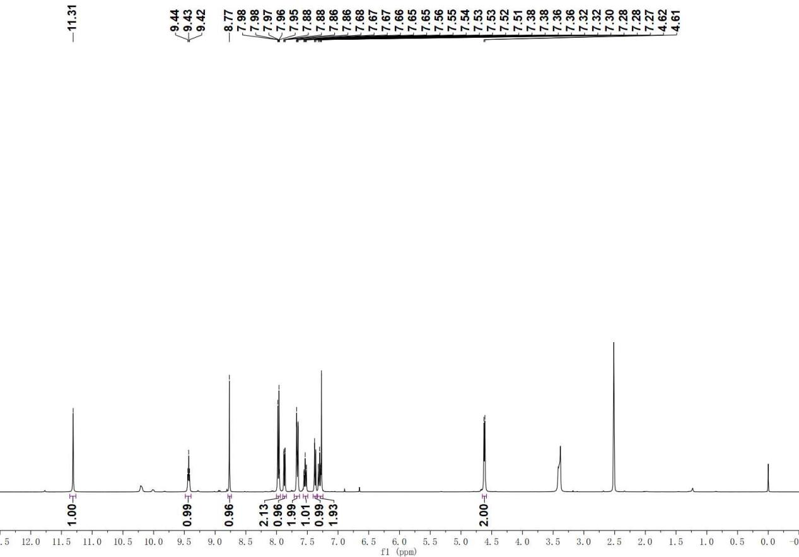

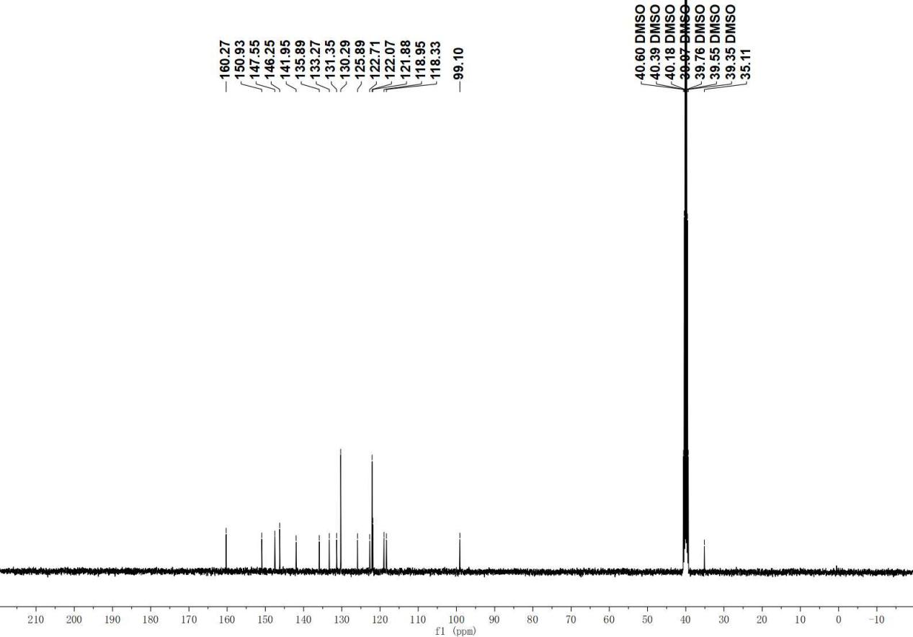

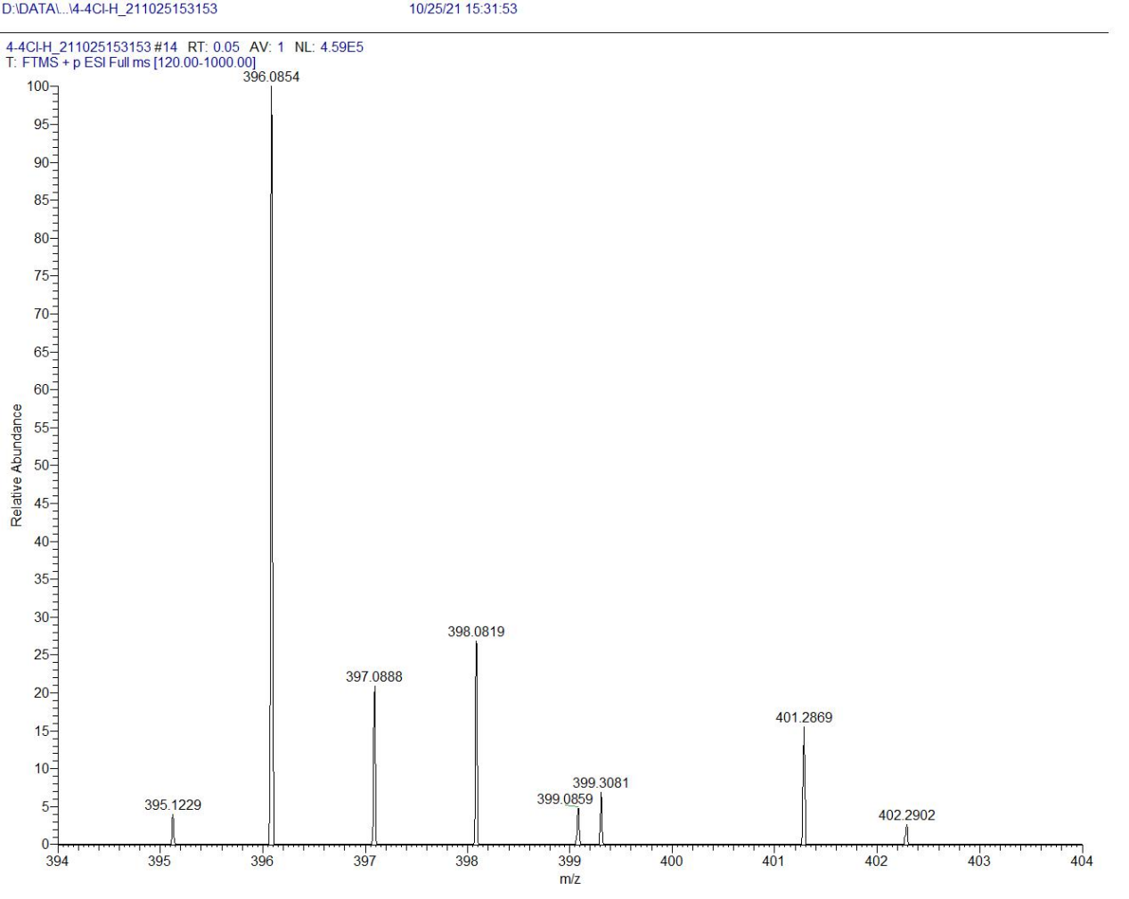
D10

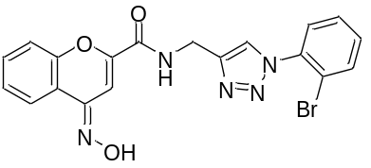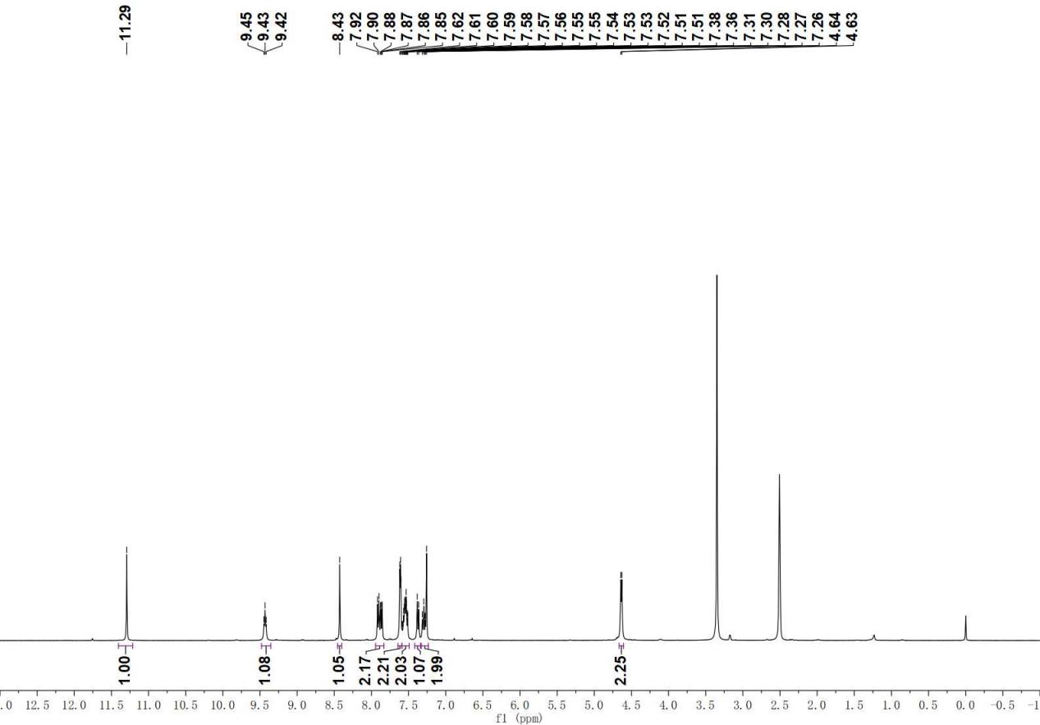

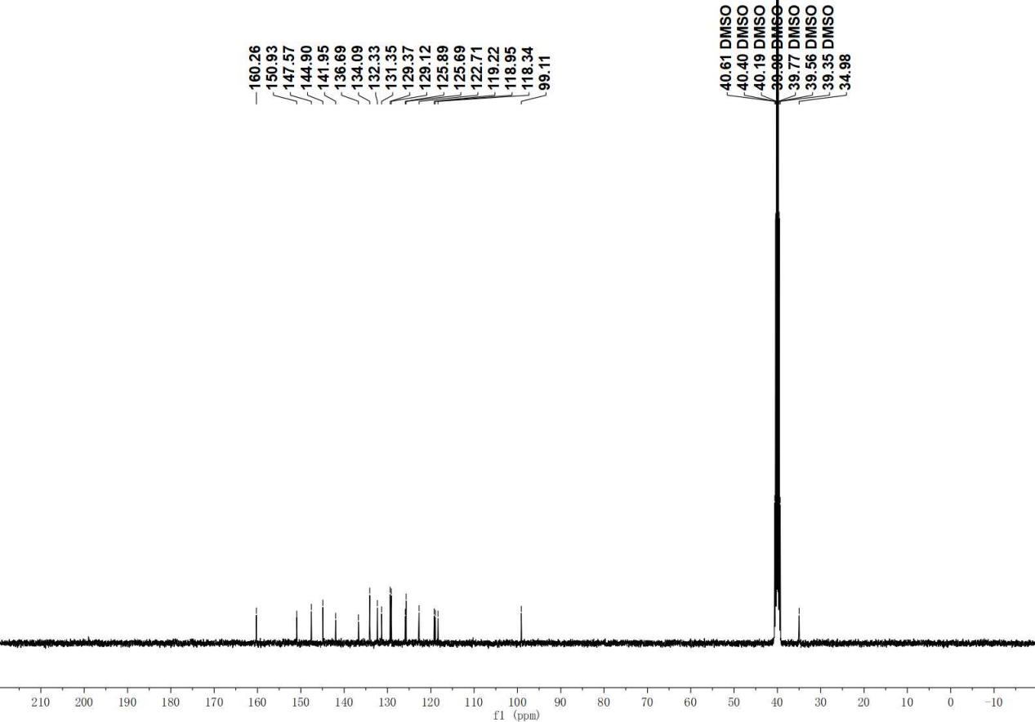

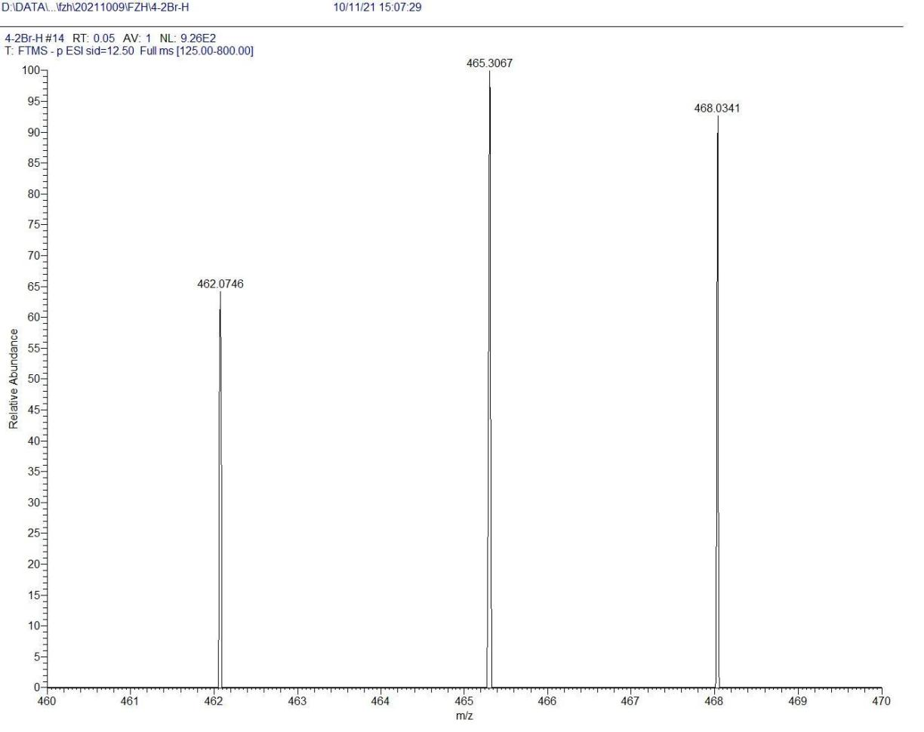

D11

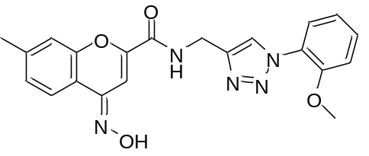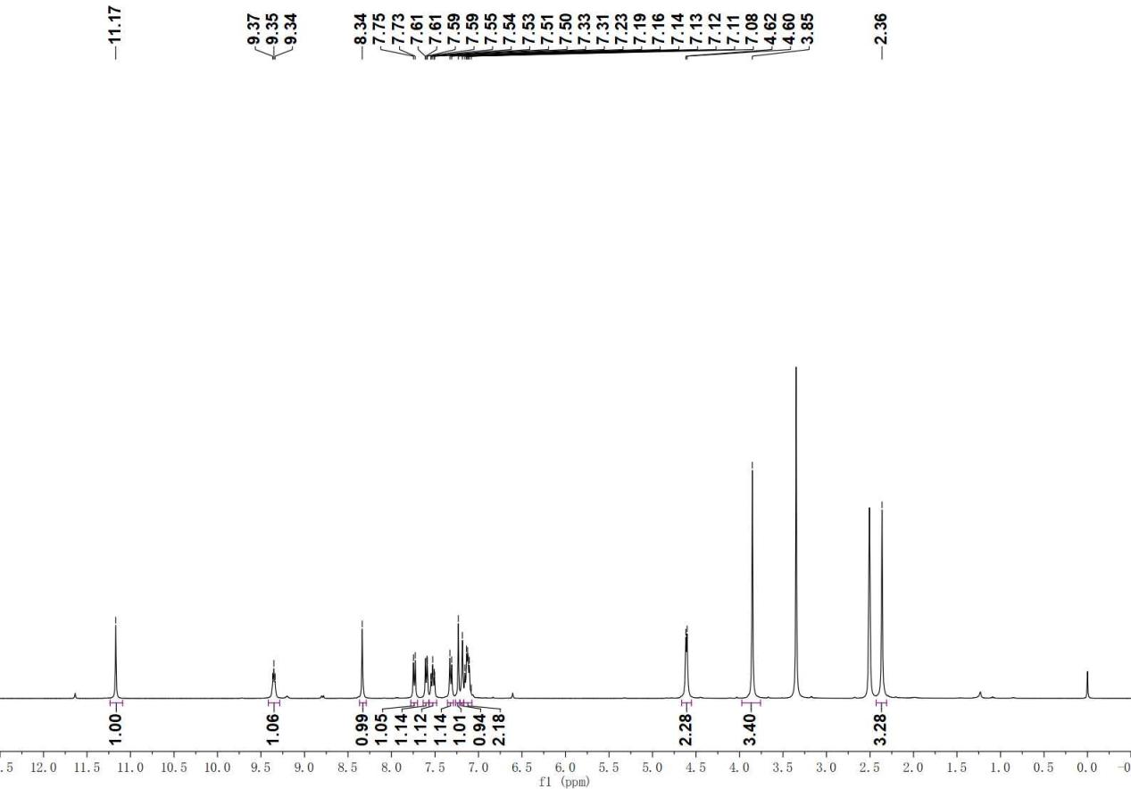

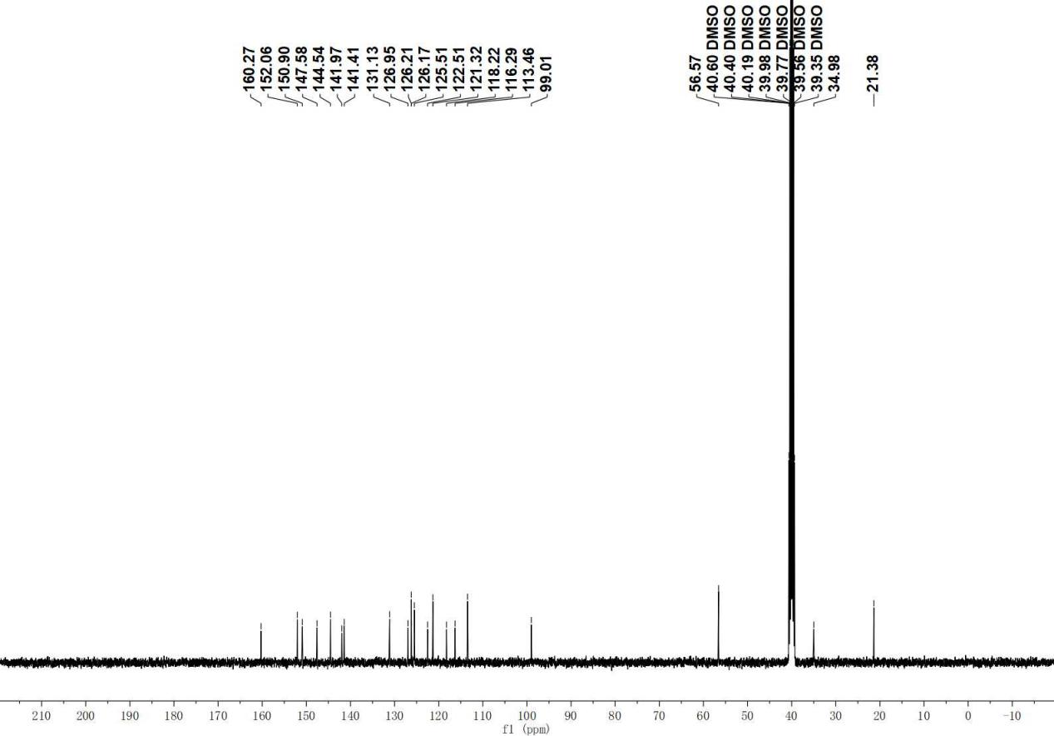

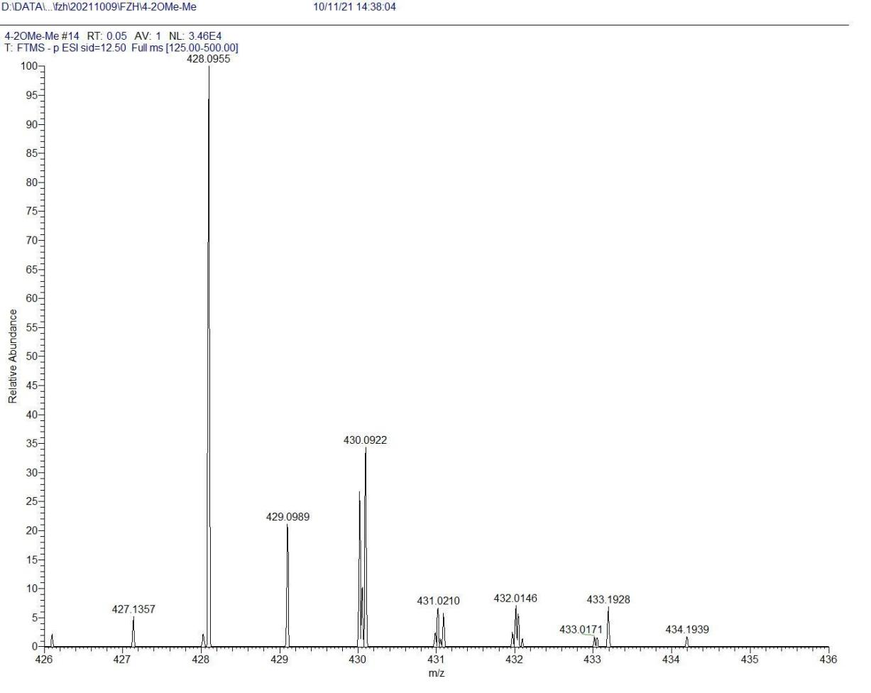
D12

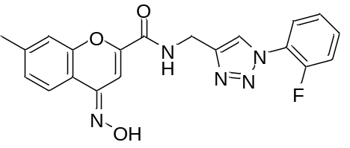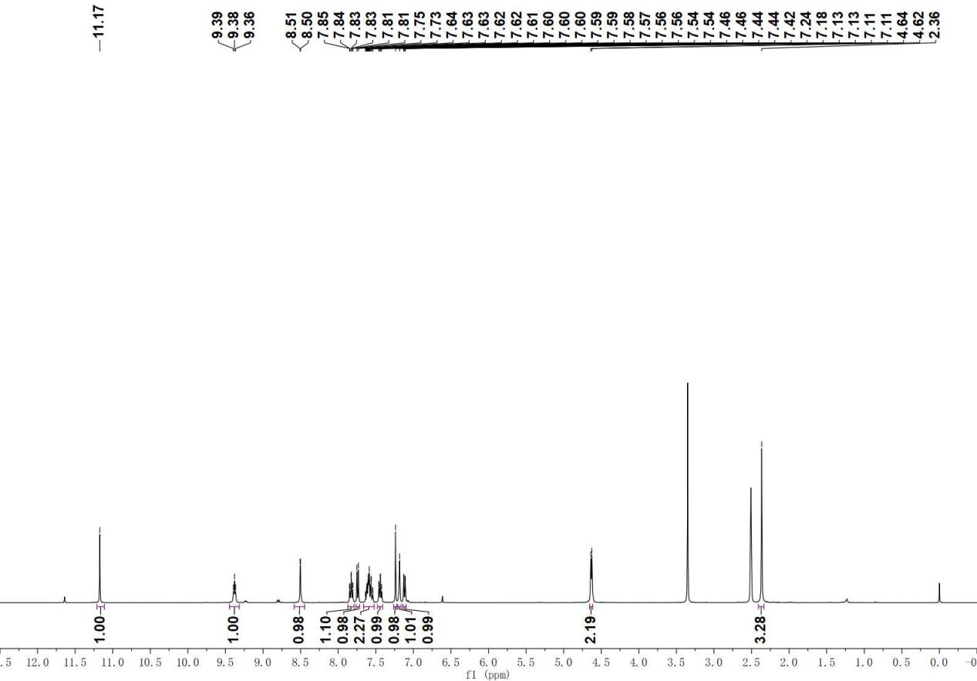

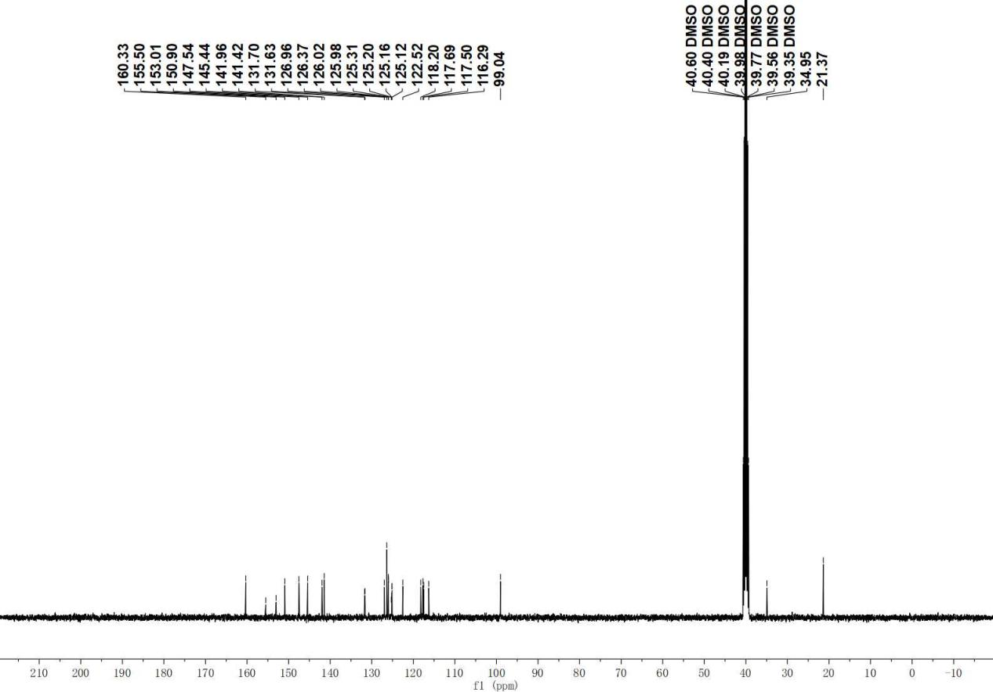

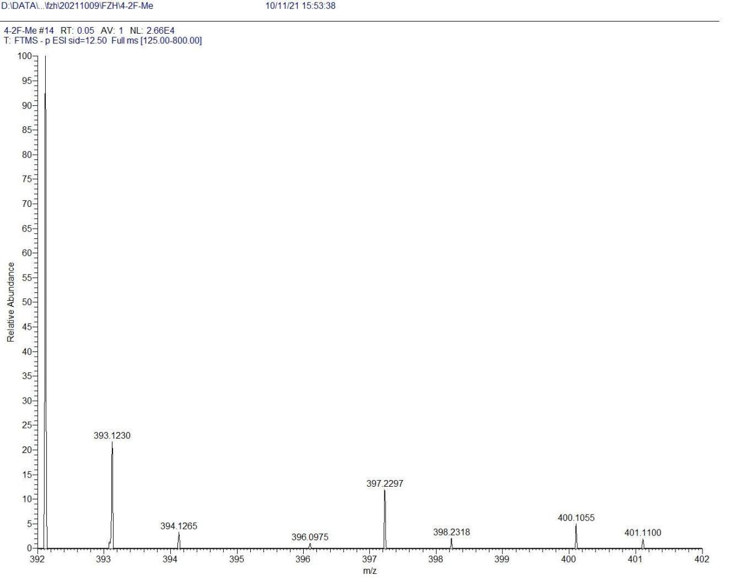

D13

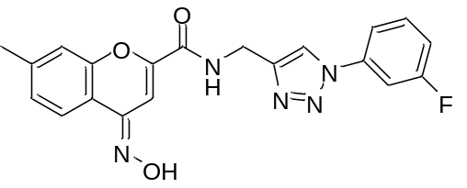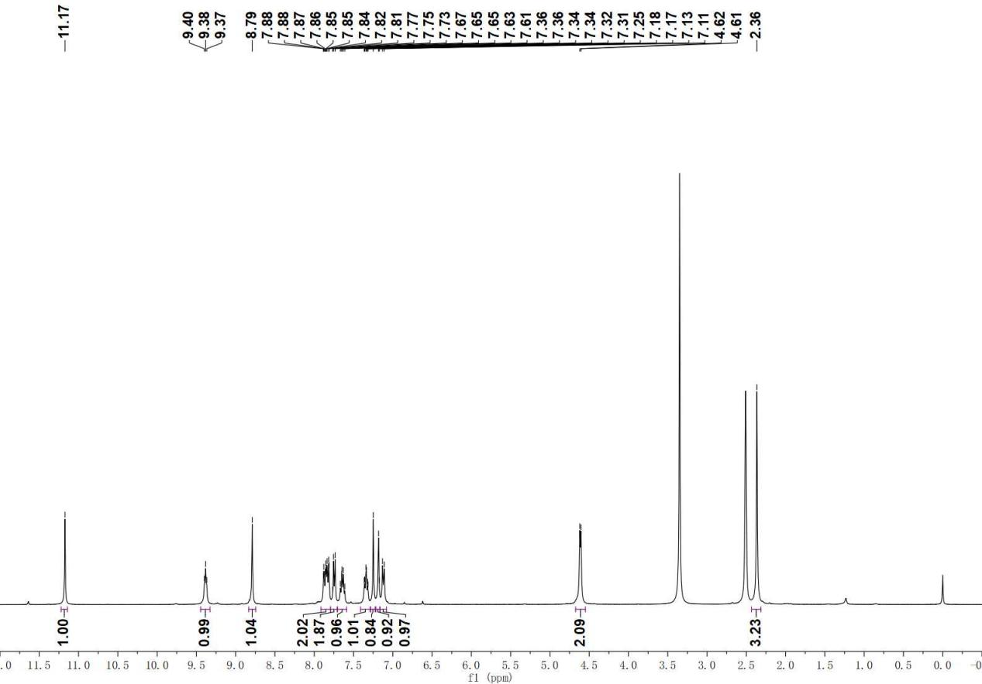

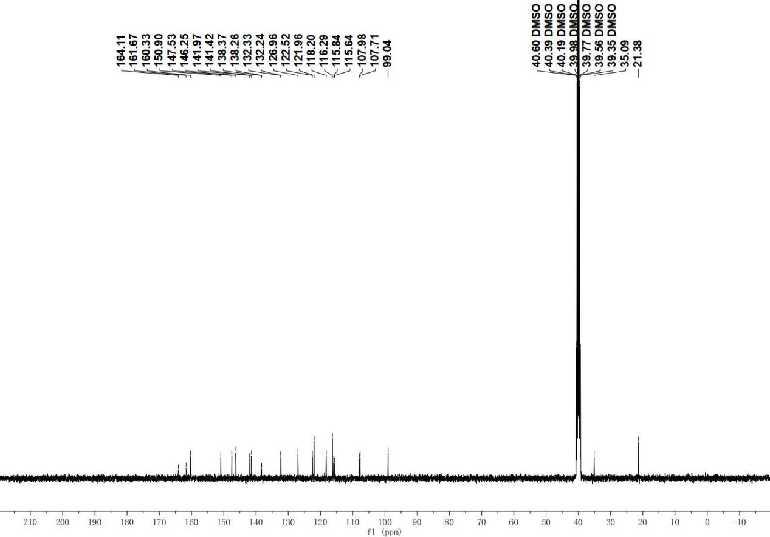

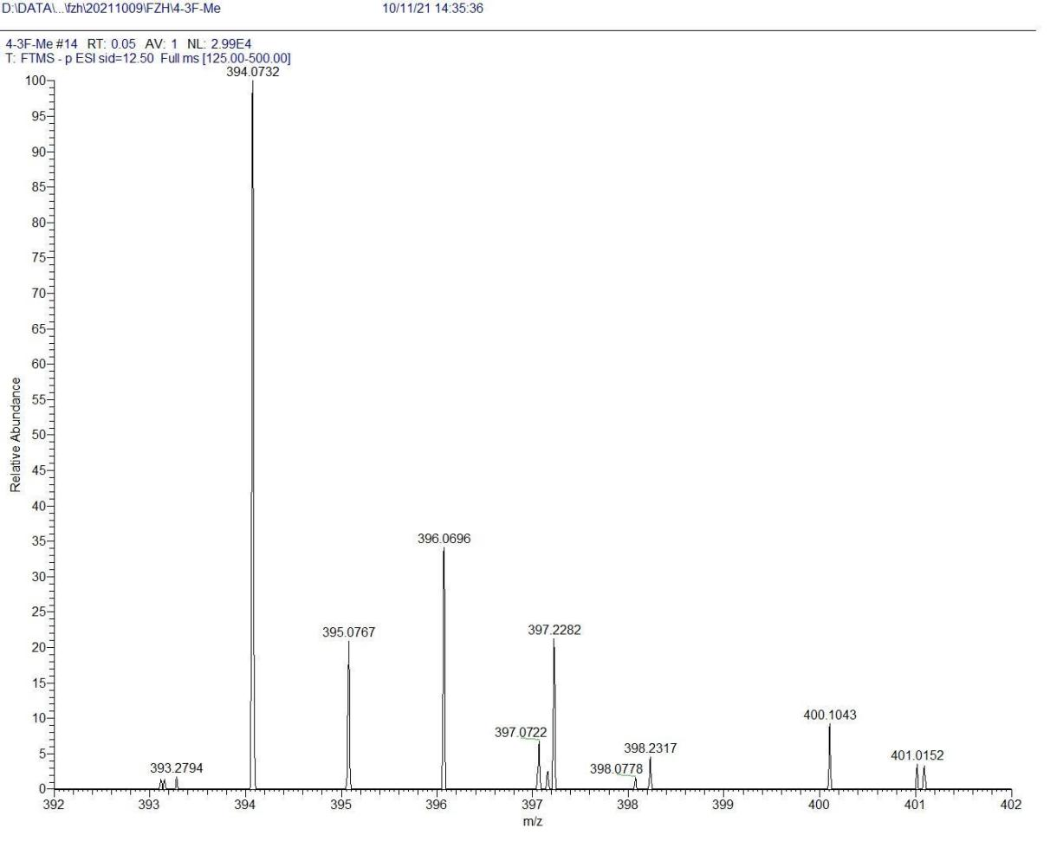
D14

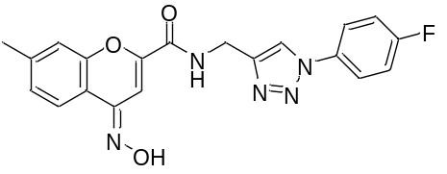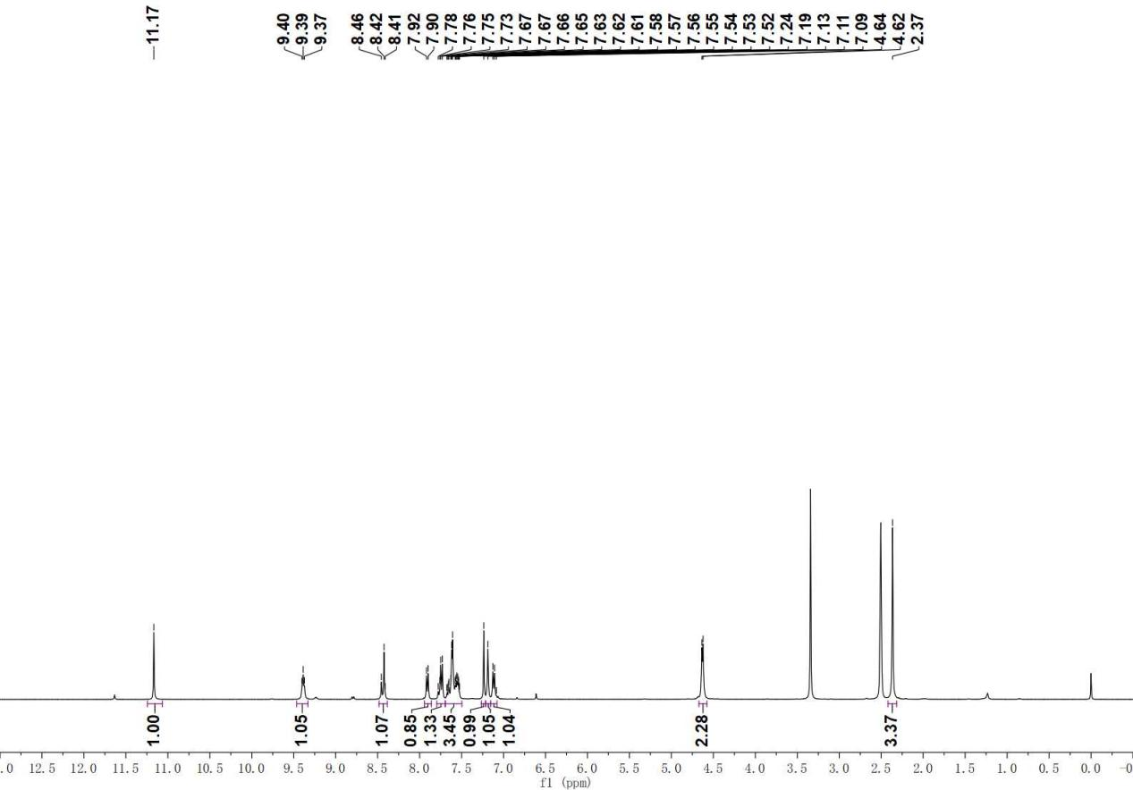

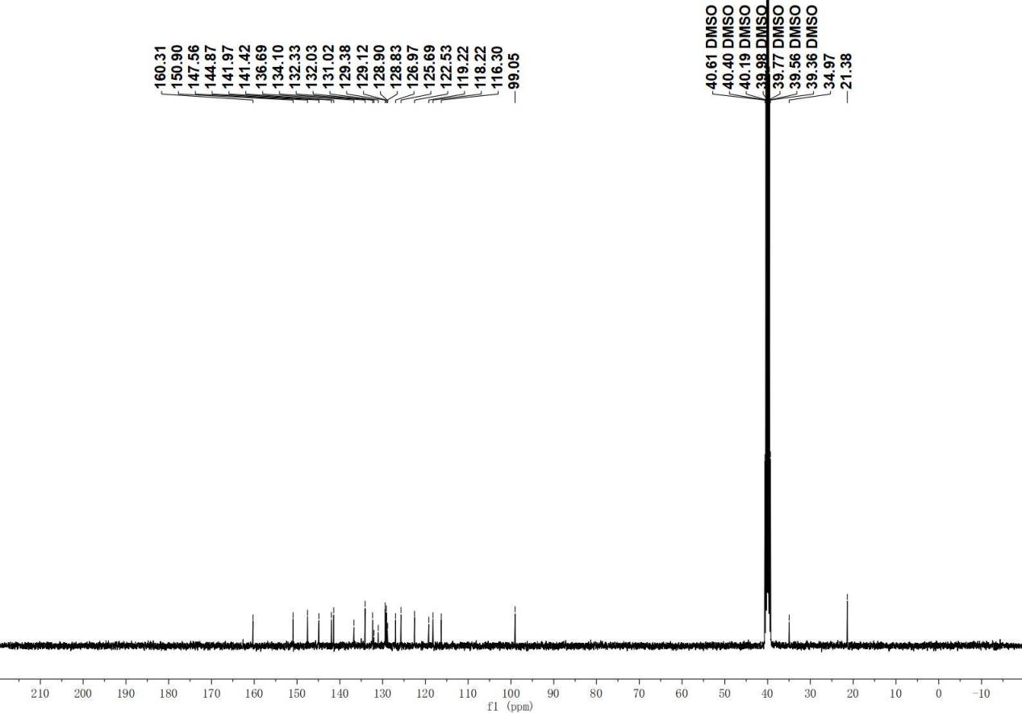

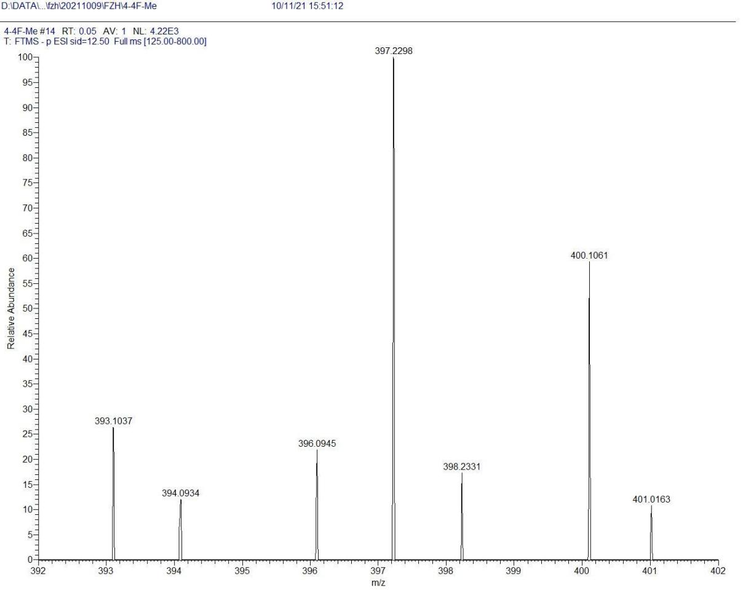

D15

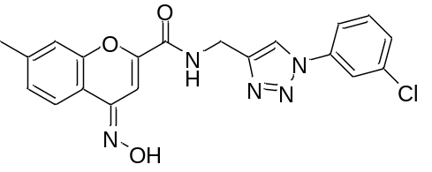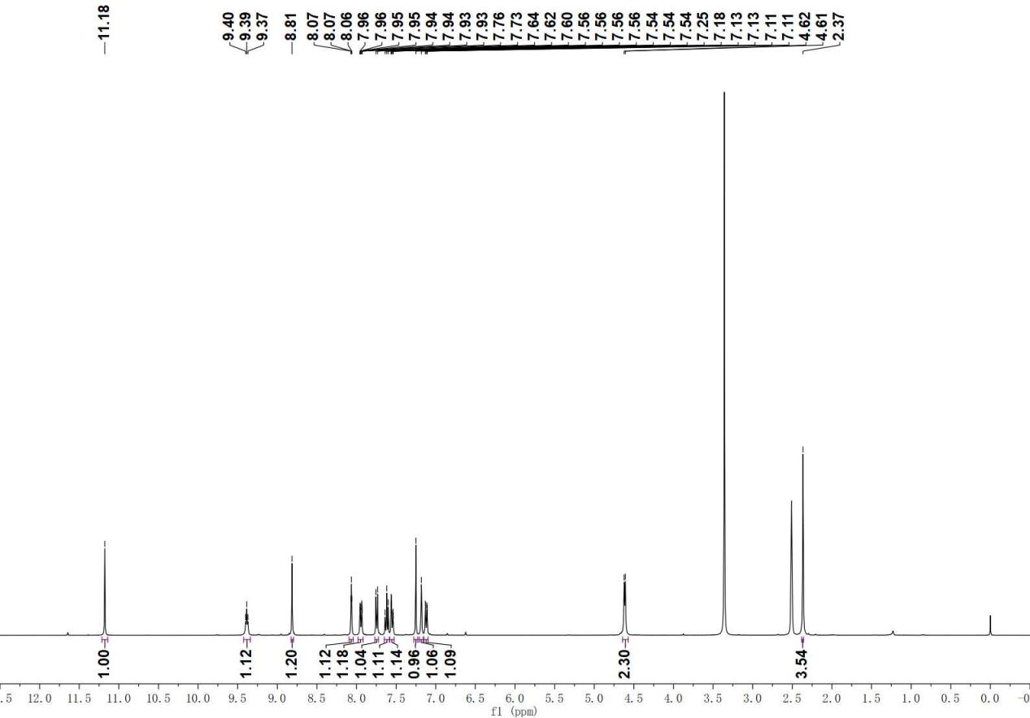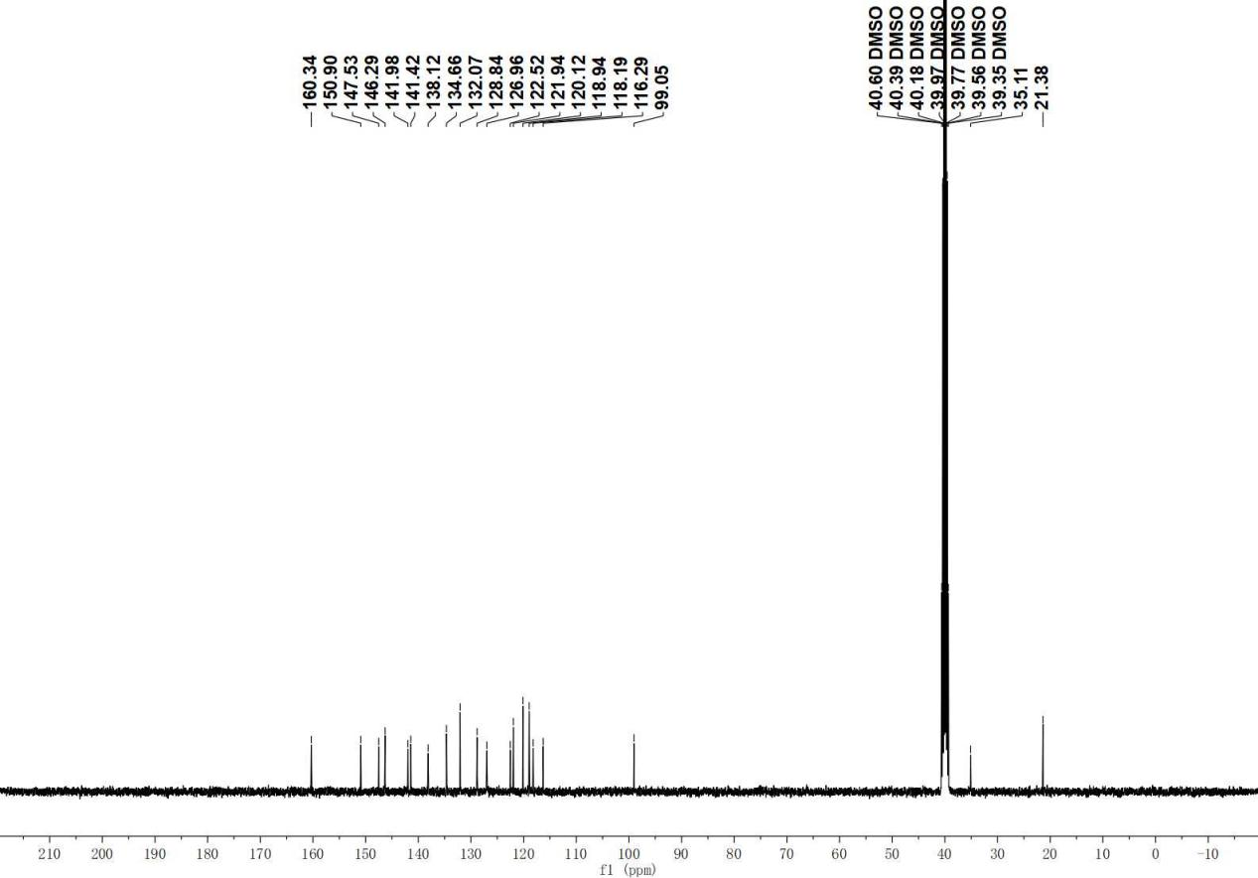

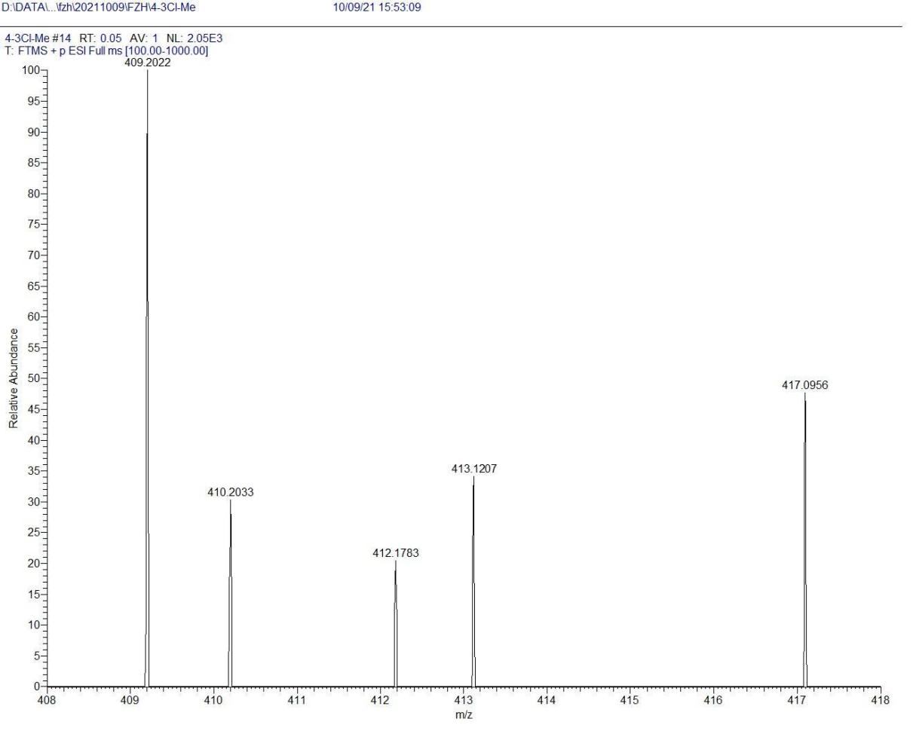
D16
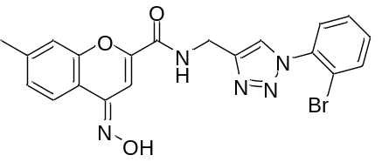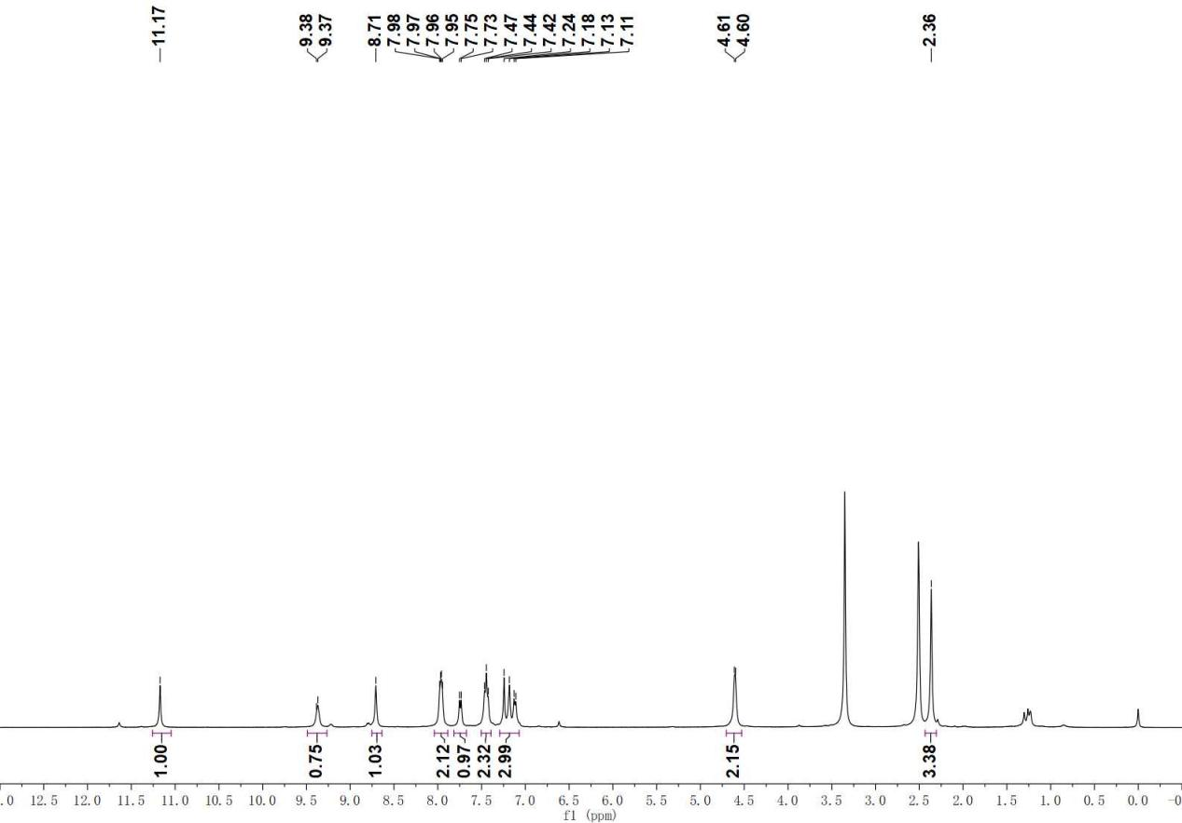
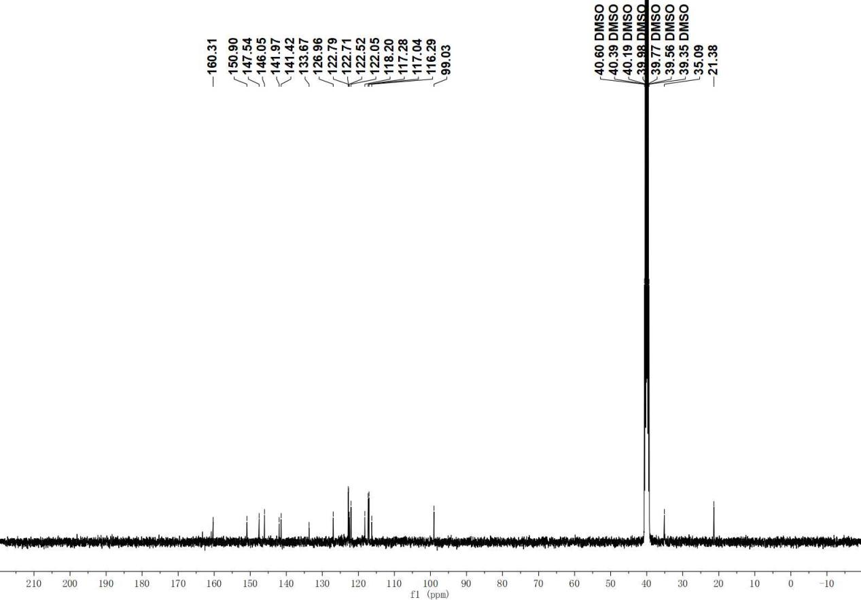
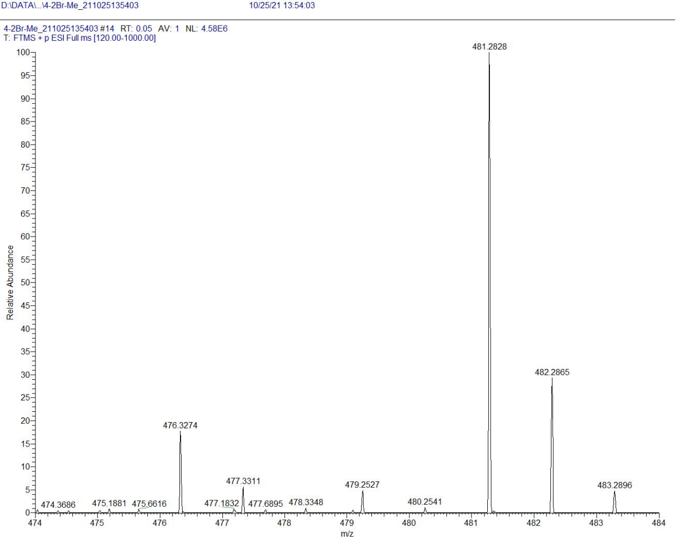

D17

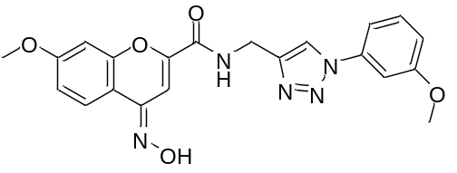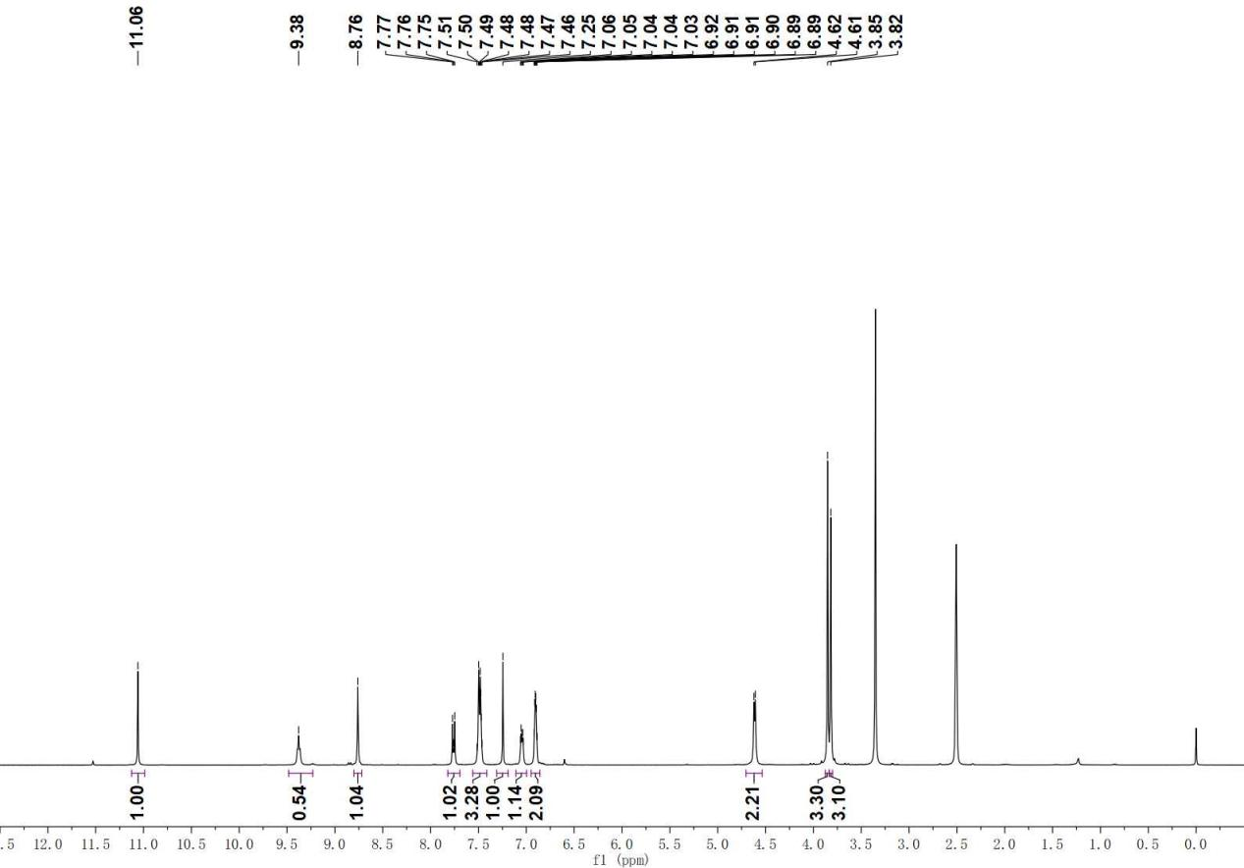

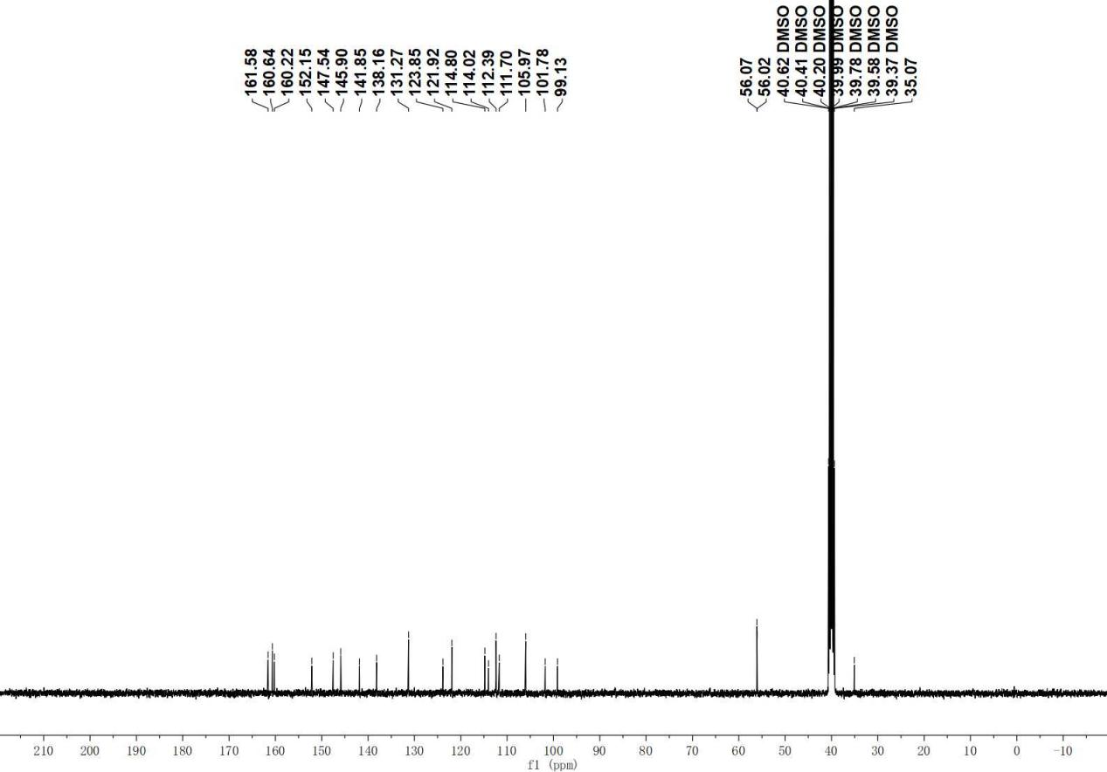

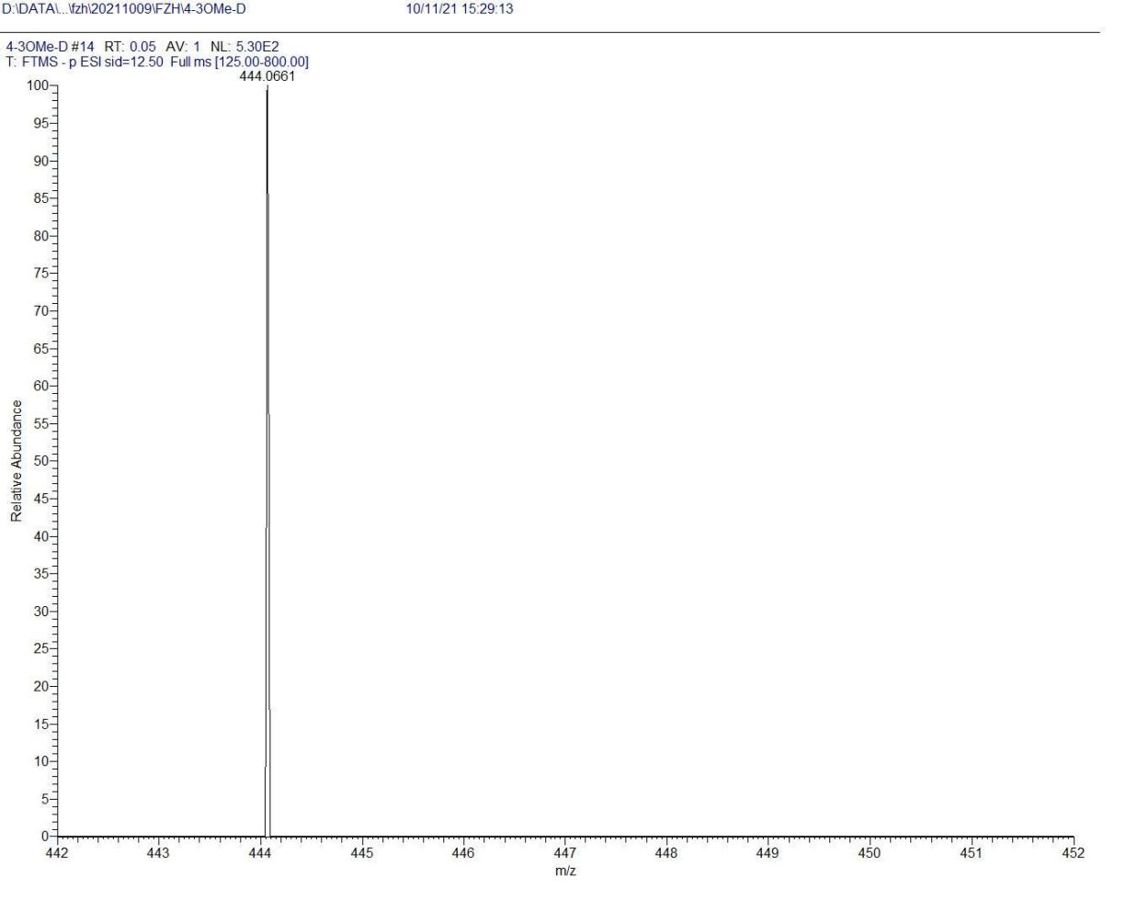

D18

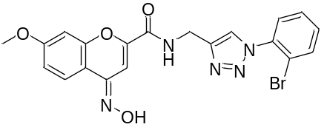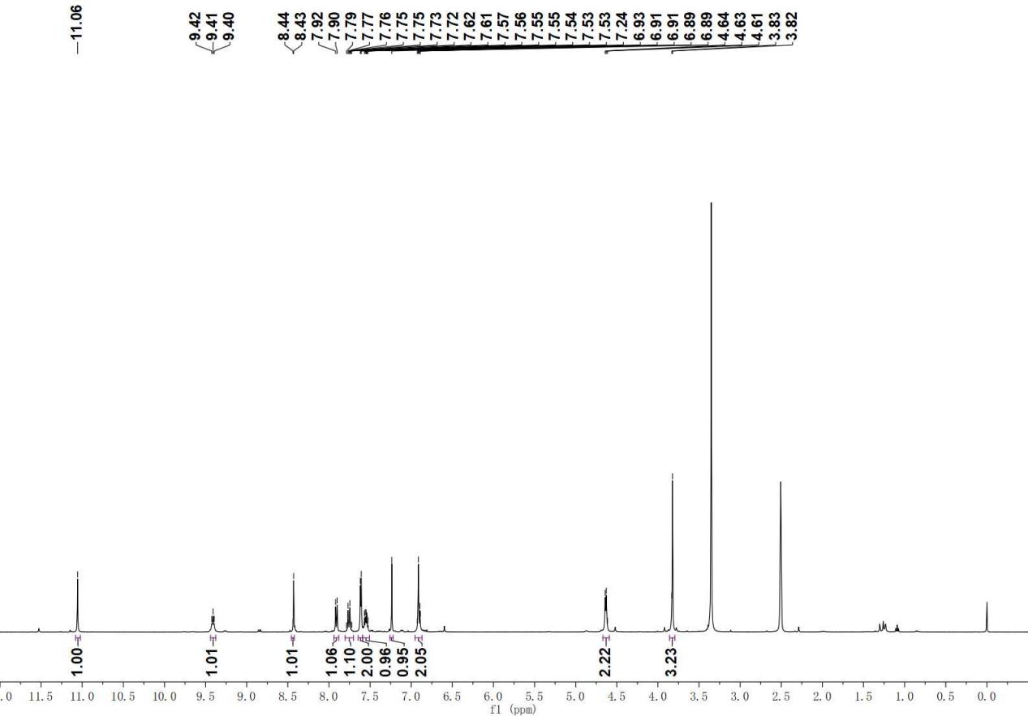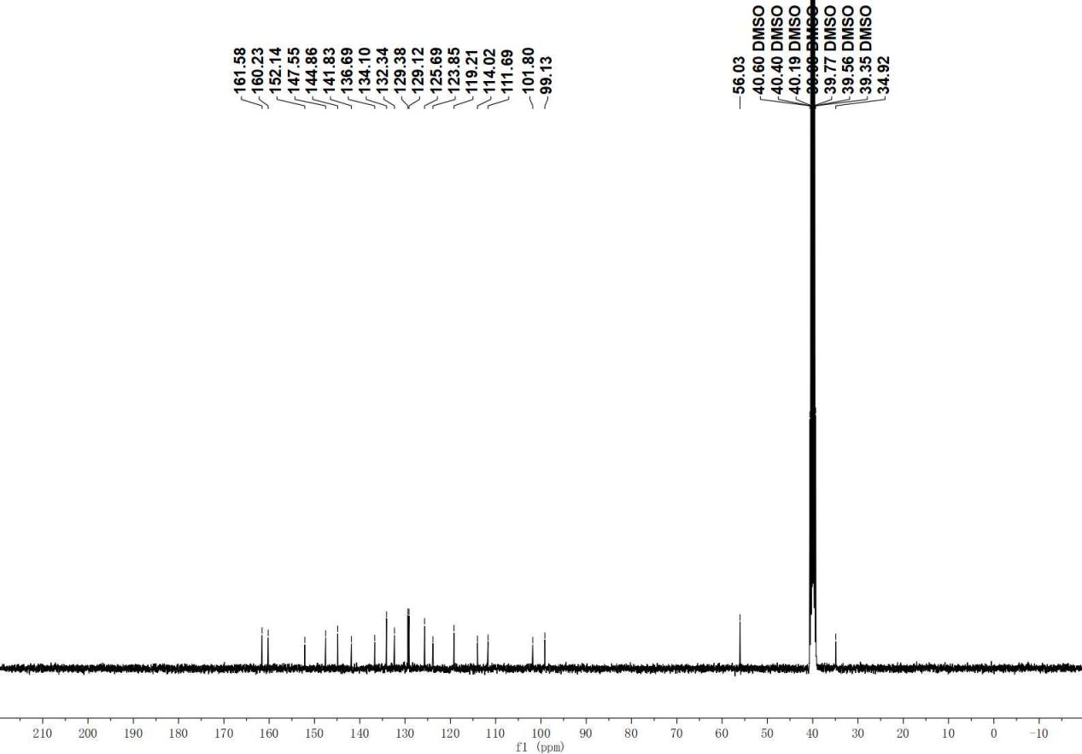

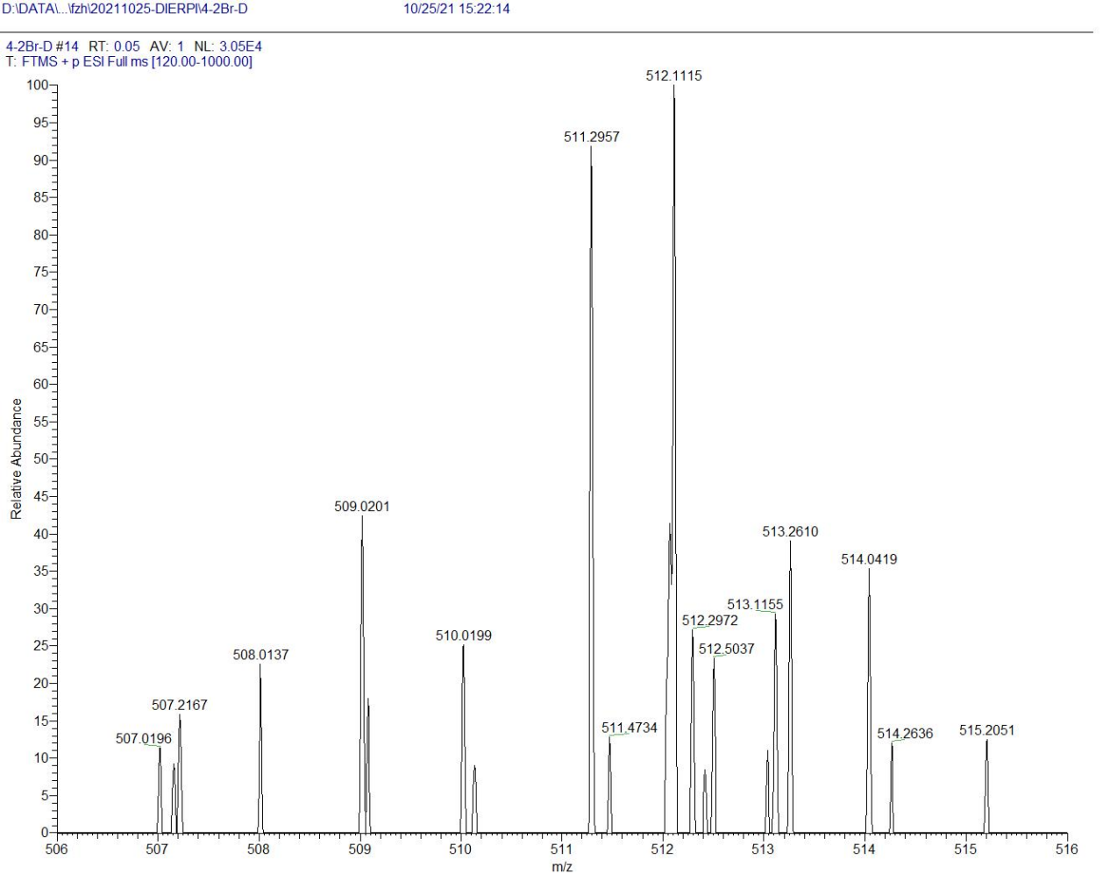

D19

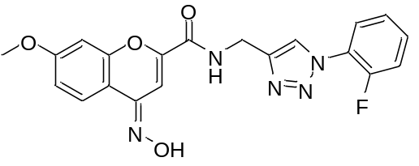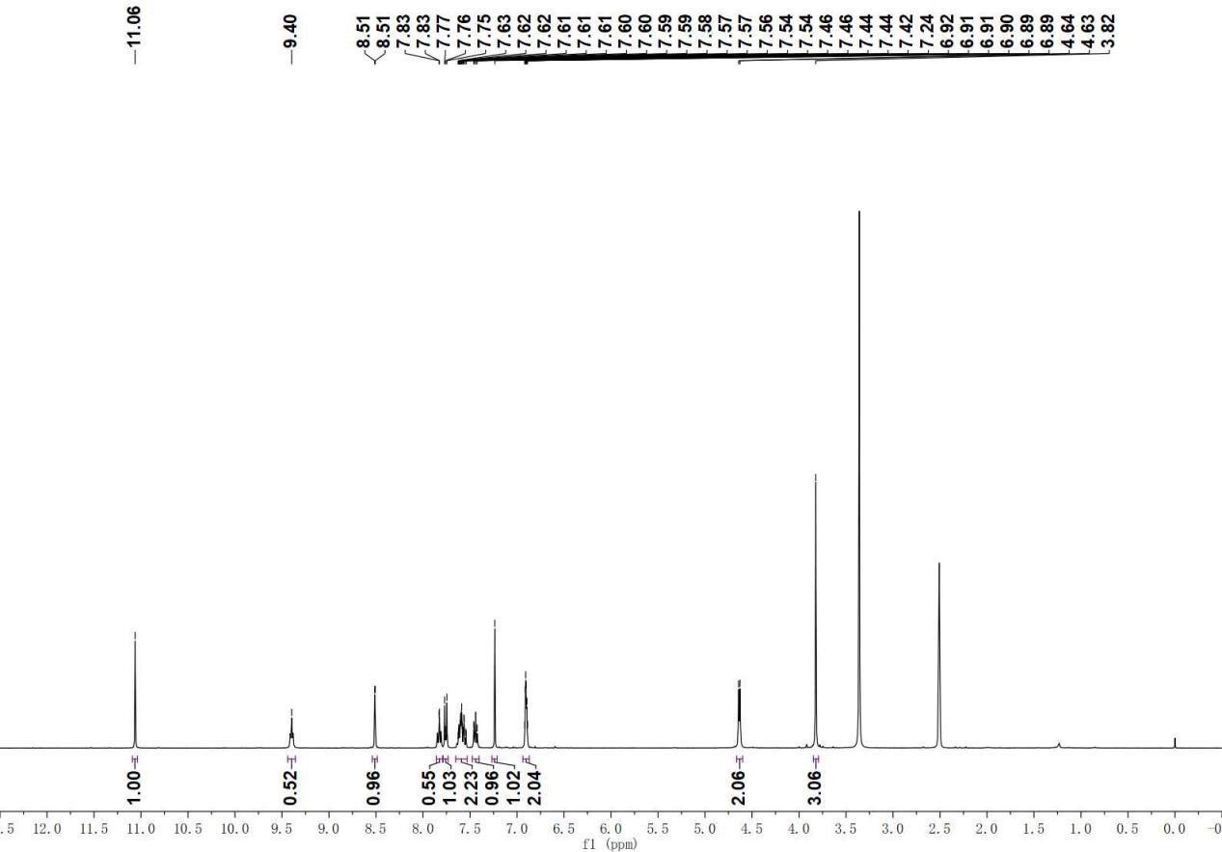

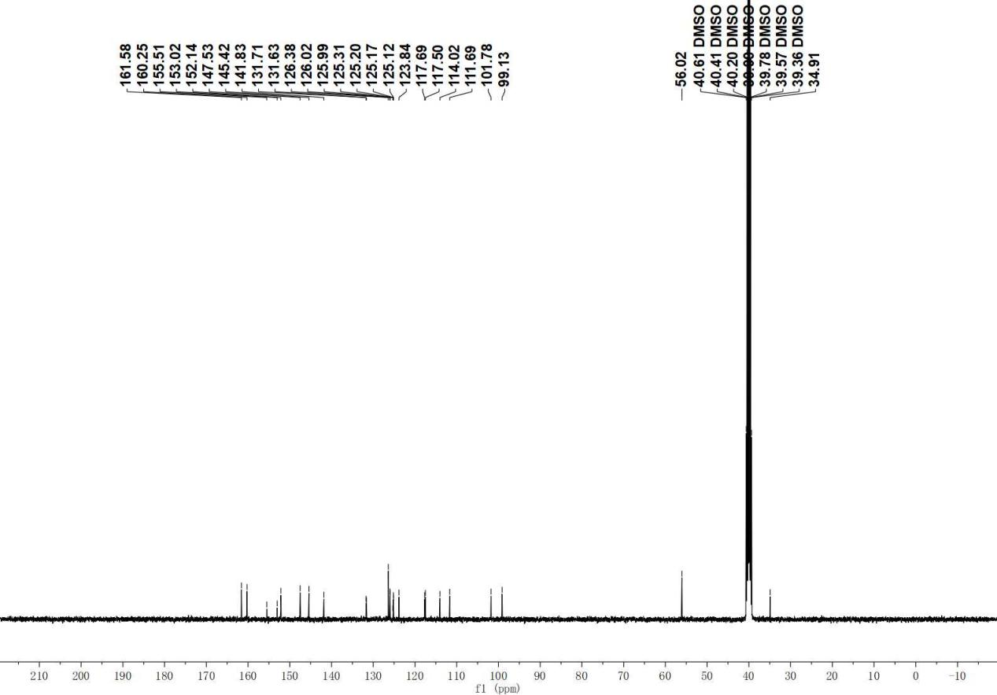

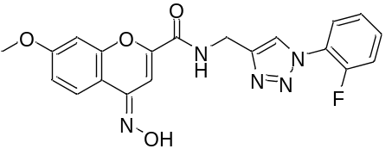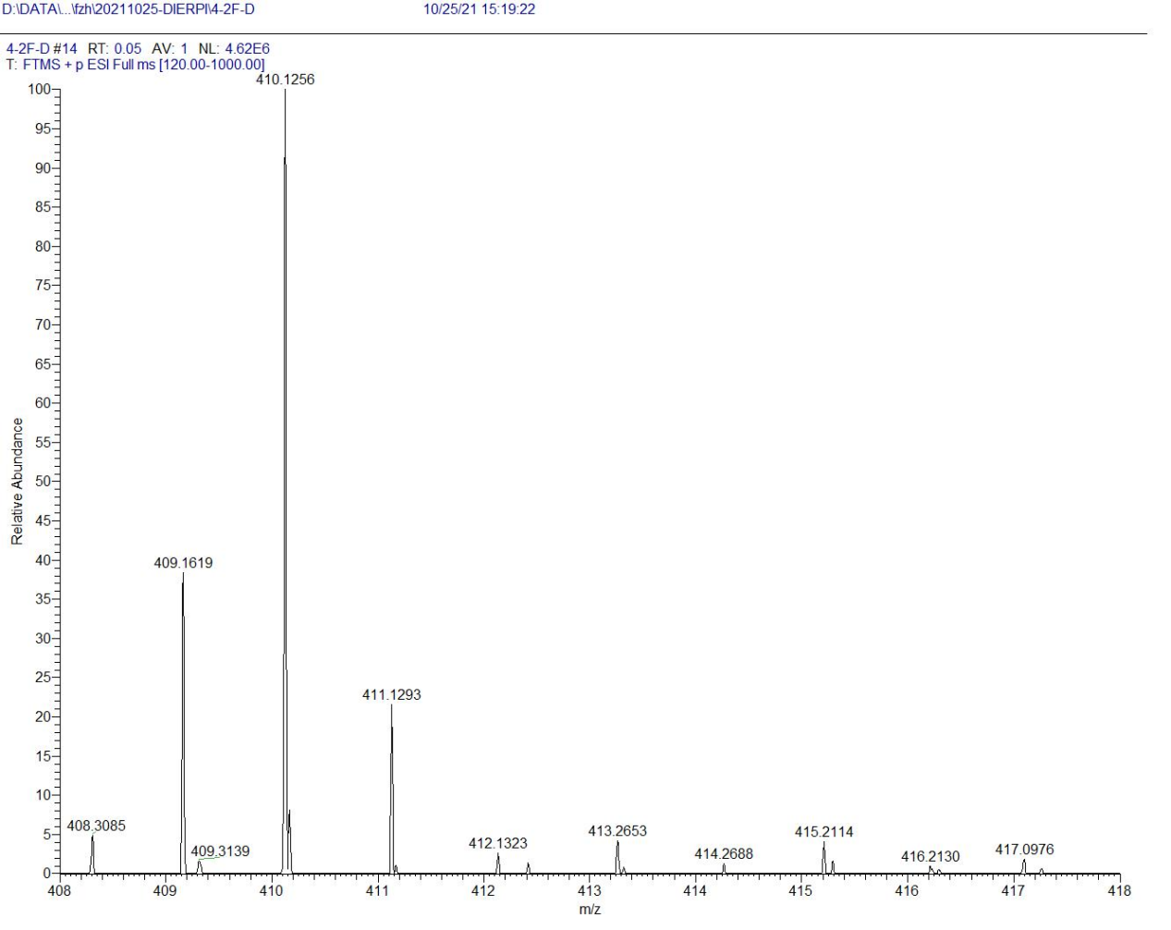
D20

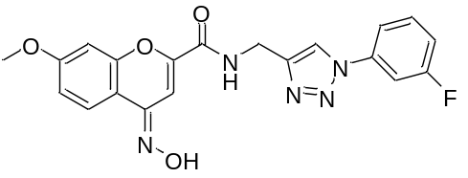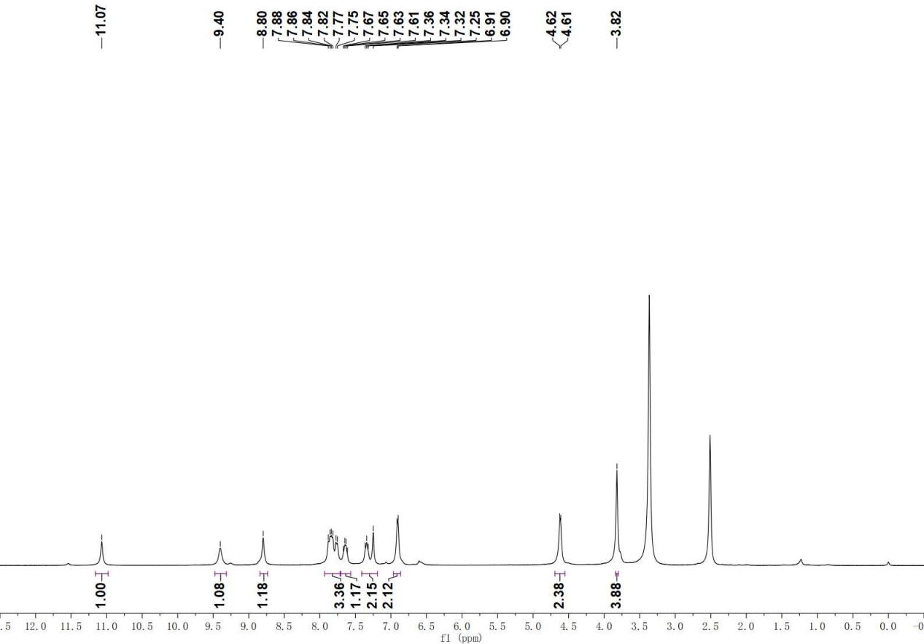

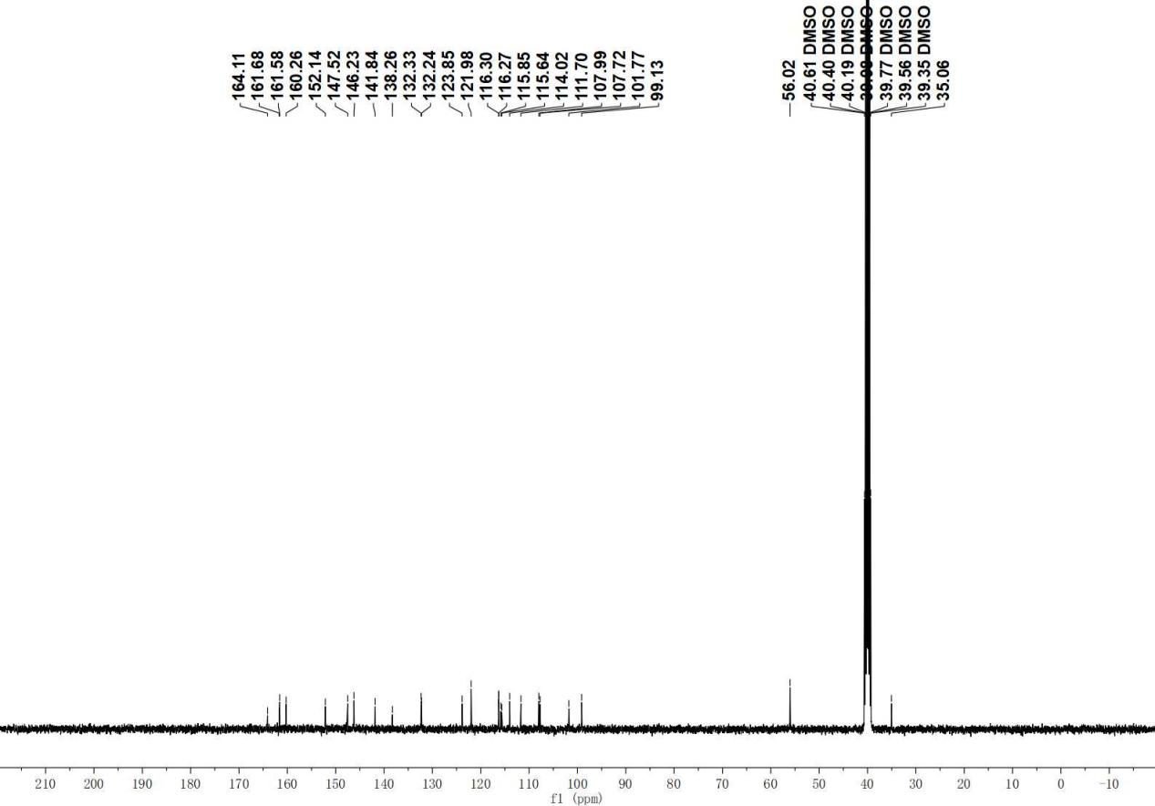

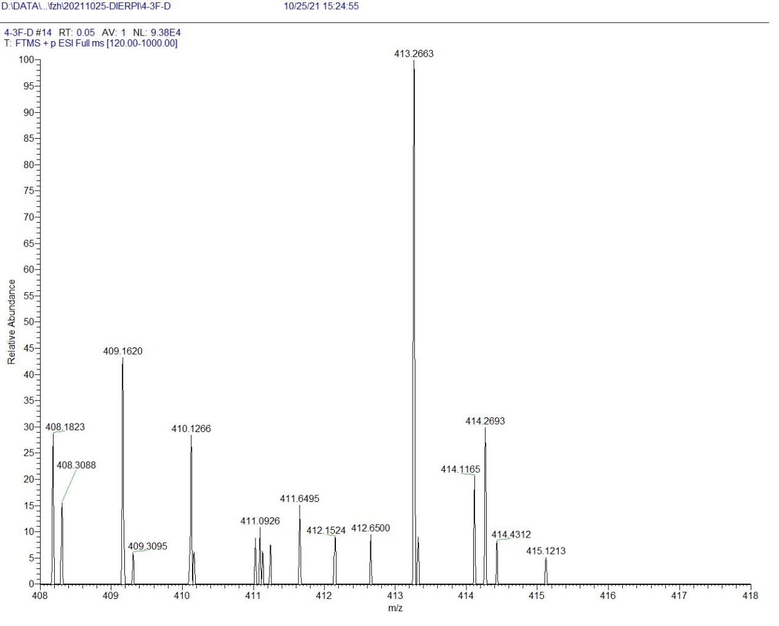

D21

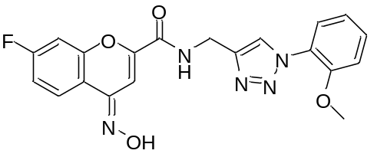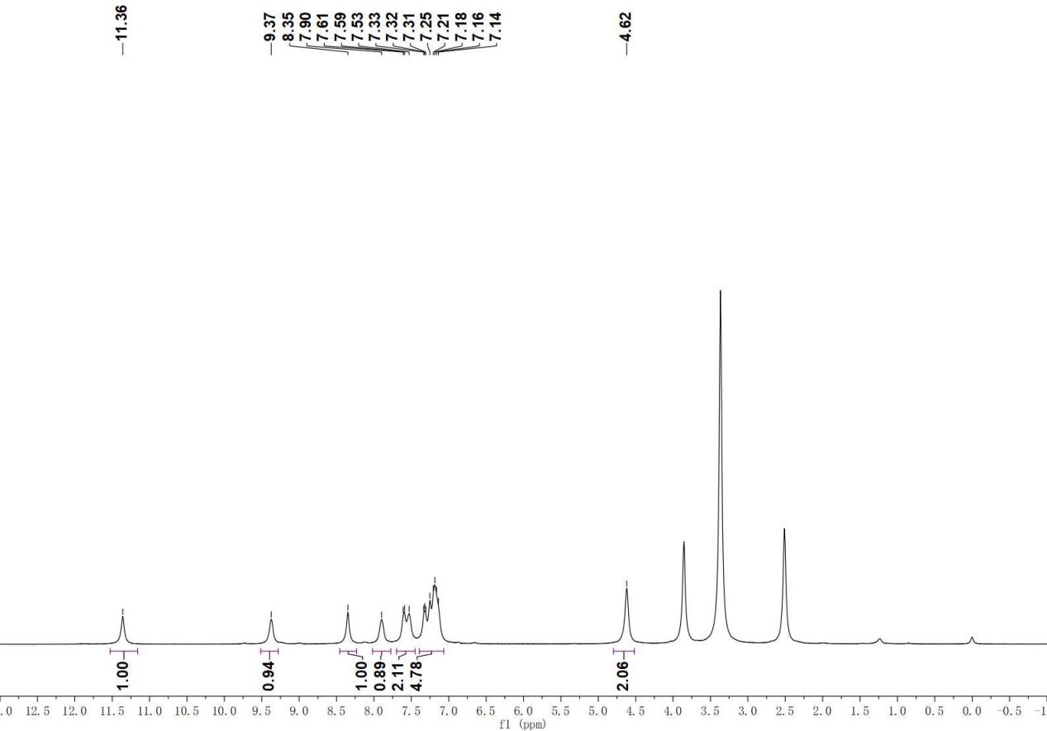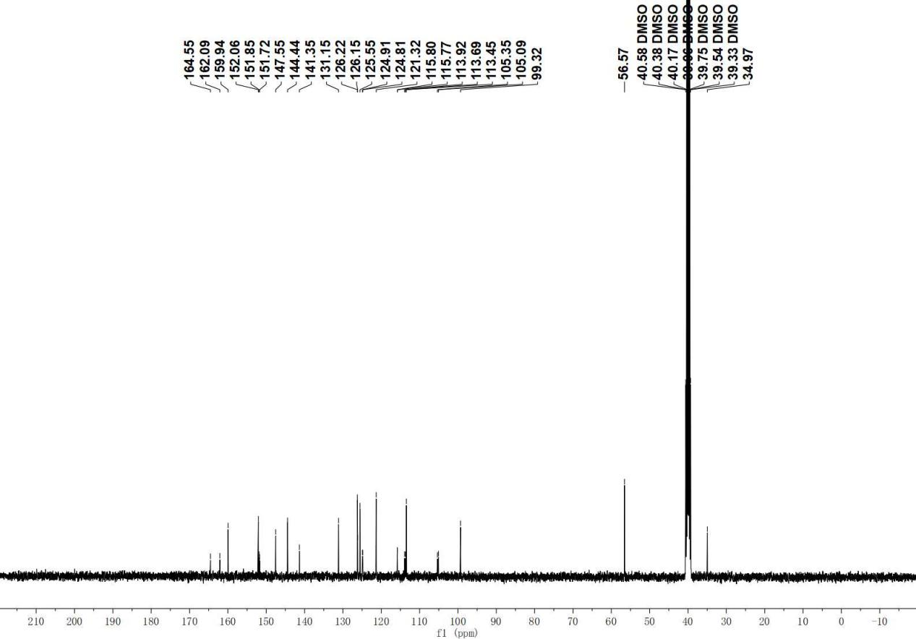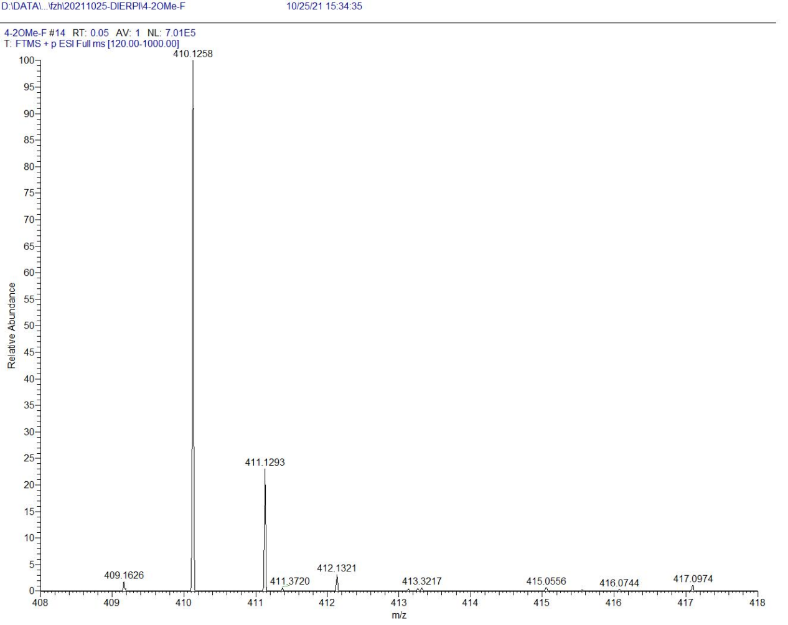
D22

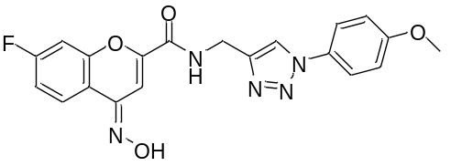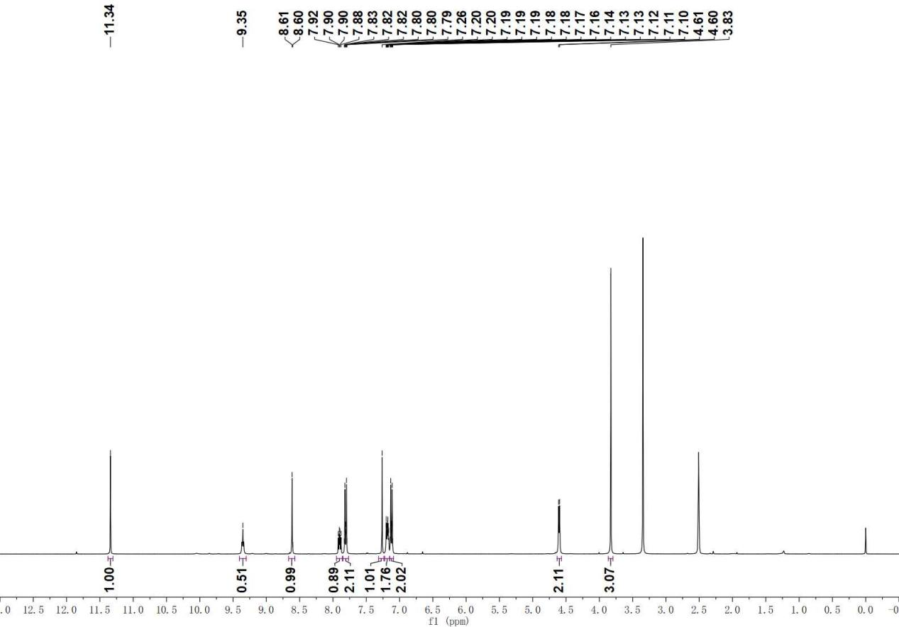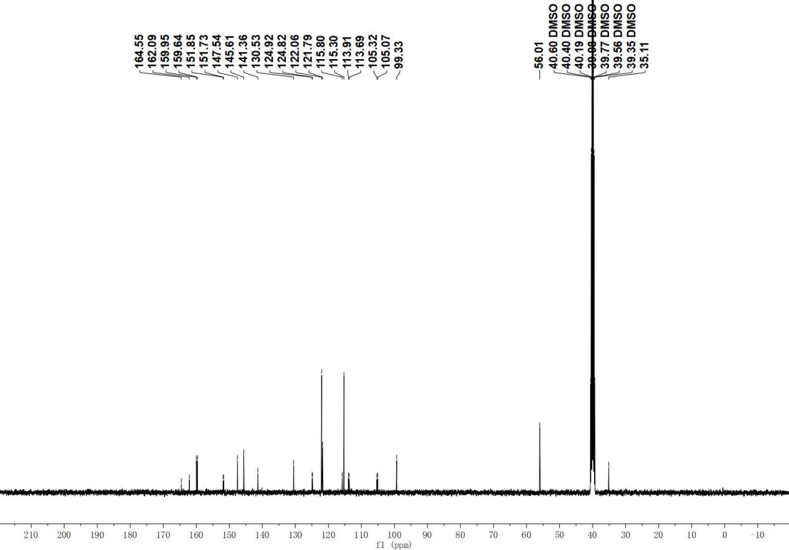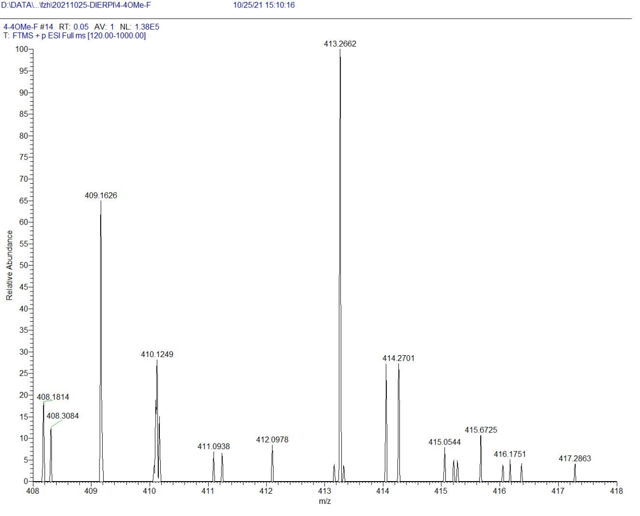

D23

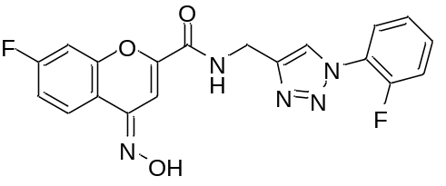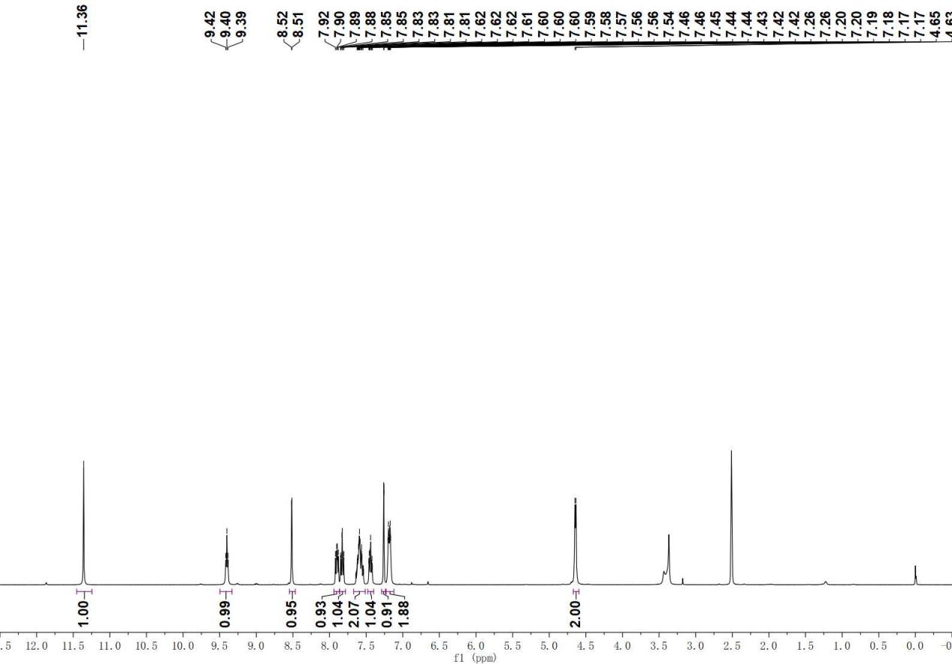

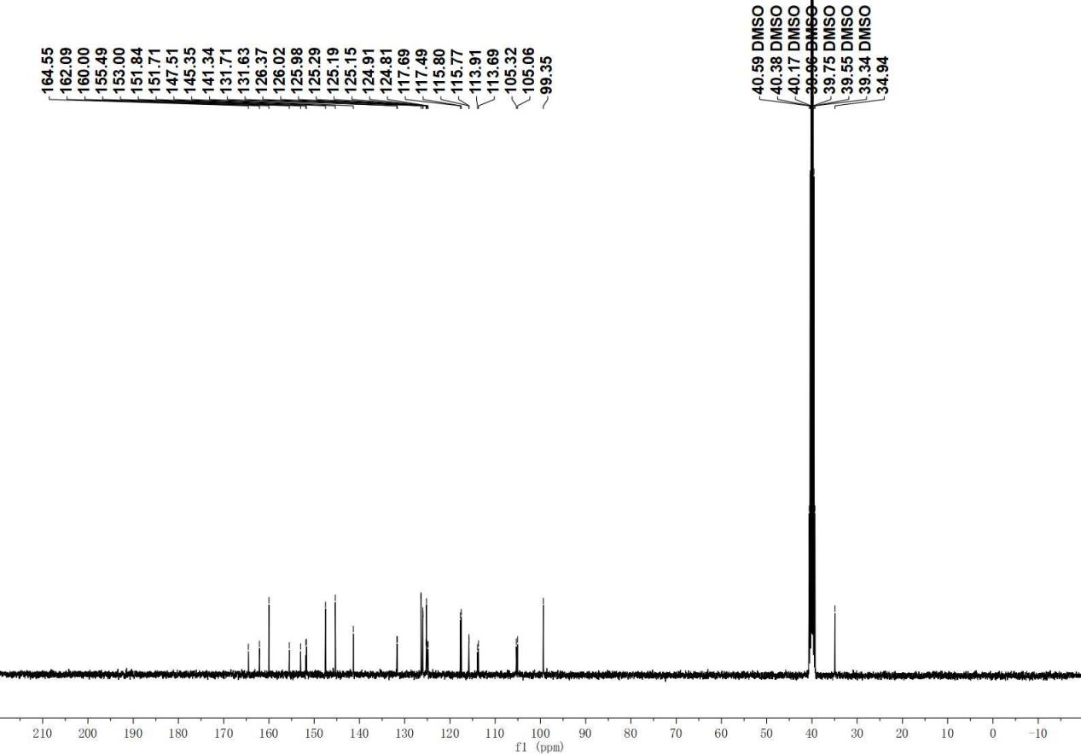

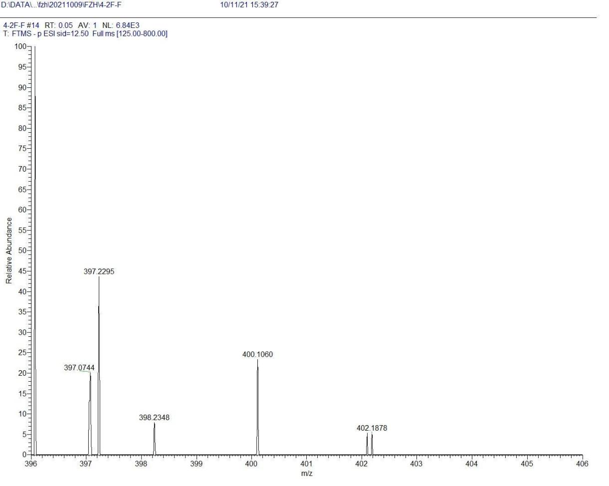
D24

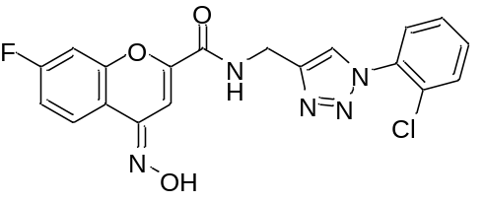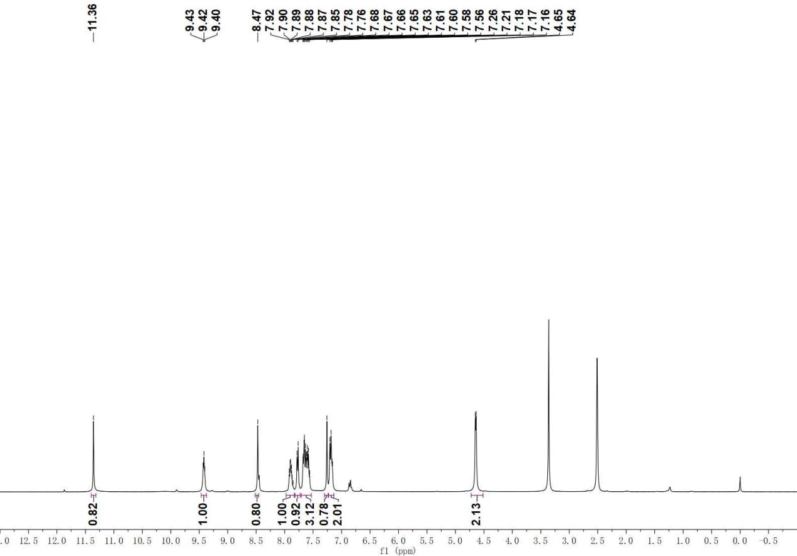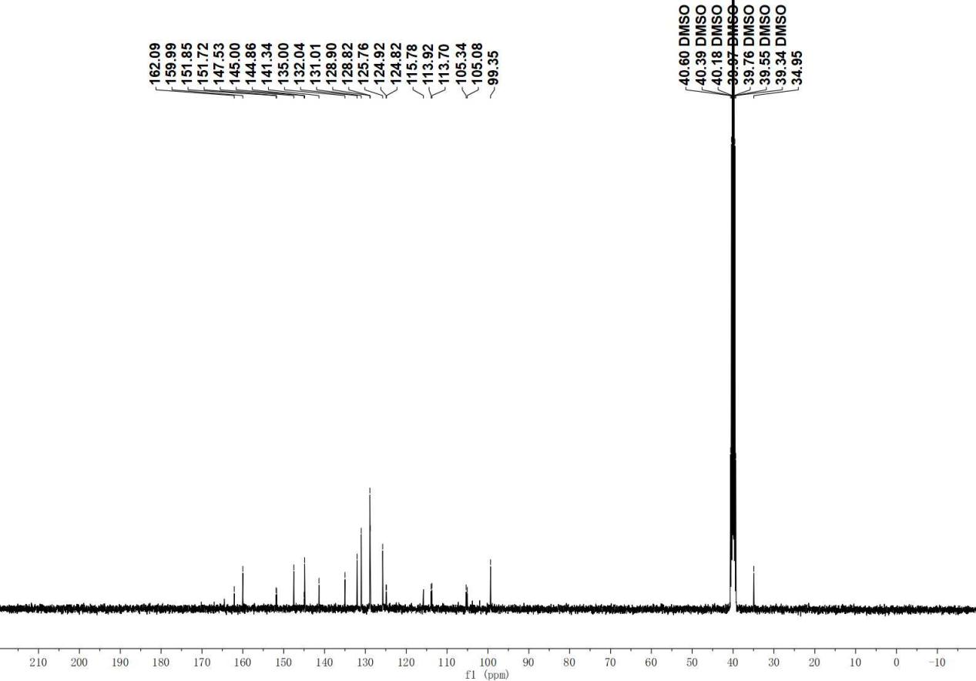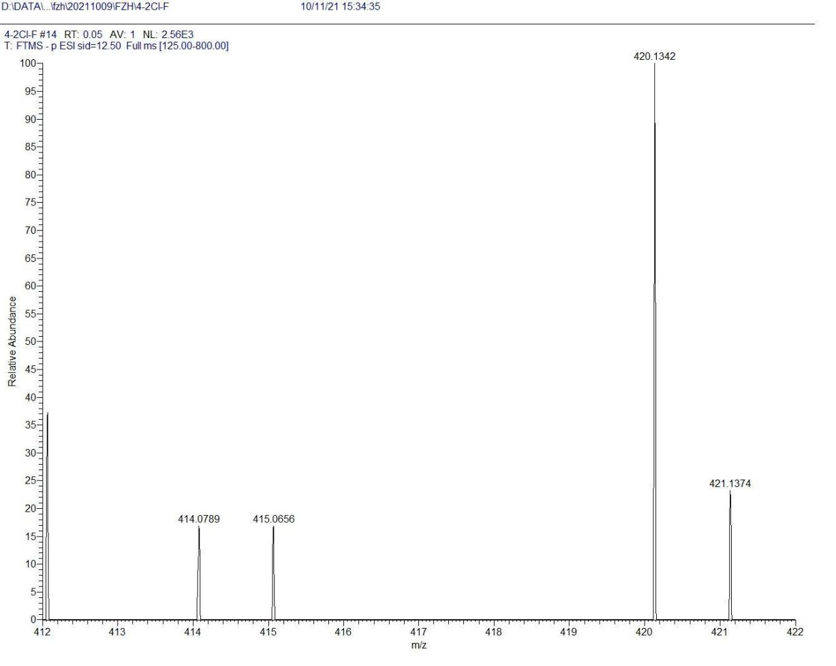

D25

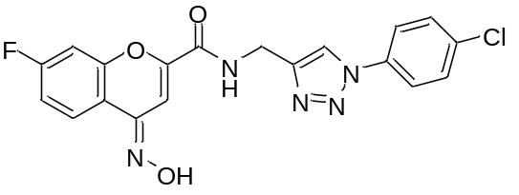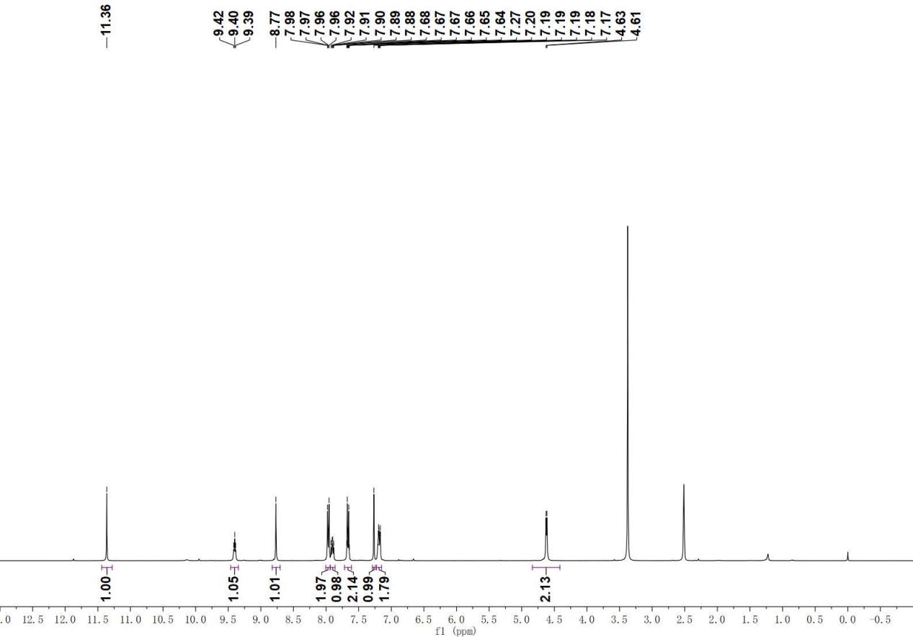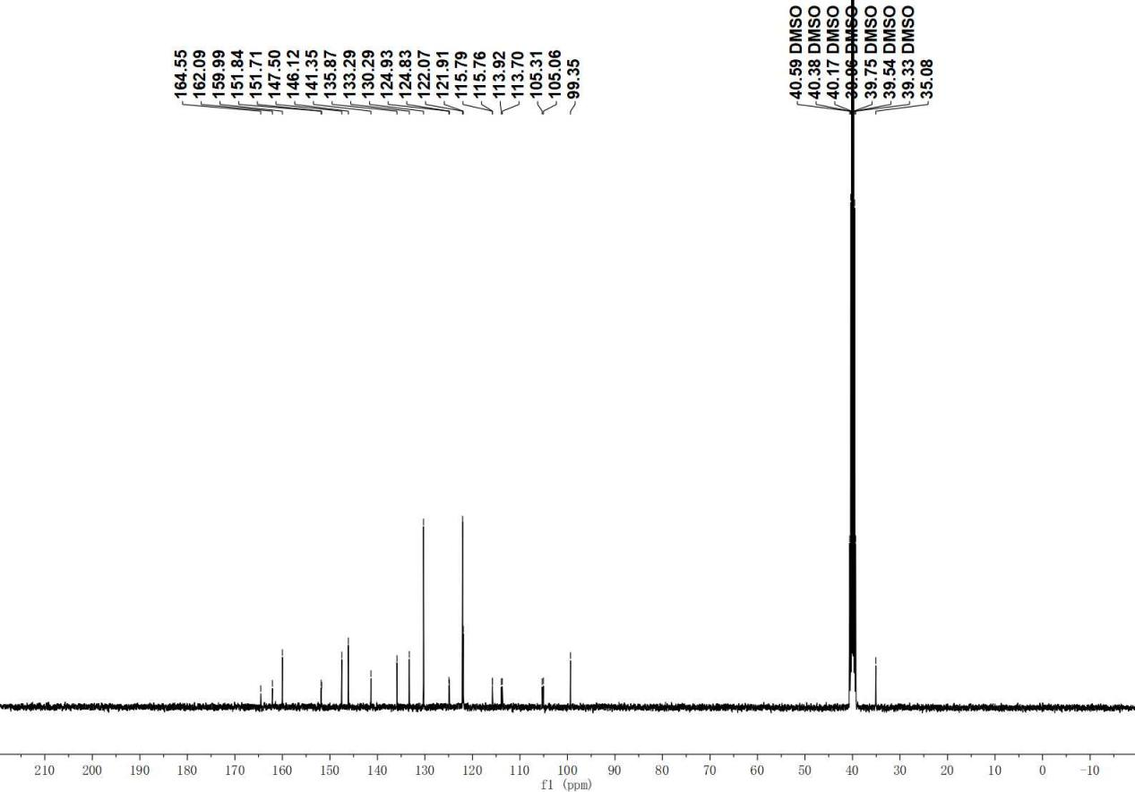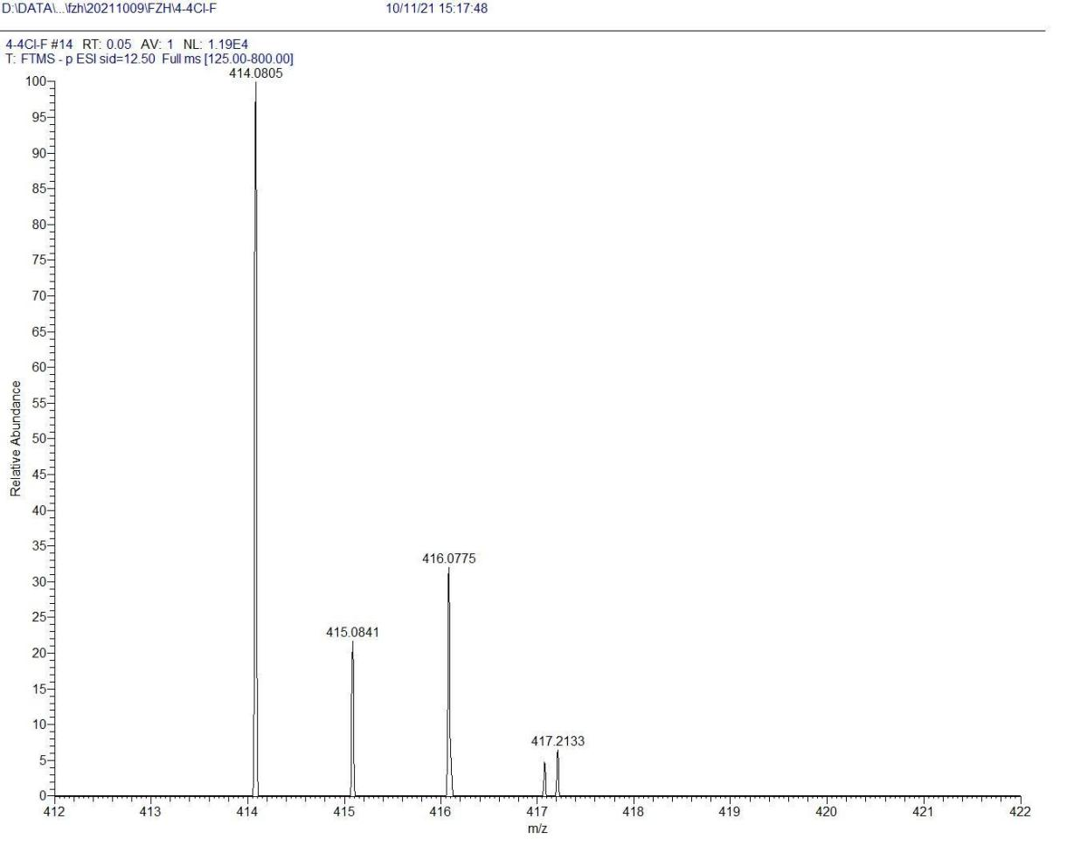
D26

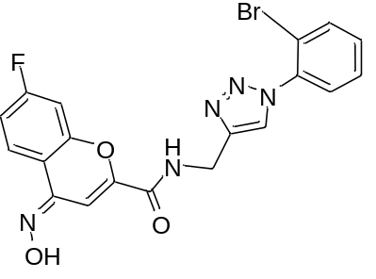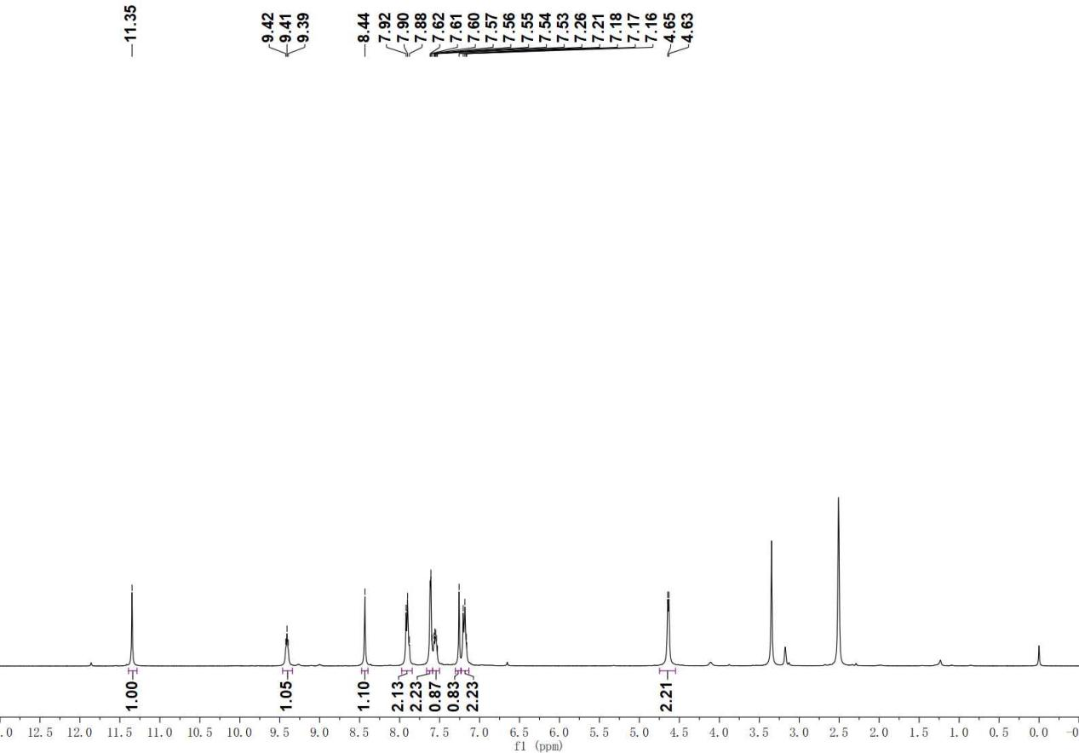

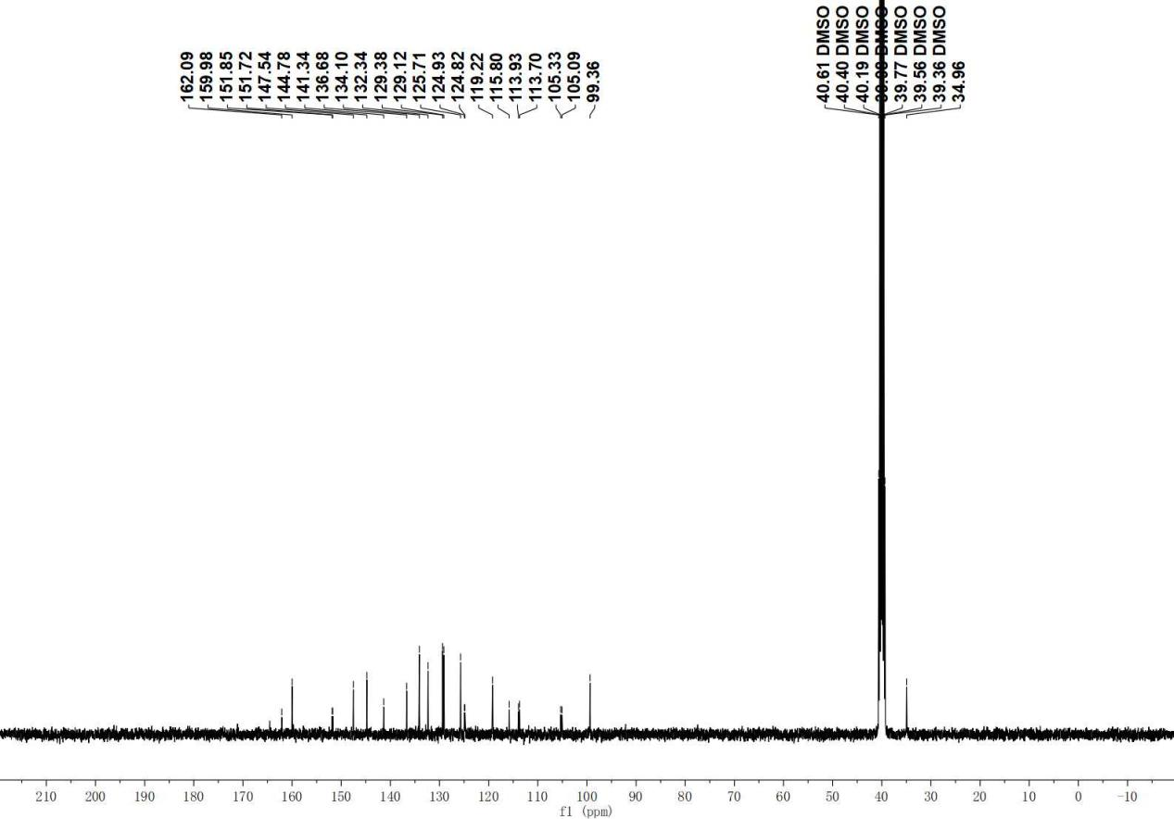

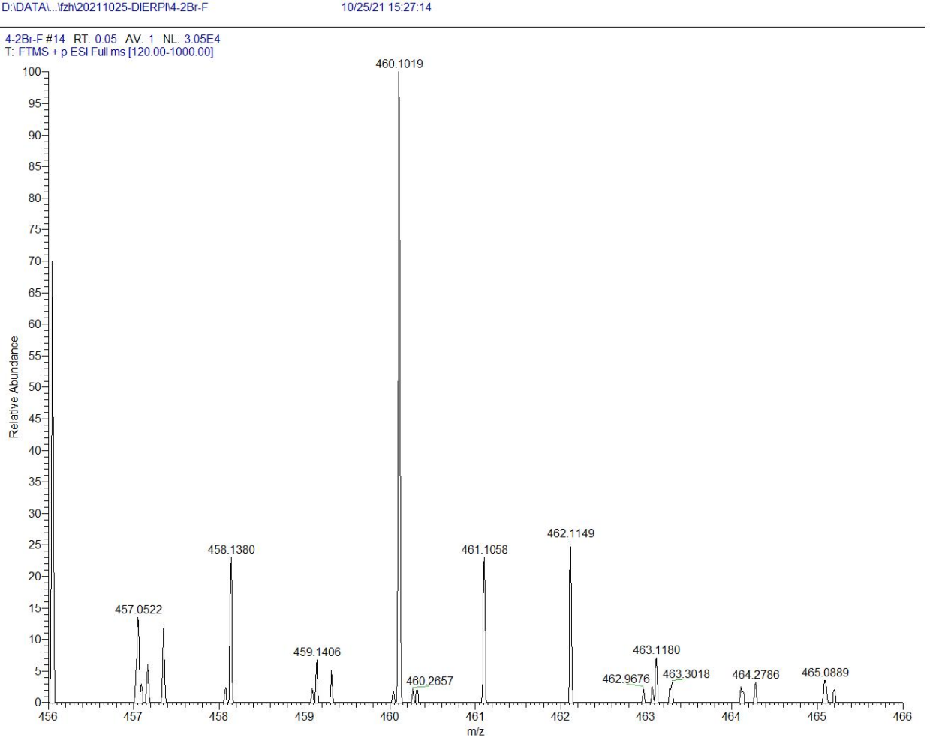

References
[1] R. Huang, X. Jing, X. Huang, Y. Pan, Y. Fang, G. Liang, Z. Liao, H. Wang, Z. Chen, Y. Zhang, Bifunctional naphthoquinone aromatic amide-oxime derivatives exert combined immunotherapeutic and antitumor effects through simultaneous targeting of indoleamine-2,3-dioxygenase and signal transducer and activator of transcription 3, J. Med. Chem. 63 (2020) 1544−1563.
[2] X. Feng, P. Shen, Y. Wang, Z. Li, J. Bian, Synthesis and in vivo antitumor evaluation of an orally active potent phosphonamidate derivative targeting IDO1/IDO2/TDO. Biochem. Pharmacol. 168 (2019) 214–223.
[3] S. Luo, K. Xu, S. Xiang, J. Chen, C. Chen, C. Guo, Y. Tong, L. Tong, High-resolution structures of inhibitor complexes of human indoleamine 2,3-dioxygenase 1 in a new crystal form. Acta Crystallogr. F. 74 (2018) 717−724.

