Figure 1a-g. The LC-MS analysis of a hydroethanolic extract of R. turkestanicum root. (a) The total ion chromatogram in the negative mode. (b) Chromatogram of emodin and corresponding mass adduct, [M-H], at m/z 269.52. (c). Chromatogram of Quercetin and corresponding mass adduct, [M-H], at m/z 301.32. (d). Chromatogram of Revandchinone 1 and corresponding mass adduct, [M-H], at m/z 520.86. (e). Chromatogram of Chrysophanol and corresponding mass adduct, [M-H], at m/z 253.20. (f). Chromatogram of Rhein and corresponding mass adduct, [M-H], at m/z 283.68. (g). Mass spectra of Gallocatechol [M-H], at m/z 305.28.

A
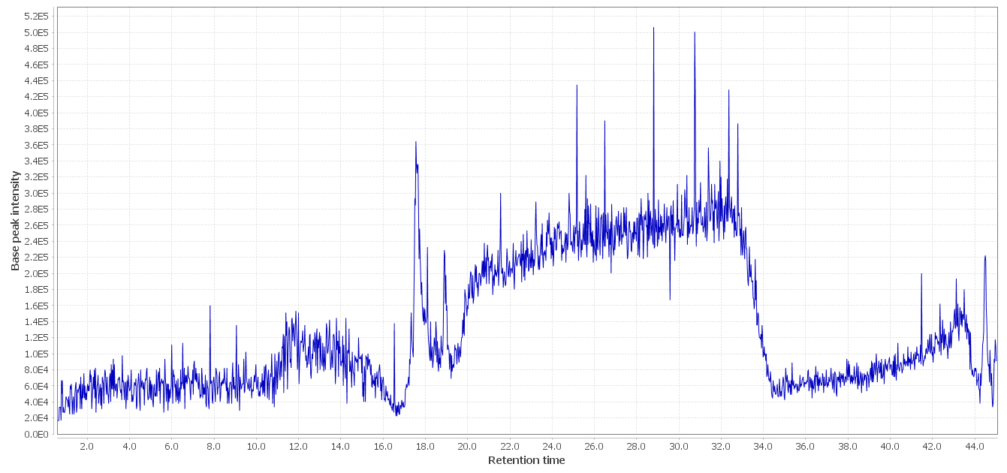
B
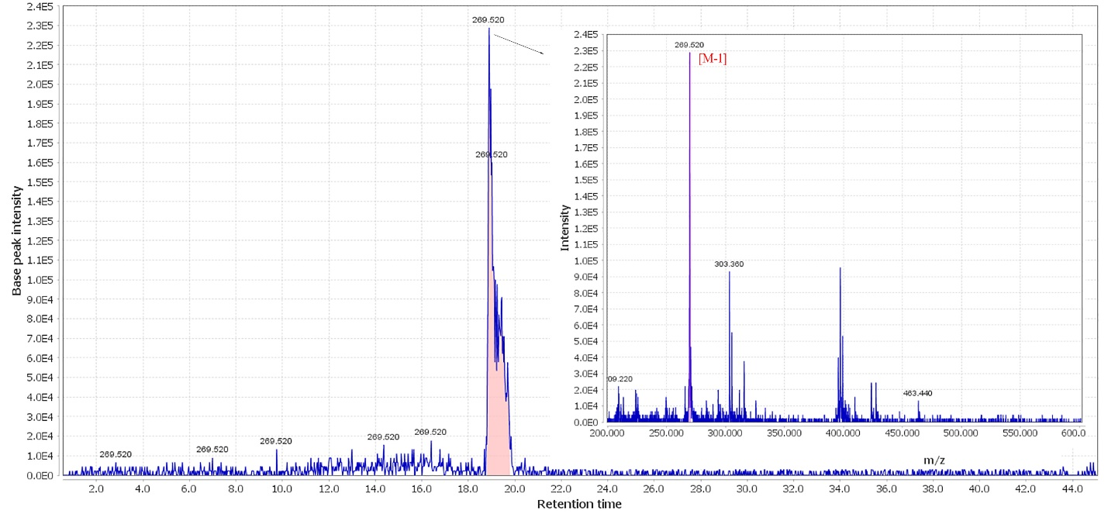
C
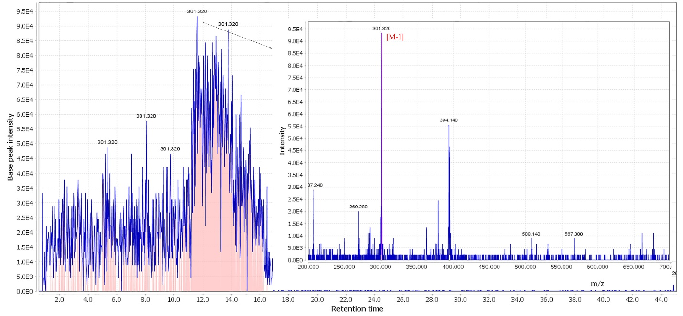
D
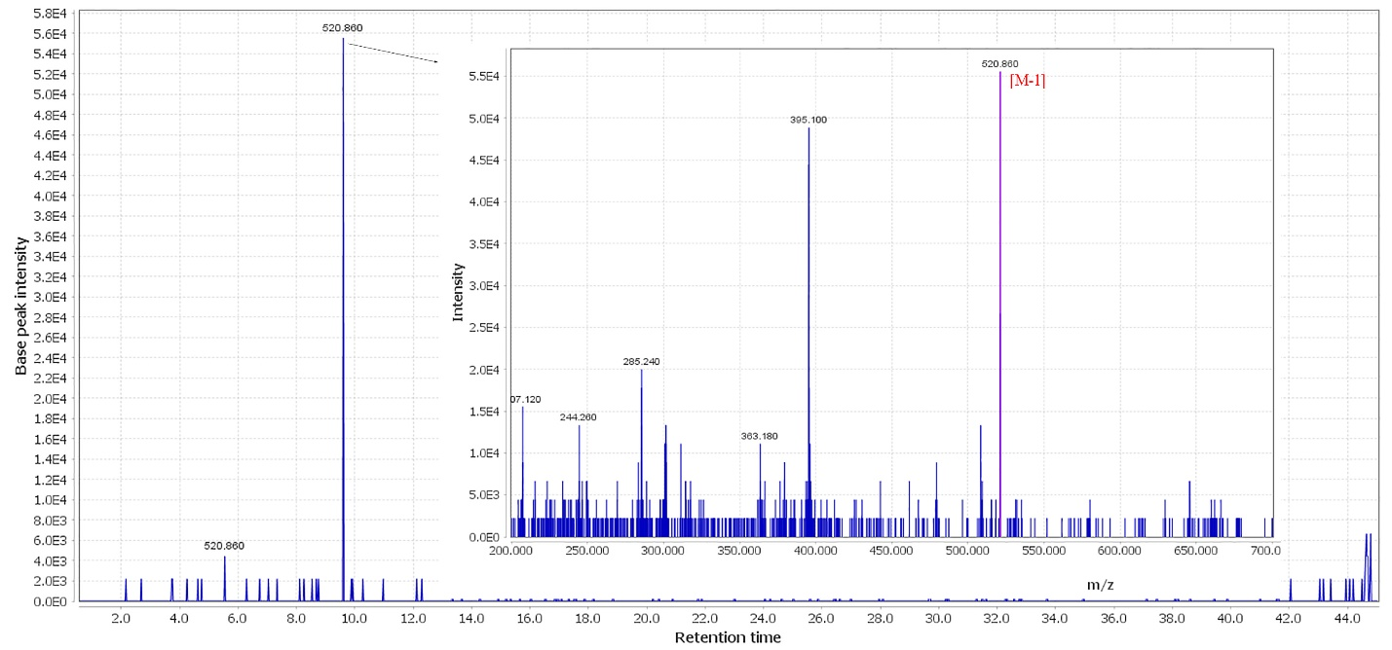
E
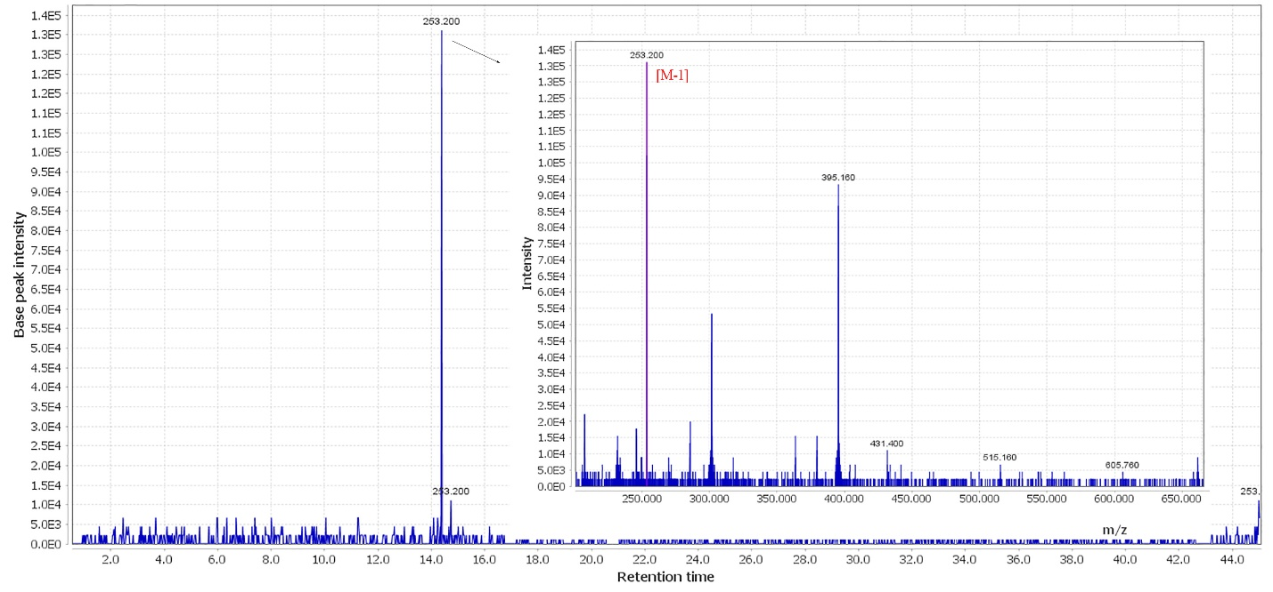
F
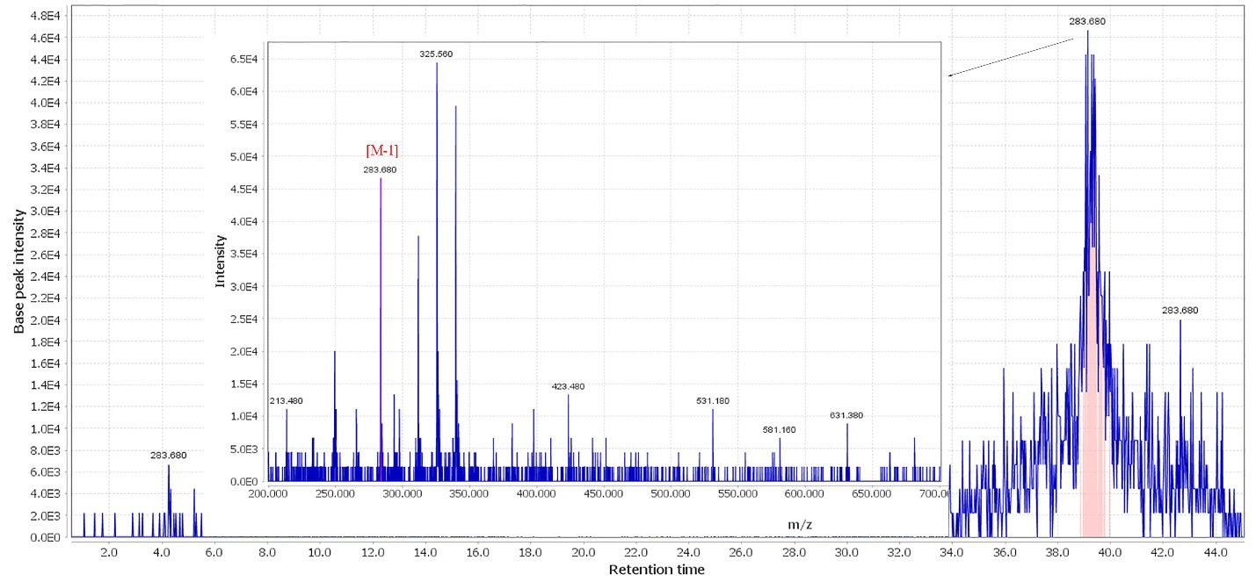
G
