Supplementary Information

Electrochemical Reactivity of PZT Materials in Li-Ion and Na-Ion Batteries
M. Taha Demirkan^{1,*}, Mehbare Dogrusoz^{2,3}
1 Department of Material Science and Engineering, 41400, Kocaeli, Turkey
2 Department of Chemical Engineering, 41400, Kocaeli, Turkey
3 Institute of Nanotechnology, Gebze Technical University, 41400, Kocaeli, Turkey

S1. Voltage Profiles of PbO Anodes
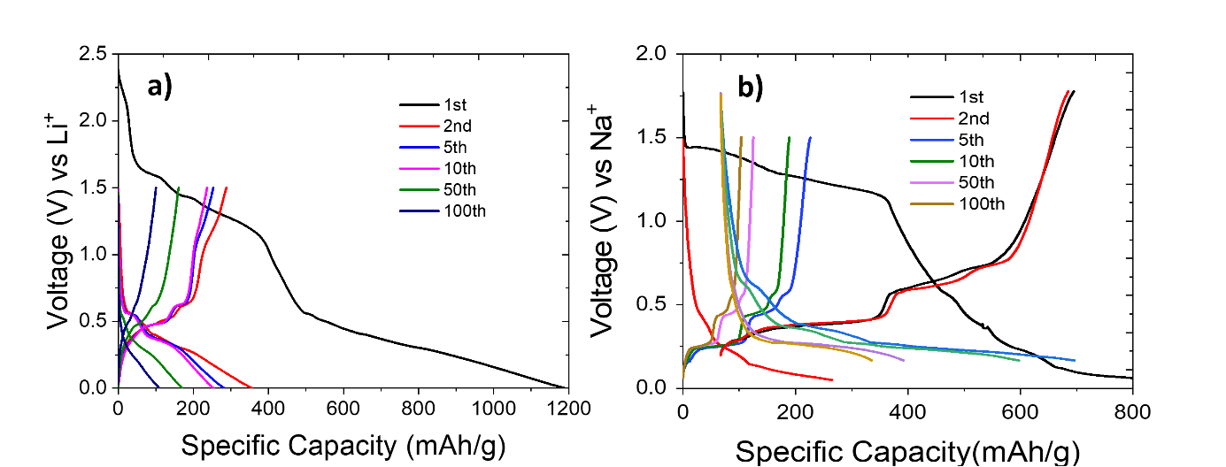
Figure-S1: Voltage profiles of PbO materials as anodes vs. Li (a) and Na (b).

S2. Investigations as Cathode for Lithium-ion Batteries
In order to examine the activity of PZT materials in the Li-ion batteries as cathode materials, similar to anode sections, 80% PZT-5H and 20% carbon-containing materials with an additional 10% of PVdF were prepared. The same parameters and materials in the anode tests were also used in the cathode range (~2.5 V- 3.5 V) for CV and galvanostatic cycles. Although there were small reduction / oxidation indicatives in the 3.0-3.5 V range in the first cycles of the CV test, no peak after 10 cycles designates that the material is not a continuous active material in the cathode operating range (Sup. Fig.-2(a)). Low current density of this graph also suggests inadequacy of the Na insertion reactions.
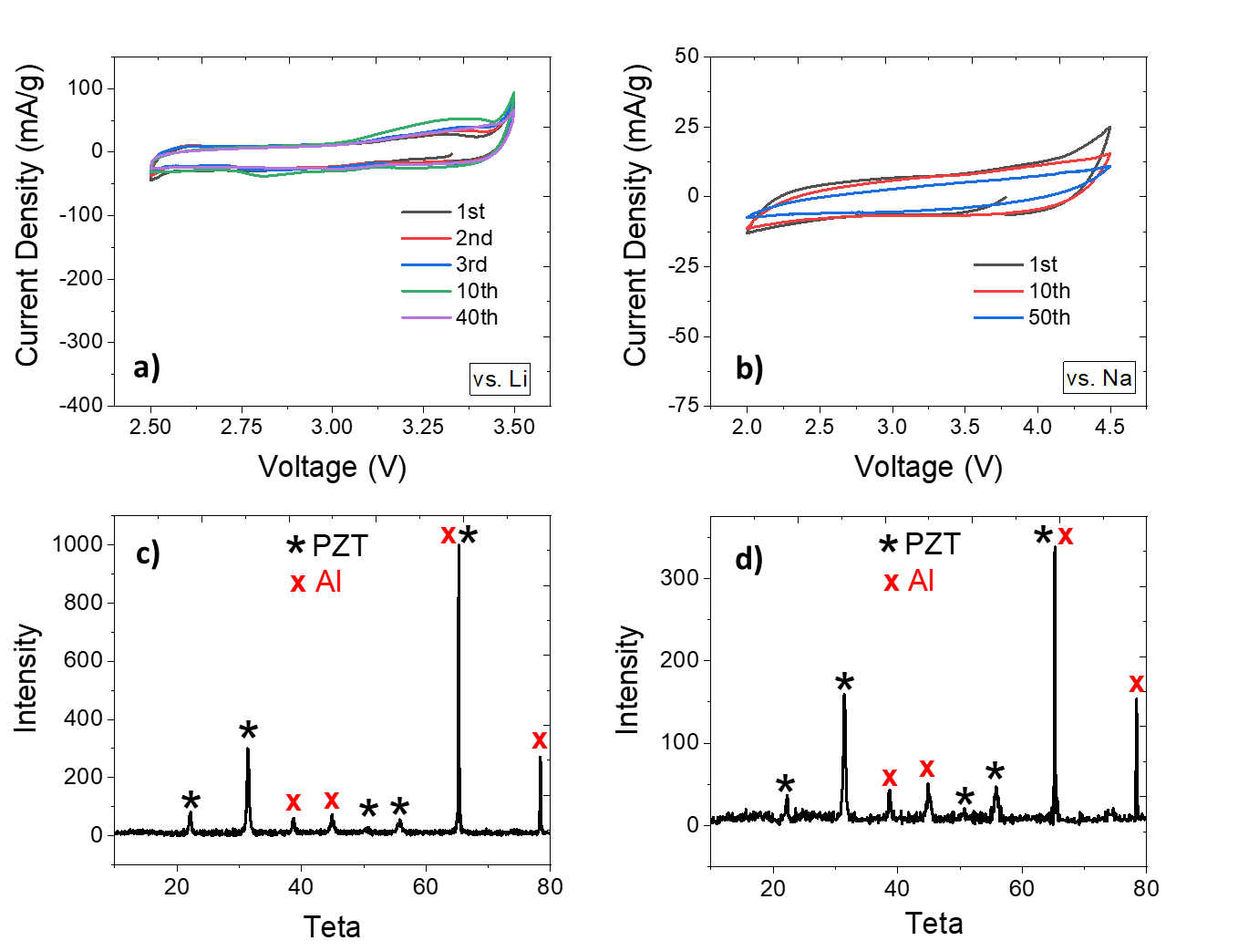
Figure-S2: CV of PZT materials versus Li (a) and Na (b) electrodes in cathode range. XRD of PZT material after one-charge CV of PZT material as an cathode vs. Li (c) and vs. Na (d) electrodes.
A CV cycle test was conducted to observe the structural changes in PZT material when operated in the cathode operating range. The PZT sample on Al foil was tested with a very low sweeping rate of 0.001 V/s up to 4.5 V, and later analyzed using XRD. The XRD plot of sample after one-charge CV clearly shows that there were no significant changes that disrupted the PZT structure as a result of the first cycle (Sup.Fig.-2(c)).
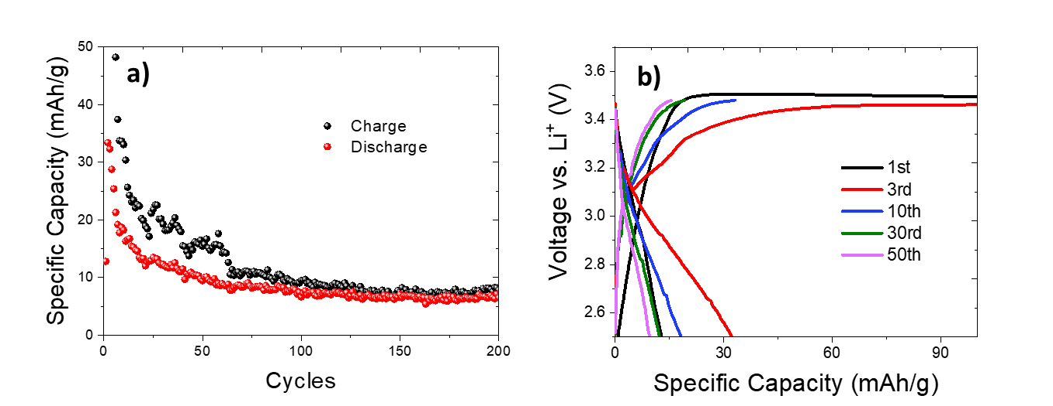
Figure-S3: Results of capacity tests (a) and voltammogram (b) of PZT samples as cathode materials against Li.
Charge / discharge tests were carried out with the same electrolyte and the same parameters, using a constant current of ~10 mA/g in the 2.5-3.48 V range. For Li-ion batteries, voltage profile of PZT material showed a plateau around 3.45 V after the 1st cycle as seen in Sup.Fig.-3(a). Although it gives 100 mAh/g specific capacity values ​​in the first cycles, it is seen that the capacity drops below 10 mAh/g very quickly which can be considered as a total capacity failure. Voltage profile (Sup.Fig.-3 (b)) does not show any characteristics of PbO-Li interaction. It can be said that PZT material does not contribute much to the capacity in the cathode operating range and cannot be accepted as an active cathode material in Li-ion batteries.

S3. Investigations as Cathode for Sodium-ion Batteries
As CV tests in Sup.Fig.-2(b) show no remarkable peaks, where only a very small current is seen. This indicates that there is no appreciable reaction is happening between PZT material and Na ions in the cathode range. The XRD analysis confirms that the crystalline structure of PZT materials is intact, and it does not react actively with Na in the cathode operating range. XRD result of the sample after one-charge CV test, seen in (Sup.Fig.-2(d))., has shown very clear peaks of PZT materials alongside with Al, which confirms the PZT structure is almost completely intact, and it does not react actively with Na ions in the cathode operating range. Therefore, it can be concluded that PZT material cannot be used as an active cathode material also in Na-ion batteries.

