Supplementary file 1:

Table 1: List of contaminating genera identified in this study based on information from previous studies on possible bacterial contaminants.
Genus | Habitat | Genus | Habitat | Genus | Habitat
Acidibacter | Water | Ezakiella | Human | Nocardioides | Soil
Aciditerrimonas | Soil | Flavobacterium | Water | Nosocomiicoccus | Hospital surfaces
Acidovorax | Water/environment | Fusobacterium | Human | Ornithinimicrobium | Green algae
Acinetobacter | Animal/environment | Gemella | Human | Panacagrimonas | Soil
Actinomyces | Human | Geodermatophilus | Soil | Pantoea | Plant
Actinophytocola | Soil | Gp6 | Non-bacterial | Pelomonas | Soil
Actinotalea | Soil | Granulicatella | Human | Peptoniphilus | Human
Actinotignum | Human | Haemophilus | Human | Povalibacter | Plant
Aerococcus | Human | Haliscomenobacter | Environment | Prevotella | Human
Anaerococcus | Human | Herbaspirillum | Plant | Prosthecobacter | Environment
Anaerosphaera | Human | Hydrogenophaga | Soil | Pseudomonas | Human/environment
Aquabacterium | Water | Hydrotalea | Water | Pseudonocardia | Water/environment
Armatimonas | Aquatic | Kocuria | Food | Ralstonia | Soil/environment
Arthrobacter | Soil | Kosakonia | Environment | Ramlibacter | Soil
Azospirillum | Soil | Lactobacillus | Food | Rheinheimera | Soil
Bacillus | Environment/human | Lactococcus | Food | Rhodococcus | Environment
Bergeyella | Human | Lautropia | Human | Rubrivivax | Environment
Blastococcus | Water/environment | Leptotrichia | Human | Rudanella | Environment
Bordetella | Human | Leuconostoc | Plant | Ruminococcus | Human
Brevibacterium | Environment/mammal | Limnobacter | Water | Salmonella | Food
Campylobacter | Food | Lysinibacillus | Soil/environment | Selenomonas | Human
Cellvibrio | Soil | Lysobacter | Soil | Snodgrassella | Insect
Comamonas | Soil/environment | Marmoricola | Soil | Solibacillus | Air
Corynebacterium | Animal | Massilia | Soil/environment | Spirillospora | Environment
Craurococcus | Environment | Meiothermus | water | Staphylococcus | Animal
Cryptosporangium | Plant | Methylobacterium | Water | Stenotrophomonas | Soil/environment
Dechloromonas | Environment | Methyloversatilis | Water | Streptococcus | Human
Dietzia | Plant | Microbacterium | Soil/environment | Tetrasphaera | Water
Domibacillus | Soil | Micrococcus | Human | Turicella | Human
Enhydrobacter | Water | Micromonospora | Environment | Vampirovibrio | Algae
Enterobacter | Human/environment | Mobiluncus | Human | Variovorax | Soil
Escherichia | Human | Mycobacterium | Mammal | Veillonella | Human
Exiguobacterium | Water | Neisseria | Human

Table 2: Published 16S rRNA gene sequences retrieved from GenBank and included in the Anaplasma phylogenetic analysis in this study.
Accession number | Genus/Species | Strain/Isolate | Accession number | Genus/Species | Strain/Isolate
AF414870.1 | Anaplasma ovis | OVI | MF576175.1 | Anaplasma | ST Mymensingh
CP015994.1 | Anaplasma ovis | Haibei | MH762077.1 | Anaplasma capra | AK-Rm-429
CP000030.1 | Anaplasma marginale | St. Maries | U03775.1 | Anaplasma bovis | NA
CP001759.1 | Anaplasma centrale | Israel | KU586025.1 | “Candidatus Anaplasma boleense” | WHANSP-48
OQ909445 | Anaplasma | KNP2 platys-like | MG869522.1 | Anaplasma | Zhengxiaocun
KU686784.1 | Anaplasma centrale | Uganda | MG869519.1 | Anaplasma | Wangmang
MK814419.1 | Anaplasma platys | Apla1 | LC269823.1 | Anaplasma | ZAM dog-181
CP046391.1 | Anaplasma platys | S3 | AY570538.1 | Anaplasma | SA dog-1108
U54806.1 | Anaplasma | Omatjenne | OK560162.1 | Anaplasma bovis-like | 9100t
CP006618.1 | Anaplasma phagocytophilum | Dog2 | NR118489.1 | Anaplasma odocoilei | UMUM76
KF843825.1 | “Candidatus Anaplasma camelii” | Camel 7 | MK814449.1 | Anaplasma | Mymensingh
KF843824.1 | “Candidatus Anaplasma camelii” | Camel 4 | LC558313.1 | Anaplasma | Om5
MK575506.1 | Anaplasma | Mongolia | NR074513.2* | Ehrlichia ruminantium | Welgevonden
* Outgroup
Table 3: Published 16S rRNA gene sequences retrieved from GenBank and included in the Coxiella phylogenetic analysis in this study. Coxiella-like endosymbionts (CLE) are identified according to their tick host.
Accession number | Species | Strain/ Isolate | Accession number | Species | Strain/ Isolate
CP011126.1 | “Candidatus Coxiella mudrowiae” | CRt | KP994833.1 | CLE Rhipicephalus decoloratus | Rhdeco1
CP024961.1 | “Candidatus Coxiella mudrowiae” | CRS-CAT | KP994835.1 | CLE Rhipicephalus evertsi | Rhever1
KU892220.1 | CLE Rhipicephalus sanguineus | NA | KP994839.1 | CLE Rhipicephalus microplus | Rhmicro1
CP000890.1 | Coxiella burnetii | RSA 331 | KP994824.1 | CLE Ixodes hexagonus | Ihexa2
MN263245.1 | Coxiella burnetii | B10 | KP994826.1 | CLE Ixodes ricinus | Iric2
KC170759.1 | CLE Haemaphysalis obesa | TPSD8 | KP994795.1 | CLE Ornithodoros rupestris | Orupes1
KP994843.1 | CLE Rhipicephalus sanguineus | Rhsa1 | KP994816.1 | CLE Haemaphysalis punctata | Haepun5
KP994769.1 | CLE Argas monachus | Amo02 | KP994810.1 | CLE Amblyomma variegatum | Avar2
KP994799.1 | CLE Ornithodoros spheniscus | Osphe1 | EF413063.1 | Coxiella cheraxi | TO-98
KP994812.1 | CLE Dermacentor marginatus | Dmar2 | KP994804.1 | CLE Amblyomma americanum | Aame2
KP994814.1 | CLE Dermacentor silvarum | Dsilv2 | U11021.1* | Rickettsia rickettsii | NA
MZ836861 | CLE Rhipicephalus sanguineus | no3-51
* Outgroup

Table 4: Published 16S rRNA gene sequences retrieved from GenBank and included in the Ehrlichia/Wolbachia phylogenetic analysis in this study.
Accession number | Species | Accession number | Species
AB074459.1 | “Candidatus Ehrlichia shimanensis” | EU833482.1 | Wolbachia radopholus
KY425523.1 | “Candidatus Ehrlichia sp.” | KX155505.1 | “Candidatus Wolbachia massiliensis”
NR074513.2 | Ehrlichia ruminantium | DQ402518.1 | “Candidatus Wolbachia inokumae”
NR044747.1 | Ehrlichia ewingii | DQ402520.1 | “Candidatus Wolbachia brouquii”
NR074500.2 | Ehrlichia chaffeensis | JX669531.1 | Uncultured bacterium
NR025962.1 | Ehrlichia muris | KX155506.1 | Wolbachia pipientis
DQ647318.1 | Ehrlichia sp. HF | MN383047.1 | Wolbachia endosymbiont Aedes aegypti
NR148800.1 | Ehrlichia minasensis
NR118741.1 | Ehrlichia canis | NR 043755.1* | Rickettsia conorii raoultii
MK507008.1 | Ehrlichia canis
JN121380.1 | Uncultured Ehrlichia
* Outgroup
Table 5: Published 16S rRNA gene sequences retrieved from GenBank and included in the Rickettsia phylogenetic analysis in this study.
Accession number | Species | Accession number | Species
DQ015802.1 | Uncultured bacterium | NR 074394.1 | Rickettsia typhi
NR074467 | Rickettsia honei | NR 044656.2 | Rickettsia prowazekii
KC331445.1 | Uncultured bacterium | L36098 | Rickettsia africae
MK616425.1 | Uncultured Rickettsiales | U11021 | Rickettsia rickettsii
MK616428.1 | Uncultured Rickettsiales | NR 036848.1 | Rickettsia sibirica
MG563925.1 | “Candidatus Megaera benefice” | NR 074469.2 | Rickettsia conorii heilongjiangensis
MG827267.1 | Uncultured Rickettsia | D38622 | Orientia tsutsugamushi
AF322442.1 | Rickettsia limoniae | D38626 | Orientia tsutsugamushi
NR 029155.1 | Rickettsia canadensis | GU937608 | Occidentia massiliensis
NR 074484.2 | Rickettsia bellii | NR149220 | Occidentia massiliensis
NR 074459.2 | Rickettsia japonica
NR 036773.1 | Rickettsia australis | NR 074500.2* | Ehrlichia chaffeensis
* Outgroup
Table 6: Published 16S rDNA gene sequences retrieved from GenBank and included in the Borrelia phylogenetic analysis in this study.
Accession number | Species | Accession number | Species
Borrelia |  | NR 136451.1 | Spirochaeta lutea
AB007450.1 | Borrelia garinii | NR 117123.1 | Spirochaeta thermophila
AJ224130.1 | Borrelia burgdorferi | NR 044756.2 | Spirochaeta halophila
EF570070.1 | Borrelia sp | NR 043329.1 | Spirochaeta dissipatitropha
MZ564265.1 | Uncultured Borrelia sp | AY599019.1 | Spirochaeta aurantia
AB113315.1 | Borrelia duttonii | Trepnonema
CP025785.1 | “Candidatus Borreliella tachyglossi” | NR 181480.1 | Treponema peruense
JF681792.1 | Borrelia microti | NR 180741.1 | Treponema phagedenis
AF210137.1 | Borrelia parkeri | NR 118740.1 | Treponema pectinovorum
AY166715.1 | Borrelia lonestari | Cristispira
Spirochaeta |  | U42638.1 | Cristispira
NR 044505.1 | Spirochaeta cellobiosiphila
NR 134185.1 | Spirochaeta psychrophila | NR043259.1* | Leptospira borgpetersenii
NR 117137.1 | Spirochaeta isovalerica
* Outgroup

Table 7: Summary of all samples from 2016, 2017, and 2019, providing information on raw sequence read counts, post-quality control read counts, and final read counts. Final read counts were calculated after chimeras, possible contaminants, and uncharacterized sequences were removed.
Sample ID | Tissue Type | Raw read count | Post-quality control read count | Final read count
Year: 2016
Y1M3 | Midgut | 2002 | 1055 | 1055
Y1M4 | Midgut | 3338 | 1804 | 1801
Y1M6 | Midgut | 1709 | 1002 | 1002
Y1M7 | Midgut | 1304 | 590 | 590
Y1M8 | Midgut | 1291 | 643 | 643
Y1M9 | Midgut | 3386 | 1618 | 1616
Y1M10 | Midgut | 4758 | 2371 | 2369
Y1S1 | Salivary gland | 6593 | 1842 | 1381
Y1S2 | Salivary gland | 1820 | 913 | 910
Y1S3 | Salivary gland | 864 | 428 | 428*
Y1S5 | Salivary gland | 1502 | 438 | 423*
Y1S7 | Salivary gland | 1972 | 905 | 905
Y1S8 | Salivary gland | 1611 | 750 | 750
Y1S9 | Salivary gland | 1990 | 1005 | 1000
Y1S10 | Salivary gland | 4101 | 1663 | 1659
Total read counts |  | 38241 | 17027 | 16532
Year: 2017
Y2M1 | Midgut | 2699 | 1418 | 1295
Y2M2 | Midgut | 997 | 605 | 599
Y2M8 | Midgut | 1035 | 587 | 587
Y2M9 | Midgut | 2741 | 1428 | 1422
Y2S1 | Salivary gland | 1132 | 607 | 607
Y2S2 | Salivary gland | 1075 | 627 | 625
Y2S3 | Salivary gland | 1639 | 923 | 558
Y2S4 | Salivary gland | 1354 | 746 | 743
Y2S8 | Salivary gland | 1731 | 987 | 987
Y2S10 | Salivary gland | 1239 | 628 | 601
Total read counts |  | 15642 | 8556 | 8024
Year: 2019
Y3M1 | Midgut | 9317 | 7509 | 4918
Y3M3 | Midgut | 7882 | 6389 | 1374
Y3M5 | Midgut | 6041 | 4823 | 1539
Y3M6 | Midgut | 8544 | 7085 | 4400
Y3M12 | Midgut | 200 | 153 | 70*
Y3M15 | Midgut | 6432 | 2911 | 273*
Y3S3 | Salivary gland | 2241 | 1646 | 268*
Y3S5 | Salivary gland | 2055 | 1543 | 715
Y3S6 | Salivary gland | 2032 | 1504 | 1055
Y3S10 | Salivary gland | 8083 | 6061 | 2225
Y3S12 | Salivary gland | 9580 | 7763 | 1224
Y3S15 | Salivary gland | 18288 | 7196 | 1155
Total read counts |  | 80695 | 54583 | 18605
*Low read count samples were removed from further analysis

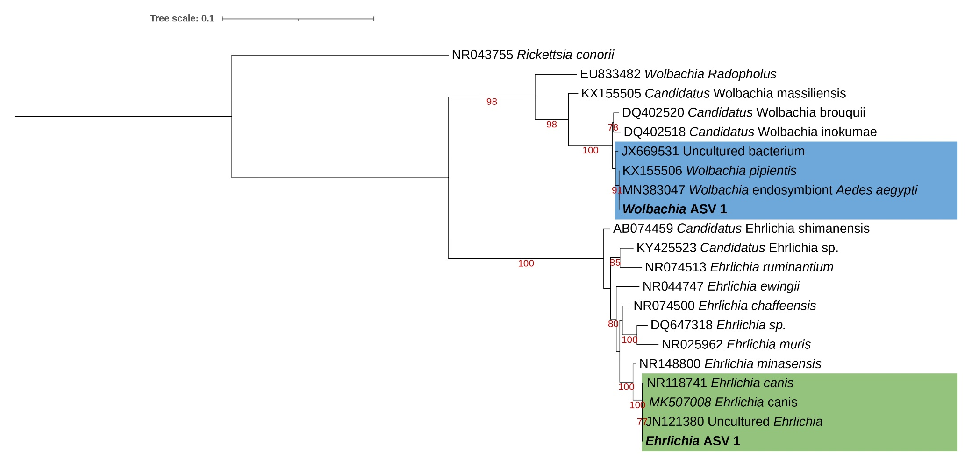
Figure 1: Maximum likelihood analysis indicating the relationships of Ehrlichia amplicon sequence variants detected in this study with known Ehrlichia and Wolbachia sequences from GenBank. A maximum likelihood inference was conducted using the TIM3+F+I+G4 model and 1000 bootstrap replicates (alignment length 1251 bp). Maximum likelihood bootstrap values (>75) are indicated below the branch. Ehrlichia amplicon sequence variants are indicated in bold. Ehrlichia sequences are indicated in a green box, while Wolbachia sequences are indicated in a blue box.
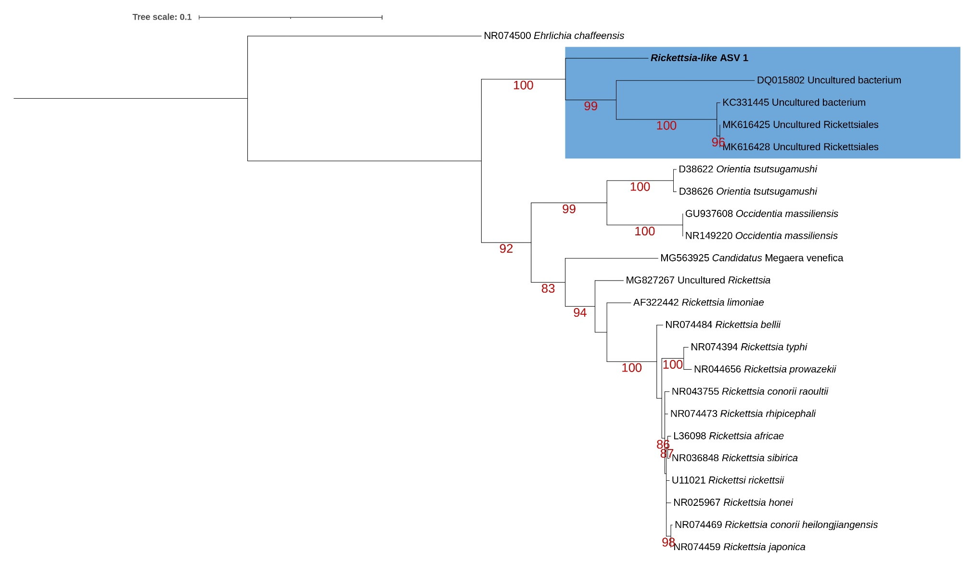
Figure 2: Maximum likelihood analysis indicating the relationship of a Rickettsia-like amplicon sequence variant detected in this study with known Rickettsia sequences from GenBank. A maximum likelihood inference was conducted using the GTR+F+I+G4 model and 1000 bootstrap replicates (alignment length 1251 bp). Maximum likelihood bootstrap values (>75) are indicated below the branch. The Rickettsia-like amplicon sequence variant is indicated in bold. Uncultured Rickettsiales sequences are indicated in a blue box.
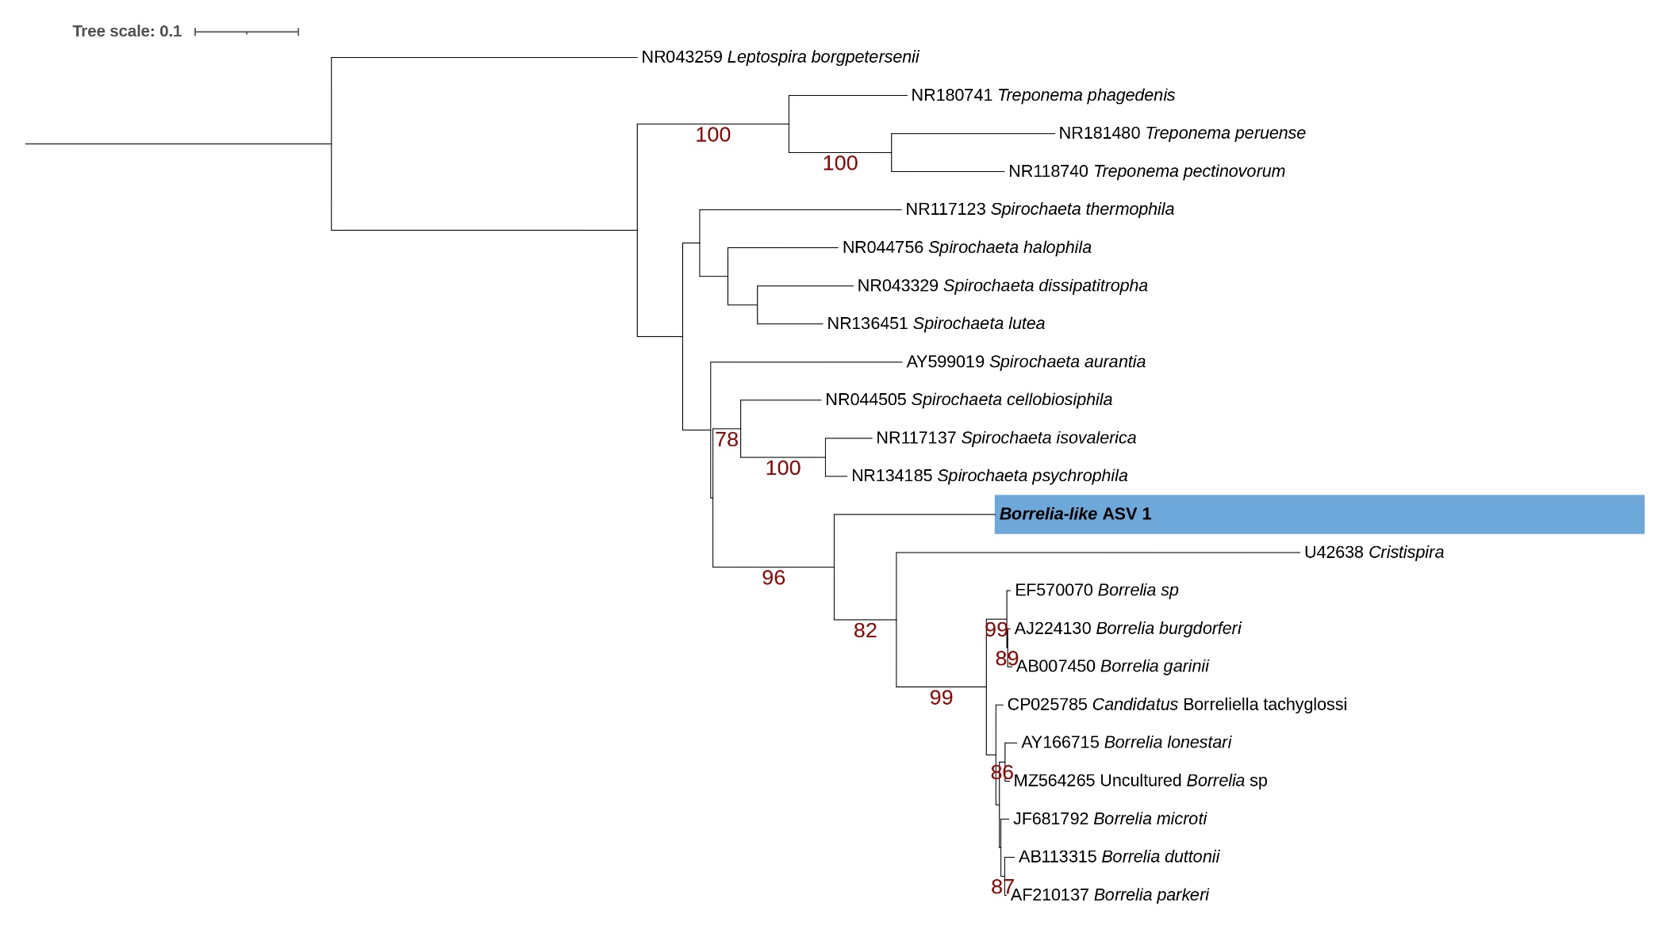
Figure 3: Maximum likelihood analysis indicating the relationship of a Borrelia-like amplicon sequence variant detected in this study with known sequences from taxa within the Borreliaceae family. A maximum likelihood inference was conducted using the TIM3+F+I+G4 model and 1000 bootstrap replicates (alignment length 1297 bp). Maximum likelihood bootstrap values are indicated below the branch. The Borrelia-like amplicon sequence variant is indicated in bold and highlighted in a blue box.

