Supplementary Table 1. Seroprevalence according to sociodemographic characteristics
 | First survey |  |  | Second survey |  |  | Third survey |  |  | Fourth survey
 | Positive tests | estimate [95% CI] | P-values | Positive tests | estimate [95% CI] | P-values | Positive tests | estimate [95% CI] | P-values | Positive tests | estimate [95% CI] | P-values
Location
Rural | 299 /1550 | 19.3% (17.4 - 21.3) | <0.001 | 340 /1340 | 25.4% (23.1 - 27.8) | <0.001 | 461 /1176 | 39.2% (36.4 - 42.0) | <0.001 | 861 /1121 | 76.8% (74.2 - 79.2) | 0.006
Urban | 624 /2429 | 25.7% (24.0 - 27.5) | <0.001 | 529 /1660 | 31.9% (29.7 - 34.2) | <0.001 | 851 /1499 | 56.8% (54.2 - 59.3) | <0.001 | 908 /1114 | 81.5% (79.1 - 83.7) | 0.006
Gender
Male | 375 /1629 | 23.0% (21.0 - 25.1) | 0.826 | 349 /1158 | 30.1% (27.6 - 32.8) | 0.262 | 518 /1048 | 49.4% (46.4 - 52.5) | 0.752 | 686 /876 | 78.3% (75.5 - 80.9) | 0.433
Female | 548 /2350 | 23.3% (21.7 - 25.1) | 0.826 | 520 /1842 | 28.2% (26.2 - 30.3) | 0.262 | 794 /1627 | 48.8% (46.4 - 51.2) | 0.752 | 1083 /1359 | 79.7% (77.5 - 81.7) | 0.433
Age (Years)
0–4 | 27 /224 | 12.1% (8.4 - 17.0) | <0.001 | 24 /136 | 17.6% (12.1 - 25.0) | 0.003 | 42 /131 | 32.1% (24.6 - 40.5) | <0.001 | 49 /104 | 47.1% (37.7 - 56.7) | 0.000
5-9 | 59 /401 | 14.7% (11.6 - 18.5) | <0.001 | 54 /283 | 19.1% (14.9 - 24.1) | <0.001 | 94 /273 | 34.4% (29.0 - 40.3) | <0.001 | 143 /214 | 66.8% (60.2 - 72.8) | 0.000
10-19 | 218 /932 | 23.4% (20.8 - 26.2) | 0.873 | 217 /729 | 29.8% (26.6 - 33.2) | 0.584 | 320 /657 | 48.7% (44.9 - 52.5) | 0.841 | 431 /558 | 77.2% (73.6 - 80.5) | 0.200
20-29 | 174 /739 | 23.5% (20.6 - 26.7) | 0.804 | 169 /562 | 30.1% (26.4 - 34.0) | 0.522 | 233 /463 | 50.3% (45.8 - 54.9) | 0.546 | 322 /395 | 81.5% (77.4 - 85.0) | 0.202
30-39 | 171 /619 | 27.6% (24.2 - 31.3) | 0.005 | 148 /472 | 31.4% (27.3 - 35.7) | 0.213 | 237 /437 | 54.2% (49.5 - 58.9) | 0.018 | 318 /371 | 85.7% (81.8 - 88.9) | 0.001
40-49 | 135 /481 | 28.1% (24.2 - 32.3) | 0.007 | 140 /384 | 36.5% (31.8 - 41.4) | 0.001 | 188 /334 | 56.3% (50.9 - 61.5) | 0.005 | 242 /275 | 88.0% (83.6 - 91.3) | 0.000
50-59 | 73 /298 | 24.5% (19.9 - 29.7) | 0.581 | 58 /224 | 25.9% (20.6 - 32.0) | 0.292 | 96 /184 | 52.2% (45.0 - 59.3) | 0.380 | 149 /170 | 87.6% (81.8 - 91.8) | 0.005
60-69 | 45 /179 | 25.1% (19.3 - 32.0) | 0.529 | 40 /132 | 30.3% (23.1 - 38.7) | 0.729 | 67 /126 | 53.2% (44.4 - 61.7) | 0.343 | 77 /102 | 75.5% (66.2 - 82.9) | 0.353
70-79 | 17 /84 | 20.2% (13.0 - 30.2) | 0.517 | 16 /64 | 25.0% (15.9 - 37.0) | 0.480 | 31 /58 | 53.4% (40.7 - 65.8) | 0.498 | 32 /39 | 82.1% (66.9 - 91.2) | 0.653
80 and above | 4 /22 | 18.2% (7.0 - 39.6) | 0.578 | 3 /14 | 21.4% (7.1 - 49.4) | 0.536 | 4 /12 | 33.3% (13.1 - 62.4) | 0.284 | 6 /7 | 85.7% (41.9 - 98.0) | 0.672
District
Matiari | 299 /1550 | 19.3% (17.4 - 21.3) | <0.001 | 340 /1340 | 25.4% (23.1 - 27.8) | <0.001 | 461 /1176 | 39.2% (36.4 - 42.0) | <0.001 | 861 /1121 | 76.8% (74.2 - 79.2) | 0.006
Karachi Central | 113 /498 | 22.7% (19.2 - 26.6) | 0.775 | 94 /345 | 27.2% (22.8 - 32.2) | 0.454 | 196 /306 | 64.1% (58.5 - 69.2) | <0.001 | 236 /281 | 84.0% (79.2 - 87.8) | 0.034
Karachi East | 133 /529 | 25.1% (21.6 - 29.0) | 0.255 | 92 /324 | 28.4% (23.7 - 33.6) | 0.810 | 152 /280 | 54.3% (48.4 - 60.0) | 0.064 | 175 /220 | 79.5% (73.7 - 84.4) | 0.879
Karachi South | 85 /323 | 26.3% (21.8 - 31.4) | 0.166 | 62 /244 | 25.4% (20.3 - 31.2) | 0.202 | 116 /221 | 52.5% (45.9 - 59.0) | 0.286 | 89 /124 | 71.8% (63.2 - 79.0) | 0.039
Karachi West | 182 /587 | 31.0% (27.4 - 34.9) | <0.001 | 179 /455 | 39.3% (35.0 - 43.9) | <0.001 | 224 /401 | 55.9% (51.0 - 60.7) | 0.003 | 275 /325 | 84.6% (80.3 - 88.1) | 0.009
Korangi | 57 /212 | 26.9% (21.3 - 33.3) | 0.192 | 59 /147 | 40.1% (32.5 - 48.3) | 0.002 | 79 /143 | 55.2% (47.0 - 63.2) | 0.128 | 82 /95 | 86.3% (77.8 - 91.9) | 0.082
Malir | 54 /280 | 19.3% (15.1 - 24.3) | 0.109 | 43 /145 | 29.7% (22.8 - 37.6) | 0.851 | 84 /148 | 56.8% (48.7 - 64.5) | 0.054 | 51 /69 | 73.9% (62.3 - 82.9) | 0.278
HH Size
1 | 1 /10 | 10.0% (1.4 - 46.7) | 0.342 | 1 /5 | 20.0% (2.7 - 69.1) | 0.661 | 2 /6 | 33.3% (8.4 - 73.2) | 0.449 | 4 /7 | 57.1% (23.0 - 85.6) | 0.170
2 | 38 /143 | 26.6% (20.0 - 34.4) | 0.331 | 38 /114 | 33.3% (25.3 - 42.5) | 0.295 | 43 /93 | 46.2% (36.4 - 56.4) | 0.581 | 73 /89 | 82.0% (72.6 - 88.7) | 0.497
3 | 15 /81 | 18.5% (11.5 - 28.5) | 0.315 | 15 /54 | 27.8% (17.5 - 41.1) | 0.846 | 27 /53 | 50.9% (37.7 - 64.0) | 0.780 | 30 /40 | 75.0% (59.4 - 86.0) | 0.515
4-5 | 135 /542 | 24.9% (21.4 - 28.7) | 0.310 | 109 /386 | 28.2% (24.0 - 32.9) | 0.735 | 158 /311 | 50.8% (45.3 - 56.3) | 0.510 | 200 /246 | 81.3% (75.9 - 85.7) | 0.379
6 and above | 734 /3203 | 22.9% (21.5 - 24.4) | 0.394 | 706 /2441 | 28.9% (27.2 - 30.8) | 0.911 | 1082 /2212 | 48.9% (46.8 - 51.0) | 0.766 | 1462 /1853 | 78.9% (77.0 - 80.7) | 0.520
Wealth Quintile
Poorest | 154 /756 | 20.4% (17.6 - 23.4) | 0.041 | 133 /545 | 24.4% (21.0 - 28.2) | 0.010 | 182 /452 | 40.3% (35.8 - 44.9) | <0.001 | 320 /426 | 75.1% (70.8 - 79.0) | 0.023
Poor | 172 /830 | 20.7% (18.1 - 23.6) | 0.058 | 167 /645 | 25.9% (22.7 - 29.4) | 0.052 | 251 /559 | 44.9% (40.8 - 49.1) | 0.028 | 340 /434 | 78.3% (74.2 - 82.0) | 0.644
Middle | 192 /771 | 24.9% (22.0 - 28.1) | 0.212 | 183 /567 | 32.3% (28.6 - 36.2) | 0.054 | 247 /469 | 52.7% (48.1 - 57.2) | 0.085 | 345 /423 | 81.6% (77.6 - 85.0) | 0.176
Rich | 203 /761 | 26.7% (23.7 - 29.9) | 0.012 | 188 /595 | 31.6% (28.0 - 35.4) | 0.114 | 291 /534 | 54.5% (50.2 - 58.7) | 0.005 | 349 /423 | 82.5% (78.6 - 85.8) | 0.060
Richest | 202 /861 | 23.5% (20.7 - 26.4) | 0.836 | 198 /648 | 30.6% (27.1 - 34.2) | 0.314 | 341 /661 | 51.6% (47.8 - 55.4) | 0.132 | 415 /529 | 78.4% (74.7 - 81.7) | 0.650
Mother tongue
Urdu | 163 /716 | 22.8% (19.8 - 26.0) | 0.763 | 137 /538 | 25.5% (22.0 - 29.3) | 0.048 | 286 /530 | 54.0% (49.7 - 58.2) | 0.012 | 333 /425 | 78.4% (74.2 - 82.0) | 0.653
Punjabi | 105 /376 | 27.9% (23.6 - 32.7) | 0.023 | 83 /223 | 37.2% (31.1 - 43.8) | 0.005 | 83 /146 | 56.8% (48.7 - 64.6) | 0.053 | 76 /95 | 80.0% (70.8 - 86.9) | 0.835
Sindhi | 379 /1936 | 19.6% (17.9 - 21.4) | <0.001 | 432 /1596 | 27.1% (24.9 - 29.3) | 0.015 | 647 /1462 | 44.3% (41.7 - 46.8) | <0.001 | 994 /1277 | 77.8% (75.5 - 80.0) | 0.078
Pashto | 87 /287 | 30.3% (25.3 - 35.9) | 0.003 | 74 /206 | 35.9% (29.7 - 42.7) | 0.023 | 82 /144 | 56.9% (48.7 - 64.8) | 0.052 | 128 /153 | 83.7% (76.9 - 88.7) | 0.156
Balochi | 53 /166 | 31.9% (25.3 - 39.4) | 0.007 | 35 /111 | 31.5% (23.6 - 40.7) | 0.544 | 52 /97 | 53.6% (43.7 - 63.3) | 0.361 | 66 /79 | 83.5% (73.7 - 90.2) | 0.329
Saraiki | 10 /41 | 24.4% (13.7 - 39.7) | 0.856 | 7 /17 | 41.2% (21.0 - 64.8) | 0.272 | 9 /24 | 37.5% (20.8 - 57.8) | 0.260 | 5 /8 | 62.5% (28.5 - 87.5) | 0.259
Hindko | 10 /36 | 27.8% (15.6 - 44.4) | 0.514 | 6 /18 | 33.3% (15.8 - 57.1) | 0.683 | 8 /19 | 42.1% (22.6 - 64.4) | 0.545 | 11 /17 | 64.7% (40.4 - 83.2) | 0.150
Others | 116 /421 | 27.6% (23.5 - 32.0) | 0.025 | 95 /291 | 32.6% (27.5 - 38.2) | 0.146 | 145 /253 | 57.3% (51.1 - 63.3) | 0.006 | 156 /181 | 86.2% (80.4 - 90.5) | 0.016

The number of samples with a positive as compared with a negative antibody seroprevalence result were compared between subgroups and those with p-values ≤ 0.05 were considered to significantly different

Supplementary Table 2. Risk factors associated with COVID-19 antibody seropositivity

 | Unadjusted | P-values | Adjusted | P-values
 | OR 95% CI | P-values | OR 95% CI | P-values
Survey Round
1 | Ref. |  | Ref.
2 | 1.8 (1.5,2.0) | <0.001 | 1.8 (1.5,2.1) | <0.001
3 | 9.7 (8.2,11.6) | <0.001 | 10 (8.3,11.9) | <0.001
4 | 124.3 (95.9,161.1) | <0.001 | 128.6 (99,167) | <0.001
Area
Rural | Ref. |  | Ref.
Urban | 1.3 (1.2,1.5) | <0.001 | 2.6 (1.9,3.6) | <0.001
Gender
Male | Ref.
Female | 1.0 (0.9,1.2) | 0.745
Age
0-4 Years | Ref. |  | Ref.
5-9 Years | 1.5 (1.1,2.2) | 0.017 | 1.8 (1.0,3.1) | 0.052
10-19 Years | 2.9 (2.1,3.9) | <0.001 | 5.1 (3.1,8.6) | <0.001
20-49 Years | 3.5 (2.6,4.7) | <0.001 | 7.5 (4.6,12.4) | <0.001
>=50 years | 3.0 (2.2,4.2) | <0.001 | 6.4 (3.7,10.9) | <0.001
Mother tongue
Urdu | Ref. |  | Ref.
Punjabi | 0.9 (0.7,1.2) | 0.6 | 1.8 (1.2,2.7) | 0.007
Sindhi | 0.9 (0.7,1.0) | 0.06 | 1.5 (1.0,2.2) | 0.028
Pashto | 1.3 (1.0,1.7) | 0.036 | 2.1 (1.3,3.3) | 0.001
Balochi | 1.2 (0.8,1.6) | 0.339 | 1.9 (1.1,3.3) | 0.022
Saraiki | 0.6 (0.3,1.2) | 0.147 | 1.4 (0.5,4.2) | 0.508
 | Unadjusted  OR 95% CI | P-values | Adjusted  OR 95% CI | P-values
Hindko | 0.9 (0.4,1.7) | 0.645 | 0.8 (0.3,2.3) | 0.615
Others | 1.1 (0.9,1.4) | 0.372 | 1.5 (1.0,2.2) | 0.054
Number of family members
1 | Ref.
2 | 2.2 (0.6,8.3) | 0.231
3 | 1.5 (0.4,5.9) | 0.53
4-5 | 1.9 (0.5,6.8) | 0.329
6 and above | 1.9 (0.5,6.7) | 0.332
Wealth Index(quintiles)
Poorest | Ref. |  | Ref.
Poor | 1.1 (0.9,1.3) | 0.38 | 1.3 (1.0,1.8) | 0.07
Middle | 1.4 (1.2,1.7) | <0.001 | 1.8 (1.3,2.4) | <0.001
Rich | 1.6 (1.3,1.9) | <0.001 | 1.9 (1.4,2.7) | <0.001
Richest | 1.4 (1.2,1.7) | <0.001 | 1.5 (1.1,2.0) | 0.018
Fever
Yes | 1.9 (1.7,2.1) | <0.001
No | Ref.
Loss of Smell
Yes | 2.8 (2,3.9) | <0.001
No | Ref.
Loss of Taste
Yes | 3.0 (2.2,4.1) | <0.001
No | Ref.
Dry cough
Yes | 1.4 (1.2,1.6) | <0.001
No | Ref.
 | Unadjusted  OR 95% CI | P-values | Adjusted  OR 95% CI | P-values
Sore throat
Yes | 1.3 (1.1,1.5) | 0.01
No | Ref.
Diarrhoea
Yes | 1.6 (1.3,2) | <0.001
No | Ref.
Difficulty breathing or shortness of breath/Chest pain or pressure
Yes | 2.0 (1.6,2.5) | <0.001
No | Ref.
Loss of speech or movement /Weakness/Tiredness
Yes | 2.3 (2.0,2.6) | <0.001
No | Ref.
Aches and pains/Headache
Yes | 2.3 (2,2.6) | <0.001
No | Ref.
Conjunctivitis
Yes | 2.8 (2.2,3.6) | <0.001 | 1.6 (1.1,2.2) | 0.007
No | Ref. |  | Ref.
Chronic disease
Yes | 1.2 (1.0,1.4) | 0.044
No | Ref.
Travelled in the las 2 weeks
Yes | 1.2 (0.9,1.7) | 0.264
No | Ref.
Visited any health care facility in last 2 weeks
 | Unadjusted  OR 95% CI | P-values | Adjusted  OR 95% CI | P-values
Yes | 1.4 (0.9,2.3) | 0.125
No | Ref.
Contact with a confirmed COVID case in last 2 weeks
Yes | 6.1 (3.7,10.1) | <0.001 | 3.2 (1.5,6.8) | 0.003
No | Ref. |  | Ref.
HB level
Severe deficiency (<7 gm/dL) | 1.3 (0.4,4.2) | 0.612
Moderate deficiency (7 - 11.99 gm/dL) | 0.9 (0.8,1.1) | 0.357
Normal (>= 12 gm/dL) | Ref.
Vitamin D Level (µmol/L)
Severe Deficiency (<8.0 ng/mL) | 1.6 (1.2,2.2) | 0.002 | 2.1 (1.3,3.5) | 0.003
Deficiency (8.0 - 20.0 ng/mL) | 1.3 (1.1,1.6) | 0.001 | 1.7 (1.3,2.3) | 0.001
Desirable (>20.0 - 30.0 ng/mL) | 1.1 (0.9,1.3) | 0.407 | 1.2 (0.9,1.7) | 0.211
Sufficient (>30.0 ng/mL) | Ref. |  | Ref.
CRP Level
Normal (<=0.5)
Elevated (>0.5) | 1.0 (0.9,1.2) | 0.81
Zinc | Ref.
Deficient (<60 µg/dL) | 0.9 (0.8,1.0) | 0.194
Non-Deficient (>=60 µg/dL) | Ref.

Risk of positive antibodies was determined by unadjusted and adjusted ORs and respective p-values. All potential covariates (P-values <0.25 in the univariate analysis) included in the
multivariable analysis and were dropped consecutively based on statistical significance. The variables having p-value <0.05 retained in the model for final adjustment.

Supplementary Table 3. Cox proportional regression model for overall time to seropositivity among study participants from July 2020 to November 2021

 | Unadjusted | P-values | Adjusted | P-values
 | HR 95% CI | P-values | HR 95% CI | P-values
Area
Rural | Ref.
Urban | 1.0 (0.9,1.1) | 0.869
Gender
Male | Ref.
Female | 1.1 (1,1.2) | 0.039
Age
0-4 Years | Ref. |  | Ref.
5-9 Years | 1.4 (1.1,1.8) | 0.017 | 1.3 (1.0,1.7) | 0.035
10-19 Years | 2.1 (1.6,2.6) | <0.001 | 1.9 (1.5,2.5) | <0.001
20-49 Years | 2.3 (1.8,2.8) | <0.001 | 2.2 (1.7,2.7) | <0.001
>=50 years | 2.2 (1.7,2.8) | <0.001 | 2.2 (1.7,2.8) | <0.001
Mother tongue
Urdu | Ref. |  | Ref.
Punjabi | 1.3 (1.1,1.5) | 0.003 | 1.4 (1.2,1.6) | <0.001
Sindhi | 1.1 (1,1.3) | 0.009 | 1.2 (1.1,1.3) | 0.002
Pashto | 0.9 (0.8,1.1) | 0.27 | 1.0 (0.8,1.2) | 0.835
Balochi | 1.2 (0.9,1.4) | 0.157 | 1.3 (1.0,1.6) | 0.035
Saraiki | 1.2 (0.8,2) | 0.368 | 1.5 (0.9,2.3) | 0.105
Hindko | 0.8 (0.5,1.3) | 0.336 | 0.8 (0.5,1.3) | 0.399
Others | 1.2 (1.1,1.4) | 0.007 | 1.2 (1.1,1.5) | 0.006
Number of family members
1 | Ref.
 | Unadjusted  HR 95% CI | P-values | Adjusted  HR 95% CI | P-values
2 | 1.5 (0.7,3.5) | 0.309
3 | 1.5 (0.6,3.5) | 0.368
4-5 | 1.6 (0.7,3.6) | 0.249
6 and above | 1.5 (0.7,3.4) | 0.31
Wealth Index(quintiles)
Poorest | Ref. |  | Ref.
Poor | 1.2 (1.1,1.4) | 0.004 | 1.2 (1.1,1.4) | 0.003
Middle | 1.2 (1.1,1.4) | 0.005 | 1.2 (1.1,1.4) | 0.002
Rich | 1.3 (1.1,1.5) | <0.001 | 1.3 (1.1,1.5) | <0.001
Richest | 1.1 (1,1.3) | 0.058 | 1.1 (1.0,1.3) | 0.048
Travelled in the las 2 weeks
Yes | 1.2 (1,1.5) | 0.06
No | Ref.
Visited any health care facility in last 2 weeks
Yes | 1.1 (0.8,1.4) | 0.613
No | Ref.
HB level
Severe deficiency (<7 gm/dL) | 1.2 (0.6,2.3) | 0.652
Moderate deficiency (7 - 11.99 gm/dL) | 1.0 (0.9,1.1) | 0.521
Normal (>= 12 gm/dL) | Ref.
Vitamin D Level (µmol/L)
Severe Deficiency (<8.0 ng/mL) | 1.4 (1.2,1.7) | <0.001 | 1.4 (1.1,1.7) | 0.001
Deficiency (8.0 - 20.0 ng/mL) | 1.3 (1.1,1.4) | <0.001 | 1.2 (1.1,1.4) | <0.001
Desirable (>20.0 - 30.0 ng/mL) | 1.1 (1.0,1.2) | 0.174 | 1.1 (1.0,1.2) | 0.12
Sufficient (>30.0 ng/mL) | Ref. |  | Ref.
 | Unadjusted  HR 95% CI | P-values | Adjusted  HR 95% CI | P-values
CRP Level
Normal (<=0.5) | Ref.
Elevated (>0.5) | 1.1 (1,1.3) | 0.03
Zinc | Ref.
Deficient (<60 µg/dL) | 1.0 (0.9,1.1) | 0.997
Non-Deficient (>=60 µg/dL) | Ref.

The risk of COVID-19 antibody seropositivity was determined using the Cox’s proportional regression model with unadjusted and adjusted hazard ratios using to identify significant differences between
sub-groups, p-values ≤ 0.05 are considered significant.

Supplementary Figure 1.
Map of study sites and change in antibody prevalence against SARS-CoV-2
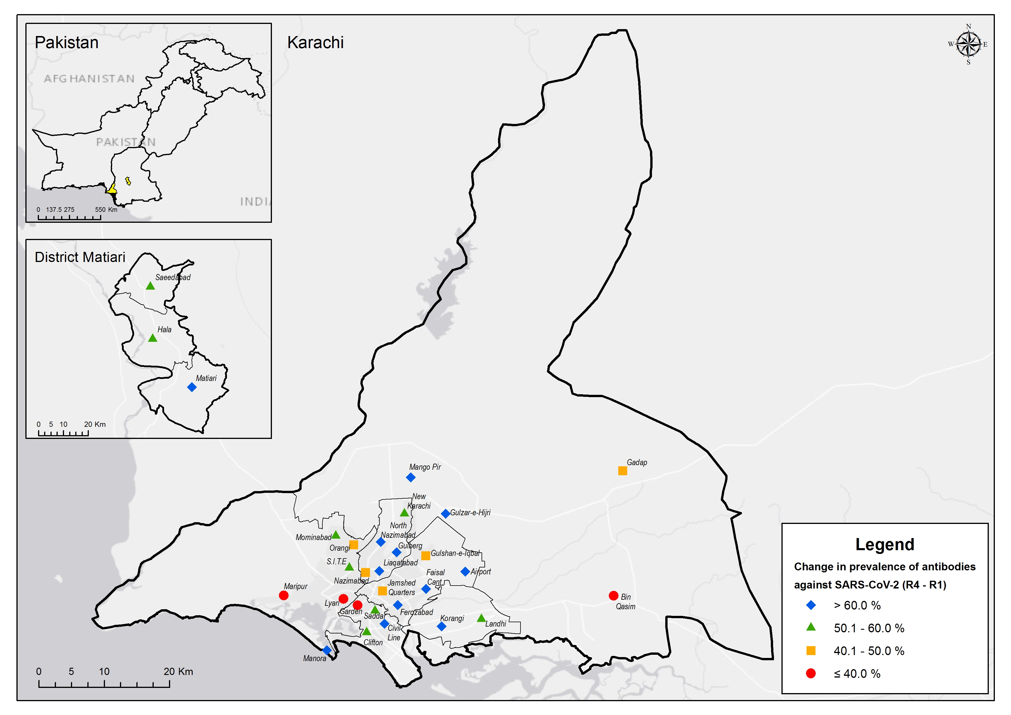
The figure illustrates the spatial distribution and variation in seroprevalence changes across the selected study sites. The main map details Karachi city, the upper inset shows a map of Pakistan highlighting the locations of Karachi city, while the lower inset zooms in on district Matiari.The colored symbols on the map indicate the change in prevalence of antibodies against SARS-CoV-2 between survey rounds (R4 - R1) across different areas.

Supplementary Figure 2.
Flow diagram of sampling method and timeline of the study

The chart describes the periods of surveys 1, 2, 3 and 4, respectively which were conducted between July 2020 and November 2021. The number of households interviewed as well as the number of participants requested to participate in the study are indicated. The final number of individuals who consent to participate in each round of the study are also listed.

Supplementary Figure 3.
COVID-19 cases in Pakistan during the study period

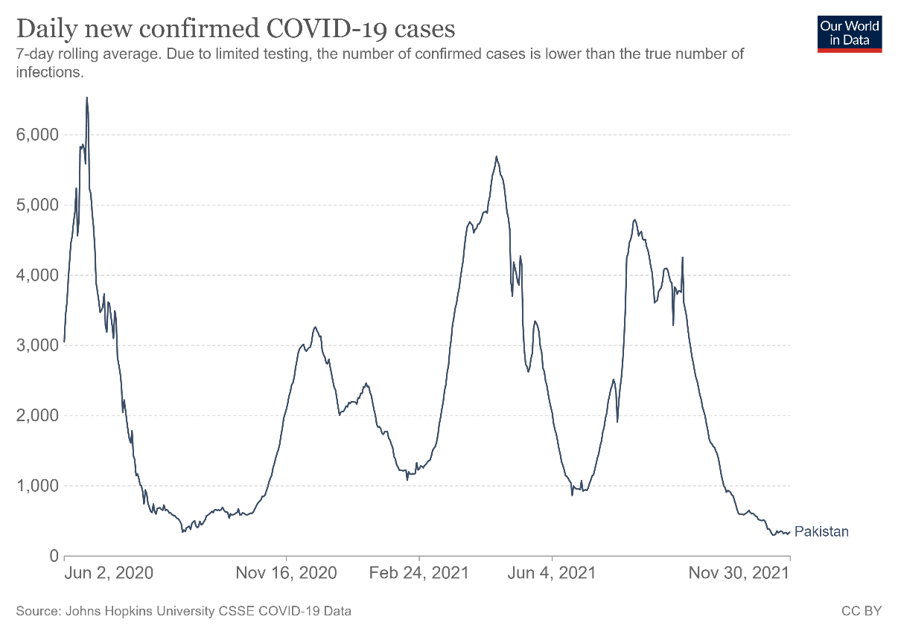
The figure illustrates the number of new confirmed COVID-19 cases reported in Pakistan during the study period, from July 2020 and November 2021. This data was sourced from the Johns Hopkins University COVID-19 Data Repository.

