Additional file 1. Supplementary Figure 1. Units included in Skåne Naloxone program, June 2018 – June 2023.
All individuals (n=2685) took part of the theoretical and practical overdose prevention training and were provided with a naloxone-kit from one of the OEND units (n=52) in Skåne county. The study included the following units in the region: NSPs (n=4), OATs (n=30), emergency ward (n=1), in-patient addiction units, non-OAT out-patient addiction units and psychiatric facilities (n=17) [Figure 1], of which three OAT facilities closed during the study period.
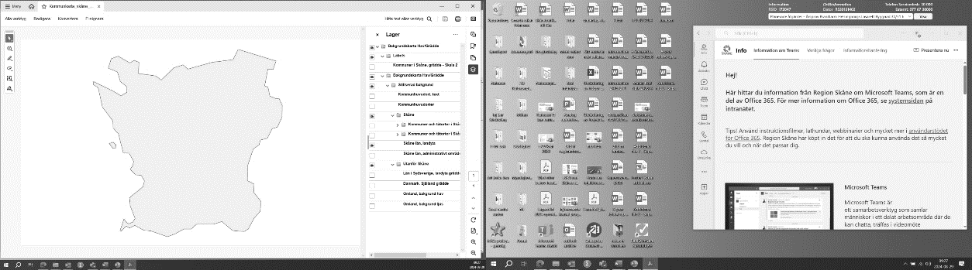
NSP
OAT (of which 3 units have closed)
Addiction and psychiatric facilities (non-OAT)
Emergency care unit

Figure 1. Units included in Skåne Naloxone program, June 2018 – June 2023.

