Supplementary materials
- List of antibodies for Western Blot or IHC.
Reagent | Art.NO. | Brand
CD73 | Bsm-30125M-APC | Bioss
CD90 | Bsm-3010M-FITC | Bioss
CD105 | Bsm-30132M-APC-Cy7 | Bioss
CD34 | Bsm-30097M-PE-Cy5 | Bioss
CD45 | Bsm-30095M-PE | Bioss
CD9 | 20597-1-AP | Proteintech
CD81 | 27855-1-AP | Proteintech
CD63 | ER1905-64 | HUABIO
beta Actin Rabbit mAb | R23613 | Proteintech
GAPDH Monoclonal antibody | 60004-1-lg | Proteintech
TGFβ1 Polyclonal antibody | IPB0036 | Baijia
Smad2/3 Polyclonal antibody | IPB0670 | Baijia
Phospho-Smad2/3 Rabbit pAb | IPB0231 | Baijia
Smad7(Acetyl Lys70) rabbit pAb | IPB11718 | Baijia
LYVE-1 Polyclonal antibody | 51011-1-AP | Proteintech
RIPA Lysate | P0013B | Beyotime
QuickBlock™ Western Blocking solution | P0239 | Beyotime
TBST | P0239 | Beyotime
Western Antibody Dilution | P0239 | Beyotime
Ultra High Sensitive ECL Kit | P0018S | Beyotime
Goat Anti-Mouse IgG H&L（HRP） | 511103 | Zenbio
Goat Anti-Rabbit IgG H&L（HRP） | 511203 | Zenbio

- ADSC isolation and identification.
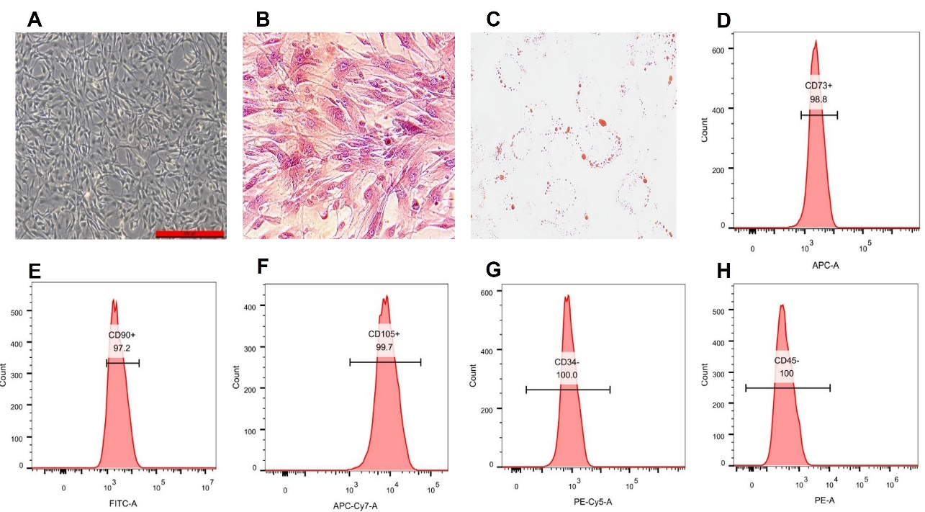
Figure S1. Morphology of ADSCs under bright field, adipogenic and osteogenic differentiation experiments and identification of ADSCs by flow cytometry.

- ADSC-Ex isolation and identification.
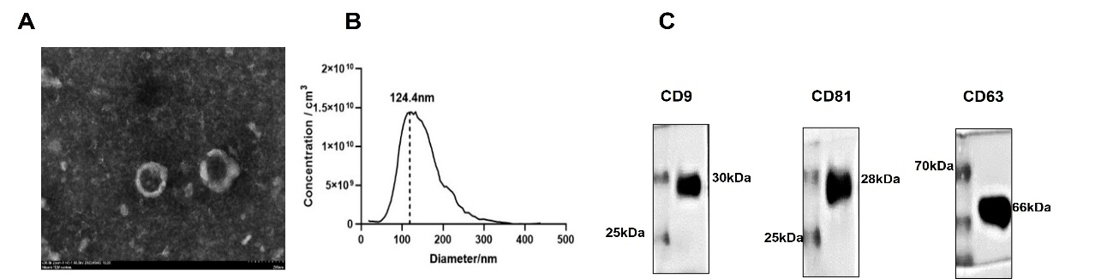
Figure S2. Electron micrograph analysis of whole-mount ADSC-Exs. Scale bar= 200nm. qNano analysis of the exosomes diameter (nm) isolated from ADSCs/VEGF-C conditioned medium and western blot analysis showing exosome marker CD9, CD81 and CD63 in the exosome.

