Supplementary Information of

Recent climate change strengthens the local cooling·of European forests

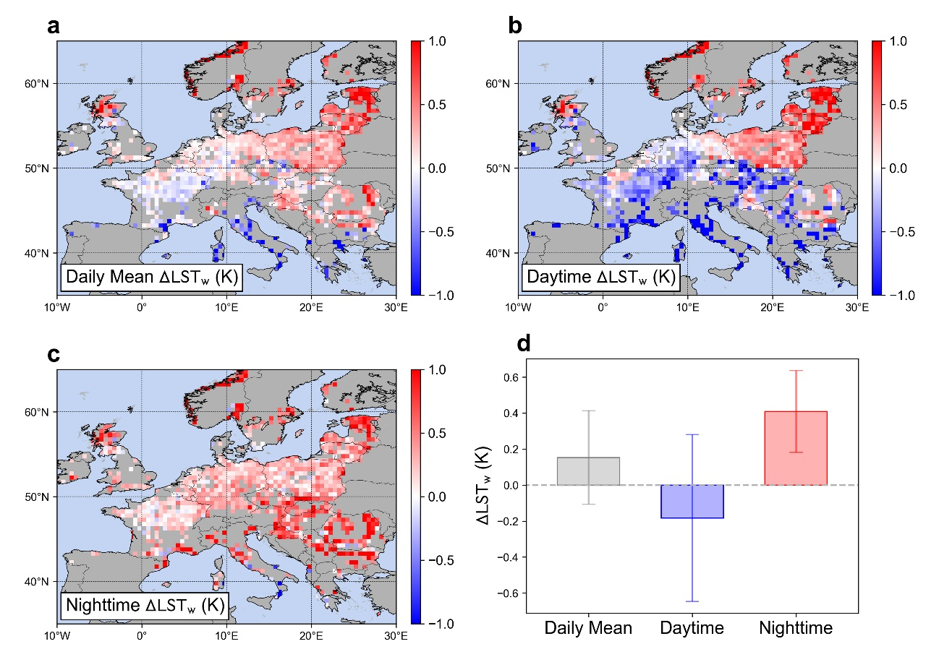

Fig. S1. Mean biophysical land surface temperature effect of European forest in winter from 2003 to 2023 (ΔLST_{w}). (a to c) Spatial pattern of daily mean, daytime, and nighttime ΔLST_{w}. (d) Regional mean ΔLST_{w}. Error bars show the half of standard deviation.
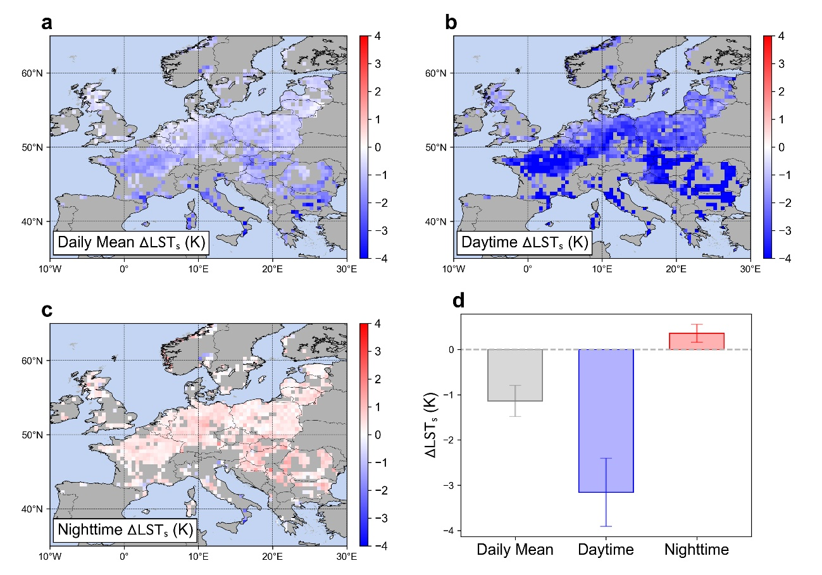
Fig. S2. Mean biophysical land surface temperature effect of European forest in summer from 2003 to 2023 (ΔLST_{s}). (a to c) Spatial pattern of daily mean, daytime, and nighttime ΔLST_{s}. (d) Regional mean ΔLST_{s}. Error bars show the half of standard deviation.

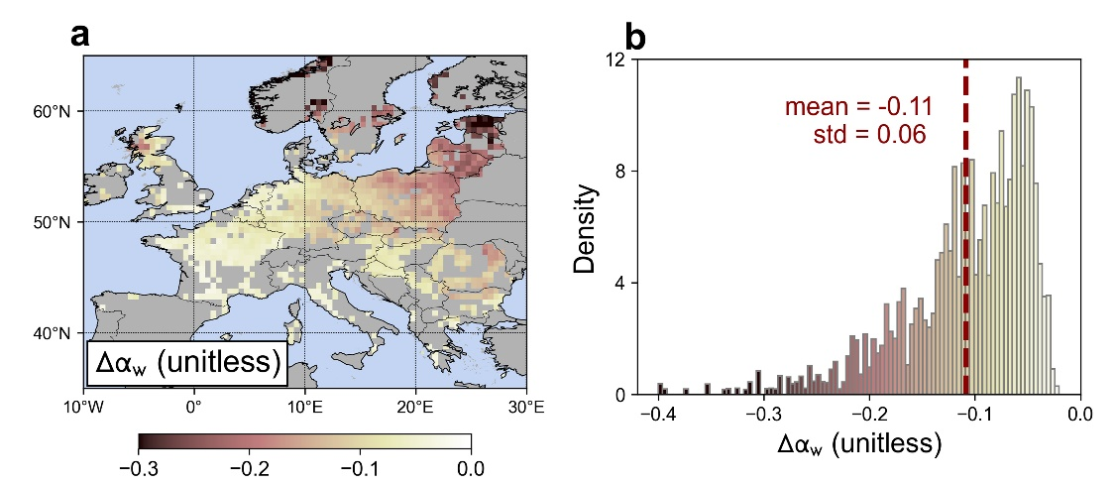
Fig. S3. Mean albedo effect of European forest in winter from 2003 to 2023 (Δα_{w}). (a) Spatial pattern of Δα_{w}. (b) Density histogram of Δα_{w}.
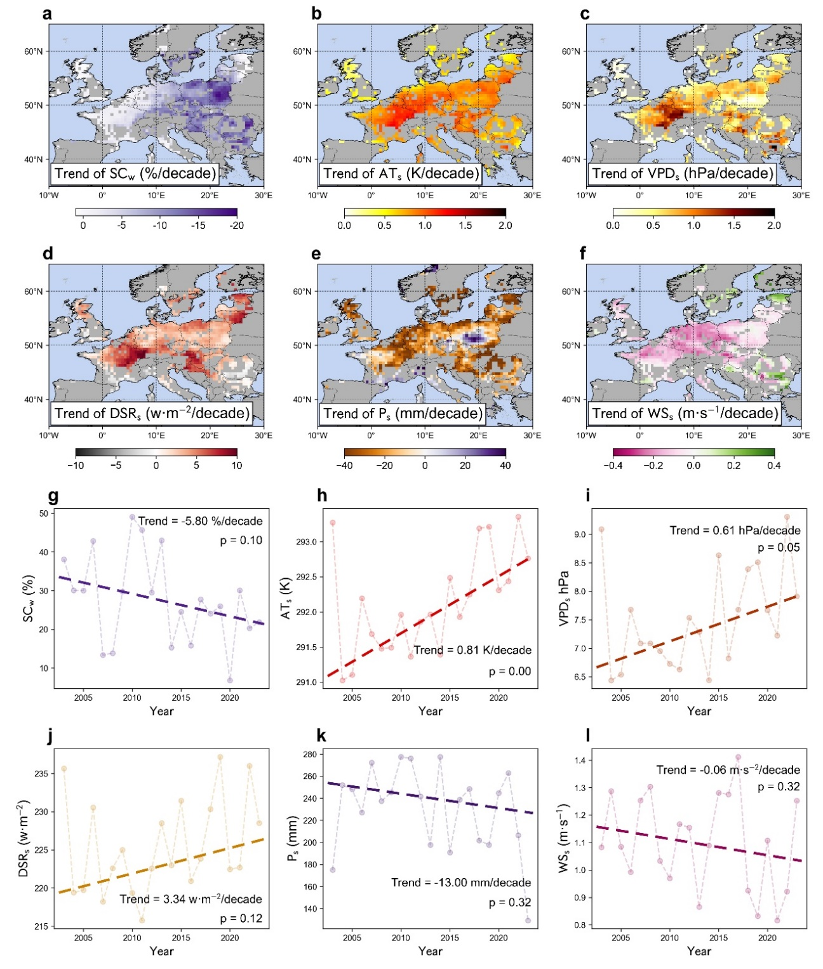
Fig. S4. Climate change in Europe from 2003 to 2023. (a to f) Spatial pattern of trends of snow cover (SC_{w}), summer air temperature (AT_{s}), vapor pressure deficit (VPD_{s}), downward shortwave radiation (DSR_{s}), precipitation (P_{s}) and wind speed (WS_{s}). (g to l) Regional mean interannual variations and trends of the climate variables. The subscripts s and w represent summer and winter, respectively.
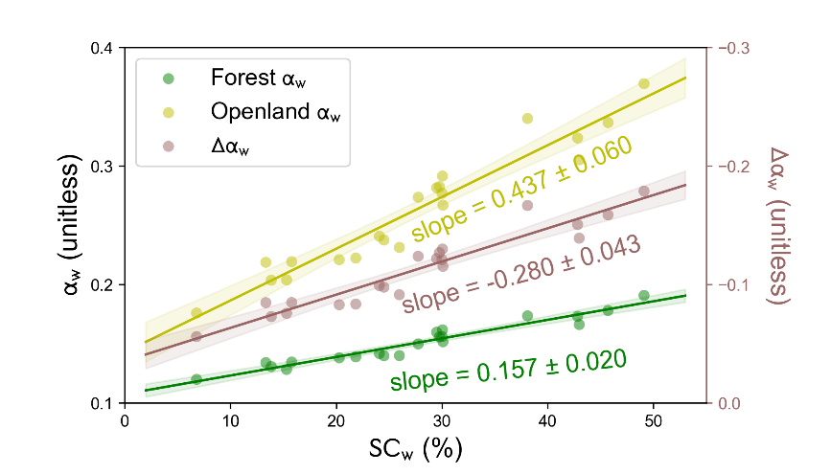
Fig. S5. Temporal relationships between the regional mean SC_{w} and α_{w} in forests and openlands, and the resultant relationship between SC_{w} and Δα_{w}.

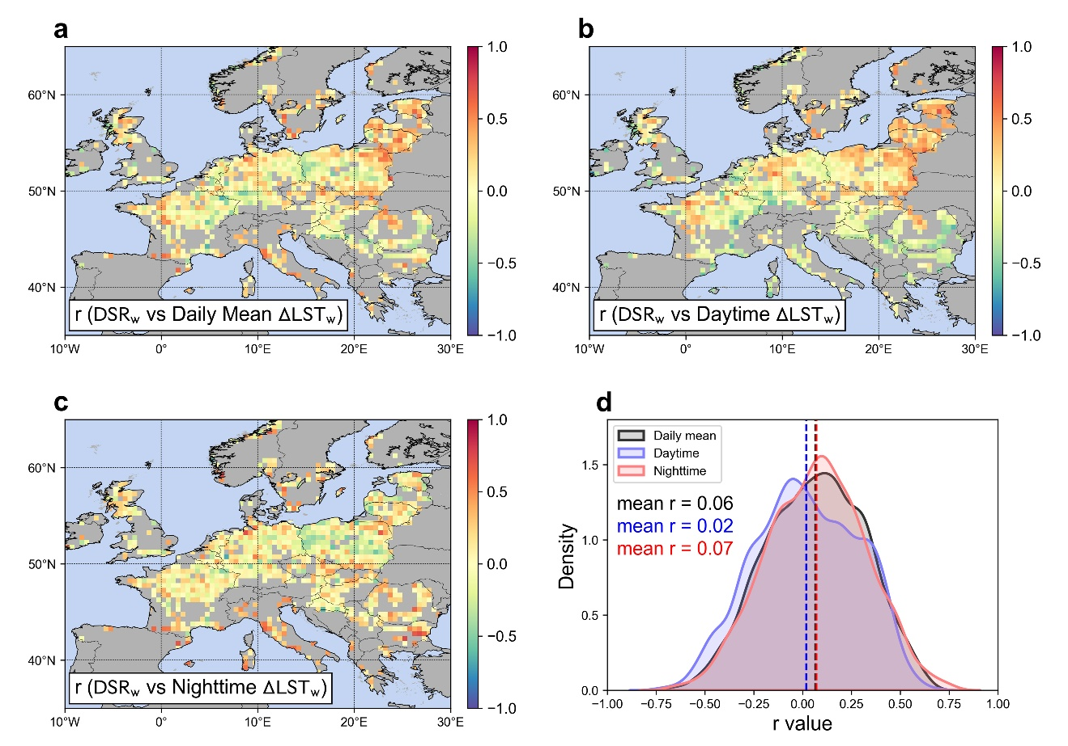
Fig. S6. Temporal correlation coefficient (r) between DSR_{w} and ΔLST_{w}. (a to c) Spatial pattern of r between DSR_{w} and daily mean, daytime and nighttime ΔLST_{w}. (d) Density of the r values.
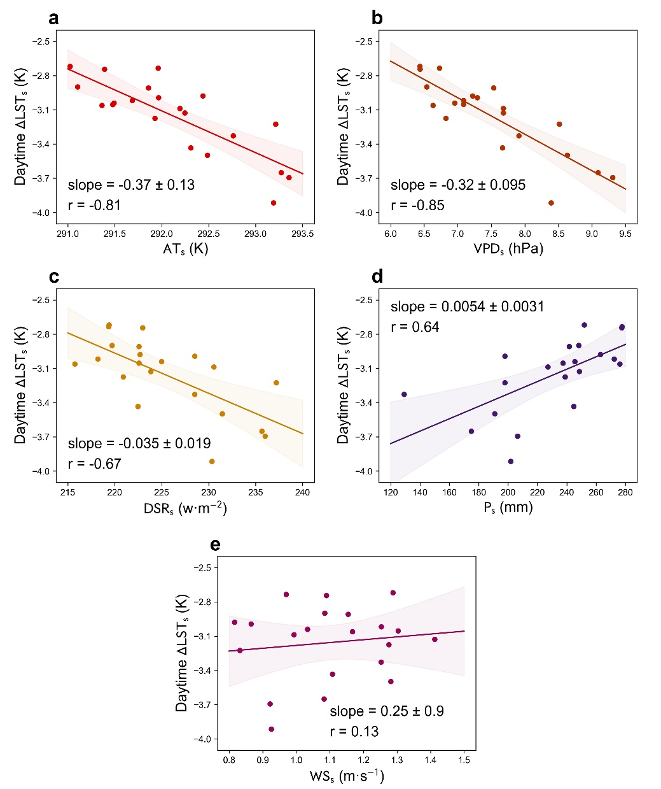
Fig. S7. Regressions between regional mean daytime ΔLST_{s} and (a) air temperature (AT_{s}), (b) vapor pressure deficit (VPD_{s}), (c) downward shortwave radiation (DSR_{s}), (d) precipitation (P_{s}) and (e) wind speed (WS_{s}) in summer.
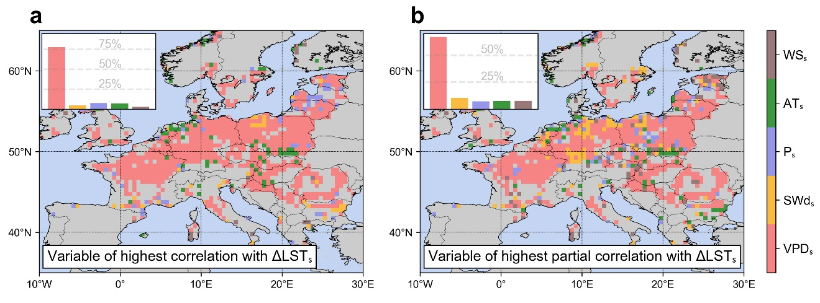
Fig. S8. Climatic drivers of daytime ΔLST_{s} determined by largest absolute (a) correlation coefficient and (b) partial correlation coefficient.

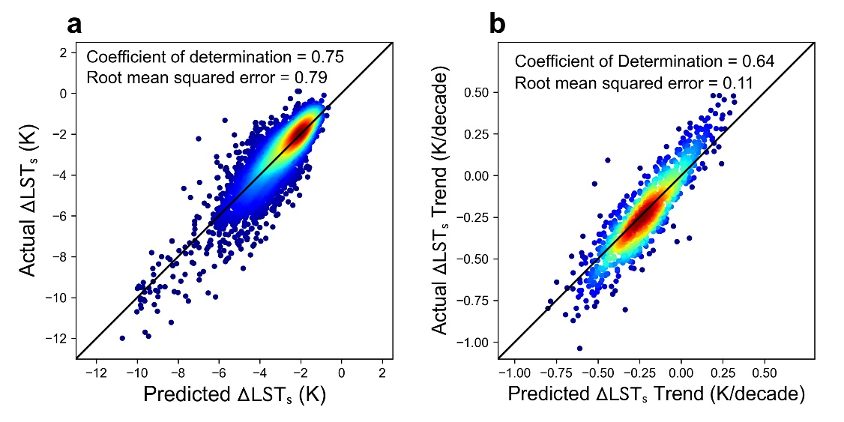
Fig. S9. Validation of the random forest model for estimating the daytime ΔLST_{s}. (a) Scatter plot between predicted ΔLST_{s} and observed ΔLST_{s}. (b) Similar with a, but for the trends of ΔLST_{s}.
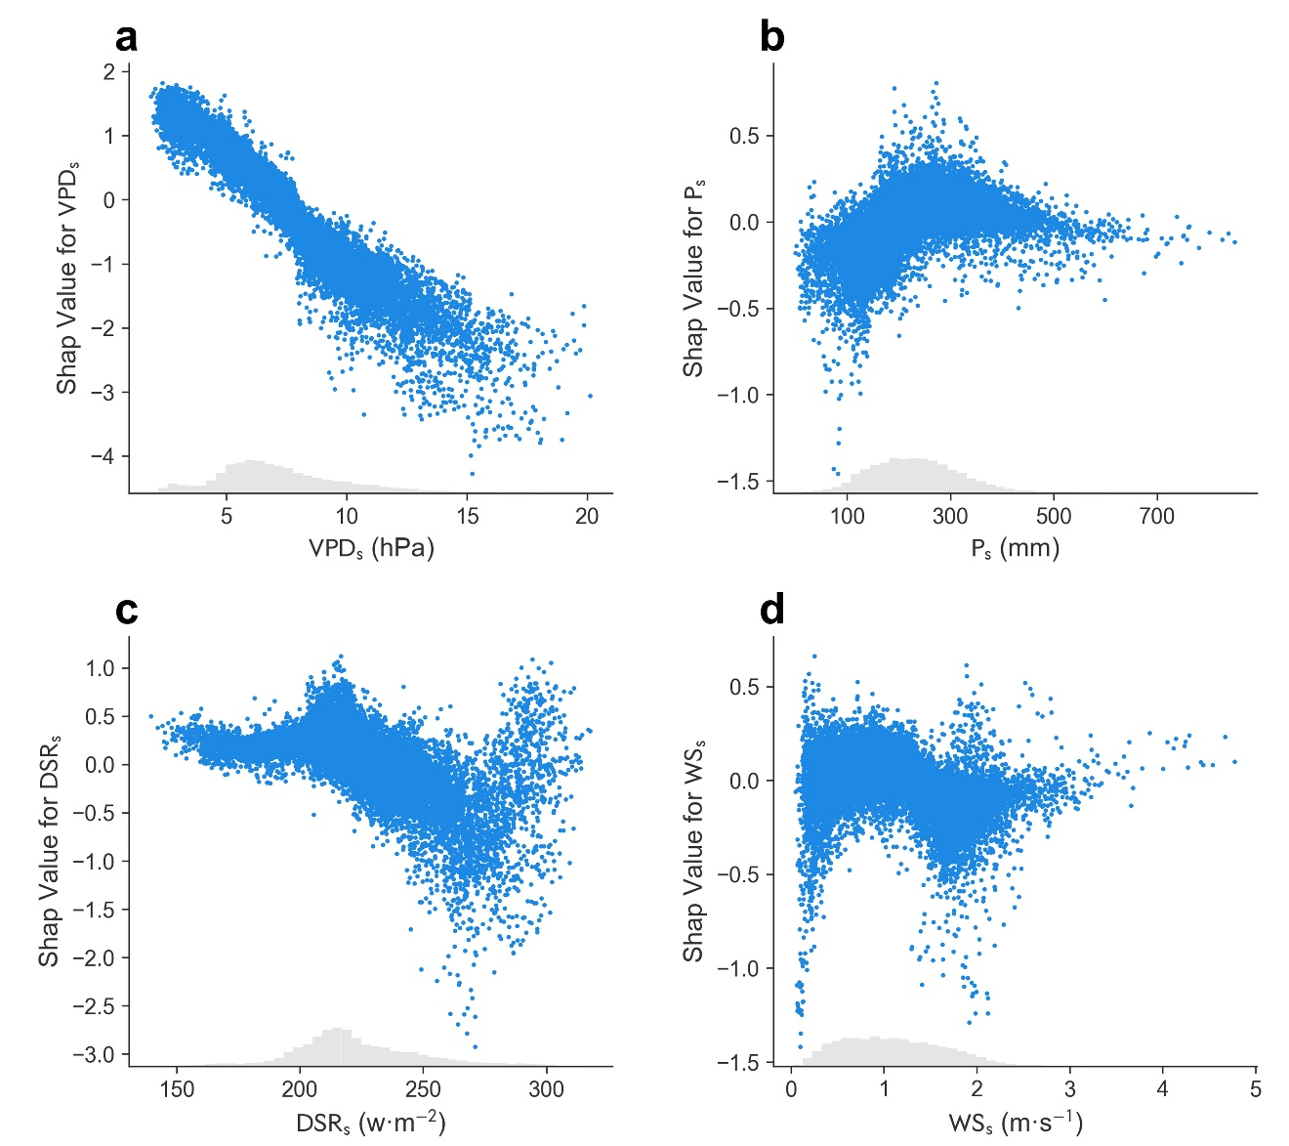
Fig. S10. Scatter plots between input data and corresponding Shapley Additive Explanations (SHAP) values for summer (a) vapor pressure deficit (VPD_{s}), (b) precipitation (P_{s}), (c) downward shortwave radiation (DSR_{s}), (d) wind speed (WS_{s}).

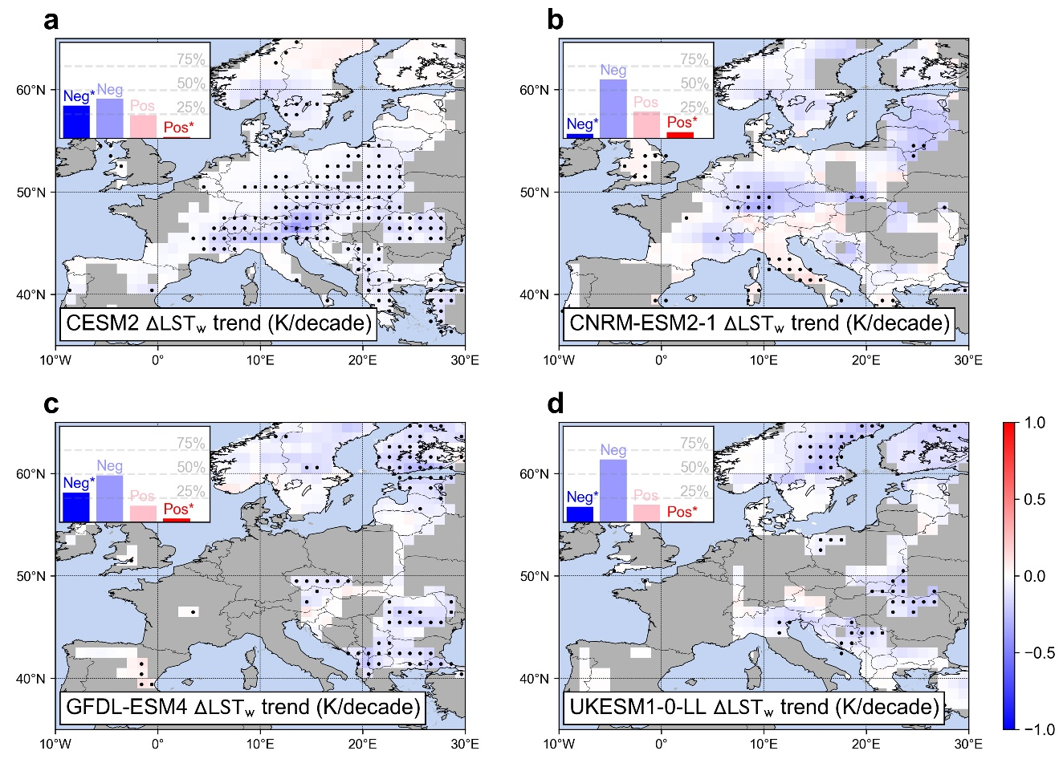
Fig S11. Simulated temporal dynamics in wintertime daily mean land surface temperatures effects of European forests (ΔLST_{w}) over 1985 to 2014 from (a) CESM2, (b) CNRM-ESM2-1, (c) GFDL-ESM4, and (d) UKESM1-0-LL. The dots indicate the grids with significant trends (p<0.05). The difference in valid grids is due to the distinctive effective forest tiles in four models.

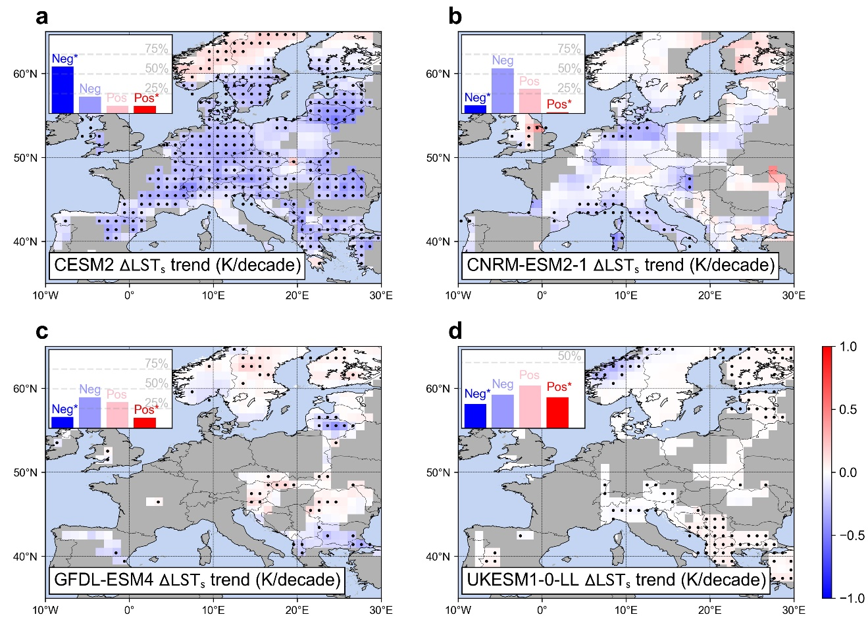
Fig S12. Simulated temporal dynamics in summertime daily mean land surface temperatures effects of European forests (ΔLST_{s}) over 1985 to 2014 from (a) CESM2, (b) CNRM-ESM2-1, (c) GFDL-ESM4, and (d) UKESM1-0-LL. The dots indicate the grids with significant trends (p<0.05). The difference in valid grids is due to the distinctive effective forest tiles in four models.

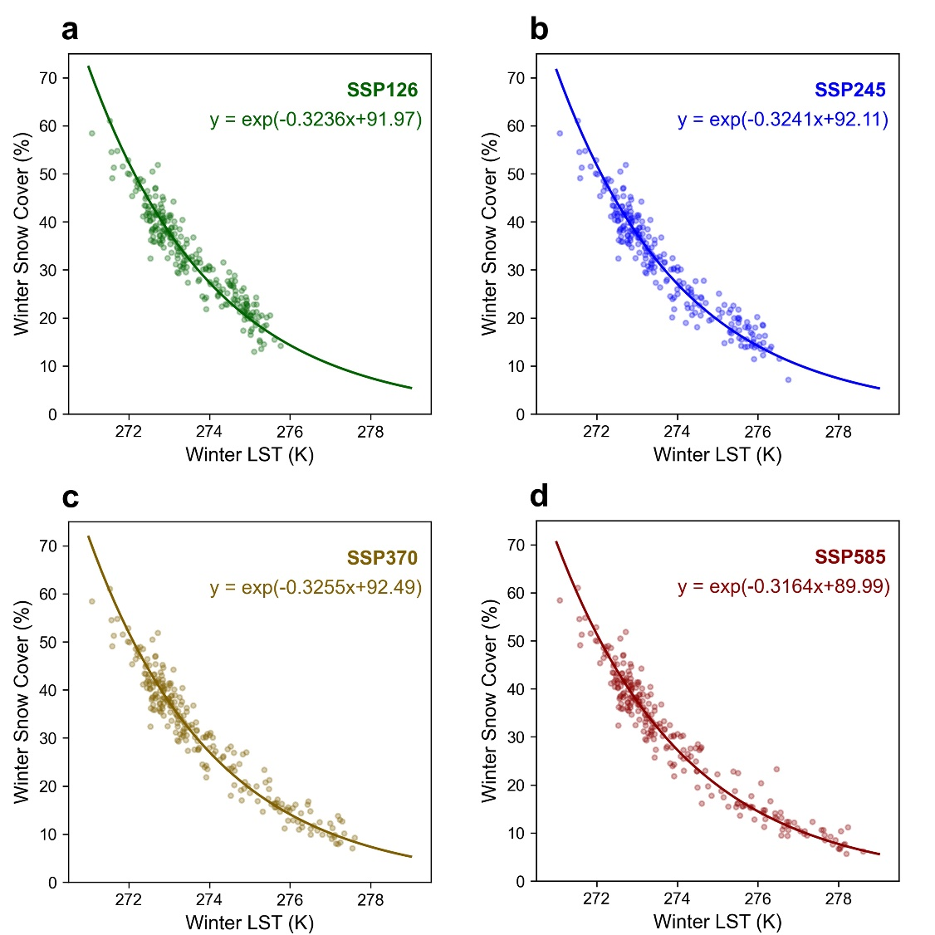
Fig S13. Relationship between wintertime land surface temperature (LST) and snow cover over (a) SSP126, (b) SSP245, (c) SSP370, and (d) SSP585.

