The Effective Control of Harmful Components in Smoke Using a Novel Laser-Based Smoking Device

Chen Chen¹, Xinyuan Wang¹, Yajun Ye¹, Chunsheng Guo¹, Baodan Na¹, Xiaoping Ning¹, Ye Tian¹, Linda Li¹, Xingquan Zhao¹, He Du^{1,*}
¹ Inner Mongolia Kunming Cigarette Co., Ltd. 19 Daerdeng North Road, 010020, Hohhot, Inner Mongolia, China
Email: * d15672883703@163.com

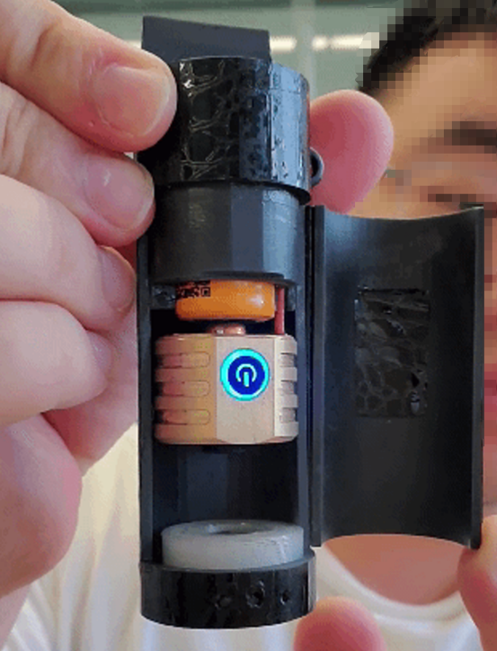
Figure S1. Photograph of the novel smoking device. The laser and circuitry are concealed within the device, covered by a magnetic lid. Internally, from bottom to top, the components include a base (white cylinder), the laser head (brass material, with the circuitry encased in the heat dissipation system), and the battery (orange).

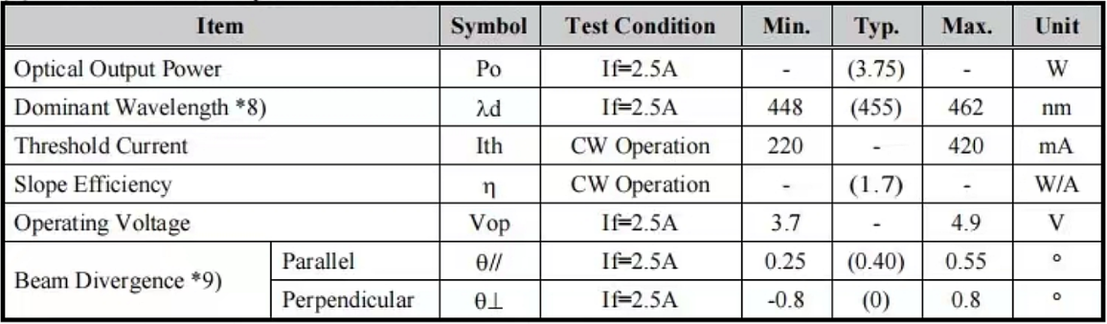
Figure S2. Laser head circuit specifications

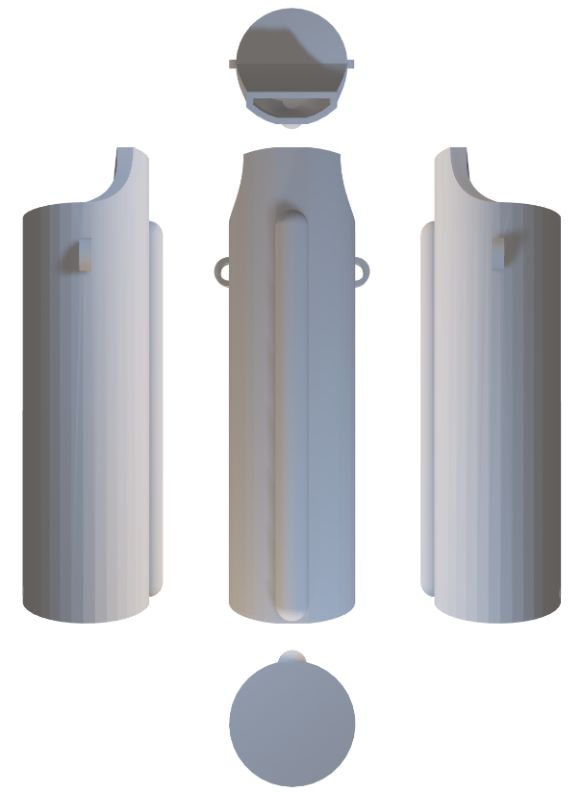
Figure S3. 3D design of the laser and different perspectives

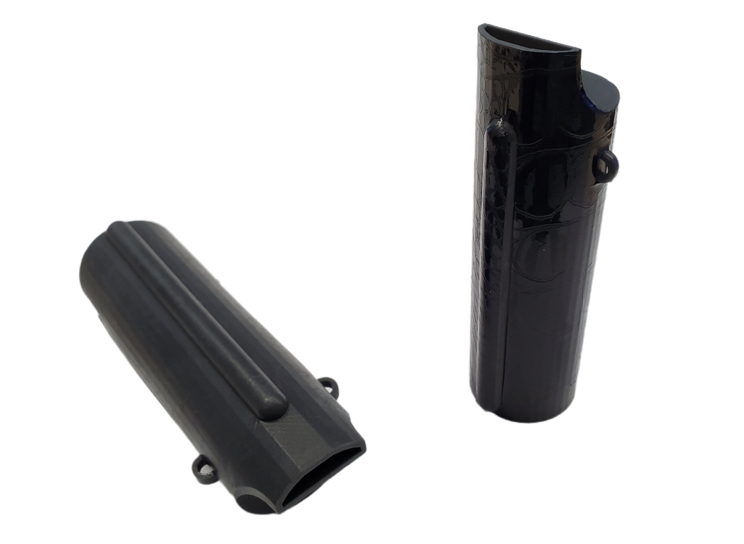
Figure S4. The device housing printed using 3D printing technology, with a customizable protective film applied (Right )

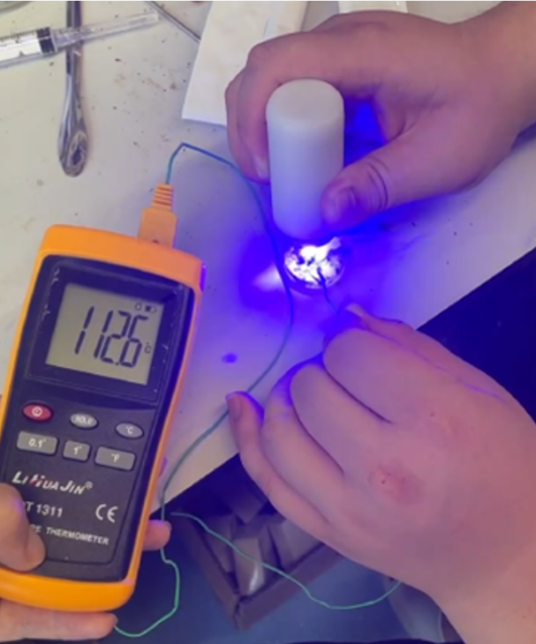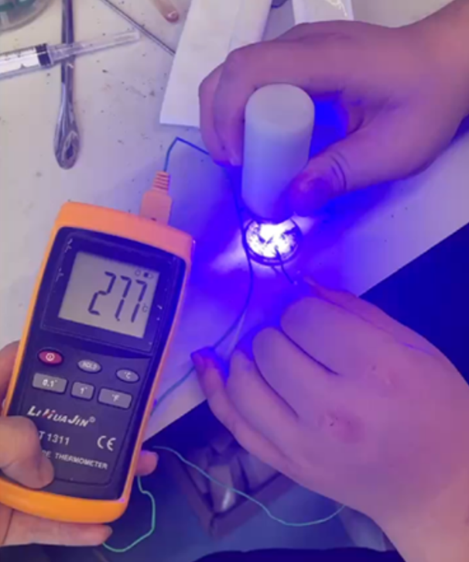
Figure S5. Measurement of laser temperature. The temperature probe is placed at the laser spot to accurately measure the temperature at the spot.

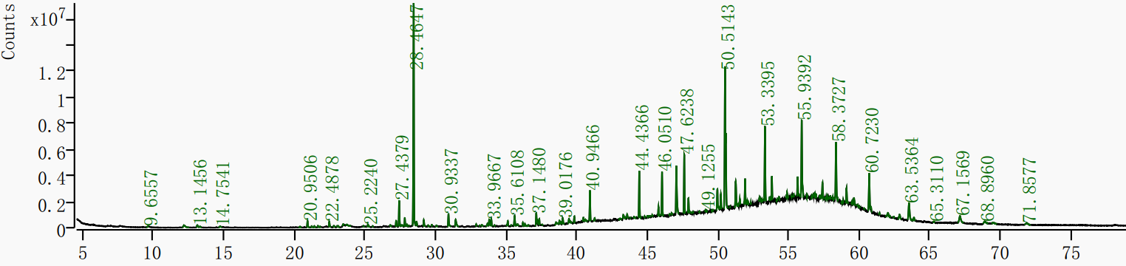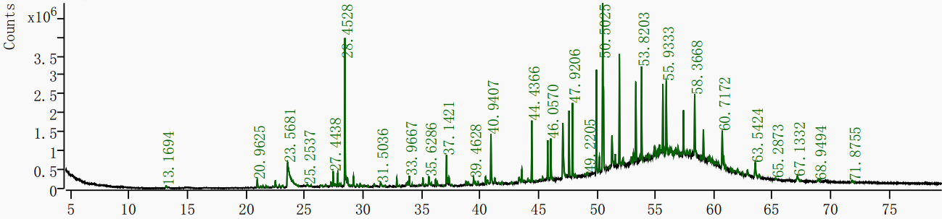
Figure S6. Total ion current chromatograms of smoke measured using GC-MS. The upper figure shows the total ion current chromatogram of smoke generated by traditional flame ignition, while the lower figure presents the total ion current chromatogram of smoke generated by laser ignition.

