Appendix: The details of the Problem-category-target matches for top 6 health problems
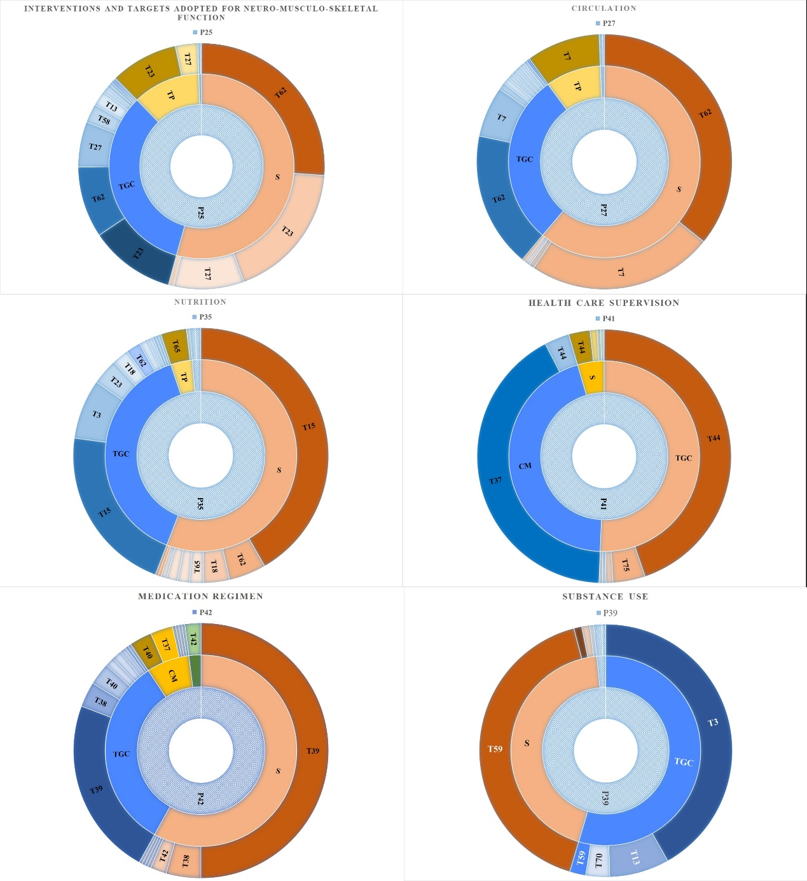
Note: P25, Neuro-musculo-skeletal function; S, Surveillance; TGC, Teaching, Guidance, and Counselling; TP, Treatment and Procedures; T27, Gait training; T23, Exercises; T62, Signs/symptoms-physical; T58, Safety
P27, Circulation; S, Surveillance; TGC, Teaching, Guidance, and Counselling; TP, Treatment and Procedures; T7, Cardiac care; T62, Signs/symptoms-physical
P35, Nutrition; S, Surveillance; TGC, Teaching, Guidance, and Counselling; TP, Treatment and Procedures; T15, Dietary management; T62, Signs/symptoms-physical; T18, Durable medical equipment; T3, Behavior modification; T65, Specimen collection; T23, Exercises
P41, Health care supervision; S, Surveillance; TGC, Teaching, Guidance, and Counselling; TP, Treatment and Procedures; T44, Nursing care; T37, Medical/dental care; T75, Wellness
P42, Medication regimen; S, Surveillance; TGC, Teaching, Guidance, and Counselling; TP, Treatment and Procedures; T39, Medication administration; T38, Medication action/side effects; T40, Medication coordination/ordering; T37, Medical/dental care
P39, Substance use; S, Surveillance; TGC, Teaching, Guidance, and Counselling; TP, Treatment and Procedures; T3, Behavior modification; T59, Screening procedures; T13, Coping skills; T70, Substance use cessation

