Figure S1. The CT or panendoscopy image of the patients¹
Case 1 | Case 2  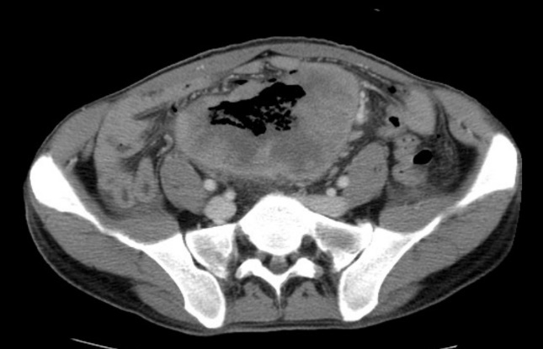
Case 4 | Case 6  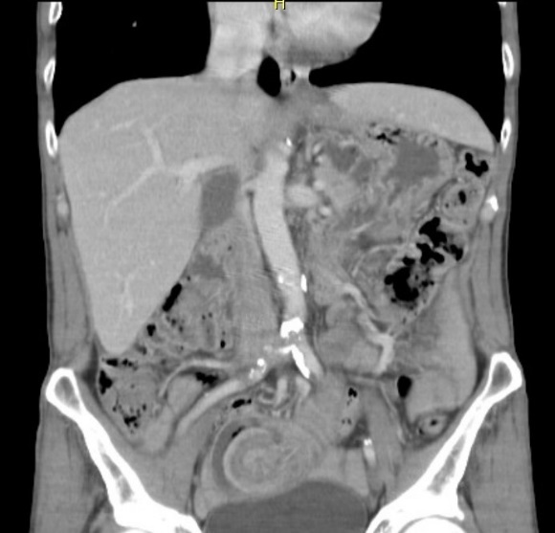
Case 7  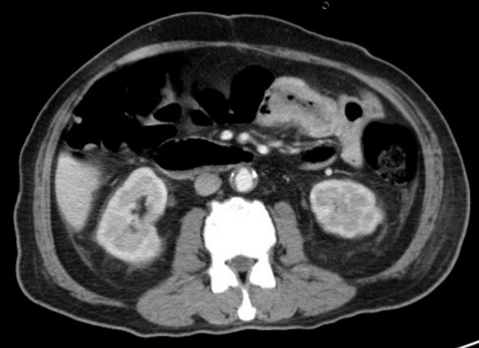 | Case 8  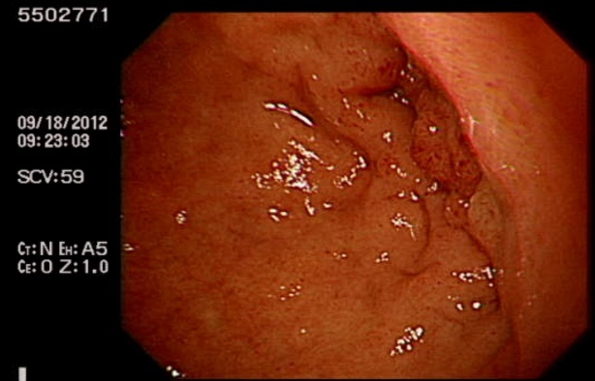
Case 9 | Case 10  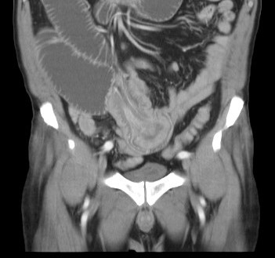
Case 11  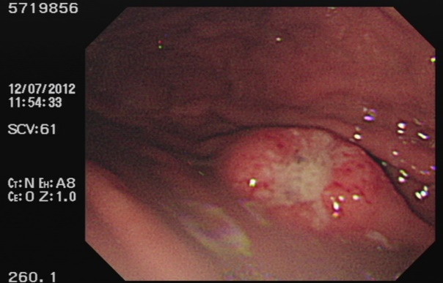 | Case 12  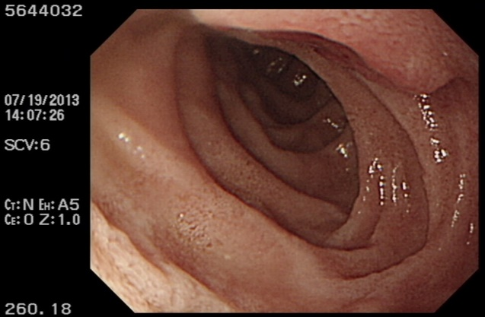
Case 14  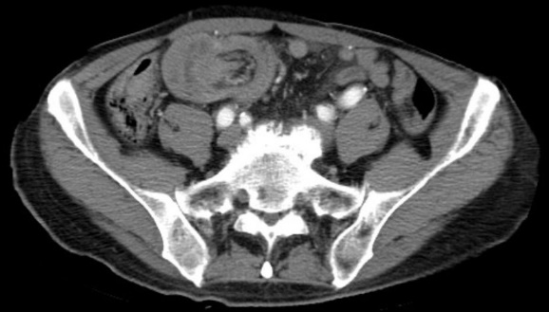 | Case 15  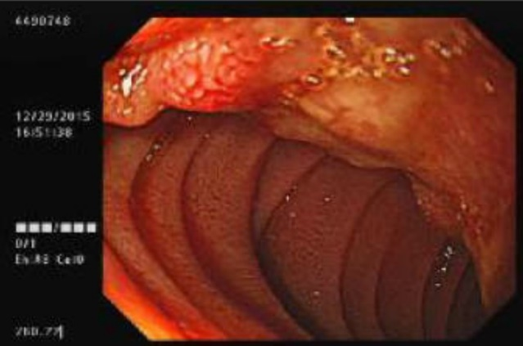
Case 16 | Case 17
Case 18 | Case 19
Case 20 | Case 21
Case 22 | Case 23
Case 24 | Case 25
Case 26 | Case 27
Case 28 | Case 29
Case 31 | ¹ All patients were sequenced by the diagnostic date of SB metastasis. No tumor was identified on CT scan of Case 3, 5, 13 and 30.

