Author’s biography

Mr. Tesfaye Barza is a Lecturer, Researcher, and International Reviewer at Wolaita Sodo University in Ethiopia. He holds both M.Sc. and B.Sc. degrees in Mechanical Engineering, specializing in Thermal Engineering. His research interests encompass Heating, Ventilating, and Air-Conditioning (HVAC), nanotechnology, Computational Fluid Dynamics, and turbulent flows. Mr. Barza is committed to advancing engineering education, mentoring students, and fostering international collaboration in research.
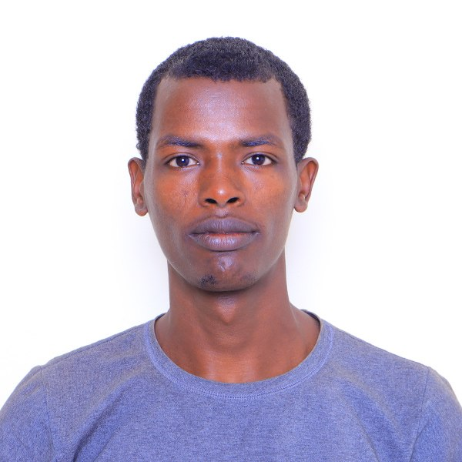 Mr. Akalework Tadele Degu is working in the School of Mechanical Engineering at wsu and Technology University, Ethiopia. His research interests include in heat transfer analysis.

